1.*Write a query which will display the customer id, account type they hold, their account number and bank name.

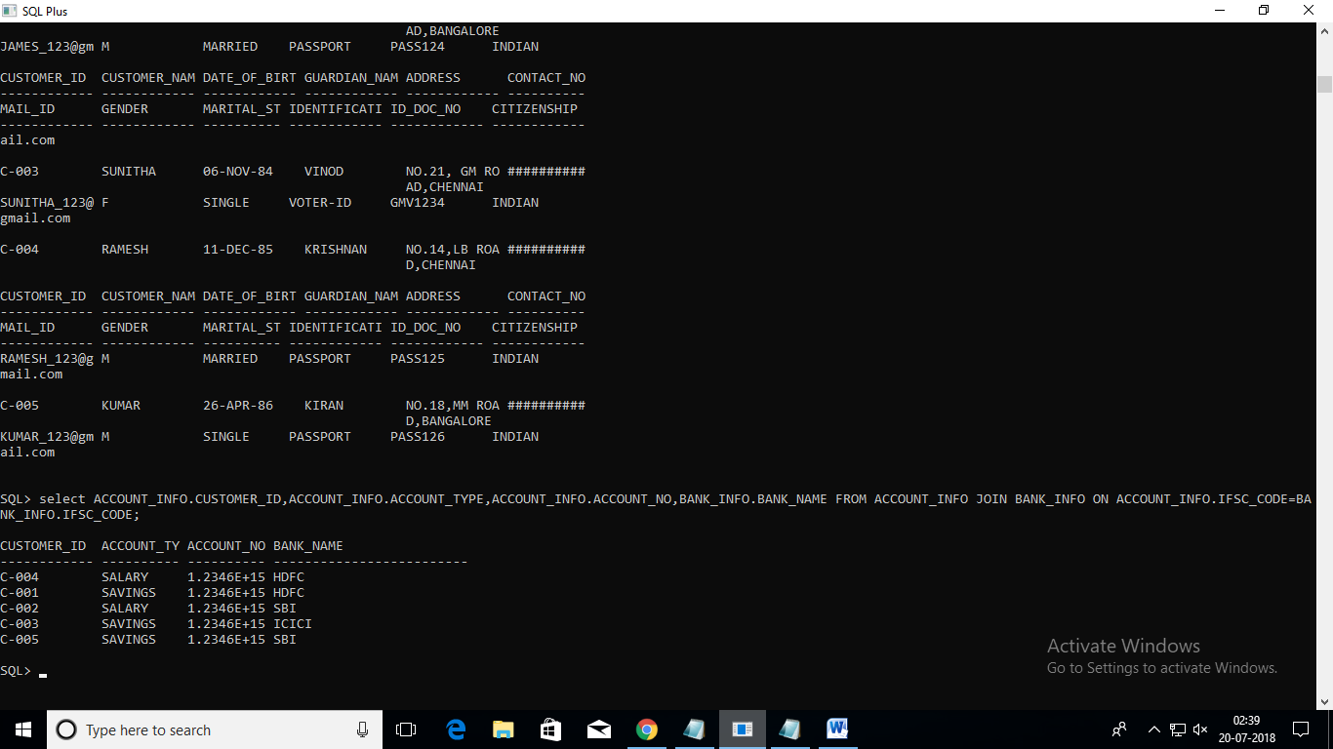

2.*Write a query which will display the customer id, account type and the account number of HDFC customers who registered after 12-JAN-2012 and before 04-APR-2012.

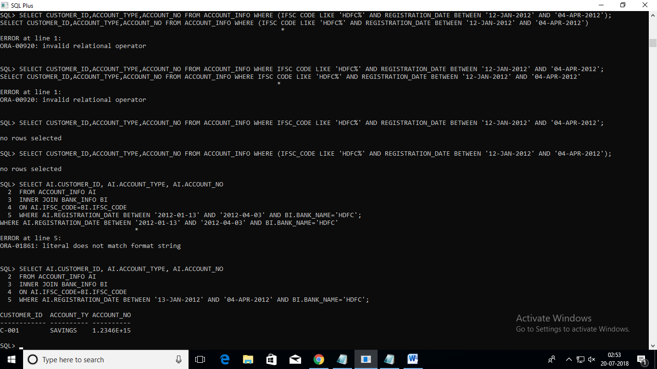

3.*Write a query which will display the customer id, customer name, account no, account type and bank name where the customers hold the account.

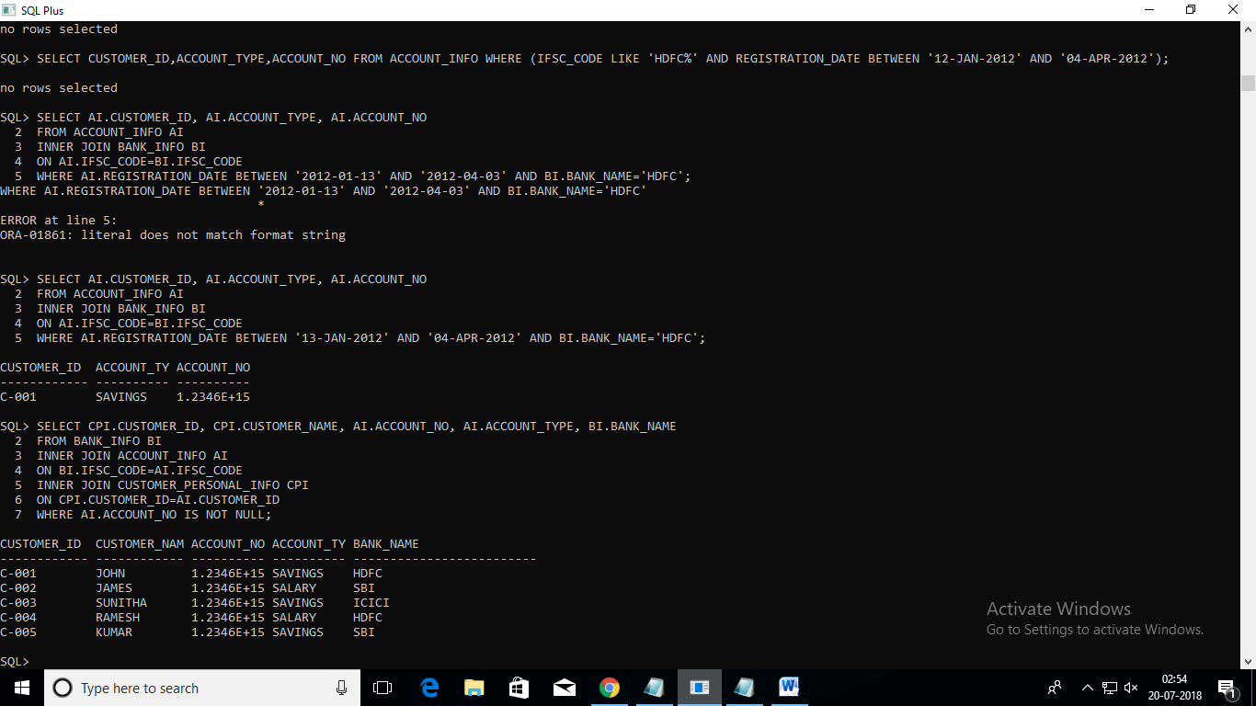

4.Write a query which will display the customer id, customer name, gender, marital status along with the unique reference string and sort the records based on customer id in descending order.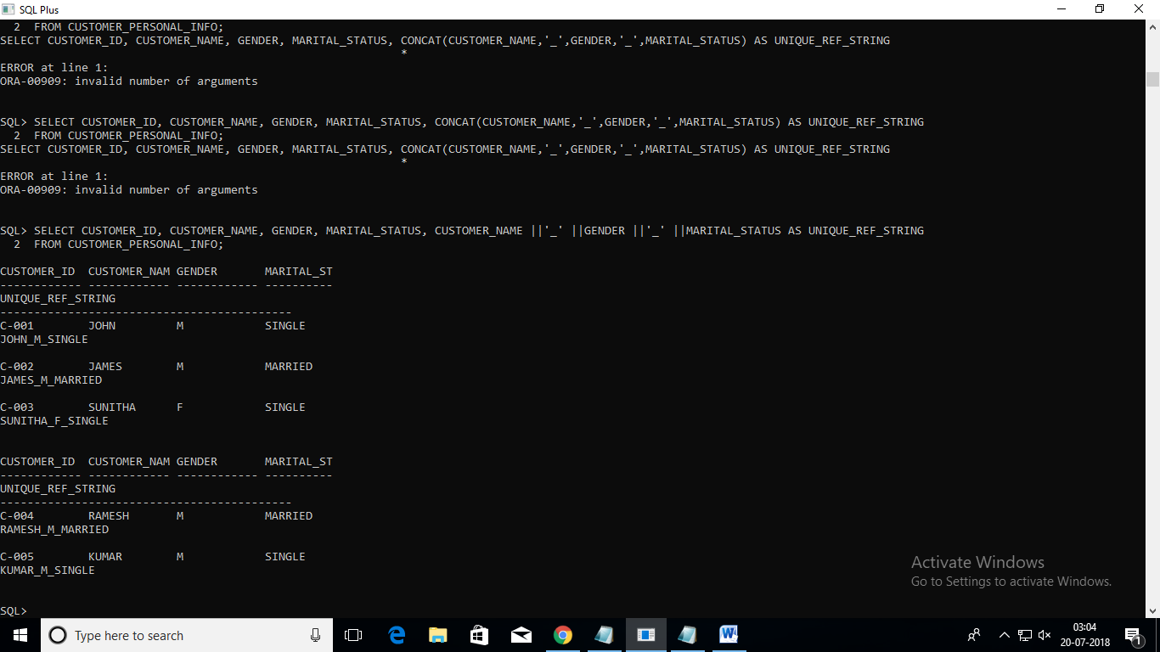

5. Write a query which will display the account number, customer id, registration date, initial deposit amount of the customer whose initial deposit amount is within the range of Rs.15000 to Rs.25000.

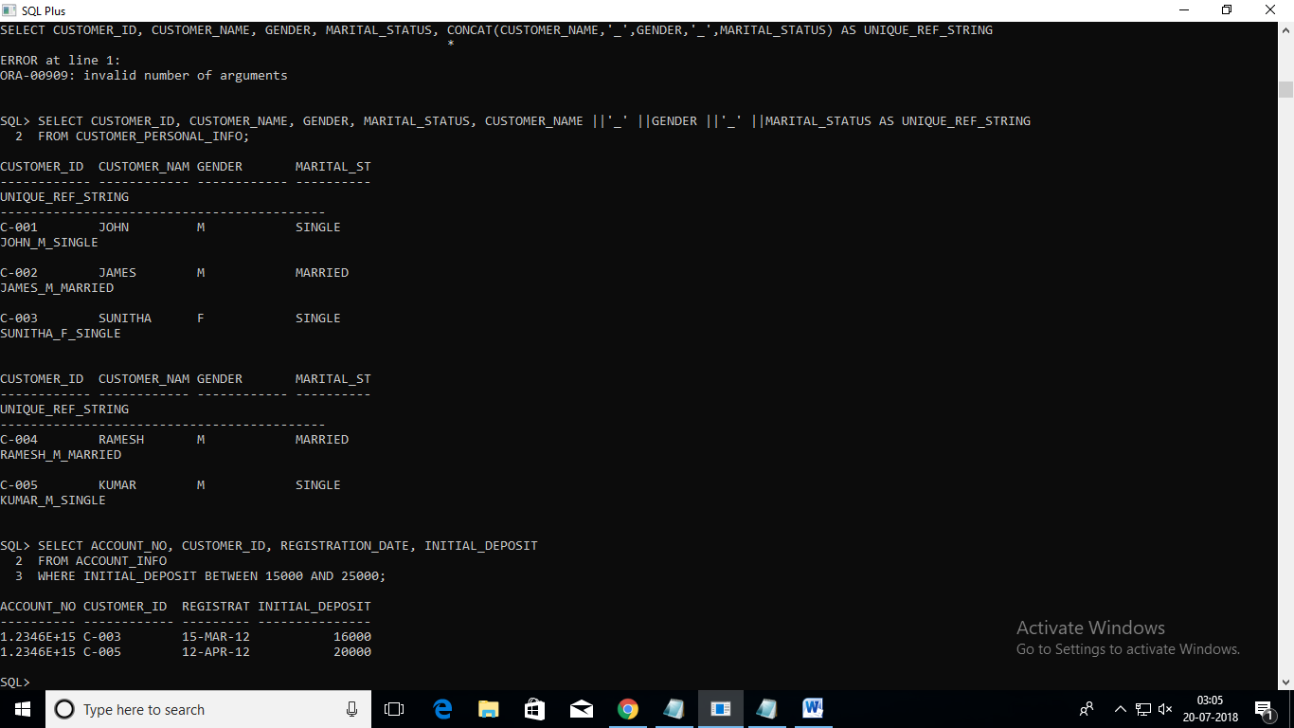

6. Write a query which will display customer id, customer name, date of birth, guardian name of the customers whose name starts with 'J'

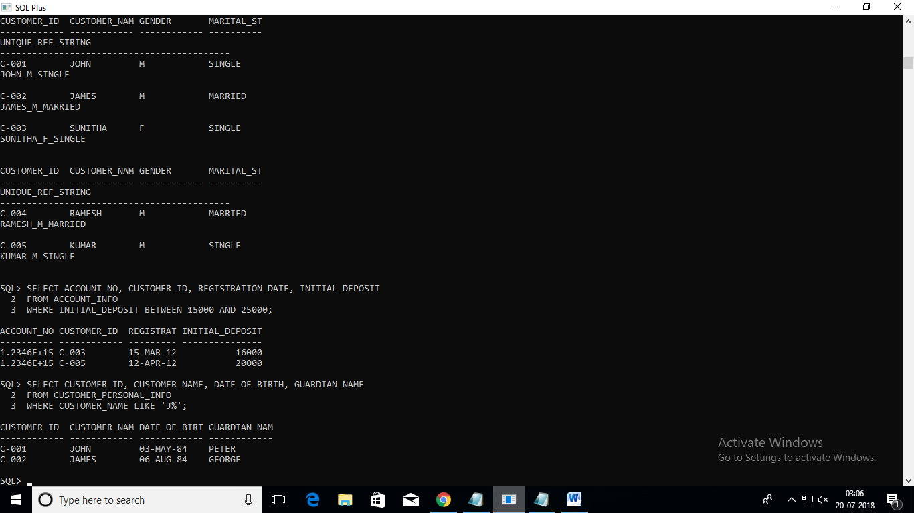

7. Write a query which will display customer id, account number and passcode.

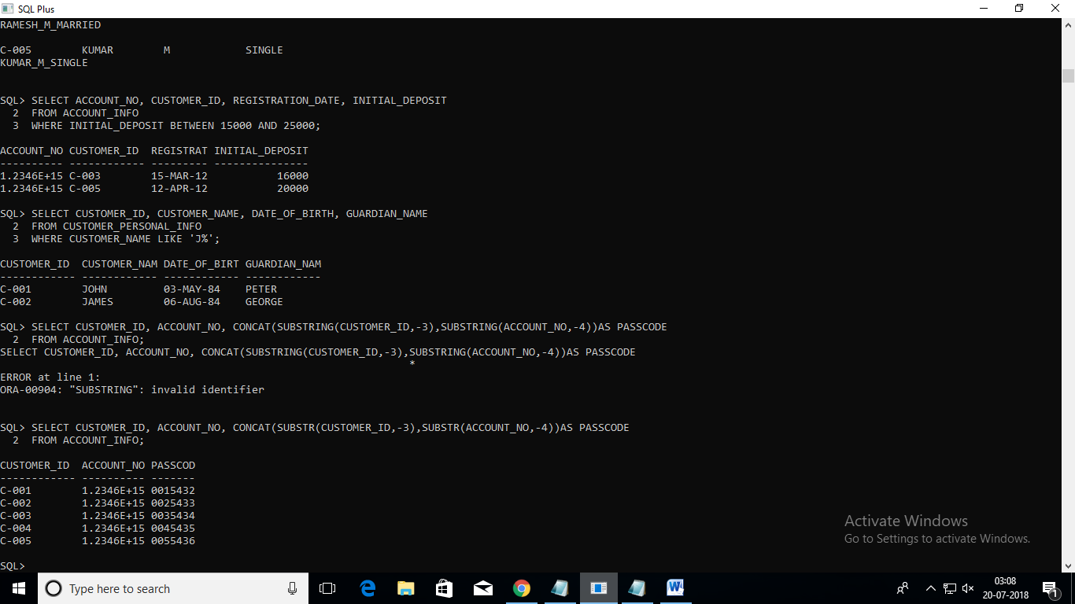

8. Write a query which will display the customer id, customer name, date of birth, Marital Status, Gender, Guardian name, contact no and email id of the customers whose gender is male 'M' and marital status is MARRIED.

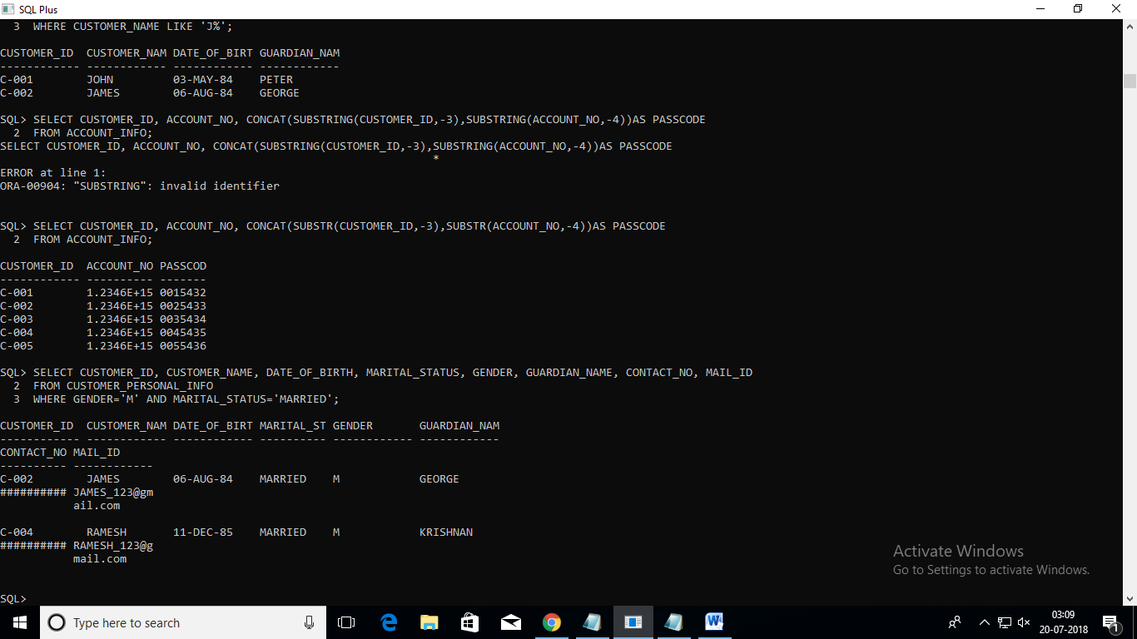

9. Write a query which will display the customer id, customer name, guardian name, reference account holders name of the customers who are referenced / referred by their 'FRIEND'.

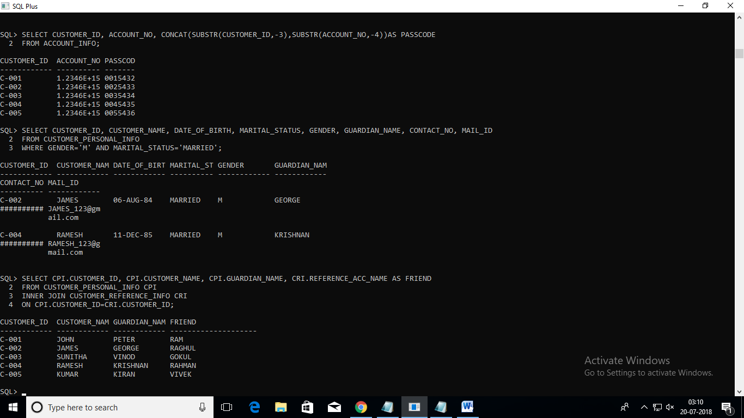

10. Write a query to display the customer id, account number and interest amount in the below format with INTEREST_AMT as alias name

Sort the result based on the INTEREST_AMT in ascending order.

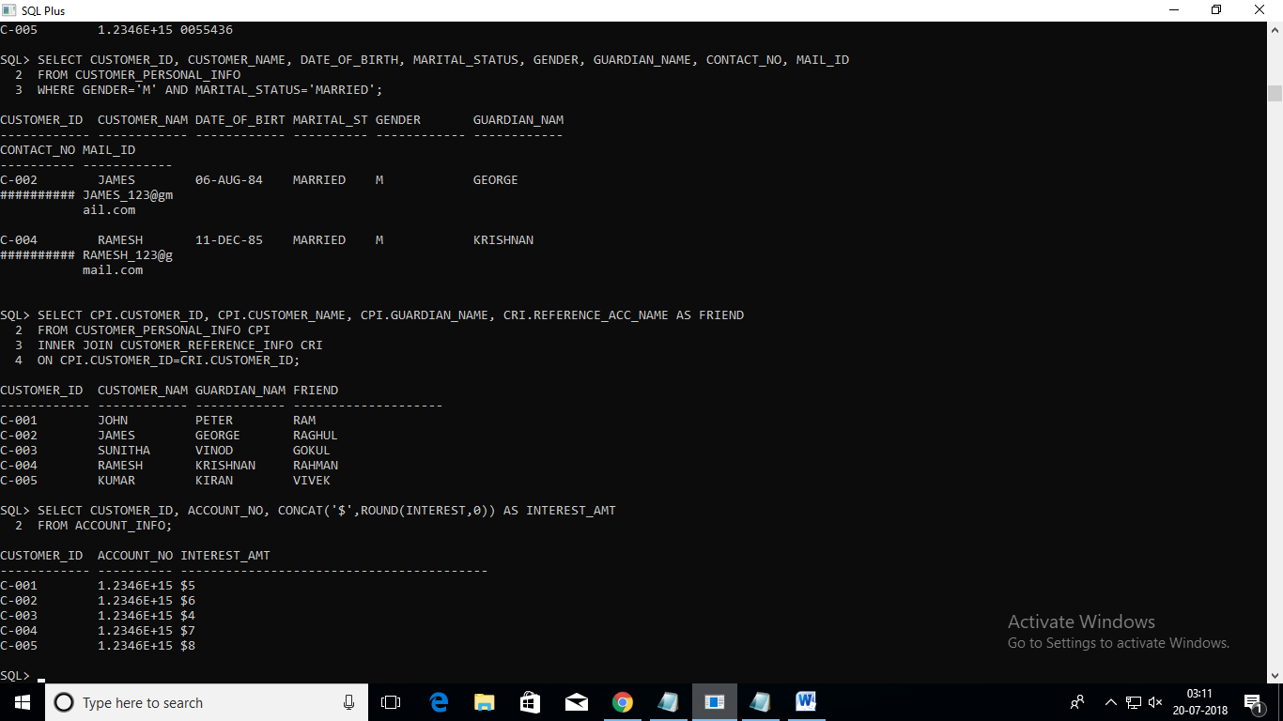

11. Write a query which will display the customer id, customer name, account no, account type, activation date, bank name whose account will be activated on '10-APR-2012'

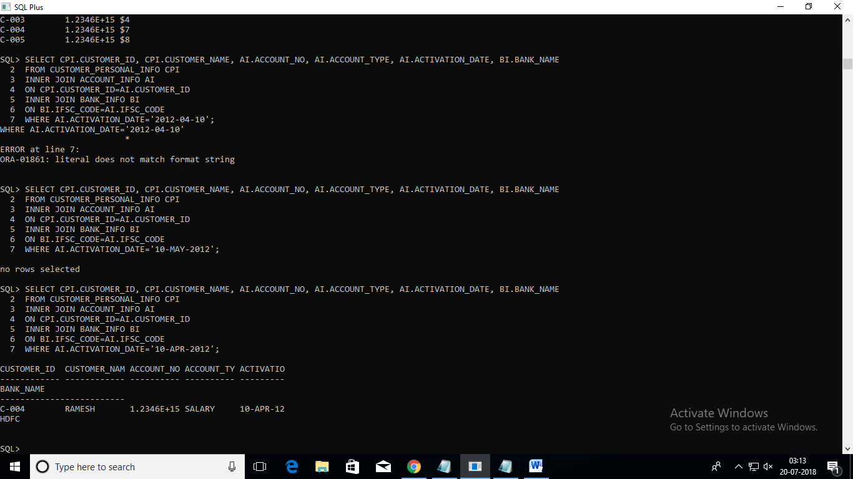

12. Write a query which will display account number, customer id, customer name, bank name, branch name, ifsc code, citizenship, interest and initial deposit amount of all the customers.

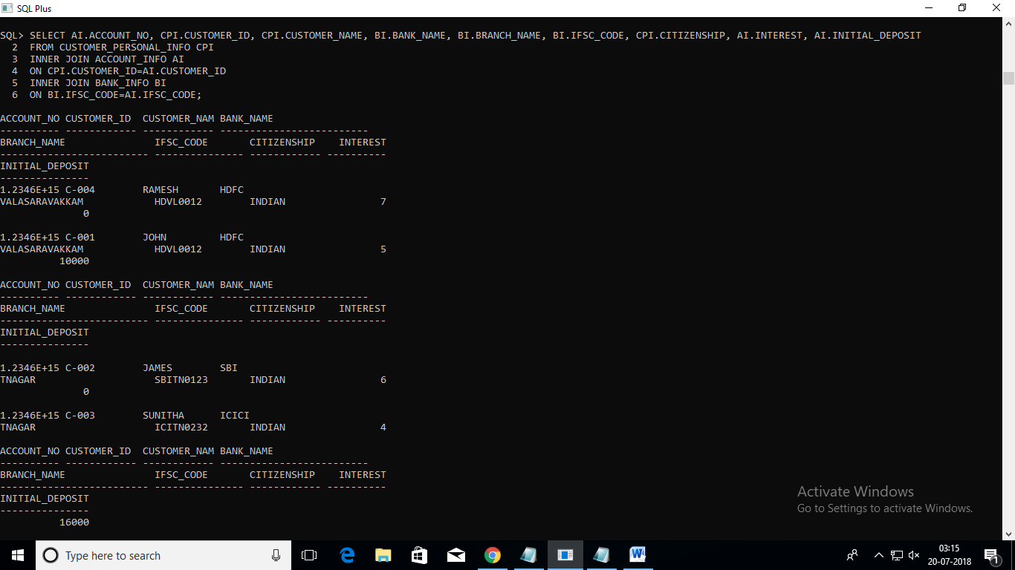

13. Write a query which will display customer id, customer name, date of birth, guardian name, contact number, mail id and reference account holder's name of the customers who has submitted the passport as an identification document.

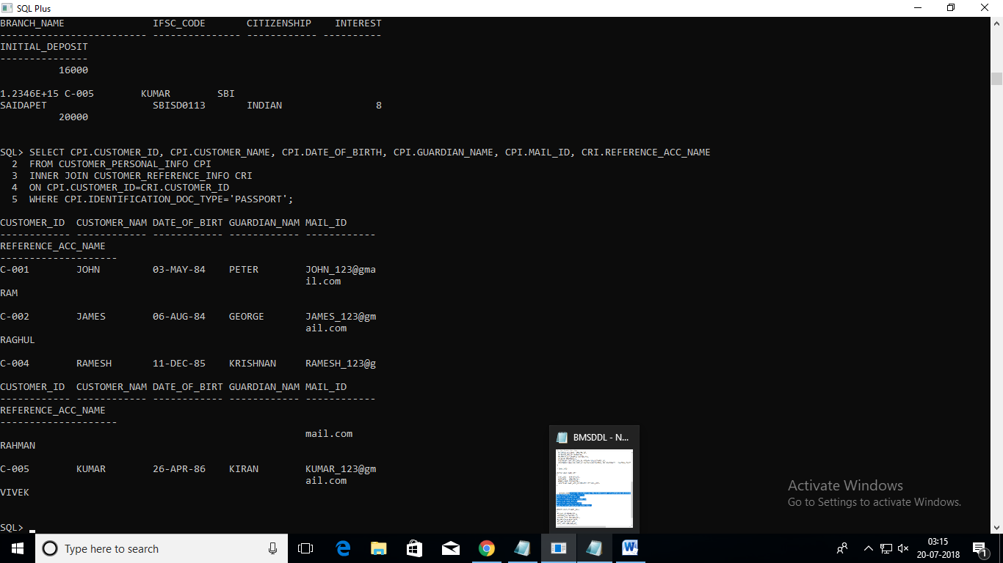

16. Write a query to display the customer id, customer name, account no, bank name, contact no and mail id of the customers who are from BANGALORE.

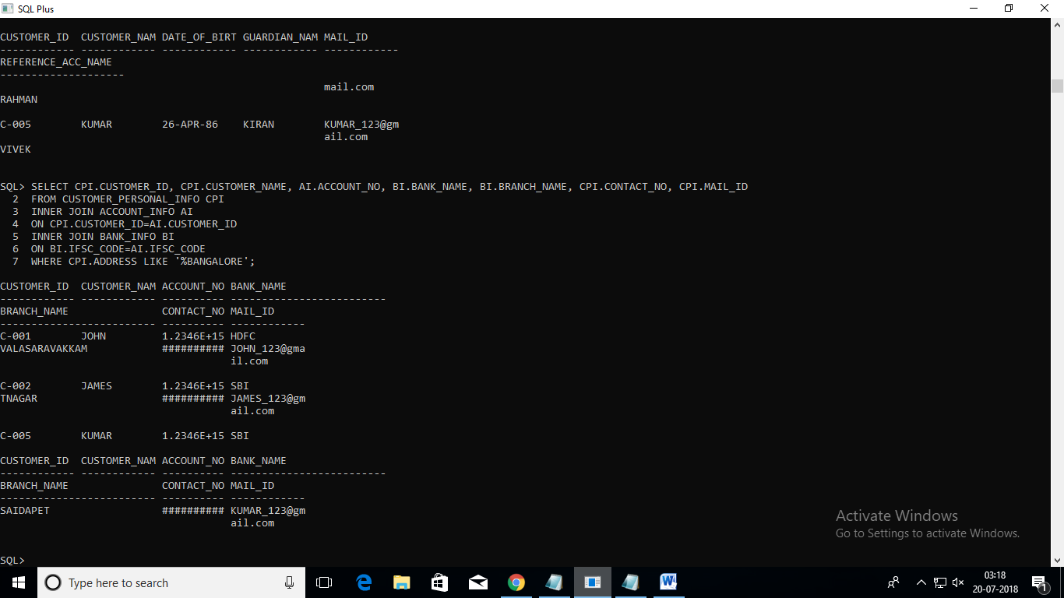

17. Write a query which will display customer id, bank name, branch name, ifsc code, registration date, activation date of the customers whose activation date is in the month of march (March 1'st to March 31'st).

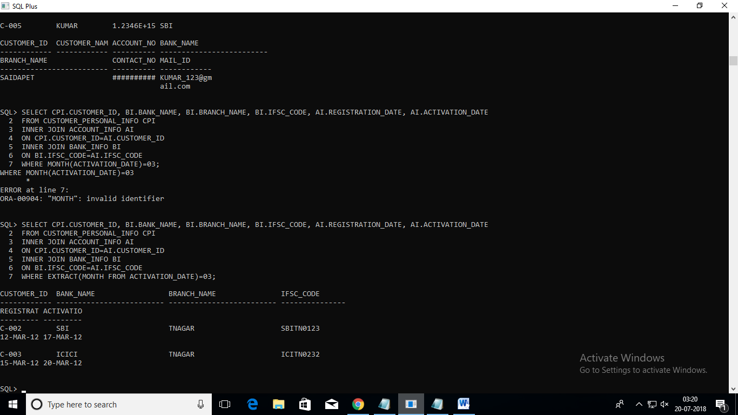

18. Write a query which will calculate the interest amount and display it along with customer id, customer name, account number, account type, interest, and initial deposit amount

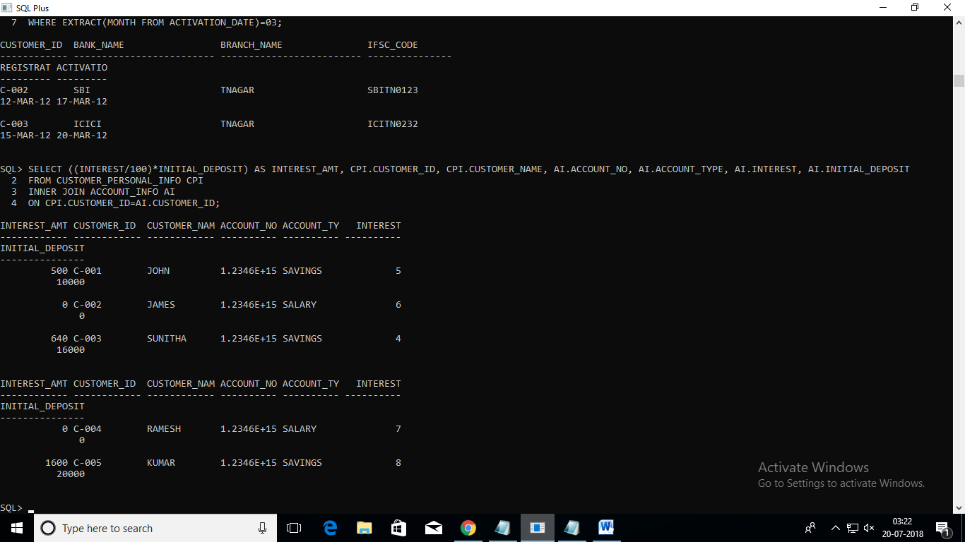

19. Write a query to display the customer id, customer name, date of birth, guardian name, contact number, mail id, reference name who has been referenced by 'RAGHUL'.

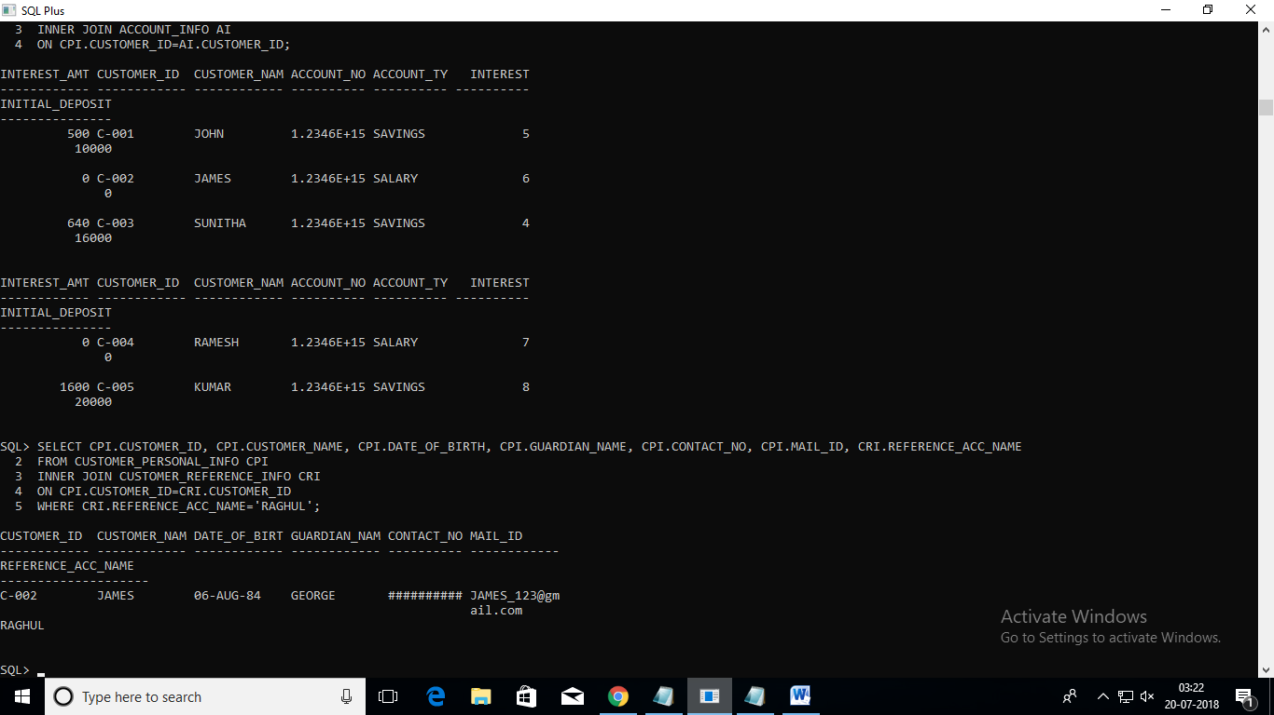

20. Write a query which will display the customer id, customer name and contact number with ISD code of all customers in below mentioned format. Sort the result based on the customer id in descending order.

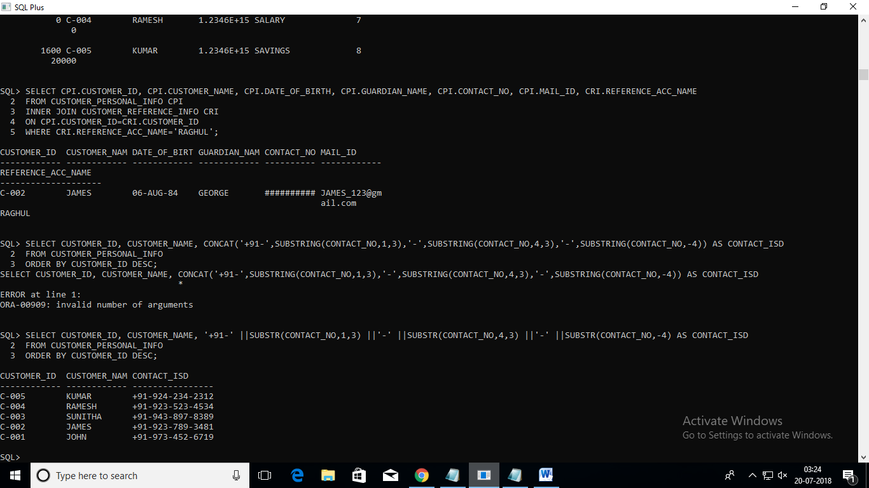

21.Write a query which will display account number, account type, customer id, customer name, date of birth, guardian name, contact no, mail id , gender, reference account holders name, reference account holders account number, registration date, activation date, number of days between the registration date and activation date with alias name "NoofdaysforActivation", bank name, branch name and initial deposit for all the customers.

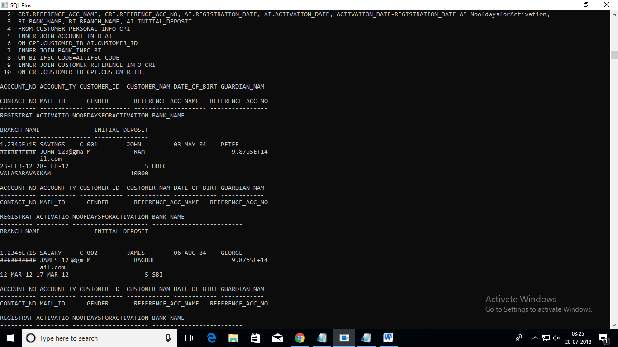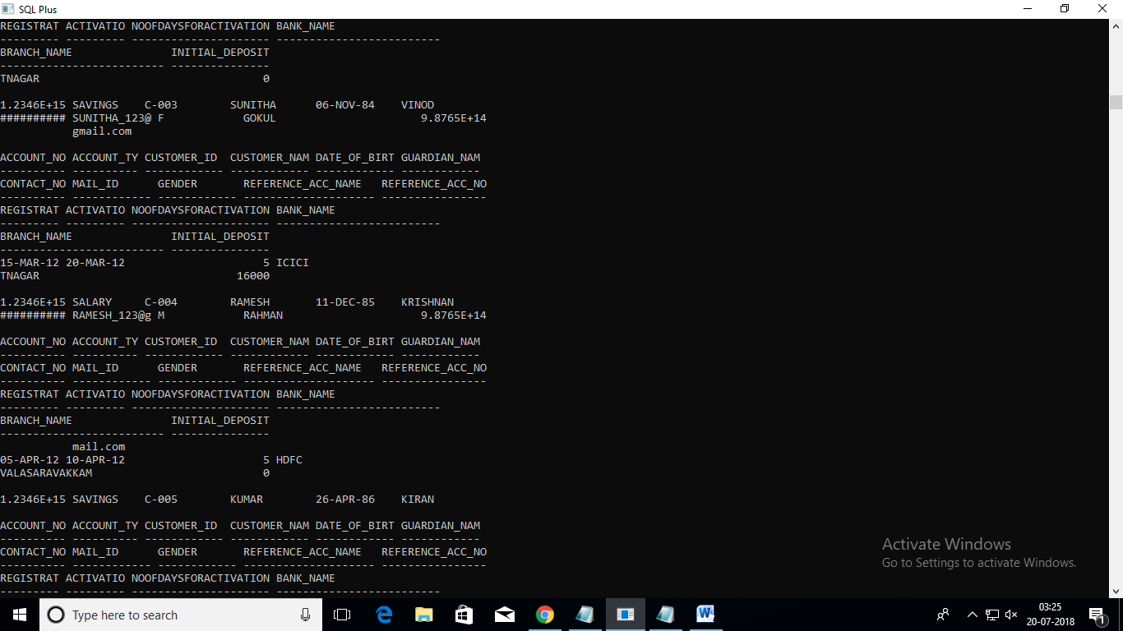

22. Write a query which will display customer id, customer name, guardian name, identification doc type,reference account holders name, account type, ifsc code, bank name and current balance for the customers who has only the savings account.

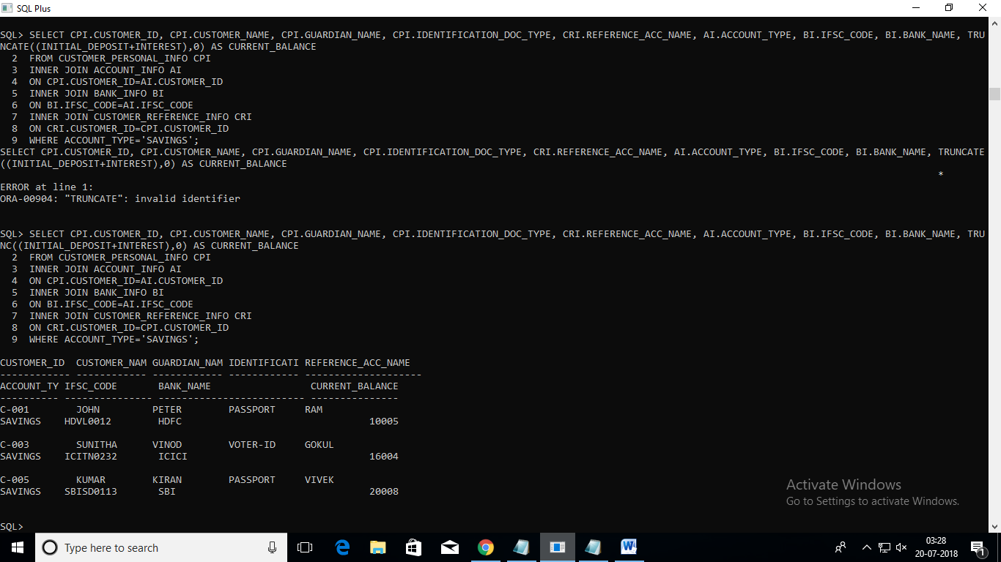

23. Write a query which will display the customer id, customer name, account number, account type, interest, initial deposit

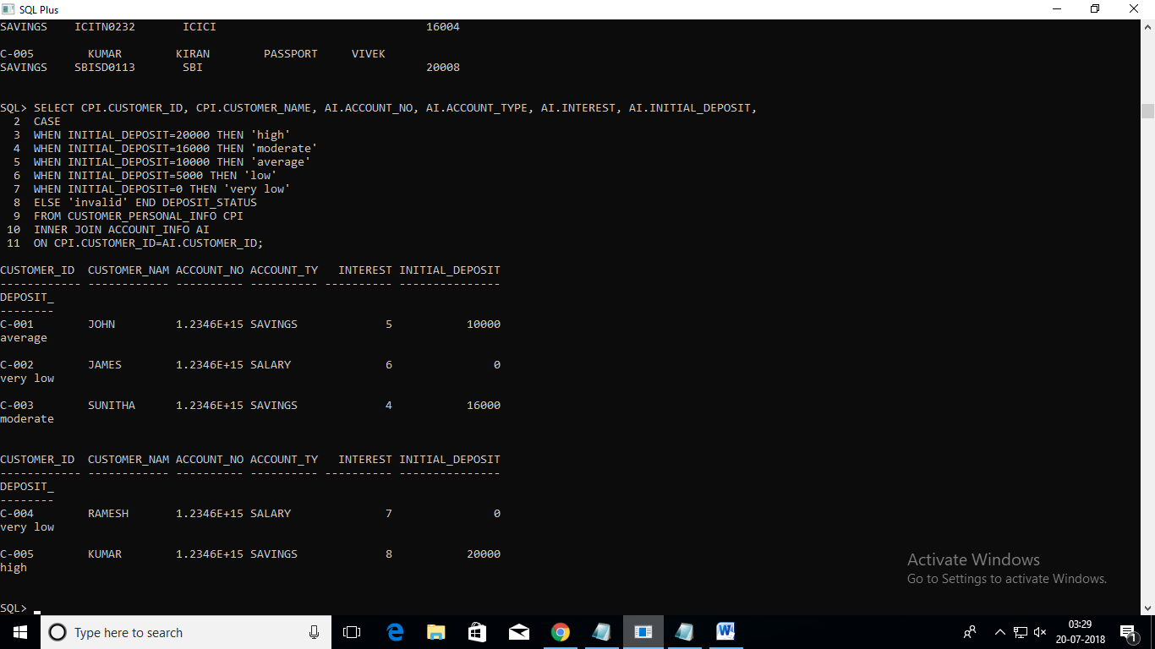

24. Write a query which will display customer id, customer name, account number, account type, bank name, ifsc code, initial deposit amount and new interest amount for the customers whose name starts with ""J"".

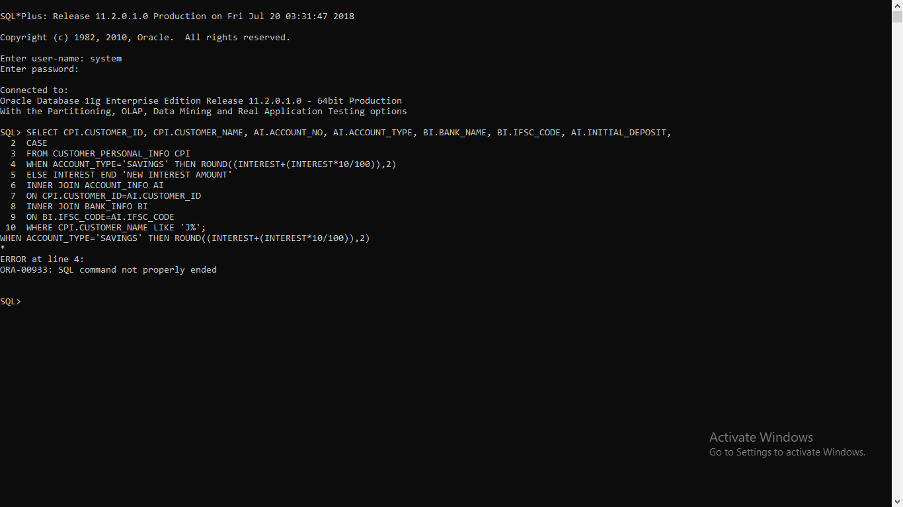

25. Write query to display the customer id, customer name, account no, initial deposit, tax percentage as calculated below.

