In [2]:

**import** numpy **as** np

**import** pandas **as** pd

**from** functools **import** reduce

In [3]:

df_index**=**pd.read_excel('data/CSUSHPINSA wb.xlsx') df_market**=**pd.read_excel('data/NASDAQ100 wb.xlsx') df_pop**=**pd.read_excel('data/POPTHM wb.xlsx')

df_construction**=**pd.read_excel('data/WPUSI012011 wb.xlsx') df_unemp**=**pd.read_excel('data/UNRATE wb.xlsx')

df_interest**=**pd.read_excel('data/BOGZ1FL075035503Q wb.xlsx') df_mortgage**=**pd.read_excel('data/MORTGAGE30US wb.xlsx')

df_percapinc**=**pd.read_excel('data/percapinc.xls') df_hunits**=**pd.read_excel('data/houseunits.xls')

In [4]:

data**=**[df_market,df_pop,df_construction,df_unemp,df_interest,df_mortgage,df_percapinc,df

In [5]:

**for** dataset **in** data:

print(dataset.shape)

|  |  |
| --- | --- |
| (90, | 2) |
| (90, | 2) |
| (90, | 2) |
| (90, | 2) |
| (90, | 2) |
| (90, | 2) |
| (90, | 2) |
| (90, | 2) |

In [6]:

**for** dataset **in** data:

print(dataset.columns)

Index(['Quarter', 'NASDAQ100'], dtype='object') Index(['Quarter', 'POPTHM'], dtype='object')

Index(['Quarter', 'WPUSI012011'], dtype='object') Index(['Quarter', 'UNRATE'], dtype='object')

Index(['Quarter', 'Interest_rate'], dtype='object') Index(['Quarter', 'MORTGAGE30US'], dtype='object') Index(['Quarter', 'percapinc'], dtype='object')

Index(['Quarter', 'housunits'], dtype='object')

In [ ]:

In [7]:

dfs **=** [df_index,df_market, df_interest, df_construction,df_mortgage,df_pop,df_unemp,df_

*#merge all DataFrames into one*

df **=** reduce(**lambda** left,right: pd.merge(left,right,on**=**['Quarter'],

how**=**'outer'), dfs)

In [8]:

df.head()

Out[8]:

|  |  |  |  |  |  |  |
| --- | --- | --- | --- | --- | --- | --- |
| **Quarter CSUSHPINSA** | **NASDAQ100** | **Interest_rate** | **WPUSI012011** | **MORTGAGE30US** | **POPTHM** | **UNR** |
| **0** 2000 100.679000 | 4046.825397 | 127696 | 144.733333 | 8.256923 | 281304.333333 | 4.033 |
| **1** 2000 103.698667 | 3629.497460 | 126924 | 145.166667 | 8.316154 | 282002.000000 | 3.933 |
| **2** 2000 106.459000 | 3779.890000 | 139947 | 143.833333 | 8.020000 | 282768.666667 | 4.000 |
| **3** 2000 108.270000 | 2941.222857 | 144433 | 142.833333 | 7.620769 | 283518.666667 | 3.900 |
| **4** 2001 109.749333 | 2168.620952 | 143811 | 142.266667 | 7.006923 | 284168.666667 | 4.233 |

Q1 Q2 Q3 Q4 Q1

In [37]:

df.rename(columns**=**{'CSUSHPINSA':'Index','WPUSI012011':'cons_mat'},inplace**=True**)

In [38]:

df.shape

Out[38]: (90, 10)

In [39]:

df.info()

<class 'pandas.core.frame.DataFrame'> Int64Index: 90 entries, 0 to 89

Data columns (total 10 columns):

# Column Non-Null Count Dtype

|  |  |  |  |  |  |  |
| --- | --- | --- | --- | --- | --- | --- |
| 0 |  | Quarter | 90 | non-null |  | object |
| 1 |  | Index | 90 | non-null |  | float64 |
| 2 |  | NASDAQ100 | 90 | non-null |  | float64 |
| 3 |  | Interest_rate | 90 | non-null |  | int64 |
| 4 |  | cons_mat | 90 | non-null |  | float64 |
| 5 |  | MORTGAGE30US | 90 | non-null |  | float64 |
| 6 |  | POPTHM | 90 | non-null |  | float64 |
| 7 |  | UNRATE | 90 | non-null |  | float64 |
| 8 |  | percapinc | 90 | non-null |  | int64 |
| 9 |  | housunits | 90 | non-null |  | int64 |

dtypes: float64(6), int64(3), object(1) memory usage: 7.7+ KB

In [40]:

df.describe(include**=**"all")

|  |  |  |  |  |  |  |  |  |  |
| --- | --- | --- | --- | --- | --- | --- | --- | --- | --- |
| Out[40]: |  | | | | | | | | |
|  |  | **Quarter** | **Index** | **NASDAQ100** | **Interest_rate** | **cons_mat** | **MORTGAGE30US** | **POPTHM** | **U** |
|  | **count** | 90 | 90.000000 | 90.000000 | 90.000000 | 90.000000 | 90.000000 | 90.000000 | 90 |
|  | **unique** | 90 | NaN | NaN | NaN | NaN | NaN | NaN |  |
|  | **top** | 2000 | NaN | NaN | NaN | NaN | NaN | NaN |  |
|  | | Q1 |  |  |  |  |  |  |  |
| **freq** | | 1 | NaN | NaN | NaN | NaN | NaN | NaN |  |
| **mean** | | NaN | 169.041648 | 4100.429369 | 216455.144444 | 200.884230 | 4.985707 | 310426.674074 | 5 |
| **std** | | NaN | 41.061039 | 3610.055121 | 58960.683183 | 43.961087 | 1.359509 | 16100.877054 | 1 |
| **min** | | NaN | 100.679000 | 945.332813 | 126924.000000 | 142.033333 | 2.760714 | 281304.333333 | 3 |
| **25%** | | NaN | 141.962583 | 1633.297222 | 169301.500000 | 170.400000 | 3.887349 | 296526.666667 | 4 |
| **50%** | | NaN | 165.653000 | 2588.831357 | 212705.500000 | 201.950000 | 4.717692 | 311658.333333 | 5 |
| **75%** | | NaN | 184.360417 | 4814.456295 | 254024.000000 | 215.683333 | 6.084038 | 325399.333333 | 6 |
| **max** | | NaN | 305.348000 | 15843.419219 | 360001.000000 | 348.737333 | 8.316154 | 332939.666667 | 12 |

In [42]:

*#Finding correlation*

df.corr()['Index'].sort_values(ascending**=False**)

|  |  |  |
| --- | --- | --- |
| Out[42]: | Index | 1.000000 |
|  | Interest_rate | 0.956532 |
|  | cons_mat | 0.896744 |
|  | percapinc | 0.877490 |
|  | NASDAQ100 | 0.849974 |
|  | housunits | 0.814834 |
|  | POPTHM | 0.771812 |
|  | UNRATE | -0.262429 |
|  | MORTGAGE30US | -0.583233 |
|  | Name: Index, | dtype: float64 |

In [43]:

*#No missing values*

df.isnull().sum()

Out[43]: Quarter 0

Index 0

NASDAQ100 0

Interest_rate 0

cons_mat 0

MORTGAGE30US 0

POPTHM 0

UNRATE 0

percapinc 0

housunits 0

dtype: int64

In [44]:

df.to_excel('data/data.xlsx',index**=False**)

In [46]:

x**=**df.drop(["Index","Quarter"],axis**=True**) y**=**df["Index"]

In [56]:

**from** sklearn.ensemble **import** RandomForestRegressor

**import** matplotlib.pyplot **as** plt

In [48]:

*#training random forest model*

reg **=** RandomForestRegressor(n_estimators**=**100) reg.fit(x,y)

Out[48]: RandomForestRegressor() In [49]:

|  |  |  |
| --- | --- | --- |
| *#feature importance*  df_feature_importance **=** pd.DataFrame(reg.feature_importances_, index**=**x.columns, columns df_feature_importance | | |
|  |  |  |

|  |  |  |
| --- | --- | --- |
| Out[49]: |  | |
|  |  | **feature importance** |
|  | **Interest_rate** | 0.315570 |
|  | **cons_mat** | 0.153915 |
|  | **percapinc** | 0.144698 |
|  | **housunits** | 0.131795 |
|  | **NASDAQ100** | 0.101607 |
|  | **POPTHM** | 0.098465 |
|  | **UNRATE** | 0.040440 |
|  | **MORTGAGE30US** | 0.013510 |

In [50]:

df_feature_importance.plot(kind**=**'bar');

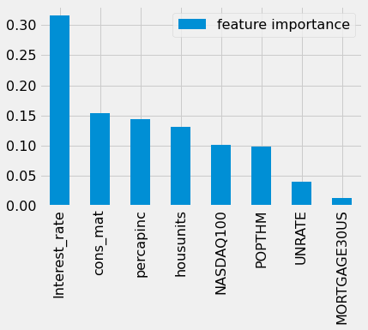

In [51]:

*#training xgboost regressor*

**import** xgboost **as** xgb

**from** sklearn.model_selection **import** GridSearchCV

In [52]:

xgbregressor**=**xgb.XGBRegressor(eval_metric**=**'rmsle')

In [53]:

param_grid **=** {"max_depth":

[4, 5],

"n_estimators": [500, 600, 700],

"learning_rate": [0.01, 0.015]}

*# try out every combination of the above values*

search **=** GridSearchCV(xgbregressor, param_grid, cv**=**5).fit(x,y)

print("The best hyperparameters are ",search.best_params_)

The best hyperparameters are {'learning_rate': 0.015, 'max_depth': 4, 'n_estimators': 600}

In [54]:

xgbregressor**=**xgb.XGBRegressor(learning_rate **=** search.best_params_["learning_rate"],

n_estimators **=** search.best_params_["n_estimators"], max_depth **=** search.best_params_["max_depth"],

eval_metric**=**'rmsle')

xgbregressor.fit(x,y)

Out[54]: XGBRegressor(base_score=0.5, booster='gbtree', callbacks=None,

colsample_bylevel=1, colsample_bynode=1, colsample_bytree=1, early_stopping_rounds=None, enable_categorical=False,

eval_metric='rmsle', gamma=0, gpu_id=-1, grow_policy='depthwise', importance_type=None, interaction_constraints='',

learning_rate=0.015, max_bin=256, max_cat_to_onehot=4,

max_delta_step=0, max_depth=4, max_leaves=0, min_child_weight=1,

missing=nan, monotone_constraints='()', n_estimators=600, n_jobs=0, num_parallel_tree=1, predictor='auto', random_state=0, reg_alpha=0, reg_lambda=1, ...)

In [55]:

**from** xgboost **import** plot_importance

**import** matplotlib.pyplot **as** plt

plot_importance(xgbregressor) plt.show()

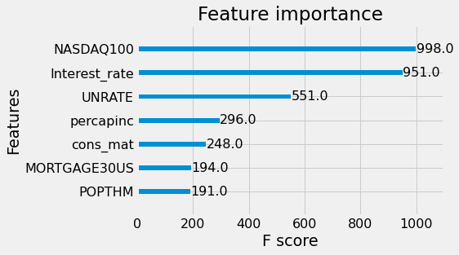

In [ ]: