**Supply and Demand Factors Affecting**

**Housing Prices in US**

**Introduction:**

**The aim is to find important supply and demand factors having a significant effect while predicting the US housing prices.**

I have used quarterly data from 1st January 2000 till date.

We are considering the following national factors for finding out how much the affect the housing prices in US. The data for all the following factors is imported individually and then combined in python to give a single data frame.

* NASDAQ 100 Index
* Producer Price Index by Commodity: Special Indexes: Construction Materials
* Interest Rates and Price Indexes; Commercial Real Estate Price Index, Level
* Producer Price Index by Commodity: Special Indexes: Construction Materials
* Population
* Unemployment Rate
* Per Capita Income
* Mortgage
* Housing units

**Analysis Description:**

All the data was imported in python. Correlation of the features with housing index was calculated. A random forest regression model was trained with housing index as the independent variable and the above features as dependent variables. An XGBregression model was also trained. Both the models were then used to find out the feature importance.

The ipynb file is included.

**Results:**

The final factors are given on the basis of feature importance of the two models trained and the correlation of all factors with housing index.

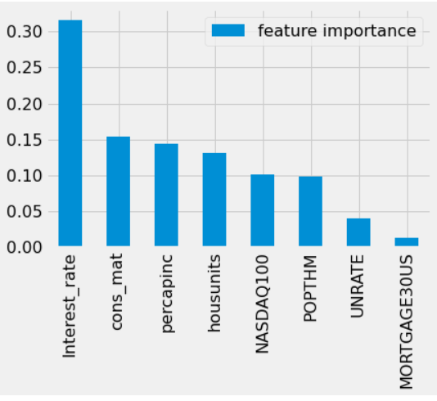

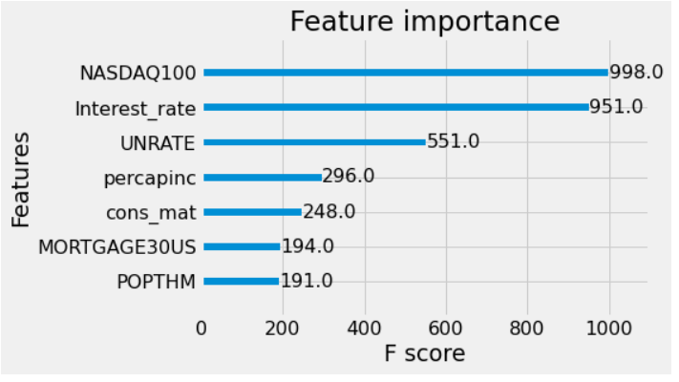

A few Important Demand Factors are: Population, economic growth, per capita income

A few Important Supply Factors are: Interest Rates, Construction Materials, Housing units

**Further Scope of Improvement:**

For improvement we can consider more features like housing affordability and inflation etc. We can also try using more models like linear regression, SVM, neural nets and then find feature importance for those models.

**References:**

Data: https://fred.stlouisfed.org/