Renewable Energy Analytics Dashboard
Power BI Portfolio Report
Analysis of Australia's renewable energy transition, source composition, regional comparisons and 2030 forecasting.

Executive Summary:
This research has been conducted to analyse the progress of renewable energy implementation in Australia. In doing so four key questions were addressed: the changing proportion of renewable energy since 2005, the evolving composition of energy sources, regional comparisons with neighbouring countries, and forecasts for 2030. The main aim of this analysis is to highlight the strategies employed by the government to enhance renewable energy uptake, thereby supporting sustainable development and national energy security.
To effectively fulfil these objectives, a thorough analysis of the data extracted from the Australian official energy statistics and comparative international datasets from Japan, Indonesia, and New Zealand was undertaken (Department of Climate Change 2024; IRENA 2025). These datasets were analysed using Power BI, thereby leveraging detailed and dynamic visualisations to illustrate the trends occurring in a clear and effective manner.
The research gained from these visualisations indicates a significant increase in the proportion of renewable energy being generated in Australia, rising from approximately 10% in 2005 to over 30% in 2023 (Department of Climate Change 2024). This notable expansion has been propelled primarily by the increased use of solar and wind energy, whereas traditional sources such as hydroelectricity have maintained a stable yet relatively modest contribution (MacGill 2010; Nelson et al. 2013).
Simultaneously, Australia’s renewable energy adoption is set to be on a stable and growing path, although the total generation remains quite low compared to countries like Japan, meaning that in the upcoming years there is potential for more growth. Meanwhile, Australia still leads its regional peers such as Indonesia and New Zealand, even though they progress steadily towards renewable energy sources with the rise in scale of energy being generated, showcasing a consistent upward trajectory (IRENA 2025; Mills and Schleich 2021).
The forecasting model projects a continued and robust growth in the Australian renewable energy capacity, with substantial growth expected by 2030. This trajectory aligns with the national target of achieving 82% renewable electricity generation by 2030, as outlined in the government's energy policy framework (Australian Energy Council 2023). Recent studies underscore the necessity of integrating battery energy storage systems (BESS) to support this transition effectively (Page and Fuller 2021).
The results obtained from the analysis have been able to provide valuable insights into the Australian renewable energy market, thus, demonstrating achievements, identifying areas for policy enhancement, and delivering informed guidance for future planning towards a secure and more sustainable energy future.

Introduction:
Renewable energy has increasingly become a cornerstone in global affairs to mitigate climate change impacts, provide a sustainable environment, and achieve long-term energy security. With international commitments intensifying, countries worldwide, including Australia, have all pledged to advocate substantial efforts towards enhancing their renewable energy portfolios. Australia, in particular, has been pursuing strategic policies and investments since 2005, with the aim to expand its renewable energy generation capacity to align with national objectives and international climate agreements such as the Paris Accord (UNFCCC 2015; Priatna, Monk, and Khan 2025).
This report is meant to critically assess Australia’s renewable energy landscape by addressing four key analytical objectives. First, it examines the proportion of renewable energy within Australia’s total energy generation since 2005, highlighting the trends and identifying the driving factors behind the changes happening (Department of Climate Change 2024). Recognising how Australia’s energy composition has periodically evolved provides a clearer picture into the effectiveness of past policies and investments, more so, in solar, wind, and hydroelectric power sectors (MacGill 2010; Nelson et al. 2013).
Second, the report explores the shifts occurring with the composition of renewable energy sources. Understanding such changes sheds light on technological advancements, economical viability, and the dynamic interactions between the various renewable technologies at hand.
Third, to contextualise the Australian renewable energy progress within the broader regional geography, by comparing Australia’s performance with that of its regional neighbours being Japan, Indonesia, and New Zealand. This comparative analysis facilitates the identification of Australia’s competitive advantages, the areas where potential developments are needed, and the opportunities for regional leadership in renewable energy initiatives (IRENA 2025; Mills and Schleich 2021).
Finally, the report offers a robust forecast of Australia’s renewable energy generation up to the year of 2030. The employment of such advanced forecasting methods evaluates the anticipated growth trajectory, while at the same time assesses the alignment with the national policy targets and international commitments. Notably, the Australian government has set an ambitious target of achieving 82% renewable electricity generation by 2030, necessitating significant investments in renewable infrastructure and energy storage solutions (Australian Energy Council 2023; Page and Fuller 2021).
In order to achieve this in-depth examination, the report utilised data from the official Australian energy statistics and international databases. The data gained from these sources were then cleaned, analysed, and verified using advanced data visualisation and analytical techniques found in Power BI. This was done to provide accurate, clear, and comprehensive insights.
The outlined objectives aim at providing a structured analysis with clear strategic direction for fostering a sustainable and resilient energy in Australia to all stakeholders, policymakers, and third parties interested in the development of a better future.

1. Change in Proportion of Renewable Energy in Australia (2005-2023)
Why this question matters:
To understand how the share of renewable energy has been evolving over the course of time is critical for assessing the efficiency of national energy policies and Australia’s progression toward environmental sustainability. The insight gained helps energy planners, agencies working with the government, and environmental advocates to evaluate whether Australia is on track to meet its renewable energy targets and climate commitments (UNFCCC 2015).
Methodology and Data Sources:
The analysis done on the data from the Australian Energy Statistics – Table O published by the Department of Climate Change (2024), covers the years 2005-06 to 2022-23. This dataset was imported and visualised using Power BI. Renewable energy sources that were included in the calculation are as follows: Hydro, Wind, Large-scale solar PV, Small-scale solar PV, and bioenergy. Two visualisations were created:
- The first one being a line chart showing the annual proportion of total electricity generation from renewable sources.
- The second one being a stacked column chart showing the GWh contribution from each renewable source over a period.
Data Analysis and Interpretation:
As shown in Figure 1, Australia’s proportion of renewable energy has remained quite relatively low (below 10%) between the years of 2005 and 2010, with a minor dip in 2008-09. Afterwards, a clear upward trajectory began around 2010-11, which accelerated at a significant pace after 2017. By 2022-23, the renewable share had surpassed the threshold of 33%.
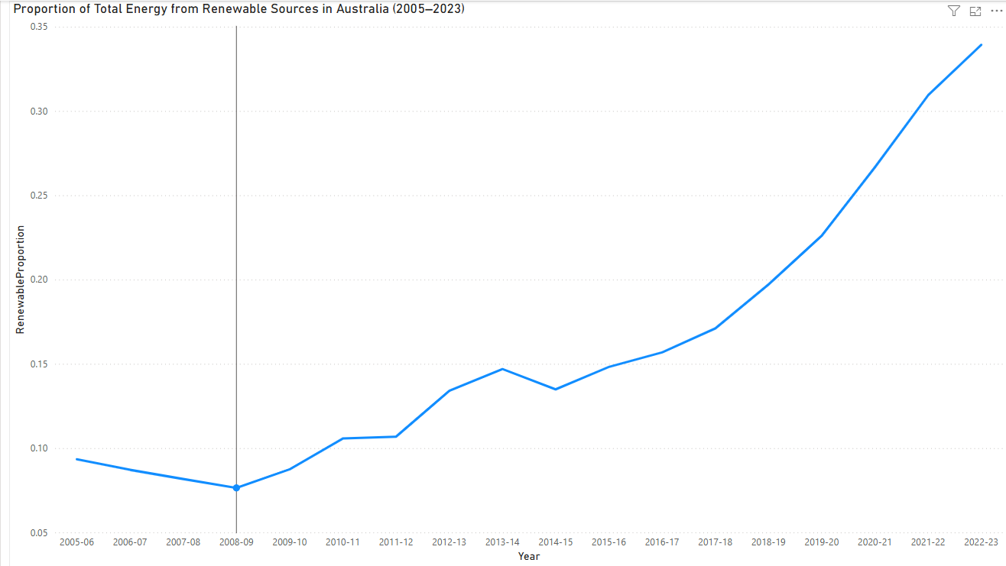
Figure 1. Proportion of Total Energy from Renewable Sources in Australia (2005–2023)
Figure 2, on the other hand, illustrates the growth driven by the rapid expansion of wind and solar PV generation. As seen on the visualisation, the wind generation increased from 2K GWh in 2005-06 to 31K GWh in 2022-23, while solar, whether it is large-scale or small-scale, grew from under 1K GWh to an astonishing 42K GWh combined. Hydroelectricity remained stable, consistently contributing to the generation of around 13K-17K GWh annually.
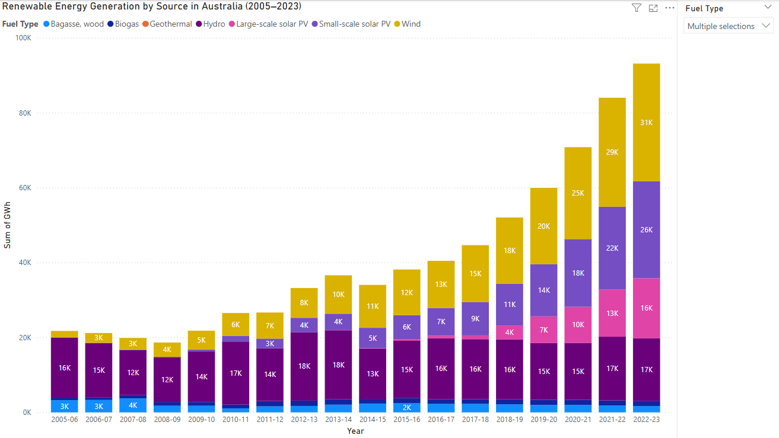
Figure 2. Renewable Energy Generation by Source in Australia (2005–2023)
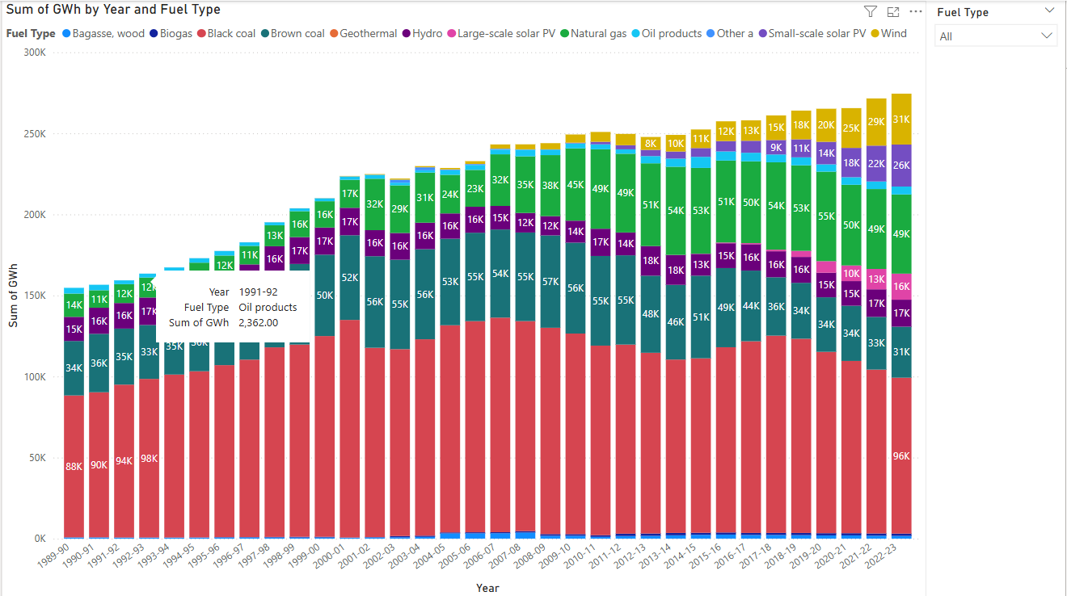
Figure 2b. Sum of GWh by Year and Fuel Type
Figure 2b. showcases the total electricity generation by fuel type in Australia as from 1989 to 2023, providing additional information on the fossil fuel sources as well as the renewable energy during these years. Even though renewable energy has grown dramatically, fossil fuels such as coal and natural gas are dominating. The decline seen of black coal after the year 2010 might be an indication of a transition beginning towards energy sources.
Key Findings:
Australia’s renewable energy share has increased from approximately 9% in 2005 to over 33% by 2023. This has marked a significant improvement in the adoption of a clean energy structure, which reflects the impact of government incentives like the renewable energy target, which has declined the costs of solar and wind technologies, while at the same time increasing public-private investment (MacGill 2010; Nelson et al. 2013).
Recommendation:
To sustain an upward growth, policymakers need to prioritise the expansion of grid infrastructure and smart grid technologies, invest in proper energy storage systems (batteries, pumped hydro, and more), support rooftop solar and wind integrations, and support community and commercial-scale renewable projects.

2. Change in the Composition of Renewable Energy Sources in Australia (2005-2023)
Why this question matters:
The importance of understanding the way in which the composition of renewable energy sources has shifted throughout the years is valuable as it provides insight into Australia’s technological progress, policy effectiveness, and the market change within the renewable energy sector. Tracking such shifts helps assess the diversification, energy resilience, and the output of primary effective technologies contributing to the emission reduction and supply reliability (MacGill 2010; Nelson et al. 2013).
Methodology and Data Sources:
This analysis on the data of Australian Energy Statistics – Table O provided by the Department of Climate Change (2024), covers the fiscal years of 2005-06 to 2022-23. The dataset was imported and analysed using Power BI as to generate two useful visualisations:
- Figure 3: A 100% stacked column chart that displays the relative composition (%) of each renewable energy source annually.
- Figure 4: An area chart showing the absolute GWH generation by fuel type over the same period.
The renewable energy sources included in these visualisations are: Hydro, Wind, Small-scale solar PV, Large-scale solar PV, and Bioenergy (which includes Bagasse, Wood, Biogas, and others).
Data Analysis and Interpretation:
As seen in Figure 3, Australia’s renewable energy composition has been undergoing a big transformation. During the year of 2005-06, hydroelectricity was dominating with around 74% of the renewable mix, followed by bioenergy with 15%, and wind 8%, while solar PV remained basically non-existent.
2010 and onwards, wind and solar started to rise slowly but surely, and by 2017-18, wind overtook hydro as the leading source, and both small and large-scale solar PV increases at a steady rate.
By 2022-23, the landscape was no more the same, as wind was now contributing a staggering 33.7%, small-scale solar PV at 27.8%, and large-scale solar PV at 17.3%. Whereas Hydro took a strong decline to 17.9% and Bioenergy dropping below 5%.
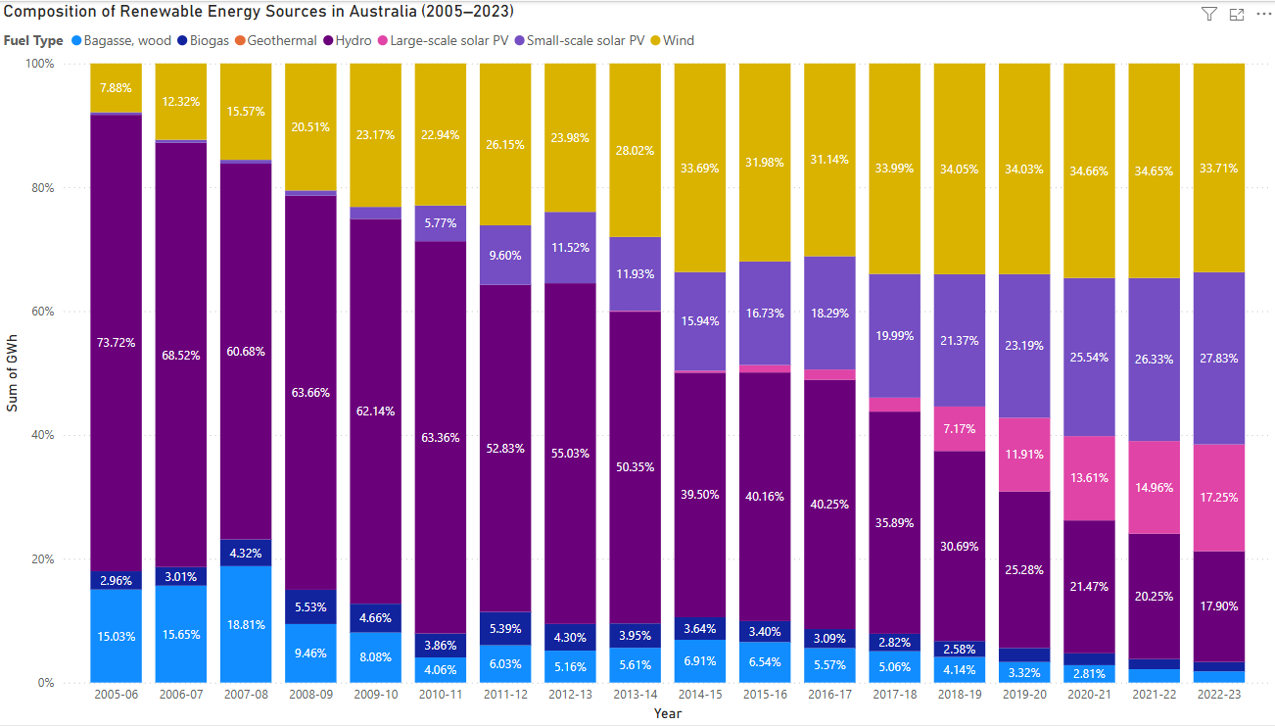
Figure 3. Composition of Renewable Energy Sources in Australia (2005-2023)
Figure 4 is a confirmation of these trends in absolute terms, as hydro remained relatively stable in generation (14K-18K GWh annually), wind grew from 2K GWh in 2005,06 to 31.4K GWh in 2022-23, small-scale solar PV rose sharply from 2010, peaking at 25.9K GWh in 2022-23, large-scale solar PV increased at a significant pace from 2015-16, reaching 17K GWh, and finally Bioenergy growing only marginally to 1.4K-2K GWh.
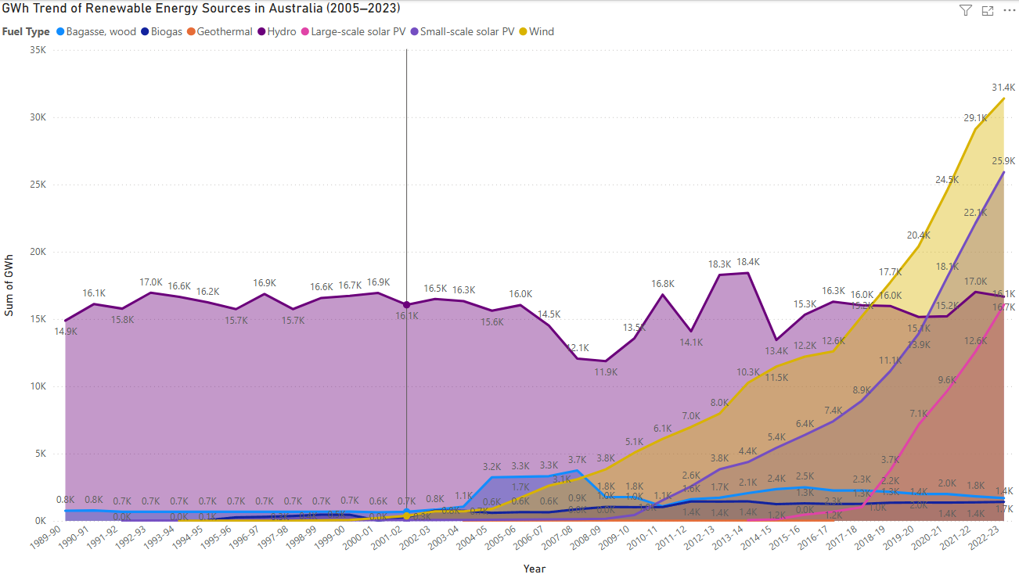
Figure 4. GWh Trend of Renewable Energy Sources in Australia (2005-2023)
Key Findings:
Australia has been able to diversify its renewable energy portfolio quite well, going from hydro-dominated mix in 2005, to a subtle but well-planned transition of wind and solar PV, effectively bringing hydro to a more modest ground of contribution. This shift is both a reflection of technological advancements and strong policy support for the solar and wind infrastructure (Nelson and Simshauser 2013).
Recommendations:
As to maintain a positive trajectory, energy policy needs to continue monitor and support the expansion of wind and solar technologies while at the same time, upgrade transmission networks as to accommodate solar and wind projects dispersed around the country. Enhance energy storage capacity to create a balance of intermittent sources, maintain hydro assets for a more stable grid and use during peak demands, and finally encourage investors and people to innovate in more emerging renewable like geothermal or next-generation bioenergy sources, ensuring a long-term diversification and security.

3. Regional Comparison of Renewable Energy Generation (2005-2023)
Why this question matters:
Comprehending the energy generation of Australia compared to its regional peers such as Japan, Indonesia, and New Zealand, is a vital element in evaluating its leadership, competitiveness, and policy effectiveness during these times where clean energy transition is considered the go-to model. Such a comparison makes it possible for policymakers and stakeholders to properly identify performance gaps, strengths between regional peers, and collaborative opportunities. It also describes the progress done so far in Australia within a broader international frame, as to assess whether national targets align with the regional trends and ambitions.
Methodology and Data Sources:
The analysis done using the Combined_Energy_Countries dataset, incorporates the electricity generation statistics for Australia, Japan, Indonesia, and New Zealand over the course of 2005 to 2030. The data extracted was visualised using Power BI with two of the following charts:
- Figure 5: Stacked area chart showcasing the total electricity generation (GWh) for each country during each year.
- Figure 6: A renewable-only area chart that compares the annual renewable electricity generation in GWh for all the countries involved.
The renewable energy technologies filtered for inclusion were Hydro, Wind, Solar (Large-scale and Small-scale), Geothermal, Biogas, and Bagasse/Wood.
Data Analysis and Interpretation:
As seen in Figure 5, Japan has been consistent with its generation of total electricity reaching the highest amount of around 1.07 million GWh in 2005 to approximately 0.93 million GWh in 2023, even though it went through a decline during recent years. Australia, by contrast, has been producing significantly less, hence the rise from 230K GWh in 2005 to 310K GWh in 2023. Indonesia and New Zealand had similar total output while remaining the lowest, with Indonesia steadily growing compared to New Zealand that stayed relatively flat.
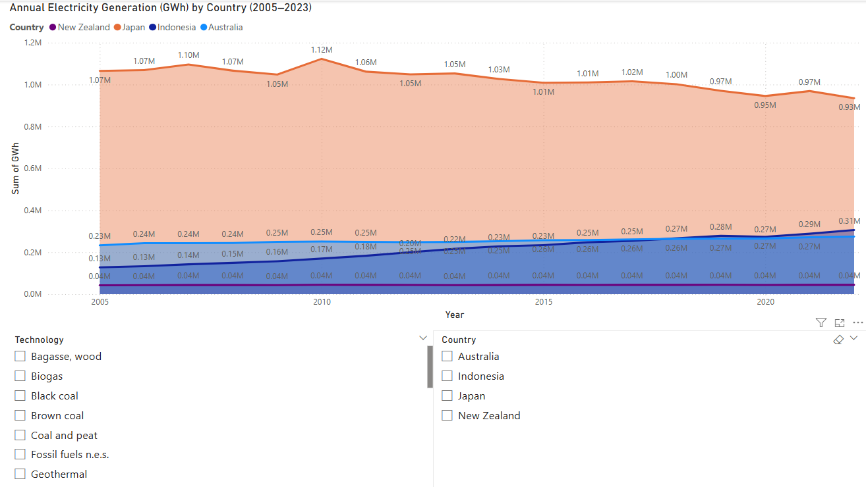
Figure 5. Annual Electricity Generation (GWh) by Country (2005-2023)
In difference, Figure 6 tells a completely different story when isolating renewable energy generation, having Japan lead in absolute GWh terms, from an increase of 83K GWh to 182K GWh in 2023. This huge surge is a result of heavy post-Fukushima investments in solar and wind energy alternatives.
Australia had a steep growth trajectory, going up from 22K GWh in 2005 to 93K GWh in 2023. This sharp incline started around 2015, where new policies were introduced like the Large-scale Renewable Energy Target (LRET) and falling solar PV costs.
New Zealand has been exhibiting a consistent strong renewable base of 27-39K GWh due to its longstanding reliance on hydro and geothermal energy. Whereas, Indonesia has had a slow growth, going only from 16K GWh in 2005 to 39K GWh in 2023, which reflects that a change in its infrastructure to clean energy sources is occurring.
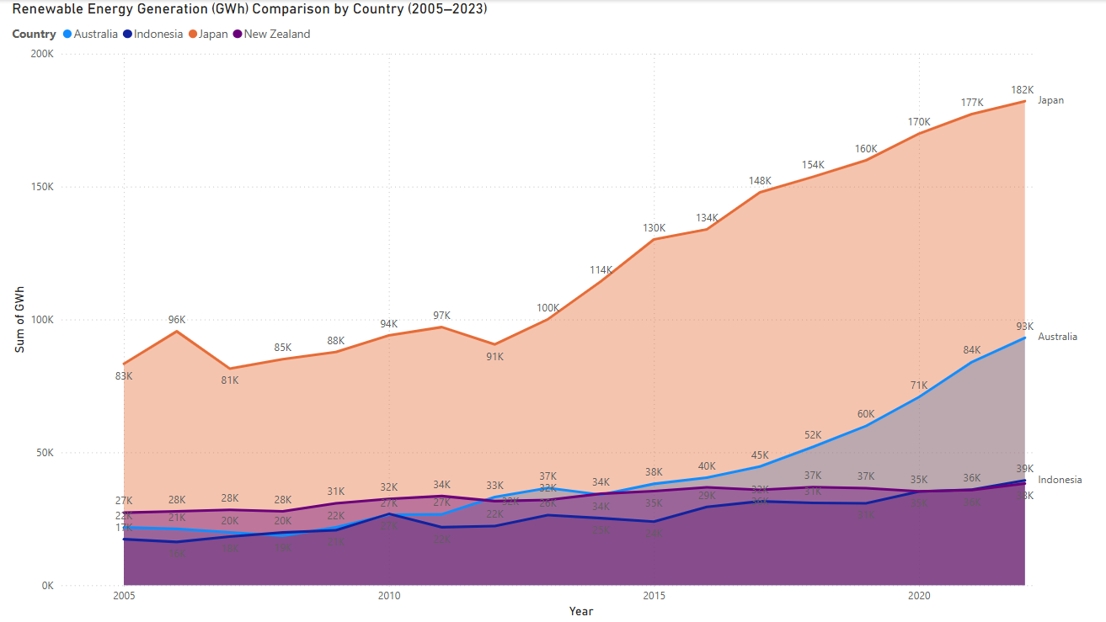
Figure 6. Renewable Energy Generation (GWh) Comparison by Country (2005-2023)
Key Findings:
Australia has ranked second in absolute renewable energy generation right behind Japan, but analysing the graphs, we can assume that this will change in the upcoming years as it is arguably first in growth rate and scalability, more so after 2015. All of this is mainly driven by the strong national policies such as the LRET scheme (Nelson et al. 2013; MacGill 2010).
Japan has been leading in renewables due to the demand of a large-scale energy switch and rapid investment post-nuclear transition (IRENA 2025).
New Zealand remains within the scope of a high renewable-reliant consumer but is not expanding as fast as it should be due to the saturated hydro/geothermal capacity (Mills and Schleich 2021). Finally, Indonesia is last both in pace and scale, even though it is consistent in its upward trend meaning that a growing demand and need for renewable energy is being focusing nationally (Priatna, Monk, and Khan 2025).
Recommendations:
Australia must continue to expand its renewable capacity as to close the gap with Japan, by investing in battery storage, green hydrogen, and offshore wind to keep a steady growth momentum. A regional cooperation between Australia, Japan and New Zealand must happen as to share knowledge and technology, particularly on grid flexibility and geothermal deployment. Indonesia can take advantage of Australia’s expertise in the domain of solar, policy design, and investment as to accelerate its energy transition (Priatna, Monk, and Khan 2025; IRENA 2025). Ultimately, a comparative benchmarking must be adopted every year to keep track of the progress being made and realign with new policies being implemented in relation to regional peers.

4. Forecast of Renewable Energy Generation in Australia (2024-2030)
Why this question matters:
Forecasting renewable energy generation is needed to evaluate whether Australia is on the right track to meet its long-term sustainability goals, which is based on the national target of 82% renewable electricity by 2030 (Clean Energy Council 2023). A reliable projection helps assist governments, investors and energy companies in identifying any sort of required infrastructure, policy gaps, and investment strategies that would be helpful to the transition of clean energy (Australian Energy Council 2023).
Methodology and Data Sources:
The forecast is based on data from the Energy_Australia dataset, which keep track of Australia’s renewable electricity generation in GWh as from 2005 to 2023. By utilising Power BI built-in exponential smoothing forecast model, the chart was extended to estimate the renewable energy generation until 2030.
- Figure 7 is a display of the forecasted trend line with a 95% confidence interval as to project the likelihood of future values. The model is created to assume a consistent growth based on the values gained from previous years.
Data Analysis and Interpretation:
The illustration of Figure 7, showcases a low to moderate increase which occurred until 2015, followed by a rapid rise between 2016 and 2023, growing from 45K GWh to around 100K GWh. The forecast is based on the theory that this trend will continue to rise, reaching an approximate of 190K GWh by 2030.
The confidence band is there to potentially introduce an approximative guidance to what might occur in the future as nothing is really 100% predictable. This means that the potential for generation might be between 130K GWh to over 270K GWh, depending on all the factors like, investment, policy interventions, and technological innovations breakthroughs (Obuseh et al. 2025).
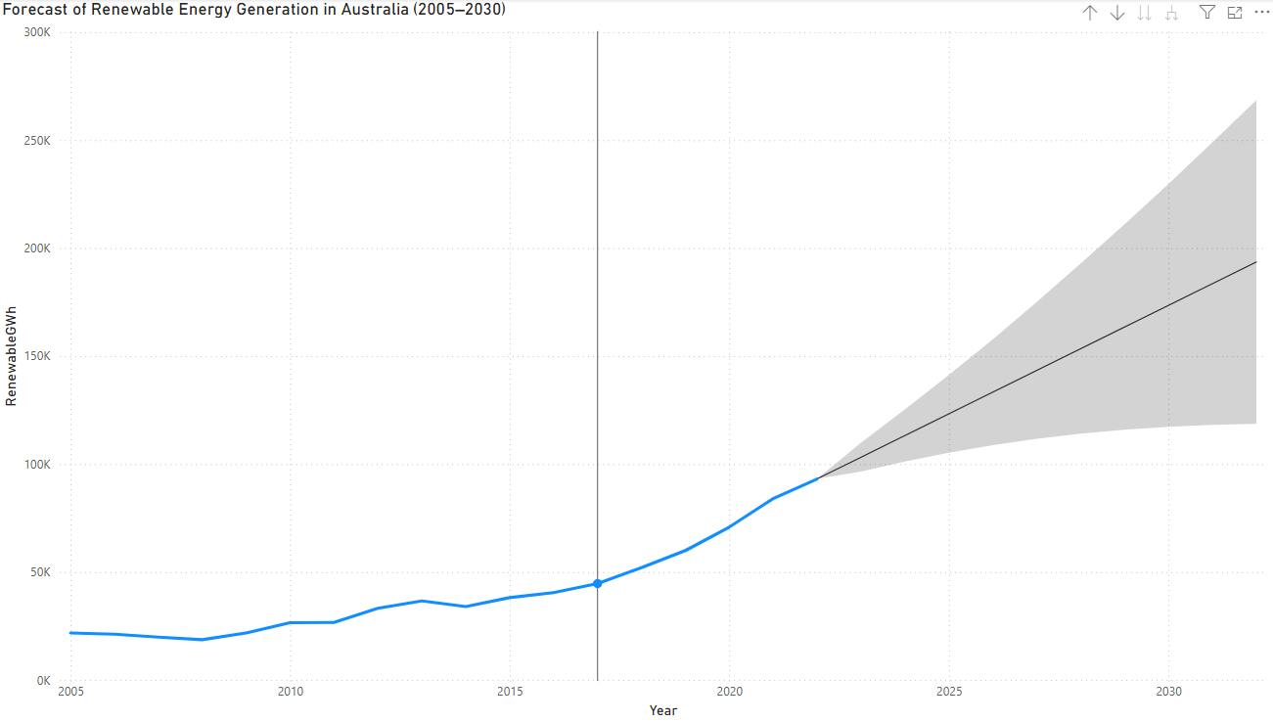
Figure 7. Forecast of Renewable Energy Generation in Australia (2005-2030)
Key Findings:
As seen by the forecast, Australia is on a clear upward trajectory, that indicated a doubling of renewable energy GWh generation by the year 2030. This growth aligns with the national 82% renewable electricity target, even though reaching the outcome of this trend will require multiple investments and policy supports. Solar and Wind are to remain relevant and dominant contributors, while hydro will as done in previous years continue to maintain a stable base.
Recommendations:
As to ensure the forecasted growth is met or even exceeded, an investment in battery energy storage systems (BESS) is needed as to manage the variability of solar and win output (Page and Fuller 2021). Furthermore, an expansion of transmission networks, that connect remote wind and solar farms to urban load centres have to be established. While supports for offshore wind development and green hydrogen starter programs are to be implemented within the renewable energy portfolio of the country. By encouraging a long-term proactive approach of power purchase agreements (PPAs), this will ensure that investors will be backed up when introduced to new projects. PPAs, like fixed-price Run of Plant (RoP) contracts, have been proven to be vital shielding for developers where the market is quite volatile and still under improvement (Nelson et al. 2023; ARENA 2021). Finally, a monitoring and adjustment policy instruments such as the Large-scale renewable energy target (LRET) has to keep its momentum for this outcome to become a reality (MacGill 2010; Nelson and Simshauser 2013).
Conclusion:
The report was created to analyse the development of renewable energy in Australia as from 2005 until 2023, four main key research questions were introduced regarding the proportion of renewable energy in total electricity generation, the changing composition of renewable energy sources, a regional comparison between Australia and his neighbouring partners, and most importantly a forecast of expected outcome by 2030. Hence, by utilising resources such as public national and international datasets, with the support of analytical tools like Power BI and academic literature, this report intentions to provide an evidence-based perspective on Australia’s renewable energy scene was achieve.
On the regional side of things, Australia trails Japan in total renewable generation while still exhibiting the strongest growth rate, especially after the year of 2015.
However, it is really important for us citizens to acknowledge the limitations of the analysis. Forecasting models are built on past trends which assume stability and continuous investments and policy upkeeps. Additionally, the data available lacks values on new technologies such as green hydrogen or offshore wind and fails to fully account for systematic barriers like regular delays, grid constraints, and social resistance, factors commonly reported in the renewable energy transition literature (Obuseh et al. 2025), which in theory would influence the transition of clean energy greatly.
The analysis showed that Australia’s renewable electricity share had an increase that went from 9% in 2005 to over 33% in 2023, as solar and wind technologies started overtaking hydro as the primary contributors towards clean energy scheme. The regional comparison highlighted that Australia underwent a rapid growth in renewable energy adoption, which was largely supported by the Large-Scale Renewable Energy Target (LRET), as well as its strong positioning in comparison with its neighbouring nations. The forecast model showed that the renewable energy generation would double by 2030, achieving the expected national target of 82% renewable electricity.
As to ensure this progress, future studies should include scenario based forecasting methodologies, conduct proper economical cost-benefit analysis on the different technological energy sources being utilised, and include a monitoring of new innovations on a regular basis. Eventually, gaining new data on emerging technologies would enable more comprehensive planning. Likewise, a need for a long-term energy security based on the development of infrastructure, an expansion of grid connectivity, and a consistency of support for policies at both a national and international level.

References:
ARENA. 2021. Corporate Renewable Power Purchase Agreements (PPAs): State of the Market 2021. Australian Renewable Energy Agency. https://arena.gov.au/assets/2021/09/corporate- renewable-power-purchase-agreements-ppas-state-of-the-market-2021.pdf
Australian Energy Council. 2023. State of the Energy Market Report. https://www.energycouncil.com.au/
Clean Energy Council. 2023. Clean Energy Australia Report 2023. https://www.cleanenergycouncil.org.au/
Department of Climate Change. 2024. Australian Energy Statistics, Table O: Electricity Generation by Fuel Type 2022–23 and 2023. https://www.energy.gov.au/publications/australian-energy- statistics-table-o-electricity-generation-fuel-type-2022-23-and-2023
International Renewable Energy Agency (IRENA). 2025. Electricity Generation Statistics Dataset: Power Capacity and Generation. https://pxweb.irena.org/pxweb/en/IRENASTAT/
Page, Margaret, and Sara Fuller. 2021. "Governing Energy Transitions in Australia: Low Carbon Innovation and the Role for Intermediary Actors." Energy Research & Social Science 73: 101896. https://doi.org/10.1016/j.erss.2020.101896
MacGill, Iain. 2010. “Electricity Market Design for Facilitating the Integration of Wind Energy: Experience and Prospects with the Australian National Electricity Market.” Energy Policy 38 (7): 3180–91. https://doi.org/10.1016/j.enpol.2009.07.047
Mills, Evan, and Joachim Schleich. 2021. “Renewable Energy in the Asia-Pacific Region: Comparative Country Trends.” Energy Research & Social Science 79: 102166. https://doi.org/10.1016/j.erss.2021.102166
Nelson, Tim, James Nelson, Jude Ariyaratnam, and Simon Camroux. 2013. “An Analysis of Australia's Large-Scale Renewable Energy Target: Restoring Market Confidence.” Energy Policy 62: 386–400. https://doi.org/10.1016/j.enpol.2013.07.028
Nelson, Tim, and Paul Simshauser. 2013. “Is the Merchant Power Producer a Broken Model?” Energy Policy 53: 298–310. https://doi.org/10.1016/j.enpol.2012.10.070
Nelson, Tim, Amy Boyd, and Michael Pincus. 2023. “Market Structures for Renewable Energy PPAs: Lessons from Australia.” Applied Energy 351: 120956. https://doi.org/10.1016/j.apenergy.2023.120956
Obuseh, E., Eyenubo, J., Alele, J., Okpare, A., & Oghogho, I. (2025). A systematic review of barriers to renewable energy integration and adoption. Journal of Asian Energy Studies, 9, 26–45. https://doi.org/10.24112/jaes.090002
Priatna, Dolly, Kathryn Monk, and Shujaul Khan. 2025. “Empowering the Planet: The 2025 Earth Day Resolution.” Indonesian Journal of Applied Environmental Studies 6 (1): 1–6. https://www.researchgate.net/publication/391630655_Empowering_the_Planet_The_2025_Ea rth_Day_Resolution
UNFCCC. 2015. Paris Agreement. United Nations Framework Convention on Climate Change. https://unfccc.int/process-and-meetings/the-paris-agreement/the-paris-agreement

Appendices:
- Tools used:
  - Microsoft Power BI Desktop for data visualisation
  - Power BI Query Editor for data preparation
  - Power BI Forecast for forecasting tool
- Data Sources
Datasets:
Australia-Table O: https://www.energy.gov.au/publications/australian-energy-statistics-table-o-electricity-generation-fuel-type-2022-23-and-2023
New Zealand, Japan, Indonesia: https://pxweb.irena.org/pxweb/en/IRENASTAT/IRENASTAT__Power%20Capacity%20and%20Generation/Country_ELECSTAT_2025_H1-PX.px/
Data Preparation steps:
- Cleansing Australia Dataset
  - Import Table O from the Australian Energy Statistics Excel file
  - Remove all header and footer rows while filtering data from 2005 to 2023
  - Rename Sheet Energy_Australia
  - Add following columns: Total Renewable GWh, Renewable Proportion = Renewable GWh/Total GWh
  - YearDate: #date(Number.FromText(Text.Start([Year], 4)), 1, 1)
- Prepare country comparison
  - Load and clean the datasets for each country
  - Standardized the columns in all datasets: Year, Country, Technology, GWh
  - For New Zealand remove subtotal rows and metadata
  - Create new table Combined_Energy_Comparison by appending all 4 countries
  - Add calculated column: YearDate = #date(Number.FromText([Year]), 1, 1)
- Conversion
  - Ensure all GWh columns are set to decimal number
  - YearDate is set to Date, Year is used for visuals
  - Country and Technology set to Text
Visualisation Creation:
Q1. Line Chart: Year vs Renewable Proportion (%)
Stacked column chart: Raw GWh of all sources to compare scale and growth
Slicer added for the fuel type
Q.2 100% Stacked column chart: Share of renewable types over time
Area chart: GWh growth by renewable type
Slicer added for dynamic filtering
Q.3 Stacked area chart: GWh over time across Australia, NZ, Japan, and Indonesia
Data sourced from merged Combined_Energy_Comparison table
Used Country as legend and YearDate for X-axis
Q.4 Line Chart: Renewable GWh by year
Enabled Forecast in analytics panel set to length 7 years
Used YearDate on X-axis and set to continuous
Metadata and Assumptions:
Year ranges used are between 2005-2023 for Australia and 2005-2022 for all others
Forecasting is created based on past trendlines
IRENA definitions used as to identify energy categories
Replication Instructions:
- Download all files to a folder
- Open PowerBI
- Load each file and clean using the steps above
- Append country data into Combined_Energy_Comparison
- Create new measures and columns in PowerBI or Power Query
- Recreate all visuals using the fields, slicers, and analysis settings

