Python Introduction Lab

Assignment 1


Submitted By :- ANGAD SINGH

CSE-1

(00713202717)

Q1. Create a program that asks the user to enter their name and their age. Print out a message addressed to them that tells them the year that they will turn 100 years old.

Extras:

- Add on to the previous program by asking the user for another number and printing out that many copies of the previous message.

- Print out that many copies of the previous message on separate lines. (Hint: the string "\n is the same as pressing the ENTER button)

Pseudocode

def printName():

name = input("Enter Your Name\t")

age = int(input("Enter You Age\t"))

age_100 = (datetime.datetime.now().year) + (100-age)

print("Hello! "+name+ ", you know you will celebrate your centennial in "+ str(age_100)+"\n")

number = int(input("Enter the Number of times you want to print this message \t"))

for i in range(number):

print("\nHello! "+name+ ", you know you will celebrate your centennial in "+ str(age_100))

Code&Output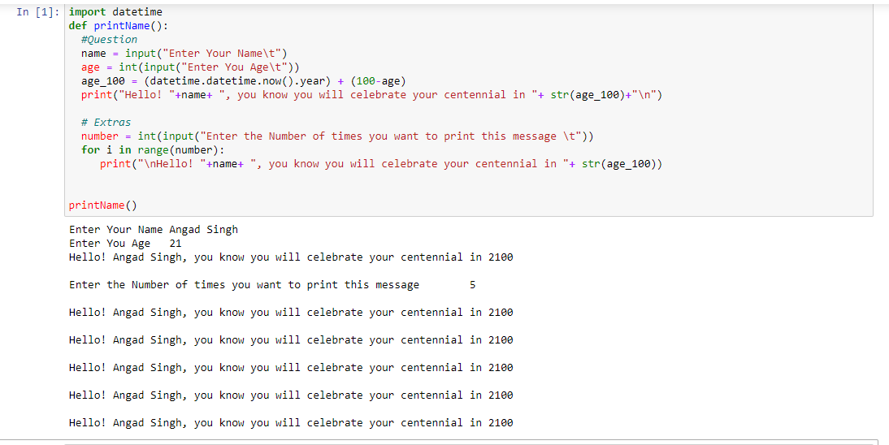

Q2. Take a list, say for example this one: a = [1, 1, 2, 3, 5, 8, 13, 21, 34, 55, 89] and write a program that prints out all the elements of the list that are less than 5. Extras:

- Instead of printing the elements one by one, make a new list that has all the elements less than 5 from this list in it and print out this new list.

- Write this in one line of Python.

- Ask the user for a number and return a list that contains only elements from the original list a that are smaller than that number given by the user.

Pseudocode

def printelements(lst):

- Printing Elements Less than 5 new_lst = []

for i in lst: if i<5: print(i)

##1. Appending in List new_lst.append(i)

print("New List is {}".format(new_lst))

##2. Appending in one line

new_lst2 = [x for x in lst if x<5]

print("New List in one line is{}".format(new_lst2))

##3. Asking user and responding accordingly

number = int(input("Enter the number to find element smaller than the number"))

new_lst3 = [x for x in lst if x<number]

print("Elements smaller than{} are {}".format(number, new_lst3))

a = [1, 1, 2, 3, 5, 8, 13, 21, 34, 55, 89]

printelements(a)

Code & Output
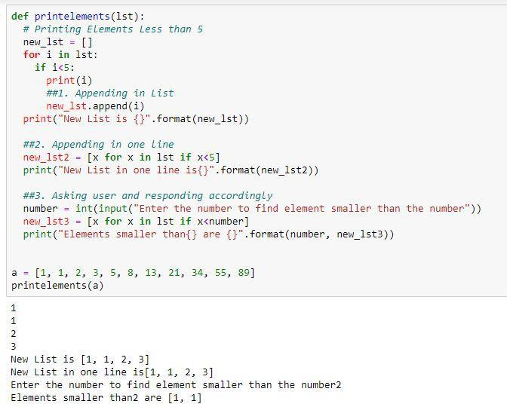

Q3. Write a program that asks the user how many Fibonacci numbers to generate and then generates them. Take this opportunity to think about how you can use functions. Make sure to ask the user to enter the number of numbers in the sequence to generate.(Hint: The Fibonacci seqence is a sequence of numbers where the next number in the sequence is the sum of the previous two numbers in the sequence. The sequence

looks like this: 1, 1, 2, 3, 5, 8, 13, …)

Pseudocode

def fibo(n):

if n <= 1:

return n

else:

return(fibo(n-1) + fibo(n-2))

nterms = int(input("Enter the number of numbers for seq."))

print("Fibonacci sequence:")

for i in range(nterms):

print(fibo(i))

Code & Output
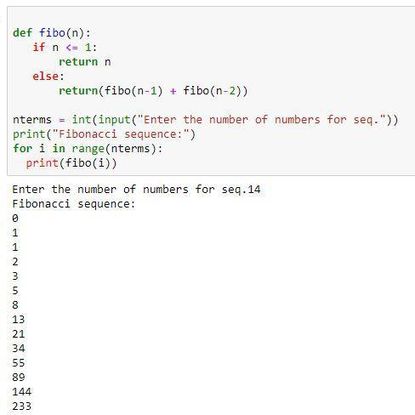

Q4. Write a program (function!) that takes a list and returns a new list that contains all the elements of the first list minus all the duplicates.

Extras:

- Write two different functions to do this - one using a loop and constructing a list, and another using sets.

Pseudocode

def lst_unique(lst):

unique = []

for l in lst:

if l not in unique:

unique.append(l)

for x in unique:

print(x)

def using_set(lst):

list_set = set(lst)

unique_list = list(list_set)

for x in unique_list:

print(x)

a = [1, 1, 2, 3, 5, 8, 13, 21, 34, 55, 89, 21, 89]

print("Without using Sets")

lst_unique(a)

print("\nUsing Sets")

using_set(a)

Code & Output
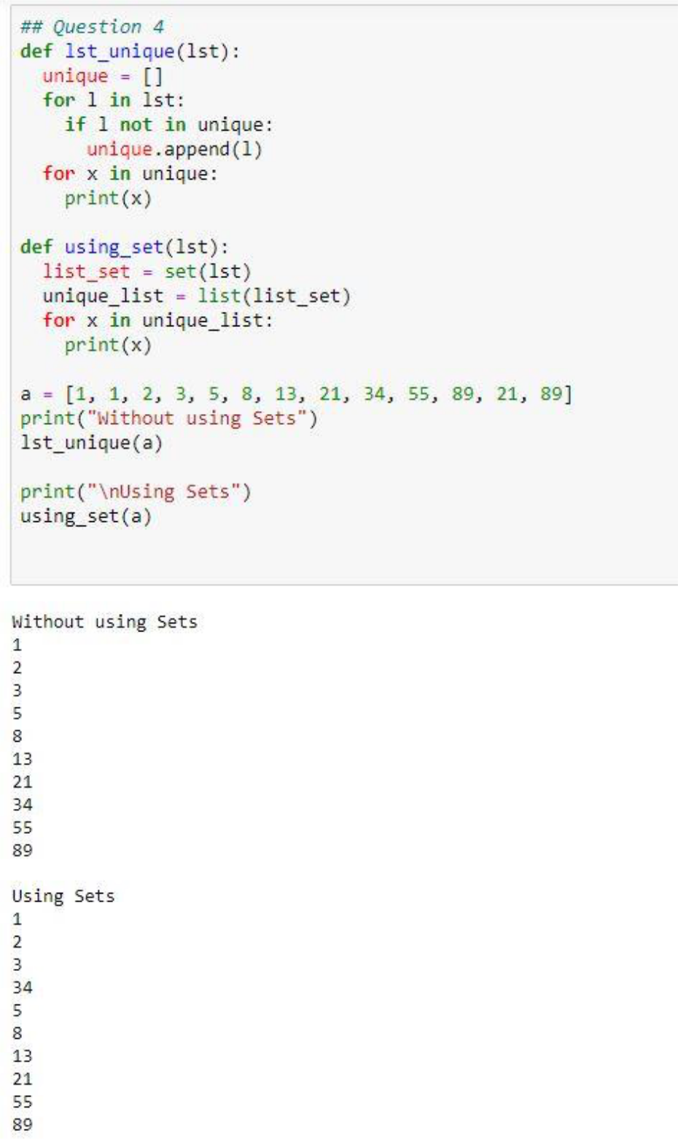

Q5. Ask the user for a number and determine whether the number is prime or not. (For

those who have forgotten, a prime number is a number that has no divisors.). Use

functions

Pseudocode

def isPrime():

num = int(input("Enter Number you want to check \t"))

flag = 1

for i in range(2, int(num/2)):

if(num%i == 0):

flag = 0

break

if(flag==0):

print("Number is not Prime")

else:

print("Number is Prime")

Code & Output
