Survey Feedback Analyser

About the Project
Survey Feedback Analyzer is a Python program written in a Jupyter Notebook. It reads customer feedback, cleans the text, and shows useful results such as the average rating, the longest feedback and word counts.
It starts with 10 feedbacks already stored in the notebook. The user can add more feedbacks while the notebook runs. The notebook then cleans all the text and prints the results, one step per cell.

Overview of what the Program Does
Step | Task | How it is done
1 | Store 10 feedbacks | A dictionary called feedback_data holding four lists
2 | Add more feedbacks | A loop asks for name, feedback and rating; serial numbers start at 11
3 | Clean the text | The function clean_text() fixes capitals, punctuation and spaces
4 | Count words | The function count_word_in_feedbacks() counts feedbacks with a given word
5 | Show the data | The dictionary is printed as a whole, then list by list
6 | Show a summary | Average rating, longest feedback and a set of unique words
7 | Sort by rating | zip() and sorted() arrange feedbacks from highest to lowest

How the Data Is Stored
All data is kept in one dictionary. It has four keys, and each key holds a list. The same position in every list belongs to the same person.
feedback_data = {
'S_No': [1, 2, 3, ..., 10],
'Name': ['Ravi', 'Meera', ...],
'Feedback': [' Very GOOD Service!!!', ...],
'Rating': [5, 2, 5, ...]
}
For example, position 0 in every list is Ravi: serial number 1, name Ravi, his feedback and his rating of 5. Because of this, every new record must be added to all four lists.

How the Code Works

Adding new feedbacks

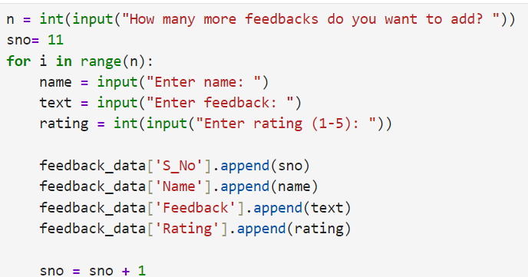
- input() reads what the user types, and int() turns it into a number.
- sno starts at 11 because the stored feedbacks use serial numbers 1 to 10.
- The for loop repeats once for each new feedback.
- append() adds the new values to the end of each list, and sno goes up by 1 each time.
- The rating is not checked. A value such as 9 is accepted as it is.

Cleaning the text
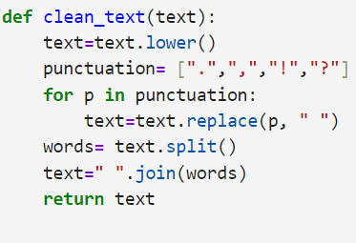
The function works in four small steps:
- lower() changes all letters to lowercase.
- replace() swaps each punctuation mark for a space.
- split() breaks the text into a list of words and ignores extra spaces.
- " ".join() puts the words back together with a single space between them.
Example: " Very GOOD Service!!!" becomes "very good service".
The function is then applied to every feedback in the list:
The position i is used so that the cleaned text replaces the old text in the same place. The original text is overwritten, so it is not kept anywhere. The cleaned list is then printed to check the result.

Counting words

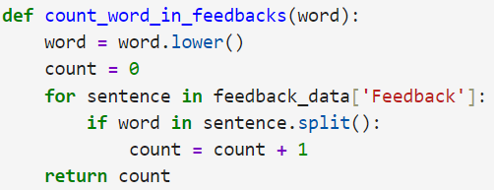
- The function counts how many feedbacks contain the word, not how many times the word appears. "good food and good ambience" counts as 1.
- Checking against the list of words from split() means only complete words match. For example, "bad" will not match "badly".
- This step must run after cleaning, otherwise words like "GOOD" or "good!!!" would be missed.
The notebook calls it for three words: good, poor and excellent.

Showing the data and summary results
Before the summary, the data is printed twice: once as the full dictionary, and once list by list with the labels S_No, Name, Feedback and Rating.
- Average rating: sum() adds the ratings and len() counts them. The total is divided by the count and rounded to 2 decimal places with round().
- Longest feedback: the notebook loops over each feedback, remembers the highest word count, and keeps its position in feedback_about. That position is used to find the person's name. If two feedbacks tie, the first one is shown.
- Unique words: every word is added to a set called unique_words, which does not allow duplicates. The set is built but not printed in the notebook.
- Sorted by rating: zip() joins the rating, name and feedback lists into rows. sorted(..., reverse=True) arranges them from highest to lowest rating. The result is stored in sorted_data and printed as a list of tuples.
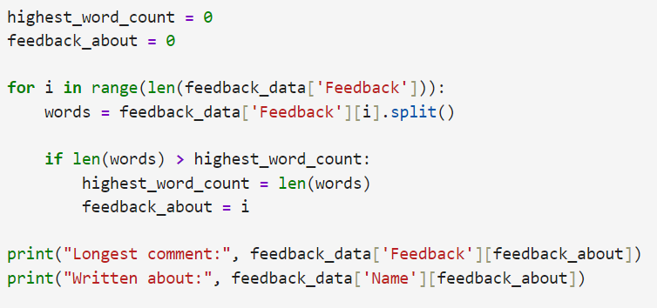
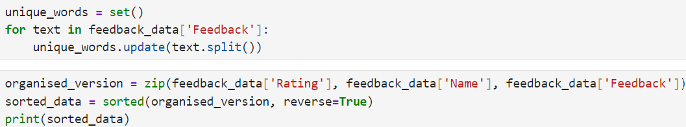

How to Run
- Make sure Python and Jupyter Notebook (or JupyterLab) are installed.
- Open Python_module_end_assignment.ipynb in Jupyter.
- Run the cells one by one from top to bottom (Shift + Enter).

Sample Output
Results from the recorded run, where 1 extra feedback was added (jean, "good performance", rating 4):
Result | Value
Feedbacks containing good | 4
Feedbacks containing poor | 2
Feedbacks containing excellent | 1
Average rating | 3.45
Longest feedback | Kiran (7 words): "poor response and poor handling of issue"
Unique words stored in the set | 31 (30 if no feedback is added)

