Discussion and Justification of Results
BERT Fine-Tuning for Mental-Health Text Classification (7-class) — 5-Model Comparison
Model: bert-base-uncased · Dataset: 103,487 samples · Split: 82,789 / 10,349 / 10,349 (80/10/10, stratified) · 3 epochs

Overview of Results
Table 1. Configuration and test-set performance of the five models. The best model (O) is highlighted.
Model | max_len | Eff. batch | LR | Warmup | Val F1 | Test F1 | Test Acc | Test Loss
A_baseline | 256 | 8 | 2e-5 | 0.0 | 0.9153 | 0.9182 | 0.9183 | 0.361
F_baseline_512 | 512 | 8 | 2e-5 | 0.0 | 0.9200 | 0.9208 | 0.9208 | 0.400
O_warmup_512 ★ | 512 | 8 | 2e-5 | 0.1 | 0.9174 | 0.9223 | 0.9223 | 0.392
M_lgbatch_hi-lr_512 | 512 | 32 | 3e-5 | 0.0 | 0.9208 | 0.9205 | 0.9206 | 0.266
M_warmup_512 | 512 | 32 | 3e-5 | 0.1 | 0.9216 | 0.9195 | 0.9195 | 0.259

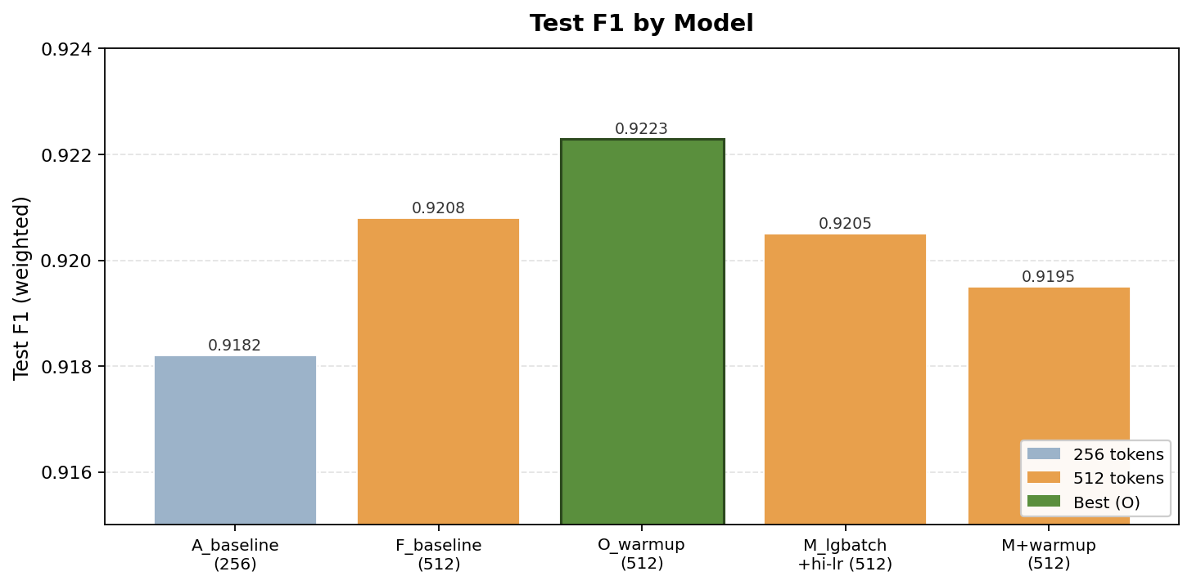
Figure 1. Test F1 by model. The 512-token models (orange/green) all sit above the 256-token baseline (grey); O is the best.

1. Why we focus on F1
The dataset is imbalanced, with class sizes ranging from anxiety (17,620) down to suicidal (11,046). Under imbalance, plain accuracy is misleading: a model can report a high accuracy by classifying the large classes well while quietly failing the small ones, and that failure is hidden inside the accuracy figure. F1 is the harmonic mean of precision and recall, so it stays high only when the model is both not over-predicting a class (precision) and not missing it (recall); a model that sacrifices one for the other is penalised. We use the weighted F1, which averages each class's F1 by its support so that every class contributes fairly.
This is particularly important in a mental-health setting, where the two error types carry very different costs — failing to flag a genuinely suicidal post (a false negative) is far more serious than a false alarm — so a precision/recall-aware measure is more appropriate than raw accuracy. Accuracy and weighted F1 happen to coincide almost exactly here, which is reassuring, but F1 remains the more defensible headline metric.

2. Longer maximum sequence length
Increasing the maximum sequence length from 256 to 512 tokens is the clearest and most reliable improvement in the study: Model A (256) rises from a test F1 of 0.9182 to Model F (512) at 0.9208. The mechanism is concrete and measurable rather than speculative — truncation falls from 8.2% of training texts at 256 tokens to only 2.3% at 512. Longer inputs retain discriminative signal that the shorter cap discarded.
The gain appears precisely where expected — in the hard classes. As Table 2 shows, depression rises 0.798 → 0.805 and suicidal 0.755 → 0.767, whereas the easy classes (anxiety, bipolar, personality disorder) barely move because they were already near-saturated. Depression and suicidal posts tend to be longer, more narrative texts, so they are the categories most damaged by a 256-token cut and most helped by extending to 512. The trade-off is compute: 512 tokens roughly doubled training time (≈54 to ≈72 minutes) for about 0.26 F1 points.
Table 2. Per-class F1 for the two bottleneck classes across all models.
Model | depression F1 | suicidal F1
A_baseline | 0.798 | 0.755
F_baseline_512 | 0.805 | 0.767
O_warmup_512 | 0.809 | 0.770
M_lgbatch_hi-lr_512 | 0.809 | 0.769
M_warmup_512 | 0.805 | 0.761

3. Effect of larger batch size and higher learning rate
Models M and M+warmup raise the effective batch to 32 (via gradient accumulation) and the learning rate to 3e-5. Two distinct effects follow.
First, F1 does not improve. M reaches 0.9205 and M+warmup 0.9195, both statistically indistinguishable from the F baseline (0.9208). For accuracy purposes, scaling up batch and learning rate is neutral.
Second, the loss and efficiency change markedly. M and M+warmup have by far the lowest test losses (0.266 and 0.259, versus ≈0.39–0.40 for the small-batch models). A larger batch yields smoother, lower-variance gradient estimates, so the model becomes better calibrated — its probabilities are less over-confident — even though the argmax decisions, and therefore F1, do not change. The large-batch runs also complete in far fewer optimiser steps (7,764 versus 31,047), making them more compute-efficient per epoch.
Raising the learning rate was necessary to make the larger batch work. In earlier experiments, a batch of 32 with the learning rate left at 2e-5 underperformed. Pairing the larger batch with a higher learning rate — the standard linear-scaling intuition that bigger batches require bigger steps — recovered that gap, which is why M matches the baseline rather than falling below it. The conclusion is that larger batch with a scaled learning rate buys speed and calibration, not accuracy.

4. Which parameters help
Ranking the levers by how much they actually moved F1:
- Sequence length (256 → 512) is the only change that produced a clear, reliable gain (+0.26), concentrated in the hard classes. This is the genuine winner.
- Warmup (0.1) gave the best single test number — O at 0.9223 versus F at 0.9208 — by stabilising early updates so the freshly-initialised classifier head does not make large destructive changes to the pretrained weights before the learning rate settles. However, this is a marginal and noisy effect (see Section 5), and it only helped the small-batch configuration: adding warmup to the large-batch M actually lowered test F1 (0.9205 → 0.9195). Warmup is therefore not a universal win.
- Larger batch + higher LR helps neither metric — it improves only loss/calibration and training speed.
In short: maximum sequence length clearly helps; warmup helps marginally but unreliably; batch size and learning rate are neutral for the metric of interest.

5. The best model
On the test set, the best model is O_warmup_512 (512 tokens with warmup 0.1): test F1 0.9223 and test accuracy 0.9223.
An honest caveat belongs here, because it is the defensible position. Comparing validation against test, O has the lowest validation F1 of all five models (0.9174) yet the highest test F1, while M+warmup has the highest validation F1 (0.9216) but a lower test F1 (0.9195). The validation and test rankings are essentially reversed. When the two splits disagree to this degree, the spread among the 512-token models (0.9195–0.9223, about 0.28 points) is run-to-run variance rather than a real quality difference.
The fully defensible conclusion is therefore two-tiered. The 512-token family (≈0.920–0.922) clearly and consistently beats the 256-token baseline (0.918), and that difference is real. Within the 512-token family the models are statistically tied; O gives the best test result and is a reasonable choice, but it cannot be claimed to be robustly superior to F or M. If a single best model must be reported, name O (best test F1) while stating that the 512-token configurations are within noise of one another.
Why warmup helped Model O. Warmup linearly ramps the learning rate from zero up to its target (2e-5) over the first 10% of training steps before the usual decay begins, rather than starting at full speed. This matters when fine-tuning a pretrained model for two related reasons. First, the classification head is randomly initialised while the BERT body is already pretrained; in the opening steps that random head produces large, noisy gradients, and at full learning rate those gradients propagate back into the carefully pretrained weights and can partially erase what the model already knows. Warmup keeps the learning rate small while the head settles, protecting the pretrained representations during the most unstable phase. Second, the AdamW optimiser sets each parameter's step size from running estimates of the gradient statistics, which are unreliable when based on only a handful of early batches; warmup limits the damage from these erratic early adaptive steps until the estimates have stabilised.
This mechanism is visible in the training trajectory. After the first epoch, O's validation F1 (0.906) is actually lower than the no-warmup baseline F's (0.909) — exactly what a throttled early learning rate should produce — yet by the end O reaches the best test F1 of the five models. The deliberately conservative start protects the pretrained weights and lets the model converge to a slightly better final solution.
The same reasoning explains the interaction with batch size. Warmup helped the small-batch model O but not the large-batch M+warmup, because a larger batch already produces smoother, lower-variance gradients from the outset; the early instability that warmup is designed to tame is largely absent there, so adding warmup is redundant and merely delays convergence within the fixed three-epoch budget. Warmup helps most precisely when early-training instability is greatest — the small-batch, cold-started case — which is consistent with the result. The caveat from above still applies: the winning margin (about 0.0015 test F1) is within noise, so warmup is best read as a principled, low-risk, well-motivated choice rather than a change proven to be robustly superior.

6. Effect of training for more epochs
Training for additional epochs was also tested, and performance did not improve — it degraded. In extended runs allowing up to five epochs, test F1 came out lower than the three-epoch baseline (the 256-token five-epoch run fell to roughly 0.912 and the 512-token five-epoch run to roughly 0.920, neither beating its three-epoch counterpart).
The cause is visible directly in the per-epoch logs of these very models, as shown in Figure 2: validation loss rises every epoch even while validation F1 only creeps up, and training loss continues to fall. For Model F, training loss drops from 0.536 to 0.229 across the three epochs while validation loss climbs from 0.289 to 0.394. That widening gap — training loss down, validation loss up — is the classic onset of over-fitting, where the model begins to memorise the training set rather than generalise. Three epochs sits at the sweet spot, just before over-fitting takes over, so additional epochs only increase memorisation and harm generalisation without any F1 benefit.
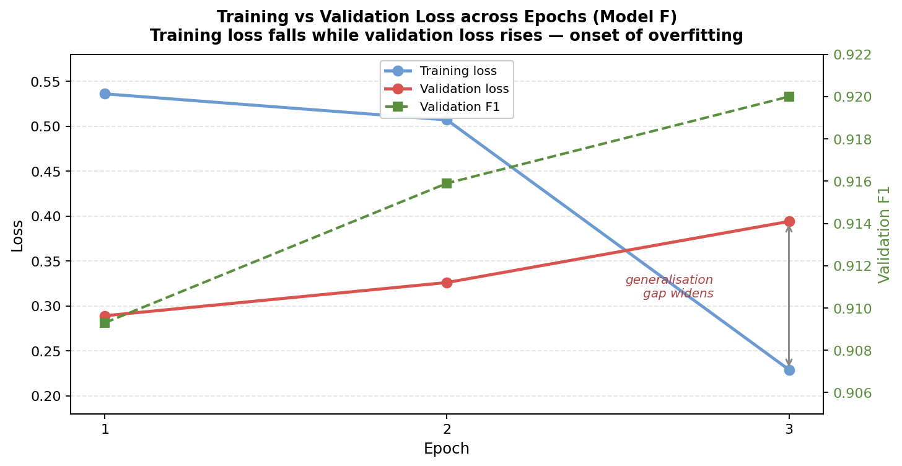
Figure 2. Model F across epochs: training loss falls while validation loss rises, and validation F1 plateaus — the signature of over-fitting. Adding epochs would worsen, not help, generalisation.

Summary
Weighted F1 is the appropriate metric for an imbalanced, high-stakes classification task. Longer context (512 tokens) is the one change that delivers a real, reliable gain, concentrated in the depression and suicidal classes. A larger batch with a scaled-up learning rate buys efficiency and calibration but not accuracy. Warmup yields the best, though noisy, test result. The best model is O_warmup_512 at test F1 0.9223, with the honest caveat that the 512-token models are within noise of each other. Finally, training for more epochs over-fits rather than helps, so three epochs is retained as the optimal training length.

Future Improvements
The results show that the performance ceiling of roughly 92% F1 is set by the semantic overlap between the depression and suicidal classes — a data- and label-level limitation — rather than by optimisation, since batch size, learning rate, warmup, and epoch count were all explored and none broke past that ceiling. Future work should therefore be directed at the data and the model rather than at further hyperparameter tuning. The following directions are ordered roughly by expected impact.
A. Target the depression–suicidal bottleneck (highest priority).
- Class-weighted or focal loss to focus learning on the hard and minority classes; suicidal has both the lowest support (1,104) and the lowest F1, so re-weighting the loss toward it directly attacks the main error source.
- Re-examine the labelling guidelines and re-annotate ambiguous depression-versus-suicidal cases. Part of the overlap is likely label noise, and cleaner class boundaries would raise the ceiling that no optimiser can lift.
- Two-stage (hierarchical) classification: first separate the easy classes, then route depression/suicidal candidates to a dedicated binary classifier trained specifically on that boundary.
- Cost-sensitive thresholding biased toward suicidal recall, reflecting that missing an at-risk post is costlier than a false alarm, with suicidal recall reported explicitly as a safety metric.
B. Stronger and domain-specific models.
- Domain-pretrained encoders such as MentalBERT or ClinicalBERT, or stronger general models such as RoBERTa or DeBERTa-v3, which frequently outperform vanilla bert-base-uncased on text classification.
- Long-document models such as Longformer or BigBird to eliminate truncation entirely for the small fraction of very long posts that even 512 tokens cannot fully capture.
C. Statistical rigour to make model selection defensible.
- Multi-seed runs (3–5 seeds) reporting mean ± standard deviation, since the differences among the 512-token models currently fall within run-to-run noise.
- Paired significance testing (e.g. McNemar's test or a paired bootstrap) before claiming that one model genuinely outperforms another.
- k-fold cross-validation instead of a single split, to obtain a more stable estimate of generalisation performance.
D. Data augmentation and error analysis.
- Augment the minority and hard classes through back-translation or paraphrasing to increase the effective support of the suicidal class.
- Confusion-matrix and qualitative error analysis of misclassified depression and suicidal posts, to characterise the failure modes and guide both labelling and modelling choices.
E. Deployment and safety (mental-health context).
- Probability calibration (e.g. temperature scaling) if the model's confidence scores feed a downstream risk-scoring system, since the larger-batch models already showed differences in calibration.
- Explainability and human-in-the-loop review using attention or SHAP-based explanations, with human verification of high-risk (suicidal) predictions before any action is taken.

