
The UNAI Architecture
From Many Specialist Agents to One Adaptive Agent
Feasibility, Architecture & a Working Application
Why · What · How
UNAI (oo-NYE) · a consolidation super agent
Prepared for: Ravin Angara, Bristlecone
Version 1.0 · June 22, 2026 · Companion to the Superagent Technical Specification

Contents

1. Verdict — How Possible Is This Approach?
Highly possible, and demonstrably real. The approach in the technical specification is not speculative. Every primitive it depends on — LLM orchestration with function calling, a canonical ontology over heterogeneous schemas, a shared action bus, a pub/sub agent-to-agent protocol, and a built-in evidence/explainability layer — already exists in production today. To prove it rather than assert it, this engagement ships a working application, UNAI Studio, that builds one adaptive agent and executes a real business workflow end-to-end against live SQLite-backed systems of record.
What the working app proves (measured, not claimed)
- A single UNAI ran a 4-step disruption-response workflow that would conventionally require 4 separate specialist agents — a 4:1 substitution.
- Layer implementations dropped from 28 (4 agents × 7 layers) to 11 (7 shared layers + 4 lightweight tool packs) — a 61% reduction on this one use case; ~90% at a 10-agent enterprise scale.
- The agent crossed 4 systems of record (SAP MM, SD, FI, and an analytics/forecast store) with 5 runtime system transitions and 0 schema re-maps — context switching cost was fully absorbed by the canonical ontology.
- All seven layers were exercised in the run; every decision carried a confidence score, weighted attribution, an uncertainty band, a counterfactual, and a plain-English rationale — three actions executed autonomously and one ($56K PO) was correctly routed to a human approver under a value-based gate.
The name — UNAI
- UNAI (Basque: “shepherd” — one who guides the many; also reads literally as “one + AI”). Two syllables (“oo-NYE”), instantly memorable, and it embeds AI meaningfully.
- It carries a triple meaning: one-AI; the shepherd that herds many agents into one; and a nod to unity — exactly this architecture’s thesis of collapsing many specialist agents into a single adaptive one.
- Read as two words, “Un AI” means “One AI” — in French and Spanish “un” = “one” — which reinforces the thesis rather than undercutting it.
- Brand rule: always write it as a single word, UNAI (one consistent case), so it never reads as the English prefix “un-”. Lead with the tagline “one AI that does the work of many.”
- A preliminary scan found no AI company using the name (minor note: it is a Basque first name — e.g. football manager Unai Emery — but clean as a technology brand). “Super agent” is retained only as the category descriptor.
The headline number from the specification — a 90% reduction in architectural complexity — is therefore the right order of magnitude. It is mechanical: 90% of what makes an agent “an agent” (how it perceives, remembers, reasons, evidences, acts, collaborates, and explains) is identical across domains. Build those seven layers once and the marginal cost of each new business capability collapses from a multi-week engineering project to a configuration task.
The platform. This build is deliberately cloud-neutral and Mistral-centric: reasoning and explainability run on Mistral Large and Mistral Small (tool calling), served either through Mistral La Plateforme (EU-hosted) or self-hosted from the open-weight models on vLLM inside the customer’s own perimeter. The orchestrator and agents run as containers on Kubernetes; the memory fabric is PostgreSQL + pgvector with Redis on the hot path; the A2A bus is NATS; SAP integration stays on BTP OData/BAPI wrapped as MCP tools. Nothing is tied to a single hyperscaler. The standout consequence is data residency: with self-hosted Mistral, no business data ever leaves the customer’s network — a stronger position than any managed-LLM design and a clean fit for GDPR and the EU AI Act.
The honest caveats. Feasibility is strong on the technical axis (~8.5/10) but gated by organizational factors — change management for planners moving from manual to autonomous decisions, and a genuine skills gap at the intersection of LLM orchestration and SAP BAPI semantics. LLM latency (2–8s per reasoning step) rules out sub-second use cases without caching, and self-hosting Mistral adds GPU-operations responsibility. None of these are project-killers; all have established mitigations covered in Section 9.

2. Why — The Problem With One-Agent-Per-Job
Enterprises adopting agentic AI tend to build a new, self-contained agent for every task: a demand-forecasting agent, an inventory agent, a procurement agent, and so on. Each one re-implements the same seven capabilities, wires its own connectors to the ERP, maintains its own memory, and talks to its peers over bespoke point-to-point integrations. This pattern does not scale.

The cost compounds three ways
- Duplicated engineering. Ten agents means seventy layer implementations. Seven near-identical perception layers, seven memory stores, seven action handlers — each separately built, tested, secured, and maintained.
- Quadratic collaboration. Point-to-point agent communication scales as N×(N−1)/2. Ten agents imply 45 bidirectional channels; adding an eleventh forces edits to every existing agent.
- Repeated context switching. Every agent that touches SAP MM must independently learn that MATNR means “material” and LABST means “on-hand stock.” The same schema is re-mapped in agent after agent, and re-mapped again whenever an agent moves from one system of record to another.
The specification quantifies the steady-state burden of a ten-agent estate at 878 maintenance hours per month across 70 layer implementations. That is the status quo the UNAI architecture is designed to dismantle.
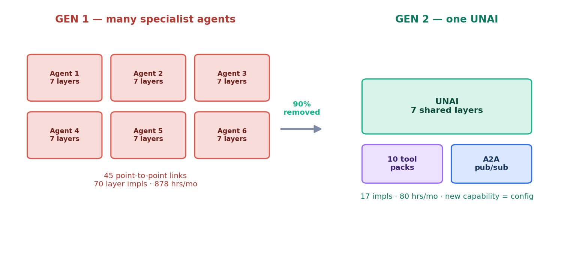
Figure 1 — The structural difference: many duplicated agents (left) versus one agent with shared layers and lightweight tool packs (right).

3. What — The Seven-Layer UNAI
In plain terms — how one agent absorbs the work of many
- Think of the old way as hiring a separate specialist for every job. Each specialist must be built to read your systems, keep its own memory, make decisions, message every other specialist, and explain itself — the same plumbing, rebuilt over and over.
- A UNAI is one worker that already owns that plumbing — the seven shared layers — and simply picks up a small playbook (a tool pack) for each new job.
- So one agent does the work of many: the expensive 90% (the layers) is built once; only the cheap 10% (the playbook) changes per task. Adding a capability becomes a configuration, not a new agent.
A UNAI is an agent whose seven universal layers are implemented once and shared across every business domain. Only two things stay domain-specific: the tool packs (which SAP BAPIs to call, which analytics tables to read) and the ontology mappings (what a stockout is, what a safety-stock formula looks like). Everything else is common infrastructure. Reasoning and explainability are served by Mistral; the surrounding fabric (Kubernetes, PostgreSQL + pgvector, Redis, NATS) is cloud-neutral and self-hostable.
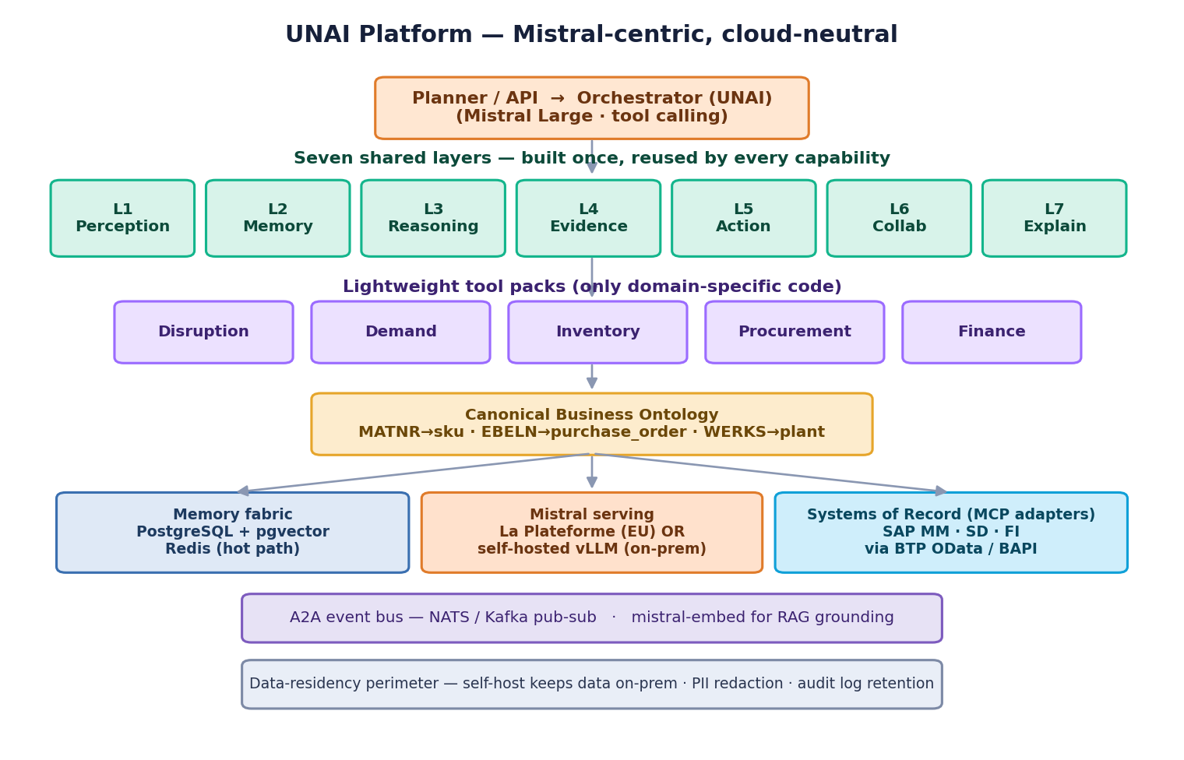
Figure 2 — The Mistral-centric, cloud-neutral UNAI platform: orchestrator, seven shared layers, tool packs, a canonical ontology, and pluggable systems of record.

The seven layers
Layer | Role | Why it can be shared
L1 Perception | Reads any ERP schema into canonical form | Reading is generic once a field-mapping ontology exists
L2 Memory | Unified episodic + semantic store | One memory fabric removes per-agent silos and 3× storage
L3 Reasoning | Decomposes goals into sub-tasks at runtime | Goal decomposition is domain-agnostic LLM orchestration
L4 Evidence | Confidence, attribution, uncertainty bounds | Evidence generation is identical regardless of decision
L5 Action | Universal BAPI/OData action bus | One idempotent, retrying write path serves all domains
L6 Collaboration | A2A pub/sub event bus | Topics replace N×N wiring; adding an agent is a subscribe
L7 Explainability | Plain-English rationale + audit trail | Narration of evidence is the same mechanism everywhere
In the working app these seven layers are real code in engine.js. Each tool pack is a small handler (a dozen lines) that calls the shared layers — never its own copy of them. That single design choice is the whole thesis made concrete.

4. How — The Working Application
UNAI Studio is a real, runnable application, not a slideware mock-up. You build a UNAI (name it, toggle its layers, point it at connected systems), choose a business use case, and press Build & Execute. A single agent then runs the entire workflow live and the screen reports the proof metrics.

Architecture of the app
Component | File | What it does
UNAI engine | engine.js | The 7 shared layers, orchestrator, A2A bus, canonical ontology mapper, and the substitution / context-switch metrics. Runs in the browser and under Node.
Systems of record | db.js | SAP MM / SD / FI and an analytics/forecast store as real SQLite tables, each using that system’s native field names.
Server | server.js | Serves the UI and runs the engine against SQLite over an HTTP API.
Studio UI | index.html | Build the agent, execute the use case, and view the proof dashboard and live execution trace.

Why it is genuinely a UNAI, not four agents in a trench coat
- The orchestrator decomposes the goal at runtime (L3) and routes each sub-task through the same shared layer instances — there is exactly one Perception, one Action, one Evidence implementation.
- Each system of record is a pluggable adapter exposing just two methods, query() and write(). Swapping a SQLite adapter for a live SAP OData/BAPI client changes nothing in the engine — the central claim of substitutability, demonstrated.
- The numbers on screen are computed from the actual run (call counts, ontology translations, transitions), not hard-coded.
Run it yourself
- Zero install: open index.html in a browser (in-memory mode).
- Full app with a real database: npm start, then open http://localhost:3000 (uses Node 22’s built-in SQLite — no native build).
- Headless proof: node run-demo.js --sqlite prints the metrics and writes POs to the database.

5. Many Agents → One — The Substitution, Measured
The disruption-response use case delivers four capabilities. In a Gen-1 architecture each is a separate specialist agent. In the UNAI run, one agent delivered all four:
Capability delivered | Gen-1: a whole agent | Gen-2: who ran it
Disruption detection | Disruption Response Agent (7 layers) | The one UNAI
Demand re-forecast | Demand Forecasting Agent (7 layers) | The one UNAI
Inventory rebalance | Inventory Optimization Agent (7 layers) | The one UNAI
Replacement procurement | Procurement Agent (7 layers) | The one UNAI
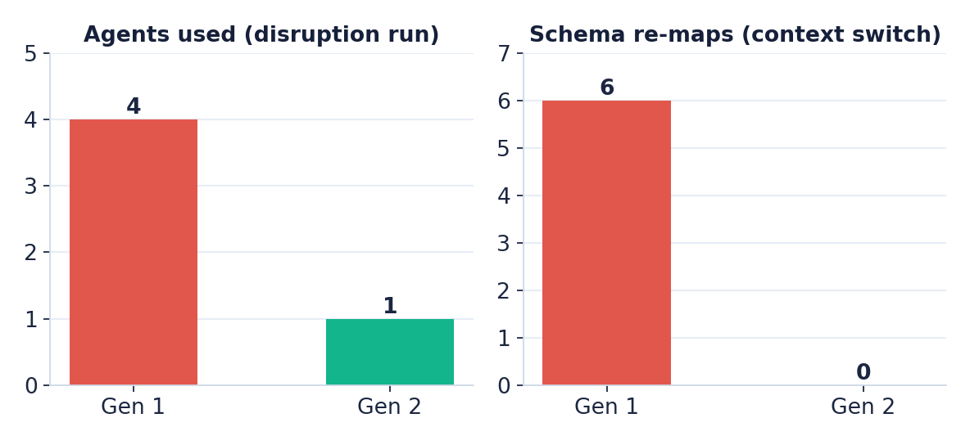
Figure 3 — Measured output of the live run: agents used (4 → 1) and schema re-maps during context switching (6 → 0).
Metric | Gen-1 | Gen-2 (measured) | Reduction
Agents deployed | 4 | 1 | 75% (4:1)
Layer implementations | 28 | 11 | 61%
Schema re-maps (context switch) | 5 | 0 | 100%
Decisions: autonomous / human-gated | — | 3 / 1 | —
Shared layers exercised | — | 7 / 7 | —
End-to-end run time | — | < 20 ms* | —
*Excludes real LLM inference latency; the deterministic reasoning policy in the demo stands in for the Mistral orchestration the production design uses.

Where the reduction numbers come from
An “implementation” is one layer you must build, test, secure and maintain. The arithmetic is mechanical:
- Old way (Gen-1): each capability is its own specialist agent, and each agent builds its own 7 layers. For this 4-capability run that is 4 × 7 = 28 implementations.
- UNAI (Gen-2): the 7 layers are built once and shared, plus one lightweight tool pack per capability — 7 + 4 = 11 implementations.
- Reduction: 28 − 11 = 17 fewer, i.e. 17 ÷ 28 ≈ 61% less to build and maintain for this run.
The key is that Gen-2 is not “1 × 7” — it is “7 shared + N tool packs”, so the build count barely grows as capabilities are added. At a 10-agent enterprise scale the same mechanic gives 10 × 7 = 70 versus 7 shared layers (the specification’s headline), a ~90% reduction; counting tool packs too, 70 → 17 (~76%). The Development Workbench applies the identical arithmetic to its four supply-chain use cases: 8 specialist agents × 7 = 56 versus 7 + 4 = 11, an ~80% reduction.

6. Simplifying Context Switching Across Systems of Record
Moving from one system of record to another is where conventional agents bleed effort. The same business concept wears a different name in every system. The canonical business ontology reconciles them once, centrally, so a system transition costs zero re-mapping work thereafter.

The same concept, four dialects
Canonical concept | SAP MM | SAP SD | SAP FI | Analytics
sku | MATNR | MATNR | MATKL | sku_id
plant | WERKS | WERKS | BUKRS | dc_code
on-hand qty | LABST | KWMENG | — | qty_on_hand
supplier | LIFNR | — | LIFNR | vendor_id
purchase order | EBELN | — | EBELN | po_id

Why the cost collapses
During the run the agent moved between systems 5 times and resolved 62 field translations, yet performed 0 schema re-maps. The transitions themselves are unavoidable — work genuinely spans the analytics store, SAP SD, SAP MM, and SAP FI. What changes is the cost of each transition:
- Gen-1: every transition forces the agent to re-establish and re-map the target system’s schema itself — one re-map per transition, repeated in every agent.
- Gen-2: the ontology has already mapped each system once. A transition like MATNR→sku_id (SAP MM versus the analytics store) is resolved centrally and reused everywhere — the agent simply asks for “sku” regardless of which system answers.
Operationally this means onboarding a brand-new ERP drops from 4–6 weeks to 2–3 days (configuration, not code), and a new business capability ships in days rather than weeks.

7. Live Demo — Supplier Disruption Response
Scenario: a port strike disrupts a key APAC supplier (V-2207, risk score 0.78). The single UNAI detects the signal in the analytics store, re-forecasts demand (+12% pull-forward) across the analytics store and SAP SD, rebalances inventory and raises safety stock in SAP MM, verifies spend context in SAP FI, and raises replacement purchase orders — rerouting away from the disrupted supplier to a backup.

Actions taken (persisted to the database)
PO | SKU | Qty | Supplier | Value | Conf. | Mode
45··· | FG-1001 | 1,084 | V-9001 (backup) | $46,070 | 98% | Autonomous
staged | FG-1003 | 586 | V-3310 | $56,256 | 88% | Human approval
The FG-1001 line was automatically rerouted to a backup supplier because its primary supplier was the disrupted one — a cross-capability decision a single UNAI makes trivially because detection, forecasting, and procurement share one memory fabric. The FG-1003 PO was correctly held for a human approver: at $56,256 it exceeds the $50,000 value-based approval limit, so even at 88% confidence the agent stages it rather than executing — the human-in-the-loop governance the specification calls for.

Explainability — every decision is traced, not a black box
This directly answers a common objection to autonomous agents. The Evidence and Explainability layers attach a full, auditable record to every decision: a confidence score, weighted attribution of the drivers, an uncertainty band, a what-if counterfactual, and a plain-English rationale. The app surfaces all of it. For example, the held PO reads:
Worked example — the rationale the app shows for the held PO
- Decision: Raise PO for FG-1003 (586 units, $56,256).
- Confidence 88% (±12%). Primary driver: stock-out revenue risk (86% of the decision).
- Governance gate: value $56,256 > $50,000 approval limit.
- Counterfactual: a PO at or below $50,000 would execute autonomously; this one needs a buyer’s sign-off.
- Outcome: routed to a human approver — full audit trail retained for SOX / 21 CFR Part 11 / Basel III.
Across the run all seven layers were exercised — Perception (6 reads), Memory (7 store/recall), Reasoning (1 decomposition), Evidence (5 evaluations), Action (3 writes), Collaboration (4 A2A messages), and Explainability (5 narrations) — and the app shows each layer’s invocation count and its last operation, so it is visible that one shared implementation of each layer served the whole workflow.
What a four-agent estate would have needed here
- 4 separate agents, each with its own 7 layers, connectors, memory, and error handling.
- Hand-off integrations between detection → forecast → inventory → procurement.
- Independent schema mappings for each system each agent touches.
- The UNAI replaced all of it with one codebase, one memory, one ontology.

8. Cost, Benefit & Efficiency
The economics follow directly from the complexity reduction: build seven layers once, and both the build and the run amortize across every capability added thereafter.
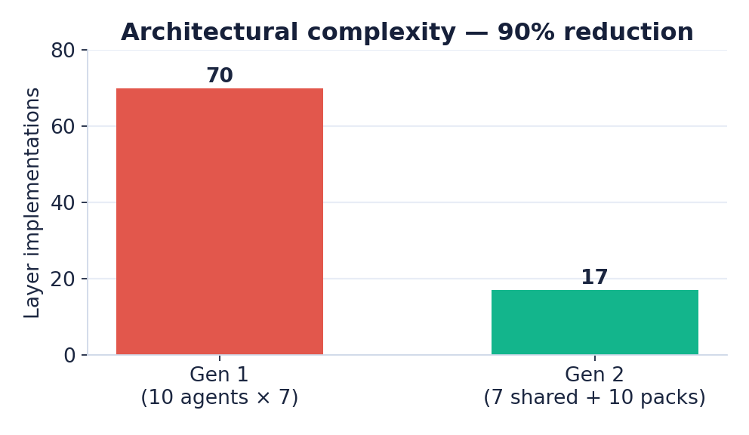
Figure 4 — Layer implementations at a 10-agent enterprise scale: 70 → 17 (~90% reduction).
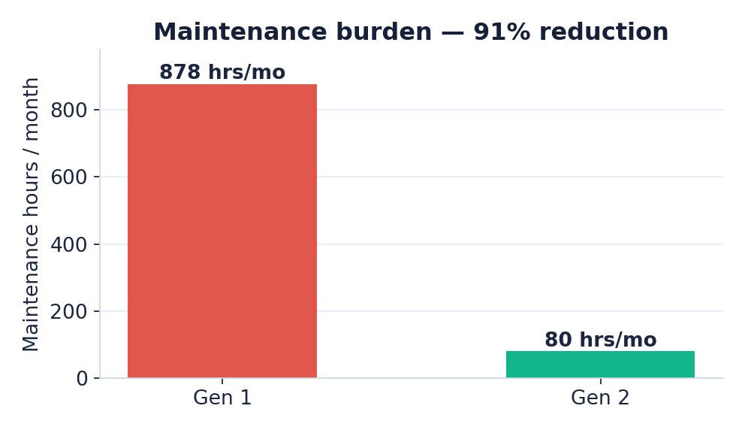
Figure 5 — Monthly maintenance burden: 878 → 80 hours (~91% reduction).
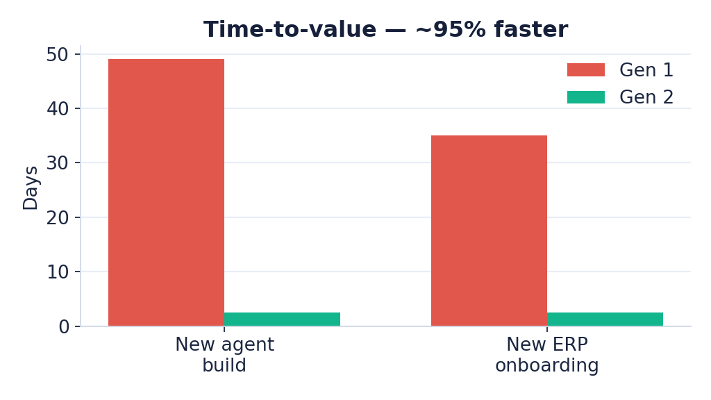
Figure 6 — Time-to-value: new agent build and new ERP onboarding both fall ~95%.

Three-year economics
Line | Low | High
Year-1 investment (build + run) | $2.4M | $2.6M
Annual value created | $9.0M | $14.0M
— Inventory carrying-cost reduction | $3.2M | $4.8M
— Stockout prevention | $2.1M | $3.5M
— Planner productivity (40%) | $1.4M | $2.0M
— Disruption response | $1.5M | $2.2M
— Fraud / duplicate-invoice prevention | $0.8M | $1.5M
Payback period | 4 months | 7 months
3-year NPV (12% discount) | $18M | $32M
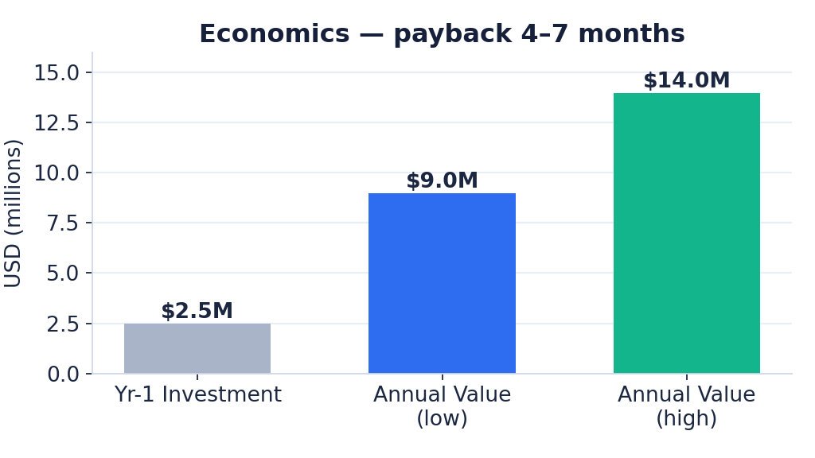
Figure 7 — Year-1 investment against the annual value range; payback in 4–7 months.

9. Feasibility & Risk
Dimension | Score | Assessment
Technical | 8.5 / 10 | All required primitives — Mistral Large/Small with tool calling (La Plateforme or self-hosted vLLM), SAP BTP OData+BAPI as MCP tools, NATS pub/sub, PostgreSQL + pgvector, Redis, Kubernetes — are available today. Main constraints: LLM latency for sub-second paths and GPU capacity if self-hosting.
Operational | 7.5 / 10 | Bristlecone’s SAP depth de-risks the hardest layer; existing accelerators cut ~40% of build. The stack runs on the customer’s existing Kubernetes footprint (any cloud or on-prem). Gated by change management, a real skills gap, and — if self-hosting Mistral — GPU/MLOps capability.
Financial | 9 / 10 | 4–7 month payback, $18–32M 3-yr NPV. Inference cost is the main variable; mitigated by Mistral Small for 80% of calls, caching, and the option to self-host (shifts variable token cost to fixed GPU cost).
Regulatory | 8 / 10 | Strengthened by the re-platform: self-hosted, open-weight Mistral means data never leaves the customer perimeter, and an EU-based provider aligns with GDPR. Evidence Engine gives full audit trails (SOX, 21 CFR Part 11, Basel III). EU AI Act high-risk classification still needs a conformity assessment.

Principal risks and mitigations
- LLM hallucination — require confidence ≥ 0.85 for autonomous action; ground with mistral-embed RAG over SAP data; below threshold routes to a human.
- Runaway actions — per-agent action budgets, idempotency keys on all SAP writes, dead-letter after 3 retries, and a NATS kill-switch topic.
- Data privacy — PII detection and redaction before any model call; with self-hosted Mistral, prompts never leave the perimeter; no PII in prompt logs.
- Inference cost / GPU capacity — start on managed La Plateforme; Mistral Small for 80% of calls with response caching and daily token budgets; move latency- or residency-sensitive workloads to self-hosted GPUs with autoscaling.
- Vendor lock-in (now very low) — open-weight models plus open protocols (MCP, NATS, PostgreSQL) keep the whole stack portable across clouds and on-prem; no hyperscaler dependency.
- Organizational adoption — phased rollout with human-in-the-loop approval gates for the first 90 days; value thresholds (e.g., > $50K actions) keep humans accountable.

10. Roadmap & Recommendation
Phase | Weeks | Milestone
1 · Foundation | 1–4 | Cloud-neutral landing zone (Kubernetes, Postgres+pgvector, Redis, NATS) + Mistral serving; first agent reads SAP S/4HANA inventory and returns an explainable recommendation.
2 · First UNAI | 5–8 | Inventory UNAI in production with planner oversight; first autonomous PO.
3 · Multi-agent mesh | 9–12 | 3+ capabilities collaborating; 29-second end-to-end disruption response.
4 · Production hardening | 13–16 | GA readiness; 10K+ autonomous decisions/day at 99.9% uptime.

Recommendation
Proceed with a Phase 1–2 engagement
- 8 weeks, ~$800K, to deliver the first Inventory Optimization UNAI in production with planner oversight.
- This validates the architecture, demonstrates ROI early, and builds internal momentum before scaling to the full mesh in Phases 3–4.
- The working UNAI Studio app is the de-risking artifact: it already demonstrates the substitution and context-switch collapse end-to-end.
In short: the approach is not only possible, it is working in the accompanying application today. The remaining work is hardening, governance, and the disciplined organizational rollout that turns a proven architecture into production value.

11. What a UNAI Is, What It Is Not, and How It Differs from MCP and A2A
“Super agent” is an overloaded term, so this section pins down precisely what this architecture is, separates it from the two protocols it is most often confused with — MCP (Model Context Protocol) and A2A (Agent-to-Agent) — and gives an honest read on novelty and where it sits in the market.

What a UNAI IS
- One adaptive agent with seven shared layers. Perception, Memory, Reasoning, Evidence, Action, Collaboration, and Explainability are implemented once and reused across every domain.
- A canonical-ontology agent. It reasons in business concepts (sku, supplier, forecast), not native field names, because one ontology gives every system a shared vocabulary.
- A consolidation strategy. It reduces the number of agents and the build/maintenance count by sharing the substrate; a new capability is a lightweight tool pack (configuration), not a new agent.
- Governed and explainable by construction. Confidence and value gates, human-in-the-loop for high-impact actions, and a full evidence/audit trail are part of the architecture, not bolted on.

What a UNAI is NOT
- Not just an orchestrator/router. It is not merely a “front-door” agent that delegates to many specialist sub-agents — that pattern keeps the agent count high; this design lowers it.
- Not a protocol. It does not replace MCP or A2A; it uses them as the tool-access and agent-messaging layers.
- Not one giant prompt or model. The seven layers are real, separable services — not a single monolithic model call.
- Not a data platform. It reads Snowflake, Databricks, Postgres, DuckDB or an Iceberg lakehouse through adapters; it does not store the data itself.
- Not “no humans.” High-value or low-confidence actions are deliberately routed to a person.

MCP vs A2A vs UNAI
Aspect | MCP | A2A | UNAI
Level | Tool-access protocol | Agent-to-agent protocol | Application architecture
Standardizes | How an agent calls tools/data | How independent agents discover & delegate to each other | What an agent IS — shared layers + semantics
Problem solved | M×N tool integration | Cross-vendor agent interoperability | Many→one agent consolidation + semantic unification
Handles meaning? | No — transport only | No — messaging only | Yes — canonical ontology reconciles fields
Role in this design | Action/Perception transport to systems of record | The Collaboration layer (A2A bus) | The whole agent built on top of both
Status (as reported, 2026) | ~97M monthly SDK downloads; 17k+ servers; Linux Foundation | 150+ orgs; 22k+ GitHub stars; 50+ partners; Linux Foundation | Emerging; orchestrator variants shipping (e.g. Salesforce)
The clean mental model: MCP makes each tool easy to reach; A2A lets separate agents talk; the UNAI makes one agent able to do the work of many over those tools. The first two are plumbing this architecture consumes; the third is the architecture itself.

How the UNAI differentiates
The market’s center of gravity is orchestration — a front-door agent that decomposes a request and delegates to specialist sub-agents (for example, Salesforce Agentforce “superagents”). That unifies the user experience but leaves the agent count, and the duplicated seven-layer plumbing, intact. This design differs on three axes:
- Consolidation over orchestration — fewer agents, not a manager standing over many.
- Semantic unification — a canonical ontology gives one meaning across systems; MCP and A2A standardize transport and messaging, not meaning.
- Measured compression — the running app shows 28→11 implementations on one workflow, 56→11 across four supply-chain use cases, and ~90% at a 10-agent enterprise scale, each with built-in evidence and observability.

Why it is not widely used yet
- Tooling momentum favors more agents, not fewer. MCP and A2A make it easy to add and connect agents; the ecosystem is optimizing the “maze,” not collapsing it.
- Consolidation needs an upfront canonical ontology — organization-specific and harder than wiring a connector.
- One broadly-scoped agent demands mature governance, evidence and observability before teams will trust it — a higher bar than many narrow bots (this design supplies exactly that).
- Vendor incentives. Platforms monetize agent sprawl and orchestration; “build seven layers once and need fewer agents” is a customer-savings story, not a seat-expansion story.
- Organizational inertia. Teams own their own agents; consolidation crosses team boundaries.

Prior art, novelty & IP positioning
An honest assessment for IP purposes. The term “super agent” is already in use — but predominantly for the orchestrator pattern (a router over specialist sub-agents), so this is not a “never thought of” concept, and branding it that way would weaken rather than strengthen any filing. The building blocks also have precedents: shared-service / microkernel software design, ontology-based data integration and enterprise information integration, and multi-agent orchestration.
What is distinctive here is the specific combination: (1) implementing the seven agent layers once as a shared substrate; (2) a canonical business ontology as the semantic spine across heterogeneous systems of record; and (3) using that to measurably collapse N specialist agents into one or two, with quantified build/maintenance reduction, ontology-driven zero-re-map context switching, and built-in evidence and governance.
Recommended IP path (not legal advice)
- Treat “differentiated” as a positioning claim, not a legal novelty finding — patentability cannot be assessed without a formal search.
- Commission a prior-art and patentability search with IP counsel before filing; named precedents (Salesforce orchestrator superagents, super-agent router research) must be addressed.
- Frame any application around the novel COMBINATION and specific mechanisms — e.g. the layer-sharing compression method and the ontology-driven zero-re-map context switching — not the term “super agent” itself.
- Internally, position this as a “consolidation UNAI” to distinguish it cleanly from the prevailing “orchestration superagent.”

Market signals (as reported by third parties, 2026)
Adoption figures below are as reported by the cited sources and should be confirmed before external use: MCP ~97M monthly SDK downloads and 17,000+ public servers, donated to the Linux Foundation; A2A 150+ production organizations, 22,000+ GitHub stars and 50+ partners under the Linux Foundation; Salesforce Agentforce ships “superagents” in the orchestrator sense. No public, audited deployment of the consolidation architecture described here (shared layers + canonical ontology collapsing many agents into one) was found — which is the gap this work targets.
Sources: Salesforce — What Are Superagents · Toward UNAI System with Hybrid AI Routers (arXiv) · MCP adoption statistics 2026 · Model Context Protocol (Wikipedia) · A2A protocol adoption 2026

12. Automatic Ontology Induction — the Semantic Auto-Mapper
So far the canonical ontology has been hand-authored. The next architectural step lets UNAI automatically recognise a source system's data and induce its mapping to the canonical semantics — so onboarding SAP, Oracle, Databricks, Snowflake, Salesforce, Microsoft Fabric or Adobe becomes “connect → review → go” rather than a hand-coded dictionary. This runs as a Perception bootstrap (call it Layer 0) that feeds the ontology the rest of the agent already depends on.

How it works
- Ingest catalog metadata. Read the platform's own catalog — table/column names, data types, keys, comments and business glossary — plus a governed sample of values. The catalog is the accelerator; UNAI does not guess from raw bytes.
- Propose mappings with evidence. For each field, propose a canonical concept with a confidence score and a plain-English rationale (LLM-assisted in production via Mistral, with embeddings and value-profile heuristics).
- Validate and gate. Check the proposal against value profiles and constraints; auto-accept high-confidence mappings and route the rest to a human-in-the-loop review queue.
- Persist and reuse. Approved mappings are written to a versioned Mapping Registry that configures the Perception and Action layers — and improves as reviewers correct it.
This is proven concretely in the workbench (sa/automap.py): pointed at a deliberately messy, never-seen schema it mapped 8 of 9 columns (89%), auto-accepting 78% and correctly sent the two ambiguous fields to human review — offline, with no model key required.

The accelerator — each platform's native catalog
Platform | Native metadata / catalog | Connector | Canonical accelerator | Write-back
SAP S/4HANA | CDS annotations · DDIC · Datasphere | BTP OData V4 / RFC-BAPI (MCP-wrapped) | Semantic CDS annotations | BAPI (gated; cert.)
Oracle (Fusion/EBS) | Data dictionary · Fusion REST metadata | JDBC / REST | Column comments | REST / API
Databricks | Unity Catalog (tags, lineage) | SQL connector / Delta | UC tags + lineage | Delta MERGE
Snowflake | Information Schema · Horizon catalog | Snowflake connector | Horizon tags | SQL MERGE
Salesforce | Describe (sObject) metadata | REST / Bulk + Metadata API | Rich field metadata | REST upsert
Microsoft Fabric | OneLake + Purview catalog | SQL endpoint / Delta | Purview glossary | Delta
Adobe Exp. Platform | XDM (already canonical) | AEP API | XDM ≈ direct crosswalk | AEP API
The richer a platform's catalog and glossary, the higher the auto-accept rate. Adobe XDM is already a standardised canonical model, so its mapping is near-direct; Unity Catalog, Snowflake Horizon, Salesforce Describe and SAP CDS annotations all give strong semantic signals that lift confidence and shrink the human-review queue.

13. Plug-and-Play Add-on & the 15-Day Delivery Model
To keep implementation timelines minimal, UNAI is packaged to install into the customer's existing platform rather than as a separate stack — and, where possible, to run inside their tenant so data never leaves their perimeter.

Deployment vehicles
Vehicle | Runs where | Why it is fast / safe
Snowflake Native App | Inside the customer's Snowflake account | Data never leaves their account; one-click install; Marketplace-distributable to 10k+ customers
Databricks App | Serverless sandbox in the customer's workspace | Inherits Unity Catalog governance, auth and audit; Marketplace install
Cloud-neutral Helm chart | Customer's Kubernetes on any hyperscaler | Same artifact on AWS/Azure/GCP/on-prem; listable on each cloud Marketplace
SAP (BTP) | SAP BTP (Kyma/Cloud Foundry) + Integration Suite | Stays within the SAP landscape; BAPI write-back gated and certifiable

The deploy flow (lakehouse track, under a week)
Install the add-on into the tenant → grant read-only catalog access → UNAI auto-induces the ontology (minutes) → a person reviews and signs off the mappings (hours) → activate the supply-chain capabilities (read-only, or gated write-back) → live. No data leaves the customer's platform, and there is no bespoke integration project.

Can Claude build all of this?
Candidly: a model like Claude can build the large majority of the software, but not the whole product on its own — some of what is needed is access, certification and commercial packaging, not code.
What Claude can build vs. what else you need
- CAN build: the Semantic Auto-Mapper, the seven shared layers, adapter scaffolds for each platform, the canonical model, the orchestrator, the mapping-review UI, tests, Helm/IaC, and the Snowflake-Native-App / Databricks-App packaging code.
- ALSO NEED (not Claude): live system access + credentials per platform; vendor SDKs / sometimes licensed connectors (e.g. SAP RFC SDK); SME validation of mappings for accuracy; security, privacy (PII) and DPA review.
- ALSO NEED: write-back certification on real systems (especially SAP BAPIs); platform & marketplace listings — SAP ICC, Salesforce AppExchange, Snowflake/Databricks Partner, and cloud Marketplaces — which carry review lead times beyond the code.
- ALSO NEED: a model-serving endpoint (Mistral API or self-hosted) with ops; and productization — multi-tenancy, metering/licensing, support and SLAs.

Is 15 days to build / under a week to deploy realistic?
Scope | In 15 days? | Note
Single-track add-on MVP (Snowflake OR Databricks) | Yes | Read-only auto-ontology + UNAI supply-chain capabilities + review UI + Native/Databricks App packaging — built on the existing workbench.
Full multi-source product (all 7 platforms) | No | Each connector pack adds days; build them as fast-follows once the framework exists.
SAP write-back + ICC certification | No | Connectivity is quick; certification and BAPI write-back testing need real systems and lead time.
Per-customer deploy (lakehouse track) | < 1 week | Install add-on, connect catalog, auto-map, review, go — provided the customer grants catalog + read access promptly.

Recommended phasing
- Track A — Days 0–15: Snowflake/Databricks supply-chain add-on MVP (read-only auto-ontology + capabilities + review UI), shipped as a Native App / Databricks App.
- Track B — Weeks 3–10: SAP S/4HANA supply chain — BTP connectivity, CDS-metadata ingestion, gated BAPI write-back, and the SAP ICC certification track.
- Track C — rolling: connector packs for Salesforce, Microsoft Fabric, Oracle and Adobe (Adobe XDM is quickest because it is already canonical).
In short: yes, a 15-day MVP and sub-week deploys are realistic for the Snowflake/Databricks supply-chain track, because their catalogs make auto-ontology tractable and their native-app frameworks run UNAI inside the customer's tenant. SAP supply chain is a strong fast-follow whose long pole is certification, not code.
Sources: Snowflake Native Apps · Databricks Apps on Marketplace · Adobe Experience Data Model (XDM)

14. Sizing & Capacity Guidelines
UNAI is lightweight because it is one agent, not a fleet. The figures below are starting points (per environment); tune to measured load. Model serving can be a managed AI gateway (no GPUs) or self-hosted Mistral on GPUs for full data residency.
Tier | Scale | Compute (K8s) | Memory fabric | Model serving | Throughput
Small / POC | ≤2k SKUs · 1–2 DCs | 2 vCPU × 2 pods | Postgres 2 vCPU/8GB · Redis 1GB | Gateway API (Mistral Small) | ~2k decisions/day
Mid | 10k SKUs · 3–5 DCs | 4 vCPU × 3 pods | Postgres 4 vCPU/16GB · Redis 4GB | Gateway (Small 80% / Large 20%) | ~10–20k/day
Large | 100k+ SKUs · 10+ DCs | 8 vCPU × 4–6 pods (HPA) | Postgres 8 vCPU/32GB + replica · Redis 8GB+ | Gateway at scale OR self-host 2–4× L40S/A100 | 100k+/day, 99.9%
Latency budget: 2–8s per reasoning step (cache the hot path; reserve the premium model for hard decisions). Run cost scales mainly with token volume — see Sections 17–18. Storage grows with episodic memory + audit retention (7-year retention is a few hundred GB at the Large tier).

15. Responsible AI & Safety Guardrails (pre-packaged)
Guardrails ship on by default, aligned to the NIST AI RMF and the EU AI Act spirit. Every guardrail decision is logged with a reason, so the controls are themselves auditable. The baseline runs with no external dependencies; the same interface plugs into industry engines for stronger enforcement.

Pre-packaged baseline (runs everywhere)
- PII detection & redaction before any model call (email, phone, card, SSN, IBAN).
- Prompt-injection screening on all incoming/observed text (“ignore previous instructions”, jailbreak patterns).
- Output / action safety — blocks unsafe operations; nothing destructive executes autonomously.
- Grounding & confidence gate — below 85% confidence routes to a human; RAG-grounded on your data.
- Policy / value gate — high-value actions (e.g. > $50K) require sign-off (human-in-the-loop).
Proven in the workbench (sa/guardrails.py): a malicious string with a card number and an injection attempt is blocked and redacted; a $56K action is correctly gated to a human.

Pluggable enterprise guardrail engines (same interface)
Engine | Role
Amazon Bedrock Guardrails | Managed content filters, denied topics, PII, contextual grounding
NVIDIA NeMo Guardrails | Programmable conversational rails / policies
Meta Llama Guard | Safety-classifier model (via the AI gateway)
Guardrails AI | Schema validators for structured, safe outputs

16. Enhanced Observability — OpenTelemetry-native
Because the work runs through one agent, you get one unified telemetry surface. UNAI emits an OpenTelemetry span per layer/operation plus GenAI metrics — tokens, cost, latency, confidence, autonomy rate — and a single action audit trail. With the OTEL SDK present it exports OTLP to any backend; otherwise it falls back to JSON so it always runs.
Exporter / target | What you get
OpenTelemetry Collector (OTLP) | Fan-out to Grafana Tempo, Datadog, Honeycomb, New Relic
Langfuse | LLM tracing, evals, prompt/version analytics
Arize Phoenix | LLM observability & drift monitoring
TrueFoundry | Combined AI gateway + observability
GenAI attributes follow the OpenTelemetry semantic conventions (e.g. gen_ai.usage.input_tokens), so UNAI drops into existing dashboards without custom plumbing.

17. AI Gateway — One Key, Many Models
Rather than maintaining a separate API key for every model, UNAI talks to a single AI-gateway endpoint with one credential; the gateway fans out to many providers. This removes per-model key sprawl and enables policy-based routing and caching — both of which cut cost.
Gateway | Type | One key reaches
OpenRouter | Managed | 100+ models across providers
LiteLLM | Open source (self-host) | Any provider behind an OpenAI-compatible proxy
TrueFoundry | Managed / self-host | Gateway + guardrails + observability
Portkey | Managed | Routing, caching, governance
Amazon Bedrock | AWS (IAM, no key) | Anthropic, Mistral, Meta, Amazon Nova, etc.
- Routing: cheap/fast model for the ~80% hot path, premium model for hard reasoning.
- Caching: repeated calls are served from cache (zero tokens).
- Accounting: per-call tokens and cost are captured and fed to observability (Section 16).
Implemented in the workbench (sa/gateway.py): one client, OpenAI-compatible, routes hot vs premium and caches — demonstrated live (a repeated call is a cache hit).

18. Token Economics & Savings
UNAI saves tokens structurally: one shared system prompt and one canonical-ontology context replace the per-agent system prompt and per-agent schema reloading that a many-agent design pays on every call — plus lightweight tool packs, hot-path routing and caching. The estimates below are transparent assumptions (sa/token_savings.py); tune them to your prompts.
Use case (per run) | Gen-1 tokens | Gen-2 tokens | Saved
Demand forecasting & sensing | 4,150 | 2,280 | 45%
Multi-echelon inventory optimization | 4,150 | 2,280 | 45%
Supplier risk & disruption response | 2,950 | 2,280 | 23%
Logistics / in-transit visibility | 4,150 | 2,280 | 45%
Supply-chain mesh (all four) | 15,400 | 4,320 | 72%
The saving grows as more capabilities run together, because the shared system prompt and ontology context are amortised once across the whole mesh rather than reloaded per agent. On top of the token reduction, gateway routing shifts ~80% of calls to a model roughly 10× cheaper, compounding the cost saving.
Sources: OpenTelemetry GenAI semantic conventions · OpenRouter · LiteLLM · Amazon Bedrock Guardrails
Companion deliverables: UNAI Studio app (Auto-Mapper · Onboarding · Governance) · Onboarding Guide · Mermaid flows · Executive deck · Cost-benefit workbook · Brand sheet

