UNAI · UNIVERSAL AGENTIC RUNTIME
Technical Specification
Architecture, Components, APIs & Roadmap

Bristlecone · Version 2.2 · August 2026. Supersedes v1.0 (6/22/2026). This revision documents the shipped platform: the Agent Foundry (build / convert / compose / marketplace), the persisted Neo4j ontology store, the model-neutral LLM router and Claude economizer, live governed warehouse connectors (Databricks, Snowflake, BigQuery), feasibility-aware live tools, the Execution/FinOps/Governance surfaces, and — new in v2.1–2.2 — the Supply-Chain Cognition Layer (Section 6) with a 32-use-case, SAP IBP-grounded catalog, UNAI's principal differentiation moat.

1 · Executive Summary
UNAI (Universal Agentic Runtime) is a shared cognitive runtime for enterprise supply chain. Rather than building many narrow, single-purpose specialist agents — each re-implementing its own perception, memory, reasoning, evidence, action, collaboration and explainability — UNAI builds those seven layers once and exposes each new business capability as a lightweight tool pack (a thin executor) on the shared runtime. The result is fewer cognitive stacks to build and run, lower and more predictable token cost, and one governed, observable substrate.
Since v1.0, the platform has added four ways to put an agent on the runtime (Agent Foundry), a persisted canonical ontology graph (Neo4j), a quota-aware multi-provider LLM router with a Claude prompt-cache economizer, live read-only connectors to three cloud warehouses, feasibility-aware external tools, and end-to-end execution/observability and FinOps views. UNAI is model-neutral, warehouse-neutral, SAP-compliant and cloud-portable.
Verdict: the architecture is feasible today on existing cloud and SAP integration primitives and is running as a demonstrator. The primary risks are organizational (change management, skills) rather than technical.

2 · Architecture at a Glance
The platform is organized as a stack of horizontal planes, wrapped by a governance, explainability and observability rail. Agents are created in the Foundry and registered as declarative manifests onto the shared runtime; the runtime resolves data through the canonical ontology, executes through thin tool packs, and calls models through a cost-aware router.
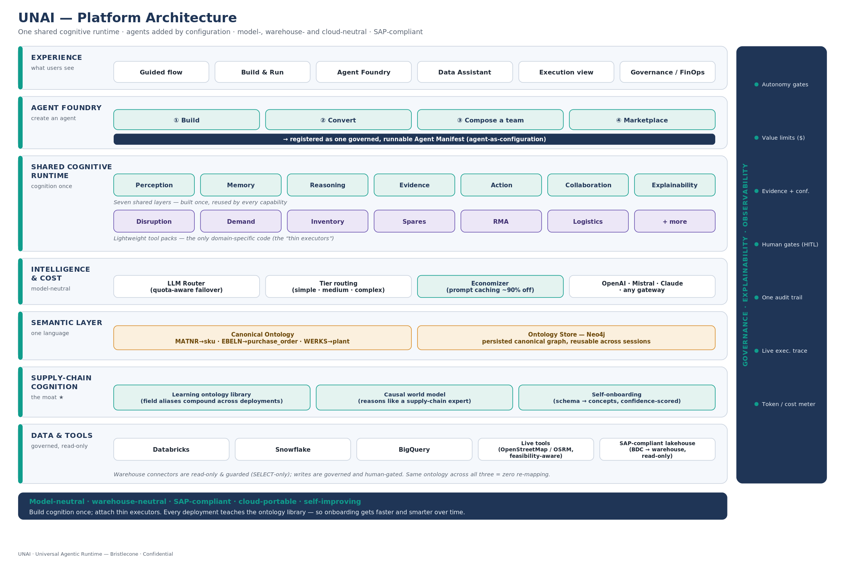
Figure 1 — UNAI platform architecture (current build).

3 · The Shared Cognitive Runtime
A single adaptive runtime implements seven universal layers once and shares them across every capability. At v1 the capabilities run in-sequence in one process and share one in-memory store and one ontology context — that single shared context is exactly what drives the token savings. Layer 6 (Collaboration) is a hand-off / scale-out seam (A2A), not per-capability agent delegation; it only matters when scaling out to multiple runtimes or handing off to humans/other systems.
Layer | Responsibility | Notes
Perception | Reads any system into canonical concepts via the ontology. | One reader; no per-agent re-mapping.
Memory | Short-term working context + retrieval (vector/cache). | One shared store across capabilities.
Reasoning | Decomposes the goal; runs the right technique per step (ML / optimization / LLM / rules). | One plan per goal — paid once.
Evidence | Attaches confidence, attribution, uncertainty, counterfactual. | Feeds governance gates & explainability.
Action | Writes back through one governed action bus. | Read-only first; writes idempotent, human-gated.
Collaboration | Hand-off / scale-out seam (A2A). | Not per-capability delegation.
Explainability | Plain-English rationale for every decision. | One trace, one audit trail.
Domain behavior is added only as tool packs (Disruption, Demand, Inventory, Spares, RMA, Logistics, …) — the thin, domain-specific 10%. Adding a capability is a configuration task, not a new agent.

4 · Agent Foundry — Four Ways to Create an Agent
The Foundry is the self-service surface that puts agents onto the runtime. All four modes produce one governed, runnable Agent Manifest (agent-as-configuration), registered into the engine's use-case registry and persisted in the browser (with server-side registration for execution).
Mode | What it does
① Build | Compose a new agent from capabilities/tool packs; map systems through the ontology; set governance; publish.
② Convert | Import an existing agent (e.g. LangGraph, CrewAI, an assistant, an MCP tool list); re-home it as a thin executor on the shared layers.
③ Compose a team | Stand up several capabilities at once as one multi-capability runtime (N roles → 1 runtime). Shows the consolidation math (N×7 → 7+N layer builds).
④ Marketplace | Install curated, certified agent & capability packs; paste-a-spec import.

5 · Canonical Ontology & Neo4j Ontology Store
The canonical ontology maps each system's native field names to one shared business concept, once (e.g. MATNR → sku, EBELN → purchase_order, WERKS → plant, LIFNR → supplier). The runtime only ever asks for the canonical concept, so moving across SAP / Snowflake / Databricks / BigQuery costs no re-mapping. The ontology can be induced from a connected warehouse (automap) or imported from an ontology a team already maintains.
New in v2.0: the canonical ontology is persisted to a Neo4j graph (AuraDB Free supported) as (:Concept)-[:MAPS_TO {field}]->(:System). The connector (connect_neo4j.py) supports test / publish / fetch; the Knowledge Graph view reads it back so the ontology survives across sessions and is queryable in Cypher. This makes the ontology a durable, shared organizational asset rather than a per-run artifact.

6 · The Supply-Chain Cognition Layer (Differentiation Moat)
This is UNAI's principal, defensible differentiation. Implemented in cognition.js and exposed as the in-app Cognition Layer view plus the /api/cognition, /api/onboard and /api/onboard-confirm endpoints, it turns the canonical ontology from a per-engagement artifact into a compounding asset. It has three parts — each a distinct moat — plus a privacy model.

6.1 · A canonical ontology that learns across deployments (data / network-effect moat)
The ontology library maps each canonical concept to the field-name patterns (aliases) seen for it across ERPs and warehouses — e.g. sku ← MATNR, item_code, material_number, default_code, productId. It ships seeded with 63 canonical concepts and 300+ field aliases across thirteen domains. Every confirmed mapping teaches it: learn() adds the new pattern and the server persists it (cognition_learned.json) so the library compounds across deployments. Each new customer onboards faster and more accurately because of the ones before — a genuine data network effect that horizontal platforms cannot replicate without the supply-chain corpus.

6.2 · A causal world model (domain / expertise moat)
The world model encodes supply-chain cause-and-effect (e.g. supplier risk → lead time ↑ → safety stock ↑; promotion → demand lift and cannibalization; excess → inventory turns ↓) and reusable domain formulas (safety stock, reorder point, spares demand, landed cost). It lets the runtime reason like a supply-chain expert rather than a generic LLM re-told the rules each time, and it maps each concept to the use cases it enables — which drives the 'unlocked use cases' logic in self-onboarding.

6.3 · Confidence-scored self-onboarding (speed moat)
Self-onboarding (autoOnboard) takes any system's schema — pasted columns or a live warehouse introspection — and matches each column to a canonical concept using alias, token and synonym scoring, returning a per-column confidence and method, an overall coverage percentage, the unmatched columns, and the use cases unlocked (≥70% of a use case's required concepts present). Unsure matches are confirmed by a human and fed back to the library. This collapses new-system onboarding from weeks to minutes and is the customer-visible edge of the two moats above.

6.4 · Supply-Chain Use-Case Catalog (SAP IBP-grounded)
The Cognition Layer ships a catalog of 32 supply-chain use cases, grounded in the SAP IBP module set (Demand; Inventory Optimization / MEIO; Demand-Driven Replenishment / DDMRP; MRO; Response & Supply / order-based; Synchronized Planning; Control Tower; Sustainability). Onboarding a system unlocks every use case whose required canonical concepts have been mapped.
IBP module | Use cases
Demand | statistical forecasting, demand sensing, curve based forecast, outlier correction, product lifecycle planning, promotion planning, cannibalization analysis, forecast accuracy monitoring, demand planning
Demand · S&OP | consensus demand sop
Inventory · IO | inventory optimization
Inventory · MEIO | multi echelon inventory
Inventory | safety stock planning, service level prediction, excess and obsolescence
DDR · DDMRP | demand driven replenishment
MRO | mro inventory planning
Supply | supply planning, net requirements planning
Response · order-based | response planning
Response | allocation planning
Production | capacity planning, production planning
Synchronized Planning | synchronized planning
Procurement | procurement sourcing
Logistics | logistics transportation
Supply · Risk | disruption response
Aftermarket | spares planning ibp, returns forecasting
Aftermarket · RMA | rma execution
Control Tower | control tower alerts
Sustainability | sustainability planning

6.5 · Privacy & multi-tenant governance
The library stores ONLY anonymized field-name patterns, canonical concepts and domain rules — never customer data, values or identifiers; cross-deployment learning persists only {concept, field-name} pairs. This is enforced from the outset, not bolted on, so the network effect never leaks tenant data.
Why it widens the gap: against horizontal cognition fabrics (e.g. Cisco Outshift) UNAI is vertical where they are horizontal; against closed planning suites (Kinaxis/o9) it is model- and warehouse-neutral; against platform vendors (Databricks) it owns the semantic + causal layer above the platform. Each new logo makes the next faster and smarter — the compounding they cannot match.

7 · Intelligence & Cost — Router, Tiering & Economizer
All model calls flow through a model-neutral router (llm.js). resolveProviders() builds an ordered provider chain from environment configuration; chatWithFailover() tries each provider in turn and fails over on a 429 (rate/quota), 5xx or timeout. This is the quota-aware gateway: with keys for multiple providers, traffic redirects automatically when one is throttled.
Intelligent model routing tiers each task (simple / medium / complex) and maps the tier to a model, so light work (e.g. NL→SQL) runs on a cheaper model while heavy reasoning uses a larger one. The registry is extensible: built-in providers plus fully custom providers via environment variables, all OpenAI-compatible.
The Claude economizer is a native Anthropic adapter (/v1/messages) that automatically marks the large, reused context envelope (instructions + ontology/RAG context) as a cached prefix. Repeat executor calls over the same envelope pay the deeply-discounted cache-read price (~90% off cached input) instead of re-billing the whole prefix. Usage counters (input/output, cache-read/cache-write) are surfaced so the saving is measured, not modeled. Claude is added without replacing the OpenAI→Mistral defaults; it only joins the chain when configured.

8 · Data Plane & Connectors
Live warehouse connectors are spawned by the server as read-only Python processes. Each supports query (guarded, SELECT-only), schema (introspection) and automap (emits a canonical-ontology mapping for the Knowledge Graph). Writes are governed and human-gated; the default architecture consumes the governed lakehouse copy rather than hammering the ERP directly, keeping it on the SAP-compliant side.
Connector | Auth / mode | Commands
Databricks | SQL warehouse + token | test · introspect · automap · query · schema · run
Snowflake | Key-pair (MFA-safe) or password | test · query · schema · automap
BigQuery | Service account / ADC | test · query · schema · automap
Neo4j (ontology store) | URI + user/password | test · publish · fetch
Live tools | Keyless public APIs | OpenStreetMap (places), OSRM (routing) — feasibility-aware
Feasibility-aware live tools: the drive-time/ETA executor geocodes both endpoints, then classifies the result before quoting — it rejects journeys across disconnected landmasses (country → landmass check) and physically impossible routes (a route shorter than the great-circle distance), returning an honest air-travel estimate instead of a bogus drive time.

9 · Execution, Observability & Governance
The Execution view watches an agent run end-to-end, attributing tokens per step (shared cognition vs. thin executor) and invoking real live tools where wired. Observability instruments three layers — agent autonomy/efficiency, cost-per-outcome, and reliability — with circuit-breakers on loops/max-steps and one unified audit trail. Governance applies autonomy thresholds and value limits: decisions above the confidence/value gate execute autonomously; the rest route to a human approver. A FinOps view models pricing scenarios (new / convert / enhance).

10 · API Surface (server.js)
Endpoint | Purpose
POST /api/login | Cookie-gated app login (session token rotates per start).
GET /api/health | Backend, gateway/router providers, warehouse & Neo4j config status.
POST /api/run | Execute a use case through the engine; optional live-model rationale upgrade.
POST /api/ask | Grounded Q&A (Data Assistant) over supplied UNAI context; returns token/cache meter.
POST /api/query | Data Assistant NL→SQL / templates over a connected warehouse (read-only).
POST /api/databricks · /api/snowflake · /api/bigquery | Warehouse test / introspect / automap / query / schema / run.
POST /api/neo4j | Ontology store test / publish / fetch.
POST /api/router-test | Ping each configured LLM provider (incl. native Anthropic) and report reachability + cache capability.
POST /api/route · /api/places | Feasibility-aware routing / places live tools (OSRM, OpenStreetMap).
POST /api/driver | Guided driver install/check for warehouse & Neo4j Python packages.
POST /api/arch | Password-gated Architecture fragment.

11 · Component & File Map
Component | Role
superagent-app/engine.js | Cognitive-runtime engine: token model, use cases, tool packs, ontology graph, specialist registry, progressive disclosure.
superagent-app/server.js | HTTP server, API endpoints, warehouse/Neo4j process spawns, live tools, auth wall, gateway status.
superagent-app/llm.js | LLM router (resolveProviders, chatWithFailover), Anthropic economizer, tier routing, nlToSql, grounded answers.
superagent-app/index.html | Single-page UI: nav, Foundry, Knowledge Graph, Data Assistant, Execution, FinOps, Governance, Observability.
superagent-app/arch_fragment.html | Password-gated Architecture view (embeds the platform diagram).
supply-chain-workbench/connect_databricks|snowflake|bigquery.py | Read-only warehouse connectors (guarded query/schema/automap).
supply-chain-workbench/connect_neo4j.py | Ontology store connector (test/publish/fetch).
coworkers/test_buddy_suite.js | Verification suite (engine, LLM router, frontend, server) — gates rebuilds.

12 · Token Economics — Measured vs. Modeled
The saving is structural: because it is one process sharing one context, the cognition base (ontology context + a single plan) is paid once per goal instead of each specialist agent re-sending its system prompt and re-loading the schema on every call. This is the same principle as prompt caching (repeated prefixes are waste) — UNAI removes the repetition structurally, and caching removes whatever remains; the two are additive, not double-counted.
Honest limits: it is not a linear 1/N cut; it is workload-dependent (~53–80% across the demonstrator flows). A single-capability goal saves little, and genuinely new data per query still costs full tokens — only the repeated overhead shrinks. In-app percentages are modeled until a gateway is connected; the router reads the provider's own usage counters (input/output, cache-read/write) so the figure can be proven live.

13 · Security & Compliance
Secrets are supplied via environment variables only (never in UI or code); the local env file is gitignored. The app is cookie-gated and the Architecture view is password-gated. Warehouse access is read-only and SELECT-guarded; writes are human-gated and idempotent with a single audit trail. The SAP-compliant pattern reads the governed lakehouse copy (SAP BDC → warehouse) rather than calling restricted ERP APIs directly. Vendor agent policies change quarterly; verify current SAP/vendor terms and indirect-access licensing before production.

14 · Feasibility & Roadmap
Technical feasibility is high — the platform runs today against real Databricks, Snowflake and BigQuery workspaces and a Neo4j store, with a model-neutral router. Recommended rollout: (1) Prove — stand up UNAI read-only on one use case against the customer's lakehouse; induce the ontology; demonstrate measured value. (2) Expand — add 2–3 capabilities as tool packs; enable gated write-back; wire guardrails, observability and the router. (3) Scale — roll across functions on the shared runtime; persist the ontology in Neo4j; self-host or gateway the model in-perimeter. Read-only first; writes gated and human-approved until validated.

15 · What's New in v2.1–2.2
Area | Added since v1.0
IBP use-case catalog | Expanded to 32 SAP IBP-grounded use cases + 63 concepts (300+ aliases); one-click buildable in the Agent Foundry.
Supply-Chain Cognition Layer | Learning ontology library + causal world model + confidence-scored self-onboarding (cognition.js; /api/cognition, /api/onboard). The differentiation moat.
Agent Foundry | Build / Convert / Compose-a-team / Marketplace; agent-as-manifest; runnable & persisted.
Ontology store | Persisted Neo4j canonical graph (publish/fetch); Knowledge Graph round-trip.
LLM router | Quota-aware multi-provider failover; tier-based model routing; extensible registry.
Claude economizer | Native Anthropic adapter with automatic prompt-caching of the shared envelope + token/cache meter.
Warehouse connectors | Live read-only Databricks, Snowflake (key-pair), BigQuery; guarded query/schema/automap.
Live tools | Feasibility-aware routing/places (OSRM, OpenStreetMap).
Surfaces | Execution view, FinOps pricing, Governance router panel, redesigned purpose/role navigation.
Proprietary & Confidential — Bristlecone. This specification and the architecture it embodies are the exclusive property of the copyright holders.

