1. 404 page not found while posting ads
2. After a post, returning 500 server error

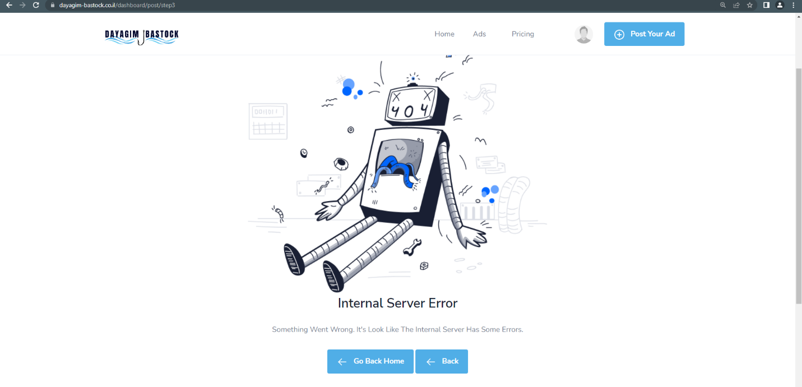

1. It doesn’t take single image, should be at least 2
2. Asking for a location when default is set already.

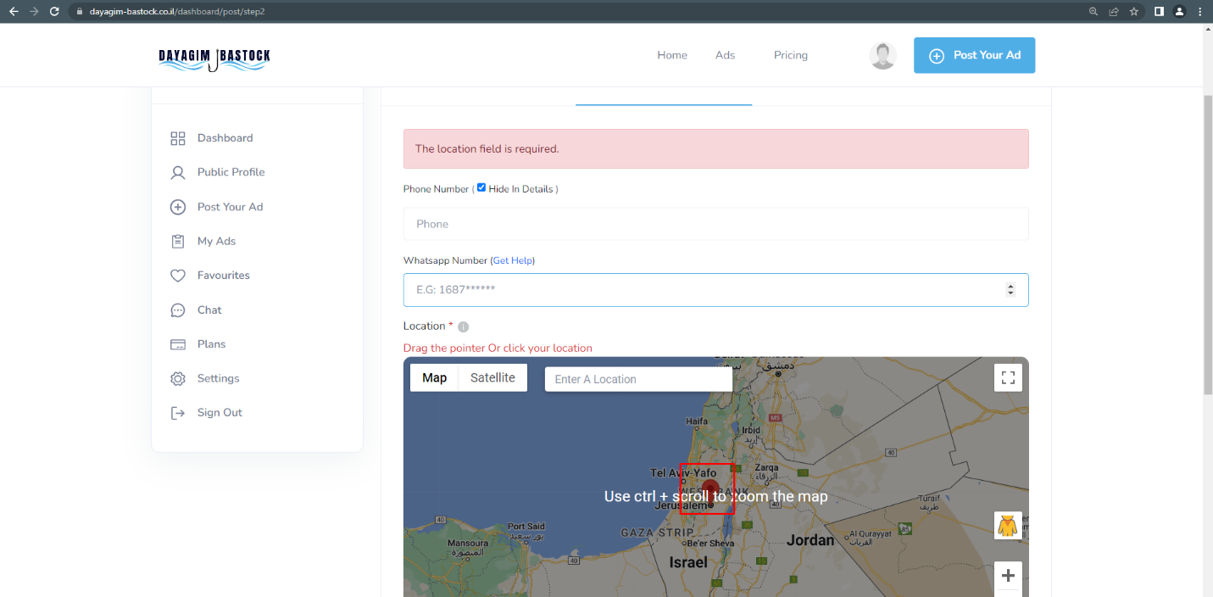

1. Without selecting a brand name you can proceed , but at last returns a server error.
2. Map missing for ad edit.

