Symmetric and Asymmetric Cryptography: AES and RSA Encryption Techniques

1.Introduction
Demonstrate the use of AES (symmetric) and RSA (asymmetric) encryption to secure a text file. Compare how symmetric and asymmetric cryptography differ in key usage and application. Environment: Kali Linux VM (Oracle VirtualBox), Tools: OpenSSL (AES & RSA), Becrypt.

2.Sample File Creation
- Create a simple text file containing sensitive information:
echo "Confidential: Project data for internal use only" > secret.txt
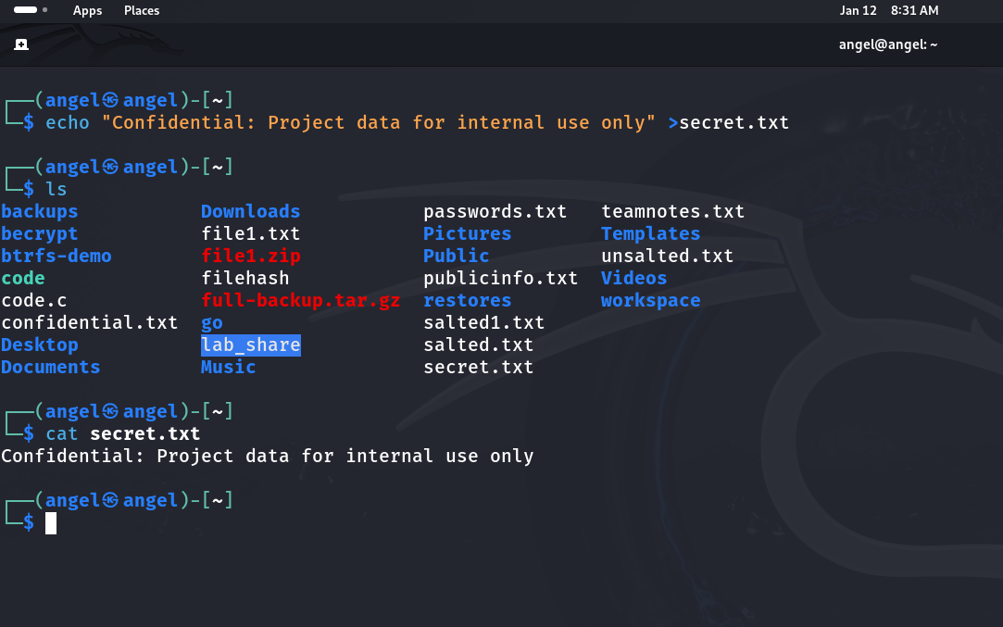

3.AES Encryption and Decryption (Symmetric)

AES Encryption
- Encrypt the file using AES with a shared key:
openssl enc -aes-256-cbc -in secret.txt -out secret.enc -k mypassword
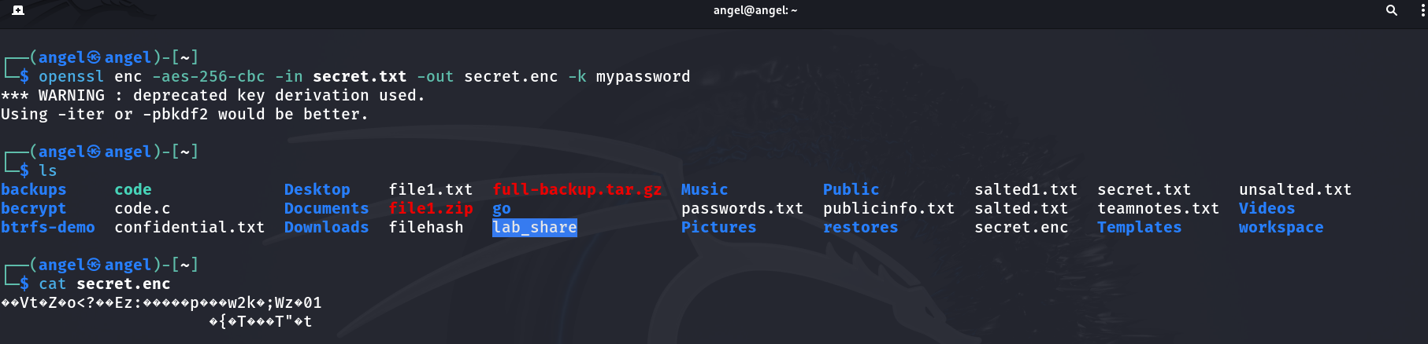

AES Decryption
- Decrypt the file using the same key:
openssl enc -d -aes-256-cbc -in secret.enc -out secret_decrypted.txt -k mypassword
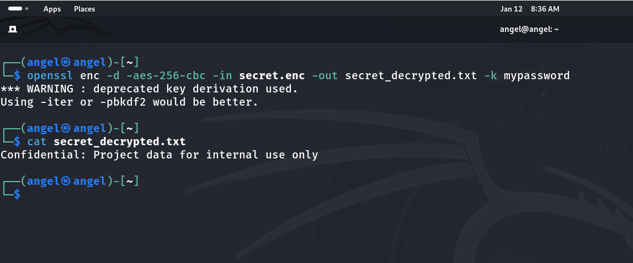

4.RSA Encryption and Decryption (Asymmetric)

RSA Key Pair Generation
- Generate a 2048-bit RSA key pair:
openssl genrsa -out private.pem 2048
openssl rsa -in private.pem -pubout -out public.pem
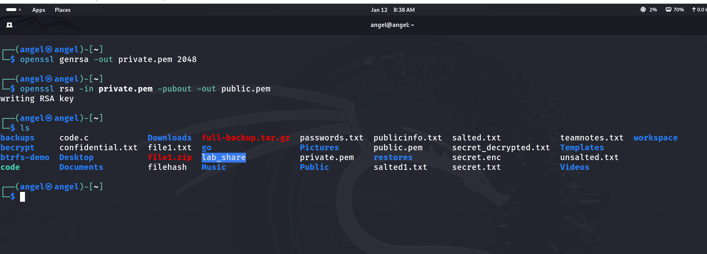

RSA Encryption
- Encrypt the file using the public key:
openssl rsautl -encrypt -inkey public.pem -pubin -in secret.txt -out secret.rsa.enc
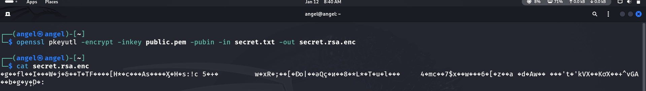

RSA Decryption
- Decrypt the file using the private key:
openssl rsautl -decrypt -inkey private.pem -in secret.rsa.enc -out secret_rsa_decrypted.txt
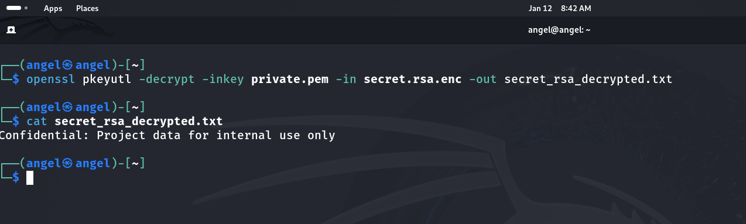

5.Key Usage Comparison
Method | Key Type | Encryption | Decryption | Use Case
AES (Symmetric) | Same secret key | Encrypts with shared key | Decrypts with same key | Fast, secure storage, bulk data
RSA (Asymmetric) | Public & private key pair | Encrypts with public key | Decrypts with private key | Secure key exchange, digital signatures

6.Conclusion
- AES (Symmetric): Efficient for encrypting large files; requires secure key sharing.
- RSA (Asymmetric): Ideal for secure communication and key exchange; slower but eliminates key distribution issues.
- Key Insight: AES and RSA complement each other—RSA often secures the AES key, while AES handles bulk data encryption.

