Implementing Secure Data Exchange Using Cryptographic Techniques

Title
“Implementing Secure Data Exchange Using Cryptographic Techniques”

Problem Statement
Organizations increasingly exchange sensitive data across networks and cloud environments, often over public or untrusted channels. Without proper encryption and authentication mechanisms, data in transit is highly vulnerable to interception, manipulation, and unauthorized access. These risks are particularly critical in sectors such as finance, healthcare, and government, where data breaches can result in severe legal, financial, and reputational consequences.
Many organizations lack a structured approach to implementing cryptographic controls, including key management, certificate handling, and secure communication protocols. This project aims to address these challenges by designing and implementing a secure data exchange system using robust cryptographic techniques to ensure confidentiality, integrity, and authenticity of data.

Objectives
- Implement symmetric and asymmetric cryptographic algorithms to secure data during transmission.
- Use digital signatures and digital certificates to ensure data integrity, authentication, and non-repudiation.
- Design and deploy a Public Key Infrastructure (PKI) for effective management of cryptographic keys and certificates.
- Apply Secure Sockets Layer / Transport Layer Security (SSL/TLS) protocols for secure data exchange over the internet.
- Implement and validate cryptographic mechanisms using tools such as OpenSSL.

Expected Outcomes
- A secure data exchange solution utilizing symmetric and asymmetric encryption, digital signatures, and PKI.
- Practical implementation of SSL/TLS protocols to protect data confidentiality and integrity during transmission.
- Hands-on experience in applying cryptographic techniques to real-world data exchange scenarios.
- Improved understanding of key management, certificate lifecycle management, and secure communication standards.

Deliverables

Cryptographic Techniques Implementation
- Symmetric Encryption (AES):
- AES-256 used for bulk data encryption. Key generation using OpenSSL.
- Generate a random AES-256 key
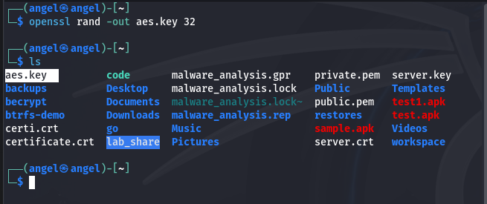
- Encrypt a file (sample.txt content: Hi this is a plaintext file!!) using AES-256
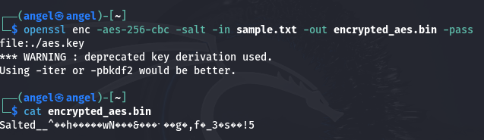

- Decrypt the file
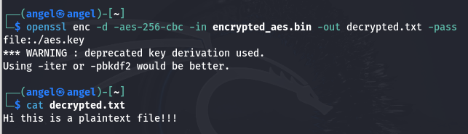
- Asymmetric Encryption (RSA):
- RSA-2048 used for secure key exchange.
- Generate RSA private key (2048-bit)
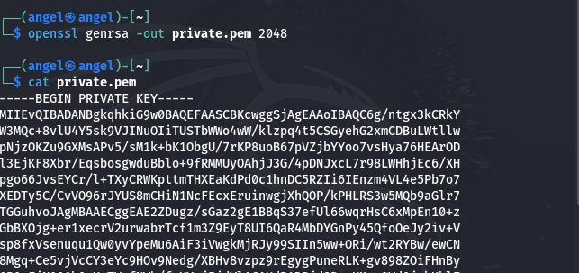
- Extract public key
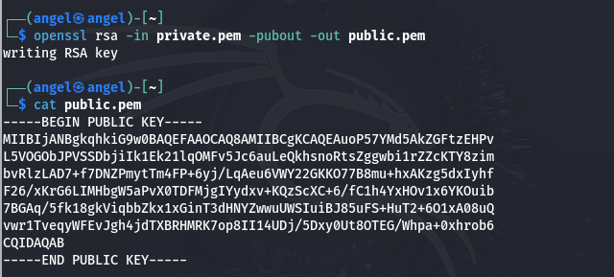
- Encrypt AES key with RSA public key
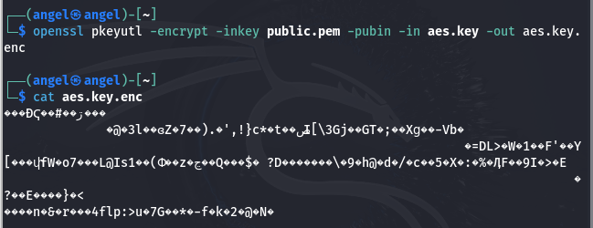
- Decrypt AES key with RSA private key
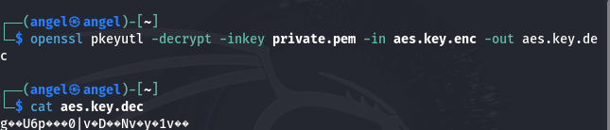
- Digital Signatures:
- SHA-256 hashing combined with RSA private key signing.
- Create SHA-256 hash of file
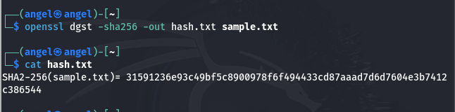
- Sign hash with RSA private key
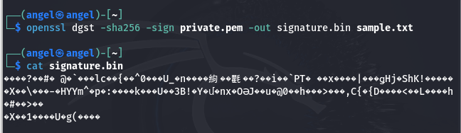
- Verification using RSA public key.
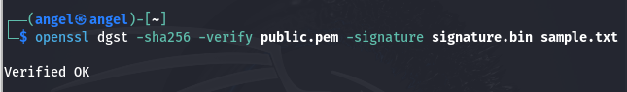
PKI Setup and Configuration
- Certificate Authority (CA):
- Setup of root CA using OpenSSL.
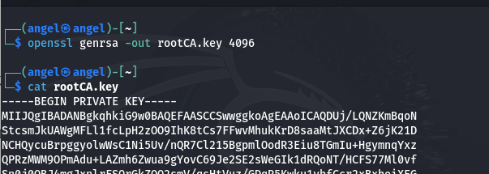
- Issuance of server and client certificates.
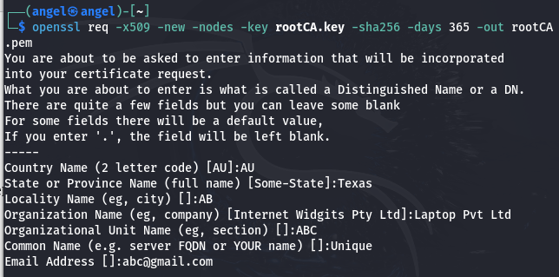
- Certificate Lifecycle Management:
- Certificate issuance, validation, and revocation.
- Create Server private Key
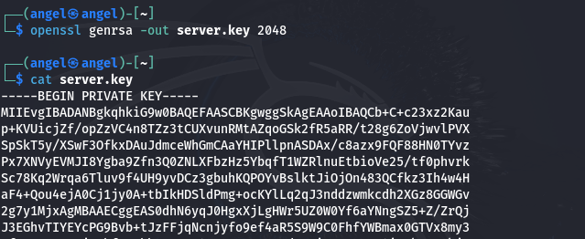
- Generate server CSR
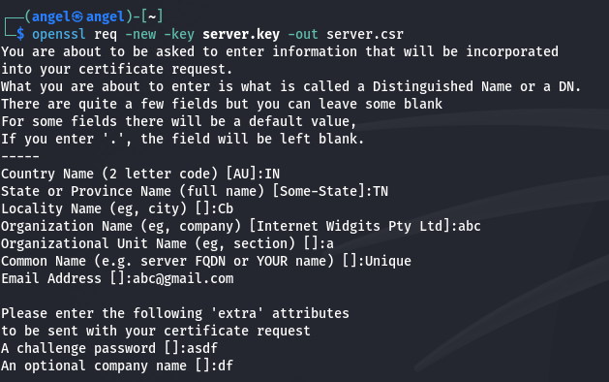

- Sign CSR with Root CA
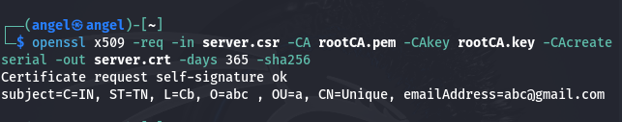

SSL/TLS Implementation Guide
- Server Configuration:
- Enabling HTTPS using Apache/Nginx with SSL/TLS.
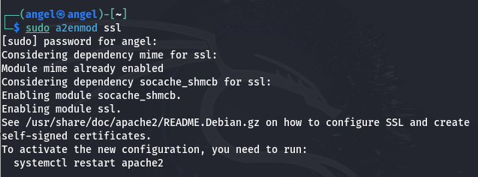
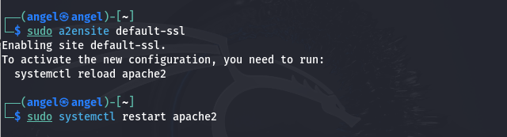
- Installing server certificate and private key.
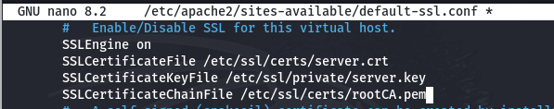
- Restart and verify
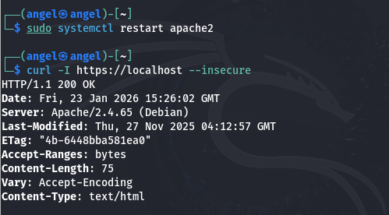
- Client Communication:
- Secure handshake demonstration.
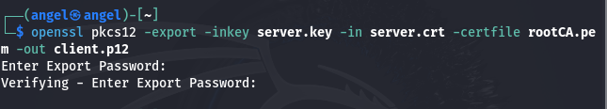
- Mutual authentication using client certificates.
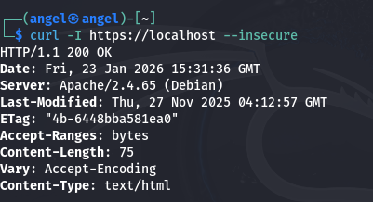
- Best Practices:
- Use TLS 1.3.
- Disable weak ciphers.
- Regular certificate rotation.

Security Testing
- Testing Tools:
- Wireshark for packet inspection.
- OpenSSL for protocol validation.
- Findings:
- Data encrypted with AES not readable in transit.
- SSL handshake verified with mutual authentication.
- Certificates validated successfully.
- Potential Vulnerabilities:
- Weak key storage practices.
- Outdated SSL versions (SSLv2/SSLv3).
- Mitigation Strategies:
- Enforce TLS 1.3.
- Use Hardware Security Modules (HSMs) for key storage.
- Regular vulnerability scans.
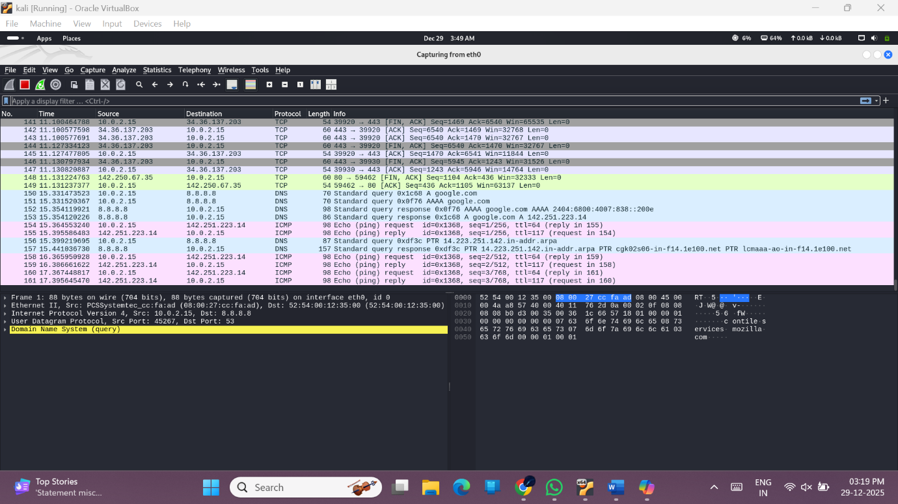

Demonstration of Secure Data Exchange
- Scenario:
- Secure communication between Client A and Server B.
- Data encrypted using AES, keys exchanged via RSA.
- Authentication via PKI certificates.
- SSL/TLS ensures secure channel.
- Steps:
  - AES key encrypted with RSA public key of server.
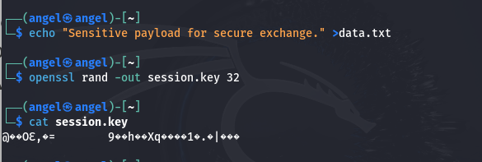
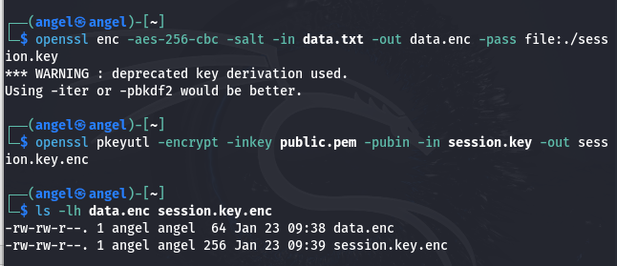
  - Server decrypts AES key with RSA private key.
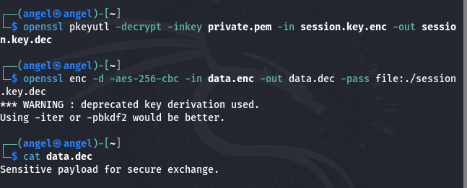
  - Secure channel established with SSL/TLS.
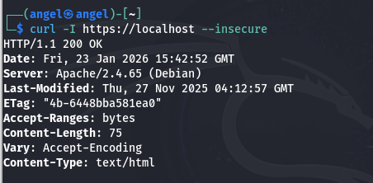
  - Digital signature ensures authenticity.
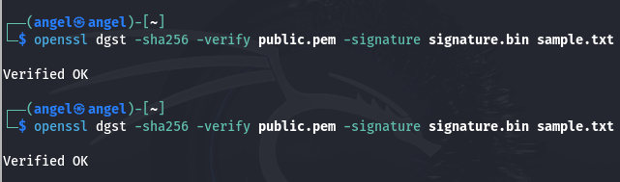

Conclusion
This project successfully demonstrates the implementation of secure data exchange using cryptographic techniques. By combining symmetric and asymmetric encryption, digital signatures, PKI, and SSL/TLS protocols, the solution ensures confidentiality, integrity, and authenticity of sensitive data. The hands-on implementation provides practical insights into cryptographic mechanisms and strengthens understanding of secure communication standards.

