Inspector: Lenin Basantes Team of “The Noders”

Members: Lenin Basantes, Edison Baez, Alan Bermudez, Madely Bentancourt.

# 4. URIs design 8/10 (Required attributes and written in Spanish)

Attributes innacesary

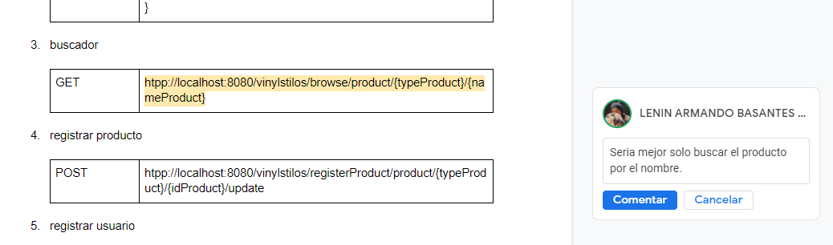

The project’s name not found in the URI

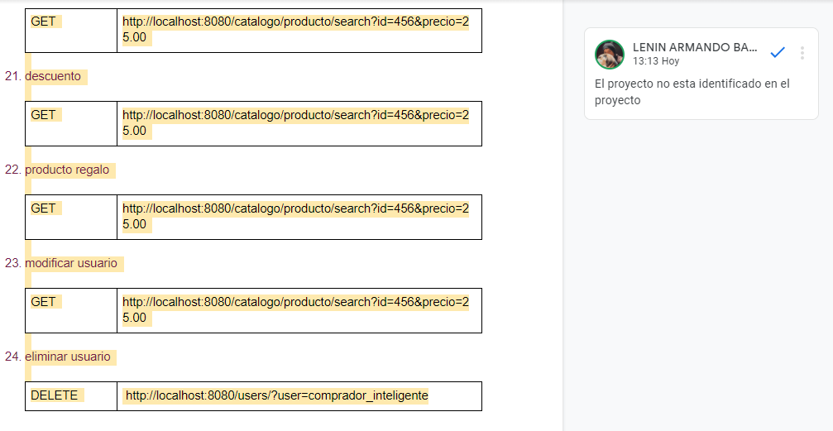

Use mixed spanish and english in the identifiers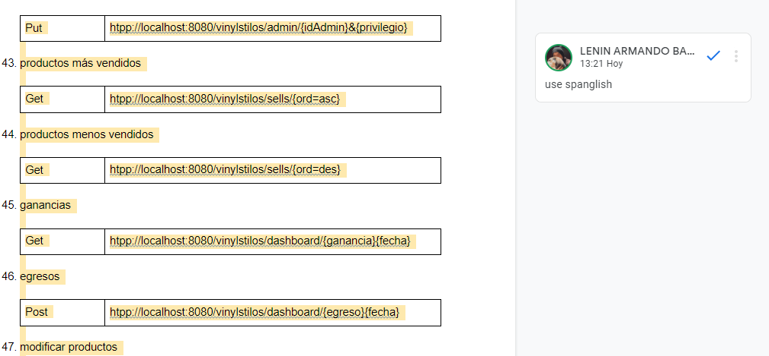

# 5. DB(SLQ/NoSQL) 7/10 (The description script is missing and the password is not encrypted)

# 6. REST services 17/20 (does not use all the uri’s that was proposed)

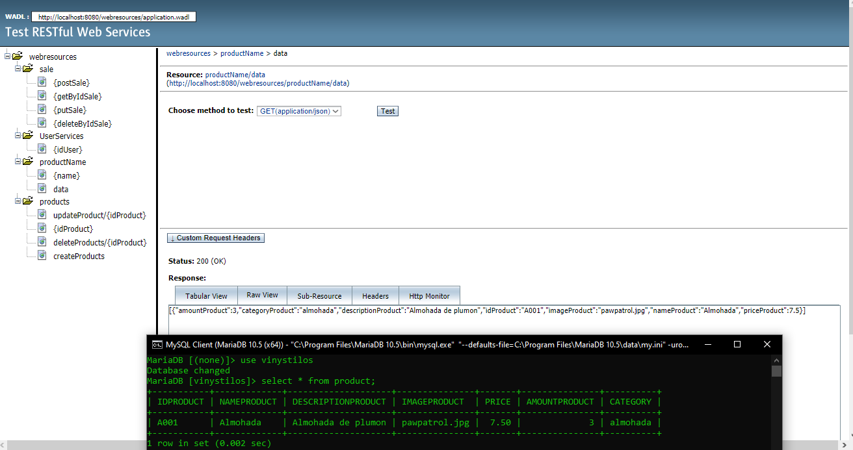

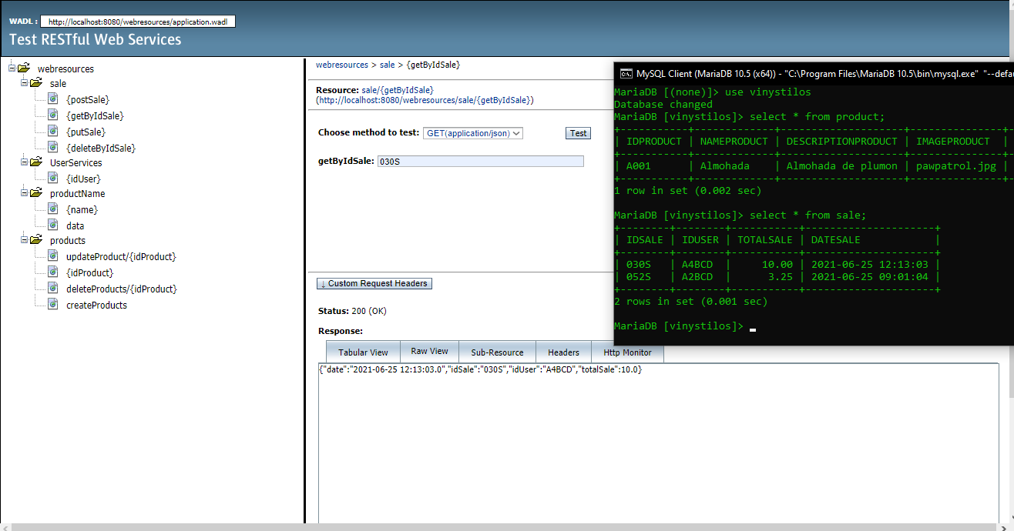

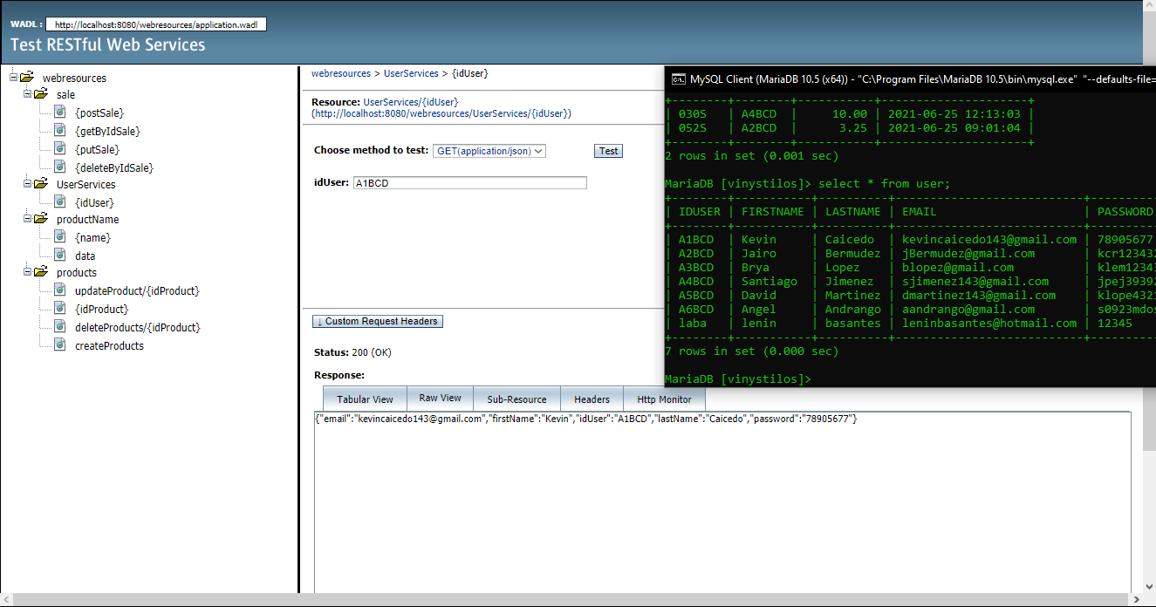

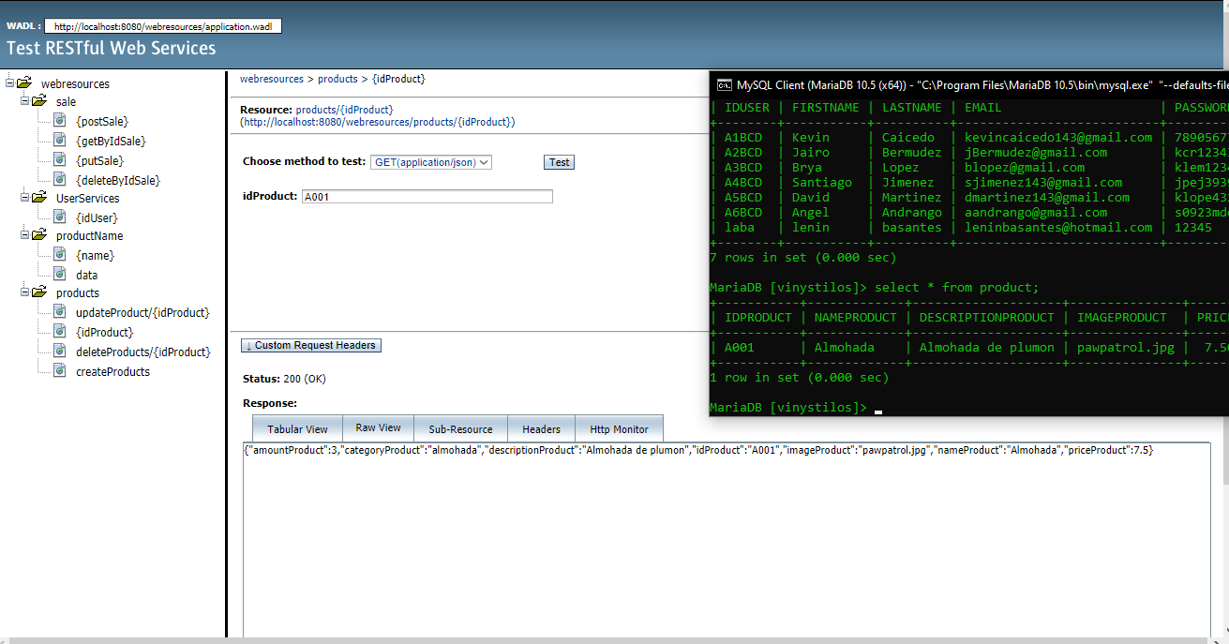

# 7. Web Client 8 /10

