Report

Weka with some examples

Using the weather set as an example and with the default values we get:

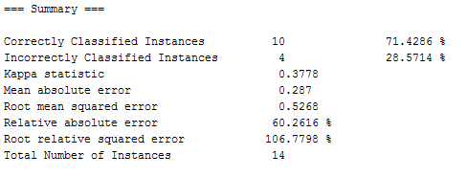

Modifying the learning rate from 0.3 to 0.1:

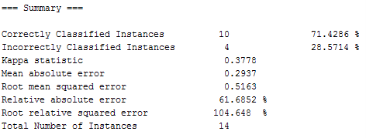

We don’t see much difference here, but as the learning rate is being modified, the RMSE increases too. Here’s a screenshot of the same dataset with the learning rate at .99

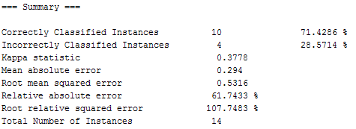

These variations were caused by modifying one single variable, in this case the learning rate. It does seem that the optimal training value is 0.3. With less value, it’s having a bit more error and so with large values. It is worth mention that the training time is difficult in ANN. With a single neuron, the training time is not that great, but with big ANN with many layers and many hidden nodes, this time will increase with every input and expected output. Getting the weights of the connections right can insert a certain overhead that might not be optimal for small solutions. This is due to the level of specifications required for real-life problems. They need enough information to model and generalize a useful network. Also, with big ANN, time and space is an issue to always keep in mind. The need to process huge amounts of data, for example millions of databases, makes large ANN slow when the hardware capabilities are not build to support this kind of queries.