Background

Every year in the United States, thousands of people overdose on prescription narcotics, drugs that, while originally envisaged to help reduce pain, are instead causing death, leaving broken families and a hollowed out American heartland in their wake. Over the years, this crisis has only increased in severity. Between the years 2005 to 2012, over 100,00 people died from an overdose on prescription opioids. Politicians on both sides of the political aisle have recognized this catastrophe; however, the course of action required to curb this disaster is far from obvious. Over the past decade, many states have passed laws intended to counter this crisis. The efficacy of these laws, however, has not been conclusively determined. The purpose of this research project is to investigate the prescription opioid changes in three separate states to determine if those law changes resulted in a subsequent decline in opioid deaths. The three states are Florida, which changed their opioid prescription laws in 2010; Washington state, which changed their opioid laws in 2012; and Texas, which reformed their opioid laws in 2007. Each state will undergo a pre-post analysis comparing their opioid deaths before and after the law changes. In addition, each state will undergo a difference-in-difference analysis, with each test state’s opioid death trends compared to a collection of three control states chosen based on geographical proximity. The trends of the test states will be compared to the average trends of the three control states. For Florida, the test states are Georgia, Alabama, and North Carolina. For Texas, the control states are Arizona, New Mexico, and California. For Washington, the three control states are Oregon, Idaho, and Montana. Additionally, Florida and its control states will also undergo a pre-post and difference-in-difference analysis using morphine equivalents as a response variable. This should provide an indication as to whether the opioid laws are also effective at reducing opioid shipments to states, which could further help curb the opioid epidemic.

Data

For each state, the population of each county in that state was collected from the IPUMS database for the years 2003 to 2015, with the exception of 2008. Population data for the 12 states examined from 2008 was instead obtained from the Washington Post and added directly to the population .csv file. The Washington Post also provided data on the number of opioid deaths per county for all US states, and data on the number of opioid shipments for the southeastern US states used in this analysis. A small dataframe consisting of the 12 states, state initials, and a column containing information on either control status or year opioid laws were changed, was constructed by hand.

The data was further cleaned by removing extraneous county labels, such as ‘County’ or ‘Borough’.

To construct the final dataframe used in the analysis, the population data was outer joined onto the control dataframe. Next, this intermediate dataframe was outer joined to the death data obtained from the Washington Post. The opioid shipment data, measured in morphine equivalents as determined by the DEA, were obtained in four separate dataframes, one data frame for each state in the morphine equivalent analysis (Florida, Georgia, Alabama, and North Carolina).

These four dataframes were outer joined together, and then outer joined onto the other intermediate dataframe. Finally, the 12 states were filtered out of the intermediate data frame into a separate data frame, which was then used for this analysis.

Exploratory Data Analysis

Deaths Per Capita

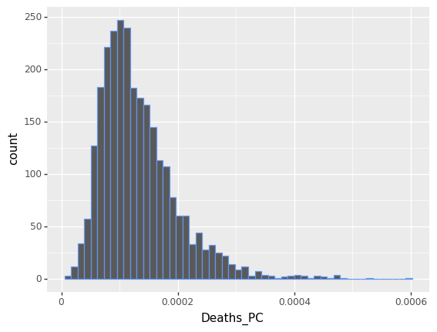

In order to determine if the Deaths per capita according to counties were sufficiently gaussian for the analysis, the deaths per capita which were not zero were graphed into a histogram. Though the graph is left skewed with a long tail, this was deemed acceptable for the current analysis.

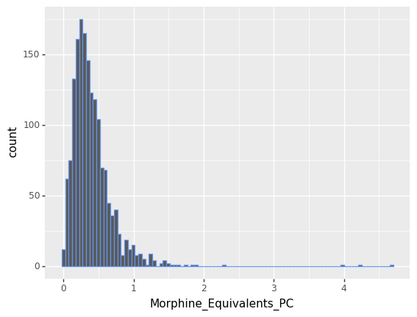

The same procedure was applied to the morphine equivalents per capita. Though there is a very long tail (including points which are not in the graph) the non-zero values of morphine equivalents per capita were sufficiently gaussian to use in this analysis.

Analysis

Texas- Law Change 2007

Pre-Post for Texas

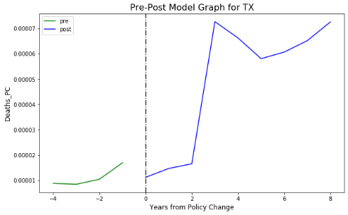 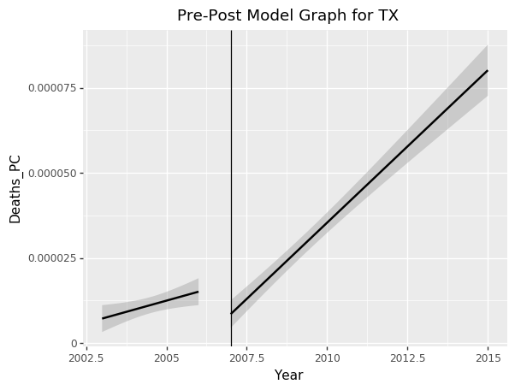

Out of the three states examined in this study, Texas was the first to enact laws to counter the opioid epidemic. From the pre-post graphs for Texas, there is an obvious trend towards increasing deaths from opioids, including numerous spikes in deaths over the years. After the laws came into effect, the overdose death trend continues upward. This indicates that the laws do not appear to have an effect on the opioid deaths per capita in Texas.

.

Difference-In-Difference For Texas

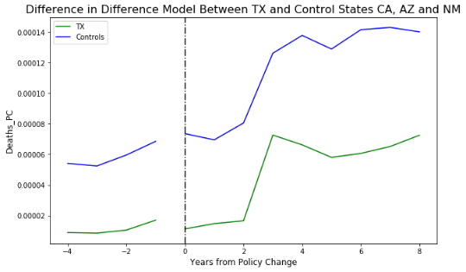 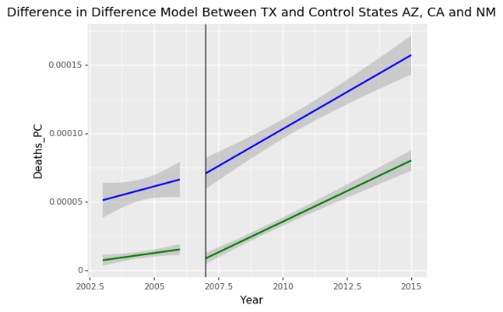

According to the difference in difference graph for Texas vs the control states, there was no obvious change in trends between Texas and the control states. Both before and after the opioid law changes, there was no difference in the trends of opioid deaths per capita. Additionally, Texas’ trends are very similar to the control states trends. This indicates that the opioid law changes made in Texas were ineffective at curbing the opioid epidemic.

Linear Regression for Texas

From the linear regression, the coefficient indicates that the trend is, on the whole, negative. The absolute t value of 5.508 indicates that this result is significant, so the opioid laws do have a statistically significant effect on opioid deaths per capita. However, though statistically significant, the effect is very small, as seen in the graphs above, indicating on the whole that the policy was most likely not effective at curbing the opioid epidemic in Texas.

Florida- Law Change 2010

Pre-Post for Florida

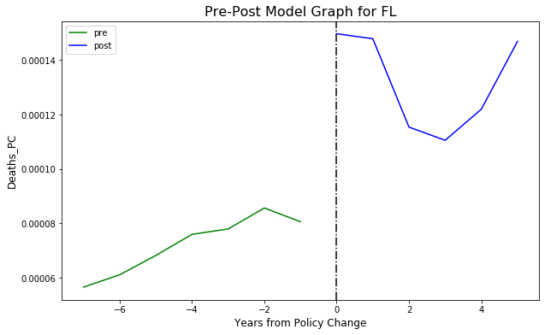 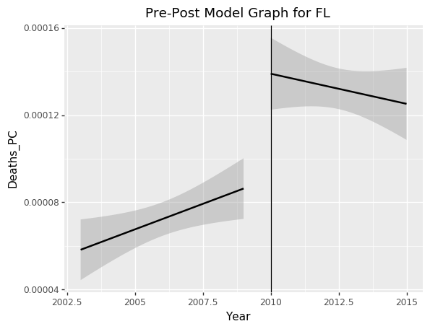

From the pre-post analysis of Florida by opioid overdose deaths, the trend after the introduction of the laws appears to indicate that the laws had a positive effect on overdose deaths. However, when the graph showing the absolute number of deaths per capita is examined, in the first several years there does appear to be a reduction in opioid overdose deaths. However, after a few years this is followed by a sharp upsurge in opioid deaths. While according to the trend the law changes were effective in the short term at reducing the trend of opioid deaths, there appear to be other indications that the laws may not have a positive effect in the long term.

Diff in Diff for Florida

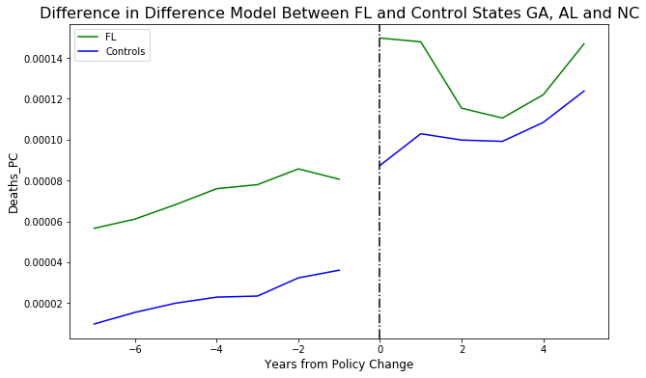 

According to the difference in difference graph for Florida vs the control states, both Florida and the control states had clear rising trends of opioid deaths per capita before the opioid laws took effect. After the laws, Florida saw a sharp decrease in the trend of opioid deaths per capita. In contrast, the control states continue their upward trend of opioid deaths. However, as in the pre-post analysis, despite the overall downward trend of opioid deaths per capita, there are indications in the later years that the opioid deaths in Florida may again be increasing. This may indicate that the Florida opioid laws were effective in the first few years of their introduction, but drastically decreased in effectiveness sometime around three to four years after their introduction. The control states follow a similar opioid overdose death trends before and after Florida’s opioid law changes, indicating these are effective controls for Florida.

Linear Regression for Florida

Florida Morphine Equivalent Analysis- Law change 2010

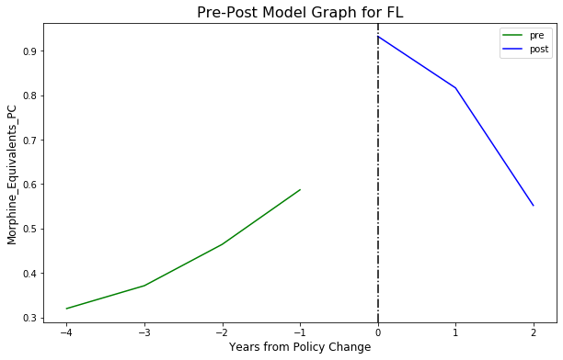 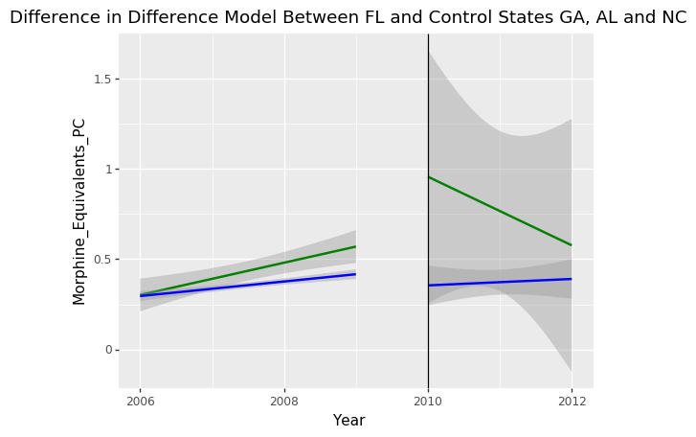

Pre post for Florida Morphine Equivalents

Before the opioid laws took effect, the trend for Florida morphine equivalents was increasing. After the morphine laws took effect, the trend for the morphine equivalents per capita shipped to the state were drastically reduced, indicating that the opioid laws had a positive effect at reducing the shipments of opioids to the state.

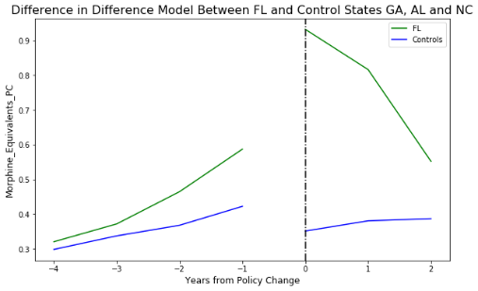 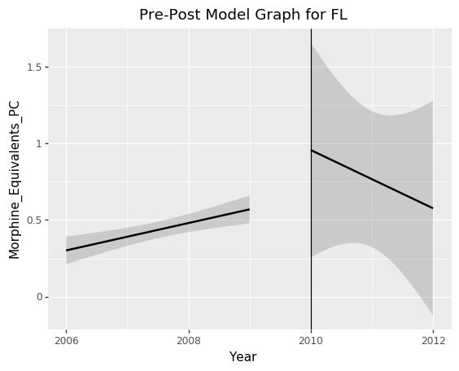

Diff in Diff for Florida Morphine Equivalents

This trend is also shown in a difference in difference plot comparing Florida’s opioid shipments to opioid shipments for Florida’s control states Georgia, Alabama, and North Carolina. Before the opioid law changes, Florida and the control states showed an increasing trend of opioid shipments to their states. After the opioid law change in Florida, however, the trend of Florida’s shipments drastically declined, while the control states’ shipments continued their gradual upward trend. This indicates that Florida’s opioid laws were effective for reducing the amount of morphine equivalents shipped to the state as compared to control states which did not have similar opioid laws passed.

Pre-Post for Washington

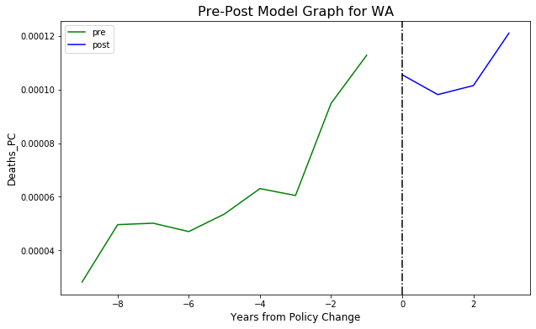 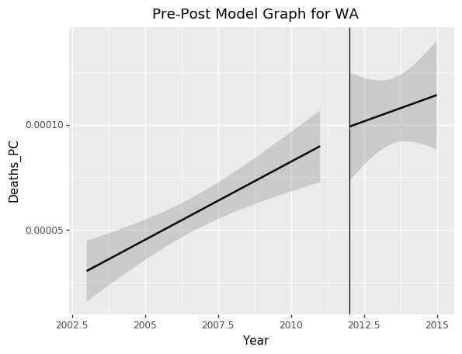

Before the opioid laws were passed in Washington, the general trend in opioid deaths per capita was increasing, with a single reduction spike two years before the law change. Just after the law, the trend of opioid deaths per capita decreased for several years. However, at the end of the time frame examined, the opioid deaths per capita trend appears to increase again, indicating the long term effects of these laws may not be positive at reducing opioid deaths. Overall, the actual trend in opioid deaths per capita in Washington was largely unchanged before and after the opioid laws took effect.

Diff in Diff for Washington

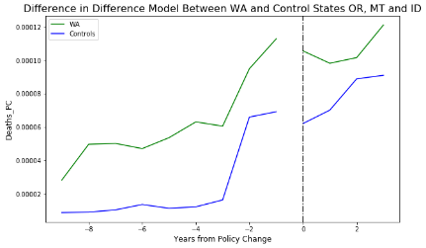 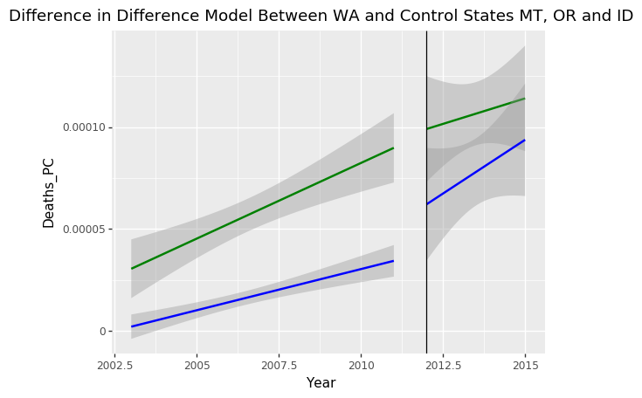

Before Washington introduced their opioid laws, the trends of the average of the control states was generally upward, with a sharp decreasing spike four years before the laws were introduced. Overall, the trend in opioid deaths per capita for both the control states and Washington was increasing toward more opioid deaths per capita. The control’s slight upward trend continued after the Washington opioid laws were passed, and even as Washington’s opioid death’s increased several years after introducing the opioid laws, the controls and Washington continued to have similar trends in opioid deaths per capita. This appears to indicate that Washington’s opioid laws were ineffective at curbing opioid deaths per capita, especially as compared to control states with similar geographic locations and population sizes.

Conclusion

From these results, it appears that the effectiveness of the opioid laws varies by state and which laws were enacted. Texas and Washington’s opioid laws do not appear to be effective at reducing deaths per capita from opioid overdoses, while Florida, after some initial success, may have some indications that the initial positive trends may be instead returning towards a trend similar to Florida’s control states which did not have an opioid law change.

For the morphine equivalents per capita, the opioid law in Florida had a positive effect at reducing morphine equivalents per capita as compared to control state trends. However, the data stops just before the rebound in opioid deaths observed in Florida- additional data on morphine equivalents sold in Florida in the years covering this time period could help to show whether the rebound in opioid deaths was due to black market activity or legal drug sales. Knowing this can inform policymakers about how best to target laws to reduce the opioid epidemic.

Overall, policymakers should look to Florida to inform their opioid policies. This state saw a reduction in opioid deaths for several years after introducing their opioid laws. However, further investigation should be carried out into later years in Florida to see if this downward trend continues, or if there is a rebound in opioid deaths per capita.

Future Research

Additional analysis should be performed on Florida’s opioid laws to determine why their opioid law changes were effective at reducing opioid overdose deaths per capita. Additional analysis should also be performed to examine why Washington and Texas did not see a decrease in opioid deaths per capita following introduction of their opioid laws, including a further analysis of morphine equivalent shipments. An analysis of these two states can inform why their opioid laws failed in the long term and, combined with an analysis of Florida’s laws, help inform policymakers looking to legislate long term solutions to the opioid epidemic.