2018/05/22
Angela Chen
Proposal of Research

E-textile Shirt for Poor Posture Detection

1 Background and Purpose

Poor posture can be defined as misalignment of body parts such that undue stress is placed on the muscles and ligaments of the body [1]. It has long been linked to a number of health problems, from increased tenseness in muscles to a larger risk of sustaining injuries [2]. In general, individuals are encouraged to self-regulate their posture and to make their working environment more ergonomic to encourage better posture. While the latter of these two suggestions is a one-time fix, the former requires constant vigilance on the part of the subject, which can be difficult to remember. As the ultimate goal is to ingrain a new habit in the mind of the user, the device used must be portable, comfortable and unobtrusive. I propose that e-textiles, known for the aforementioned properties [3], can be applied to this problem.

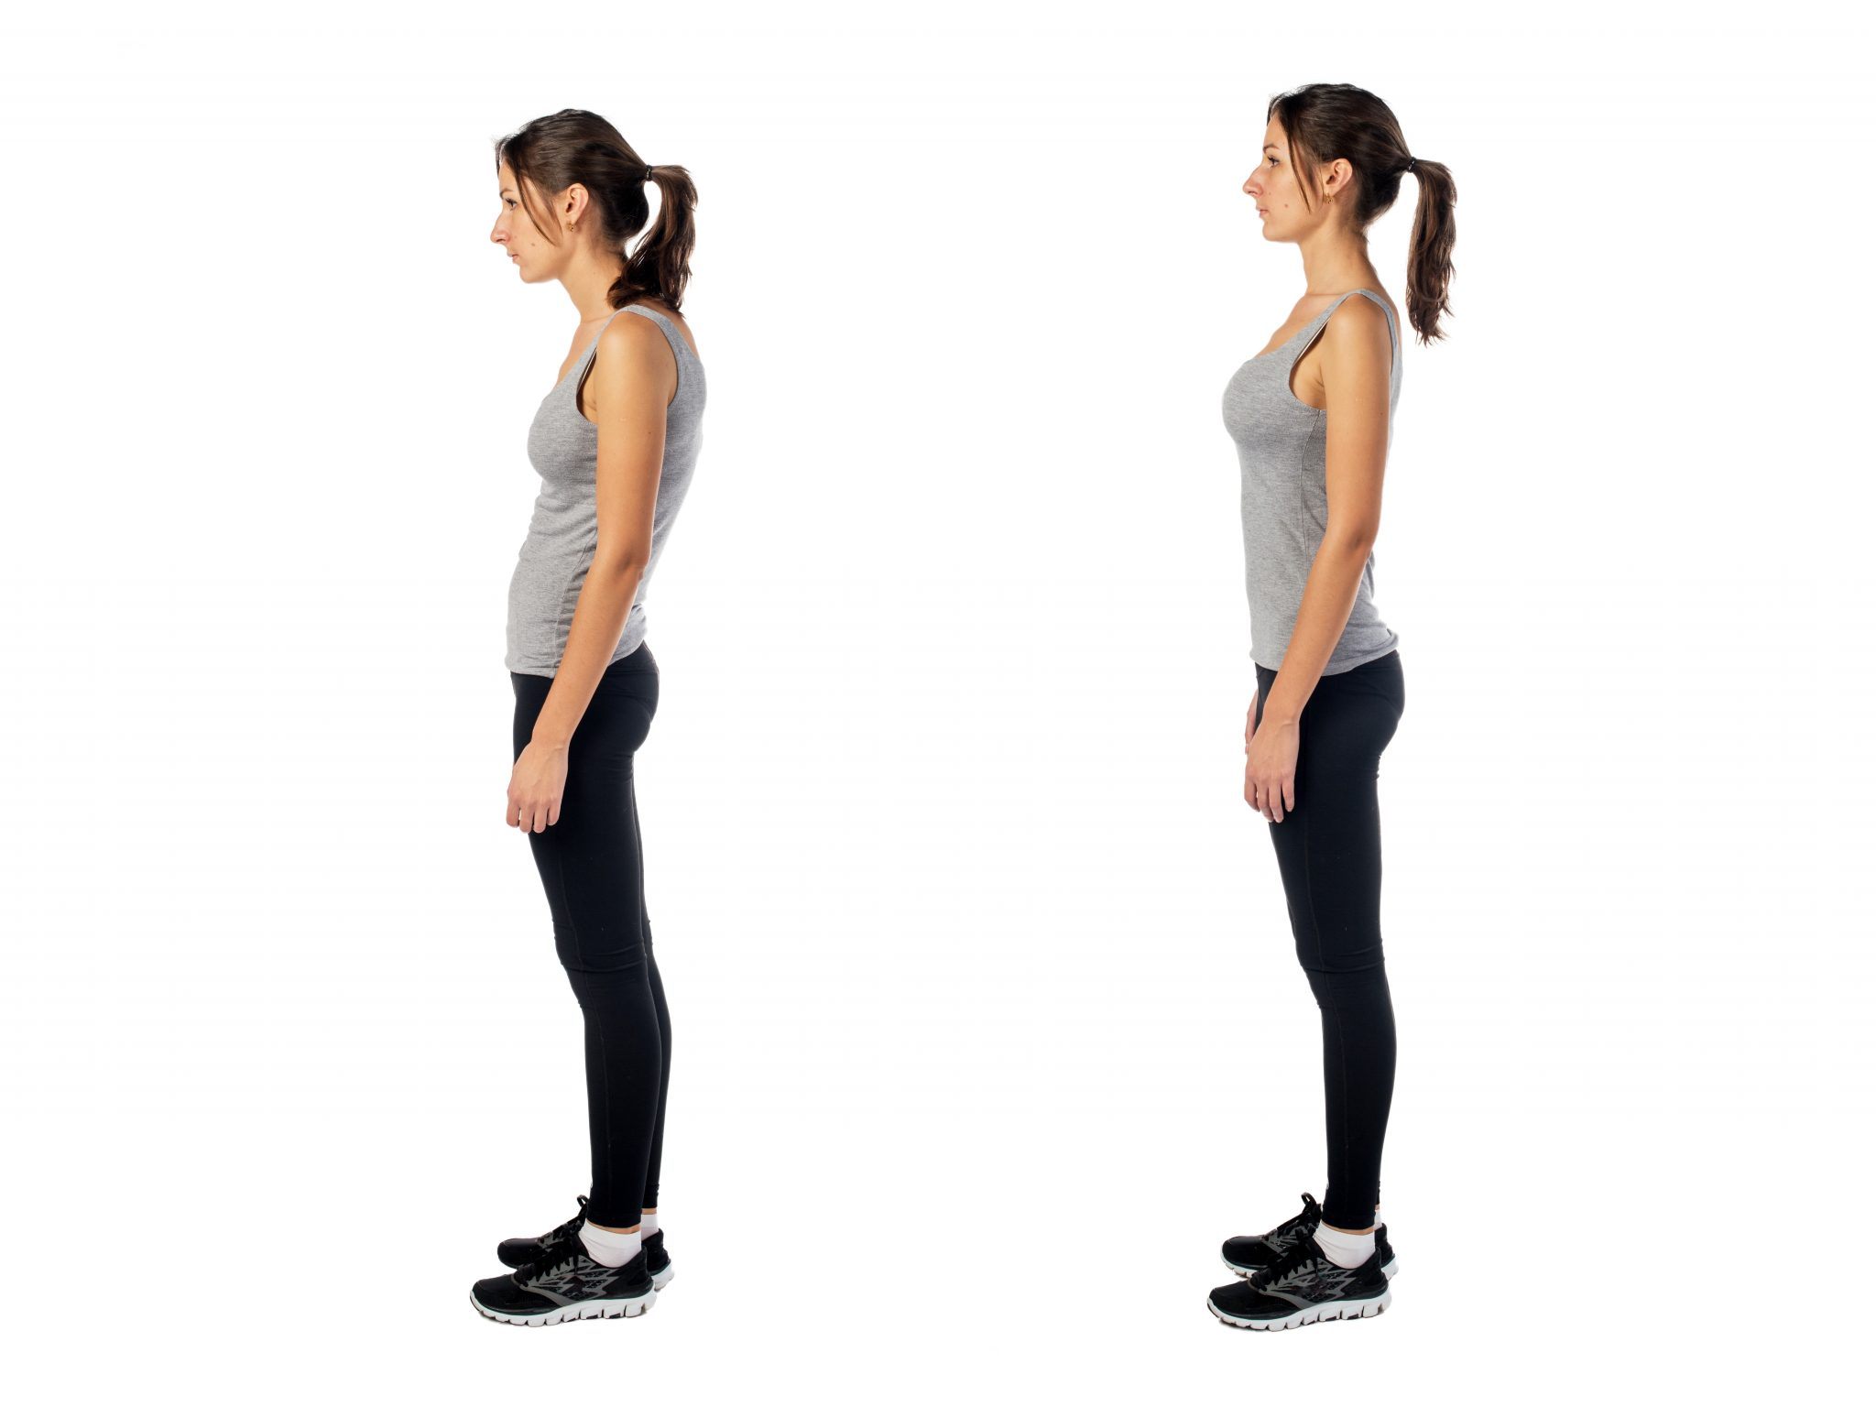

Figure 1: Poor standing posture (left) vs good standing posture (right).

2 Textile Resistors

Stitched sensors can be used to detect bending of fabric substrates [4]. This can be accomplished by using uninsulated, conductive thread stitched in a pattern that will overlap when the fabric is relaxed, and separate when the fabric is stretched.
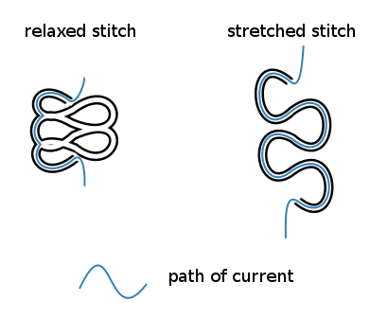

Figure 2: Resistance of conductive thread when it is relaxed (left) and stretched (right).
When the uninsulated thread overlaps, the effective length of the resistor reduces, and its resistance decreases (see Figure 2). This changed resistance can be measured by the micro-controller.

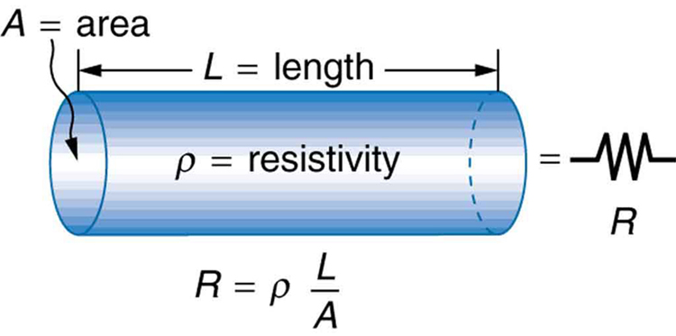

Figure 3: Cylindrical resistor formula.

3 System Outline

By stitching uninsulated conductive thread into a fitted shirt, it is possible to detect user’s poor posture and provide haptic or visual cues if the position is maintained for an extended period of time.
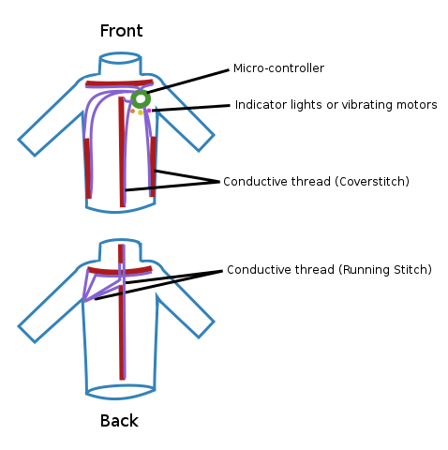

Figure 4: Stitched resistor layout on shirt

4 Future Tasks

- Determining location of stitched resistors
  - Mostly on torso (arms are mobile)
  - Together, they should cover all ranges of bad posture (anterior-posterior slouching, and right-left asymmetry)
- Ensuring that the stitched sensors are sensitive enough to detect poor posture
  - Measure difference in fabric length between good posture and bad posture
  - Consider different stitches or longer resistors for better sensitivity
- Price and equipment searching

References

[1] Watson, A W S; C Mac Donncha. A reliable technique for the assessment of posture: Assessment criteria for aspects of posture. Journal of Sports Medicine and Physical Fitness.
Available: https://search.proquest.com/docview/202676332?pq-origsite=gscholar
[2] Correcting working postures in industry: A practical method for analysis.
[3] Wearable Electronics and Photonics.
[4] Gioberto, G., Coughlin, J., et al. (2013). Detecting Bends and Fabric Folds using Stitched Sensors. University of Minnesota. The United States of America. DOI:10.1145/2493988.2494355

Image Sources

Figure 1: Online link [http://rittenhousespine.com/poor-posture-affecting-joint-pain/]

Figure 3: Online link [https://phys.libretexts.org/?title=TextBooks_%26_TextMaps/College_Physics_TextMaps/Map:_College_Physics_(OpenStax)/20:_Electric_Current,_Resistance,_and_Ohm%27s_Law/20.3:_Resistance_and_Resistivity]

