Angela Lin

6.831

AS1 Report

# Problem

I chose to work on and improve the Sudoku UI.

# Collaborators

I discussed this assignment with Helen Ho and Larry Wang.

# Illustrations

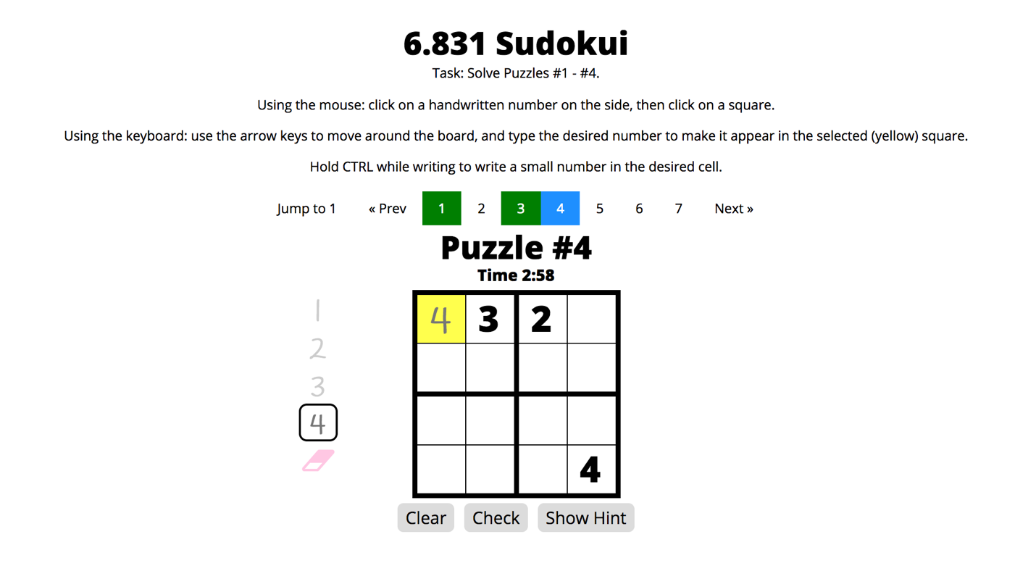

This first illustration depicts an overview of my new interface. Users are able to not only use the existing mouse controls, but also use the keyboard to move around and insert numbers. The highlighted square represents their current position on the board; yellow signifies that the user can edit the square, while gray signifies that the user cannot (because the number was given).

This illustration also shows the new navigation bar I implemented. Users can jump to specific puzzles using the pagination bar. Blue signifies the current active puzzle, while green signifies a completed puzzle.

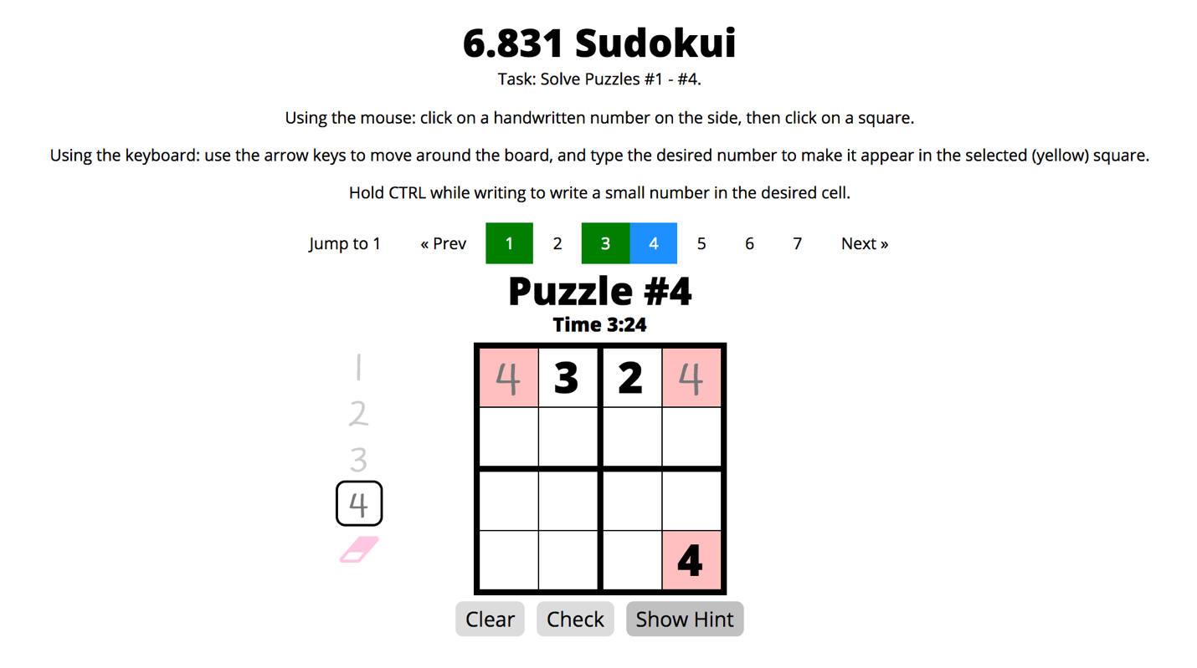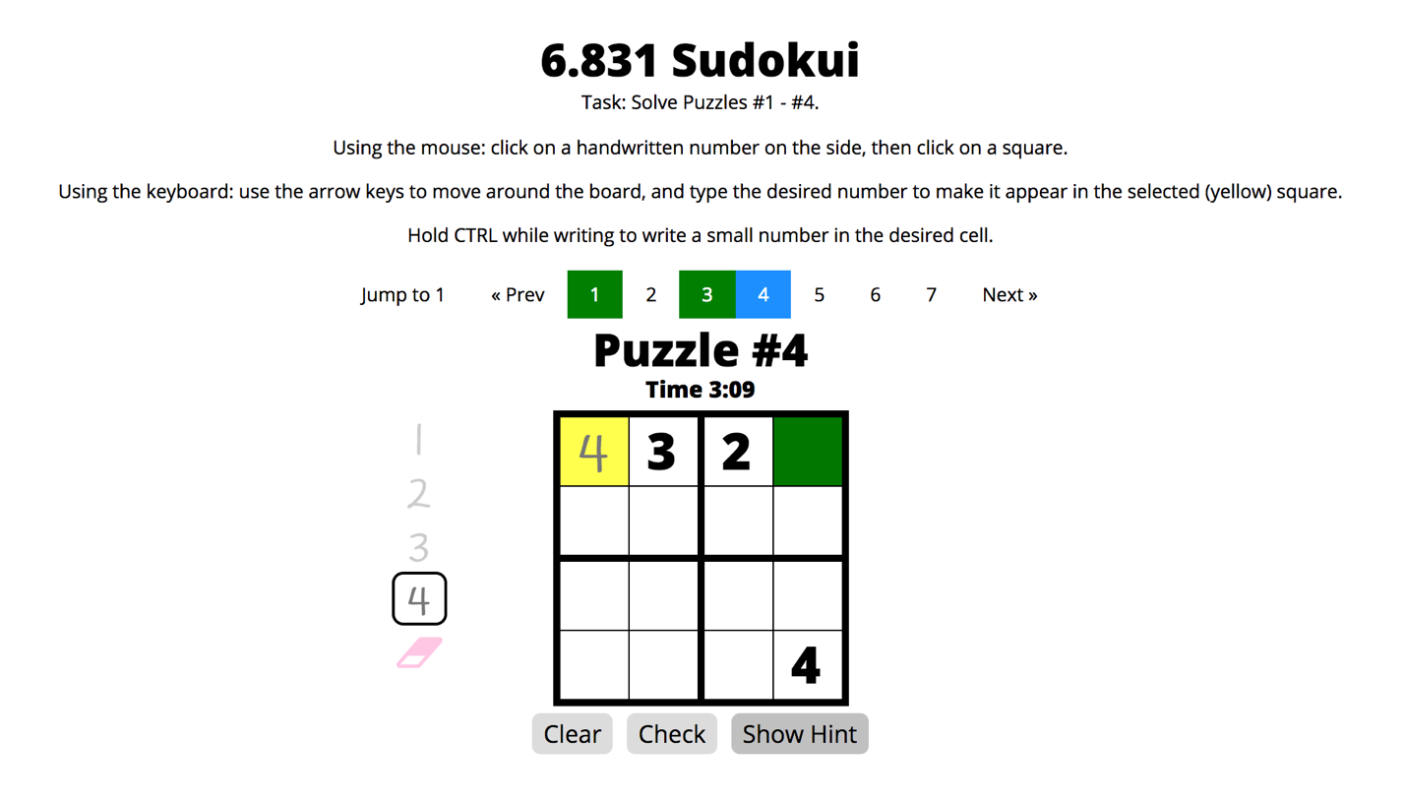

These next two illustrations depict the new “Show Hint” button and functionality. The first shows a hint indicating that there are conflicting numbers on the board, meaning the user has made a mistake. The second shows a hint that tells the player (based on what they have inputted) there should be an obvious answer in the green square—here, 1. These two hints make it easier for a beginner Sudoku player who may occasionally get stuck to play.

# Experimental Hypothesis

Through my changes, I primarily want to improve the efficiency of *entering numbers into the Sudoku board.* By logging when users move around the board using the keyboard and when they type both valid and invalid inputs, and then comparing this data with the mouse clicks logged in version A, I can analyze how efficient it is for users to use the keyboard for control and input. In addition, by logging when and how the eraser is being used, I can analyze how often mistakes are being made, and which method users prefer to use to remove numbers.

# KLM Analysis

***Task:*** *Complete Puzzle #1-#4 as quickly as possible.*

* For interface A, users can complete the task by clicking on the number palette to select a number, and then clicking on squares on the board to draw that number. They can navigate between puzzles using the “Next” and “Previous” buttons, and check their answers using the “Check” button.
* For interface B, users can complete the task by either using the same mouse functionalities in interface A or using the arrow keys to move around and typing in the numbers to input a specific number. They can navigate between puzzles using the “Next” and “Previous” buttons or clicking on specific puzzle numbers, and check their answers using the “Check” button. They can also ask for hints via the “Show Hint” buttons.

## Baseline (Version A) KLM Analysis

First, I defined the subtasks of inserting a number and of completing a puzzle because it was so frequently done. I assumed that a user would check their answers after approximately every four numbers, there was an average of 12 numbers to fill, and that the user made no mistakes. The operators used are M (Mentally Prepare), P (Point with Mouse), and B (Button press).

*Subtask: Inserting number to square (“Insert”):*

M

P [point to palette]

B [click number]

P [point to board]

B [click square]

Total Estimated Time = M + 2P + 2B = 1.2 + 2.2 + 0.2 = 3.6 s

*Subtask: Completing a puzzle (“Complete”):*

Insert x 4

P [point to check button]

B [click check button]

Insert x 4

P [point to check button]

B [click check button]

Insert x 4

P [point to check button]

B [click check button]

Total Estimate Time = 12I + 3P + 3B = 43.2 + 3.3 + 0.3 = 46.8 s

**Thus, the full KLM analysis for Version A is:**

M [read introduction screen]

B [dismiss introduction screen]

Complete [puzzle #1]

P [point to next button]

B [click next button]

Complete [puzzle #2]

P [point to next button]

B [click next button]

Complete [puzzle #3]

P [point to next button]

B [click next button]

Complete [puzzle #4]

**Total Estimated Time** = M + 4B + 3P + 4C = 1.2 + 0.4 + 3.3 + 187.2 = **192.1 s**

## Version B KLM Analysis

Since in Version B, users can use the keyboard to move, I estimated that getting to a desired square would require traversing an average of 5 squares. The operators used are M (Mentally Prepare), P (Point with Mouse), B (Button press), K (Keystroke), and H (Home hands between mouse and keyboard).

*Subtask: Navigating to and inserting number to square (“Insert”):*

M

K x 5 [move to desired square]

K [enter number]

Total Estimated Time = M + 6K = 1.2 + 1.68 = 2.88 s

*Subtask: Completing a puzzle (“Complete”):*

Insert x 4

H

P [point to check button]

B [click check button]

H

Insert x 4

H

P [point to check button]

B [click check button]

H

Insert x 4

H

P [point to check button]

B [click check button]

H

Total Estimate Time = 12I + 3P + 3B + 6H = 34.56 + 3.3 + 0.3 + 2.4 = 40.56 s

**Thus, the full KLM analysis for Version B is:**

M [read introduction screen]

B [dismiss introduction screen]

Complete [puzzle #1]

P [point to next button]

B [click next button]

Complete [puzzle #2]

P [point to next button]

B [click next button]

Complete [puzzle #3]

P [point to next button]

B [click next button]

Complete [puzzle #4]

**Total Estimated Time** = M + 4B + 3P + 4C = 1.2 + 0.4 + 3.3 + 161.84 = **167.14 s**

# New Logged Events

I included the following new custom events:

* “eraserUsed,” which logs when the eraser was used and how it was used. This is because I implemented the backspace key as a new way to erase, and want to see how useful it is compared to the original click-and-erase method.
* “numberEntered,” which logs when the user has used keys to enter a number, so I can compare it to the original multi-step mouse method to insert numbers.
* “invalidNumberEntered,” which logs when the user has used keys to enter a number, but the number is invalid (ex: “8” on a 2x2x2 board). I want track the possibility of making mistakes when using keys (as opposed to the mouse) to enter numbers, since incorrect key presses are likely very common.
* “moveCells,” which tracks when the user uses keys to move around the board, so I can keep track of how many moves it generally takes for a user to get to their desired square.