Heuristic Evaluation of *Choreo****GRAPH****y™*

# Usability Problems

**Problem:** There is no way to edit the stage shape besides refreshing the page and starting over when the user has made a mistake while drawing.

**Relevant usability heuristic:** Safety / Reversible actions (Shneiderman’s 8)

**Severity:** Minor, since users only need to draw their stage shape once per dance.

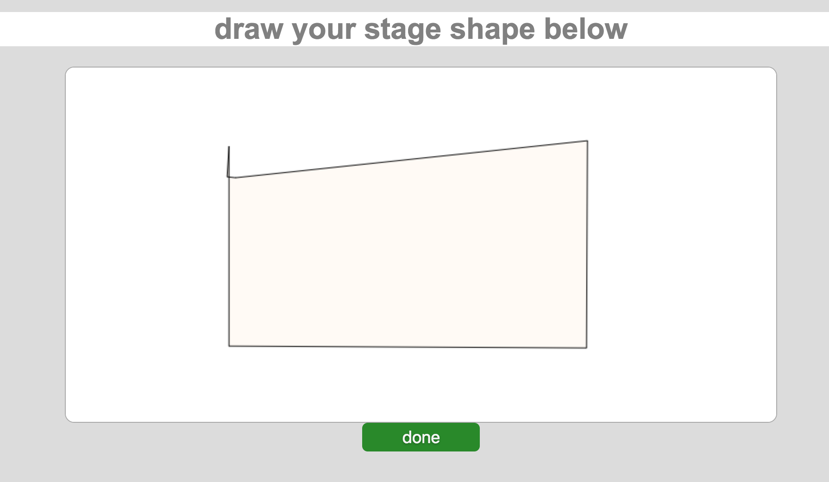

2.

**Problem:** Formation title (see “3” in screenshot) is cut off and partially obstructed

**Relevant usability heuristic:** Readability (Tog’s First Principles)

**Severity:** Cosmetic

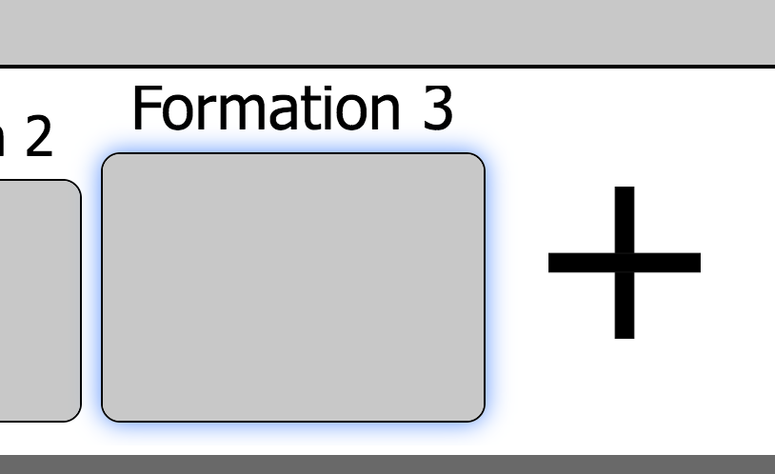

3.

**Problem:** Inconsistent font used for the left toolbar

**Relevant usability heuristic:** Internal consistency / typography

**Severity:** Cosmetic

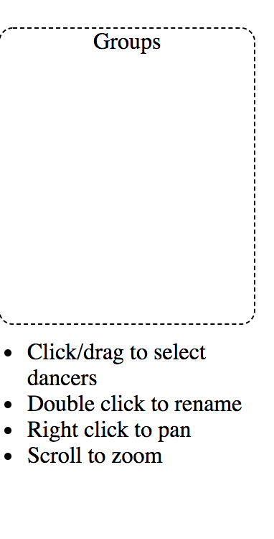 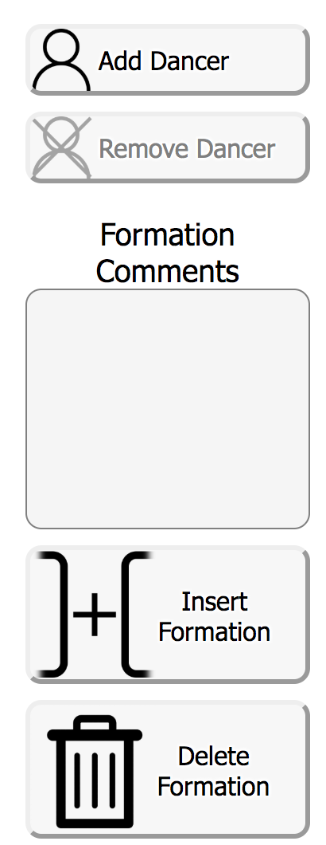

4.

**Problem:** It is possible for users to bypass the stage creation page and end up with an empty space, where they cannot add any dancers or do anything!)

**Relevant usability heuristic:** Safety

**Severity:** Minor

Perhaps, you can disable the “Done” button until a valid shape has been created!

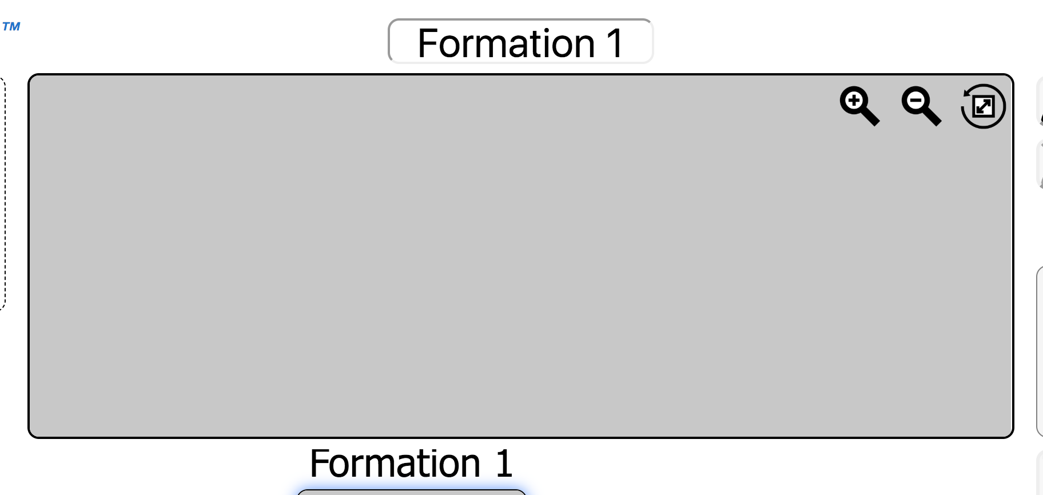

5.

**Problem:** There is no indication that the “Plus” sign is a button that users can click on to add a new formation—even when hovering over—until the user has already tried clicking it.

**Relevant usability heuristic:** Affordance / Feedback

**Severity:** Minor

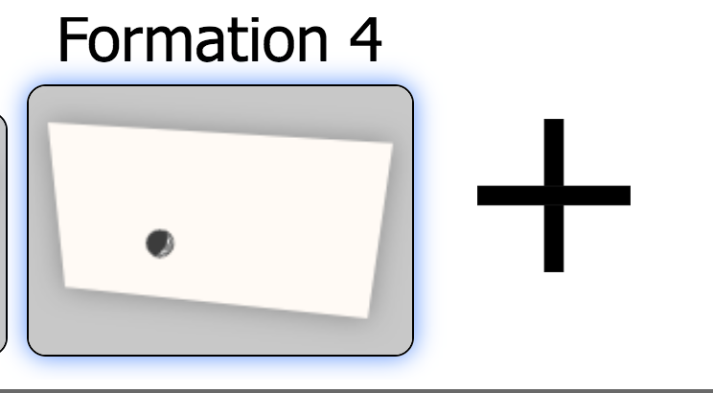

6.

**Problem:** Because the highlighted name text is almost the same color as the halo surrounding the dancer’s icon, it is difficult to tell that the user is able to edit the dancer’s name here (rather than just being blue for selection)

**Relevant usability heuristic:** Affordance / visibility of system status (Nielsen)

**Severity:** Minor / cosmetic



7.

**Problem:** It is difficult to discover that user can rearrange formation slides by dragging them.

**Relevant usability heuristic:** Affordance

**Severity:** Minor

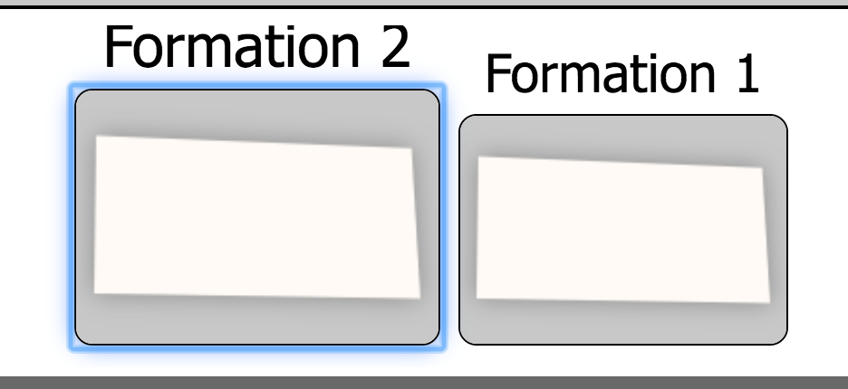

8.

**Problem:** There is no way to undo “Delete Formation” / “Remove Dancer”

**Relevant usability heuristic:** Safety / Reversible actions (Shneiderman’s 8)

**Severity:** Minor, especially since buttons are generally very large but may be an issue if the user means to add a dancer or insert formation, but misclicks.

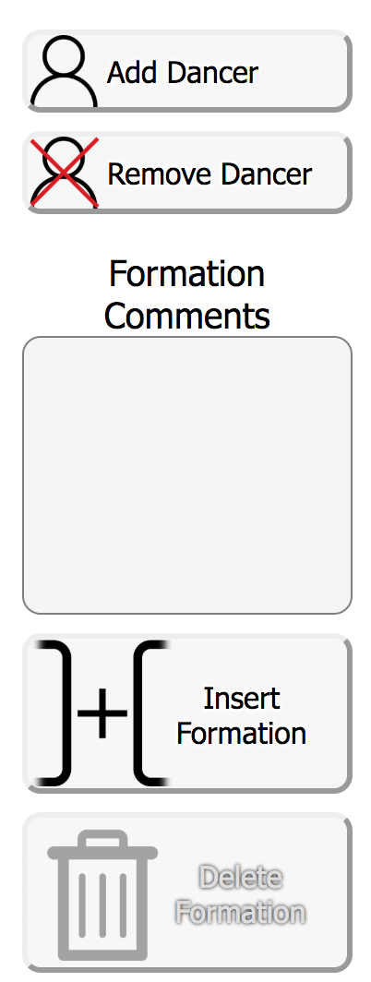

9.

**Problem:** There is little to no feedback given to the user when they try to edit slide order. (Instead, there is only really jerky movement as the slides swap order.)

**Relevant usability heuristic:** Visibility of system status (Nielsen’s Heuristics)

**Severity:** Minor

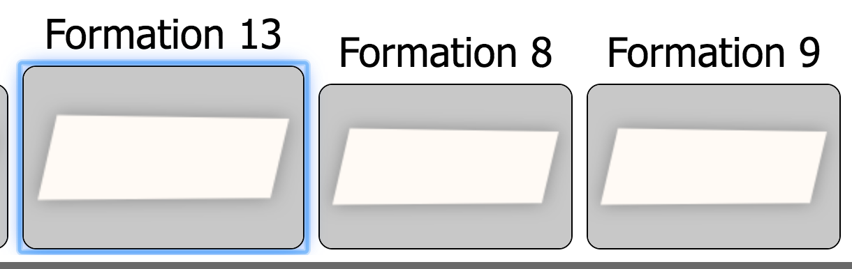

10.

**Problem:** When there are more formations than there is space on the screen, the list of formations seems to be “cut off.”

**Relevant usability heuristic:** Readability, layout

**Severity:** Cosmetic

I would suggest adding some sort of boundary along where the left edge of the formations list is at?

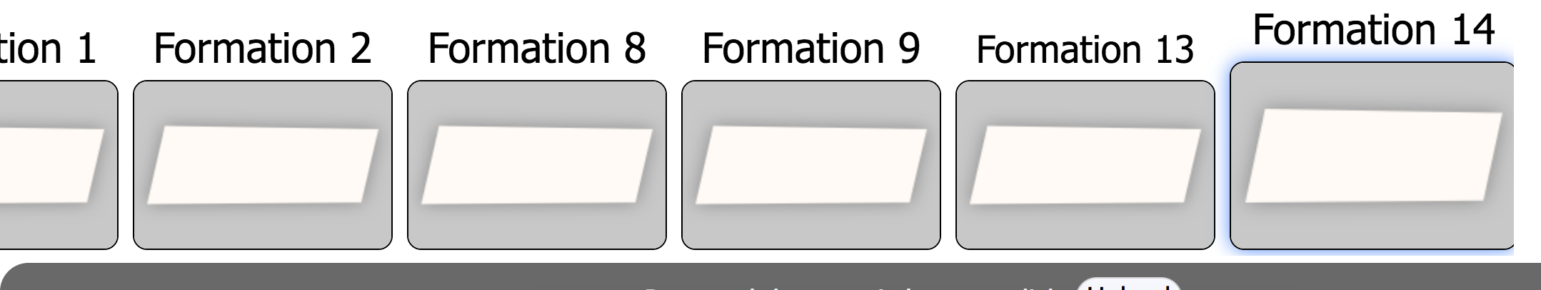

# Usability Successes

1.

**Positive feature:** When the user does not click exactly where they should to close the stage shape (but close enough), the interface assumes that the user wishes to close and fill the shape.

**Relevant usability heuristic:** Efficiency, anticipation

**Severity:** Good! ☺

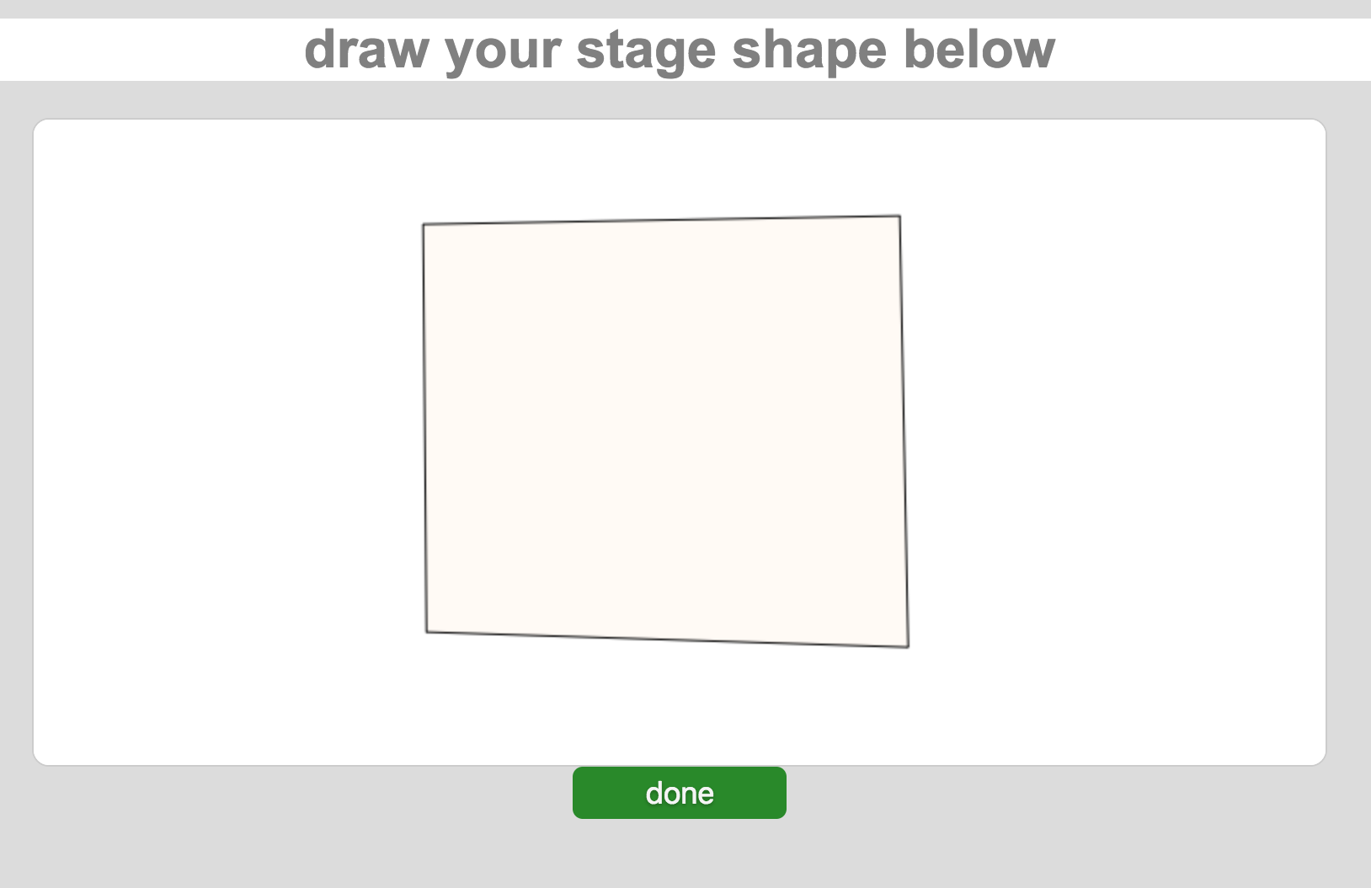

2.

**Positive feature:** Font size for name of dancer increases when hovered over.

**Relevant usability heuristic:** Feedback

**Severity:** Good! ☺



3.

**Positive feature:** When a dancer has not been selected, “Remove Dancer” button is visibly disabled.

**Relevant usability heuristic:** Feedback

**Severity:** Good! ☺



4.

**Positive feature:** Zoom in, zoom out, and reset zoom icons are consistent with general conventions, making them easy to learn

**Relevant usability heuristic:** External consistency, learnability

**Severity:** Good! ☺



5.

**Positive feature:** Buttons are large, simple, and clear.

**Relevant usability heuristic:** Fitt’s Law, efficiency

**Severity:** Good! ☺

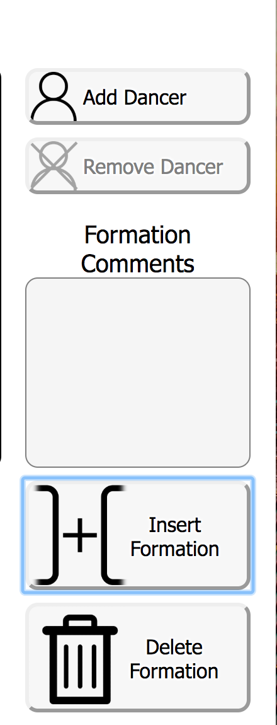

6.

**Positive feature:** Colors for “Insert Formation” and “Delete Formation” are externally consistent (green as adding or increasing, while red as removing or decreasing)

**Relevant usability heuristic:** External consistency

**Severity:** Good! ☺

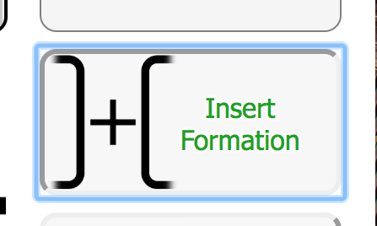

7.

**Positive feature:** Overall, interface is relatively minimalistic, with simple button controls, good contrast, and few colors!

**Relevant usability heuristic:** Aesthetic & minimalist design (Nielsen's Heuristics)

**Severity:** Good! ☺

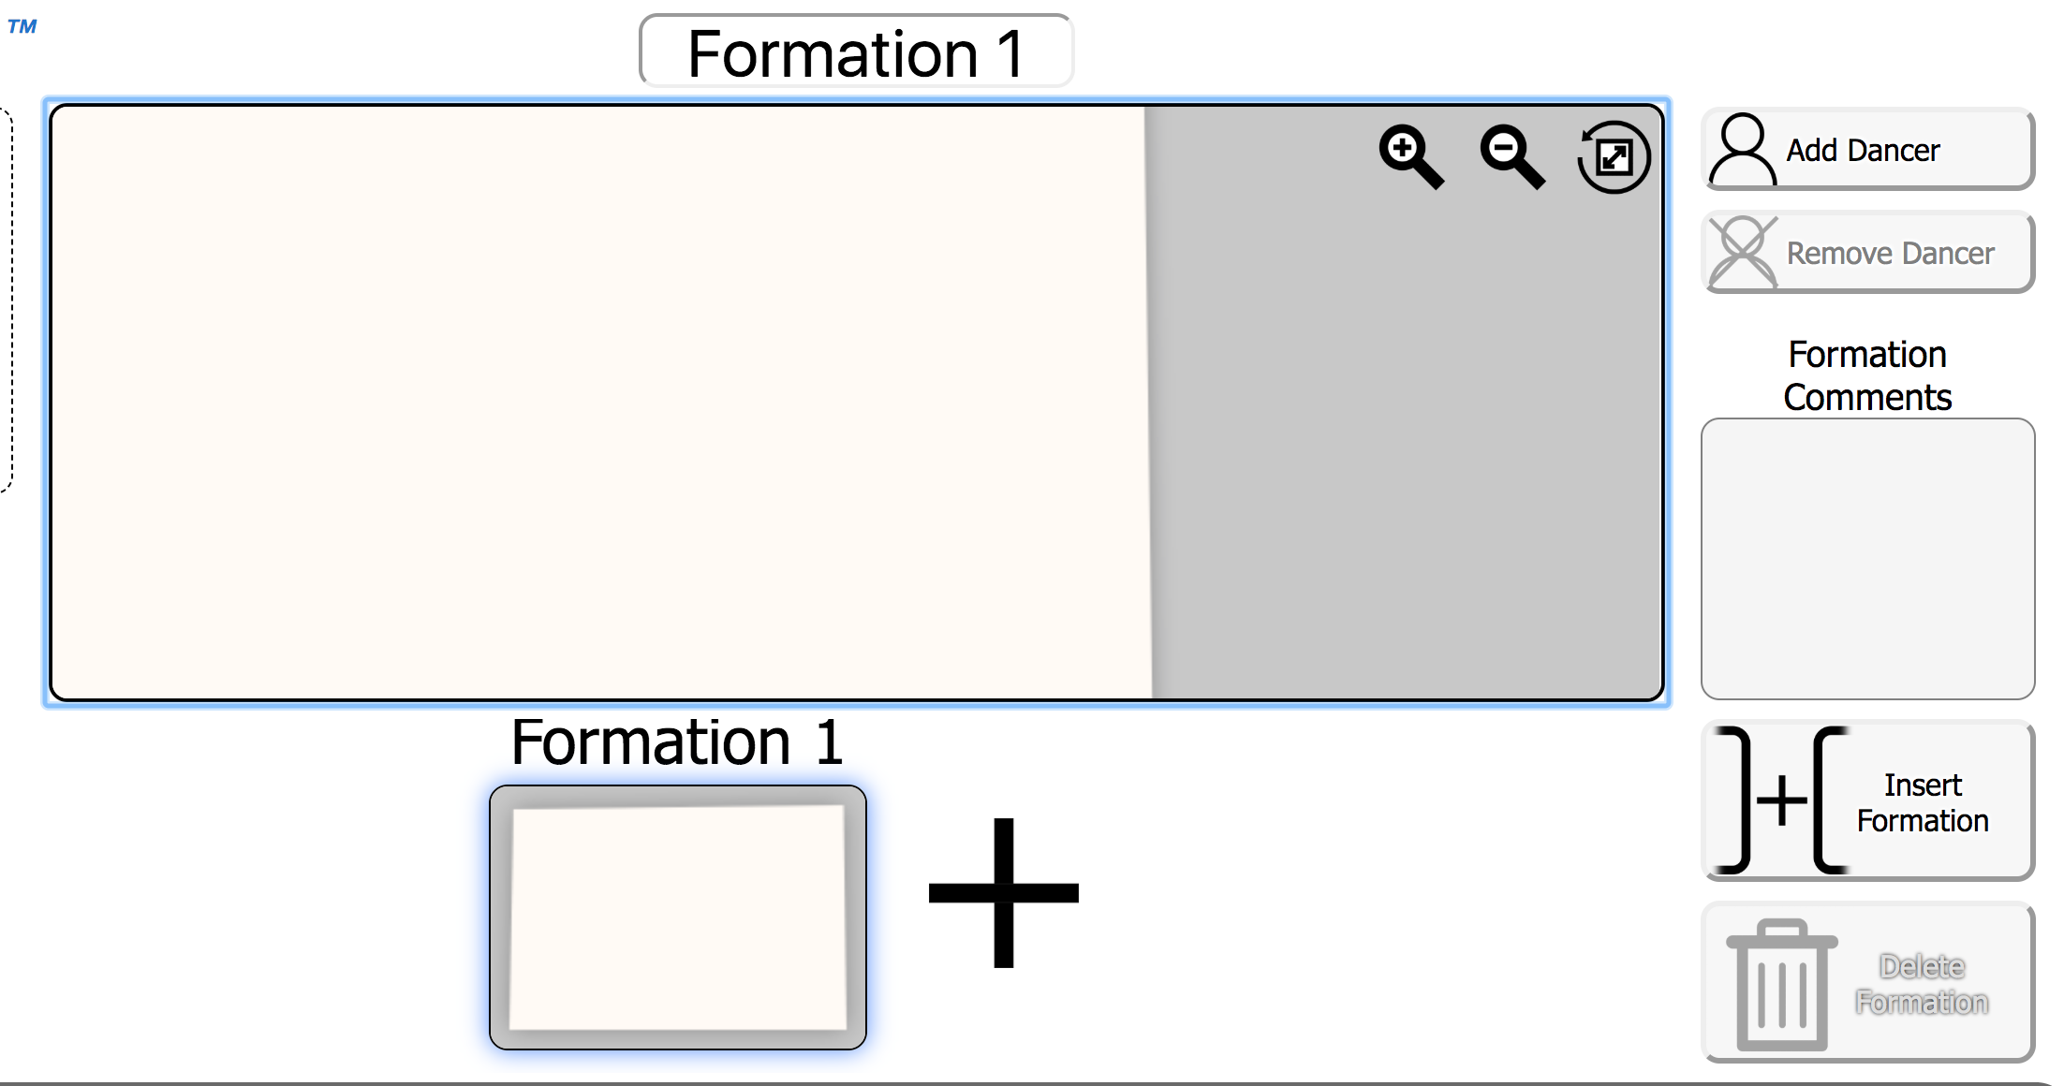

8.

**Positive feature:** It is very apparent that the user can rotate each dancer icon, and exactly how to do so.

**Relevant usability heuristic:** Affordance

**Severity:** Good! ☺



9.

**Positive feature:** The help text on the left side is extremely helpful, organized, and concise. More specifically, it helps the user discover features that may not be immediately obvious. (However, it feels a little out of place below the “Groups” box.)

**Relevant usability heuristic:** Aesthetic & minimalist design (Nielsen's Heuristics)

**Severity:** Good! ☺

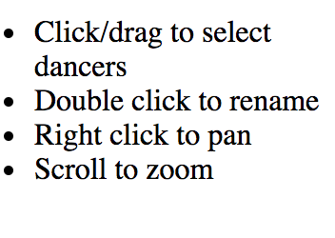

10.

**Positive feature:** Being able to directly interact with, move, and edit dancers is very intuitive and easy to use.

**Relevant usability heuristic:** Human interface objects (Tog’s First Principles)

**Severity:** Good! ☺

