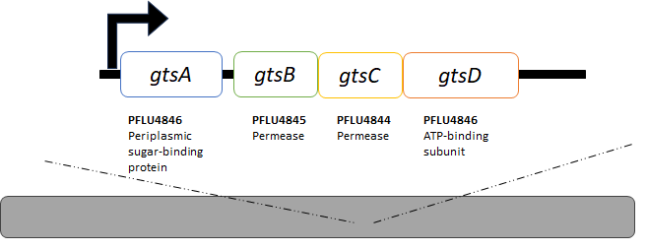
A
B
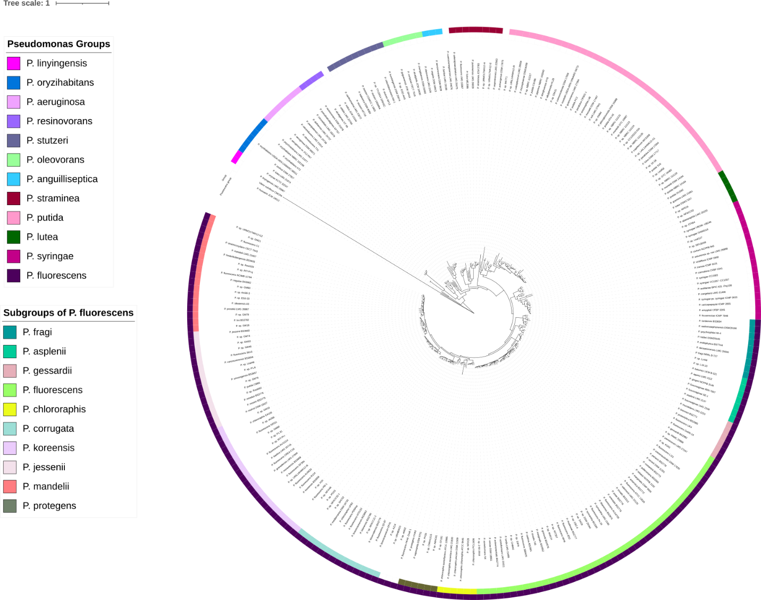
Figure S1. Organization of the gtsABCD operon and phylogenetic tree of Pseudomonas species. (A) Gene architecture of the gtsABCD operon. (B) Maximum likelihood phylogeny based on protein sequence alignments of 100 single-copy orthologous genes from 258 strains of Pseudomonas species.
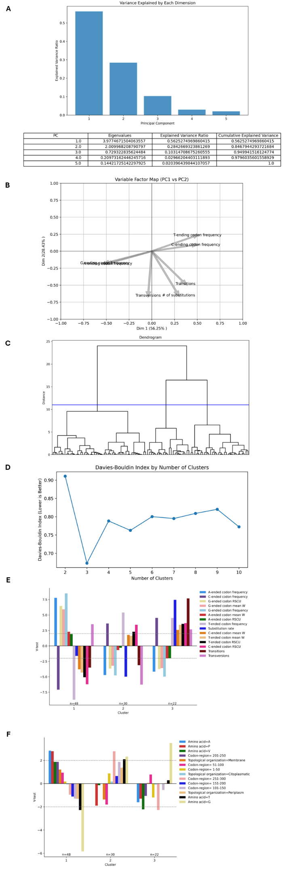
Figure S2. Hierarchical Clustering on Principal Components metrics on four-fold sites on the gtsB gene (n=100) using seven quantitative variables. (A) Proportion of Variance plot. (B) Variable factor map on PC1 vs PC2. (C) Hierarchical clustering dendrogram using the PCA's first two dimensions. The height of the branches indicates the dissimilarity between clusters. The blue line cuts the tree into four clusters. (D) Davies–Bouldin index by number of clusters. (E) Comparison of active and codon usage supplementary quantitative variables by clusters: The V-test represents a standardized deviation between the mean of each variable among positions in a cluster compared to the general average. Horizontal dotted lines indicate a cutline, where V-test scores equal to or greater than 2 or equal or lesser than -2 are considered significant (P < 0.05). (F) Relationship between qualitative supplementary variables: the position of the site within a sequence of 50 consecutive amino acids, predicted structure, and amino acid and clusters.

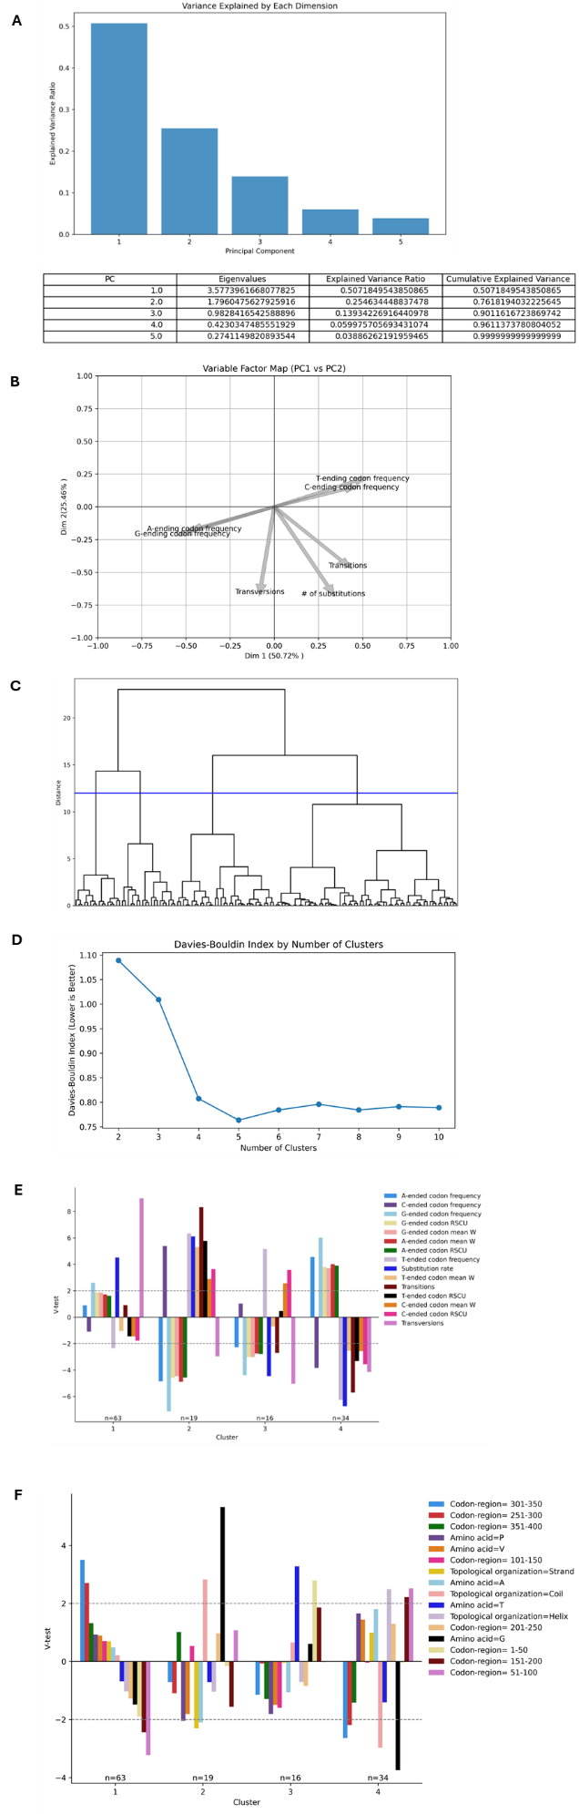
Figure S3. Hierarchical Clustering on Principal Components metrics on four-fold sites on the gtsD gene (n = 132) using seven quantitative variables. (A) Proportion of Variance plot. (B) Variable factor map on PC1 vs PC2. (C) Hierarchical clustering dendrogram using the PCA's first two dimensions. The height of the branches indicates the dissimilarity between clusters. The blue line cuts the tree into four clusters. (D) Davies–Bouldin index by number of clusters. (E) Comparison of active and codon usage supplementary quantitative variables by clusters: The V-test represents a standardized deviation between the mean of each variable among positions in a cluster compared to the general average. Horizontal dotted lines indicate a cutline, where V-test scores equal to or greater than 2 or equal or lesser than -2 are considered significant (P < 0.05). (F) Relationship between qualitative supplementary variables: the position of the site within a sequence of 50 consecutive amino acids, predicted structure, and amino acid and clusters.

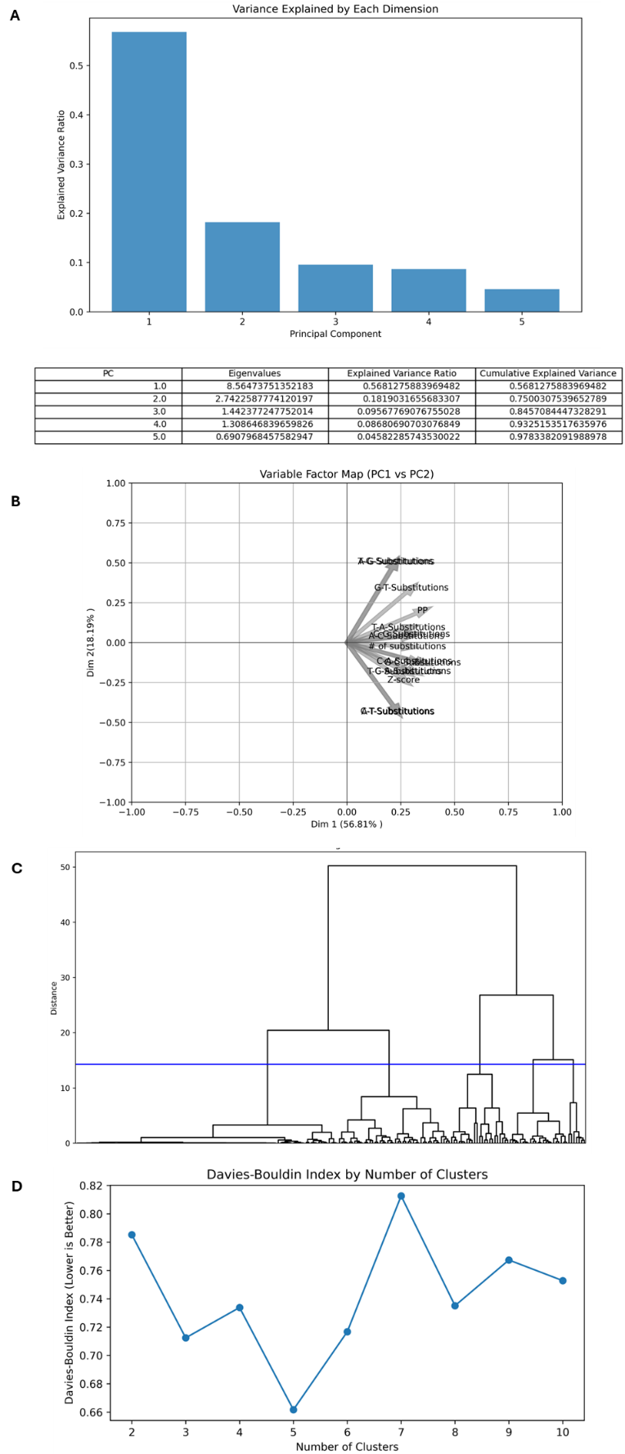
Figure S4. Hierarchical Clustering on Principal Components metrics on the second and third positions of four-fold amino acids in gtsB (n = 200) using 15 quantitative active variables. (A) Proportion of Variance plot. (B) Variable factor map on PC1 vs PC2. (C) Hierarchical clustering dendrogram using the PCA's first two dimensions. The height of the branches indicates the dissimilarity between clusters. The blue line cuts the tree into six clusters. (D) Davies–Bouldin index by number of clusters.

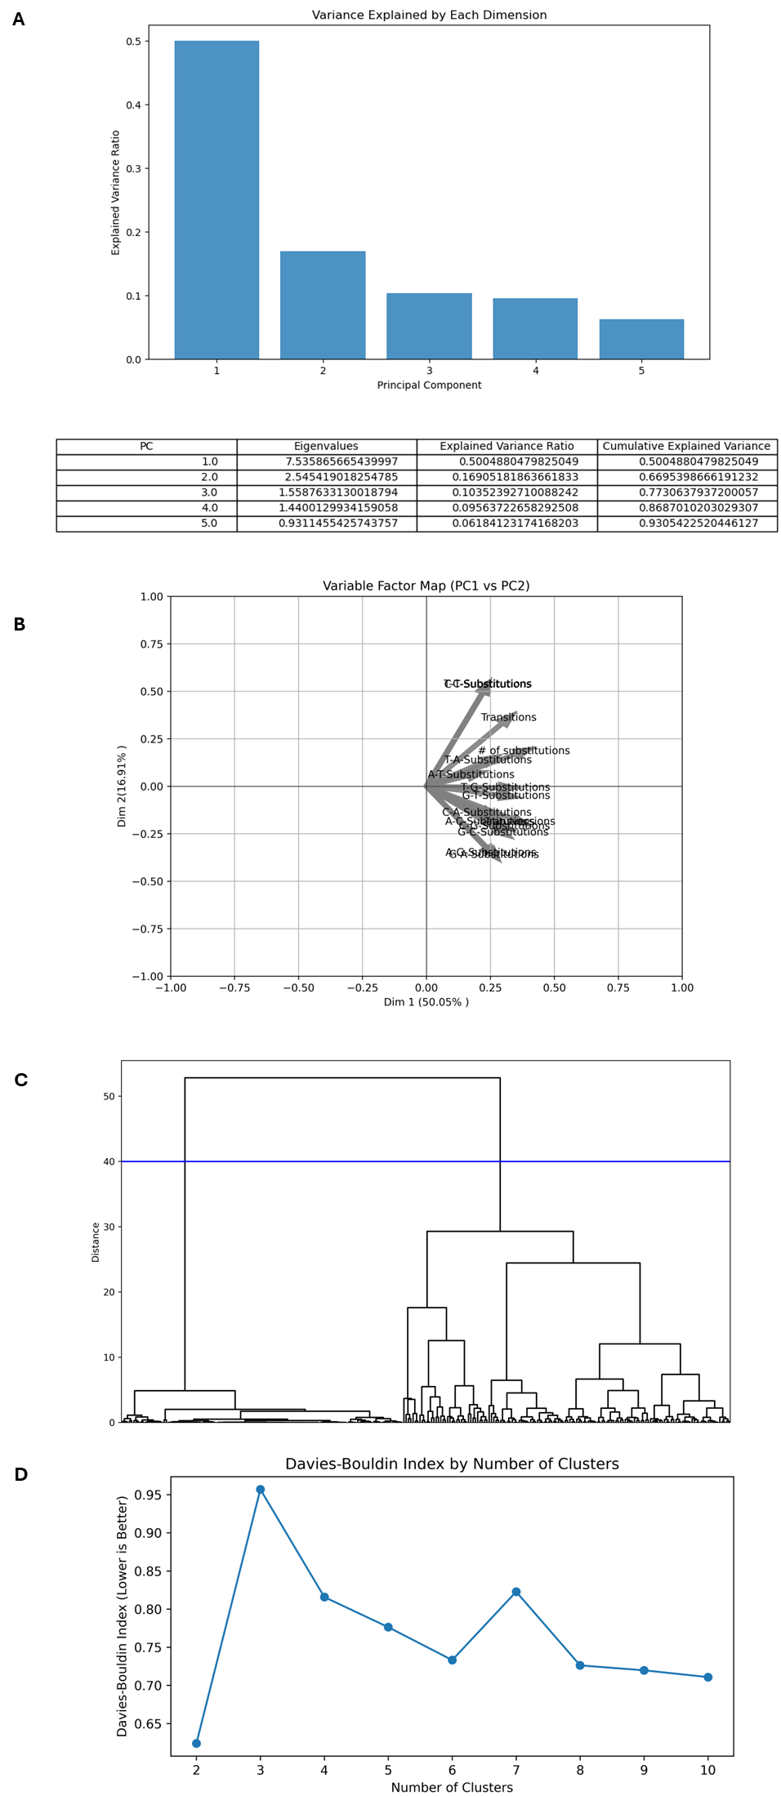
Figure S5. Hierarchical Clustering on Principal Components metrics on the second the second and third positions of four-fold amino acids in gtsD (n = 264) using 15 quantitative varriables. (A) Proportion of Variance plot. (B) Variable factor map on PC1 vs PC2. (C) Hierarchical clustering dendrogram using the PCA's first two dimensions. The height of the branches indicates the dissimilarity between clusters. The blue line cuts the tree into five clusters. (D) Davies–Bouldin index by number of clusters.

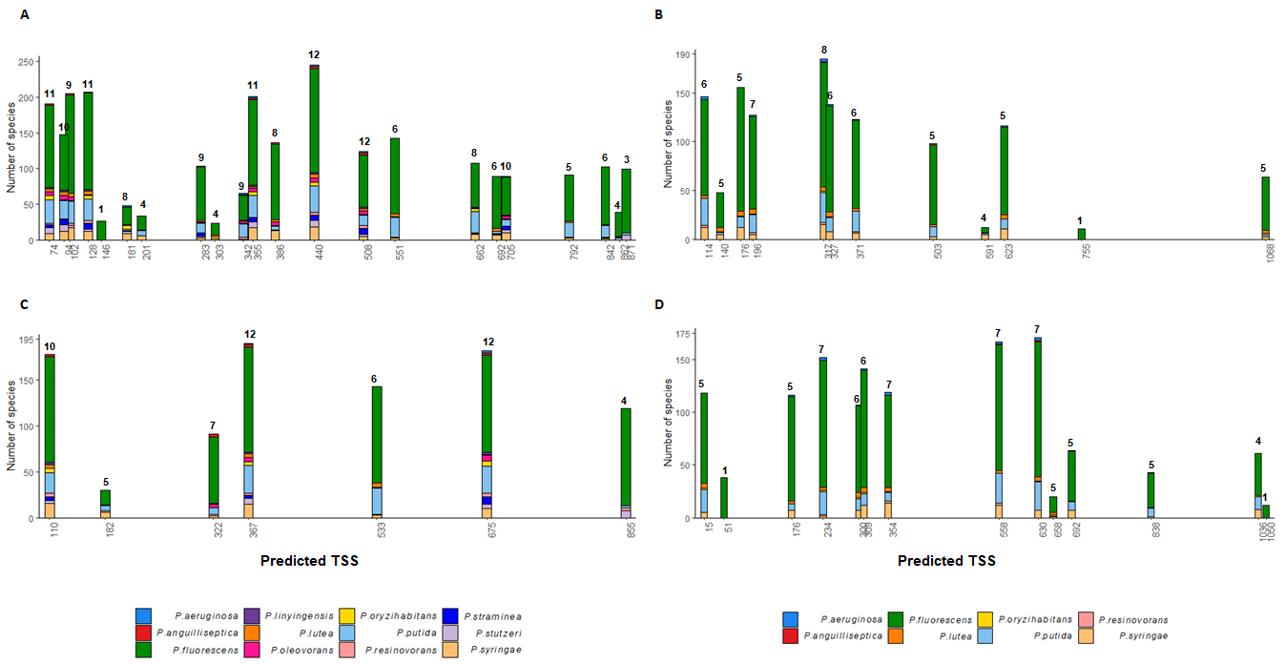
Figure S6. Repeatability of Transcription Start Sites (TSS) predicted in the gtsB and gtsD genes in Pseudomonas fluorescens SBW25 across a Pseudomonas phylogeny. (A) 22 TSS predicted on gtsB ORF. (B) 12 TSS predicted on gtsD ORF. (C) 7 TSS predicted in the reverse complement of gtsB ORF. (D) 14 TSS predicted on the reverse complement of gtsD ORF. Each color in the stack bars corresponds to the species within one of the 12 groups of Pseudomonas (N = 251 species in gtsB and N = 193 species gtsD). Numbers displayed at the top of each bar represent the number of Pseudomonas groups (colors). A TSS prediction was deemed to be present if it corresponded to the TSS prediction for P. fluorescens SBW25, or if it was predicted one position either preceding or following the SBW25-predicted site.

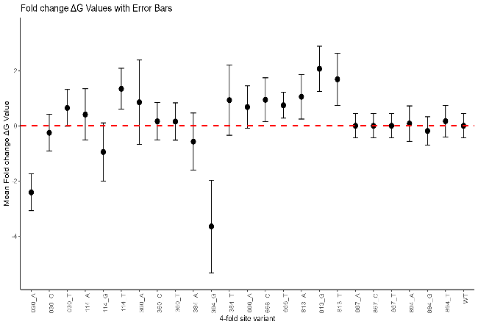
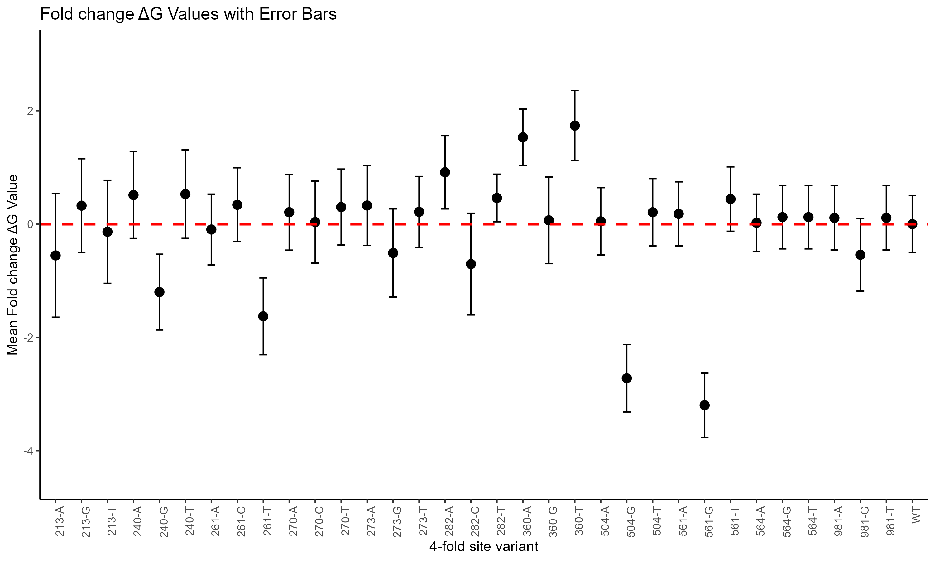
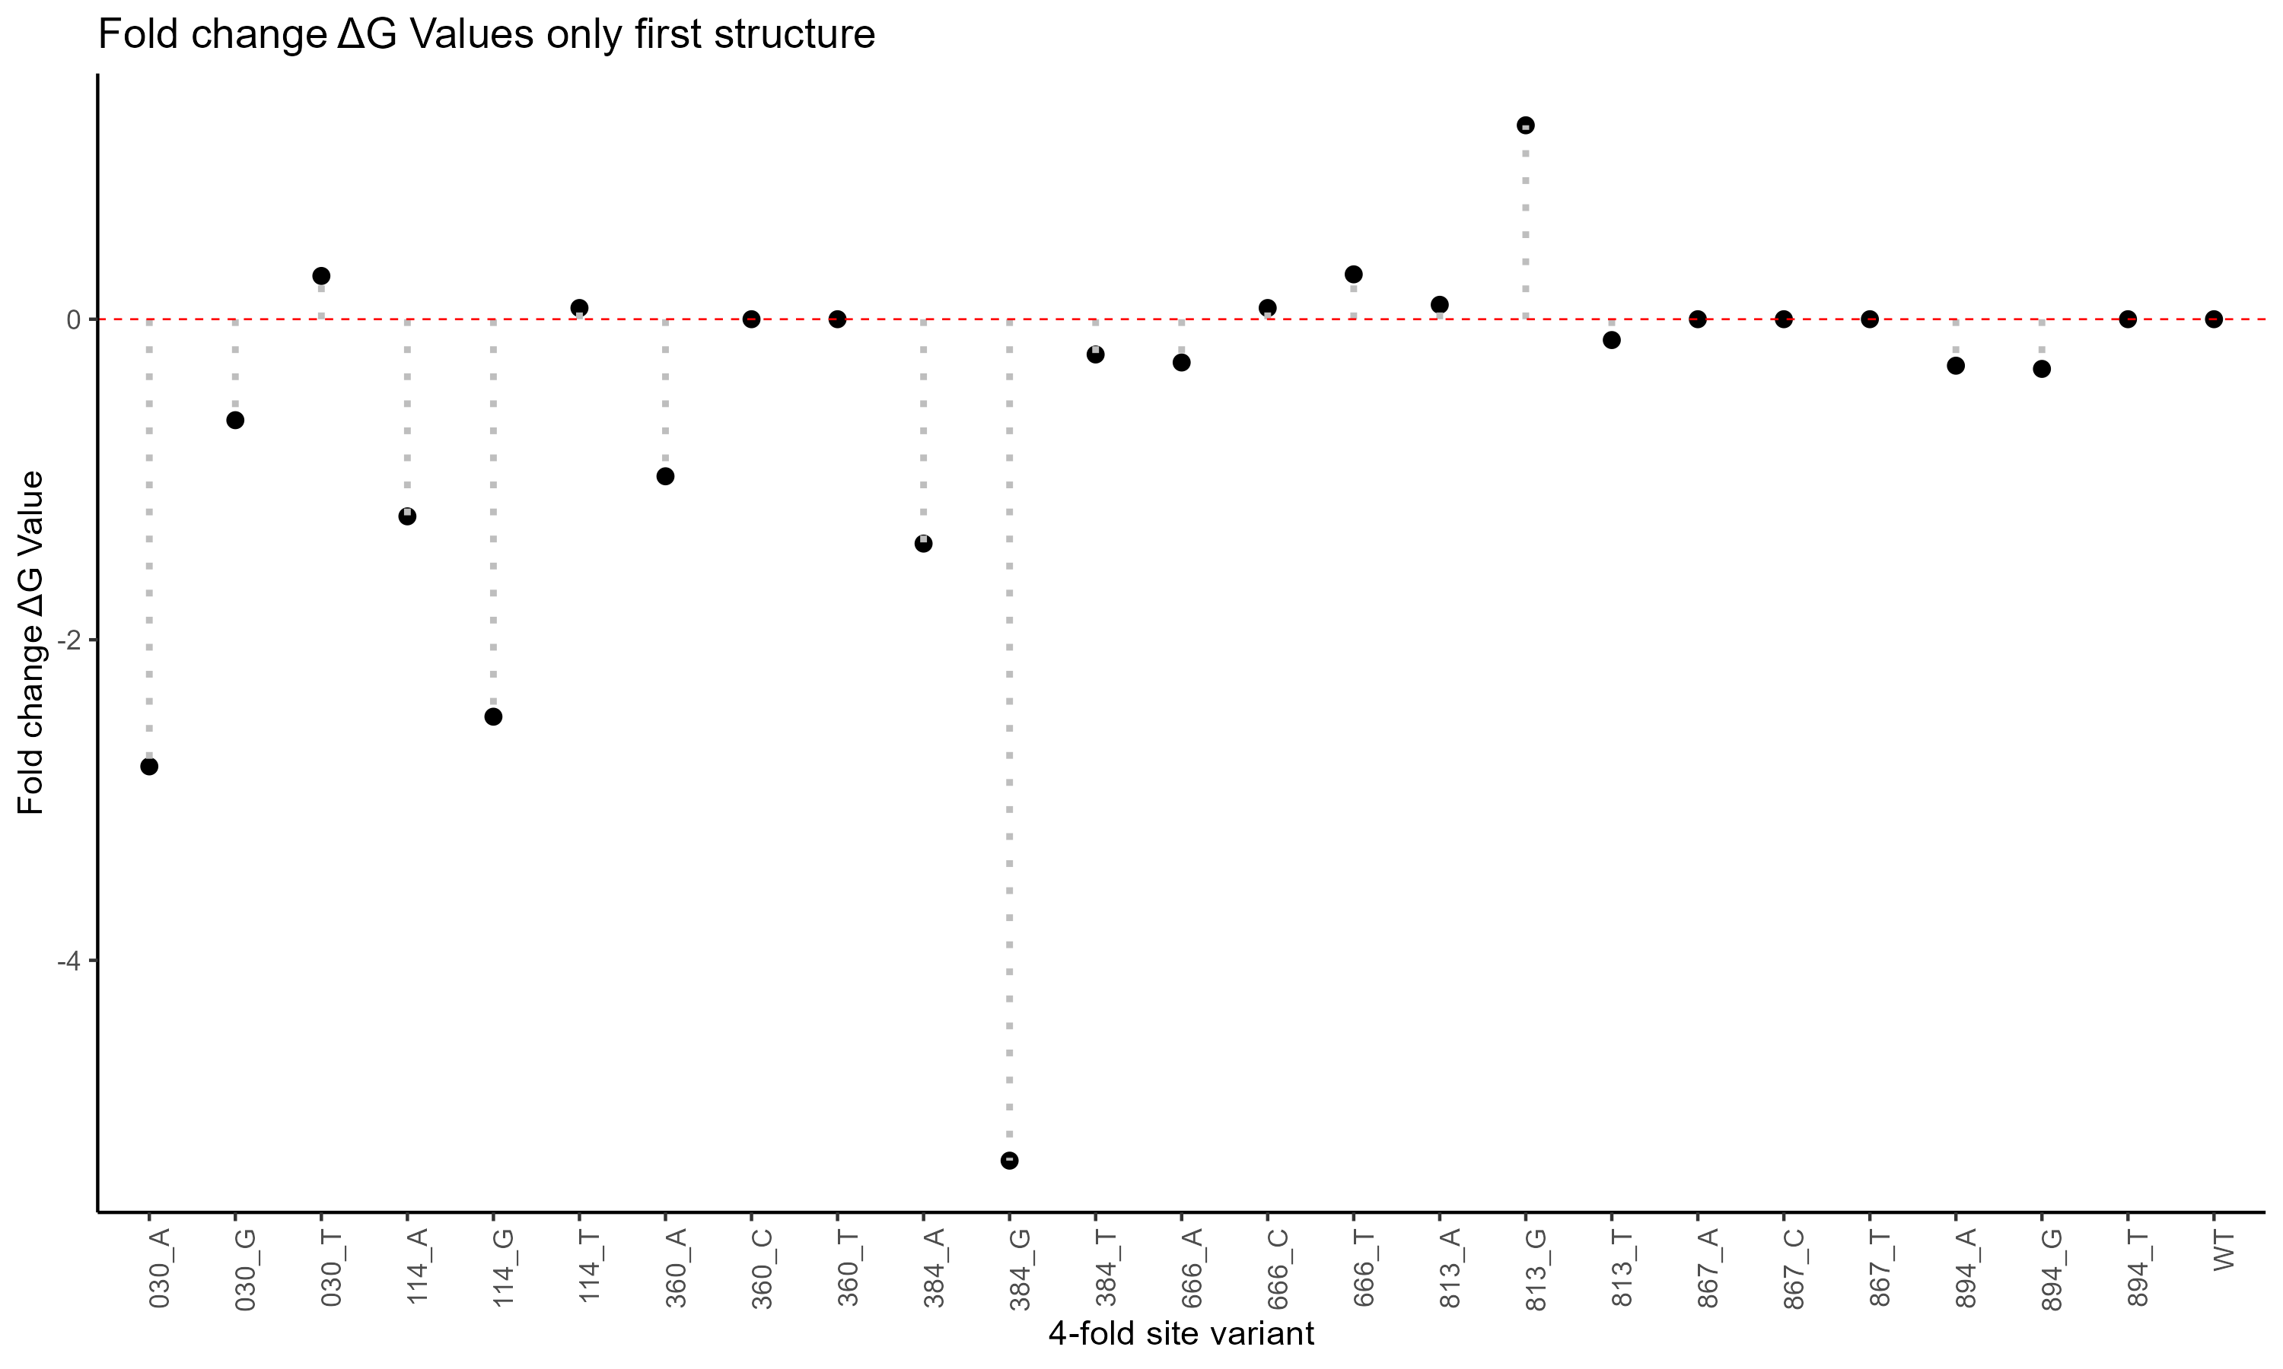
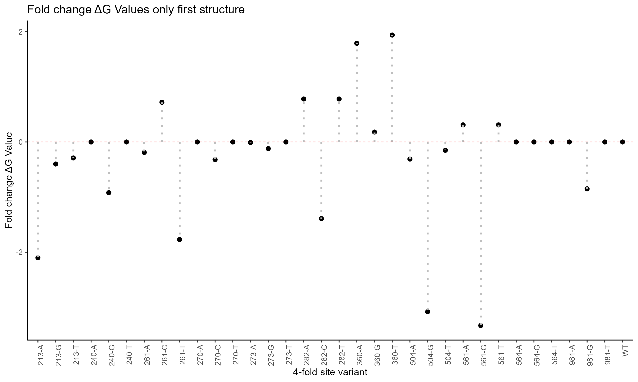
A
C
B
D

Figure S7. The predicted effect of four-fold alleles at identified constrained sites on mRNA folding stability, measured as free energy (kcal/mol), in the gtsB and gtsD sequences of P. fluorescens SBW25. A. Change in the first ten predicted structures in gtsB (n = 8) and B. Change in the first ten predicted structures in gtsD (n = 11). Error bars represent the standard error of the mean. C-D. Change in the free energy on the first predicted structure of gtsB and gtsD, respectively.

