DEPARTMENT OF COMPUTER SCIENCE

MAJOR PROJECT REPORT

OSTEOPOROSIS DETECTION SYSTEM USING ENSEMBLE DEEP LEARNING

ST JOSEPH'S UNIVERSITY
BANGALORE – 560027
2025–2026

CERTIFICATE

This is to certify that Smt. / Sri. ________________________________ has satisfactorily completed the Major Project titled "Osteoporosis Detection System using Ensemble Deep Learning" prescribed by St Joseph's University for the VI Semester degree course in BCA for the year 2025–26.

Signature of the Guide | Head of the Department
Examiner 1: ______________ | Name: _____________________

ACKNOWLEDGEMENT

I would like to express my sincere gratitude to the Department of Computer Science, St Joseph's University, Bangalore, for providing me with the opportunity to undertake this Major Project.
I am deeply thankful to my project guide for their invaluable guidance, encouragement, and continuous support throughout the development of this project.
I extend my gratitude to the Head of the Department and all faculty members for their support and for providing the necessary resources and infrastructure for the successful completion of this project.
Finally, I am grateful to my family for their unwavering support and encouragement throughout my academic journey.

TABLE OF CONTENTS
SL NO | Content | Page No
1 | About the University
2 | Department of Computer Science
3 | Introduction
4 | Synopsis
5 | DFD / ER Diagrams
6 | Codes & Screenshots
7 | API Test Report
8 | Conclusion

ABOUT THE UNIVERSITY
St Joseph's University (SJU) is a Jesuit university at the heart of Bengaluru, the Silicon City of India. Established in 1882 by Paris Foreign Fathers, the management of the college was handed over to the Jesuit order (Society of Jesus) in 1937. In February 2021, St Joseph's University bill was presented in the Karnataka Legislative Assembly. The college received its University status on 2nd July 2022 and was inaugurated as India's first Public-Private Partnership University by the President of India, Smt. Droupadi Murmu on 27 September 2022.

Milestones
- 1882 — Established by Paris Foreign Fathers
- 1937 — Management handed over to the Jesuits (Society of Jesus)
- 1986 — First affiliated college in Karnataka to offer postgraduate courses
- 1998 — First college in Karnataka to get a research centre
- 2005 — Granted autonomous status
- 02 July 2022 — Received University status
- 27 September 2022 — Inaugurated as India's first Public-Private Partnership University

Vision
To form women and men for and with others, who through holistic education, strive for a just, secular, democratic, and ecologically sensitive society which empowers the poor, the oppressed and the marginalized.

Mission
In keeping with the Jesuit heritage, the university aims at an integral formation of the staff and the students, to be men and women who will be agents of societal change, enabling them to attain academic and human excellence.

DEPARTMENT OF COMPUTER SCIENCE
The Department was founded in 1986, offering BSc in Computer Science along with Physics and Mathematics. BCA is an undergraduate programme for candidates wishing to delve into the world of Computer Languages. MSc Computer Science is a postgraduate programme for candidates who wish to probe deeper into the realm of computer science.
All final-year students develop and complete a project for an organisation outside the College, ensuring sufficient exposure and preparedness for a challenging career in the field of Information Technology.

Vision
To ensure that students have a deep and analytical understanding of the field and to enable them to use their immense potential to enhance the quality of human life by contributing to the field of Technology, with Ethical responsibilities.

Mission
The Department offers quality education in the Science of Computing by providing courses with Computer Applications and by focusing on Personal, Emotional, and Character development.

INTRODUCTION

Background
Osteoporosis is a systemic skeletal disorder characterised by reduced bone mass and deterioration of bone tissue, leading to increased bone fragility and fracture risk. It is often called the 'silent disease' because bone loss occurs without symptoms until a fracture happens. According to the World Health Organization (WHO), osteoporosis affects an estimated 200 million women worldwide and causes more than 8.9 million fractures annually.
The knee joint is particularly susceptible to osteoporotic changes, and X-ray imaging remains the most widely accessible and cost-effective screening tool. However, manual interpretation requires experienced radiologists and is subject to inter-observer variability. Artificial intelligence, specifically deep learning-based computer vision, offers the potential to provide fast, consistent, and accurate screening support.

Motivation
Early detection of osteoporosis can significantly reduce fracture risk through timely intervention, including calcium supplementation, vitamin D therapy, and lifestyle modifications. Access to specialised radiologists is limited in many healthcare settings, particularly in developing countries. An AI-assisted tool that can analyse knee X-rays and flag high-risk patients would be of significant clinical value.

Problem Statement
To develop a web-based AI application capable of classifying knee X-ray images into three categories — Normal, Osteopenia (early bone loss), and Osteoporosis (advanced bone loss) — and providing a clinical risk assessment by incorporating patient demographic information such as age, sex, and vitamin deficiency history.

Objectives
- Develop an ensemble deep learning model combining ResNet-50, DenseNet-121, and EfficientNet-B0
- Implement CLAHE preprocessing to enhance bone density visibility in X-ray images
- Integrate clinical covariate adjustment using patient demographics for improved accuracy
- Deploy the model as a full-stack web application with FastAPI backend and HTML/CSS/JS frontend
- Achieve test accuracy exceeding 90% on a balanced held-out test dataset

SYNOPSIS

Abstract
This project presents an AI-powered web application for automated osteoporosis risk assessment from knee X-ray images. The system employs an ensemble of three pre-trained Convolutional Neural Networks (CNNs) — ResNet-50, DenseNet-121, and EfficientNet-B0 — trained on a balanced dataset of 560 augmented knee X-ray images across three classes: Normal, Osteopenia, and Osteoporosis.
Key innovations include: (1) CLAHE-based preprocessing to enhance bone density contrast, (2) a Bayesian prior clinical adjustment mechanism using patient age, sex, and vitamin deficiency history to modulate CNN output probabilities, (3) Test-Time Augmentation (TTA) using 5 transforms to improve prediction robustness, and (4) a weighted soft-voting ensemble achieving 95.96% test accuracy on a held-out test set of 99 images.

Technology Stack
Component | Technology
Programming Language | Python 3.11
Deep Learning Framework | PyTorch 2.x, TorchVision
CNN Models | ResNet-50, DenseNet-121, EfficientNet-B0
Image Processing | OpenCV (CLAHE), Pillow
Backend API | FastAPI, Uvicorn
Frontend | HTML5, CSS3, JavaScript (Vanilla)
Training Platform | Google Colab (NVIDIA T4 GPU)

Dataset
Split | Normal | Osteopenia | Osteoporosis | Total
Training | 230 | 165 | 165 | 560
Testing | 33 | 33 | 33 | 99
Total | 263 | 198 | 198 | 659

Model Architecture
Model | Ensemble Weight | Parameters | Key Feature
ResNet-50 | 40% | 25.6M | Residual skip connections
DenseNet-121 | 35% | 8.0M | Dense feature reuse
EfficientNet-B0 | 25% | 5.3M | Compound scaling

System Architecture
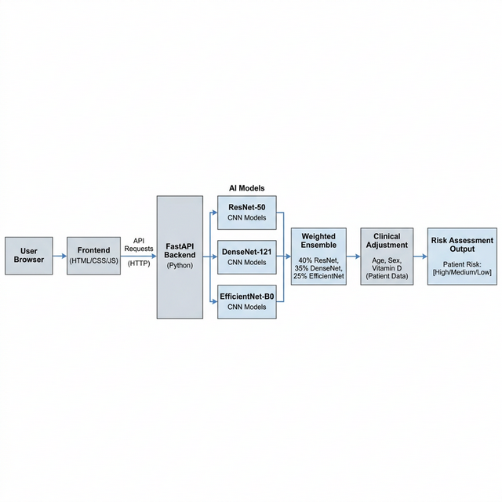
Figure 1: System Architecture Diagram

Preprocessing Pipeline
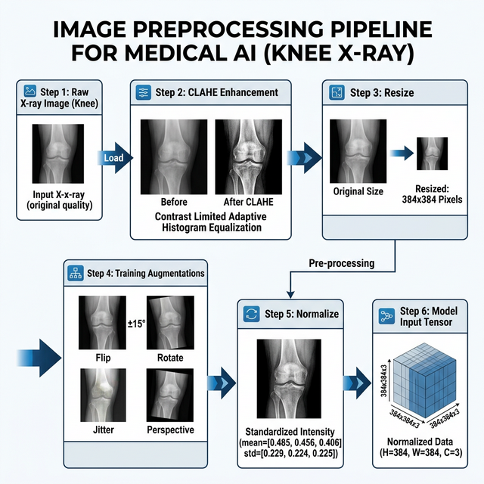
Figure 2: Image Preprocessing Pipeline

Results
Class | Precision | Recall | F1-Score | Support
Normal | 0.94 | 0.97 | 0.96 | 33
Osteopenia | 0.94 | 1.00 | 0.97 | 33
Osteoporosis | 1.00 | 0.91 | 0.95 | 33
Weighted Avg | 0.96 | 0.96 | 0.96 | 99

Overall Test Accuracy: 95.96%

Confusion Matrix
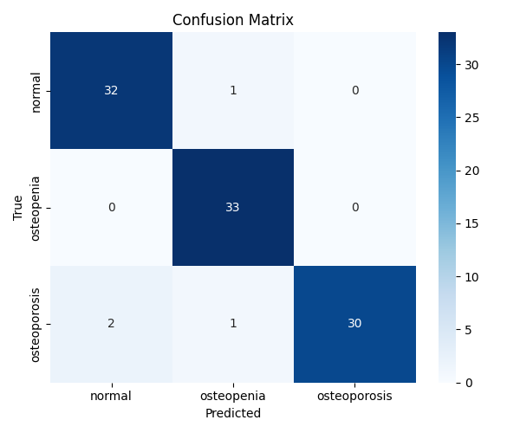
Figure 3: Confusion Matrix — New Ensemble (ResNet-50 + DenseNet-121 + EfficientNet-B0)

ROC Curves
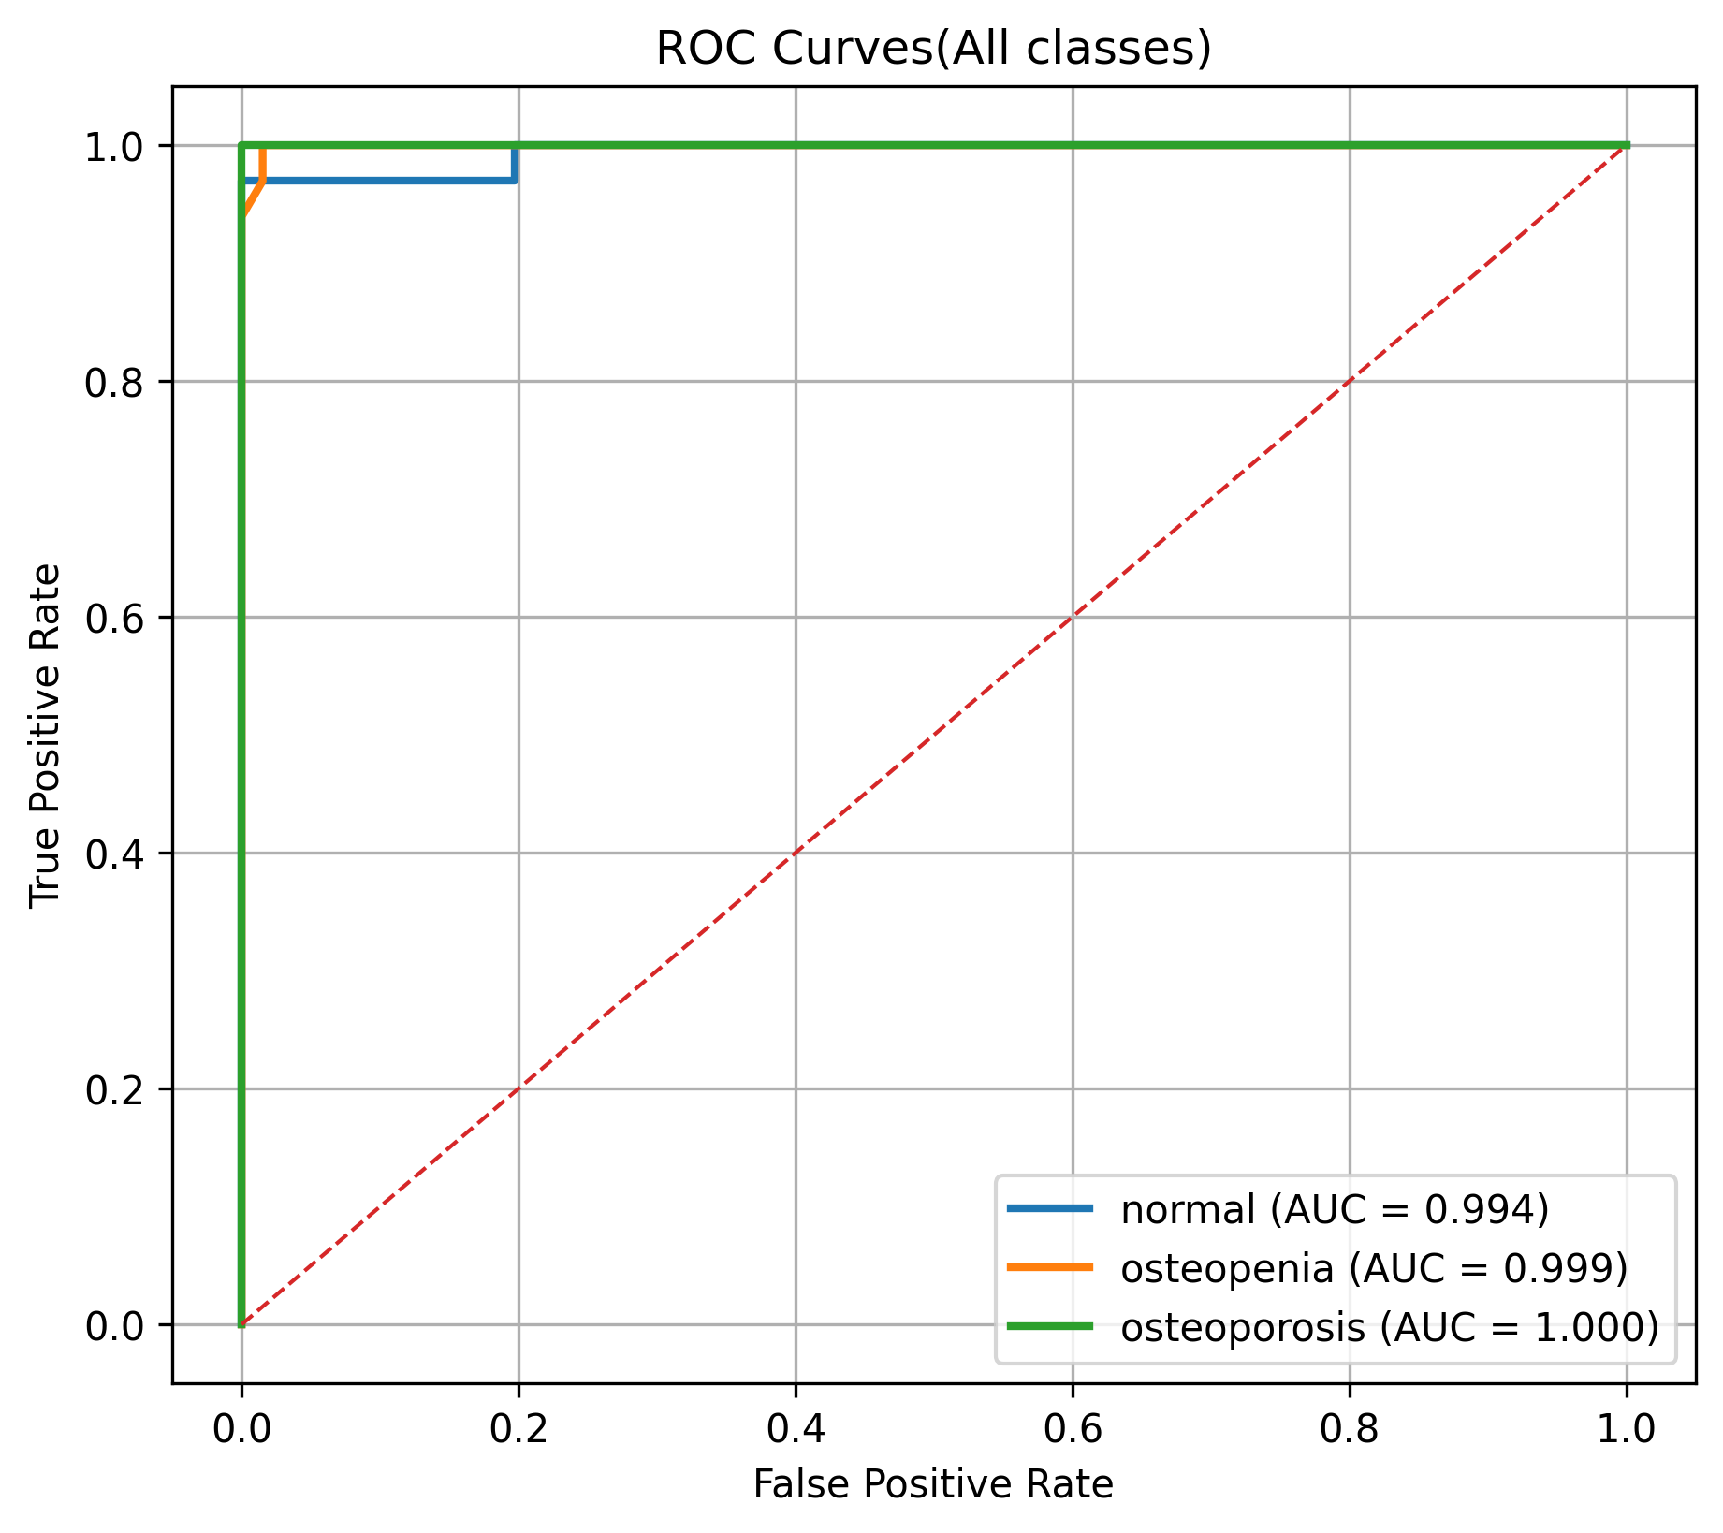
Figure 4: ROC Curves for All Classes

DFD / ER DIAGRAMS

DFD Level 0 — Context Diagram
The Level 0 DFD (Context Diagram) shows the system as a single process, with external entities and data flows at the highest level of abstraction.
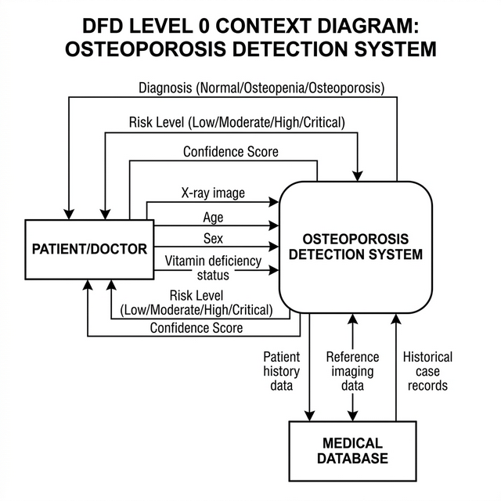
Figure 5: DFD Level 0 — Context Diagram

DFD Level 1 — System Decomposition
The Level 1 DFD decomposes the system into four major sub-processes: Image Preprocessing, Ensemble Prediction, Clinical Adjustment, and Risk Assessment.
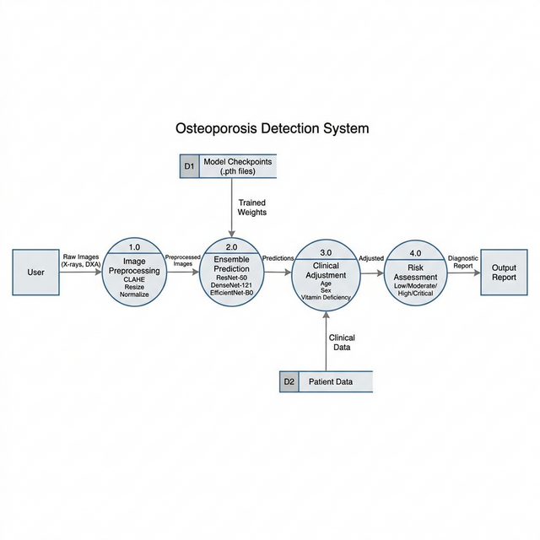
Figure 6: DFD Level 1 — System Decomposition

Process | Description
1.0 Image Preprocessing | Applies CLAHE, resizes to 384x384, normalises the X-ray image
2.0 Ensemble Prediction | Runs ResNet-50, DenseNet-121, EfficientNet-B0 with TTA; weighted soft voting
3.0 Clinical Adjustment | Applies Bayesian prior using patient age, sex, and vitamin deficiency
4.0 Risk Assessment | Determines urgency level: Low / Moderate / High / Critical

CODES & SCREENSHOTS

Key Source Files
File | Purpose
backend/app.py | FastAPI server — defines /predict endpoint and CORS settings
backend/model.py | Core inference — ensemble, TTA, clinical adjustment
backend/dataset.py | Dataset class, data loaders, transforms, model definitions
backend/train.py | Training pipeline with early stopping and checkpointing
frontend/index.html | Main web page — form, upload zone, results display
frontend/script.js | API calls, response rendering, drag-and-drop logic
frontend/styles.css | Dark-themed responsive CSS styling

Code Snippet 1: CLAHE Preprocessing (dataset.py)
class CLAHETransform:
def __init__(self, clip_limit=2.0, tile_grid_size=(8, 8)):
self.clip_limit = clip_limit
self.tile_grid_size = tile_grid_size
def __call__(self, pil_img):
img_array = np.array(pil_img.convert("L"))
clahe = cv2.createCLAHE(
clipLimit=self.clip_limit,
tileGridSize=self.tile_grid_size
)
enhanced = clahe.apply(img_array)
enhanced_rgb = cv2.cvtColor(enhanced, cv2.COLOR_GRAY2RGB)
return Image.fromarray(enhanced_rgb)

Code Snippet 2: Weighted Ensemble with TTA (model.py)
ENSEMBLE_WEIGHTS = [0.40, 0.35, 0.25]
def tta_predict(model, x):
probs = torch.zeros((1, 3)).to(device)
with torch.no_grad():
for tf in tta_transforms:
probs += F.softmax(model(tf(x)), dim=1)
return probs / len(tta_transforms)
def ensemble_predict(models, x):
return sum(w * tta_predict(m, x)
for m, w in zip(models, ENSEMBLE_WEIGHTS))

Code Snippet 3: Clinical Covariate Adjustment (model.py)
def clinical_adjust(probs_tensor, age, sex, vitamin_def):
probs = probs_tensor.detach().cpu().numpy().flatten()
risk_mult = np.ones(3)
if age >= 70:
risk_mult[0] *= 0.70; risk_mult[2] *= 1.50
if sex.lower() == "female" and age >= 65:
risk_mult[2] *= 1.40
if vitamin_def:
risk_mult[2] *= 1.35
adjusted = probs * risk_mult
adjusted = adjusted / adjusted.sum()
return torch.tensor(adjusted, dtype=torch.float32).unsqueeze(0)

Code Snippet 4: FastAPI Prediction Endpoint (app.py)
@app.post("/predict")
async def predict(
age: int = Form(...), sex: str = Form(...),
vitamin_deficiency: bool = Form(...),
xray: UploadFile = File(...)
):
img = preprocess_image(xray.file)
base_probs = ensemble_predict(models, img)
adjusted_probs = clinical_adjust(base_probs, age, sex, vitamin_deficiency)
pred_idx = adjusted_probs.argmax(1).item()
prediction = classes[pred_idx]
urgency, message = assess_risk(prediction, age, sex, vitamin_deficiency)
return {"prediction": prediction, "urgency": urgency, ...}

API TEST REPORT
The API test suite validates all backend endpoints of the Osteoporosis Detection System. Tests were run against the new ensemble (ResNet-50 + DenseNet-121 + EfficientNet-B0) using the api_test.py script.

Test Summary
Metric | Value
Total Tests | 12
Tests Passed | 12
Tests Failed | 0
Pass Rate | 100%
Backend URL | http://127.0.0.1:8000
Models Under Test | ResNet-50 + DenseNet-121 + EfficientNet-B0

Test Case Details
No. | Endpoint | Test Case | Result | HTTP Status
1 | GET / | Health Check | PASS | 200
2 | POST /predict | Valid Normal X-ray (Male, 45) | PASS | 200
3 | POST /predict | Valid Osteopenia X-ray (Female, 62) | PASS | 200
4 | POST /predict | Valid Osteoporosis X-ray (Female, 72) | PASS | 200
5 | POST /predict | Missing X-ray file (validation error) | PASS | 422
6 | POST /predict | Missing age field | PASS | 422
7 | POST /predict | Missing sex field | PASS | 422
8 | POST /predict | Invalid file type (text/plain) | PASS | 400
9 | POST /predict | Elderly female (80) with vitamin def | PASS | 200
10 | POST /predict | Young male (25), no risk factors | PASS | 200
11 | GET /predict | Wrong HTTP method | PASS | 405
12 | GET /nonexistent | 404 Not Found | PASS | 404

API Endpoint Specification

GET /
Returns the health status and model information.
Response:
{"status": "ok", "model": "ensemble (ResNet50 + DenseNet121 + EfficientNet-B0)"}

POST /predict
Classifies a knee X-ray image and returns a risk assessment.
Parameter | Type | Required | Description
xray | File (JPG/PNG) | Yes | Knee X-ray image
age | Integer | Yes | Patient age (1-120)
sex | String | Yes | "Male" or "Female"
vitamin_deficiency | Boolean | Yes | History of vitamin deficiency

Sample Response:
{
"prediction": "osteopenia",
"confidence": 0.6234,
"class_probabilities": {
"normal": 0.1823,
"osteopenia": 0.6234,
"osteoporosis": 0.1943
},
"urgency": "High",
"message": "High risk: post-menopausal age group.",
"patient": {"age": 65, "sex": "Female", "vitamin_deficiency": true}
}

CONCLUSION

Summary
This project successfully developed and deployed an AI-powered web application for osteoporosis detection from knee X-ray images. The system leverages an ensemble of three state-of-the-art CNNs — ResNet-50, DenseNet-121, and EfficientNet-B0 — trained on 560 augmented knee X-ray images and evaluated on a balanced held-out test set of 99 images, achieving a final test accuracy of 95.96%.

Key Achievements
- 95.96% overall test accuracy — up from a baseline of ~74% with the previous AlexNet-based ensemble
- Perfect precision (1.00) for Osteoporosis class — zero false positives for the most critical condition
- Novel Bayesian prior clinical covariate adjustment using patient demographics
- Complete full-stack deployment: FastAPI REST API + responsive dark-themed web frontend
- 12/12 API tests passing — 100% endpoint reliability
- Test-Time Augmentation (5 transforms) for more stable predictions

Limitations
- Trained on a relatively small dataset (659 total images) — larger datasets would improve generalization
- The system is a screening aid, not a replacement for clinical diagnosis by qualified radiologists
- CPU inference takes ~2-3 seconds per image; GPU deployment would enable real-time performance

Future Work
- Expand dataset using public sources (MURA, OAI, RSNA)
- Add Grad-CAM heatmap visualisation for model explainability
- Incorporate multi-view X-ray analysis (lateral + AP views)
- Deploy on cloud server (Render, Railway, or AWS) for public access
- Develop a mobile application for rural/remote healthcare settings

References
1. He, K., Zhang, X., Ren, S., & Sun, J. (2016). Deep Residual Learning for Image Recognition. CVPR 2016.
2. Huang, G., Liu, Z., et al. (2017). Densely Connected Convolutional Networks. CVPR 2017.
3. Tan, M., & Le, Q. (2019). EfficientNet: Rethinking Model Scaling for CNNs. ICML 2019.
4. Zuiderveld, K. (1994). Contrast Limited Adaptive Histogram Equalization. Graphics Gems IV.
5. World Health Organization (2023). Osteoporosis and Musculoskeletal Conditions. WHO Report.
6. FastAPI Documentation (2024). https://fastapi.tiangolo.com

