Predictive Maintenance of Journal Bearing Shells Using Machine Learning

Abstract
This project investigates the application of machine learning methods for predictive maintenance of journal bearing shells using experimental data obtained from Journal Bearing Adapter (JBA) tests. Multiple sensor signals, including torque, speed, temperature, load, and acoustic emission measurements, are analyzed to model frictional behavior during repeated start–stop cycles. Several regression models are trained and evaluated to predict the coefficient of friction, and their performance is compared using standard statistical metrics. The results demonstrate that data-driven approaches can accurately capture tribological behavior and support condition monitoring and predictive maintenance applications.

Introduction

Background

Journal bearings are critical components in many mechanical systems, where excessive friction and wear can lead to performance degradation or failure. Understanding frictional behavior under realistic operating conditions, such as repeated start–stop cycles, is essential for improving reliability and enabling predictive maintenance strategies. Traditional physics-based models often require detailed material and contact information and may not fully capture complex nonlinear effects.

Objectives
The objective of this project is to apply machine learning techniques to experimental journal bearing data in order to predict friction-related quantities from sensor measurements. The specific goals are:
- To preprocess and analyze multi-sensor tribological data,
- To train and compare different regression models,
- To evaluate their predictive performance using statistical metrics,
- To assess the suitability of machine learning methods for predictive maintenance of bearing shells.

Related Work

Machine learning methods have been increasingly applied in the field of tribology and predictive maintenance to model friction, wear, and degradation processes in mechanical systems. Traditional approaches often rely on physics-based models, which require detailed knowledge of material properties and contact conditions and may struggle to capture complex nonlinear behavior under varying operating conditions.
Recent studies have shown that data-driven methods, such as regression models and neural networks, can effectively learn relationships between sensor measurements (e.g., torque, speed, temperature, acoustic emission signals) and tribological quantities like the coefficient of friction or wear. Ensemble-based models, such as Random Forests, have been reported to provide robust performance due to their ability to handle nonlinearities and interactions between multiple input features. Neural-network-based approaches, including multi-layer perceptrons, have also been explored, particularly for capturing temporal dependencies in tribological time-series data.
In this project, a data-driven machine learning approach is applied to experimental Journal Bearing Adapter (JBA) data, where multiple regression models are trained and compared to predict the coefficient of friction based on sensor measurements and derived physical features.

Methods

Data Acquisition

The dataset used in this project originates from Journal Bearing Adapter (JBA) experiments conducted at Montanuniversität Leoben. The experiments involve repeated start–stop cycles of a journal bearing system operating mainly in the hydrodynamic lubrication regime. Sensor signals are recorded at 10 Hz over the entire test duration and at 1 kHz for selected cycles, including torque, rotational speed, normal load, temperatures, contact potential, and acoustic emission (AE) RMS values.

Data Preprocessing
The raw data is first cleaned by removing duplicate entries and handling missing values using numerical conversion and filtering. Outliers are inspected and removed using statistical criteria. Relevant physical quantities are computed, such as frictional power and acoustic emission energy. The data is then normalized using standardization, and finally split into training, validation, and test datasets.

Model Training
Two regression models are implemented and evaluated:
- Random Forest Regressor, representing an ensemble-based machine learning approach,
- Multi-Layer Perceptron (MLP), representing a neural-network-based method.
Both models are trained to predict the coefficient of friction using sensor measurements and derived features as inputs.

Results

Data Exploration
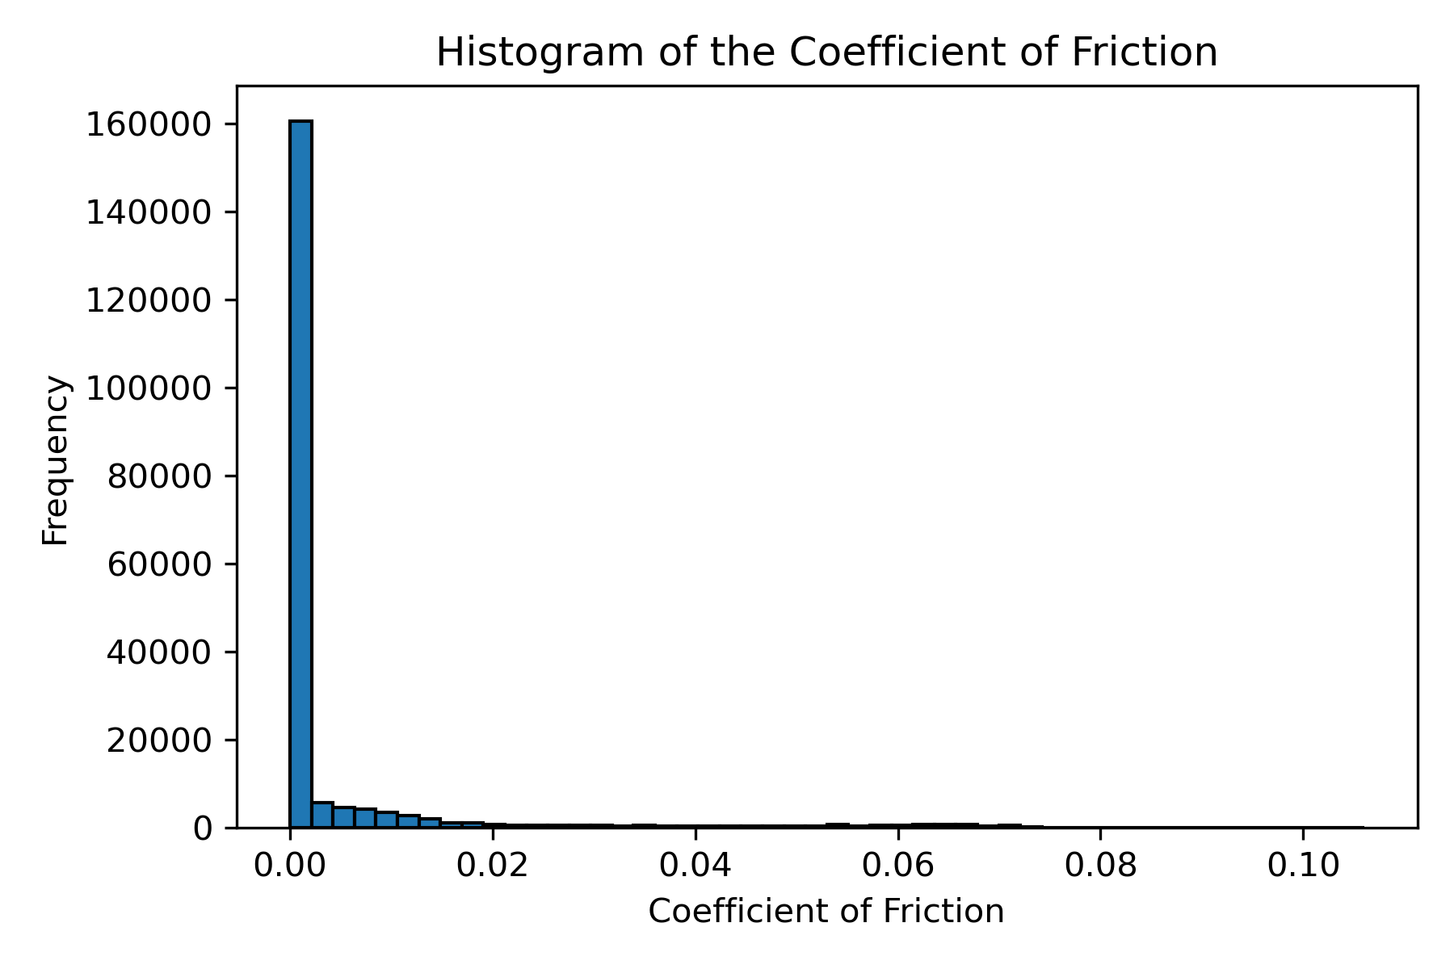
Figure 1: Histogram of the coefficient of friction showing its distribution across the dataset.

Table 1: Summary statistics of selected input features.
Feature | Mean | Std | Min | Max
Specimen Speed (rpm) | 85.5 | 139 | 0 | 503
Load (kN) | 0.30 | 0.002 | 0.289 | 0.314
Torque (Nm) | 0.34 | 0.95 | -0.016 | 7.69
AE RMS (V) | 0.41 | 0.96 | -0.105 | 5.73
Oil Bath Temp (°C) | 119.5 | 6.9 | 25 | 130
Friction Coefficient | 0.0046 | 0.013 | 0 | 0.106

Model Comparison
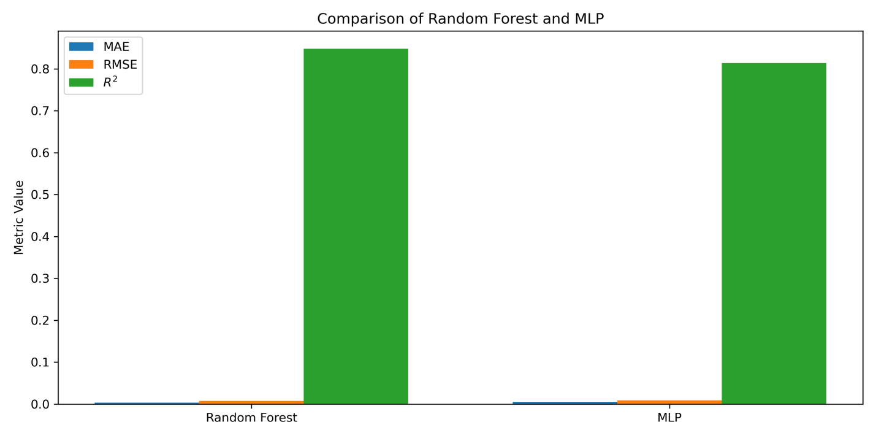
Figure 2: Comparison of regression model performance on the test set using RMSE, MAE, and $R^{2}$.

Random Forest Performance
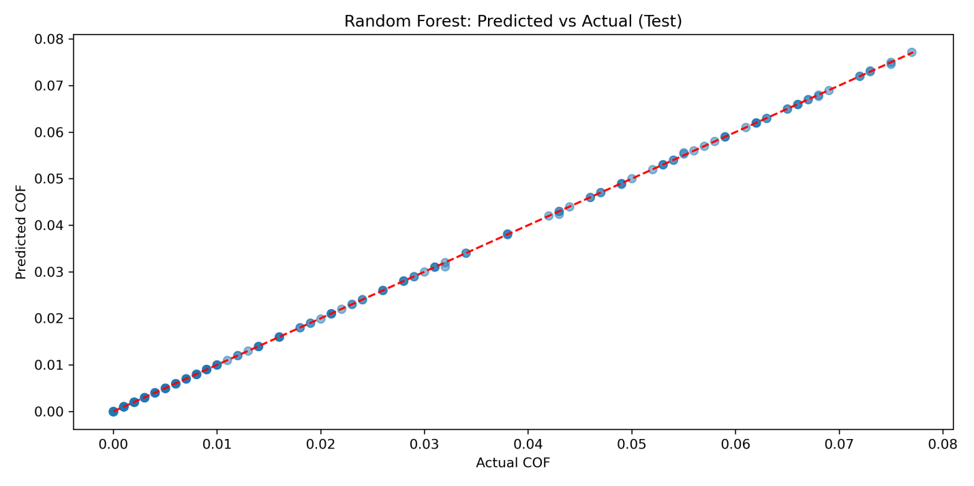
Figure 3: Predicted vs Actual coefficient of friction for the Random Forest model on the test dataset.

Feature Analysis
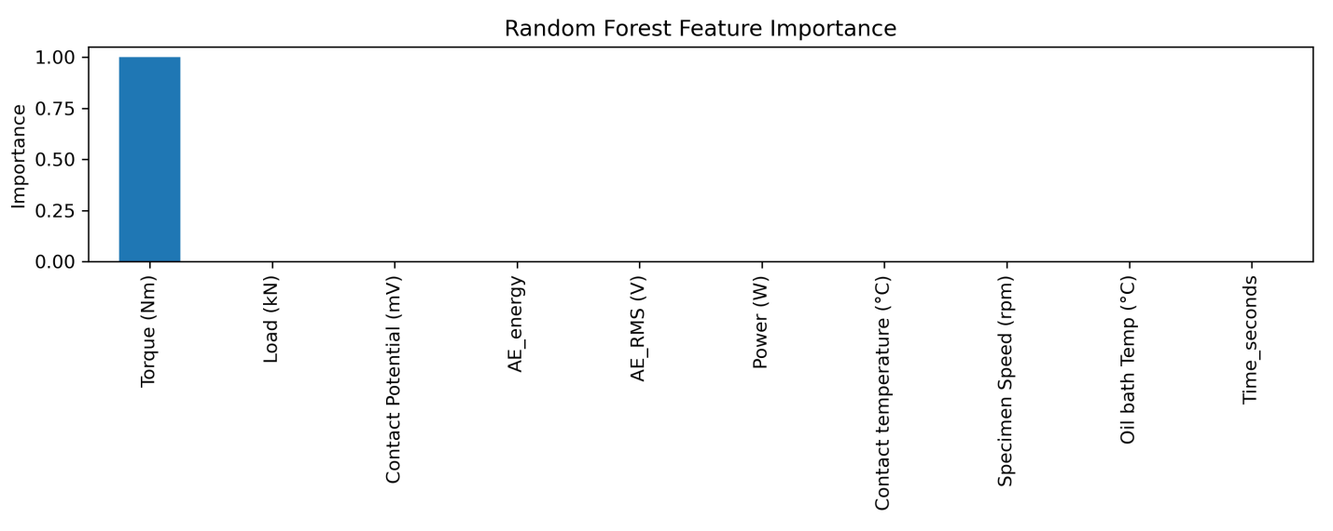
Figure 4: Feature importance obtained from the Random Forest model.

Evaluation Methodology
The performance of the implemented models is evaluated on a held-out test dataset. Root Mean Square Error (RMSE), Mean Absolute Error (MAE), and the coefficient of determination (R²) are used as evaluation metrics, as they are standard measures for regression problems and allow quantitative comparison between different models.

Model Performance

Table 2: Performance comparison of regression models on the test dataset.
Model | RMSE (Test) | MAE (Test) | R² (Test)
Random Forest | 1.20 × 10⁻⁴ | 3.17 × 10⁻⁵ | 0.99997
MLP Regressor | 4.82 × 10⁻² | 1.49 × 10⁻² | −4.07

The Random Forest model achieves very high predictive accuracy, while the MLP model shows significantly worse generalization performance on the test set.

Feature Importance and Visual Analysis

Feature importance analysis indicates that torque is the dominant input variable for predicting the coefficient of friction, while other parameters such as load, temperature, and acoustic emission contribute less significantly. Additional visualizations, including histograms and predicted-versus-actual plots, further support the quantitative findings.

Discussion
The results demonstrate that the Random Forest model is highly effective for modeling friction behavior in journal bearings based on sensor data. Its robustness against overfitting and ability to capture nonlinear relationships explain its superior performance compared to the MLP model. The poor generalization of the MLP suggests sensitivity to data scaling, model configuration, or limited suitability for this specific regression task. Overall, the findings highlight the importance of model selection when applying machine learning to tribological systems.

Limitations
The analysis is based on data obtained from a single experimental setup and a limited range of operating conditions, which may restrict the generalizability of the results to other bearing systems or lubrication regimes. Temporal dependencies between start–stop cycles are not explicitly modeled, as advanced time-series approaches such as Long Short-Term Memory (LSTM) networks were not fully explored. Furthermore, the wear measurements in the dataset exhibit no significant variability, which prevents their effective use as prediction targets and limits the analysis primarily to friction-related quantities.

Conclusion
In this project, a complete machine learning pipeline for predictive maintenance of journal bearing shells was implemented and evaluated. The Random Forest model achieved excellent predictive performance for estimating the coefficient of friction from sensor data, demonstrating the potential of data-driven approaches in tribological monitoring. Future work could include the use of time-series models, additional experimental datasets, and the prediction of long-term wear or failure indicators.

Acknowledgements
The dataset and experimental setup were provided by Montanuniversität Leoben. The project was developed as part of the Applied Machine and Deep Learning course. ChatGPT was used as a supporting tool for code structuring, debugging assistance, and academic text refinement.

