PROJECT REPORT
SMART ELECTRICITY CONSUMPTION ANALYZER USING STATISTICAL ANOMALY DETECTION

Submitted By
Angel Agarwal

Project Domain
Data Analytics | Time-Series Analysis | Statistical Anomaly Detection

Technologies Used
Python | FastAPI | Pandas | NumPy | Matplotlib | Seaborn | SciPy

Project Description
A data-driven energy analytics system that detects abnormal electricity consumption patterns using Modified Z-Score and Median Absolute Deviation (MAD), provides consumption insights, estimates potential savings, and forecasts future energy costs through statistical analysis and visualization.

Project Links
Portfolio: https://angelagarwal2.github.io/my_portfolio/
GitHub: https://github.com/angelagarwal2
LinkedIn: https://www.linkedin.com/in/angel-agarwal-97794432a/

Date
April 2026

ACKNOWLEDGEMENT
I would like to express my sincere gratitude to everyone who contributed directly or indirectly to the completion of this project.
This project, titled "Smart Electricity Consumption Analyzer using Statistical Anomaly Detection," provided me with an opportunity to apply concepts from data analytics, statistical modeling, and software development to a real-world problem. Throughout the development process, I gained valuable hands-on experience in data preprocessing, feature engineering, anomaly detection using Modified Z-Score and Median Absolute Deviation (MAD), API development with FastAPI, and data visualization techniques.
I would also like to acknowledge the open-source community and the developers of Python libraries such as Pandas, NumPy, Matplotlib, Seaborn, SciPy, and FastAPI, whose tools and documentation greatly assisted in the successful implementation of this project.
Finally, I am grateful for the continuous learning opportunities, resources, and encouragement that helped me complete this work and enhance my understanding of data-driven problem solving.

ABSTRACT
Electricity consumption monitoring has become increasingly important for reducing energy wastage, optimizing resource utilization, and lowering operational costs. Traditional billing systems provide information about total energy usage but often fail to identify abnormal consumption patterns that may result from faulty appliances, inefficient energy usage, or unexpected power drain.
This project, "Smart Electricity Consumption Analyzer using Statistical Anomaly Detection," presents a data-driven solution for analyzing electricity consumption data and identifying unusual usage behavior. The system utilizes robust statistical techniques, including Median Absolute Deviation (MAD) and Modified Z-Score, to detect anomalies in electricity consumption records. By using median-based statistics instead of conventional mean-based approaches, the system remains effective even in the presence of extreme outliers.
The proposed solution is implemented using FastAPI, Pandas, NumPy, Matplotlib, and Seaborn. The application accepts electricity consumption data in CSV format, performs preprocessing and statistical analysis, detects anomalous consumption patterns, estimates expected energy costs, identifies potential savings opportunities, and predicts future consumption trends using rolling mean analysis. Additionally, a visualization dashboard provides graphical insights through trend analysis, probability density distributions, anomaly intensity mapping, and consumption classification plots.
The system was evaluated on a custom energy consumption dataset containing approximately 300 time-series observations. Experimental results demonstrate the effectiveness of the proposed approach in identifying abnormal energy usage and generating actionable recommendations for energy optimization.
The developed system can be applied in residential buildings, smart homes, utility monitoring systems, and energy management platforms to support informed decision-making and promote efficient energy utilization.

TABLE OF CONTENTS

S. No. | Contents | Page No.
1 | Acknowledgement | i
2 | Abstract | ii
3 | Introduction | 1
3.1 | Background | 1
3.2 | Problem Statement | 2
3.3 | Objectives | 2
3.4 | Scope of the Project | 3
4 | Literature Review | 4
5 | System Design and Architecture | 5
5.1 | System Workflow | 5
5.2 | Technology Stack | 5
5.3 | Architecture Diagram | 6
6 | Dataset Description | 7
6.1 | Dataset Overview | 7
6.2 | Features Used | 8
6.3 | Data Preprocessing | 8
7 | Methodology | 9
7.1 | Median | 9
7.2 | Median Absolute Deviation (MAD) | 10
7.3 | Modified Z-Score | 10
7.4 | Rolling Mean Analysis | 11
7.5 | Consumption Forecasting | 11
8 | Implementation | 12
8.1 | FastAPI Backend | 12
8.2 | CSV Processing Pipeline | 13
8.3 | Anomaly Detection Engine | 13
8.4 | Visualization Dashboard | 14
9 | Results and Analysis | 15
9.1 | Trend Analysis | 15
9.2 | Anomaly Detection Results | 16-17
9.3 | Potential Savings Analysis | 18
10 | Real-World Applications | 19
11 | Limitations | 20
12 | Future Enhancements | 21
13 | Conclusion | 22
14 | References | 23

3. INTRODUCTION
Electricity is a vital resource that powers homes, industries, and commercial establishments. With rising energy demand, efficient monitoring of electricity consumption has become essential for reducing costs and minimizing energy wastage. However, traditional billing systems provide limited insights into consumption behavior, making it difficult for users to identify unusual spikes in usage.
The Smart Electricity Consumption Analyzer using Statistical Anomaly Detection is designed to address this challenge by analyzing electricity consumption data and identifying abnormal usage patterns through statistical techniques. The system leverages robust statistical measures such as Median Absolute Deviation (MAD) and Modified Z-Score to detect anomalies while minimizing the influence of extreme outliers. In addition to anomaly detection, the system estimates expected consumption, calculates potential savings opportunities, predicts future electricity costs, and generates actionable recommendations for users.
The project is developed using FastAPI, Pandas, NumPy, Matplotlib, Seaborn, and SciPy. By combining data preprocessing, statistical analysis, forecasting, and visualization, the system transforms raw consumption data into actionable insights, helping users optimize energy usage and reduce costs.

3.1 BACKGROUND
Energy consumption analysis plays an important role in efficient resource management and cost optimization. Modern households and organizations generate electricity usage data that can be analyzed to identify consumption patterns and inefficiencies.
Anomaly detection is a widely used data analytics technique that identifies observations that significantly differ from normal patterns. In the context of electricity consumption, anomalies may indicate excessive energy usage, malfunctioning appliances, faulty meters, or unusual operational behavior. Detecting such anomalies at an early stage can help consumers reduce unnecessary expenses and improve energy efficiency.
Traditional anomaly detection methods often rely on mean and standard deviation, which can be heavily influenced by extreme values. To overcome this limitation, this project employs robust statistical techniques based on median and Median Absolute Deviation (MAD). These methods provide more reliable anomaly detection in real-world datasets where outliers are common. The integration of these techniques with visualization and forecasting capabilities creates a practical tool for energy consumption monitoring and analysis.

3.2 PROBLEM STATEMENT
Electricity consumers often face unexpected increases in energy bills due to abnormal consumption patterns caused by factors such as faulty appliances, excessive energy usage, meter malfunctions, or inefficient consumption habits. Traditional billing systems provide only the total units consumed and the corresponding cost, offering limited information about the underlying usage behavior.
As a result, users are unable to identify unusual consumption patterns at an early stage and often discover problems only after receiving high electricity bills. There is a need for an intelligent system that can analyze consumption data, detect anomalies, estimate future costs, and provide actionable insights to support efficient energy management.
The primary challenge addressed in this project is the development of a data-driven solution capable of identifying abnormal electricity consumption patterns using robust statistical techniques while generating meaningful recommendations for users.

3.3 OBJECTIVES
The main objectives of this project are:
- To analyze electricity consumption data using statistical and analytical techniques.
- To detect abnormal consumption patterns using Modified Z-Score and Median Absolute Deviation (MAD).
- To identify potential energy wastage and estimate possible cost savings.
- To forecast future electricity consumption trends using historical usage data.
- To provide users with actionable recommendations for improving energy efficiency.
- To visualize consumption patterns and anomaly trends through an interactive analytical dashboard.
- To develop a scalable backend solution using FastAPI for processing and analyzing consumption data.
- To promote efficient energy utilization through data-driven decision making.

3.4 SCOPE OF THE PROJECT
The scope of this project is focused on the analysis of electricity consumption data to identify abnormal usage patterns and provide meaningful insights for energy management. The system is designed to process historical electricity consumption records, detect anomalies using statistical techniques, estimate expected consumption, and forecast future energy costs.
The project can be applied in residential households, apartments, offices, educational institutions, and small commercial establishments where monitoring electricity usage is important for reducing operational costs and improving energy efficiency. By identifying unusual consumption behavior, the system helps users take corrective actions before excessive energy costs occur.
In addition to anomaly detection, the project provides data visualization and trend analysis capabilities that enable users to better understand their consumption patterns. The system also estimates potential savings opportunities and generates recommendations for optimizing electricity usage.
Although the current implementation uses historical CSV-based data, the framework can be extended to support real-time smart meter data, IoT-based monitoring systems, machine learning models, and mobile or web-based energy management applications. This makes the proposed solution scalable and adaptable for future energy analytics and smart city applications.

4. LITERATURE REVIEW
The increasing demand for electricity and the growing emphasis on energy conservation have led to the development of various techniques for monitoring and analyzing electricity consumption patterns. Traditional electricity management systems primarily focus on recording total energy usage and generating billing information. However, such systems often lack the capability to identify abnormal consumption behavior and provide actionable insights to users.
Researchers and industry professionals have explored several approaches for detecting anomalies in energy consumption data. Statistical methods such as Z-Score analysis, moving averages, and threshold-based monitoring are commonly used due to their simplicity and effectiveness. Among these techniques, anomaly detection has gained significant attention because it helps identify unusual patterns that may indicate faulty appliances, energy wastage, meter issues, or unexpected operational conditions.
Many modern energy analytics systems employ machine learning and artificial intelligence techniques to forecast consumption and detect anomalies. While these approaches can provide accurate results, they often require large labeled datasets, extensive training, and significant computational resources. In contrast, robust statistical methods offer a simpler and more interpretable solution for small and medium-sized datasets.
This project adopts a statistical approach based on Median Absolute Deviation (MAD) and Modified Z-Score. These techniques are less sensitive to extreme values than traditional mean-based methods and are therefore more suitable for real-world electricity consumption data. By combining anomaly detection, forecasting, and visualization, the proposed system provides an efficient and practical solution for energy consumption analysis and decision-making.

5. SYSTEM DESIGN AND ARCHITECTURE
The Smart Electricity Consumption Analyzer is designed as a data-driven analytical system that processes electricity consumption records, identifies anomalies, and generates meaningful insights. The architecture follows a modular approach consisting of data input, preprocessing, statistical analysis, forecasting, and visualization components. This design ensures scalability, maintainability, and ease of integration with future enhancements.

5.1 SYSTEM WORKFLOW
The system follows the following workflow:
- Upload electricity consumption data in CSV format.
- Validate and preprocess the dataset.
- Extract relevant consumption values.
- Compute Median and Median Absolute Deviation (MAD).
- Calculate Modified Z-Score for anomaly detection.
- Identify abnormal consumption patterns.
- Estimate expected consumption using rolling mean analysis.
- Calculate actual and expected electricity costs.
- Generate insights, recommendations, and savings estimates.
- Visualize results through analytical dashboards.

5.2 TECHNOLOGY STACK
The project is developed using the following technologies:
- Python – Core programming language.
- FastAPI – Backend framework for API development.
- Pandas – Data loading and preprocessing.
- NumPy – Statistical and numerical computations.
- Matplotlib – Data visualization.
- Seaborn – Advanced statistical plotting.
- SciPy – Spline interpolation and analytical computations.
These technologies provide an efficient environment for processing, analyzing, and visualizing electricity consumption data.

5.3 ARCHITECTURE DIAGRAM
The architecture of the proposed system can be represented as:
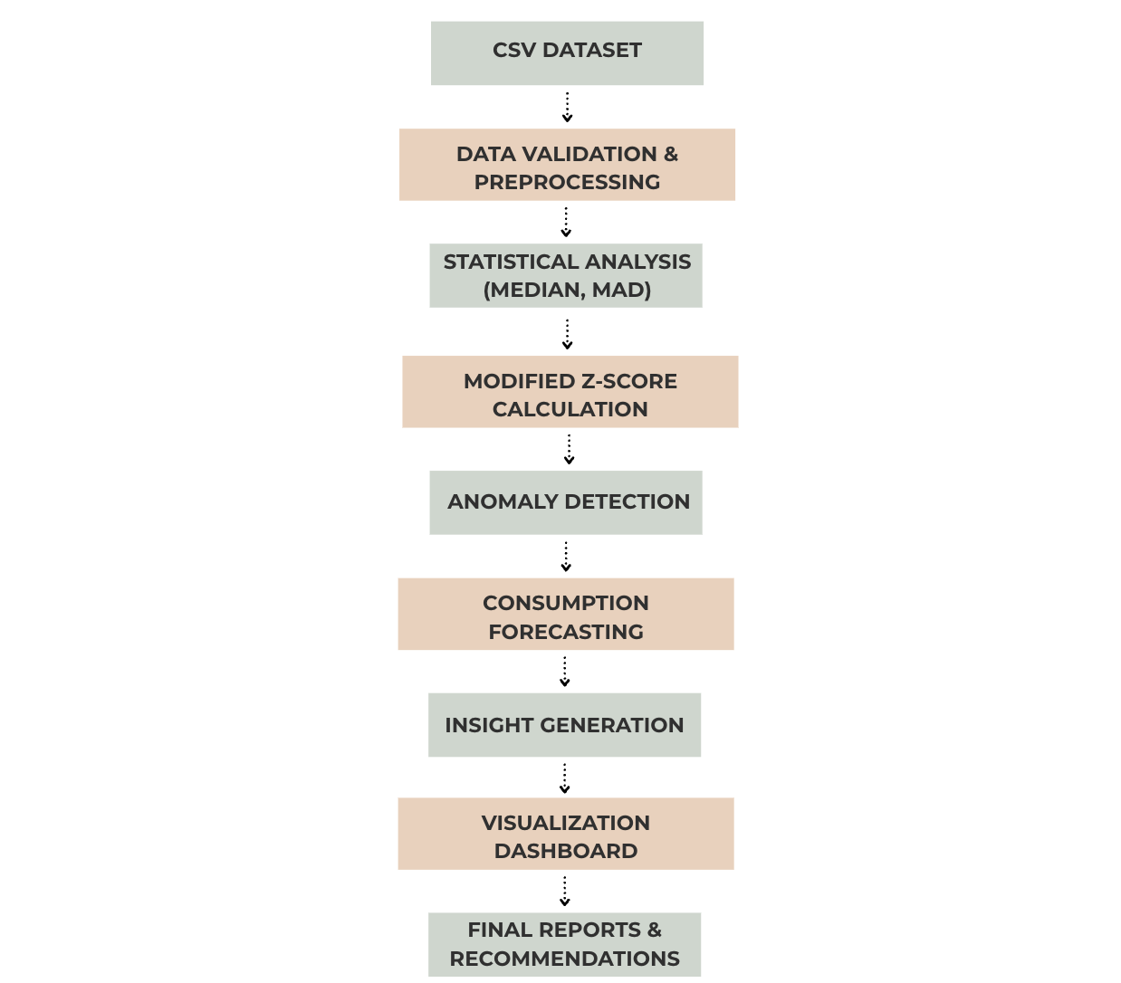
Figure 5.1: Architecture Diagram of the Smart Electricity Consumption Analyzer
The modular architecture enables efficient data processing while supporting future integration with smart meters, IoT devices, and machine learning-based forecasting systems.

6. DATASET DESCRIPTION
The performance of any analytical system depends on the quality and relevance of the data being analyzed. For this project, a custom electricity consumption dataset was used to evaluate anomaly detection, trend analysis, and forecasting capabilities.

6.1 DATASET OVERVIEW
The dataset consists of approximately 300 time-series observations representing electricity consumption records collected over sequential time periods. Each observation corresponds to the total number of electricity units consumed during a specific period.
The dataset was stored in CSV (Comma Separated Values) format, enabling easy processing and integration with Python-based analytical tools. The data was used to identify consumption patterns, detect anomalies, and estimate future energy costs.
Sample Table:
month | units
Jan | 157.45
Feb | 172.93
Mar | 203.02
Apr | 222.85
May | 189.79
Jun | 171.49
Jul | 173.69
Aug | 136.51
Sep | 99.66
Oct | 108.14
Nov | 99.75
Dec | 118.01

6.2 FEATURES USED
The following features were utilized in the project:
Feature Name | Description
Month | Time period associated with the consumption record
Units | Total electricity units consumed during the period
Rolling Mean | Expected consumption calculated using previous observations
Z-Score | Modified Z-Score used for anomaly detection
Is_Anomaly | Indicates whether a record is anomalous or normal
These features provide the necessary information for statistical analysis, forecasting, and anomaly detection.

6.3 DATA PREPROCESSING
Before analysis, the dataset undergoes several preprocessing steps to ensure data quality and consistency:
- Validation of CSV file format.
- Standardization of column names.
- Removal of unnecessary whitespace.
- Verification of required fields such as Month and Units.
- Conversion of numerical values into appropriate data types.
- Handling of missing values using suitable fallback strategies.
- Calculation of derived features including rolling mean and Modified Z-Score.
These preprocessing operations improve the reliability of statistical analysis and ensure accurate anomaly detection results.

7. METHODOLOGY
The analytical framework of the system employs a robust statistical methodology to evaluate electricity usage data and distinguish abnormal consumption behavior. This process integrates comprehensive data preprocessing, feature engineering, and advanced anomaly detection alongside forecasting and visualization components. By utilizing median-based metrics, the system maintains high performance and reliability, ensuring that extreme outliers do not skew the analytical results.
The methodological workflow is organized into five distinct phases: establishing the median baseline, calculating the Median Absolute Deviation (MAD), executing anomaly detection via Modified Z-Scores, evaluating expected usage patterns through rolling mean analysis, and generating future energy cost projections.

7.1 MEDIAN
As a fundamental measure of central tendency, the median identifies the central value within an ordered dataset. In contrast to the arithmetic mean, the median offers superior resistance to extreme data points, providing a more accurate and stable representation of typical energy consumption levels. This robustness is critical for establishing a dependable benchmark in time-series analysis.
To determine the median for a collection of observations, the data is sorted in ascending order to locate the middle element. For datasets with an even number of records, the median is derived from the mean of the two central values. This value functions as the primary reference point within the system to detect significant deviations in electricity usage. Within this project, the median serves as the core statistical anchor for measuring variance and identifying unusual shifts in energy consumption behavior.

7.2 MEDIAN ABSOLUTE DEVIATION (MAD)
Median Absolute Deviation (MAD) is a resilient statistical tool used to determine the dispersion of consumption records. The calculation involves finding the absolute difference between every observation and the dataset median, then determining the median of those resulting differences. This approach quantifies variability while minimizing the impact of non-representative spikes.
The preference for MAD over traditional standard deviation stems from its inherent stability when processing datasets containing outliers. This characteristic is especially beneficial for energy analytics, where temporary surges in power demand could otherwise distort the statistical profile of normal operational activity.
The resulting MAD value provides the necessary foundation for the Modified Z-Score, serving as the engine for detecting consumption anomalies within the proposed analytical solution.

7.3 MODIFIED Z-SCORE
Modified Z-Score is a robust statistical technique used to detect anomalies in a dataset. Unlike the traditional Z-Score, which relies on mean and standard deviation, the Modified Z-Score uses the median and Median Absolute Deviation (MAD), making it less sensitive to outliers.
The Modified Z-Score is calculated using the following formula:
Z = 0.6745 × (x − Median) / MAD
where:
- x = observed value
- Median = median of the dataset
- MAD = Median Absolute Deviation
In this project, a threshold value of 3.5 is used. Any observation with a Modified Z-Score greater than 3.5 is classified as an anomaly. This approach enables reliable identification of abnormal electricity consumption patterns.

7.4 ROLLING MEAN ANALYSIS
To estimate expected electricity consumption, the system employs a rolling mean approach. The rolling mean is calculated using the average consumption of the previous three observations.
This technique helps establish a baseline consumption level and allows comparison between actual and expected usage. By comparing current consumption against the rolling mean, the system can estimate potential excess consumption and identify unusual spikes in electricity usage.
The rolling mean also serves as the basis for estimating expected electricity costs and potential savings opportunities.

7.5 CONSUMPTION FORECASTING
The forecasting component predicts future electricity costs using recent consumption trends. The prediction is generated by calculating the average consumption of the most recent observations and converting it into an estimated bill amount.
Although simple, this forecasting approach provides users with a reasonable estimate of future electricity expenses based on historical usage patterns. The predicted values can assist users in planning energy consumption and budgeting future electricity costs.
The combination of anomaly detection, rolling mean analysis, and forecasting creates a comprehensive framework for monitoring electricity consumption and supporting data-driven energy management decisions.

8. IMPLEMENTATION
The implementation of the Smart Electricity Consumption Analyzer is divided into multiple modules responsible for data processing, anomaly detection, forecasting, and visualization. The system is developed using Python and follows a modular architecture to ensure scalability and maintainability.

8.1 FASTAPI BACKEND
FastAPI serves as the backend framework of the system. It provides a lightweight and efficient API that accepts electricity consumption datasets in CSV format and returns analytical insights.
The backend performs the following functions:
- Accepts CSV file uploads.
- Validates file format and structure.
- Processes electricity consumption records.
- Executes anomaly detection algorithms.
- Generates insights and predictions.
- Returns results in JSON format.
FastAPI was selected because of its high performance, automatic documentation support, and ease of integration with frontend applications.
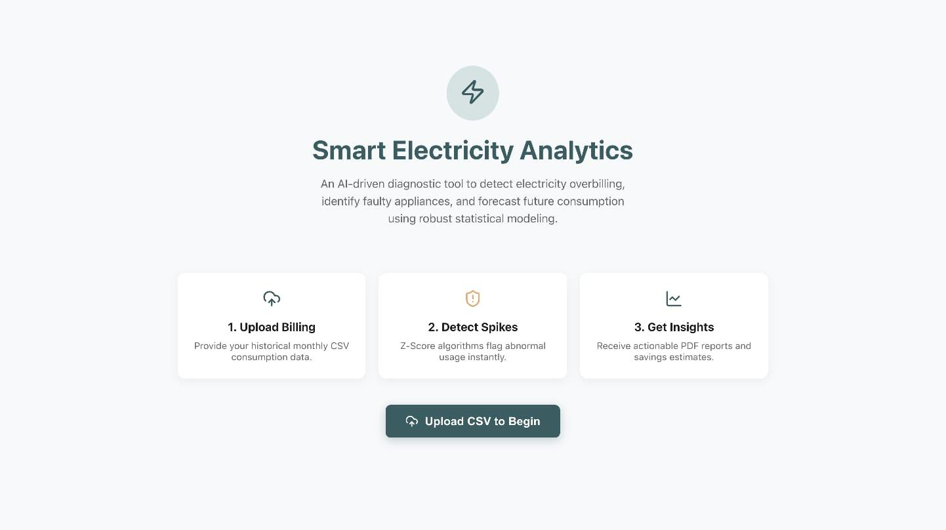
Figure 8.1: User Interface for CSV Upload and Analysis Initialization

8.2 CSV PROCESSING PIPELINE
The uploaded CSV file is processed using the Pandas library. The system first validates the dataset and verifies the presence of required columns such as Month and Units.
The preprocessing pipeline consists of:
- Reading the CSV file.
- Standardizing column names.
- Validating required attributes.
- Converting values to appropriate data types.
- Computing derived statistical features.
These steps ensure consistency and reliability of the data before analysis.

8.3 ANOMALY DETECTION ENGINE
The anomaly detection engine is the core component of the system. It utilizes robust statistical techniques based on Median Absolute Deviation (MAD) and Modified Z-Score.
The implementation process includes:
- Calculation of the dataset median.
- Computation of MAD.
- Determination of Modified Z-Score for each observation.
- Comparison against the predefined threshold value.
- Classification of observations as normal or anomalous.
The system also calculates actual and expected electricity costs and estimates potential savings for anomalous observations.
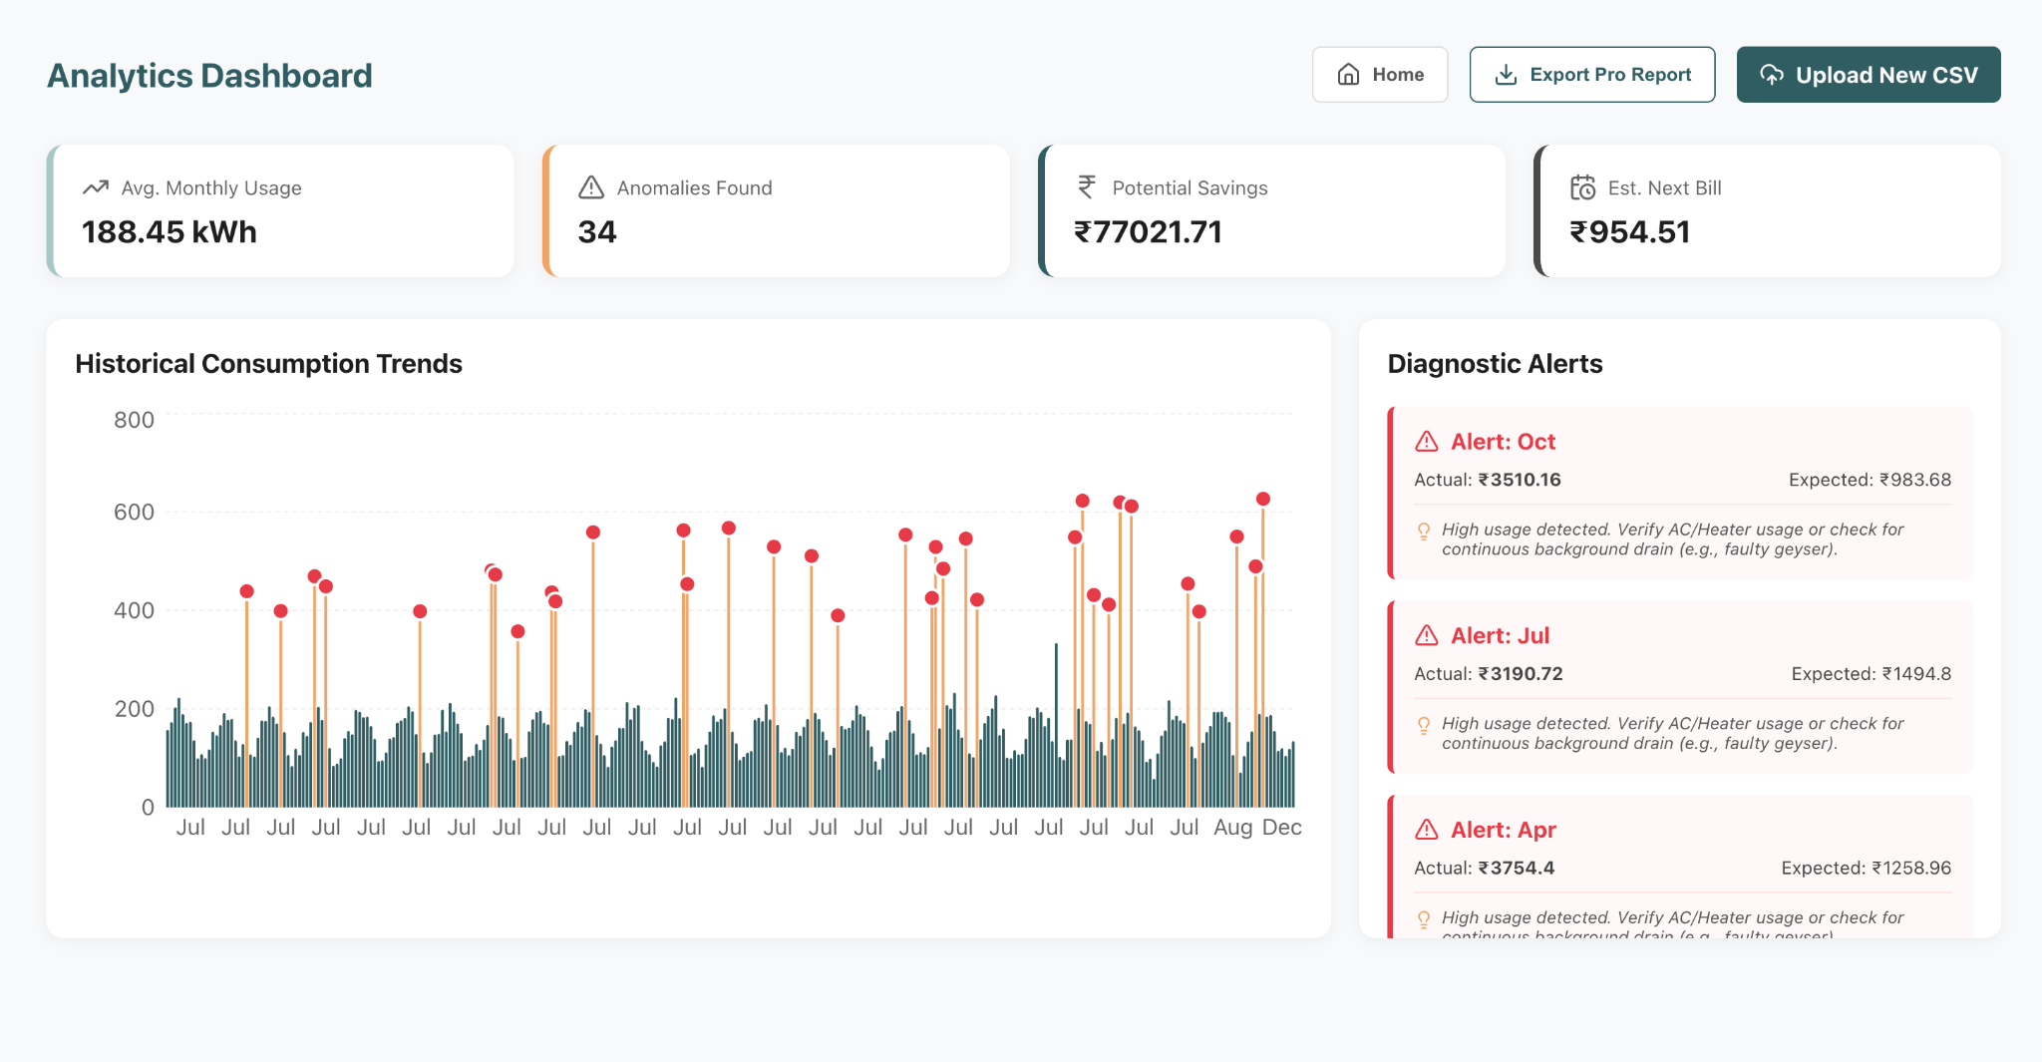

Figure 8.2: Electricity Consumption Analytics Dashboard

8.4 VISUALIZATION DASHBOARD
To improve interpretability, the system generates visual representations of electricity consumption data using Matplotlib and Seaborn.
The dashboard includes:
- Time-series trend analysis.
- Probability density distribution.
- Statistical anomaly intensity mapping.
- Normal versus anomalous consumption comparison.
These visualizations enable users to understand consumption behavior, identify unusual patterns, and make informed decisions regarding energy utilization.
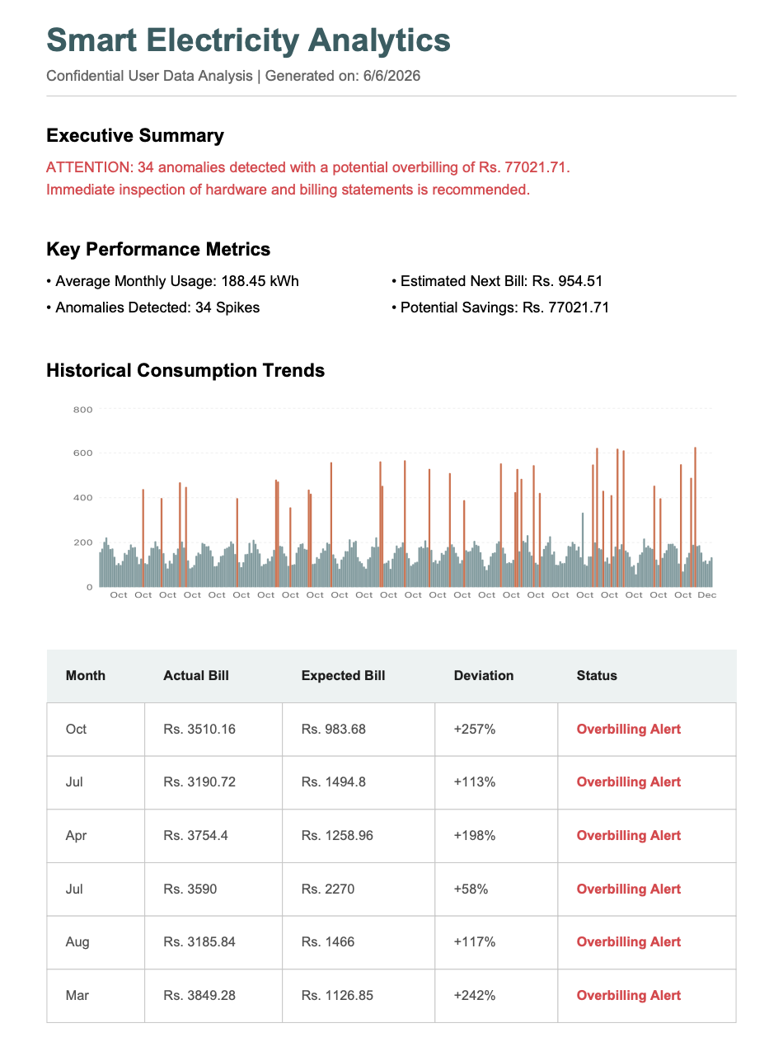
Figure 8.3: Automatically Generated Consumption Analysis Report

9. RESULTS AND ANALYSIS
The proposed system was evaluated using a custom electricity consumption dataset containing approximately 300 time-series observations. The analysis focused on identifying abnormal consumption patterns, estimating potential savings opportunities, forecasting future electricity costs, and visualizing consumption trends.

9.1 TREND ANALYSIS
The time-series visualization revealed the overall pattern of electricity consumption across different observation periods. Most observations followed a relatively stable trend, while certain periods exhibited noticeable spikes in consumption.
The analytical trend curve generated through spline interpolation helped identify long-term consumption behavior and highlighted periods of unusual activity. Such insights can assist users in understanding changes in their energy usage patterns over time.
The dashboard visualization shown in Figure 8.2 presents the historical consumption trend and highlights anomalous months. Months with unusually high electricity consumption are automatically flagged by the system for further investigation.
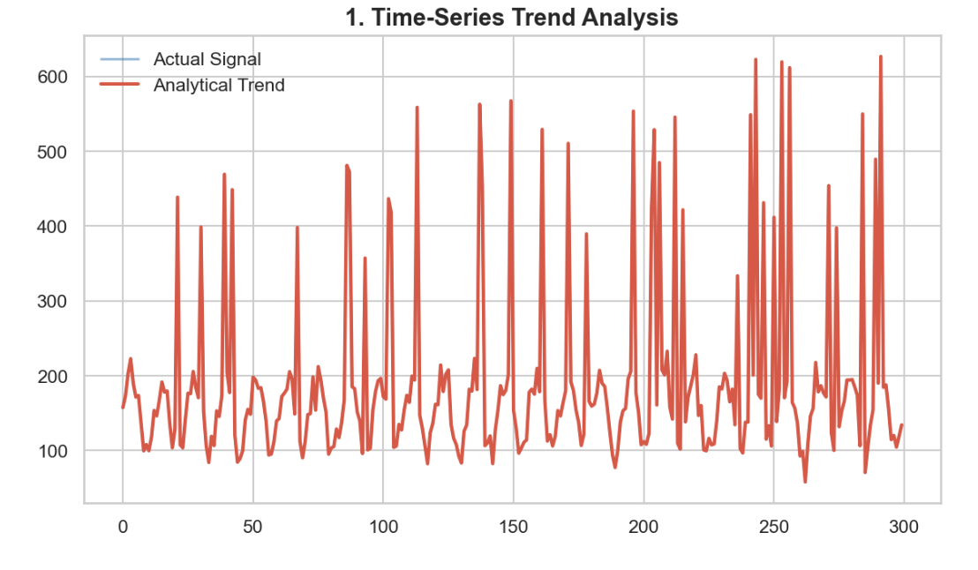
Figure 9.1: Time-Series Trend Analysis Graph

9.2 ANOMALY DETECTION RESULTS
The anomaly detection engine successfully identified observations that deviated significantly from normal consumption behavior. Using the Modified Z-Score method with a threshold value of 3.5, the system classified records as either normal or anomalous.
Detected anomalies may indicate:
- Excessive electricity usage.
- Faulty electrical appliances.
- Meter-related issues.
- Continuous background power consumption.
- Unusual operational activities.
The use of Median Absolute Deviation (MAD) improved robustness and reduced the influence of extreme outliers, resulting in reliable anomaly detection performance.
The anomaly detection engine successfully identified two significant consumption spikes. As illustrated in Figure 8.2 and Figure 8.3, the system generated diagnostic alerts and calculated expected versus actual electricity costs, enabling the estimation of potential savings opportunities.
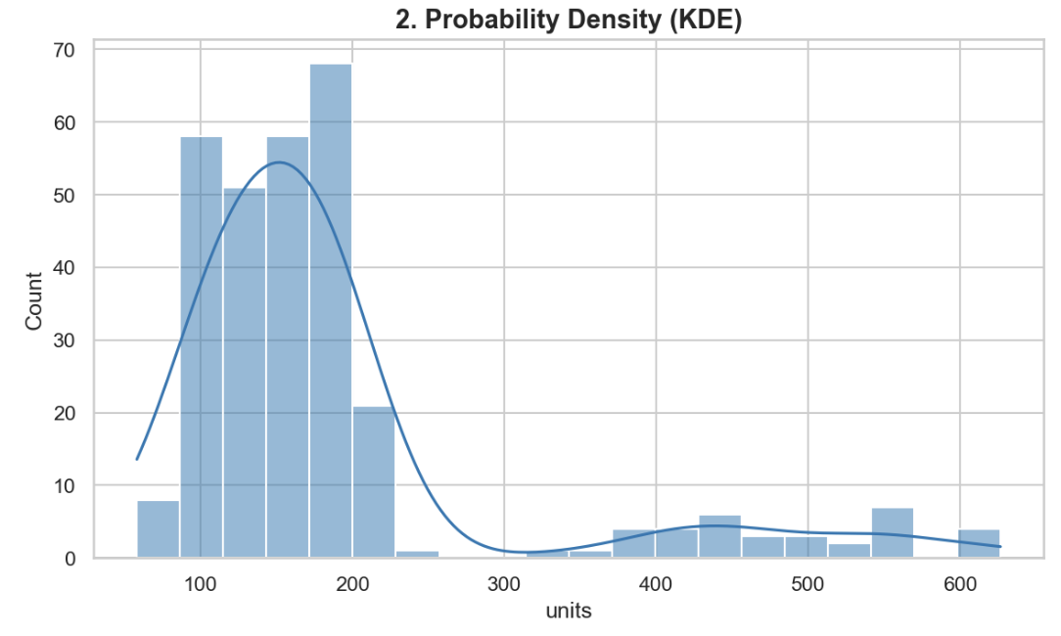
Figure 9.2: Probability Density (KDE)
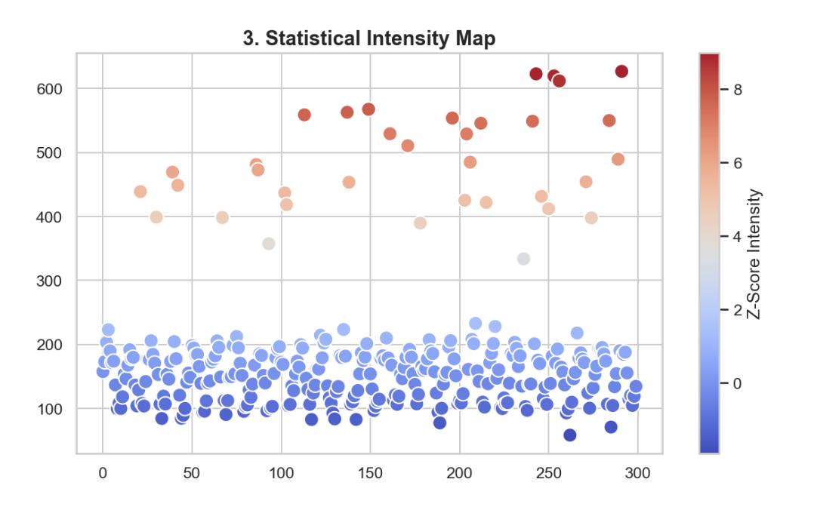
Figure 9.3: Anomaly Intensity Map
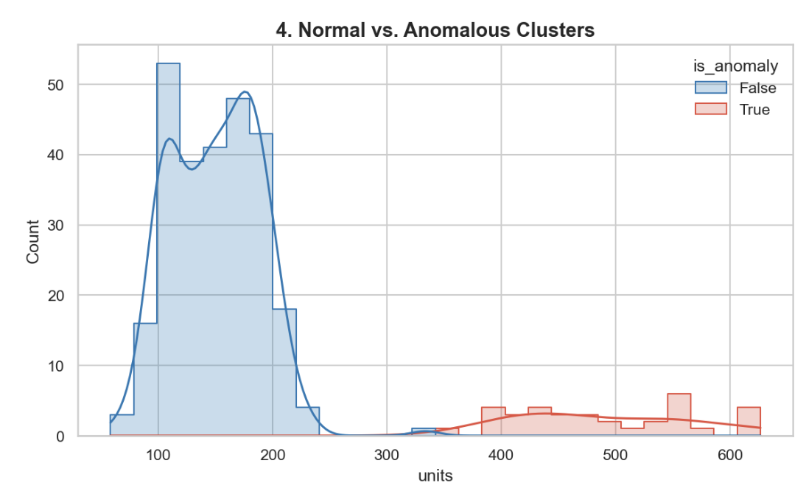
Figure 9.4: Normal vs Anomalous Consumption Distribution

9.3 POTENTIAL SAVINGS ANALYSIS
The system compared actual electricity consumption against expected consumption estimated through rolling mean analysis. This comparison enabled the identification of periods where excessive energy usage occurred.
For anomalous observations, the difference between actual and expected electricity costs was used to estimate potential savings opportunities. These insights help users understand the financial impact of abnormal consumption behavior and encourage more efficient energy usage practices.
The forecasting component further estimated future electricity costs based on recent consumption trends. Such predictions can assist users in planning energy usage and budgeting future electricity expenses.
Overall, the results demonstrate that the proposed system effectively combines anomaly detection, forecasting, and visualization to provide meaningful insights into electricity consumption behavior.
Based on rolling mean analysis and anomaly detection results, the system estimated a potential savings opportunity of approximately ₹77021.71. These insights can help users identify excessive energy consumption and reduce unnecessary expenditure.

10. REAL-WORLD APPLICATIONS
The Smart Electricity Consumption Analyzer can be applied in various domains where efficient energy management is essential. By identifying abnormal consumption patterns and providing actionable insights, the system helps users optimize electricity usage and reduce operational costs.
Some key applications include:

10.1 Residential Energy Monitoring
Homeowners can monitor electricity consumption, identify excessive energy usage, and detect faulty appliances before they lead to high electricity bills.

10.2 Smart Homes
The system can be integrated with smart home technologies to provide intelligent energy monitoring and automated alerts for unusual consumption patterns.

10.3 Commercial Buildings
Offices, educational institutions, and commercial establishments can utilize the system to track electricity usage and improve energy efficiency.

10.4 Utility and Energy Management Systems
Electricity providers can employ anomaly detection techniques to identify abnormal consumption behavior and improve operational efficiency.

10.5 Smart City Applications
The proposed framework can contribute to smart city initiatives by enabling data-driven energy monitoring and sustainable resource utilization.

11. LIMITATIONS
Although the proposed system effectively detects anomalies and provides consumption insights, certain limitations exist.
- The current implementation relies on historical CSV-based datasets and does not support real-time data collection.
- The forecasting component is based on rolling mean analysis and may not capture complex seasonal patterns.
- The system utilizes statistical methods rather than advanced machine learning algorithms.
- The accuracy of results depends on the quality and completeness of the input dataset.
- The project currently focuses on electricity consumption data and does not incorporate additional environmental or operational factors.
Despite these limitations, the system provides an efficient and practical solution for electricity consumption analysis.

12. FUTURE ENHANCEMENTS
Several improvements can be incorporated into future versions of the project to increase functionality and performance.
- Integration with IoT-enabled smart meters for real-time monitoring.
- Implementation of machine learning models for advanced anomaly detection and forecasting.
- Development of a web-based dashboard for interactive analysis.
- Mobile application support for real-time notifications and monitoring.
- Automated alert generation when abnormal consumption patterns are detected.
- Integration with cloud platforms for large-scale data storage and analytics.
- Support for multi-user and multi-building energy monitoring systems.
These enhancements would improve scalability and enable deployment in real-world smart energy management environments.

13. CONCLUSION
The Smart Electricity Consumption Analyzer using Statistical Anomaly Detection presents an effective solution for monitoring and analyzing electricity consumption data. The system successfully combines data preprocessing, anomaly detection, forecasting, and visualization techniques to transform raw consumption records into meaningful insights.
By utilizing robust statistical measures such as Median Absolute Deviation (MAD) and Modified Z-Score, the system accurately identifies abnormal consumption patterns while minimizing the influence of outliers. The incorporation of rolling mean analysis enables estimation of expected consumption and future electricity costs, while visualization dashboards enhance interpretability and decision-making.
The project demonstrates the practical application of data analytics in energy management and highlights the potential of statistical techniques in detecting unusual consumption behavior. Overall, the developed system provides a scalable foundation for future smart energy monitoring and analytics solutions.

14. REFERENCES
[1] FastAPI Documentation. Available: https://fastapi.tiangolo.com/
[2] Pandas Documentation. Available: https://pandas.pydata.org/docs/
[3] NumPy Documentation. Available: https://numpy.org/doc/
[4] Matplotlib Documentation. Available: https://matplotlib.org/stable/
[5] Seaborn Documentation. Available: https://seaborn.pydata.org/
[6] SciPy Documentation. Available: https://docs.scipy.org/
[7] Iglewicz, B., and Hoaglin, D. C., "How to Detect and Handle Outliers", ASQC Quality Press, 1993.
[8] Montgomery, D. C., "Introduction to Statistical Quality Control", Wiley Publications.
[9] Energy Analytics and Smart Grid Research Articles related to anomaly detection and consumption forecasting.

