HW5

Problem 5.1

Since the proposed solution uses the additive hash codes, there are no information with the order of the elements. Therefore, if the different numbers with same digits in different position will have the same hash key. Unwanted collisions will occur in this case. With the polynomial hash codes, the order of elements will be significant and will resolve the collision. The same digits in different position will have different values for the hash key.

Problem 5.2

a)

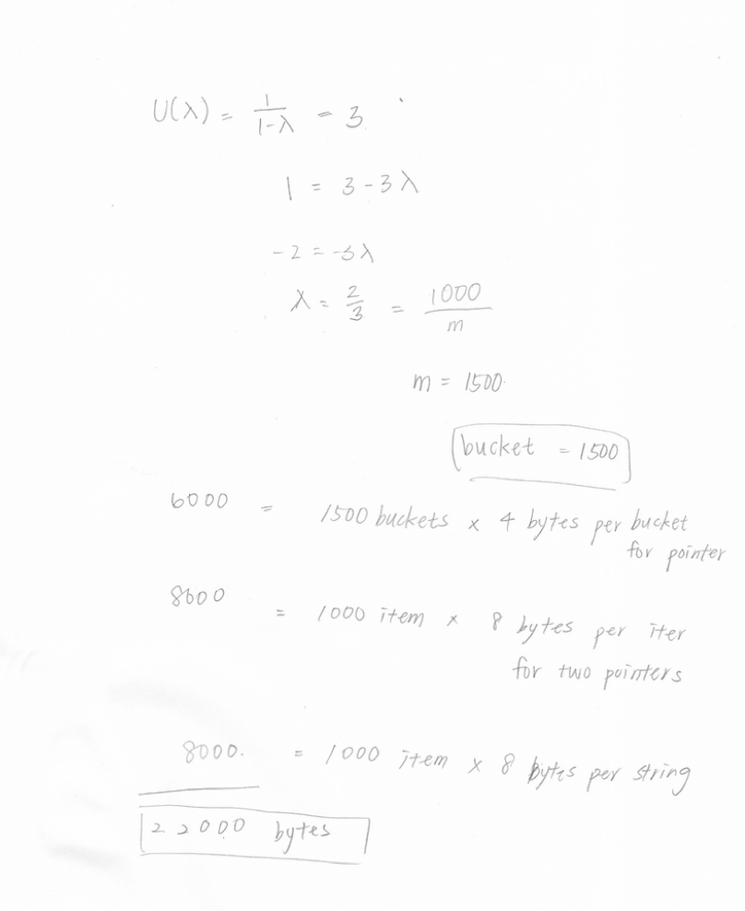

b)

λ = 1.48, when U(λ) = 3 using second equation

1.48 = 1000/m, m = 676

There will be 676 buckets.

676 buckets \* 4 bytes per bucket for pointer = 2704 bytes

2704 bytes + 16000 = 18704 bytes

Problem 5.3

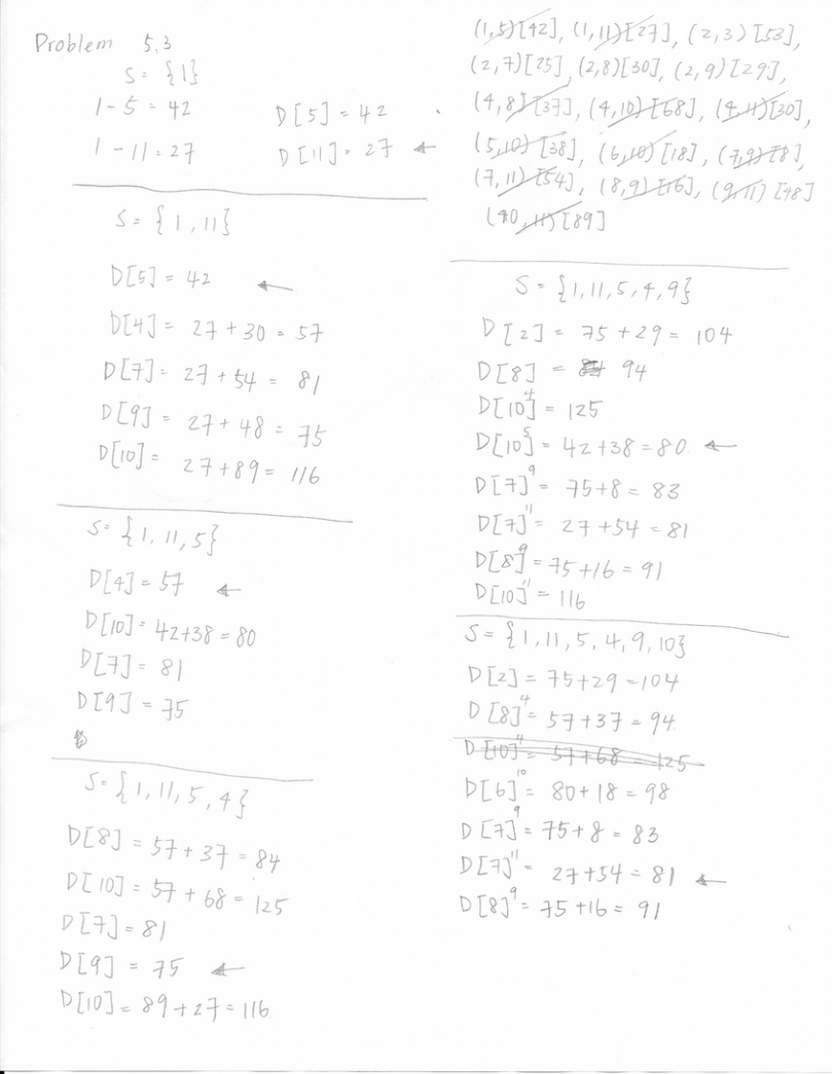

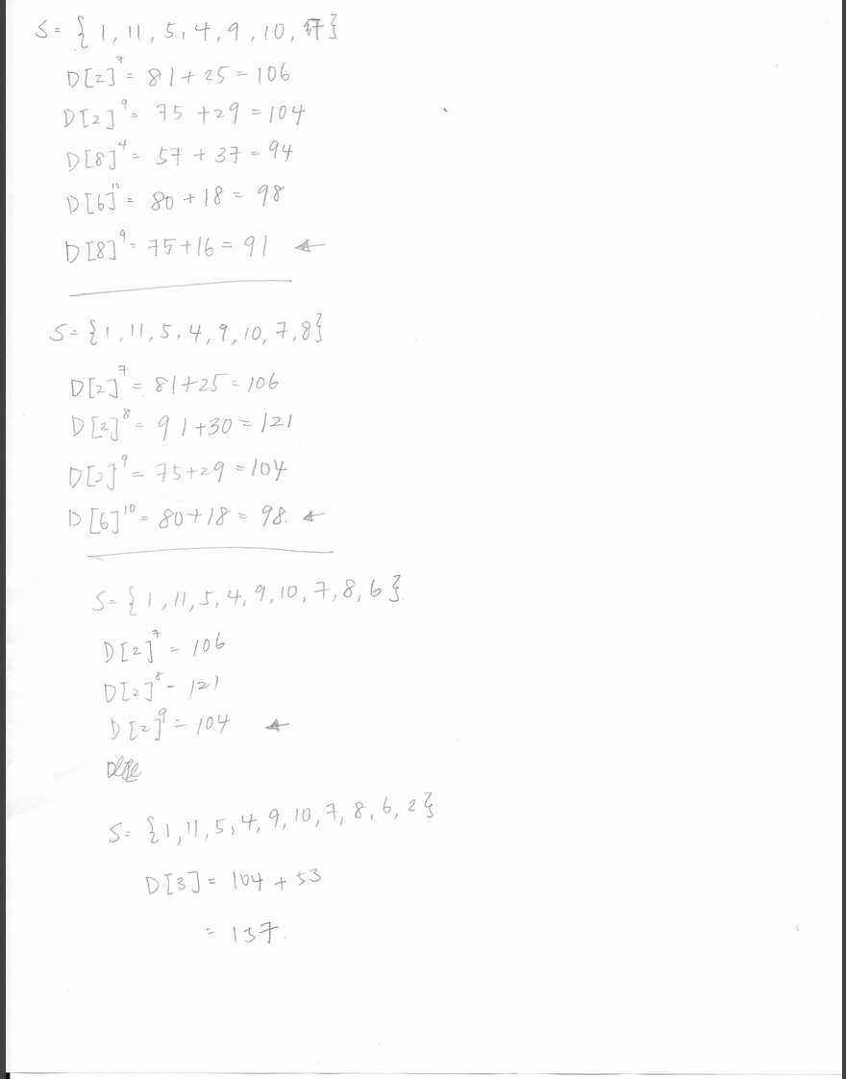

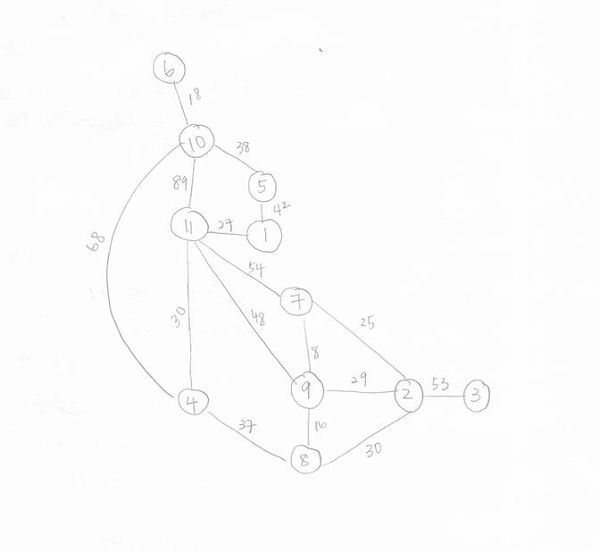

Problem 5.4

1. 1. 1,3,4
   2. 5,6,7
   3. 2
   4. 8

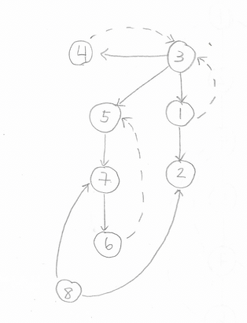



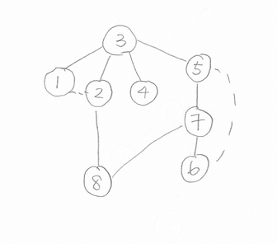

Problem 5.5



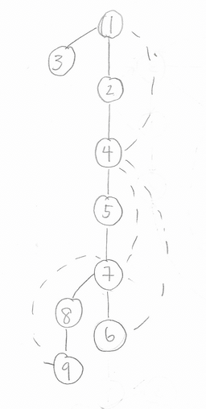



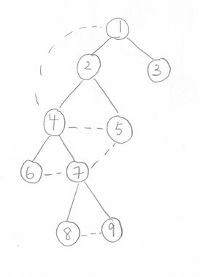



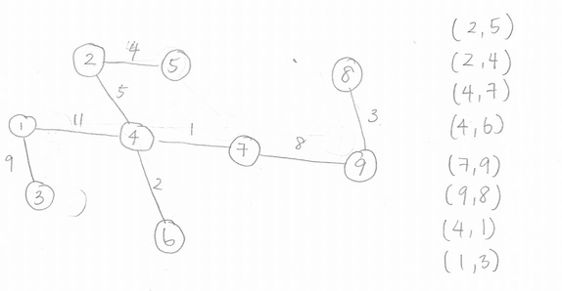



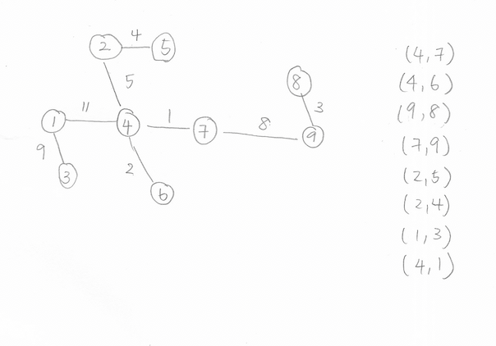

Problem 5.6

Algorithm DijkstraLeastCostPaths (directed graph G, vertex s )

// Compute shortest paths from source vertex s

for each vertex v of G do

TOLL ( v ) ← ∞

found ( v ) ← false

TOLL ( s ) ← 0

found ( s ) ← true

// Main Loop

repeat | V | times

v ← vertex s.t. found ( v ) = false && TOLL ( v ) is minimum

found ( v ) ← true

for each neighbor u of v do

if found ( u ) = false then

cost ( u,v ) ← weight ( u,v ) + TOLL(V);

// where weight(u,v) represent cost of path via edge(u,v)