At the start of most of the following, the name of a Python file is given in **blue**: **foo.py**. You should create and save the requested program source code in a file with the same name. Please add a comment at the top of each submitted .**py** giving your name and the name of the source file.

When finished, upload each **.py** file with the specified name to the Canvas **H2 Assignment** link.  
  
Do each of the following problems. (* below in [H2-2] indicates change from first version of this handout)

~~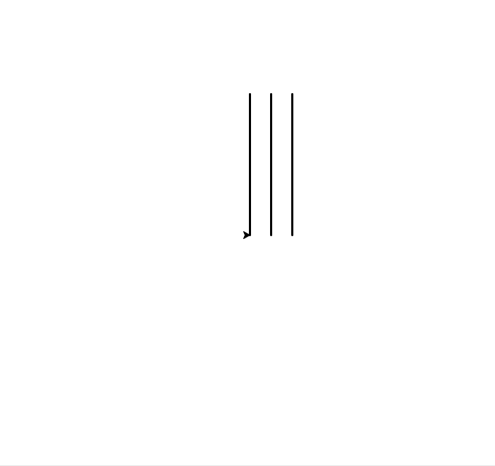~~**~~[H2-1]~~** ~~(~~**~~threelines.py~~**~~) Write a program draws the picture within the box (but you don't need to draw the box.)~~

~~Each line is of length 200 and separated from the next line by 30 units. The~~ **~~bottom right~~** ~~end of the~~ **~~lowest line~~** ~~is at (0,0) (the turtle's home location), and all lines have a pen width of 3. (HTT4 has a code example that shows how to set the pen width for a turtle.) Be sure to have~~ **~~wn.exitonclick()~~** ~~as the last statement of your program.~~

**~~[H2-2]~~** ~~(~~**~~rangefun2.py~~**~~) Write a program that uses loops of the form:~~**~~for num in range(…):~~**

**~~print (num,end=' ') # end='' keeps loop output on same line   
print () # start new line~~** ~~to print out each of the sequences below.  
  
You MUST use a~~ **~~for~~** ~~loop like the above, with~~ **~~range(x,y,z)~~** ~~for some~~ **~~int~~** ~~values of~~ **~~x, y, z~~** ~~for each.~~

**~~1 2 3 4 5 6 7 8 9 10~~**

**~~1 3 5 7 9 11 13~~**

**~~47 23~~**

**~~10 9 8 7 6 5 4 3 2 1~~**

**~~20 16 12 8 4 0~~**

**~~3 9 15 21 27 33~~**

**~~* last sequence was wrong in original post~~**

**~~[H2-3]~~** ~~(~~**~~sumrange.py~~**~~) Write a program that reads integers~~ **~~start~~** ~~and~~ **~~stop~~** ~~from the user, then calculates and prints the sum of the squares of each integer ranging from~~ **~~start~~** ~~to~~ **~~stop~~**~~, inclusive. "Inclusive" means that both the values~~ **~~start~~** ~~and~~ **~~stop~~** ~~are included.~~

~~For example, if you enter~~ **~~2~~** ~~and~~ **~~4~~**~~, your program should print~~ **~~29~~** ~~since~~ **~~2**2 + 3**2 + 4**2 == 4+9+16 == 29~~**~~. Hint: use an accumulator variable. Initialize it before the loop to 0, then add the square of the current loop variable to it within the loop body.~~

**~~[H2-4]~~** ~~(~~**~~mileage.py~~**~~) Do Exercise 10 at the end of HTT2 (in HTT2.13). Read each value as~~ **~~float~~** ~~(read as string~~ **~~st~~** ~~then convert using typecast function~~ **~~float(st)~~**~~).~~

**~~[H2-5]~~** ~~(~~**~~interest.py~~**~~) Exercise 7 at the end of HTT2 (in HTT2.13) gives a Python program that computes compound interest. The provided code does this by using a formula using the exponentiation operator~~ **~~**: b**n == b*b*...b (n times)~~**~~.~~

~~Rewrite this program without using this~~ **~~**~~** ~~operator. Use a~~ **~~for~~**~~-loop to compute~~ **~~r = b**e~~** ~~in the following way:~~

**~~result = 1~~**

**~~for counter in range (e):~~**

**~~result = result * b~~**

~~You may assume that~~ **~~e~~** ~~is always an~~ **~~int~~** ~~value.~~