IBM 6540 Final Report
  - Predicting Online Purchases from Website Behavior
Angela Qian
Bhamini Pillai
Willy Su
2026-08-12

Executive summary
This report examines whether browsing-session data can help an online retailer predict purchases and understand conversion behavior. We analyzed 12,330 sessions from the UCI Online Shoppers Purchasing Intention dataset. The outcome, Revenue, identifies whether a session ended in a purchase.
Three analytics objectives guided the project. First, we compared logistic regression, a decision tree, and a random forest for purchase classification. Second, we examined the behavioral signals associated with conversion. Third, we evaluated seasonal and visitor-type patterns that could inform campaign planning. The random forest produced the strongest test-set ranking performance, with a ROC AUC of 0.919. Page value was the dominant predictor, while product engagement, exit behavior, month, and visitor type added useful information. Because PageValues may be calculated close to the transaction, we treat it as a possible leakage risk and also report a stricter model without that variable.
The results support using predicted probabilities to rank opportunities, not automatically targeting every session classified as a purchaser. The operating threshold should reflect campaign capacity and the relative costs of missed purchasers and unnecessary outreach. All segment and partial-dependence findings are associations produced by the model; they should be validated with current company data and controlled experiments.

Report organization
- Business problem and data
- Objective 1: predict purchases
- Objective 2: explain conversion behavior
- Objective 3: find audience and timing opportunities
- Recommendations, limitations, and next steps

Introduction

Every session is a conversion opportunity
An online store receives thousands of visits, but most visitors leave without purchasing.
The business challenge is to recognize promising sessions and understand where the customer journey breaks down.
Our analysis connects browsing behavior to a clear outcome: did the session produce revenue?
[Sources] - UCI Machine Learning Repository: https://archive.ics.uci.edu/dataset/468/online+shoppers+purchasing+intention+dataset

The decision problem is practical
The e-commerce team wants to answer three questions:
- Which sessions are most likely to end in a purchase?
- Which behaviors best separate purchases from non-purchases?
- Which visitor and seasonal segments offer the strongest opportunities?
These answers can guide website improvements, media spending, and remarketing.

Three objectives divide the work clearly
Owner | Analytics objective | Business outcome
Angela Qian | Compare classification models | Choose a reliable purchase-risk model
Bhamini Pillai | Explain behavioral drivers | Identify journey signals that matter
Willy Su | Evaluate visitor and seasonal patterns | Improve audience and campaign timing

Conversion analysis matters beyond prediction
Better conversion knowledge can help a business:
- Spend marketing resources on higher-quality traffic
- Improve pages associated with customer exit
- Build more focused remarketing audiences
- Plan campaigns around stronger purchasing periods
- Monitor performance with repeatable model metrics

Data and sample

The sample represents 12,330 sessions
- One year of e-commerce sessions
- Each record represents a different user session
- 17 browsing, visitor, device, and timing predictors
- Binary outcome: purchase or no purchase
- No reported missing values
- Business dataset licensed under CC BY 4.0
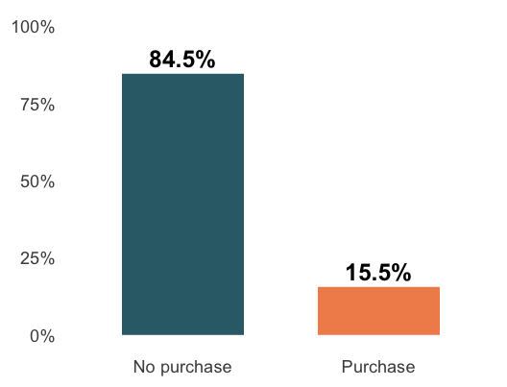
Figure 1
[Sources] - UCI dataset documentation: https://archive.ics.uci.edu/dataset/468/online+shoppers+purchasing+intention+dataset

The predictors follow the customer journey

Engagement
Page counts and time spent on administrative, informational, and product pages

Friction and value
Bounce rate, exit rate, page value, and proximity to a special day

Context
Month, visitor type, weekend, traffic source, browser, region, and operating system
[Sources] - UCI variable definitions: https://archive.ics.uci.edu/dataset/468/online+shoppers+purchasing+intention+dataset

Wrangling made the data model-ready
shop <- read_csv("Online-Shoppers-UCI.csv") |>
mutate(
Revenue = factor(Revenue,
levels = c(FALSE, TRUE),
labels = c("No purchase", "Purchase")),
Weekend = factor(Weekend),
across(c(OperatingSystems, Browser,
Region, TrafficType), factor)
)
We checked variable types, missingness, class balance, and plausible ranges before modeling.

Analytics objective 1: Purchase prediction

Which model predicts purchases best?
Owner: Angela Qian
Compare an interpretable baseline, a single decision tree, and a random forest using the same train/test split and preprocessing steps.

We tested three classification approaches
Method | Why include it?
Logistic regression | Clear baseline and interpretable coefficients
Decision tree | Simple nonlinear rules and interactions
Random forest | Ensemble that can capture complex patterns
Regression-focused methods were not selected because the business outcome is categorical.

The split protects the final evaluation
shop_split <- initial_split(
shop, prop = .80, strata = Revenue
)
shop_train <- training(shop_split)
shop_test <- testing(shop_split)
- Training set: 80% of sessions
- Test set: 20% of sessions
- Stratification: preserves the 15.5% purchase rate

One recipe keeps preprocessing consistent
shop_rec <- recipe(Revenue ~ ., data = shop_train) |>
step_novel(all_nominal_predictors()) |>
step_unknown(all_nominal_predictors()) |>
step_dummy(all_nominal_predictors()) |>
step_zv(all_predictors()) |>
step_normalize(all_numeric_predictors())
The same recipe was used for all three candidate models.

The random forest ranked sessions best
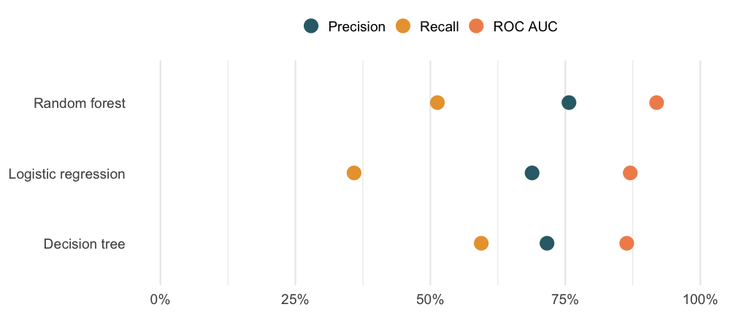
Figure 2
The random forest achieved 0.919 ROC AUC on unseen test data.

A lower threshold finds more purchasers
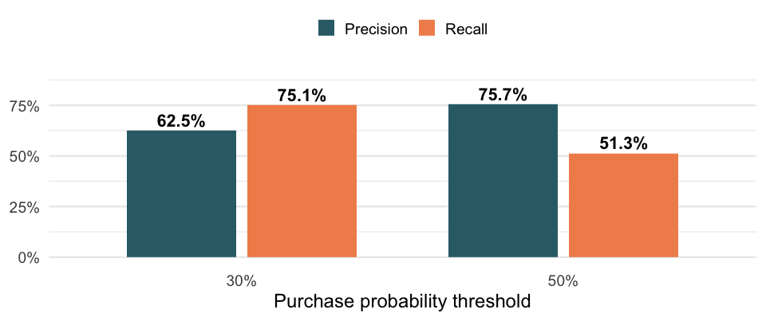
Figure 3
At 30%, recall rises to 75.1% while precision remains 62.5%.

Objective 1 finding
Use the random forest for ranking sessions, then select the threshold based on outreach capacity and the cost of missed purchasers.
- Best test ROC AUC: 0.919
- A 30% threshold finds three out of four purchasing sessions
- A 50% threshold produces fewer but more precise alerts

Analytics objective 2: Behavioral drivers

What behavior signals conversion?
Owner: Bhamini Pillai
Explain which customer-journey variables matter and whether engagement patterns remain useful without the strongest page-value signal.

Purchasers spend longer on product pages
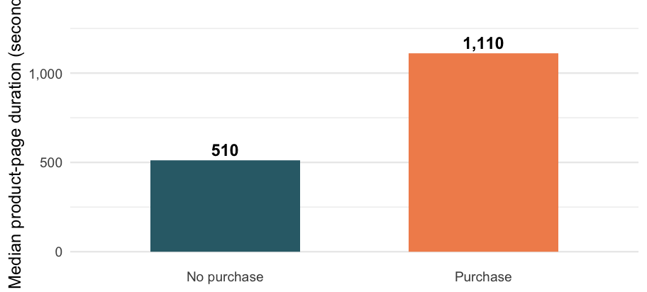
Figure 4
Purchasing sessions had a median product-page duration of 1,110 seconds versus 510 seconds.

Page value dominates model importance
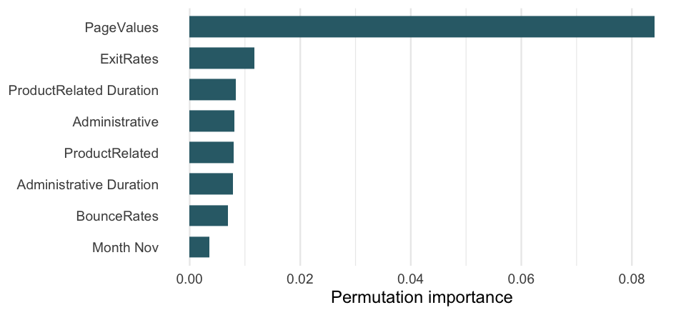
Figure 5
Exit behavior, engagement, and administrative activity also contribute to prediction.

We ran a stricter behavioral model
Page value is closely connected with transaction activity, so we also fitted logistic regression without PageValues.
behavior_recipe <- recipe(Revenue ~ ., data = shop_train) |>
step_rm(PageValues) |>
step_dummy(all_nominal_predictors()) |>
step_normalize(all_numeric_predictors())
This model asks whether earlier browsing behavior still contains predictive information.

Behavior alone provides moderate ranking power

Without page value
- ROC AUC: 0.715
- Accuracy: 83.9%
- Recall at 50%: 3.7%

Interpretation
Behavior helps rank sessions, but the default 50% cutoff misses most purchases.
The model needs threshold tuning or class-sensitive training before operational use.

Longer product engagement raises predicted probability
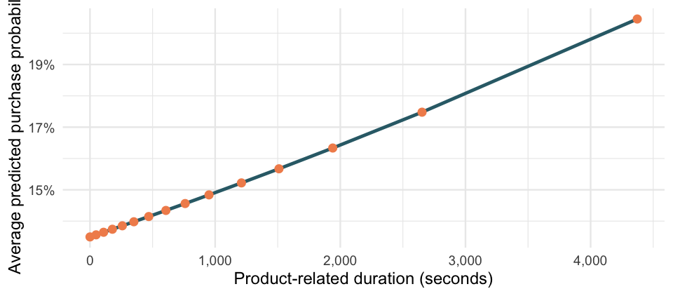
Figure 6
The partial-dependence pattern is an association, not a causal effect.

Objective 2 finding
Page value is the strongest model signal, while product engagement and exit behavior provide earlier clues about conversion.
- Use page value carefully because it is close to the transaction outcome
- Monitor exit rate as a possible friction signal
- Treat long product browsing as an opportunity for assistance or remarketing

Analytics objective 3: Visitor and seasonal segments

Which segments deserve attention?
Owner: Willy Su
Estimate how purchase probability changes across months and visitor types while the random forest holds the rest of the sample constant.

Observed conversion peaks in November
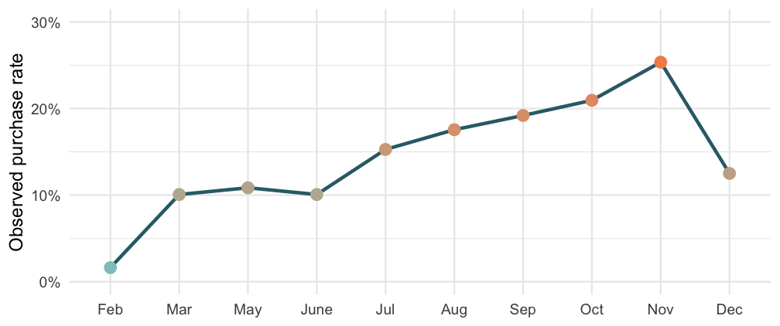
Figure 7
November’s observed purchase rate was 25.4%.

The segment analysis uses the ensemble model
For every month or visitor type, we:
- Set that feature to one value for all test sessions
- Predicted each session with the fitted random forest
- Averaged the predicted purchase probabilities
- Repeated the process for every category
This partial-dependence approach summarizes model behavior while holding the test population constant.

Month remains important after adjustment
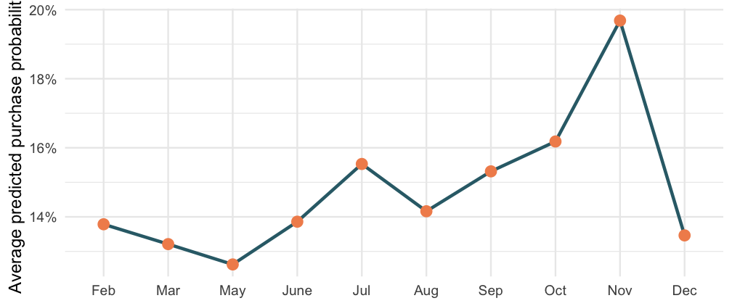
Figure 8
The model assigns the strongest adjusted probabilities to late-year sessions.

Visitor type changes predicted conversion
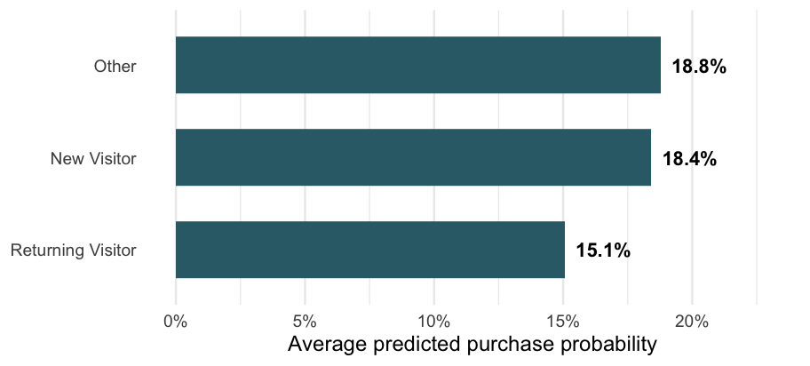
Figure 9
Visitor type should inform audience strategy, but the differences are smaller than the page-value signal.

Objective 3 finding
Timing and visitor type can improve campaign planning, but they should complement—not replace—session behavior.
- Prepare conversion campaigns before the late-year peak
- Test different messages for new and returning visitors
- Compare traffic quality within each segment
- Validate segment strategies through controlled experiments

Conclusions and recommendations

Three findings answer the business problem
- Prediction: the random forest ranked purchase likelihood well, with 0.919 test ROC AUC.
- Behavior: page value led the model; product engagement and exit behavior added useful signals.
- Segments: late-year timing and visitor type changed predicted conversion opportunities.

Recommended business actions

Prioritize
Score sessions and use a threshold matched to available outreach capacity.

Improve
Review high-exit journeys and support visitors showing sustained product interest.

Test
Run controlled experiments on timing, audiences, and remarketing messages.

Limitations
- The data represents sessions, not a longitudinal customer history
- The source does not identify the retailer or product categories
- Page value may contain information close to the final transaction
- Class imbalance makes accuracy potentially misleading
- Model relationships do not prove that a business action will cause conversion
- Current performance should be validated on newer company data

Future directions

Next steps move from model to decision
- Tune hyperparameters with cross-validation
- Compare probability calibration and business costs
- Validate the threshold using campaign capacity
- Test explanations with SHAP values
- Deploy a simple scoring app
- Measure incremental conversion through an experiment

Appendix

Project resources
GitHub repository
View the Group 6 project repository
Presentation slides
Open the published RevealJS presentation
Project dataset
View the UCI Online Shoppers dataset abstract
Dataset citation
UCI dataset DOI: 10.24432/C5F88Q
Model availability
The reproducible model analysis is included in the project QMD. A public scoring app is a planned next step.
[Sources] - UCI Machine Learning Repository: https://archive.ics.uci.edu/dataset/468/online+shoppers+purchasing+intention+dataset - Dataset DOI: https://doi.org/10.24432/C5F88Q

Reproducibility notes
- Random seed: 6540
- Stratified 80/20 train/test split
- Shared preprocessing recipe across candidate models
- Test set used only for final comparison
- R packages: tidymodels, tidyverse, ranger, and Quarto
- Complete analysis code is contained in this QMD file

Closing statement
Predict purchase likelihood, explain the customer journey, and test the actions that follow.
The model is a starting point for better decisions—not a substitute for experimentation.

Project links
GitHub repository · Published presentation

