Day 1 final project
The Weekly Client Report, up to RAG
OCBC AI Creator Masterclass · Build sprint by Algoritma for PT Bank OCBC NISP Tbk

The brief
You are building a tool for the relationship manager (RM) of one corporate client, PT Astra International Tbk (ASII). Every Monday at 07:00 the RM should find one report in output/reports/, built from four sources:
Source | Kind | Where it comes from
Account activity | Internal, CSV | data/account/ASII.csv (inflow, outflow, balance, credit facility usage)
Call reports | Internal, PDF | data/call_reports/ASII/ (what the client told us in meetings)
Market data | Public, API | Sectors: company overview, share price, latest quarter (saved copies in data/sample/ when Sectors is down)
News | Public, web page | the client's news page, http://localhost:8000/astra.html

By the end of Day 1 your report must:
- Collect all four sources, clean, and labelled with where they came from. One source failing must never stop the report: it says "missing" or "saved copy" instead.
- Run by itself every Monday at 07:00 Jakarta time, and write a line in a run log.
- Show the week in numbers (this week against last week), calculated by code, never by the model.
- Explain: the model reads the latest call report and the news, and writes a short brief for the RM. Everything it says is checked by code (evidence phrases are in the report, numbers are in the data, no judgement about creditworthiness).
- Answer questions about the call reports and the news, with numbered sources, so the RM can ask "what did the client ask us for last time?".
Code detects, the model explains, a human decides.

Today is Monday 2 November 2026; the report covers the week ending Sunday 1 November 2026. The account activity, call reports and news are invented for training. The Sectors data is real.

The system you build on Day 1
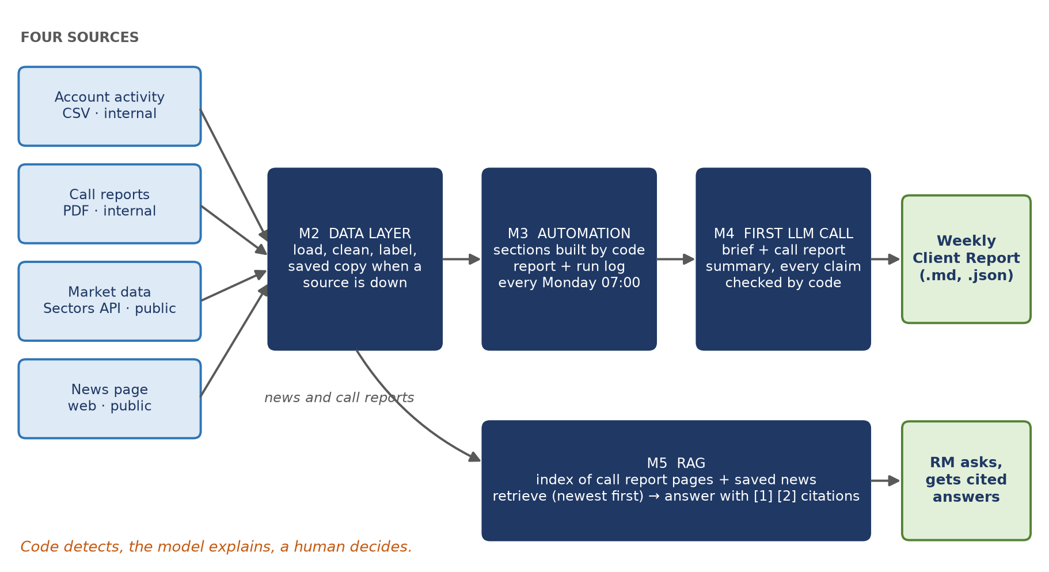
Modules 2 to 5 form one pipeline. M2 feeds M3, M3 feeds M4; M5 searches what M2 saved. Dark boxes are the code you write.

What the finished report looks like
# Weekly Client Report: PT Astra International Tbk (ASII)
## This week <- Module 4: headline + 2 to 4 observations, checked by code
## Account activity <- Module 3: table, this week against last week
## Market (Sectors) <- Module 3: overview, share price, latest quarter
## From our last meeting <- Module 4: plans, requests, follow-ups, each with its evidence phrase
## News this week <- Module 4: one line per article, with its link
*Sources: ... Generated ... Status: complete.*

Then, from the terminal: ask_documents("When is the next meeting with the client?") answers from the call reports, with [1], [2] citations.

How you will build it: one file per module
Open the files in this folder. Each has a Given part (finished: read it, it shows you the style) and a Your work part (placeholders that raise NotImplementedError until you replace them).
Module | File | You write | What it adds
2 Data layer | m2_data_layer.py | get_quarterly_financials, load_account, read_pdf_text, load_call_reports, scrape_news | The four sources, clean, with fallbacks to saved copies
3 Automation | m3_automation.py | build_account_section, run_weekly_report, start_scheduler | The report, the log, and the Monday 07:00 schedule, with no LLM
4 First LLM call | m4_llm.py | build_brief_prompt, CallReportPoints, check_call_report | The model's brief and call report summary, checked by code
5 RAG | m5_rag.py | load_call_report_docs, retrieve, ask_documents | Questions and answers over the call reports and the news, with citations

Later modules import earlier ones (m3 uses m2), so work in order. config.py (the client, the week, the keys, the models) and runner.py are Given.

Before you start
python -m venv .venv
# Windows: .venv\Scripts\activate macOS/Linux: source .venv/bin/activate
pip install -r requirements.txt

Copy .env.example to .env and fill in SECTORS_API_KEY and GEMINI_API_KEY. Use Python 3.11 or newer, and run every command from this folder.

How you know you are done
From this folder, with the news page served in a second terminal (python -m http.server 8000 --directory data/news_site):
python main.py # calls every function of every module
python main.py m3 # or one module at a time
python main.py demo # the whole Day 1 pipeline, once everything passes

main.py prints one line per function: ✅ works, ⏳ not written yet, ❌ wrong (with what to fix). You are done when every line is ✅ and demo prints a report and two answers with citations.
Module 4 reads the sections that Module 3 saves, and Module 5 searches the news that Module 2 saves. If you start a module late, run the earlier ones first (main.py m2 m3).

Rules of the project
- Numbers come from code. The model never calculates; it quotes.
- The model never judges the client's creditworthiness and never recommends a credit decision.
- Every fact says where it comes from (internal or public) and how old it is.
- Copilot is allowed. Read every line it writes, and run main.py after every function.

