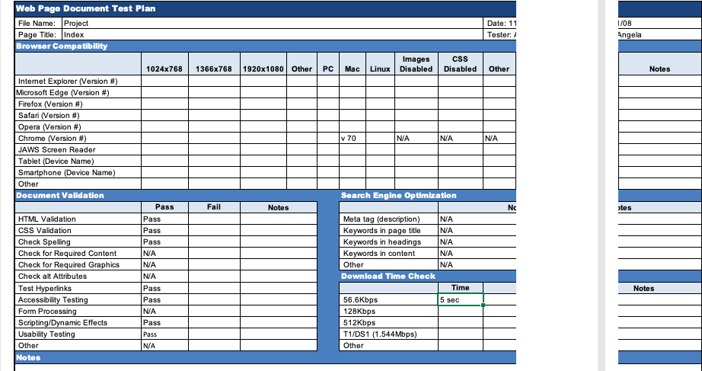

**Individuals**

1. Greg
2. Dan
3. Bill

**Improvements**

1. Photo layout
2. More content on Email page
3. Add more photos and try inserting videos