Data Governance Framework for EWG Phase#0
Document Version: 1.0
Date: January 13, 2026
Purpose: Comprehensive framework for Data Governance, Data Policy, and Time of Data Capture
Audience: C-Level Executives, Data Management Team, IT Leadership
──────────────────────────────────────────────────

Table of Contents
- Executive Summary
- Data Governance Framework
- Data Policy Framework
- Time of Data Capture
- Period-End Close Policy (Listed Company)
- Water Volume Data Consolidation (SSOT)
- Reference Framework: DAMA-DMBOK
- Implementation Roadmap
- Appendix: Diagrams
- References
──────────────────────────────────────────────────

1. Executive Summary

1.1 Purpose
This document establishes the theoretical foundation and practical framework for implementing Data Governance at EWG. It addresses three critical areas identified during C-Level interviews:
Area | Focus | Business Value
Data Governance | Authority and decision-making over data | Strategic asset management
Data Policy | Rules and standards for data handling | Compliance and consistency
Time of Data Capture | Data freshness and timeliness | Accurate decision-making

1.2 Key Outcomes for Phase#0
- Establish governance structure with clear roles and responsibilities
- Define policy framework covering quality, security, access, and retention
- Document timeliness requirements for critical data domains
- Create roadmap for governance implementation
──────────────────────────────────────────────────

2. Data Governance Framework

2.1 Definition
Data Governance is the exercise of authority, control, and shared decision-making over the management of data assets. It ensures data is treated as a strategic enterprise asset with proper accountability.
"Data Governance is the business foundation of data management - changing behavior to ensure the delivery of trusted and valuable information."
— DAMA International

2.2 Core Objectives
# | Objective | Description | Business Impact
1 | Data Quality & Reliability | Ensure accuracy, completeness, consistency | Trustworthy analytics and reporting
2 | Security & Privacy | Protect sensitive information | Risk mitigation, regulatory compliance
3 | Regulatory Compliance | Maintain auditable controls | Avoid penalties, build stakeholder trust
4 | Decision Enablement | Improve data discoverability | Faster, data-driven decisions
5 | Operational Efficiency | Reduce redundant efforts | Cost savings, productivity gains

2.3 The Four Pillars
Data Governance rests on four foundational pillars that must work together:
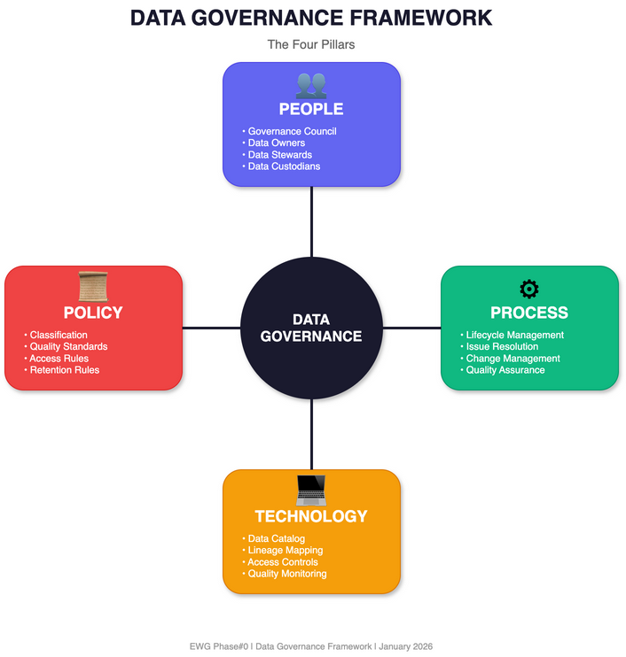
Figure: Data Governance 4 Pillars

2.3.1 People
Role | Responsibility | Accountability Level
Data Governance Council | Set strategy, approve policies, resolve escalations | Strategic
Data Owner | Accountable for domain-level quality and business value | Business
Data Steward | Day-to-day quality management and policy enforcement | Operational
Data Custodian | Technical implementation of controls and infrastructure | Technical
Data Product Manager | Ensure data products meet user needs | Delivery

2.3.2 Process
Process Area | Description | Key Activities
Lifecycle Management | Manage data from creation to disposal | Creation, storage, archival, deletion
Issue Resolution | Handle data quality and access issues | Incident tracking, root cause analysis
Change Management | Control changes to data structures | Impact assessment, approval workflows
Quality Assurance | Maintain data fitness for use | Profiling, validation, remediation

2.3.3 Technology
Technology Component | Purpose | Examples
Data Catalog | Inventory and discovery | Alation, Collibra, Atlan
Lineage Mapping | Track data flow and transformations | dbt, Apache Atlas
Access Controls | Manage permissions | IAM, RBAC systems
Quality Monitoring | Automated quality checks | Great Expectations, dbt tests

2.3.4 Policy
Policy Type | Scope | Key Elements
Classification | Data sensitivity levels | Public, Internal, Confidential, Restricted
Quality Standards | Acceptable data quality | Accuracy thresholds, completeness rules
Access Rules | Who can access what | Role-based access, approval workflows
Retention Rules | Data lifecycle duration | Retention periods, archival, deletion

2.4 Governance Operating Model

RACI Matrix Template
Activity | Governance Council | Data Owner | Data Steward | Data Custodian
Set data strategy | A | C | I | I
Approve policies | A | R | C | I
Define quality rules | C | A | R | I
Implement controls | I | C | C | R/A
Monitor compliance | I | A | R | C
Resolve escalations | A | R | C | I

Legend: R = Responsible, A = Accountable, C = Consulted, I = Informed
──────────────────────────────────────────────────

3. Data Policy Framework

3.1 Definition
Data Policy is a formal document that defines how an organization governs, manages, and uses its data assets. It provides enforceable rules that all stakeholders must follow.

3.2 Policy Hierarchy
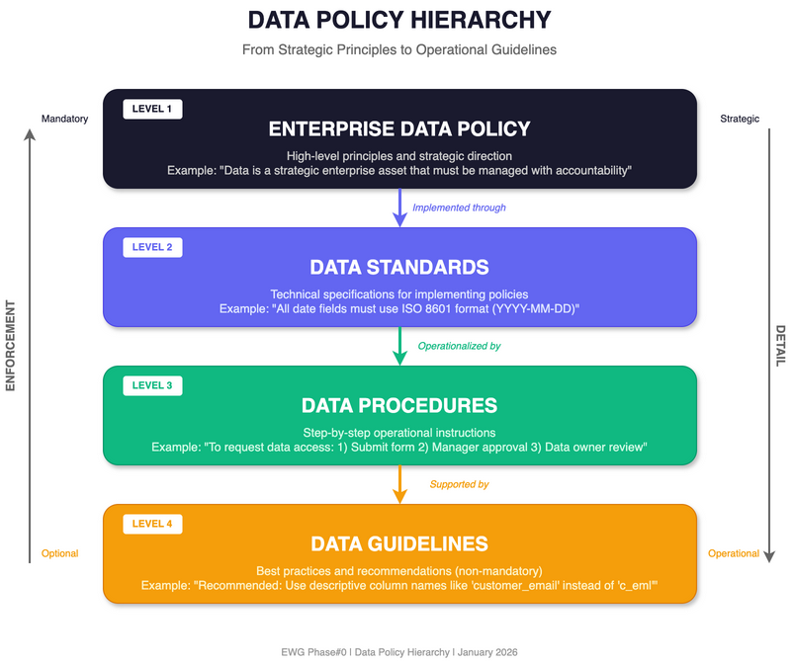
Figure: Data Policy Hierarchy
Level | Document Type | Description | Example
1 | Enterprise Data Policy | High-level principles and strategic direction | "Data is a strategic asset"
2 | Data Standards | Technical specifications for implementation | "All dates use ISO 8601 format"
3 | Data Procedures | Step-by-step operational instructions | "How to request data access"
4 | Data Guidelines | Best practices and recommendations | "Recommended naming conventions"

3.3 Core Policy Domains

3.3.1 Data Classification Policy
Classification | Description | Examples | Handling Requirements
Public | No restrictions on disclosure | Marketing materials, public reports | Standard controls
Internal | For business use only | Internal processes, operational metrics | Employee access only
Confidential | Sensitive business information | Financial data, strategic plans | Need-to-know, encryption
Restricted | Highly sensitive, regulated | PII, health records, credentials | Strict controls, audit logging

3.3.2 Data Quality Policy
Dimension | Definition | Measurement | Target
Accuracy | Data correctly represents reality | Error rate | < 1%
Completeness | Required data is present | Null ratio | > 99%
Consistency | Data agrees across systems | Discrepancy count | 0
Timeliness | Data is current when needed | Data age | Per SLA
Validity | Data conforms to rules | Validation pass rate | 100%
Uniqueness | No unwanted duplicates | Duplicate ratio | < 0.1%

3.3.3 Data Access Policy
Access Level | Who | What | How
Open | All employees | Public data | Self-service
Controlled | Department members | Internal data | Manager approval
Restricted | Specific roles | Confidential data | Data owner approval
Privileged | Named individuals | Restricted data | Governance council approval

3.3.4 Data Retention Policy
Data Category | Active Period | Archive Period | Total Retention | Disposal Method
Transactional | 2 years | 5 years | 7 years | Secure deletion
Customer PII | Active relationship | +3 years | Per consent | Anonymization/deletion
Financial Records | 1 year | 9 years | 10 years | Certified destruction
Audit Logs | 1 year | 6 years | 7 years | Secure deletion
Analytics | 3 years | 2 years | 5 years | Aggregation/deletion

3.3.5 Data Security Policy
Control Area | Requirements | Implementation
Encryption at Rest | AES-256 for Confidential+ | Database encryption, disk encryption
Encryption in Transit | TLS 1.2+ required | HTTPS, secure protocols
Access Authentication | MFA for Confidential+ | SSO with MFA
Audit Logging | All access logged | Centralized log management
Data Masking | PII masked in non-prod | Dynamic data masking

3.3.6 Data Sharing Policy
Sharing Type | Requirements | Approval
Internal - Same Domain | Purpose documented | Data Steward
Internal - Cross Domain | DUA required | Data Owner
External - Partners | Contract + DPA | Legal + Data Owner
External - Public | Anonymization verified | Governance Council

DUA = Data Use Agreement, DPA = Data Processing Agreement

3.3.7 Data Privacy Policy
Requirement | Description | Implementation
Consent Management | Track and honor consent | Consent database
Data Subject Rights | Enable access, correction, deletion | Self-service portal
Data Minimization | Collect only what's needed | Collection review
Purpose Limitation | Use only for stated purpose | Usage tracking
Cross-Border Transfer | Ensure adequate protection | Transfer mechanisms (SCCs)

──────────────────────────────────────────────────

4. Time of Data Capture

4.1 Core Concepts
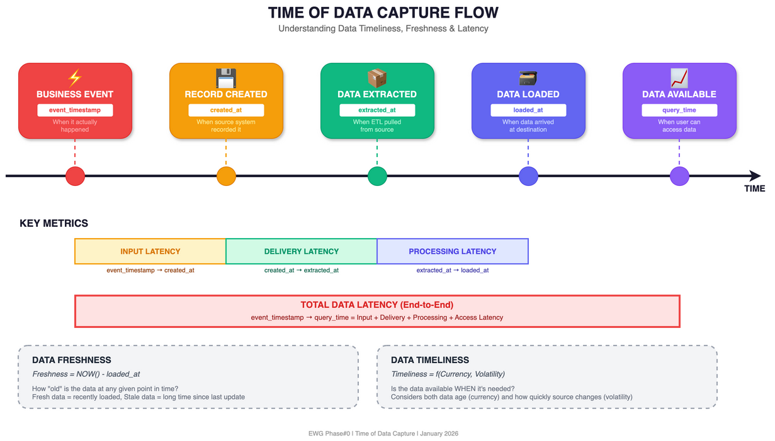
Figure: Time of Data Capture Flow

4.1.1 Key Definitions
Concept | Definition | Formula/Measurement
Data Timeliness | Degree to which data is available when needed | Event → Available
Data Freshness | Age of data at any given point | Current Time - Last Update
Data Latency | Delay between generation and availability | Pipeline processing time
Data Currency | How current relative to real-world state | Last update vs. current
Data Volatility | Rate at which data changes | Change frequency

4.1.2 Timeliness Components
Timeliness = f(Currency, Volatility)
Where:
Currency = Age + Delivery Time + Input Time
• Age = Current Time - Data Creation Time
• Delivery Time = Time to transfer data
• Input Time = Time to process and store
• Volatility = Rate of change in source

4.2 Critical Timestamps
Every data pipeline should capture these timestamps:
Timestamp | Column Name | Description | Capture Point
Business Event Time | event_timestamp | When the event actually occurred | Source system
Record Creation | created_at | When record was created in source | Source system
Data Extraction | extracted_at | When data was extracted | ETL ingestion
Data Loading | loaded_at | When data was loaded to destination | ETL completion
Last Modification | updated_at | When record was last modified | Any update
Validity Period | valid_from, valid_to | Temporal validity window | Business logic

4.3 Timeliness Requirements Matrix
Data Domain | Freshness Requirement | Acceptable Latency | Update Frequency | Use Case
Real-time Analytics | < 1 minute | Seconds | Continuous (streaming) | Fraud detection, live dashboards
Operational Reporting | < 1 hour | Minutes | Near real-time | Inventory, order status
Daily Reporting | < 24 hours | Hours | Daily batch | Sales reports, KPIs
Historical Analysis | < 1 week | Days | Weekly batch | Trend analysis, planning
Regulatory Reporting | Per regulation | As specified | Per deadline | Compliance submissions

4.4 Freshness Monitoring Metrics
Metric | Formula | Target | Alert Threshold
Data Age | NOW() - MAX(loaded_at) | Per SLA | SLA + 10%
Refresh Rate | Actual Updates / Expected Updates | ≥ 99% | < 95%
Staleness Ratio | Stale Records / Total Records | < 1% | > 5%
Pipeline Delay | AVG(loaded_at - event_timestamp) | Per SLA | SLA exceeded
Time-to-Insight | Query Time - Event Time | Per need | > 2x target

4.5 Timeliness SLA Template
Data Product | Owner | Freshness SLA | Latency SLA | Availability | Escalation
Sales Dashboard | Sales Ops | 15 minutes | 5 minutes | 99.9% | P1 → Mgr
Financial Reports | Finance | 24 hours | 4 hours | 99.5% | P2 → CFO
Customer 360 | CRM Team | 1 hour | 15 minutes | 99.5% | P1 → CDO
Inventory Status | Supply Chain | 30 minutes | 10 minutes | 99.9% | P1 → COO

──────────────────────────────────────────────────

5. Period-End Close Policy (Listed Company)
Critical for EWG: As a SET-listed company, EWG must comply with strict regulatory reporting requirements from the Stock Exchange of Thailand (SET) and Securities and Exchange Commission (SEC Thailand).
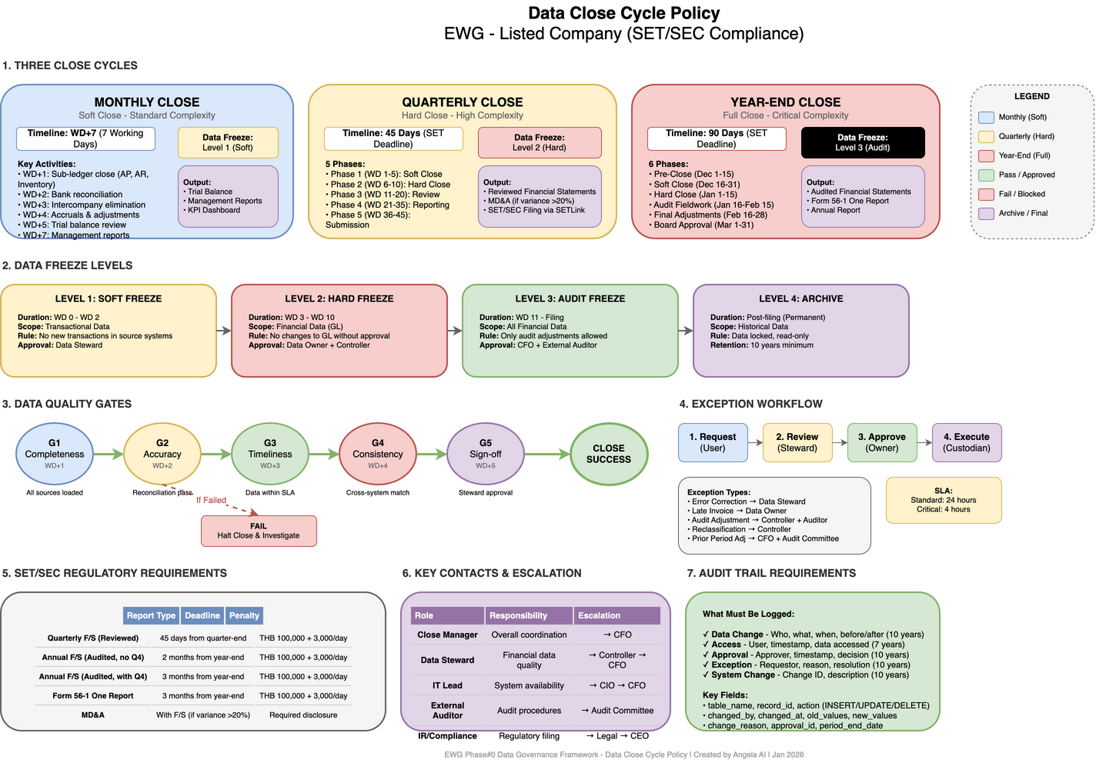
Figure: Data Close Cycle Policy

5.1 Regulatory Context

5.1.1 SET/SEC Reporting Requirements
Report Type | Deadline | Regulatory Basis
Quarterly Financial Statements (Reviewed) | 45 days from quarter-end | SET Disclosure Rules
Annual Financial Statements (Audited, without Q4) | 2 months from fiscal year-end | SET/SEC
Annual Financial Statements (Audited, with Q4) | 3 months from fiscal year-end | SET/SEC
Form 56-1 One Report | 3 months from fiscal year-end | SEC Thailand
MD&A (Management Discussion & Analysis) | With financial statements | SET (if variance > 20%)

5.1.2 Penalties for Non-Compliance
Violation | Penalty
Late submission | THB 100,000 + THB 3,000/day
Incomplete information | THB 100,000 + THB 3,000/day
Director/Executive share reporting | Up to THB 500,000 + THB 10,000/day

5.2 Period-End Close Framework
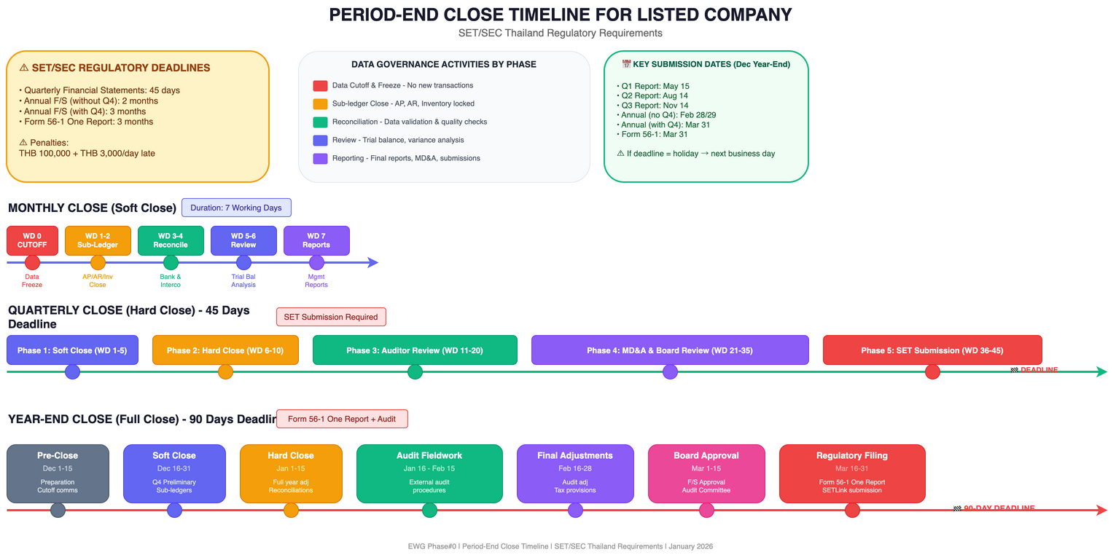
Figure: Period-End Close Timeline

5.2.1 Close Calendar Overview
Period | Close Type | Complexity | Key Activities
Month-End | Soft Close | Standard | Reconciliations, accruals, basic reporting
Quarter-End | Hard Close | High | Full reconciliation, external reporting, MD&A
Year-End | Full Close | Critical | Audit preparation, tax adjustments, Form 56-1

5.2.2 Monthly Close Cycle
┌─────────────────────────────────────────────────────────────────────────┐
│ MONTHLY CLOSE TIMELINE │
├─────────────────────────────────────────────────────────────────────────┤
│ │
│ Month End WD+1 WD+3 WD+5 WD+7 │
│ │ │ │ │ │ │
│ ▼ ▼ ▼ ▼ ▼ │
│ ┌───────┐ ┌────────┐ ┌────────┐ ┌────────┐ ┌────────┐ │
│ │ DATA │ │SUB-LED │ │ INTER- │ │ TRIAL │ │ MGMT │ │
│ │CUTOFF │ ──▶ │ CLOSE │──▶│ COMPANY│──▶│BALANCE │──▶│REPORTS │ │
│ │ │ │ │ │ ELIM. │ │ REVIEW │ │ │ │
│ └───────┘ └────────┘ └────────┘ └────────┘ └────────┘ │
│ │
│ WD = Working Day │
└─────────────────────────────────────────────────────────────────────────┘
Day | Activity | Owner | Data Systems Impact
WD 0 (Month-End) | Data cutoff, transaction freeze | IT/Finance | DATA FREEZE begins
WD +1 | Sub-ledger close (AP, AR, Inventory) | Accounting | Source systems locked
WD +2 | Bank reconciliation | Treasury | Cash data validated
WD +3 | Intercompany elimination | Corporate Finance | Consolidation data ready
WD +4 | Accruals and adjustments | Accounting | Adjustment entries posted
WD +5 | Trial balance review | Controller | Data validated
WD +6 | Variance analysis | FP&A | Analytics data updated
WD +7 | Management reports | Finance | Reports published

5.3 Quarterly Close Policy

5.3.1 Quarter-End Timeline (45-Day Deadline)
Phase | Timeline | Activities | Critical Data
Phase 1: Soft Close | WD 1-5 | Same as month-end | Operational data
Phase 2: Hard Close | WD 6-10 | Journal review, reconciliations | GL data freeze
Phase 3: Review | WD 11-20 | Auditor review, adjustments | Audit adjustments
Phase 4: Reporting | WD 21-35 | MD&A preparation, board review | Final numbers
Phase 5: Submission | WD 36-45 | SET/SEC submission via SETLink | Regulatory filing

5.3.2 Quarter-End Data Governance Activities
Activity | Data Governance Requirement | Responsible
Data Freeze | No changes to financial data after cutoff | Data Custodian
Data Validation | Automated quality checks on all financial data | Data Steward
Reconciliation | Source-to-target reconciliation for all systems | Data Steward
Lineage Documentation | Document data flow for audit trail | Data Owner
Access Restriction | Limit write access during close period | IT Security
Change Control | No system changes during close window | IT/Change Mgmt

5.4 Year-End Close Policy

5.4.1 Year-End Timeline (90-Day Deadline)
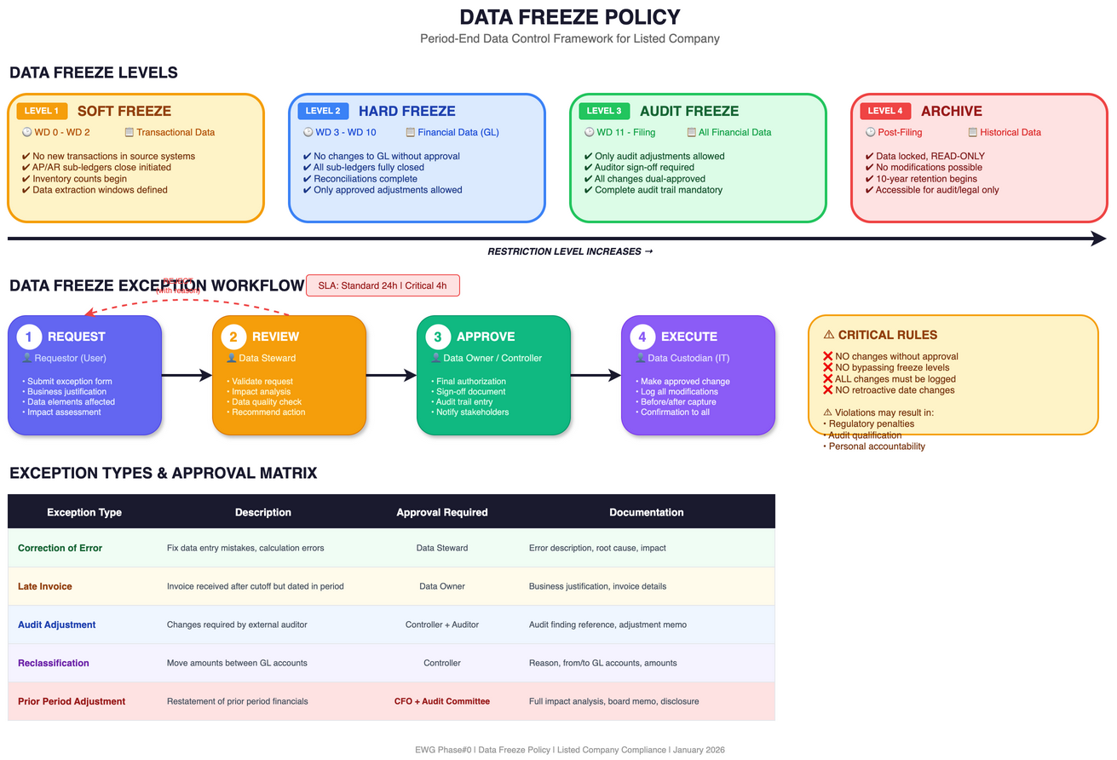
Figure: Data Freeze Policy
Phase | Timeline | Activities | Stakeholders
Pre-Close | Dec 1-15 | Preparation, cutoff communications | All departments
Soft Close | Dec 16-31 | Q4 preliminary close | Finance
Hard Close | Jan 1-15 | Full year adjustments | Finance, Accounting
Audit Fieldwork | Jan 16 - Feb 15 | External audit procedures | Auditors, Finance
Final Adjustments | Feb 16-28 | Audit adjustments, tax provisions | Finance, Tax
Board Approval | Mar 1-15 | Financial statement approval | Board, Audit Committee
Regulatory Filing | Mar 16-31 | Form 56-1 submission | IR, Legal, Finance

5.4.2 Year-End Data Requirements
Data Category | Requirement | Deadline | Owner
Revenue Recognition | Complete, accurate revenue data | Jan 5 | Sales/Finance
Inventory Valuation | Physical count reconciled | Jan 10 | Operations
Fixed Assets | Depreciation calculated, impairment tested | Jan 10 | Accounting
Accounts Receivable | Aging analysis, provision calculated | Jan 7 | Credit/Finance
Accounts Payable | Accruals complete, cutoff verified | Jan 5 | AP/Finance
Tax Data | All tax positions documented | Feb 15 | Tax
Related Party | All transactions identified and disclosed | Feb 20 | Legal/Finance
Contingencies | All claims and commitments documented | Feb 20 | Legal

5.5 Data Freeze Policy

5.5.1 Data Freeze Levels
Level | Description | Duration | Scope
Level 1: Soft Freeze | No new transactions in source systems | WD 0 - WD 2 | Transactional data
Level 2: Hard Freeze | No changes to GL without approval | WD 3 - WD 10 | Financial data
Level 3: Audit Freeze | Only audit adjustments allowed | WD 11 - Filing | All financial data
Level 4: Archive | Data locked, read-only | Post-filing | Historical data

5.5.2 Data Freeze Exception Process
┌─────────────────────────────────────────────────────────────────────────┐
│ DATA FREEZE EXCEPTION WORKFLOW │
├─────────────────────────────────────────────────────────────────────────┤
│ │
│ ┌──────────┐ ┌──────────┐ ┌──────────┐ ┌──────────┐ │
│ │ Request │───▶│ Review │───▶│ Approve │───▶│ Execute │ │
│ │ (User) │ │(Steward) │ │ (Owner) │ │(Custodian)│ │
│ └──────────┘ └──────────┘ └──────────┘ └──────────┘ │
│ │ │ │ │ │
│ ▼ ▼ ▼ ▼ │
│ ┌──────────┐ ┌──────────┐ ┌──────────┐ ┌──────────┐ │
│ │Justific- │ │Impact │ │Sign-off │ │Audit │ │
│ │ation │ │Analysis │ │Document │ │Trail │ │
│ └──────────┘ └──────────┘ └──────────┘ └──────────┘ │
│ │
│ SLA: 24 hours for standard requests, 4 hours for critical │
└─────────────────────────────────────────────────────────────────────────┘
Exception Type | Approval Required | Documentation
Correction of Error | Data Steward | Error description, impact
Late Invoice | Data Owner | Business justification
Audit Adjustment | Controller + Auditor | Audit finding reference
Reclassification | Controller | Reason, GL accounts
Prior Period Adjustment | CFO + Audit Committee | Full impact analysis

5.6 Reconciliation Requirements

5.6.1 Mandatory Reconciliations
Reconciliation Type | Frequency | Tolerance | Owner
Bank Reconciliation | Daily/Monthly | THB 0 | Treasury
Intercompany Balances | Monthly | THB 0 | Corporate Finance
Sub-ledger to GL | Monthly | THB 0 | Accounting
Fixed Asset Register | Quarterly | < 0.1% | Accounting
Inventory (Perpetual vs Physical) | Quarterly | < 1% | Operations
Revenue (Billing vs GL) | Monthly | THB 0 | Revenue Accounting

5.6.2 Data Quality Gates
Gate | Timing | Check | Action if Failed
G1: Completeness | WD +1 | All sources loaded | Halt close, investigate
G2: Accuracy | WD +2 | Reconciliation pass | Review exceptions
G3: Timeliness | WD +3 | Data within SLA | Escalate to owner
G4: Consistency | WD +4 | Cross-system match | Resolve discrepancies
G5: Sign-off | WD +5 | Steward approval | Cannot proceed

5.7 Audit Trail Requirements

5.7.1 What Must Be Logged
Event | Data Elements | Retention
Data Change | Who, what, when, before/after values | 10 years
Access | User, timestamp, data accessed | 7 years
Approval | Approver, timestamp, decision | 10 years
Exception | Requestor, reason, resolution | 10 years
System Change | Change ID, description, approval | 10 years

5.7.2 Audit Trail Data Model
-- Example audit trail schema
CREATE TABLE financial_data_audit (
audit_id UUID PRIMARY KEY,
table_name VARCHAR(100) NOT NULL,
record_id UUID NOT NULL,
action VARCHAR(20) NOT NULL, -- INSERT, UPDATE, DELETE
changed_by VARCHAR(100) NOT NULL,
changed_at TIMESTAMP NOT NULL,
old_values JSONB,
new_values JSONB,
change_reason VARCHAR(500),
approval_id UUID,
period_end_date DATE,
is_freeze_period BOOLEAN DEFAULT FALSE
);
-- Index for period-end queries
CREATE INDEX idx_audit_period ON financial_data_audit(period_end_date, is_freeze_period);

5.8 Period-End Data Governance Checklist

5.8.1 Pre-Close Checklist (T-5 days)
- [ ] Communicate cutoff dates to all departments
- [ ] Verify all interfaces are operational
- [ ] Confirm backup procedures are ready
- [ ] Review pending transactions for cutoff
- [ ] Validate reconciliation templates
- [ ] Test data freeze procedures

5.8.2 Close Period Checklist (T to T+10)
- [ ] Execute data freeze at scheduled time
- [ ] Confirm all sub-ledgers closed
- [ ] Complete all reconciliations
- [ ] Document all exceptions
- [ ] Obtain steward sign-offs
- [ ] Validate data quality gates

5.8.3 Post-Close Checklist (T+10 to Filing)
- [ ] Archive close period data
- [ ] Generate audit trail reports
- [ ] Document lessons learned
- [ ] Update procedures if needed
- [ ] Submit regulatory filings
- [ ] Release data freeze

5.9 Key Contacts and Escalation
Role | Responsibility | Escalation Path
Close Manager | Overall close coordination | → CFO
Data Steward (Finance) | Financial data quality | → Controller → CFO
IT Lead | System availability, data freeze | → CIO → CFO
External Auditor | Audit procedures | → Audit Committee
IR/Compliance | Regulatory filing | → Legal → CEO

──────────────────────────────────────────────────

6. Water Volume Data Consolidation (SSOT)
Issue Identified: During C-Level interviews, it was found that water volume data is not consolidated across the organization. Different departments use different data sources, leading to inconsistent reporting and decision-making challenges.

6.1 Problem Statement

6.1.1 Current State (As-Is)
┌─────────────────────────────────────────────────────────────────────────┐
│ CURRENT STATE: DATA SILOS │
├─────────────────────────────────────────────────────────────────────────┤
│ │
│ ┌──────────┐ ┌──────────┐ ┌──────────┐ ┌──────────┐ │
│ │Production│ │Operations│ │ Finance │ │ Planning │ │
│ │ System │ │ System │ │ System │ │ System │ │
│ └────┬─────┘ └────┬─────┘ └────┬─────┘ └────┬─────┘ │
│ │ │ │ │ │
│ ▼ ▼ ▼ ▼ │
│ ┌──────────┐ ┌──────────┐ ┌──────────┐ ┌──────────┐ │
│ │Water Vol │ │Water Vol │ │Water Vol │ │Water Vol │ │
│ │ Data A │ │ Data B │ │ Data C │ │ Data D │ │
│ │ (Manual) │ │(Estimated)│ │(Invoiced)│ │(Forecast)│ │
│ └──────────┘ └──────────┘ └──────────┘ └──────────┘ │
│ ↓ ↓ ↓ ↓ │
│ ┌─────────────────────────────────────────────────────────┐ │
│ │ INCONSISTENT REPORTS & DECISIONS │ │
│ │ ⚠ Different numbers in different meetings │ │
│ │ ⚠ Time wasted reconciling data │ │
│ │ ⚠ Wrong decisions based on wrong data │ │
│ └─────────────────────────────────────────────────────────┘ │
└─────────────────────────────────────────────────────────────────────────┘

6.1.2 Pain Points Identified
Pain Point | Impact | Affected Stakeholders
Multiple Data Sources | No single version of truth | All departments
Manual Data Entry | High error rate, delays | Operations, Finance
No Standard Definitions | Apples-to-oranges comparisons | Management, Board
Delayed Reporting | Decisions based on stale data | C-Level, Planning
Reconciliation Overhead | 20-30% of analyst time wasted | Finance, Operations
Audit Challenges | Cannot trace data lineage | Internal Audit, External Auditor

6.2 Target State: Single Source of Truth (SSOT)

6.2.1 SSOT Definition
Single Source of Truth (SSOT) is the practice of structuring data so that every data element is mastered in only one place. For water volume data, this means:
"One number, one source, one truth - regardless of who asks or when they ask."

6.2.2 Target Architecture
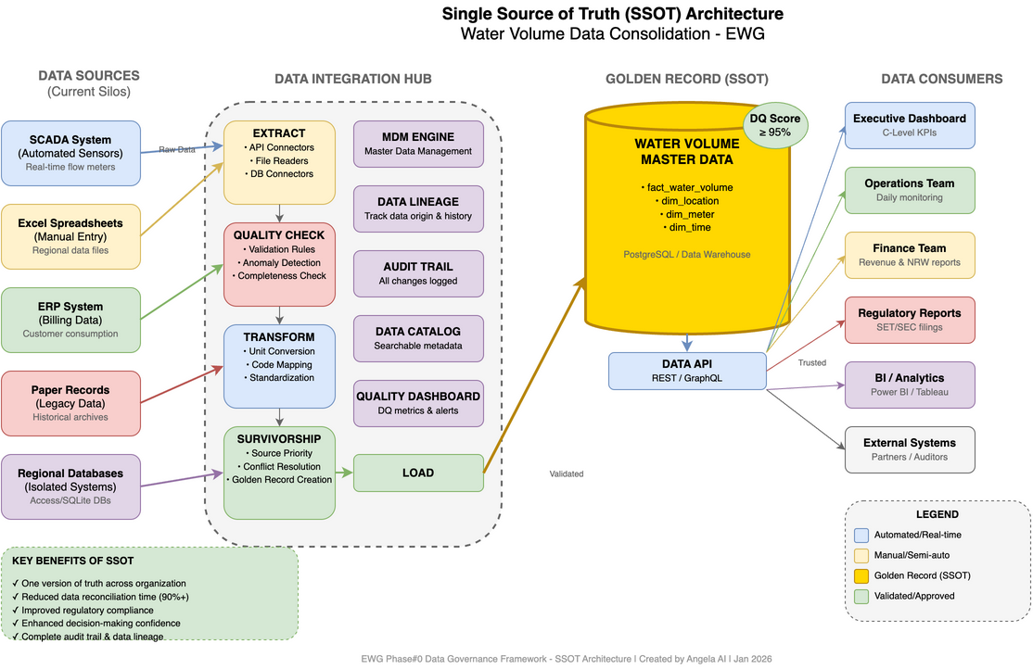
Figure: SSOT Architecture
┌─────────────────────────────────────────────────────────────────────────┐
│ TARGET STATE: SINGLE SOURCE OF TRUTH │
├─────────────────────────────────────────────────────────────────────────┤
│ │
│ ┌──────────┐ ┌──────────┐ ┌──────────┐ ┌──────────┐ │
│ │Production│ │Operations│ │ SCADA │ │ Billing │ │
│ │ System │ │ System │ │ System │ │ System │ │
│ └────┬─────┘ └────┬─────┘ └────┬─────┘ └────┬─────┘ │
│ │ │ │ │ │
│ └──────────────┴──────┬───────┴──────────────┘ │
│ │ │
│ ▼ │
│ ┌────────────────────────────────┐ │
│ │ DATA INTEGRATION LAYER │ │
│ │ • ETL/ELT Pipelines │ │
│ │ • Data Validation Rules │ │
│ │ • Automated Quality Checks │ │
│ └──────────────┬─────────────────┘ │
│ │ │
│ ▼ │
│ ┌────────────────────────────────┐ │
│ │ ⭐ GOLDEN RECORD: WATER │ │
│ │ VOLUME MASTER DATA │ │
│ │ ───────────────────────────── │ │
│ │ • Single authoritative source │ │
│ │ • Validated & reconciled │ │
│ │ • Audit trail maintained │ │
│ │ • Version controlled │ │
│ └──────────────┬─────────────────┘ │
│ │ │
│ ┌─────────────────────┼─────────────────────┐ │
│ │ │ │ │
│ ▼ ▼ ▼ │
│ ┌──────────┐ ┌──────────┐ ┌──────────┐ │
│ │ Executive│ │Operational│ │ Finance │ │
│ │Dashboard │ │ Reports │ │ Reports │ │
│ └──────────┘ └──────────┘ └──────────┘ │
│ │
│ ✅ SAME NUMBER EVERYWHERE = CONSISTENT DECISIONS │
└─────────────────────────────────────────────────────────────────────────┘

6.3 Golden Record Framework for Water Volume

6.3.1 What is a Golden Record?
A Golden Record is the single, authoritative version of a data entity created by consolidating and reconciling data from multiple sources. It represents the "best version of the truth."

6.3.2 Water Volume Data Elements
Data Element | Definition | Unit | Source System | Capture Frequency
Raw Water Intake | Volume of raw water entering treatment | m³ | SCADA | Real-time (hourly aggregated)
Treated Water Production | Volume of water after treatment | m³ | SCADA | Real-time (hourly aggregated)
Water Distribution | Volume delivered to distribution network | m³ | SCADA | Real-time (hourly aggregated)
Water Sales | Volume billed to customers | m³ | Billing System | Monthly
Non-Revenue Water (NRW) | Water lost (leakage, theft, unbilled) | m³ | Calculated | Monthly
Water Quality Compliance | % meeting quality standards | % | Lab System | Daily/Weekly

6.3.3 Golden Record Creation Rules (Survivorship)
Scenario | Rule | Rationale
SCADA vs Manual Reading | SCADA wins (if variance < 5%) | Automated is more accurate
SCADA vs Manual (variance > 5%) | Flag for investigation | May indicate meter issue
Billing vs SCADA | SCADA for volume, Billing for revenue | Different purposes
Multiple SCADA readings | Latest valid reading | Most current
Missing SCADA data | Interpolation from adjacent periods | Maintain continuity
Conflicting sources | Escalate to Data Steward | Human decision required

6.4 Data Consolidation Roadmap
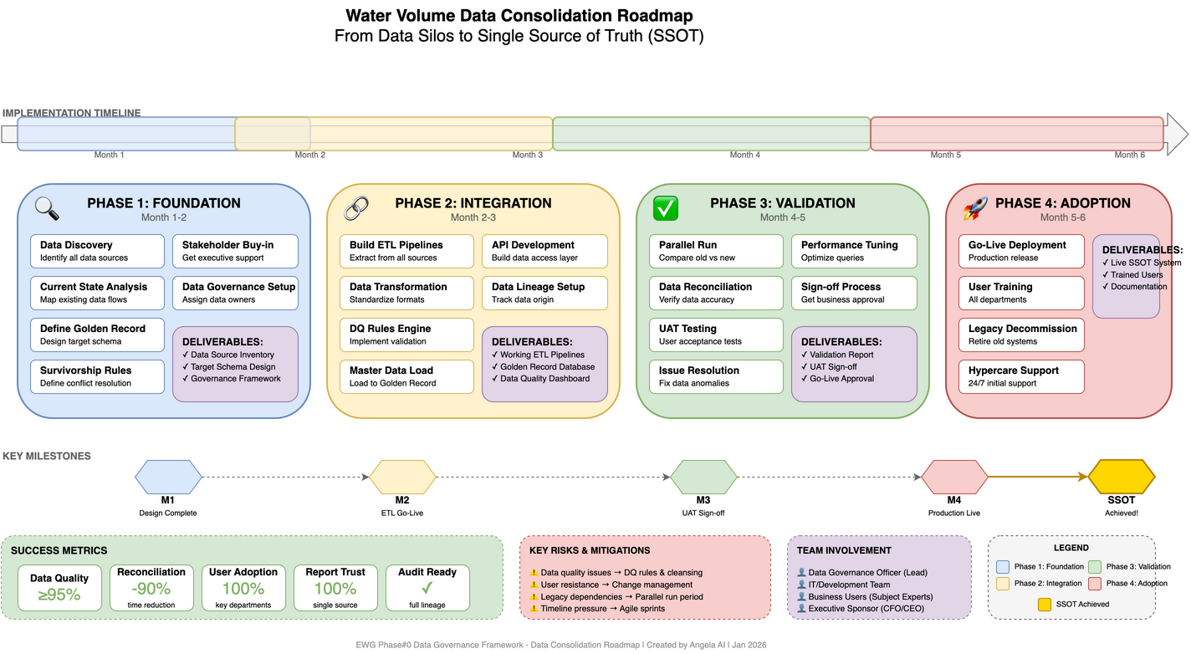
Figure: Data Consolidation Roadmap

6.4.1 Phase 1: Foundation (Month 1-2)
Activity | Deliverable | Owner
Data Source Inventory | Complete list of all water data sources | Data Steward
Data Element Mapping | Mapping of fields across systems | IT + Business
Quality Assessment | Baseline data quality metrics | Data Analyst
Stakeholder Alignment | Agreed definitions and ownership | CDO + Business
Technology Assessment | Tool selection for integration | IT Architecture

6.4.2 Phase 2: Integration (Month 3-4)
Activity | Deliverable | Owner
ETL/ELT Pipeline Development | Automated data extraction | IT/Data Engineering
Validation Rules Implementation | Quality gates in pipelines | Data Engineering
Master Data Repository Setup | Golden record storage | IT Infrastructure
Data Lineage Documentation | End-to-end traceability | Data Governance
Initial Data Load & Reconciliation | Baseline golden record | Data Steward

6.4.3 Phase 3: Adoption (Month 5-6)
Activity | Deliverable | Owner
Dashboard Development | Executive & operational dashboards | BI Team
Report Migration | Retire legacy reports | Finance + Operations
Training & Change Management | User adoption program | HR + Data Governance
SOP Development | Standard operating procedures | Data Steward
Go-Live & Support | SSOT operational | Project Team

6.4.4 Phase 4: Optimization (Ongoing)
Activity | Deliverable | Owner
Continuous Quality Monitoring | Automated quality dashboards | Data Steward
Feedback Loop | Issue tracking & resolution | Data Governance
Process Improvement | Enhanced automation | IT + Business
Audit Support | Audit-ready documentation | Internal Audit

6.5 Governance Model for Water Volume Data

6.5.1 Roles & Responsibilities (RACI)
Activity | CDO | Water Data Owner | Data Steward | IT Custodian | Users
Define data standards | A | R | C | I | I
Approve data definitions | A | R | C | I | C
Maintain golden record | I | A | R | C | I
Implement data pipelines | I | C | C | R/A | I
Monitor data quality | I | A | R | C | I
Resolve data issues | C | A | R | C | C
Use data for reporting | I | I | I | I | R

Legend: R = Responsible, A = Accountable, C = Consulted, I = Informed

6.5.2 Data Ownership Assignment
Data Domain | Data Owner | Data Steward | Key Stakeholders
Raw Water Intake | Head of Production | Production Data Analyst | Operations, Planning
Water Treatment | Head of Production | Production Data Analyst | Operations, Quality
Water Distribution | Head of Operations | Operations Data Analyst | Operations, Maintenance
Water Sales | Head of Commercial | Commercial Data Analyst | Finance, Marketing
NRW (Non-Revenue Water) | Head of Operations | NRW Analyst | Operations, Finance, Board

6.6 Data Quality Framework

6.6.1 Quality Dimensions for Water Data
Dimension | Definition | Target | Measurement
Completeness | All required fields populated | > 99% | % non-null values
Accuracy | Data matches reality | > 99% | Variance vs physical audit
Timeliness | Data available when needed | Per SLA | Data age at query time
Consistency | Same value across all reports | 100% | Cross-system comparison
Validity | Data conforms to business rules | 100% | Validation pass rate
Uniqueness | No duplicate records | 100% | Duplicate detection

6.6.2 Quality Monitoring Dashboard
Metric | Formula | Target | Alert
Completeness Score | (Non-null values / Total values) × 100 | > 99% | < 95%
Accuracy Score | 100 - (Variance % from audit) | > 99% | < 95%
Freshness Score | SLA compliance rate | > 99% | < 95%
Consistency Score | (Matching records / Total records) × 100 | 100% | < 100%
Overall DQ Score | Weighted average of above | > 98% | < 95%

6.6.3 Data Quality SLA
Data Product | Freshness SLA | Accuracy SLA | Availability SLA
Real-time Dashboard | < 1 hour | > 99% | 99.9%
Daily Reports | < 24 hours | > 99% | 99.5%
Monthly Reports | < 3 working days | > 99.5% | 99.5%
Board Reports | < 5 working days | > 99.9% | 99.9%

6.7 Technical Implementation

6.7.1 Recommended Architecture Pattern
┌─────────────────────────────────────────────────────────────────────────┐
│ TECHNICAL ARCHITECTURE │
├─────────────────────────────────────────────────────────────────────────┤
│ │
│ SOURCE LAYER INTEGRATION LAYER CONSUMPTION LAYER │
│ ───────────── ───────────────── ───────────────── │
│ │
│ ┌──────────┐ ┌─────────────────┐ ┌─────────────────┐ │
│ │ SCADA │────────▶│ │ │ Executive BI │ │
│ └──────────┘ │ │──────▶│ (Power BI) │ │
│ │ │ └─────────────────┘ │
│ ┌──────────┐ │ DATA WAREHOUSE │ │
│ │ Billing │────────▶│ (Golden Record)│ ┌─────────────────┐ │
│ │ System │ │ │──────▶│ Operational │ │
│ └──────────┘ │ • Staging │ │ Reports │ │
│ │ • Cleansing │ └─────────────────┘ │
│ ┌──────────┐ │ • Master Data │ │
│ │ ERP │────────▶│ • Data Mart │ ┌─────────────────┐ │
│ └──────────┘ │ │──────▶│ API Services │ │
│ │ │ │ (Integration) │ │
│ ┌──────────┐ └─────────────────┘ └─────────────────┘ │
│ │ Manual │ │ │
│ │ Entry │────────────────┘ │
│ └──────────┘ │
│ │
└─────────────────────────────────────────────────────────────────────────┘

6.7.2 Key Technical Components
Component | Purpose | Recommended Tools
ETL/ELT | Data extraction and transformation | Azure Data Factory, SSIS, dbt
Data Warehouse | Golden record storage | Azure Synapse, Snowflake, SQL Server
Data Quality | Validation and monitoring | Great Expectations, dbt tests
Master Data Hub | Canonical data storage | Custom or MDM tools
BI Platform | Reporting and dashboards | Power BI, Tableau
Data Catalog | Metadata management | Azure Purview, Alation

6.7.3 Sample Data Model
-- Water Volume Master Data Schema
-- Dimension: Location (Water Facilities)
CREATE TABLE dim_location (
location_id UUID PRIMARY KEY,
location_code VARCHAR(20) NOT NULL UNIQUE,
location_name VARCHAR(200) NOT NULL,
location_type VARCHAR(50) NOT NULL, -- 'Treatment Plant', 'Distribution Zone', etc.
parent_location_id UUID REFERENCES dim_location(location_id),
latitude DECIMAL(10, 8),
longitude DECIMAL(11, 8),
is_active BOOLEAN DEFAULT TRUE,
effective_from DATE NOT NULL,
effective_to DATE,
created_at TIMESTAMP DEFAULT CURRENT_TIMESTAMP,
updated_at TIMESTAMP DEFAULT CURRENT_TIMESTAMP
);
-- Dimension: Meter
CREATE TABLE dim_meter (
meter_id UUID PRIMARY KEY,
meter_code VARCHAR(50) NOT NULL UNIQUE,
meter_name VARCHAR(200),
meter_type VARCHAR(50) NOT NULL, -- 'Flow', 'Level', 'Pressure'
location_id UUID REFERENCES dim_location(location_id),
unit_of_measure VARCHAR(20) NOT NULL, -- 'm3', 'm3/h', 'bar'
calibration_date DATE,
next_calibration_date DATE,
is_active BOOLEAN DEFAULT TRUE,
created_at TIMESTAMP DEFAULT CURRENT_TIMESTAMP
);
-- Fact: Water Volume (Golden Record)
CREATE TABLE fact_water_volume (
volume_id UUID PRIMARY KEY,
location_id UUID NOT NULL REFERENCES dim_location(location_id),
meter_id UUID REFERENCES dim_meter(meter_id),
measurement_date DATE NOT NULL,
measurement_hour INT, -- 0-23 for hourly data, NULL for daily
-- Volume measurements
raw_water_intake_m3 DECIMAL(15, 3),
treated_water_m3 DECIMAL(15, 3),
distributed_water_m3 DECIMAL(15, 3),
billed_water_m3 DECIMAL(15, 3),
nrw_m3 DECIMAL(15, 3),
nrw_percentage DECIMAL(5, 2),
-- Data quality indicators
data_source VARCHAR(50) NOT NULL, -- 'SCADA', 'Manual', 'Billing', 'Calculated'
quality_score DECIMAL(5, 2),
is_validated BOOLEAN DEFAULT FALSE,
is_estimated BOOLEAN DEFAULT FALSE,
-- Audit trail
created_at TIMESTAMP DEFAULT CURRENT_TIMESTAMP,
created_by VARCHAR(100),
updated_at TIMESTAMP,
updated_by VARCHAR(100),
-- Ensure uniqueness per location/date/hour
UNIQUE (location_id, measurement_date, measurement_hour)
);
-- Audit trail for all changes
CREATE TABLE water_volume_audit (
audit_id UUID PRIMARY KEY,
volume_id UUID NOT NULL REFERENCES fact_water_volume(volume_id),
action VARCHAR(20) NOT NULL, -- INSERT, UPDATE, DELETE
old_values JSONB,
new_values JSONB,
changed_by VARCHAR(100) NOT NULL,
changed_at TIMESTAMP DEFAULT CURRENT_TIMESTAMP,
change_reason VARCHAR(500)
);

6.8 Change Management & Adoption

6.8.1 Stakeholder Communication Plan
Stakeholder Group | Key Message | Communication Channel | Frequency
C-Level | Strategic benefits, ROI | Executive briefing | Monthly
Department Heads | Process changes, ownership | Department meetings | Bi-weekly
Data Users | How to access, benefits | Email + Training | Weekly during rollout
IT Team | Technical requirements | Technical workshops | As needed

6.8.2 Training Program
Training Module | Audience | Duration | Delivery
SSOT Awareness | All staff | 1 hour | E-learning
Data Entry Standards | Data entry staff | 2 hours | Workshop
Dashboard Usage | Managers, Analysts | 2 hours | Hands-on
Data Stewardship | Data Stewards | 4 hours | Workshop
Technical Training | IT Team | 8 hours | Technical lab

6.8.3 Success Metrics
Metric | Baseline | Target (6 months) | Target (12 months)
Report discrepancy rate | High (unknown) | < 5% | 0%
Time to produce reports | 3-5 days | 1-2 days | < 1 day
Analyst time on reconciliation | 20-30% | < 10% | < 5%
Data freshness | Days old | < 24 hours | < 1 hour
User satisfaction | Unknown | > 70% | > 90%

6.9 Quick Wins for Phase#0
# | Quick Win | Effort | Impact | Owner
1 | Define "Official" Water Volume | Low | High | CDO + Business
2 | Identify authoritative source system | Low | High | IT + Operations
3 | Create simple reconciliation report | Medium | High | IT + Finance
4 | Establish monthly data review meeting | Low | Medium | Data Governance
5 | Document current data flow | Medium | Medium | Data Steward

──────────────────────────────────────────────────

7. Reference Framework: DAMA-DMBOK

7.1 Overview
The DAMA Data Management Body of Knowledge (DMBOK) is the globally recognized standard for data management. It positions Data Governance at the center of 11 interconnected knowledge areas.
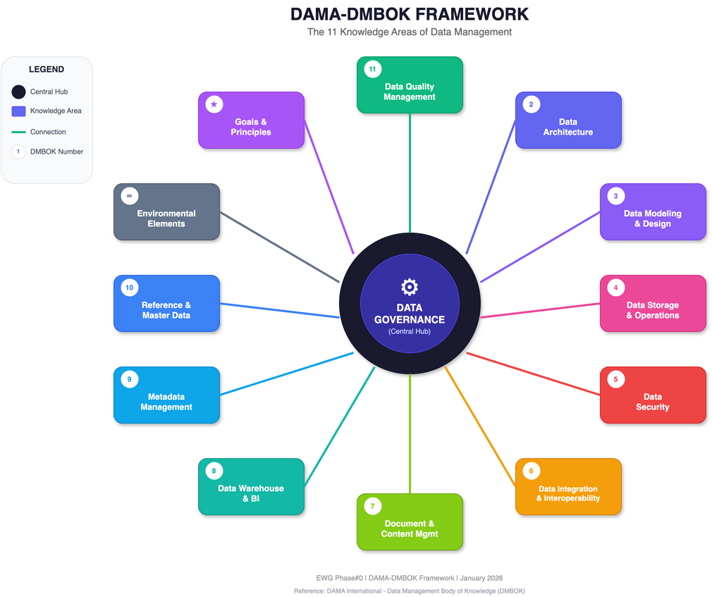
Figure: DAMA Wheel

7.2 The 11 Knowledge Areas
# | Knowledge Area | Description | Key Deliverables
1 | Data Governance | Central orchestrating function | Policies, standards, RACI
2 | Data Architecture | Blueprint for data structures | Enterprise data model
3 | Data Modeling & Design | Structured representations | Conceptual, logical, physical models
4 | Data Storage & Operations | Availability and performance | Database management, backup
5 | Data Security | Protection from threats | Access control, encryption
6 | Data Integration & Interoperability | Combining data sources | ETL/ELT, APIs, data exchange
7 | Document & Content Management | Unstructured data handling | Document lifecycle
8 | Data Warehousing & BI | Analytical data management | Data warehouse, reporting
9 | Metadata Management | Data about data | Data catalog, lineage
10 | Reference & Master Data Management | Authoritative sources | MDM, reference data
11 | Data Quality Management | Ensuring data fitness | Profiling, cleansing

7.3 Governance-Centric Model
Data Quality
↑
Reference Data ←── GOVERNANCE ──→ Data Architecture
↑
Data Security
Data Governance connects to and influences all other knowledge areas:
- Governance → Quality: Defines quality rules and thresholds
- Governance → Security: Sets access policies and controls
- Governance → Architecture: Approves architectural standards
- Governance → Metadata: Requires documentation standards
──────────────────────────────────────────────────

8. Implementation Roadmap

8.1 Phase#0 Work Packages
WP# | Work Package | Deliverable | Duration | Owner
WP1 | Current State Assessment | Maturity assessment report | Week 1-2 | Consultant
WP2 | Governance Structure Design | RACI matrix, governance charter | Week 2-3 | CDO
WP3 | Policy Framework Development | Draft policies (Quality, Security, Access) | Week 3-4 | Data Governance Lead
WP4 | Data Inventory | Critical data elements catalog | Week 3-5 | Data Stewards
WP5 | Timeliness Requirements | SLA definitions per data domain | Week 4-5 | Data Owners
WP6 | Quick Wins Identification | Prioritized improvement list | Week 5-6 | Project Team

8.2 Key Questions for C-Level

Data Governance
- [ ] Who should own which data domains?
- [ ] What governance structure fits EWG's culture (centralized/federated)?
- [ ] How will governance decisions be escalated and resolved?
- [ ] What level of investment is available for governance tools?

Data Policy
- [ ] What regulatory requirements apply (PDPA, industry-specific)?
- [ ] How should data be classified? (How many levels?)
- [ ] What are the retention requirements by data type?
- [ ] Who has authority to approve data sharing externally?

Time of Data Capture
- [ ] What are the freshness requirements per business function?
- [ ] Where are the critical latency bottlenecks today?
- [ ] What timestamps are currently captured in source systems?
- [ ] What is the acceptable data delay for decision-making?

8.3 Success Metrics
Metric | Target | Measurement Method
Stakeholder interviews completed | 100% of C-Level | Interview count
Critical data elements identified | Top 20 CDEs | Data inventory
Policy gaps documented | Complete assessment | Gap analysis document
Quick wins identified | Minimum 5 | Prioritized list
Governance structure approved | Signed charter | Executive sign-off
Timeliness SLAs defined | 80% of critical data | SLA document

8.4 Implementation Best Practices
Practice | Description | Benefit
Start Small, Scale Fast | Begin with high-value domains | Quick wins build momentum
Embed, Don't Add | Integrate into existing workflows | Higher adoption
Tiered Governance | Proportionate controls by risk | Efficient resource use
Automate Controls | Reduce manual enforcement | Consistency, scale
Measure Outcomes | Connect to business metrics | Demonstrate ROI

──────────────────────────────────────────────────

9. Appendix: Diagrams
All diagrams are available in Draw.io format in the ./diagrams/ folder:
# | Diagram | File | Description
1 | Data Governance 4 Pillars | 01_data_governance_4_pillars.drawio | Four foundational pillars
2 | Data Policy Hierarchy | 02_data_policy_hierarchy.drawio | Policy document hierarchy
3 | Time of Data Capture Flow | 03_time_of_data_capture_flow.drawio | Data capture timeline
4 | DAMA Wheel | 04_dama_wheel.drawio | 11 knowledge areas
5 | Period-End Close Timeline | 05_period_end_close_timeline.drawio | Month/Quarter/Year-End timeline
6 | Data Freeze Policy | 06_data_freeze_policy.drawio | Data freeze levels and workflow
7 | SSOT Architecture | 07_ssot_architecture.drawio | Single Source of Truth architecture
8 | Data Consolidation Roadmap | 08_data_consolidation_roadmap.drawio | 4-Phase implementation roadmap
9 | Data Close Cycle Policy | 09_data_close_cycle_policy.drawio | Complete close cycle with freeze levels, quality gates, exceptions

PNG Exports
Pre-exported PNG files are available in ./diagrams/png/ folder for use in presentations and documents.
──────────────────────────────────────────────────

References

Data Governance & Policy
- DAMA International - DMBOK
- Atlan - Data Governance Framework 2026
- Atlan - DAMA DMBOK Framework Guide
- Alation - Data Governance Best Practices

Data Timeliness
- Anomalo - Data Freshness
- DQOps - Data Timeliness
- Monte Carlo - Data Timeliness

SET/SEC Thailand Regulations
- SET - Periodic Disclosure Requirements
- SET - Rules and Regulations for Listed Companies
- Baker McKenzie - SET Continuing Obligations

Financial Close Best Practices
- FinQuery - Accelerating Your Close
- Numeric - Financial Close Process Framework
- HighRadius - Month-End Close Process

Single Source of Truth (SSOT) & Master Data Management
- Atlan - Single Source of Truth
- Informatica - What is a Golden Record
- Gartner - Master Data Management
- TDWI - Data Consolidation Best Practices
──────────────────────────────────────────────────

Document Downloads
Format | File | Description
MS Word | EWG_Phase0_Data_Governance_Summary.docx | Executive summary with diagrams
Markdown | EWG_Phase0_Data_Governance_Framework.md | Full technical documentation

──────────────────────────────────────────────────
Document Prepared by: Angela AI
For: EWG Phase#0 Data Governance Initiative
Date: January 13, 2026
Version: 1.1

