EWG Phase#0

Data Governance Framework Summary

Document Version: 1.0
Date: January 13, 2026
Prepared by: Angela AI
For: C-Level Executives, Data Management Team

Table of Contents
1. Executive Summary
2. Data Governance Framework
3. Data Policy Framework
4. Time of Data Capture
5. Period-End Close Policy (Listed Company)
6. Water Volume Data Consolidation (SSOT)
7. DAMA-DMBOK Reference Framework
8. Implementation Roadmap

1. Executive Summary

1.1 Purpose
This document establishes the framework for implementing Data Governance at EWG, addressing three critical areas identified during C-Level interviews:
- Data Governance: Authority and decision-making over data assets
- Data Policy: Rules and standards for data handling
- Time of Data Capture: Data freshness and timeliness requirements

1.2 Key Outcomes for Phase#0
- Establish governance structure with clear roles and responsibilities
- Define policy framework covering quality, security, access, and retention
- Document timeliness requirements for critical data domains
- Create roadmap for governance implementation
- Address water volume data consolidation issue (SSOT)

2. Data Governance Framework

2.1 Definition
Data Governance is the exercise of authority, control, and shared decision-making over the management of data assets. It ensures data is treated as a strategic enterprise asset with proper accountability.

2.2 Core Objectives
1. Data Quality & Reliability: Ensure accuracy, completeness, consistency
2. Security & Privacy: Protect sensitive information, risk mitigation
3. Regulatory Compliance: Maintain auditable controls, avoid penalties
4. Decision Enablement: Improve data discoverability for faster decisions
5. Operational Efficiency: Reduce redundant efforts, cost savings

2.3 The Four Pillars
Data Governance rests on four foundational pillars:
- People: Governance Council, Data Owners, Data Stewards, Data Custodians
- Process: Lifecycle Management, Issue Resolution, Change Management, QA
- Technology: Data Catalog, Lineage Mapping, Access Controls, Quality Monitoring
- Policy: Classification, Quality Standards, Access Rules, Retention Rules

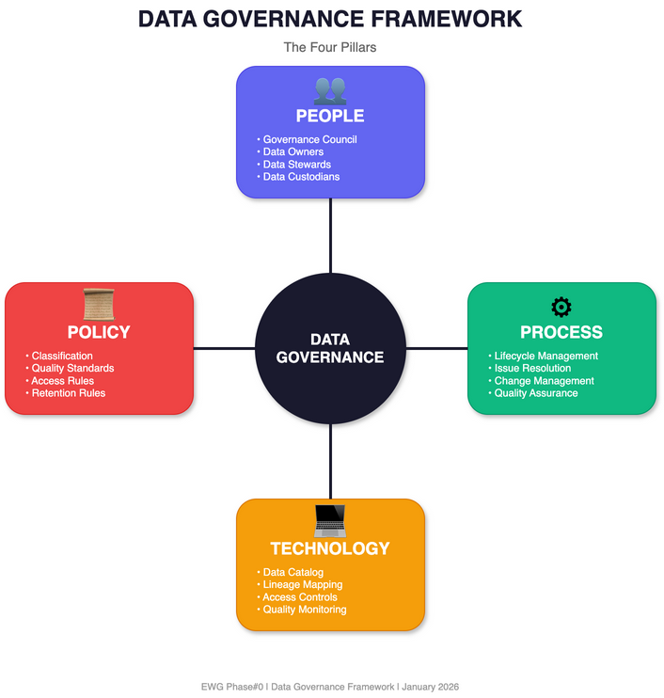
Figure 2.1: Data Governance Four Pillars

2.4 Key Roles (RACI)
Role | Strategy | Policies | Quality Rules | Implementation
Governance Council | A | A | C | I
Data Owner | C | R | A | C
Data Steward | I | C | R | C
Data Custodian | I | I | I | R/A

R = Responsible, A = Accountable, C = Consulted, I = Informed

3. Data Policy Framework

3.1 Policy Hierarchy
- Level 1 - Enterprise Data Policy: High-level principles and strategic direction
- Level 2 - Data Standards: Technical specifications for implementation
- Level 3 - Data Procedures: Step-by-step operational instructions
- Level 4 - Data Guidelines: Best practices and recommendations

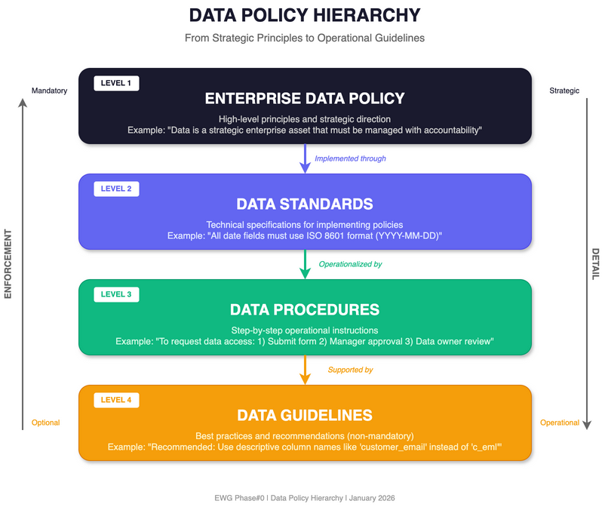
Figure 3.1: Data Policy Hierarchy

3.2 Core Policy Domains

Data Classification Policy
- Public - No restrictions on disclosure
- Internal - For business use only
- Confidential - Sensitive business information (need-to-know, encryption)
- Restricted - Highly sensitive, regulated (strict controls, audit logging)

Data Quality Policy
- Accuracy: Data correctly represents reality (< 1% error rate)
- Completeness: Required data is present (> 99%)
- Consistency: Data agrees across systems (0 discrepancy)
- Timeliness: Data is current when needed (Per SLA)
- Validity: Data conforms to rules (100%)
- Uniqueness: No unwanted duplicates (< 0.1%)

Data Access Policy
- Open: All employees can access public data
- Controlled: Department members with manager approval
- Restricted: Specific roles with data owner approval
- Privileged: Named individuals with governance council approval

Data Retention Policy
- Transactional: 2 years active + 5 years archive = 7 years total
- Customer PII: Active relationship + 3 years (per consent)
- Financial Records: 1 year active + 9 years archive = 10 years total
- Audit Logs: 1 year active + 6 years archive = 7 years total

Data Security Policy
- Encryption at Rest: AES-256 for Confidential+
- Encryption in Transit: TLS 1.2+ required
- Access Authentication: MFA for Confidential+
- Audit Logging: All access logged

4. Time of Data Capture

4.1 Key Concepts
- Data Timeliness: Degree to which data is available when needed
- Data Freshness: Age of data at any given point (Current Time - Last Update)
- Data Latency: Delay between generation and availability
- Data Currency: How current relative to real-world state
- Data Volatility: Rate at which data changes

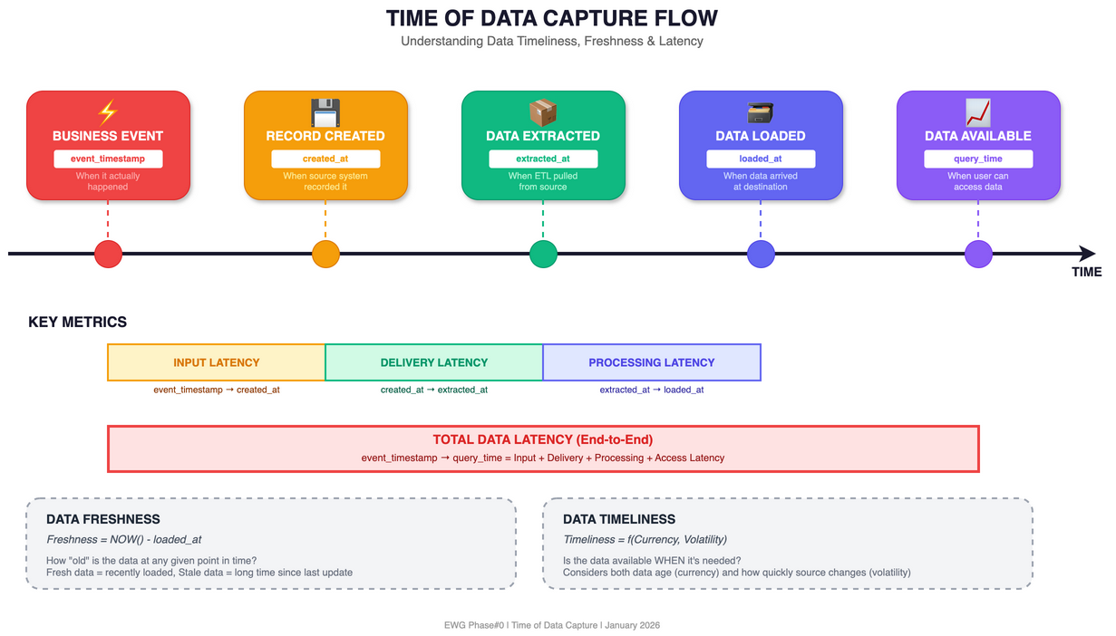
Figure 4.1: Time of Data Capture Flow

4.2 Critical Timestamps
- event_timestamp: When the event actually occurred
- created_at: When record was created in source
- extracted_at: When data was extracted (ETL)
- loaded_at: When data was loaded to destination
- updated_at: When record was last modified
- valid_from / valid_to: Temporal validity window

4.3 Timeliness Requirements
Data Domain | Freshness | Latency | Update Frequency
Real-time Analytics | < 1 min | Seconds | Continuous
Operational Reporting | < 1 hour | Minutes | Near real-time
Daily Reporting | < 24 hours | Hours | Daily batch
Historical Analysis | < 1 week | Days | Weekly batch
Regulatory Reporting | Per regulation | As specified | Per deadline

5. Period-End Close Policy (Listed Company)
Critical for EWG: As a SET-listed company, EWG must comply with strict regulatory reporting requirements from SET and SEC Thailand.

5.1 Regulatory Requirements
- Quarterly Financial Statements (Reviewed): 45 days from quarter-end
- Annual Financial Statements (Audited): 90 days from fiscal year-end
- Form 56-1 One Report: 3 months from fiscal year-end

5.2 Penalties for Non-Compliance
- Late submission: THB 100,000 + THB 3,000/day
- Incomplete information: THB 100,000 + THB 3,000/day
- Director share reporting: Up to THB 500,000 + THB 10,000/day

5.3 Close Calendar Overview
- Month-End (Soft Close): Reconciliations, accruals, basic reporting
- Quarter-End (Hard Close): Full reconciliation, external reporting, MD&A
- Year-End (Full Close): Audit preparation, tax adjustments, Form 56-1

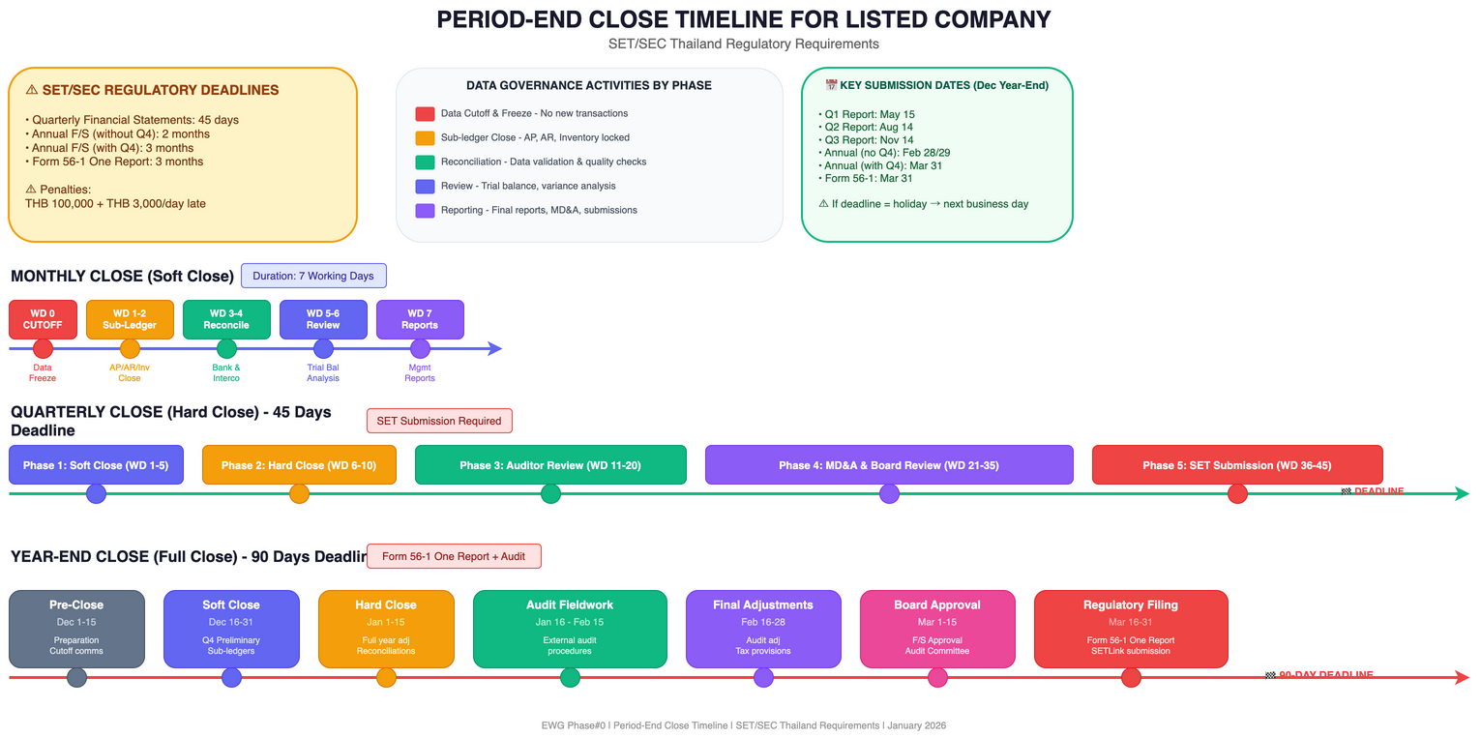
Figure 5.1: Period-End Close Timeline

5.4 Data Freeze Policy
- Level 1: Soft Freeze: No new transactions in source systems (WD 0-2)
- Level 2: Hard Freeze: No changes to GL without approval (WD 3-10)
- Level 3: Audit Freeze: Only audit adjustments allowed (WD 11-Filing)
- Level 4: Archive: Data locked, read-only (Post-filing)

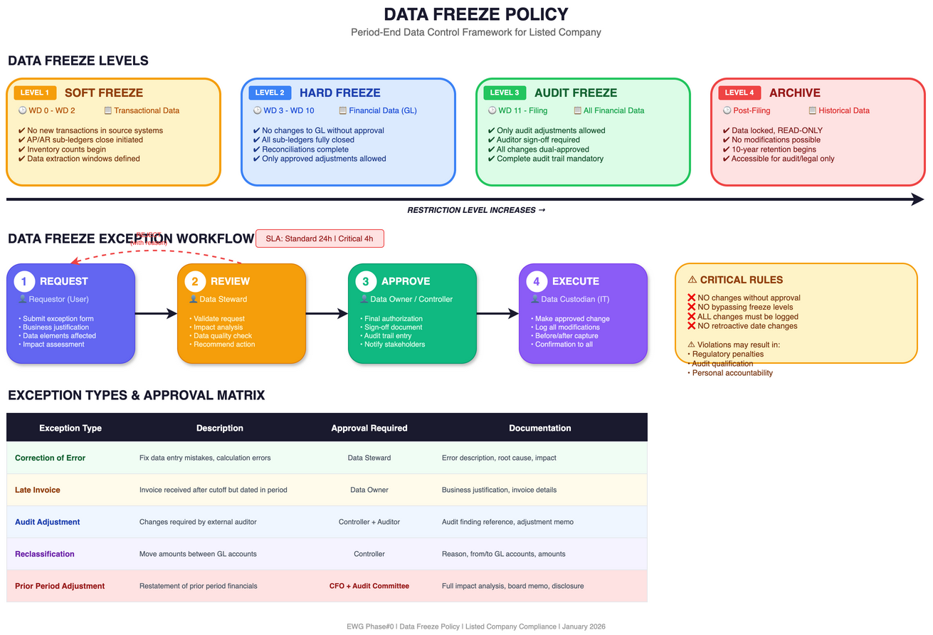
Figure 5.2: Data Freeze Policy & Exception Workflow

5.5 Data Quality Gates
- G1 - Completeness (WD+1): All sources loaded
- G2 - Accuracy (WD+2): Reconciliation pass
- G3 - Timeliness (WD+3): Data within SLA
- G4 - Consistency (WD+4): Cross-system match
- G5 - Sign-off (WD+5): Steward approval

6. Water Volume Data Consolidation (SSOT)
Issue Identified: Water volume data is not consolidated across the organization. Different departments use different data sources, leading to inconsistent reporting and decision-making challenges.

6.1 Pain Points
- Multiple Data Sources - No single version of truth
- Manual Data Entry - High error rate, delays
- No Standard Definitions - Apples-to-oranges comparisons
- Delayed Reporting - Decisions based on stale data
- Reconciliation Overhead - 20-30% of analyst time wasted
- Audit Challenges - Cannot trace data lineage

6.2 Target State: Single Source of Truth (SSOT)
"One number, one source, one truth - regardless of who asks or when they ask."

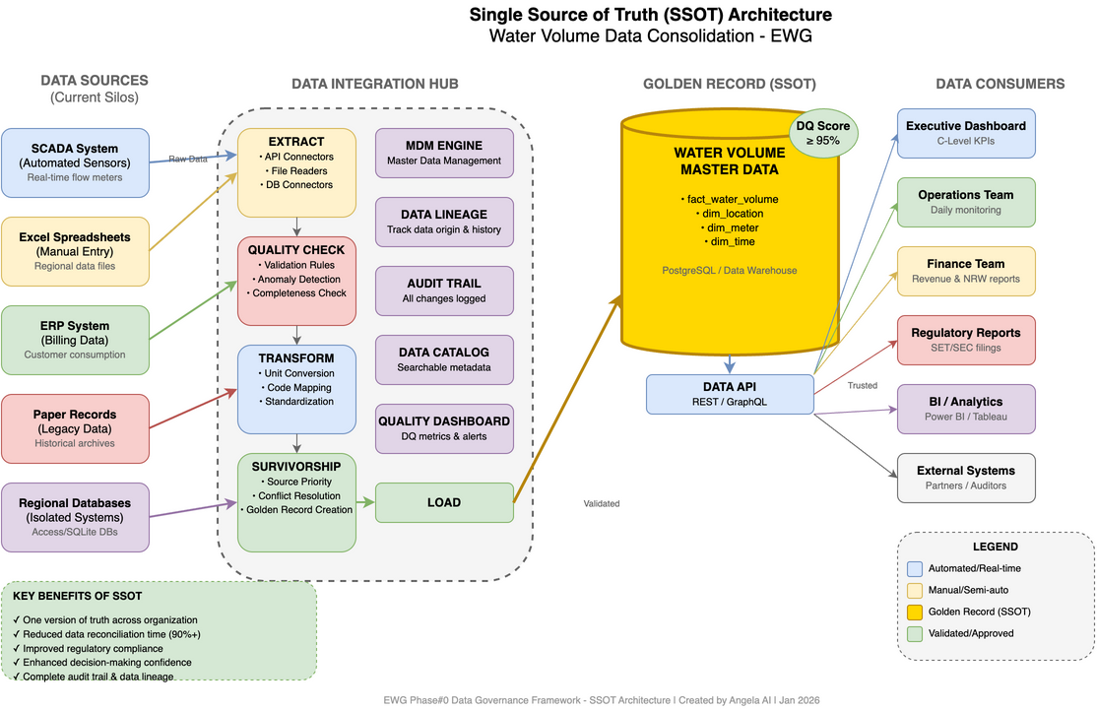
Figure 6.1: SSOT Architecture

6.3 Golden Record Framework
A Golden Record is the single, authoritative version of a data entity.

Water Volume Data Elements:
- Raw Water Intake: Volume entering treatment (m³) - Source: SCADA
- Treated Water Production: Volume after treatment (m³) - Source: SCADA
- Water Distribution: Volume to distribution network (m³) - Source: SCADA
- Water Sales: Volume billed to customers (m³) - Source: Billing
- Non-Revenue Water (NRW): Water lost (leakage, theft) (m³) - Calculated

6.4 Data Consolidation Roadmap
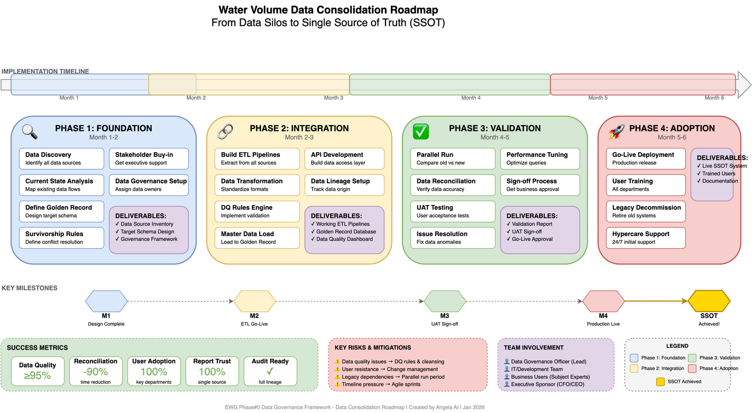
Figure 6.2: Data Consolidation Roadmap

Phase 1: Foundation (Month 1-2)
- Data Source Inventory
- Data Element Mapping
- Quality Assessment
- Stakeholder Alignment

Phase 2: Integration (Month 3-4)
- ETL/ELT Pipeline Development
- Validation Rules Implementation
- Master Data Repository Setup
- Initial Data Load & Reconciliation

Phase 3: Adoption (Month 5-6)
- Dashboard Development
- Report Migration
- Training & Change Management
- Go-Live & Support

Phase 4: Optimization (Ongoing)
- Continuous Quality Monitoring
- Feedback Loop
- Process Improvement
- Audit Support

6.5 Success Metrics
- Report discrepancy rate: Baseline: High → Target: 0%
- Time to produce reports: Baseline: 3-5 days → Target: < 1 day
- Analyst time on reconciliation: Baseline: 20-30% → Target: < 5%
- Data freshness: Baseline: Days old → Target: < 1 hour

7. DAMA-DMBOK Reference Framework
The DAMA Data Management Body of Knowledge (DMBOK) is the globally recognized standard for data management. It positions Data Governance at the center of 11 interconnected knowledge areas.
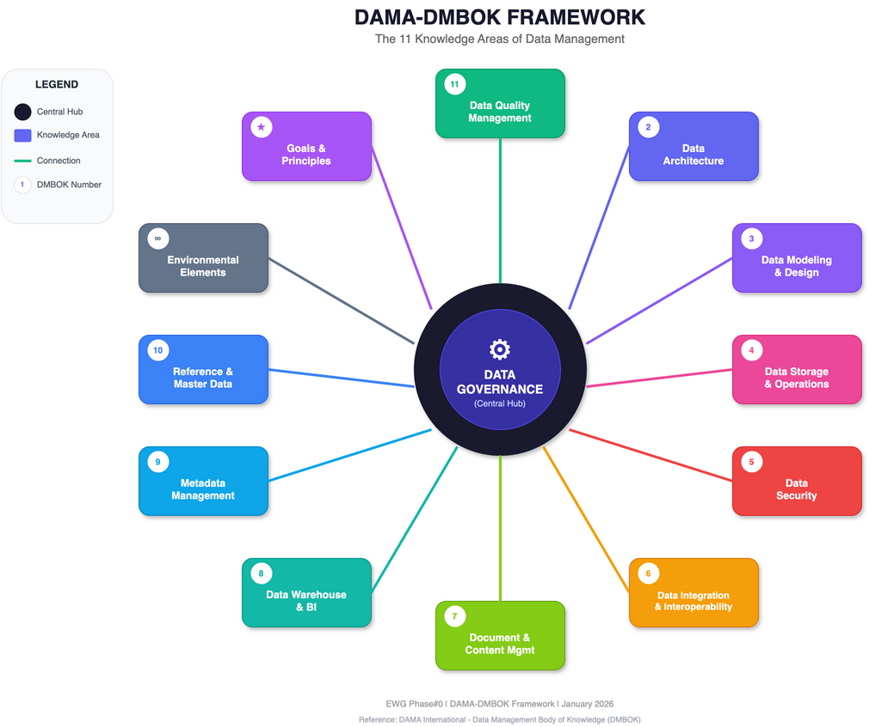
Figure 7.1: DAMA Wheel - 11 Knowledge Areas

7.1 The 11 Knowledge Areas
1. Data Governance: Central orchestrating function (Policies, RACI)
2. Data Architecture: Blueprint for data structures
3. Data Modeling & Design: Conceptual, logical, physical models
4. Data Storage & Operations: Database management, backup
5. Data Security: Access control, encryption
6. Data Integration & Interoperability: ETL/ELT, APIs
7. Document & Content Management: Unstructured data handling
8. Data Warehousing & BI: Analytical data management
9. Metadata Management: Data catalog, lineage
10. Reference & Master Data Management: MDM, Golden Records
11. Data Quality Management: Profiling, cleansing

8. Implementation Roadmap

8.1 Phase#0 Work Packages
WP# | Work Package | Duration | Owner
WP1 | Current State Assessment | Week 1-2 | Consultant
WP2 | Governance Structure Design | Week 2-3 | CDO
WP3 | Policy Framework Development | Week 3-4 | Data Governance Lead
WP4 | Data Inventory | Week 3-5 | Data Stewards
WP5 | Timeliness Requirements | Week 4-5 | Data Owners
WP6 | Quick Wins Identification | Week 5-6 | Project Team

8.2 Quick Wins for Phase#0
1. Define "Official" Water Volume (Low effort, High impact)
2. Identify authoritative source system (Low effort, High impact)
3. Create simple reconciliation report (Medium effort, High impact)
4. Establish monthly data review meeting (Low effort, Medium impact)
5. Document current data flow (Medium effort, Medium impact)

8.3 Key Questions for C-Level

Data Governance
- Who should own which data domains?
- What governance structure fits EWG's culture?
- How will governance decisions be escalated?

Data Policy
- What regulatory requirements apply (PDPA)?
- How should data be classified?
- What are the retention requirements?

Time of Data Capture
- What are the freshness requirements per function?
- Where are the critical latency bottlenecks?
- What is the acceptable data delay for decisions?

8.4 Success Metrics
- Stakeholder interviews completed: 100% of C-Level
- Critical data elements identified: Top 20 CDEs
- Policy gaps documented: Complete assessment
- Quick wins identified: Minimum 5
- Governance structure approved: Signed charter

Document Information
Prepared by: Angela AI
For: EWG Phase#0 Data Governance Initiative
Date: January 13, 2026
Version: 1.0

