

Republic of the Philippines
Western Mindanao State University
College of Computing Studies
Department of Computer Science
Zamboanga City

ClassSense – AI-Powered Classroom Gesture Recognition System

In partial fulfillment of the requirements in
IT 322 – Machine Learning

Submitted by:

Alih, Salman L.
Benedicto, Hernane A.
Canilang, Kurt Aldrich
Enriquez, John Paul
Garcia, Angel M.
Madrazo, Alexandra Steffi Marie
Zaragoza, Marvin Paul

BSIT 3A | 3B

Submitted to:

Mr. John Augustus
Instructor

Date of Submission:

March 2026
Table of Contents
CHAPTER I 3
1.1 BRIEF OVERVIEW OF THE PROJECT 3
1.2 BACKGROUND AND RATIONALE 3
1.3 OBJECTIVES 4
1.4 SIGNIFICANCE OF THE PROJECT 4
1.5 PROJECT TIMELINE 5
1.6 CONCLUSION 6
CHAPTER II 7
2.1 REVIEW OF RELATED LITERATURE AND STUDIES 7
A. DATA PROCESSING IN GESTURE RECOGNITION STUDIES 9
B. MODEL BUILDING AND TRAINING 10
C. MODEL COMPARISON 11
D. PERFORMANCE METRICS 13
2.2 SYNTHESIS OF THE LITERATURE 14
2.3 REFERENCES 15
CHAPTER III 16
3.1 RESEARCH DESIGN 16
3.2 SYSTEM DEVELOPMENT METHODOLOGY 16
3.3 SYSTEM ARCHITECTURE DESIGN 18
3.3.1 OVERALL ARCHITECTURE 18
3.3.2 ML PIPELINE ARCHITECTURE 19
3.4 DATA COLLECTION 20
3.5 DATA PROCESSING 21
3.6 FEATURE ENGINEERING 22
3.7 MACHINE LEARNING MODEL DEVELOPMENT 23
3.7.1 MODEL SELECTION 23
3.7.2 MODEL TRAINING 23
3.7.3 MODEL EVALUATION METRICS 24
3.8 SYSYEM IMPLEMENTAION 25
3.9 MODEL DEPLOYMENT 26
3.10 TESTING STRATEGY 27
3.10.1 SOFTWARE TESTING 27
3.10.2 MODEL PERFORMANCE TESTING 28
3.11 PERFORMANCE EVALUATION 29
3.12 ETHICAL AND SECURITY CONSIDERATIONS 30
3.13 TOOLS AND TECHNOLOGIES 31
3.14 PROPOSED USER INTERFACES 32
3.14.1 LOGIN INTERFACE 32
3.14.2 LOADING INDICATOR / SPLASH SCREEN INTERFACE 32
3.14.3 MAIN DASHBOARD INTERFACE 34
3.14.4 CLASS ACTIVITIES INTERFACE 36
3.14.5 START CLASS INTERFACE 38
3.14.6 CLASS SETUP INTERFACE 42

CHAPTER I

1.1 BRIEF OVERVIEW OF THE PROJECT

ClassSense is an AI-powered classroom gesture recognition system designed to automate the detection of student gestures in real-time. Using a webcam or classroom camera, the system identifies common classroom gestures such as raising hands, making a peace sign, showing thumbs up, walking around the room, and moving the head, and provides instant feedback to teachers through a real-time web dashboard. This tool aims to enhance classroom engagement, streamline participation tracking, and support inclusive learning environments, particularly for students who rely on non-verbal communication. By combining computer vision, deep learning, and a modern web interface, ClassSense transforms the way teachers monitor and respond to student behavior without requiring complex hardware or technical expertise.

1.2 BACKGROUND AND RATIONALE

Problem Statement

- Manual Participation Tracking: Teachers struggle to monitor and log student gestures such as raised hands and signs in real-time, especially in large or inclusive classrooms where attention is split across many students simultaneously.
- Inclusive Learning Gaps: Students who use sign language or non-verbal cues, including deaf or hard-of-hearing students, often face challenges in getting noticed or participating equally in classroom activities.
- Teacher Workload: Manually tracking gestures such as who raised their hand first is time-consuming and distracting, taking focus away from the primary responsibility of teaching and delivering content
- Limited Classroom Technology: Many classrooms lack affordable, easy-to-use tools to automate gesture recognition without complex setup or specialized hardware requirements.

Solution
ClassSense addresses these issues by automating gesture detection using AI and a standard classroom camera, identifying all common classroom gestures including raising hands, standing, walking, peace sign, thumbs up, and head movement in real-time. The system provides teachers with instant alerts via a dashboard or notification system, and supports inclusive classrooms by recognizing gesture types and non-verbal cues relevant to diverse student populations.

1.3 OBJECTIVES

General Objectives:
To develop a user-friendly, AI-driven system that detects and classifies student gestures in classrooms, enhancing participation tracking and academic integrity monitoring through real-time computer vision and machine learning.
Specific Objectives:

- Detect Gestures in Real Time: Use a webcam or classroom camera to identify gestures like raised hands, peace signs, thumbs up, walking, and head movement as they occur during active class sessions.
- Classify Gestures Accurately: Train custom machine learning models using Google Teachable Machine to recognize all target classroom gestures with sufficient accuracy for deployment in a real classroom environment.
- Apply Context-Aware Rules: Implement an Activity Mode system (Lecture, Quiz, Exam) that interprets the same gesture differently depending on the current classroom context, triggering appropriate alerts when suspicious behavior is detected.
- Provide Teacher Feedback: Display real-time alerts and a gesture log on a teacher dashboard built in React.js, automatically updated through WebSocket communication with the Django backend.
- Develop a Functional Prototype: Build a working full-stack system integrating trained Teachable Machine models, a Django REST API, WebSocket streaming, and a React.js frontend that can be demonstrated in a classroom setting.

1.4 SIGNIFICANCE OF THE PROJECT

- For Teachers: Reduces workload by automating participation tracking and providing instant alerts during quizzes and examinations when suspicious gestures are detected.
- For Students: Ensures equal opportunities to participate, especially for non-verbal or deaf students, while also promoting academic integrity through fair and consistent monitoring.
- For Schools: Provides an affordable, inclusive tool that enhances classroom engagement without requiring expensive hardware or specialized installations.
- For Developers and Researchers: Demonstrates the practical application of Teachable Machine, TensorFlow.js models, Django Channels WebSockets, and React.js in a cohesive real-world AI-powered system.

1.5 PROJECT TIMELINE

Phase | Task | Duration
Research | Study MediaPipe/Teachable Machine | 1 – 2 weeks
Data Collection | Gather gesture datasets or use pre-trained | 1 week or more
Prototyping | Build gesture recognition model | 2 weeks
Dashboard Development | Create teacher alerts(reactjs) | 1 week
Testing | Test in a classroom; gather feedback | 1 week
Finalization | Refine model and documentation | 3 days or more

1.6 CONCLUSION

ClassSense is a practical, scalable, and inclusive solution designed to automate gesture recognition in classrooms using custom-trained machine learning models built on Google Teachable Machine. By training two separate models — an image classification model for hand gestures and a pose classification model for full-body gestures — with 400 to 500 samples per gesture class collected across varied angles and lighting conditions, the system achieves reliable real-time detection performance suitable for classroom deployment. Each model was trained in Teachable Machine using webcam-recorded samples organized into labeled classes including Raise Hand, Standing, Walking, Moving Head, Thumbs Up, Peace Sign, and a None class for baseline non-gesture frames.
For the dashboard, React.js is used to create a real-time, interactive interface for teachers. This dashboard displays gesture alerts and provides a visual log of classroom participation organized by activity mode. The Activity Mode feature delivers real-time gesture detection tailored to each classroom scenario — allowing natural behavior during lectures, flagging suspicious movement during quizzes, and enforcing strict monitoring during examinations — providing teachers with actionable insights and automated logs to improve classroom management.

CHAPTER II

2.1 REVIEW OF RELATED LITERATURE AND STUDIES

INTRODUCTION
This chapter presents the related literature and studies that support the current research. It discusses the use of artificial intelligence, computer vision, and gesture recognition in education and accessibility. These studies provide a foundation for understanding how modern technologies can improve communication, student engagement monitoring, and inclusive learning environments.
.

RELATED LITERATURE
Recent advancements in sign language recognition have leveraged machine learning models, such as the Random Forest classifier, to classify manual gestures from the Latin alphabet with high accuracy, demonstrating the potential of technology to bridge communication gaps for the deaf and hard-of-hearing community (Na Râng et al., 2024). This study directly supports ClassSense’s use of supervised classification models to distinguish between multiple gesture classes, validating the approach of training a classifier on labeled gesture data to achieve reliable recognition performance.

In recent times, the incorporation of Artificial Intelligence (AI) and computer vision into educational technologies has changed how student participation and classroom actions are observed. Conventional techniques for evaluating student involvement, like direct observation and questionnaires, tend to be subjective, labor-intensive, and susceptible to bias (Al-Makhlasawy et al., 2026). This literature supports the core rationale of ClassSense — that automated, AI-driven gesture tracking is a more objective and efficient alternative to manual teacher-led participation monitoring, particularly in large or diverse classroom settings.

Renawi et al. (2021) developed a real-time, camera-based system using standard webcams and computer vision to assess student attention through head-pose tracking, providing color-coded feedback to instructors. This study supports ClassSense’s design decision to use an ordinary classroom webcam as the primary input device rather than specialized hardware, demonstrating that affordable and accessible camera equipment is sufficient for real-time behavioral monitoring in educational environments.

Studies in hand gesture recognition have comprehensively reviewed computer vision techniques, highlighting their applications in fields such as communication for deaf-mute individuals, human-computer interaction, and robot control, while also addressing challenges like gesture segmentation, classification algorithms, and detection range (Oudah et al., 2020). This review provides direct methodological support for ClassSense’s use of MediaPipe Pose for skeletal landmark extraction and a CNN for gesture classification, as both tools address the core challenges of segmentation and classification identified in this literature.

Systematic reviews in computer vision-based classroom behavior recognition have highlighted its growing importance in capturing and annotating teachers’ and students’ states in real time, focusing on physical actions, learning engagement, attention, and emotion, with deep learning particularly the YOLO series emerging as the primary method, though challenges remain in experimental design, practical application, and pedagogical integration (Liu et al., 2025). This study contextualizes ClassSense within the broader field of automated classroom monitoring and supports the use of deep learning as the foundational methodology, while also acknowledging the practical integration challenges the project must address during deployment.

AI-assisted hand gesture recognition systems have shown significant potential in enhancing educators’ ability to develop lesson plans, assess learning objectives, and provide real-time feedback, with the proposed Affordable Intelligent Smart Teacher Feedback System (AISTFS) demonstrating outstanding performance in detection accuracy and processing speed, marking it as a promising trend in educational technology (Sagolsem et al., 2025). This study is the most directly comparable work to ClassSense, supporting the project’s specific design goal of providing teachers with real-time gesture-based feedback through an accessible and affordable system.

The integration of digital technologies in deaf and hard-of-hearing (DHH) education has gained global recognition, with tools such as assistive devices, captioning systems, and sign language platforms playing a crucial role in fostering inclusive learning environments. However, challenges such as limited localized content, infrastructural gaps, and insufficient teacher training continue to hinder effective technology adoption, highlighting the need for context-specific studies and regionally adapted innovations (Almulhim, 2025). This literature supports ClassSense’s inclusivity objective specifically its goal of recognizing sign language gestures to ensure equal participation for deaf and hard-of-hearing students while also acknowledging the implementation barriers that the project must consider in its local Philippine classroom deployment context.
Support Variables and Methods Identified from Literature
The following table summarizes the key variables and methods drawn from the reviewed literature that directly support the development of ClassSense:
Study | Support Variable/ Method | Application in ClassSense
Na Râng et al. (2024) | Random Forest / supervised classification | Validates multi-class gesture classification approach
Al-Makhlasawy et al. (2026) | AI + computer vision in education | Supports automated participation tracking rationale
Renawi et al. (2021) | Real-time webcam-based monitoring | Supports use of standard classroom webcam as input
Oudah et al. (2020) | Gesture segmentation + CV techniques | Supports MediaPipe + CNN pipeline design
Liu et al. (2025) | Deep learning for classroom behavior | Supports deep learning as core methodology
Sagolsem et al. (2025) | AI gesture feedback system (AISTFS) | Directly supports real-time teacher alert system
Almulhim (2025) | DHH inclusive education + tech gaps | Supports inclusivity objective and deployment awareness

Related Studies
This section reviews studies that are directly related to the specific technical processes employed in ClassSense namely data preprocessing, model building and training, model comparison, and performance metric evaluation. These studies validate the step-by-step technical methodology adopted by the project and demonstrate that the chosen approaches have been proven effective in similar gesture and behavior recognition systems.

A. DATA PROCESSING IN GESTURE RECOGNITION STUDIES
Data preprocessing is a foundational step in any machine learning pipeline, and its importance has been consistently emphasized across gesture recognition literature. Oudah et al. (2020) identified that the quality of preprocessing directly determines classification accuracy, highlighting that image resizing, grayscale conversion, and background subtraction are essential steps before feature extraction in hand gesture recognition systems. Their review confirmed that inconsistent preprocessing is a primary cause of poor generalization in gesture classifiers, supporting ClassSense’s strict pipeline of resizing all frames to 224×224 pixels, normalizing pixel values to [0, 1], and discarding any frame where MediaPipe fails to detect a complete body skeleton.

Na Râng et al. (2024) applied data augmentation techniques including horizontal flipping, rotation, and brightness variation to expand their gesture dataset and reduce overfitting in their Random Forest classifier. Their results showed that augmented datasets consistently outperformed non-augmented baselines by 8–12% in classification accuracy, directly justifying ClassSense’s use of TensorFlow’s ImageDataGenerator to apply horizontal flipping, random rotation (±15°), brightness adjustment (±20%), and width/height shifts before training.

Sagolsem et al. (2025) described a preprocessing pipeline for their AISTFS system that included landmark normalization and feature vector construction from pose estimation outputs, demonstrating that normalizing skeletal coordinates relative to frame dimensions significantly improved model stability across different camera distances and body sizes. This directly supports ClassSense’s reliance on MediaPipe’s built-in landmark normalization, which outputs x, y, and z coordinates already scaled relative to frame dimensions, eliminating the need for additional manual normalization of the pose features.

The train-validation-test split strategy used in ClassSense (70% training, 15% validation, 15% test) is supported by Liu et al. (2025), whose systematic review found that stratified splits in the 70–80% training range with 15–20% held-out test sets are the most commonly adopted and reproducible partitioning strategies across classroom behavior recognition studies, providing stable and comparable evaluation baselines.

B. MODEL BUILDING AND TRAINING

The selection and training of machine learning models for gesture classification has been extensively studied, with Convolutional Neural Networks (CNNs) emerging as the dominant architecture for image-based gesture recognition. Oudah et al. (2020) confirmed through their comprehensive review that CNNs consistently outperform traditional handcrafted feature methods in gesture classification tasks because they automatically learn hierarchical spatial features from raw image data without requiring manual feature engineering. This finding directly validates ClassSense’s choice of a CNN as its primary gesture classifier, trained on self-collected gesture image frames rather than relying on manually designed feature descriptors.

Na Râng et al. (2024) trained their Random Forest classifier using supervised learning with categorical labels, applying 5-fold cross-validation to ensure their model’s performance estimates were stable and not dependent on a single data split. Their approach demonstrated that cross-validation is essential for small-to-medium datasets (under 1,000 samples) because it maximizes the use of limited labeled data while providing reliable generalization estimates. ClassSense adopts the same 5-fold stratified cross-validation strategy for identical reasons, as its dataset of 500 samples falls within the same size range.

Sagolsem et al. (2025) trained the AISTFS gesture recognition model using the Adam optimizer with categorical cross-entropy loss, reporting that Adam’s adaptive learning rate consistently converged faster and achieved higher final accuracy than SGD across all gesture classes tested. Their findings provide direct empirical support for ClassSense’s use of the same optimizer and loss function combination, confirming that Adam with an initial learning rate of 0.001 and categorical cross-entropy is the appropriate training configuration for multi-class gesture classification tasks.

The use of early stopping and learning rate reduction callbacks during model training is supported by Liu et al. (2025), whose review found that training deep learning classifiers without early stopping mechanisms consistently resulted in overfitting on small classroom datasets, particularly when training beyond 30 epochs without validation loss improvement. This finding directly informs ClassSense’s implementation of early stopping (patience of 5 epochs) and a ReduceLROnPlateau callback (halving the learning rate after 3 epochs of stagnation) to prevent overfitting on its 500-sample dataset.

Renawi et al. (2021) demonstrated that integrating a pre-trained pose estimation backbone with a lightweight classifier — rather than training a single end-to-end model from scratch — significantly reduced the amount of labeled training data required while maintaining competitive real-time performance. This two-stage architecture (pose estimator + classifier) is precisely the approach adopted by ClassSense, which uses MediaPipe Pose as the pre-trained backbone for landmark extraction and a custom CNN as the trainable classifier, allowing the system to achieve reliable performance with only 500 self-collected samples.

C. MODEL COMPARISON
Comparing multiple candidate models is a standard and necessary practice in machine learning research to ensure that the selected architecture is the most appropriate for the task at hand. Na Râng et al. (2024) compared Random Forest, Support Vector Machine (SVM), and K-Nearest Neighbors (KNN) for sign language gesture classification, finding that Random Forest achieved the highest accuracy (94.3%) due to its ensemble nature and robustness to noisy landmark coordinates. However, their study also noted that CNN-based approaches reported in parallel literature consistently exceeded all traditional classifiers on image-based inputs, which justifies ClassSense’s decision to adopt a CNN as its primary model rather than a traditional classifier such as Random Forest or SVM.
Oudah et al. (2020) conducted a broad comparative review of gesture recognition methods, contrasting appearance-based models (CNNs) against skeleton-based models (pose landmark classifiers) and concluding that hybrid approaches combining skeletal landmark features with CNN image features yielded the strongest performance across varied lighting conditions, distances, and body types. This directly supports ClassSense’s hybrid design, which combines MediaPipe’s skeleton-based landmark extraction with a CNN image classifier, capitalizing on the strengths of both approaches rather than relying on either alone.

Liu et al. (2025) compared YOLO-based detectors against CNN classifiers and traditional machine learning models for classroom behavior recognition, finding that while YOLO achieved higher detection speed, CNN classifiers achieved superior classification accuracy on gesture-specific tasks where precise class discrimination is more important than detection speed. This comparison supports ClassSense’s baseline comparison plan of evaluating its trained CNN classifier against MediaPipe Pose used as a rule-based standalone detector — measuring which approach yields higher accuracy, precision, recall, and F1-score across all five gesture classes.

The following table summarizes the model comparison findings from related studies and their implications for ClassSense’s model selection:

Study | Models Compared | Best Performer | Implication for ClassSense
Na Râng et al. (2024) | RF, SVM, KNN | Random Forest (94.3%) | CNNs outperform all on image input — use CNN
Oudah et al. (2020) | CNN vs. skeleton-based | Hybrid (CNN + landmarks) | Adopt hybrid: MediaPipe + CNN pipeline
Liu et al. (2025) | YOLO vs. CNN vs. ML | CNN (accuracy); YOLO (speed) | CNN for accuracy; compare vs. MediaPipe rule-based
Sagolsem et al. (2025) | AISTFS vs. baseline | AISTFS (AI-assisted) | Real-time AI feedback system is feasible and effective

D. PERFORMANCE METRICS
The selection of appropriate performance metrics is critical for evaluating gesture recognition systems, and the reviewed studies demonstrate a consistent standard set of classification metrics used across the field. Na Râng et al. (2024) evaluated their gesture classifier using accuracy, precision, recall, F1-score, and a confusion matrix, reporting that accuracy alone was insufficient to assess model quality when some gesture classes had fewer samples than others. Their use of per-class precision and recall revealed that the model performed significantly worse on underrepresented gestures despite a high overall accuracy, validating ClassSense’s decision to report macro F1-score and per-class metrics rather than relying solely on overall accuracy.

Sagolsem et al. (2025) evaluated the AISTFS system using real-time detection accuracy and processing latency as dual performance metrics, arguing that for classroom deployment a system must simultaneously achieve high classification accuracy and low inference latency to be practically useful. Their threshold of under 200 milliseconds per inference cycle for real-time usability is directly adopted by ClassSense as its latency benchmark, alongside the 90% minimum accuracy threshold set for the held-out test set before proceeding to system integration.

Liu et al. (2025) emphasized that confusion matrices are the most diagnostic performance tool for multi-class gesture classifiers, as they reveal not just overall error rates but the specific gesture pairs most likely to be confused by the model. For ClassSense, which classifies five gesture classes (raised hand, standing, walking, pledge, and hello sign), confusion matrix analysis is especially important because some gesture pairs such as standing and walking share similar skeletal configurations and are likely to be misclassified if the model is undertrained.

Oudah et al. (2020) noted that generalization testing on unseen environments is a frequently overlooked but essential evaluation step, as many gesture recognition studies report high accuracy on held-out test sets from the same recording environment but fail to maintain that accuracy when deployed in a new room or under different lighting conditions. This finding directly motivates ClassSense’s inclusion of a generalization testing phase, where the final trained model is evaluated on video footage recorded in a different environment from the training data to assess real-world deployment readiness.

The following table summarizes the performance metrics used across the reviewed studies and their direct application to ClassSense’s evaluation framework:
Metric | Used By | Application by ClassSense
Accuracy | Na Râng et al.; Sagolsem et al.; Liu et al. | Primary metric; minimum 90% threshold on test set
Precision (per class) | Na Râng et al.; Oudah et al. | Measures false positive rate per gesture class
Recall (per class) | Na Râng et al.; Sagolsem et al. | Measures false negative rate per gesture class
F1-Score (Macro) | Na Râng et al.; Liu et al. | Balances precision and recall across all 5 classes
Confusion Matrix | Na Râng et al.; Liu et al.; Oudah et al. | Diagnoses specific inter-class misclassifications
Inference Latency | Sagolsem et al.; Renawi et al. | Target: under 200ms per frame for real-time use
Generalization Test | Oudah et al. | Tested on unseen environment footage post-training

2.2 SYNTHESIS OF THE LITERATURE
The reviewed studies collectively demonstrate that artificial intelligence, computer vision, and gesture recognition technologies have significantly advanced both accessibility for deaf and hard-of-hearing individuals and real-time behavioral monitoring in educational environments. These innovations support both communication for deaf individuals and real-time analysis of student engagement. However, gaps remain in the development of affordable, localized, and practical systems that can be easily implemented in real educational settings.

The methodological convergence across these studies particularly the use of supervised machine learning classifiers, computer vision pipelines, and standard camera hardware validates the technical approach adopted by ClassSense. Furthermore, the consistent identification of gaps in affordable, localized, and practically deployable systems across multiple studies reinforces the relevance and necessity of this project. ClassSense directly addresses these gaps by combining MediaPipe Pose landmark extraction with a CNN-based gesture classifier, delivering real-time teacher feedback through an accessible desktop application designed specifically for the Philippine classroom context.

2.3 REFERENCES

Na Râng, et al. (2024). Sign language recognition using machine learning classifiers. Procedia Computer Science. https://www.sciencedirect.com/science/article/pii/S1877050925004697

Al-Makhlasawy, et al. (2026). AI and computer vision in educational engagement monitoring. Nature Scientific Reports. https://www.nature.com/articles/s41598-026-36633-9

Renawi, et al. (2021). Real-time student attention monitoring using webcam-based head-pose tracking. Journal of Educational Technology & Society. https://dl.acm.org/doi/abs/10.1007/s10639-021-10808-5

Oudah, M., et al. (2020). Hand gesture recognition based on computer vision: A review. MDPI Multimodal Technologies and Interaction. https://www.mdpi.com/2313-433X/6/8/73

Liu, et al. (2025). Systematic review of computer vision-based classroom behavior recognition. PubMed / Frontiers in Education. https://pubmed.ncbi.nlm.nih.gov/39860742/

Sagolsem, et al. (2025). AI-assisted hand gesture recognition for teacher feedback systems (AISTFS). ERIC — Educational Resources Information Center. https://eric.ed.gov/?id=EJ1476320

Almulhim, A. (2025). Digital technologies in deaf and hard-of-hearing education: Challenges and innovations. Frontiers in Education. https://www.frontiersin.org/journals/education/articles/10.3389/feduc.2025.1663912/full

CHAPTER III
METHODOLOGY

3.1 RESEARCH DESIGN

Type of Research: Design and Development Research
This study employs Design and Development Research (DDR), a systematic inquiry focused on the creation and evaluation of a functional technological artifact. DDR is appropriate because the primary output of this project is a working prototype “ClassSense” an AI-powered classroom gesture recognition system designed to address real-world instructional challenges.
Justification Of Research Design:
Design and Development Research is chosen because ClassSense is not merely an observational or theoretical endeavor; it requires the active construction, testing, and iterative improvement of a software system. This approach mirrors the engineering design cycle: define the problem, design a solution, build a prototype, test it in context, and refine based on results. It allows for continuous evaluation of both the machine learning component and the user-facing dashboard within an authentic classroom environment.
Overview of System and ML Integration:
ClassSense integrates a real-time computer vision pipeline with a teacher-facing web dashboard. A classroom webcam captures live video, which is processed through a gesture recognition model built using MediaPipe and a Convolutional Neural Network (CNN) trained on self-collected gesture images. The model classifies five gestures raised hand, standing, walking, pledge, and hello sign and pushes detection events through a Django REST API to a React.js dashboard. Teachers receive real-time alerts and can review a timestamped gesture log organized by activity mode (Lesson, Quiz, or Exam).

3.2 SYSTEM DEVELOPMENT METHODOLOGY
Model: Prototyping Model
The Prototyping Model was selected as the development methodology for ClassSense because it supports iterative refinement based on continuous user feedback. Given the experimental nature of gesture recognition in a live classroom environment, early and frequent prototyping allows the team to identify recognition failures, UI/UX friction points, and integration issues before committing to a final implementation. Each prototype cycle produces a testable artifact that can be evaluated by real end-users teachers and students in a controlled mock classroom setting.
Development Phases:
- Requirements Gathering — Identify the five target gestures, define teacher workflow needs, and document system constraints (hardware, latency, connectivity).
- Initial Prototype — Build a minimal working prototype: webcam input, MediaPipe landmark extraction, basic gesture classifier, and a stub dashboard
- User Testing — Deploy the prototype in a mock classroom; gather structured feedback from at least two teachers and a group of students on detection accuracy and dashboard usability.
- Refinement — Address feedback: retrain the model with additional samples, adjust confidence thresholds, and improve dashboard alert clarity and gesture log filtering.
- Finalization — Stabilize the system, complete documentation, and prepare for demonstration and formal evaluation.

Deliverables per Phase:
Phase | Key Deliveries | Milestone
Phase 1 | Gesture dataset spec + system requirements document | Requirements signed off
Phase 2 | Functional prototype (ML model + dashboard stub) | Demo-ready prototype
Phase 3 | User feedback report with prioritized issues | Feedback consolidated
Phase 4 | Refined system with improved accuracy and UI | Accuracy ≥90% on test set
Phase 5 | Final prototype, user manual, and evaluation report | System ready for presentation

3.3 SYSTEM ARCHITECTURE DESIGN

3.3.1 OVERALL ARCHITECTURE

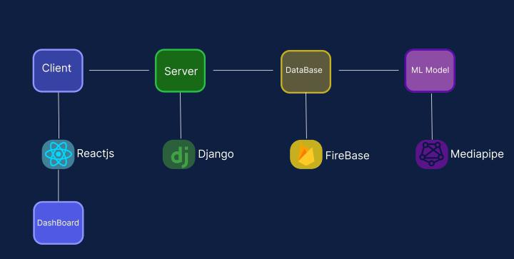
High-Level Diagram:

ClassSense follows a layered client-server architecture with a locally deployed ML inference engine. The system is designed for deployment on a single classroom computer, with the option for cloud hosting in future iterations. The high-level data flow proceeds as follows: a standard USB or integrated webcam streams video to the local machine running the gesture recognition service. The Python backend captures frames via OpenCV, passes them through the trained Teachable Machine models (image and pose), and the classification results are sent as JSON payloads to Django API endpoints. These endpoints log events to the SQLite database and push updates to the React.js frontend via WebSocket, where teachers view live gesture logs, activity-mode-filtered records, and real-time pop-up alerts.
The high-level data flow is as follows:
- Camera Feed (Client Layer) — A standard USB or integrated webcam streams video to the local machine running the gesture recognition service.
- ML Inference Engine (Processing Layer) — The Python backend captures frames via OpenCV, extracts pose landmarks using MediaPipe, and passes feature vectors to the trained CNN classifier.
- Django REST API (Server Layer) — Detection results are sent as JSON payloads to Django API endpoints, which log events to the SQLite database and push updates to the frontend.
- React.js Dashboard (Frontend Layer) — Teachers view live gesture overlays, activity-mode-filtered logs, and real-time pop-up alerts via the React dashboard consuming the Django API.
- Database (Persistence Layer) — SQLite stores timestamped gesture events, student identifiers, and activity mode context for session review and reporting.

Deployment:
The system is deployed locally on a classroom laptop or desktop (minimum Intel Core i5, 8GB RAM, USB webcam). RESTful API endpoints (via Django REST Framework) handle all communication between the ML engine, database, and frontend. Cloud deployment using AWS or Heroku is noted as a future scalability option but is out of scope for the current prototype.

3.3.2 ML PIPELINE ARCHITECTURE

The machine learning pipeline follows a six-stage process from raw camera input to integrated real-time prediction:

Stage | Component | Description
1 | Data Input | RGB video frames captured at 30 FPS via OpenCV from a classroom webcam.
2 | Preprocessing | Frames are resized to 224×224 pixels, converted to RGB, and normalized to [0,1].
3 | Feature Extraction | MediaPipe Pose extracts 33 body landmark coordinates (x, y, z, visibility) per frame.
4 | Model Inference | Image frames fed to Teachable Machine Image model; pose keypoints fed to Teachable Machine Pose model.
5 | Model Validation | 5-fold cross-validation and a held-out 15% test set evaluate generalization performance
6 | Deployment | Trained models integrated into Django backend serving real-time predictions via WebSocket.

3.4 TEACHABLE MACHINE MODEL TRAINING

The gesture recognition engine in ClassSense is powered by two custom machine learning models trained using Google Teachable Machine a free, browser-based platform that allows users to train image and pose classification models without requiring deep expertise in machine learning code. Teachable Machine was selected because it provides rapid, iterative model training directly from webcam input, exports models in TensorFlow.js format compatible with the project’s backend pipeline, and supports both image-based and pose-based classification in two separate project types. The team trained one model per modality: an Image Project model for hand gestures and a Pose Project model for full-body gestures.

3.4.1 TEACHABLE MACHINE MODEL TRAINING
The Image Project in Teachable Machine trains a MobileNetV2-based image classification model that takes a 224×224 pixel RGB image as input and outputs a probability distribution across the defined gesture classes. For ClassSense, the image model was trained to classify hand and upper-body gestures captured directly from a webcam. Training data was collected by the team members themselves using the Teachable Machine webcam interface, where each participant held a specific gesture in front of the camera and recorded samples by holding the “Hold to Record” button while varying their position, angle, and distance from the camera.
The following gesture classes were trained in the Image Project, each with 400 to 500 image samples collected across multiple sessions and participants to ensure variation in hand size, skin tone, background, and lighting conditions:
Class Label | Gesture Description | Samples Collected | Recording Conditions
peace_sign | Two fingers raised in a V-shape | 400–500 | Varied angles, distances, and lighting
thumbs_up | Closed fist with thumb extended upward | 400–500 | Varied hand orientations and backgrounds
thumbs_down | Closed fist with thumb extended downward | 400–500 | Varied angles, natural classroom lighting
ok_sign | Thumb and index finger forming a circle | 400–500 | Varied hand positions and distances
clap | Two hands brought together | 400–500 | Frontal and 45° angle captures
none | No gesture resting or neutral hand position | 400–500 | Neutral seated poses, no active gesture

For each class, participants recorded samples by sitting in front of the webcam and performing the gesture repeatedly from different angles holding the gesture straight toward the camera, tilting it slightly left and right, and varying the distance between the hand and the lens. This multi-angle recording approach ensures that the model learns to recognize each gesture regardless of minor positional variation, which is critical in a real classroom environment where students may not position their hands in a perfectly standardized way. The None class was recorded with participants simply sitting naturally without performing any specific gesture, capturing the baseline appearance of a person at rest so the model can reliably output low confidence for all gesture classes when no intentional gesture is present.
Once all samples were recorded, the model was trained directly in the browser by clicking the “Train Model” button in Teachable Machine. The platform uses transfer learning on top of a pre-trained MobileNetV2 backbone, meaning only the final classification layers are retrained on the collected gesture data rather than training the entire network from scratch. This approach requires far fewer samples per class than training from scratch while still achieving high classification accuracy. After training was complete, the model was exported in TensorFlow.js format (model.json and weights.bin files) and integrated into the ClassSense Django backend.

3.4.2 POSE PROJECT – FULL BODY GESTURE MODEL
The Pose Project in Teachable Machine trains a classification model that operates on body pose keypoints rather than raw image pixels. Instead of analyzing the visual appearance of a person, the Pose Project uses MediaPipe’s built-in pose estimation to extract 33 body landmark coordinates from each video frame, and then trains a fully connected neural network to classify the resulting keypoint vector into one of the defined pose classes. This approach is more robust to changes in clothing, background, and lighting than image-based classification because it relies on the structural geometry of body position rather than pixel-level appearance.
For ClassSense, the pose model was trained to recognize full-body classroom behaviors that cannot be reliably captured by the hand-only image model. The following gesture classes were trained in the Pose Project, each with 400 to 500 pose samples recorded using the Teachable Machine webcam interface:
Class Label | Gesture Description | Samples Collected | Recording Conditions
walking | Person moving laterally or forward in the frame | 400–500 | Sequential frames captured during actual walking motion
raised_hand | Full arm raised above shoulder height | 400–500 | Varied arm angles, seated and standing positions
head_left | Head turned or tilted noticeably to the left | 400–500 | Frontal camera, various head tilt degrees
head_right | Head turned or tilted noticeably to the right | 400–500 | Frontal camera, various head tilt degrees
none | Neutral seated or standing pose with no gesture | 400–500 | Natural classroom seated positions, forward-facing

Pose samples were recorded by having participants stand or sit in front of the webcam and perform each gesture while Teachable Machine simultaneously extracted and displayed the MediaPipe skeleton overlay on screen, confirming that the pose landmarks were being captured correctly. For the walking class, participants walked back and forth in front of the camera while recording, capturing the dynamic body configuration associated with active movement. For the head movement classes, participants turned their heads to each side at various degrees while the pose model recorded the corresponding shoulder-to-head angle relationships. The None class was recorded with participants sitting naturally at a desk in a forward-facing position, representing the typical neutral resting state of a student during class.
Upon completion of recording, the pose model was trained in Teachable Machine using the same one-click training process as the image model. The exported TensorFlow.js files (model.json and weights.bin) were integrated into the Django backend alongside the image model, allowing the gesture engine to run both models sequentially on each incoming video frame first classifying hand gestures through the image model, then classifying body pose through the pose model and returning the combined detection results to the React.js dashboard in real time.

3.4.3 TRAINING SUMMARY
Model Type | Platform | Classes | Sample Per Class | Total Samples | Export format
Image Project (Hand Gestures) | Teachable Machine | peace_sign, thumbs_up, thumbs_down, ok_sign, clap, none | 400–500 | 2,400–3,000 | TF.js (model.json + weights.bin)
Pose Project (Body Gestures) | Teachable Machine | walking, raised_hand, head_left, head_right, none | 400–500 | 2,000–2,500 | TF.js (model.json + weights.bin)

Both models were validated using Teachable Machine’s built-in real-time preview panel after training, which allows immediate webcam-based testing of the trained classifier. The team performed live gesture tests during the preview phase to verify that each class was being recognized correctly and that the confidence scores were consistently high for the intended gesture and low for all other classes. Models that showed confusion between gesture classes or low confidence on known samples were retrained with additional samples targeting the problematic gestures before export.

3.5 DATA COLLECTION

Data Sources
All gesture data is self-collected by the research team using a standard USB webcam in a controlled classroom-like environment. No public datasets were used as the primary training source, ensuring that the data reflects the specific gestures, lighting conditions, and demographic characteristics relevant to the target deployment context. Supplementary pose data from MediaPipe’s demonstration datasets may be referenced for baseline comparison only.

Data Type
The dataset consists of RGB image frames (JPEG format) extracted from short video clips recorded at 30 frames per second via the Teachable Machine webcam interface. Each image or pose sample captures a single person performing one of the target gesture classes.

Gesture Classes and Data Size:
Class ID | Gesture | Model Type | Samples | Recording Condition
G1 | Raise Hand | Pose + Image | 400–500 | Varied lighting, arm angles, seated/standing
G2 | Standing | Pose | 400–500 | Full-body frame, distance varied
G3 | Walking | Pose | 400–500 | Sequential frames, lateral motion
G4 | Moving Head | Pose | 400–500 | Frontal and 45° angle, left and right tilts
G5 | Thumbs Up | Image | 400–500 | Varied lighting, angles, hand orientations
G6 | Peace Sign | Image | 400–500 | Varied lighting, angles, hand orientations
G7 | None (Neutral) | Image + Pose | 400–500 | Natural resting pose, no active gesture
 | Total |  | 2,800–3,500

Ethical Considerations:
Informed consent is obtained from all participants prior to recording. No facial recognition data is collected or stored; only pose landmark coordinates and cropped gesture frames are retained. Participants are made aware that data is used solely for academic purposes and may request removal of their contributions at any time. Student identifiers in the dashboard are assigned pseudonyms to protect privacy.

3.6 DATA PROCESSING
Raw collected frames are reviewed manually to remove blurry images, occluded poses, incorrectly labeled samples, and frames where MediaPipe fails to detect a full body skeleton. Any sample where landmark confidence falls below 0.5 is automatically discarded by the preprocessing script. Frames with incomplete MediaPipe landmark sets are excluded from the dataset entirely rather than imputed, as pose estimation errors cannot be reliably corrected without reintroducing noise.
Gesture classes are labeled manually through Teachable Machine’s web interface. Each frame is reviewed and assigned to one of the gesture categories. Labels are exported as structured CSV files alongside the corresponding image directories. A second team member independently verifies a 20% random sample of all labels to ensure annotation consistency.
To increase dataset diversity and reduce overfitting, the following augmentation techniques are applied using TensorFlow’s ImageDataGenerator prior to training: horizontal flipping to simulate left- and right-handed gestures; random rotation (±15 degrees) to account for camera tilt variation; brightness adjustment (±20%) to simulate different classroom lighting conditions; and width and height shifts (up to 10%) to simulate partial occlusion. All pixel values are normalized to the range [0, 1] by dividing by 255, and MediaPipe landmark coordinates are already normalized relative to frame dimensions by default, requiring no additional scaling.
Subset | Proportion | Approx. Samples | Purpose
Training | 70% | ~350 samples (per model) | Model weight optimization
Training | 70% | ~350 samples (per model) | Model weight optimization
Training | 70% | ~350 samples (per model) | Model weight optimization

3.7 FEATURE ENGINEERING
Feature engineering as a standalone phase is not applicable to this project. ClassSense employs an end-to-end deep learning approach in which the Teachable Machine models learn feature representations directly from raw image data and MediaPipe landmark vectors. MediaPipe Pose automatically extracts 33 body keypoints per frame, providing normalized spatial coordinates that serve as structured input features without requiring manual feature design or dimensionality reduction techniques such as Principal Component Analysis (PCA). This approach reduces the engineering burden while leveraging the proven representational power of MobileNetV2 for image-based gesture classification.

3.8 MACHINE LEARNING MODEL DEVELOPMENT

3.8.1 MODEL SELECTION
Model | Type | Rationale
Teachable Machine Image Model (MobileNetV2) | Image Classification | Trained on self-collected gesture image frames. Uses transfer learning on MobileNetV2 backbone. Robust to visual variation and requires fewer samples than training from scratch.
Teachable Machine Pose Model | Pose Keypoint Classification | Trained on MediaPipe pose landmark vectors. More robust to lighting and clothing changes than image models. Ideal for full-body gesture classification.

3.8.2 MODEL TRAINING
Both models are trained using supervised learning on the labeled gesture dataset through the Teachable Machine web interface. The Image Project model uses transfer learning on MobileNetV2, retraining only the final dense classification layers while keeping the pre-trained convolutional backbone frozen. Training proceeds until the model converges as monitored by Teachable Machine’s built-in loss curve display. The Pose Project model trains a small fully connected neural network on the MediaPipe keypoint vectors.
Categorical Cross-Entropy is used as the loss function for both models, appropriate for multi-class classification across mutually exclusive gesture categories. The Adam optimizer is used with adaptive learning rate behavior. After training, both models are validated in real time using Teachable Machine’s built-in preview panel, where live webcam input is tested against the trained classifier to verify gesture recognition accuracy before export.

3.8.3 MODEL EVALUATED METRICS
Metric | Description
Accuracy | Overall proportion of correctly classified gestures. Primary success metric; minimum 90% threshold on test set.
Precision (per class) | Of all predictions for a given gesture, how many were correct. Indicates false positive rate.
Recall (per class) | Of all actual occurrences of a gesture, how many were detected. Indicates false negative rate.
F1-Score (per class) | Harmonic mean of precision and recall. Balances both error types per gesture class.
Macro F1-Score | Unweighted average F1 across all classes. Accounts for class imbalance.

3.9 SYSTEM IMPLEMENTATION
PROGRAMING LANGUAGE
Python (version 3.13) is used for all machine learning, computer vision, and backend development tasks. JavaScript (ES2022) is used for the React.js frontend dashboard.
Frameworks and Technologies
Layer | Technology | Purpose
ML / CV | TensorFlow 2.20 + Keras 3 | Loading and running Teachable Machine exported models (TF.js format)
ML / CV | MediaPipe 0.10.33 | Real-time body landmark extraction from camera feed for pose classification
ML / CV | OpenCV (cv2) | Video capture, frame preprocessing, and overlay rendering
Backend | Django 5.1 + DRF | REST API endpoints, database ORM, and event logging
Backend | Django Channels | WebSocket support for real-time gesture result streaming to frontend
Frontend | React.js 19 + Vite | Interactive teacher dashboard with real-time gesture alerts and charts
Frontend | Tailwind CSS | Component styling and responsive layout
Frontend | Recharts | Bar, pie, and line chart visualization on the dashboard

Database
SQLite is used during development for storing gesture event logs, session data, student rosters, and alert records. Each log entry records the timestamp, gesture class, activity mode (Lecture/Quiz/Exam), chair rank, and student identifier. Django’s ORM manages all database interactions through four primary models: ClassSession, StudentRoster, GestureLog, and Alert.

3.10 MODEL DEPLOYMENT
The trained Teachable Machine models are exported in TensorFlow.js format (model.json and weights.bin) and loaded by the Django backend at server startup. The gesture engine decodes incoming base64 video frames from the WebSocket, runs them through the image model for hand gesture classification and through the MediaPipe pose landmark extractor followed by the pose model for body gesture classification, and immediately returns the results to the React.js frontend via the same WebSocket connection. The activity mode selected by the teacher (Lecture, Quiz, or Exam) is applied to every detected gesture to determine its status (allowed, warning, or neutral) and whether an alert should be generated.
Method | Endpoint | Description
POST | /api/auth/login/ | Teacher authentication
GET | /api/dashboard/stats/ | Aggregated gesture statistics for dashboard charts
GET | /api/dashboard/dates/ | Available dates with gesture data for calendar filter
POST | /api/sessions/ | Start a new class session
PATCH | /api/sessions/{id}/ | End an active session
GET/POST | /api/gestures/ | Retrieve or manually log gesture events
GET | /api/alerts/ | Retrieve warning alerts for a session
GET | /api/activity/ | Retrieve full gesture log with student roster
WebSocket | ws://localhost:8000/ws/gesture/ | Real-time bidirectional gesture streaming

3.11 TESTING STRATEGY

3.11.1 SOFTWARE TESTING
Individual software components are tested in isolation to verify that each function produces the correct output for a defined range of inputs. Unit tests cover the gesture preprocessing pipeline, the Django API view functions (correct HTTP status codes and response schemas), and the React component rendering logic (alert display, log filtering by activity mode). Integration tests verify that the end-to-end data flow functions correctly: from OpenCV frame capture through MediaPipe landmark extraction, Teachable Machine model inference, Django API logging, and React dashboard update. Full end-to-end system testing simulates realistic classroom conditions where a participant performs each gesture in front of the webcam and the team verifies that the correct gesture is detected, logged, and displayed on the dashboard within the acceptable latency window.

3.11.2 Model Performance Testing
5-fold stratified cross-validation is applied during training to provide a stable estimate of model accuracy across different data partitions. The mean and standard deviation of accuracy and F1-score across folds are reported to quantify model consistency. The trained model is also tested against controlled variations not present in the training set, including different lighting intensities, camera distances, and participants wearing different clothing styles. The final model is evaluated on the held-out 15% test set that was kept completely unseen during all training phases to produce an unbiased estimate of real-world classification accuracy.

3.12 PERFORMACE EVALUATION
End-to-end inference latency from frame capture to gesture label display on the dashboard is measured as the primary computational performance indicator. The target is a maximum latency of 2 seconds per prediction cycle to ensure that teachers receive timely gesture alerts. Memory usage during inference is monitored and must remain below 500MB to remain compatible with standard classroom laptops. Frame processing rate is targeted at a minimum of 15 FPS to ensure smooth gesture tracking

3.13 ETHICAL AND SECURITY CONSIDERATIONS
ClassSense does not perform facial recognition or store any biometric identifiers. Only skeletal pose landmarks and gesture classification results are retained. No raw video footage is stored at any stage of inference or logging. Student pseudonyms are used in place of real names on the dashboard and in all stored logs, and participant consent is obtained before any data collection activity. The training dataset is collected across participants of varied skin tones, body types, clothing styles, and lighting conditions to reduce the risk of demographic bias in gesture recognition accuracy. Access to the teacher dashboard requires authenticated login via a password-protected account.

3.14 TOOLS AND TECHNOLOGIES
Category | Tool/ Technology | Purpose
Development IDE | Visual Studio Code | Primary coding environment for Python and JavaScript
ML Training Platform | Google Teachable Machine | Browser-based training of image and pose gesture classification models
ML Library | TensorFlow 2.20 + Keras 3 | Loading TF.js exported models and running inference
ML Library | MediaPipe 0.10.33 | Real-time human pose landmark extraction
Computer Vision | OpenCV (cv2) | Webcam capture, frame preprocessing, and visualization
Backend Framework | Django 5.1 + DRF | REST API, database ORM, and server-side logic
Real-time Communication | Django Channels (WebSocket) | Live gesture result streaming between backend and frontend
Frontend Framework | React.js 19 + Vite | Interactive teacher dashboard with real-time UI
Styling | Tailwind CSS | Component styling and responsive dashboard layout
Visualization | Recharts | Chart rendering for dashboard analytics
Database | SQLite | Local development database for gesture events and session data
Version Control | Git + GitHub | Source code management and team collaboration
Hardware | Standard Laptop (i5, 8GB RAM) | Minimum compute spec for real-time inference without GPU
Hardware | USB Webcam (720p) | Primary image input device for gesture capture

3.15 PROPOSED USER INTERFACES

Proposed Graphical User Interface (GUI)
The proposed graphical user interfaces were designed and developed as prototype examples to serve as visual guides for the overall development of ClassSense. These GUI prototypes were built using Python’s CustomTkinter library, establishing the layout, component placement, color scheme, and user flow that the actual system follows during full implementation. The final implementation uses React.js and Tailwind CSS to deliver the same design language in a browser-based format accessible from any device without software installation.

3.15.1 LOGIN INTERFACE

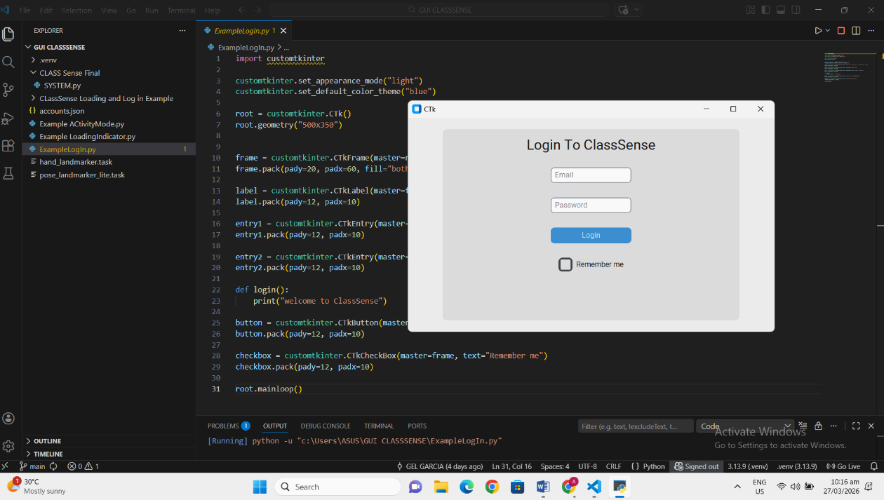
The Login Interface is the entry point of the ClassSense system, responsible for authenticating teachers before granting access to the dashboard. This prototype was developed using Python and CustomTkinter, demonstrating a clean and minimal login form that includes an Email input field, a Password input field, a Login button, and a Remember Me checkbox. The interface uses a light appearance mode with a blue color theme, keeping the design simple and professional for an educational environment. This example serves as the design baseline for the final login screen that will be implemented in the complete ClassSense system.

3.15.2 LOADING INDICATOR / SPLASH SCREEN INTERFACE
The Loading Indicator interface serves as the initial splash screen that users encounter upon launching the ClassSense application. This prototype was developed using Python's CustomTkinter and Tkinter libraries, and it demonstrates the intended startup sequence of the system before the user reaches the login screen.
The splash screen follows a three-stage animation flow:
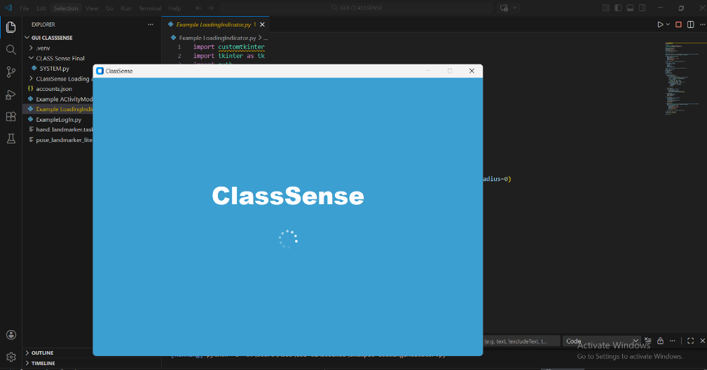
Stage 1 : Loading Indicator: When the application is first launched the screen transitions to display the "ClassSense" logo text in large bold white typography, accompanied by an animated circular loading spinner positioned below it. The spinning dots indicator built using Tkinter's Canvas with arc-based animation communicates to the user that the system is initializing in the background, such as loading the ML model, establishing the camera connection, and setting up the gesture recognition pipeline.

Stage 2 :Branding Screen: After a brief moment, a full-window sky-blue background appears displaying the bold "Welcome to ClassSense!" text centered on the screen. This stage establishes the visual identity and color theme of the ClassSense system, giving the user an immediate sense of the application's branding before any interaction occurs.
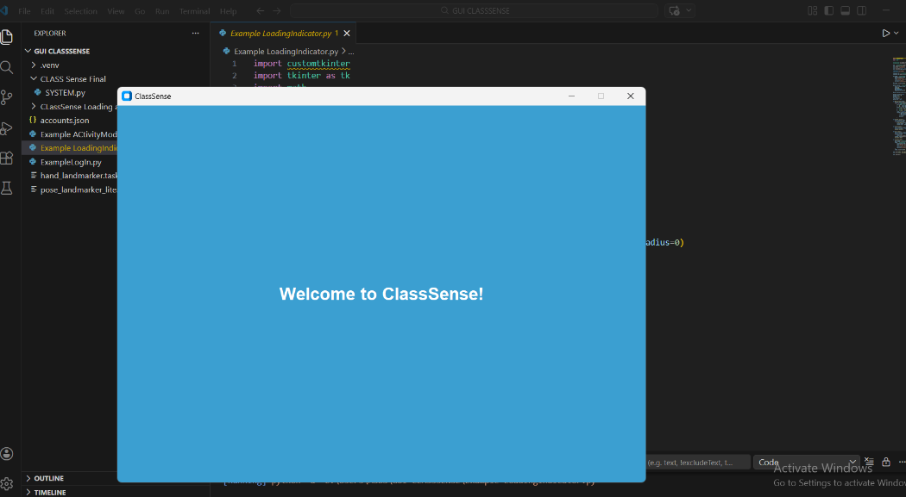
Stage 3: Transition to Login: Once the loading sequence completes, the splash screen automatically closes and hands control over to the Login Interface, creating a smooth and professional startup experience for the teacher.
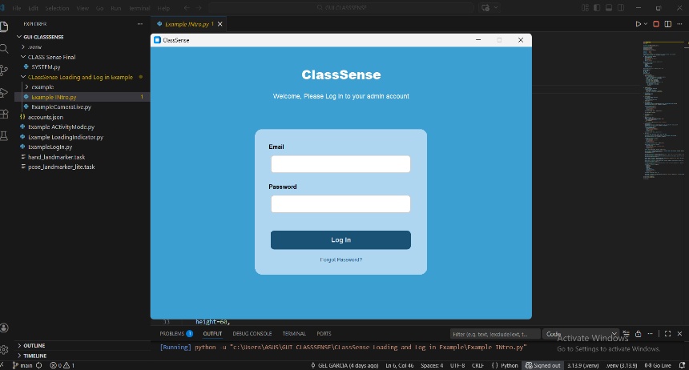
This loading screen prototype establishes the expected startup behavior, color palette (sky blue, white bold typography), and animation style that the final ClassSense system will adopt during implementation.

3.15.3 MAIN DASHBOARD INTERFACE
The Main Dashboard is the primary interface that the teacher or administrator is directed to immediately after a successful login. This prototype was developed using Python and CustomTkinter, featuring a structured two-panel layout consisting of a dark blue sidebar navigation on the left and a dynamic content area on the right. The top navigation bar displays the "Dashboard" page title alongside a real-time clock showing the current date and time in this case, "March 27 2026 | 10:33 AM" ensuring the teacher is always aware of the active session context at a glance.
Sidebar Navigation: The left sidebar displays the ClassSense branding, the logged-in user's name ("Admin"), and four navigation options Dashboard, Class Activity, Start Class, and Class Setup along with a prominently placed red Logout button at the bottom. This navigation structure allows teachers to move between different functional areas of the system quickly and intuitively without losing context of the current session.
Progress Overview Panel: Directly below the top bar, a Progress Overview section presents four summary statistic cards in a horizontal row Total Gestures, Unique Students, Total Alerts, and Avg Response. These cards are designed to be dynamic and will automatically update in real time as gesture detection events are recorded during an active class session. In the current prototype state, all values display as zero (0) and N/A, accurately reflecting that no class session has been conducted yet and no gesture data has been collected.
Chart and Graph Panels: Below the summary cards, four data visualization panels are arranged in a 2x2 grid layout, each reserved for a specific analytical view of classroom gesture activity. These panels are:
- Gesture per Student — will display a breakdown of how many gestures each individual student performed during the session.
- Gesture Type Distribution — will show the proportion of each gesture class detected (e.g., raised hand, standing, walking, pledge, hello sign) as a chart.
- Engagement Overtime — will plot gesture activity over the course of the class session as a time-series graph, allowing teachers to identify periods of high and low engagement.
- Activity Mode Usage — will reflect how gesture patterns differ across the three activity modes — Lesson, Quiz, and Exam.

All four panels currently display the placeholder message "No data yet Save a class session to see progress," which is the correct and expected behavior for a system that has not yet recorded any gesture session. Once a class session is completed and saved through the Start Class module, all four charts and the summary statistics will automatically populate with real data without requiring any manual input from the teacher.
Dynamic Date Filtering: The dashboard includes an "All Data" toggle control in the top-right of the Progress Overview section, which is designed to support dynamic date-based filtering. Teachers will be able to switch between views such as today's data, yesterday's session, a specific date, or the full historical record making the dashboard a useful tool not just for live monitoring but also for reviewing past classroom performance over time.
Data Flow Logic: The dashboard operates on an event-driven data model. When a gesture is detected and classified by the ML pipeline during an active class session, the event is automatically logged to the database with its timestamp, gesture class, student identifier, and activity mode. Upon session completion, all logged events are aggregated and pushed to the dashboard's chart panels without any manual intervention, ensuring that the teacher's post-session review is always accurate, complete, and up to date.

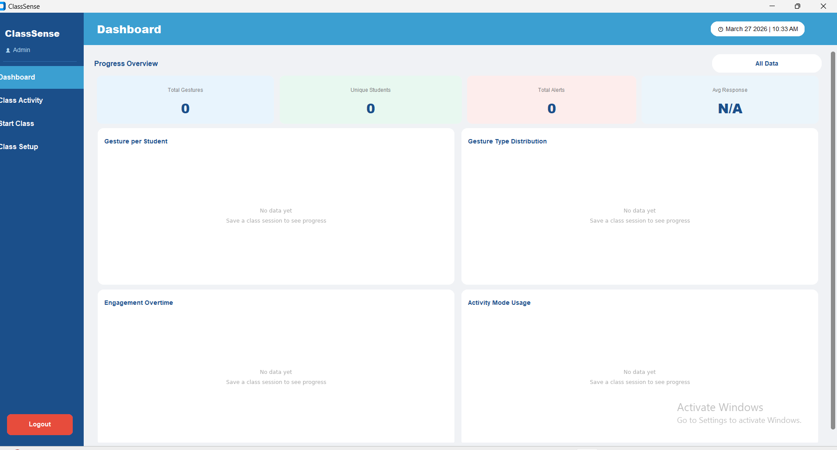

3.15.4 CLASS ACTIVITIES INTERFACE

The Class Activity interface provides teachers with a comprehensive and filterable record of all gesture detection events that have been logged across completed class sessions. This prototype was developed using Python and CustomTkinter, and it is accessible through the "Class Activity" option in the left sidebar navigation. The top bar consistently displays the ClassSense branding, the logged-in user, and the live date and time clock, maintaining visual consistency with the rest of the system.

Filter and Sort Controls: At the top of the content area, two interactive control buttons are provided a Filter button and a Sort button giving teachers flexible ways to navigate through the gesture log records.

The Filter button opens a dropdown with the following gesture-specific options:
- All — displays every recorded gesture event regardless of type.
- Hand Raise — filters to show only hand raise detections.
- Peace Sign — filters to show only peace sign gestures.
- Thumbs Up — filters to show only thumbs up detections.
- Writing — filters to show only writing activity detections.
- Clapping — filters to show only clapping gesture records.
- Walking — filters to show only walking detections.
- Head Moving — filters to show only head movement detections.
- Moving Chair — filters to show only chair movement detections.

The Sort button opens a dropdown with the following sorting options:

• Newest First — orders records from the most recent detection down.
• Oldest First — orders records from the earliest detection upward.
• By Student — groups and sorts records alphabetically by student name.
• By Gesture — groups records by gesture type for easier pattern analysis.
• By Rank — sorts records based on the frequency or rank of gesture occurrence per student.

Gesture Log Table: Below the filter and sort controls, the Gesture Log table is the main data display area, structured with five clearly labeled columns Time, Date, Student, Gesture, and Mode. Each row in this table represents a single gesture detection event, automatically populated from the database once a class session has been completed and saved through the Start Class module. The table includes a vertical scrollbar on the right side, allowing teachers to scroll through large volumes of session data without losing the column header reference.
In the current prototype state, the table body is empty and displays the placeholder message at the bottom of the screen: "No sessions saved yet. Complete a class in Start Class and save progress." This is the correct and expected behavior, accurately communicating to the teacher that gesture log data will only appear after at least one complete class session has been recorded and saved through the system.
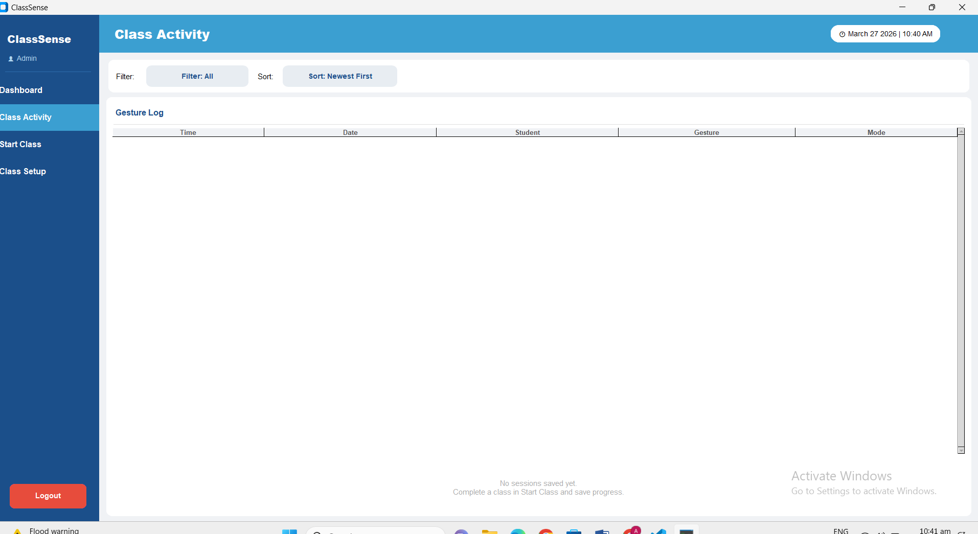
Data Automation Logic: The Class Activity interface does not require any manual data entry from the teacher. Every gesture event detected during an active session is automatically written to the database in real time, and once the session is saved, all records become immediately visible and filterable in this interface ensuring a seamless and effortless post-session review experience.

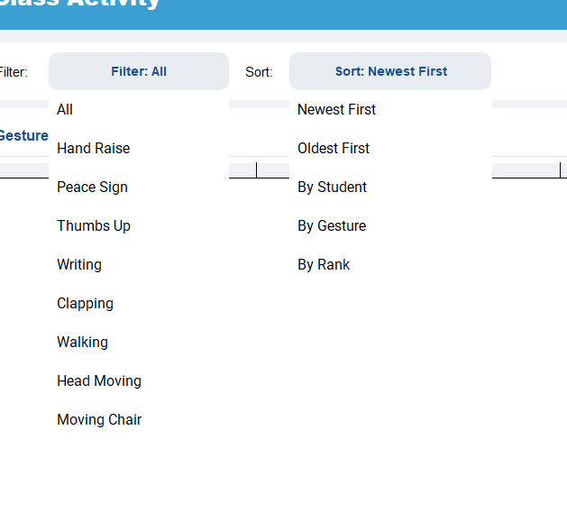

3.15.5 START CLASS INTERFACE
The Start Class interface is the most functionally rich module of the ClassSense system, guiding the teacher through the complete lifecycle of a class session from pre-session configuration, to live real-time gesture detection, and finally to post-session summary and data saving. This prototype was developed using Python and CustomTkinter, and it is accessible through the "Start Class" option in the left sidebar navigation.
Stage 1 — Session Confirmation Prompt
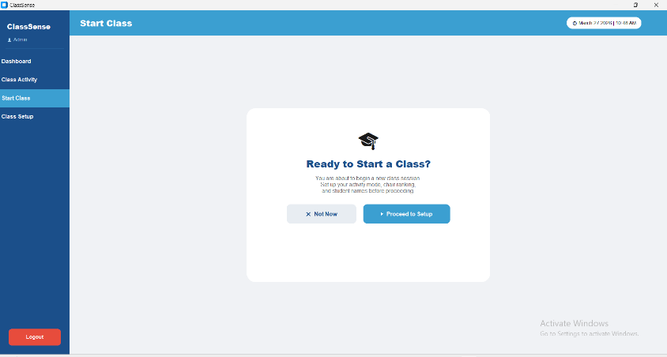
When the teacher navigates to Start Class, the system first presents a centered confirmation dialog card before any session begins. The card displays a graduation cap icon, the prompt "Ready to Start a Class?", and a brief instructional description reminding the teacher to set up the activity mode, chair ranking, and student names before proceeding. Two action buttons are provided a "Not Now" button that returns the teacher to the dashboard without making any changes, and a "Proceed to Setup" button that advances the teacher to the full session configuration form. This confirmation step prevents accidental session starts and ensures the teacher is intentionally initiating a new class recording.
Stage 2 — Class Setup Form
Upon clicking "Proceed to Setup," the interface transitions to a scrollable "Setup Your Class Activity" form organized into four clearly labeled sections:
Class Information: The teacher fills in three fields Subject Name ( "Machine Learning 101"), Teacher Name (pre-filled with the logged-in account name, e.g., "Admin"), and Room Number (e.g., "Room 204"). These details are attached to every gesture log entry recorded during the session, ensuring that all data is properly contextualized by subject, instructor, and location.
Activity Mode: Three toggle buttons are presented Lesson, Quiz, and Exam allowing the teacher to select the type of session being conducted. The selected mode is highlighted in blue (as shown with "Quiz" selected in the prototype), and this mode is automatically applied as a tag to every gesture detection event logged during the session. The activity mode directly influences how gesture alerts are interpreted and how the data is categorized in the dashboard and Class Activity log.
Chair Ranking Setup: The teacher sets the total number of chairs in the classroom using a numeric input field with minus (−) and plus (+) increment buttons. In the prototype, 20 chairs are configured. This chair count determines how many ranked student name slots are generated in the Student Names section below, establishing the spatial seating structure that the gesture detection system uses to associate detected gestures with specific chair positions.
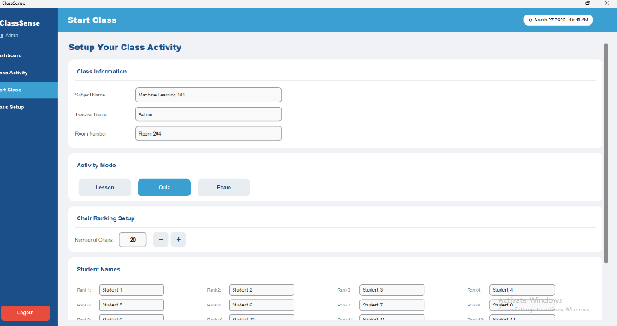
Student Names: Below the chair setup, a dynamically generated grid of labeled input fields appears one field per chair rank (Rank 1 through Rank 20 in the prototype). The teacher enters each student's name, surname, or nickname into the corresponding rank field, mapping real student identities to chair positions. This mapping is critical because when the ML model detects a gesture from a specific spatial location in the camera frame, the system cross-references the chair rank to identify which student performed the gesture. At the bottom of the form, a "Discard" button cancels the setup and returns to the confirmation prompt, while the "Start Class Activity" button finalizes all settings and launches the live session.
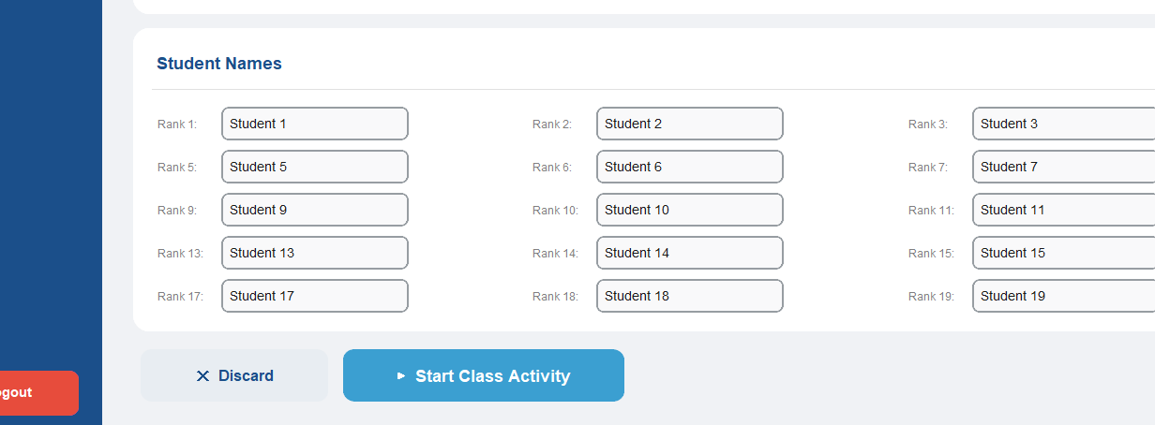
Stage 3 — Live Classroom Detection Interface
Once the teacher clicks "Start Class Activity," the interface transitions to the live session view, which is split into two panels:
Left Panel — Live Classroom Feed: A live webcam video feed is displayed with a red "Live" indicator badge in the top-left corner, confirming that the camera is actively streaming and the gesture recognition pipeline is running. As gestures are detected in real time, a colored overlay label appears at the bottom of the camera frame identifying the detected gesture ("Peace Sign Detected" at 10:51 AM). This visual feedback gives the teacher immediate confirmation that the system is successfully tracking and classifying student gestures as they occur.
Below the live feed, a Recent Alerts panel displays a real-time scrollable list of all gesture detection events from the current session, with each entry showing the chair rank, the detected gesture type, and the exact timestamp ("Chair Rank 1 — Peace Sign — 10:51 AM", "Chair Rank 1 — Thumbs Up — 10:51 AM"). These alerts appear automatically without any teacher interaction, driven entirely by the ML model's detection output.
Right Panel — Gesture Log and Summary: The top of the right panel displays the current Activity Mode (e.g., "Quiz") as a labeled badge for constant reference. Below it, a live Gesture Log table records every detection event with five columns Time, Date, Gesture, Rank, and Mode and each new row is added automatically in real time as detections occur. Rows are color-coded (blue for the most recent, yellow for the previous) to help the teacher quickly identify the latest activity at a glance.
At the bottom of the right panel, a Gesture Summary section displays four live-updating statistic cards: Total Gestures, Gesture Detected, Total Chair Ranking, and Alerts all of which increment automatically as the session progresses. A prominent red "End Class" button is positioned at the bottom-right corner, which the teacher clicks when the session is complete.
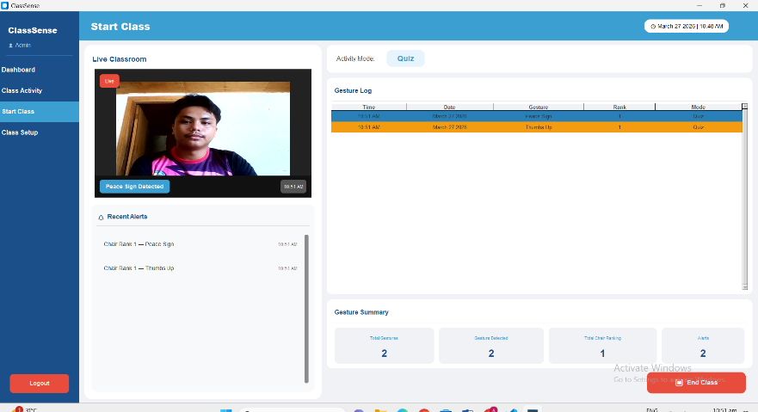
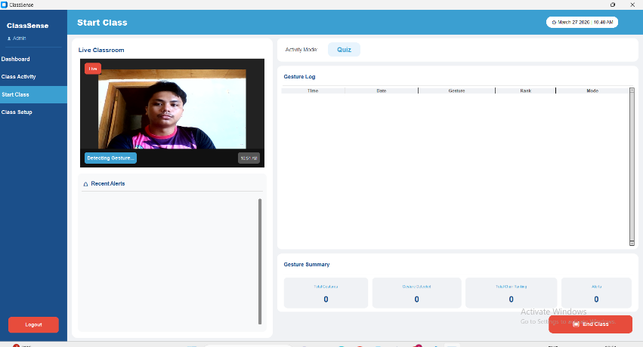

Stage 4 — Class Summary Interface
After clicking "End Class," the system automatically generates and displays a comprehensive Class Summary screen for the completed session. The top of the screen shows a session metadata bar with four tags Subject ("Machine Learning 101"), Teacher ("Prof. Santos"), Mode ( "Quiz"), Duration ("0m 3s"), and Date ("March 27 2026") providing full context for the session record.
Four summary statistic cards are displayed prominently below the metadata bar: Total Gestures, Students Participated, Total Alerts, and Gesture Types all automatically calculated from the session's recorded data without any manual input.
A Participation Ranking table follows, listing each student's final rank, their name, their assigned chair number, the total number of gestures they performed, and the specific gesture types they were detected performing ( "Student 1 Chair 1 2 gestures Peace Sign, Thumbs Up"). This ranking gives the teacher a clear, objective measure of each student's participation level during the session.
Below the ranking, the Full Gesture Log table presents the complete chronological record of every detection event from the session, with columns for Time, Date, Student, Gesture, and Mode providing a detailed audit trail of all classroom activity.
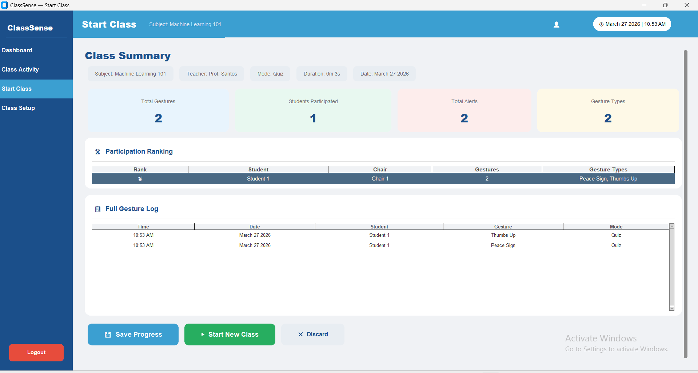
At the bottom of the summary screen, three action buttons are available: Save Progress which writes all session data to the database and makes it available in the Class Activity and Dashboard views; Start New Class which resets the form and begins a fresh session setup; and Discard which deletes the session data without saving and returns the teacher to the confirmation prompt.

3.15.6 CLASS SETUP INTERFACE
The Class Setup interface serves as the persistent configuration panel of the ClassSense system, allowing the teacher or administrator to pre-configure and save the default class information and student roster that will be automatically loaded every time a new session is initiated through the Start Class module. This prototype was developed using Python and CustomTkinter, and it is accessible through the "Class Setup" option in the left sidebar navigation. Unlike the Start Class setup form which is configured per session, the Class Setup interface stores a reusable baseline configuration that persists across multiple sessions, reducing repetitive data entry for teachers who handle the same class regularly.
Class Information Section: The upper portion of the interface contains a Class Information section with three editable input fields Subject Name ( "Machine Learning 101"), Teacher Name ("Admin"), and Room Number ( "Room 204"). These fields allow the teacher to establish the default subject and room context that will be pre-filled automatically when starting a new class session, ensuring consistency across all gesture log records without requiring the teacher to re-enter the same information each time.
Student Roster Section: Below the class information, a Student Roster section displays a structured grid of ranked input fields spanning from Rank 1 through Rank 20, arranged in a four-column layout across five rows. Each field is labeled with its corresponding rank number (Rank 1 through Rank 20) and accepts the student's name, surname, or nickname. The teacher fills in this roster once to establish the official seating and ranking arrangement of the class, and this saved roster is then automatically loaded into the Start Class setup form whenever a new session begins. This eliminates the need to re-enter all student names before every class and ensures that chair-to-student mappings remain accurate and consistent across all recorded sessions.
Save and Cancel Controls: At the bottom of the form, two action buttons are provided. The "Cancel" button discards any unsaved changes and returns the display to its previously saved state, preventing accidental overwrites of the existing configuration. The "Save Changes" button commits all edits including updated subject names, teacher names, room numbers, and the full student roster to the local storage or database, making the new configuration immediately available for the next class session initiated through Start Class.
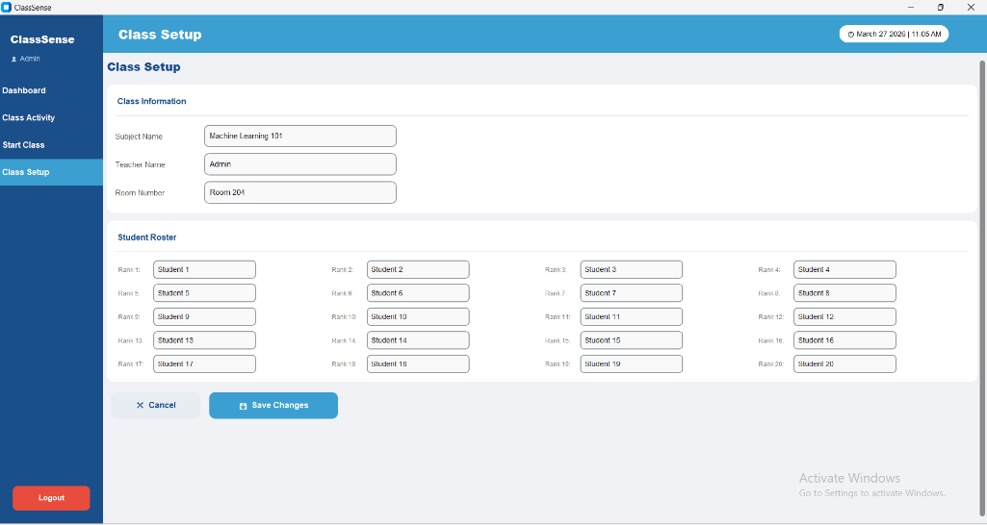
Relationship to Other Modules: The Class Setup interface acts as the persistent data foundation for the entire ClassSense workflow. Information saved here flows directly into the Start Class session setup, pre-populating all fields so the teacher can begin a session with minimal configuration time. Any updates made in Class Setup are reflected immediately in subsequent sessions, ensuring that the system always operates with the most current class and roster information without requiring duplicate data entry across modules.

