**Design Analysis: AZCart, a Shopping Cart Plugin**

**angelaz**

**OVERVIEW**

AZCart is a lightweight web application that simulates a shopping cart experience online. AZCart provides a similar service as Opencart, Shopify, Paypal, and Stripe, but it fulfills the shopkeepers’ need for a more basic and minimal setup effort required product.

**FEATURES**

When a shopper is browsing a website, they can

1. create account/log in/log out
2. add items to the shopping cart
3. remove items
4. edit quantity of an item
5. checkout items in the cart
6. retain the shopping cart across browser sessions
7. share shopping carts with other users

For a shopkeeper, AZCart will provide them a simple admin interface to:

1. add items to the catalog
2. edit a catalog item’s title, price, and quantity
3. approve or decline orders submitted by a user

**CONCEPTS**

AZCart models the following concepts:

* **User**: Represents a user on the site, could be either a Shopper or a Shopkeeper
* **Catalog**: Represents a catalog of items. Each Shopkeeper owns a Catalog and can add/remove/edit items in the Catalog.
* **Cart**: Represents a cart of items. Each Shopper owns a Cart and can add/remove/edit quantities of items in the cart.
* **Order**: Once the Shopper hits “Checkout,” an Order is made from the Cart, which is available for the shopkeeper to approve or deny.
* **Item**: Represents an individual item in the Catalog. Each item can also belong to multiple Carts and Orders.

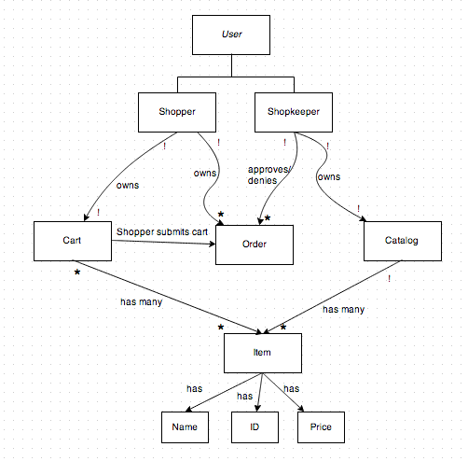

**Challenges**

Below is a list of potential challenges:

* Access control. Allowing users to create account, log in, and log out.
* Retaining the cart across browser sessions, specifically, from not logged-in to creating new account or logging into existing account.
* Cart -> Order. How to maximize efficiency. Deciding whether to copy all the items from one database to another or allow complex permission system to distinguish between Shoppers and Shopkeepers.
* Security concern. Hacking other people’s account and stealing credit card number. How to make the account session secure.
* Scaling. What happens when there are lots of shopper and shopkeepers and items? Will the database query run in a reasonable speed?