**REPUBLIQUE DU CAMEROON**

**PAIX-TRAVAIL-PATRIE**

**MINISTRE DE L’ENSEIGNEMENT** **SUPERIEUR**

**FACULTE D’INGINERIE ET TECHGNOLOGIE**

**REPUBLIC OF CAMEROON**

**PEACE-WORK-FATHERLAND**

**MINISTER OF HIGHER EDUCATION**

**FACULTY OF ENGINEERING AND TECHNOLOGY**



**FACULTY OF ENGINEERING AND TECHNOLOGY**

**DEPARTMEENT: COMPUTER ENGINEERING**

**CEF 440: INTERNET PROGRAMMING AND MOBlLE PROGRAMMING**

**TASK 2**

**REQUIREMENT ANALYSIS**

**GROUP MEMBERS**

|  |  |
| --- | --- |
| **Names** | **Matriculation** |
| **ALAIN NKEH MBUNKUH** | **FE21A133** |
| **ANANFACK ZANGO ANGELA CARINE** | **FE21A137** |
| **CHO WESLEY MUNGO** | **FE21A160** |
| **NKWETI MANGEM ANCELIA** | **FE21A280** |
| **NTUI RAOUL NTUI NJOCK** | **FE21A288** |

**COURSE INSTRUCTOR : Dr NKEMENI VALERY**

Table of Contents

**1. INTRODUCTION______________________________________________3**

**1.1.Project Overview__________________________________________3**

**1.2.Project Scope_____________________________________________3**

**1.3.Requirement Gathering_____________________________________3**

**2.STAKEHOLDER IDENTIFICATION_______________________________3**

**2.1. Definition________________________________________________3**

**2.2.KeyStakeholders___________________________________________3**

**2.3.Importance Of Involving Stakeholders In The Requirement Gathering Process_____________________________________________4**

**3.REQUIREMENT GATHERING TECHNIQUES______________________4**

**3.1. Interviews________________________________________________5**

**3.2. Observations______________________________________________5**

**3.3. Online Surveys____________________________________________5**

**3.4. Document Analysis________________________________________6**

**3.5. Brainstorming____________________________________________6**

**4. REQUIREMENT GATHERING RESULTS (Online Survey) __________7**

**4.1. Raw Data Assessment_____________________________________7**

**4.2. Data Visualization in Excel________________________________8**

**5. CATEGORISING THE REQUIREMENTS_________________________9**

**5.1. Functional requirement_____________________________________9**

**5.2. Non-functional requirement_________________________________9**

**6.REQUIREMENT CONSTRAINT AND LIMITATIONS_______________11**

**6.1. Constraint_______________________________________________11**

**6.2. Limitations______________________________________________11**

**7. CONCLUSION_________________________________________________12**

**1. INTRODUCTION**

**1.1 Project Overview**

The Biometric Student Attendance Mobile Application is a cutting-edge solution designed to revolutionize the way educational institutions manage and track student attendance. At its core, the application aims to leverage biometric technology, specifically fingerprint recognition, to streamline the attendance-taking process while enhancing security and accuracy.

**1.2 Project Scope**

The objective of our biometric student attendance mobile application is to streamline the process of tracking student attendance in educational institutional using fingerprint recognition technology.

The application aims lies in its potential to address several challenges faced by educational institutions in attendance management: like time saving, reduced administrative burden, enhanced accountability by ensuring that attendance records are accurate and cannot be manipulated, fostering a culture of responsibility among students and improved decision-making.

**1.3 Requirements analysis**

Requirements analysis (requirements engineering) is the process of determining user expectations for a new or modified product. It is usually a team effort and demands a variety of human soft skills, such as critical thinking, communication and judgment.

Requirements analysis is a common and essential concept in [software development](https://www.techtarget.com/whatis/definition/software-development) and software [project management](https://www.techtarget.com/searchcio/definition/project-management). At the start of every software project, the project team must understand, finalize and document the features and functionalities required of the end product. These required features and functionalities are often called [*functional specifications*](https://www.techtarget.com/searchsoftwarequality/definition/functional-specification), and the process of determining and understanding them is called *requirements gathering and analysis*.

Requirements must be quantifiable, as detailed as possible and relevant to the end product. In addition, they should be clearly documented so the development team has clear expectations and understands required specifications from the beginning.

Requirements analysis in software engineering does the following:

* Clarifies the required features and overall vision of a new product.
* Clarifies [stakeholder](https://www.techtarget.com/searchcio/definition/stakeholder) expectations for that product.
* Prevents conflict and communication gaps during development and testing.
* Ensures that the final product conforms to requirements, i.e., prevents [scope](https://www.techtarget.com/searchcio/definition/project-scope) creep.

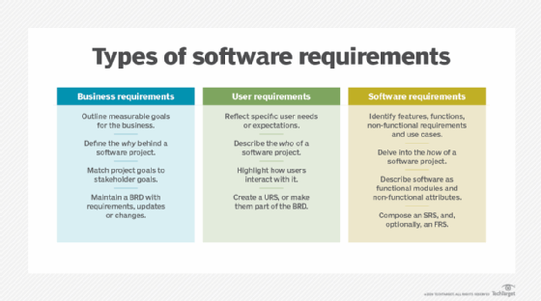

Requirements analysis is an important concept in software development.

**The importance of communication during requirements analysis**

During requirements analysis, project team members come together to understand the project goals, clarify expectations and document the product's required specifications and features. All of this requires clear and unambiguous communication between team members.

**2. STAKEHOLDER IDENTIFICATION**

**2.1 Definition**

Stakeholders are individuals, groups or entities who have an interest or “stake” in a particular project, organization, or system. They can include employees, customers, investors, suppliers, communities and government entities among others.

**2.2. Key Stakeholders**

Stakeholder involvement is crucial in the success of this biometric student attendance mobile application project. Let’s analyze the key stakeholders involved, their roles and responsibilities, and the importance of involving them in the requirement gathering process.

* **Faculty Administrators (Faculty Deans and Departments Heads):** Responsible for overseeing the implementation within their respective departments, ensuring alignment with departmental policies, and managing administrative aspect.
* **Instructors:** Responsible for taking attendance, monitoring student participation to track and manage attendance records
* **Students:** End-users of the application who rely on the system for marking their attendance, viewing their records, and receiving notifications.

**2.3. Importance of Involving them in the Requirement Gathering Process**

* **Understanding Needs:** Stakeholders have diverse perspectives and needs. Involving them ensures a comprehensive understanding of requirements, leading to a solution that meets everyone’s needs.
* **Building Support:** Engaging stakeholders early builds buy-in and support for the project. When stakeholders feel heard and involved, they are more likely to champion the project and its success.
* **Identify Risks:** Stakeholders can identify potential risks or challenges that might not be apparent to the project team. Their input helps in mitigating risks and planning for contingencies.
* **Validating Assumptions:** Often, assumptions are made during the requirement gathering process. Involving stakeholders allows these assumptions to be validated or corrected, ensuring that the project is based on accurate information.
* **Improving Communication:** By involving stakeholders, communication channels are established early on. This fosters transparency and ensures that stakeholders are kept informed throughout the project lifecycle.
* **Enhancing Quality:** Stakeholder involvement leads to better-defined requirements, reducing the likelihood of misunderstandings or misinterpretations. This ultimately contributes to the quality of the final product or solution.
* **Minimizing Resistance to Change:** When stakeholders are involved from the beginning, they are more likely to embrace changes resulting from the project. This reduces resistance and increases the likelihood of successful implementation.

**3. REQUIREMENT GATHERING TECHNIQUES**

Requirement gathering techniques encompass various methods used to collect, analyze, and documents for a project. These techniques include:

**3.1. Interviews:**

Conducted one-on-one interviews with key stakeholders, such as students, instructors and administrative staff. Asked open-ended questions to understand their requirements, expectations, and concerns regarding attendance recording. For example:

* What are the current challenges with the existing attendance recording system?
* What specific features would you like to see in the new biometric attendance system?
* How should the system integrate with other university systems?

**3.2. Observations:**

Observed the current attendance recording process in the various environment. Spent time in classrooms or lecture halls to understand how attendance is currently recorded, the devices or systems used, and any challenges faced by faculty and students. Made note of any pain points or inefficiencies that could be addressed by the new biometric system.

**3.3. Online Surveys:**

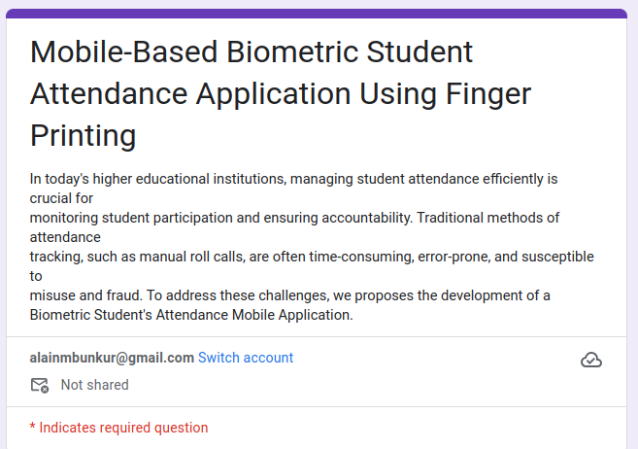

Created online surveys (e.g., via filing google forms) to a large sample of students. We collected quantitative data regarding their preferences, concerns, and expectations related to attendance recording. The survey questions could cover topics such as:

* Satisfaction with the current attendance recording process
* Willingness to adopt a biometric system
* Desired features, such as real-time reporting, notifications, or mobile access

**3.4. Document analysis**

Document analysis is a research method used to examine and interpret written or recorded information to gain insights and understanding about a particular topic or subject of interest. It involves systematically reviewing and analyzing various types of documents, such as written texts, reports, letters, memos, photographs, videos, or audio recordings.

**3.5. Brainstorming**

This is a creative problem-solving technique used to generate a large number of ideas, solutions between team members. It is a group activity that encourages participants to freely share their thoughts, suggestions, and insights without judgment or criticism. During these sessions, we engage in a structured discussion to explore various possibilities and generate innovative solutions for our project requirements.

* The student approaches the biometric system and places their finger on the fingerprint scanner.
* The system captures the fingerprint and verifies the student's identity.
* If the student's identity is successfully verified, the system records the attendance for that student.
* The system provides feedback to the student indicating successful attendance recording.

**4. REQUIREMENT GATHERING RESULTS**

**4.1 Raw Data Assessment**

After the online survey was done using Google forms, the following results were gotten from the responses of the students.

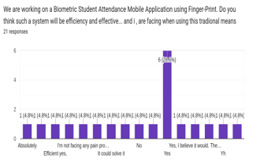

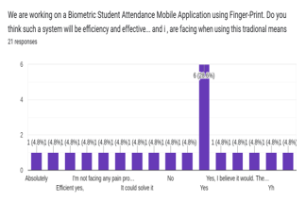

*Figure 1: google form statistics 1 Figure 2: google form statistics 2*

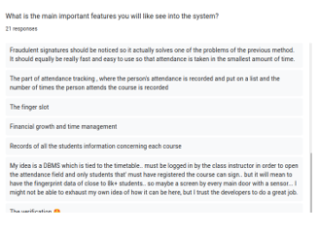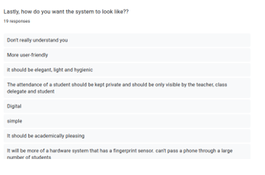

*Figure 3: google form statistics 3 Figure 4: google form statistics 4*

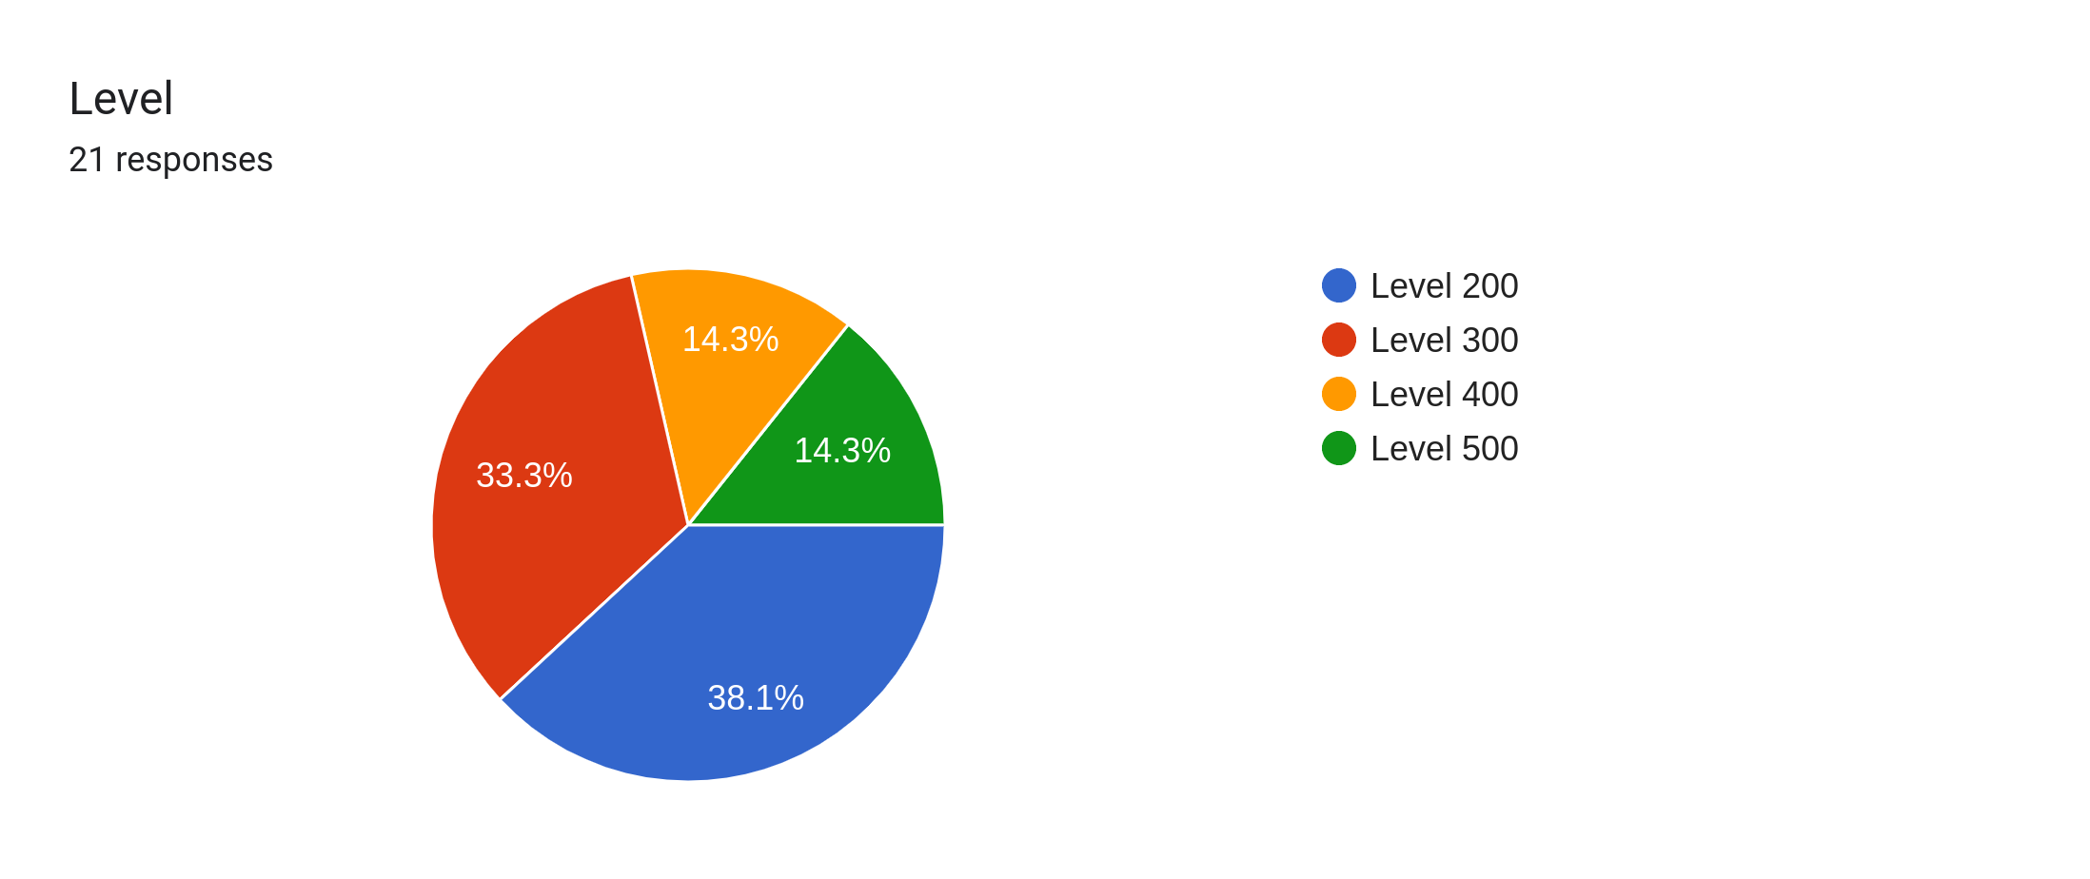

From the statistical results and replies above, we can see the students’ preferences and recommendations for the system.

**4.2. Data visualization in Excel:**

The data obtained from google forms were exported to an excel sheet for better visualization of students’ responses for the extractions of relevant requirements.

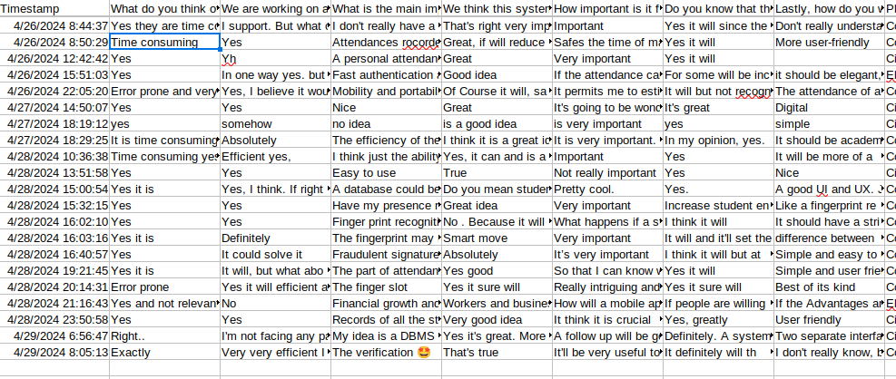Below is a view of the exported excel sheet;

**5. 5. Categorizing Requirements**

**5.1 Functional Requirements:**

* **Attendance Exception Handling:** The instructors should be able to mark attendance exceptions such as excused absences and include relevant note or explanation.
* **Attendance Backup System** : The system should have a backup option if in case the student fingerprint data is no longer recognized into the system database provided in case the student has enrolled his biometric data into the system before. In that case the lecturer is going to manually mark the attendance of the student’s name
* **Notification:** Students should be able to get attendance percentage notifications on their various mobile telephones. So as to comply with the University of Buea student’s guide which says that a student with a overall percentage attendance less than 70% is not eligible to write exams.
* Attendance Session Taking: The system should provide lecturers with the flexibility to open the attendance session taking to record students’ attendance at any time of his period and lecturers should be able to closed up the attendance session taking
* **Time Frame:**

The system should be able to show the exact time at which the students have mark their attendance

* **Registration and Login Process**

The system should enable students or instructors to be able to register or login into the system

* **Generate Attendance Records**

The system should provide lecturers with the ability to generate students’ attendance records of the course he or she teaches.

* **Attendance Summary**

The system should be able to generate the summary of the percentage of lectures that an individual student has attended and also for the course as well the percentage of students that have attended that particular course.

* **Monitoring**

The system can also be used to monitor lecturers if they are frequently coming to class. To observe the trend, pattern.

* Integrating with School Management Database (seamless data transfer)
* **Client-Server Application:**

The system should be a client Server Application. When the lecturer wants to record students’ attendance through the platform, the lecturer will just initiate the attendance taking, the student will login from their client application installed on their device and they will double authenticate themselves with their fingerprint data to issues they are one login in, after doing that, they will connect to the server of the lecturer machine/device using the lecturer hotspot and they will probe to mark their attendance using their fingerprint on their client application. And the data will be sent to the server application, which processes it, marks attendance, and stores information in a database. (*From Dr Nguti)*

* **Fingerprint Enrollment:**

The student should be able to enroll their fingerprint data through the client application and be securely stored in the server database. (*From Dr Nguti)*

* Real-time Attendance Tracking
* **Account Registration:**

Student should be able to registered themselves into the platform using their name, matriculation number, intuitional email, department, level and password.

* Recording Attendance Data (storing attendance information)

**5.2 Non-Functional Requirements:**

* **Interface Customization**

The student should be able to choose between light mode or dark mode.

* **Usability:**

The system or platform should be easy and simple to use and navigate.

* **Portability:**

This has to do with the compatibility or cross platform usability of the application with multiple devices and platforms. Students who own devices of different operating systems should be able to use the app.

* **Efficiency:**

Students’ attendance should be taken correctly as in the fingerprint of a student shouldn’t mark the presence of another student.

* **Performance:**

The application should be able to take attendance for students fast enough.

**Security:**

The attendance should be taken and stored safely since it deals with the biometric data of students which is really sensitive data.

**Offline mode:**

* **Weekly Reviews:**

Students should be able to view their attendance reports at the end of the week.

The platform or the system should be a cross platform that is compatible with both Android and iOS devices.

* **Scalability:**

The system should be scalable and customizing in mind, allowing education institution to adapt the application to their specific requirements and scale it to accommodate varying class sizes.

* **Biometric Authentication:**

The system should enable students to verify their identities using fingerprint recognition technology

**6. REQUIREMENT CONSTRAINT AND LIMITATIONS**

**6.1. Constraints:**

* Budget: The project should adhere to a specific budget allocated for developing the attendance recording system, considering the costs associated with hardware, software, and implementation.
* Time frame: There may be a predefined timeline or deadline for implementing the system, and the project should be completed within that time frame.
* Regulatory Compliance: The system must comply with relevant laws and regulations regarding biometric data and privacy, such as obtaining consent from students and ensuring data protection.
* **Unavailability of some Key stakeholders:** Some key administrative staffs like HOD were not available when we were gathering this requirement gathering. This make it really difficult to be able to meet with them and get their feedback about such system being implemented at the various department level and get their requirements.

**6.2. Limitations:**

* **Accessibility:** The biometric system may have limitations in accommodating students with disabilities or physical impairments that affect fingerprint recognition. Alternative attendance recording methods should be provided for such cases.
* **Environmental Factors:** External factors like extreme weather conditions or environmental factors (such as wet or dirty fingers) might affect the accuracy of fingerprint recognition. Mitigation strategies should be considered to address these limitations.

**7. CONCLUSION**

Overall, requirement gathering is the most essential step of project development and involving the stakeholders in the requirement process promotes collaboration, reduces risks, enhances understanding and increases the chances of the project success.