**REPUBLIQUE DU CAMEROON**

**PAIX-Travail-Patrie**

**MINISTRE DE L’ENSEIGNEMENT**

**SUPERIEUR**

**FACULTE D’INGINERIE**

**ET TECHGNOLOGIE**

**REPUBLIC OF CAMEROON**

**Peace-Work-Fatherland**

**MINISTER OF HIGHER EDUCATION**

**FACULTY OF ENGINEERING**

**AND TECHNOLOGY**



**FACULTY OF ENGINEERING AND TECHNOLOGY**

**Department : Computer Engineering**

**CEF 440: Internet Programming and Mobile programming**

**TASK 4**

**SYSTEM DESIGN AND MODELLING**

**GROUP MEMBERS:**

|  |  |
| --- | --- |
| **Names** | **Matriculation** |
| **ALAIN NKEH MBUNKUH** | **FE21A133** |
| **ANANFACK ZANGO ANGELA CARINE** | **FE21A137** |
| **CHO WESLEY MUNGO** | **FE21A160** |
| **NKWETI MANGEM ANCELIA** | **FE21A280** |
| **NTUI RAOUL NTUI RAOUL** | **FE21A288** |

**COURSE INSTRUCTOR : Dr NKEMENI VALERY**

Table of Contents

1. INTRODUCTION___________________________________________________________3

1.1. Objectives__________________________________________________________3

1.2. Scope______________________________________________________________4

2. CONTEXT DIAGRAM_______________________________________________________5

2.1. Context Diagram overview_____________________________________________5

2.2. Interaction with external entities_________________________________________6

2.3. Detailed description of system interaction__________________________________8

3. USE CASE DIAGRAM______________________________________________________10

2.1. Various actors and their use cases_______________________________________10

4. SEQUENCE DIAGRAM_____________________________________________________13

4.1. Account setup and fingerprint enrollment scenario__________________________13

4.2. Attendance taking scenario____________________________________________14

5. CLASS DIAGRAM_________________________________________________________17

5.1. Classes____________________________________________________________17

5.2. Attributes__________________________________________________________17

5.3. Methods___________________________________________________________17

5.4. Relationships_______________________________________________________18

5.5. Benefits of class diagrams_____________________________________________19

6. DEPLOYMENT DIAGRAM__________________________________________________20

6.1. Main physical device_________________________________________________20

6.2. Deployment diagram description________________________________________21

6.3. Interaction Between Components_______________________________________23

7. CONCLUSION_____________________________________________________________24

**1. INTRODUCTION**

In today's educational environment, ensuring accurate and efficient attendance tracking is a critical component for both administrative operations and academic integrity. Traditional methods of attendance tracking, such as manual roll-calling or paper-based sign-in sheets, are prone to errors, inefficiencies, and potential manipulation. To address these issues, a Biometric Student Attendance System (BSAS) offers a robust solution by leveraging biometric technology to automate and secure the process of student attendance recording.

This report presents a comprehensive analysis and design of a Biometric Student Attendance System. The primary objective of this system is to enhance the reliability and efficiency of attendance tracking through the use of biometric authentication methods, such as fingerprint or facial recognition. By implementing such a system, educational institutions can achieve a higher level of accuracy in attendance records, reduce administrative burdens, and enhance overall security.

**1.1. Objectives**

The main objectives of this report are:

* To illustrate the system design through various modeling techniques.
* To provide a detailed understanding of the system’s components and their interactions.
* To offer a blueprint for implementation that ensures the system's functionality and reliability.

**1.2. Scope**

The scope of this report includes the design and modeling of the Biometric Student Attendance System, focusing on the following diagrams:

**Context Diagram:**

An overview of the system's boundaries and its interaction with external entities.

**Use case Diagram:**

A representation of the functional requirements and interactions between users and the system.

**Sequence Diagram:**

An illustration of the sequence of interactions among the system components for specific use cases.

**Class Diagram:**

A detailed depiction of the system’s structure, highlighting classes and their relationships.

**Deployment Diagram:**

A description of the system’s physical architecture, showing how software components are deployed on hardware nodes.

**2. Context Diagram**

**2.1 Context Diagram Overview**

The context diagram provides a visual representation of the Biometric Student Attendance Mobile Application and its interactions with various external entities. It identifies the main components of the system, the external entities that interact with it, and the type of interactions that occur between them. This is the context diagram of our biometric student attendance mobile application.

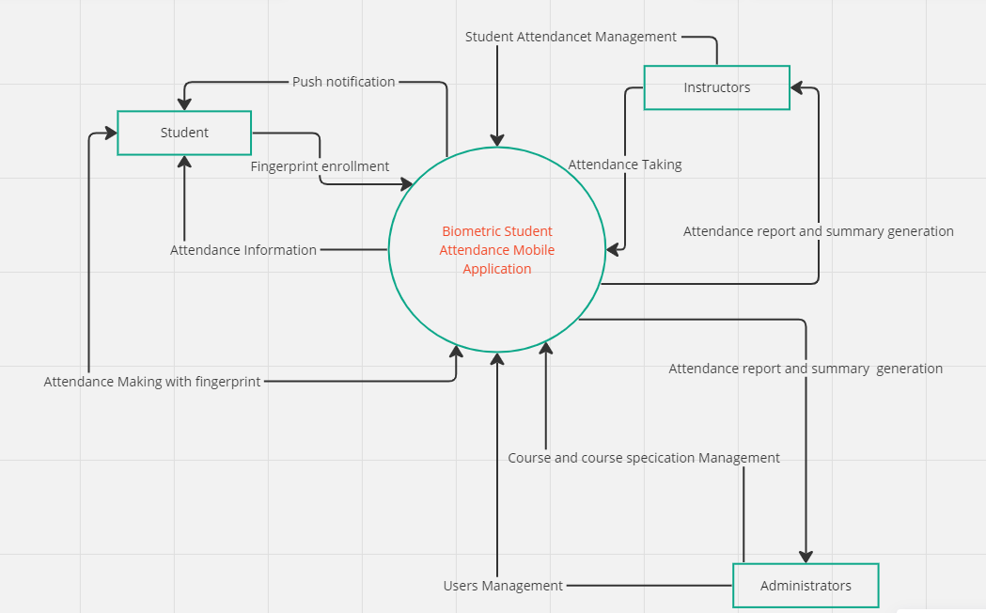Figure 1: Context Diagram: Biometric Student Attendance Mobile Application

**a. External Entities**

The key external entities interacting with the Biometric Student Attendance Mobile Application are:

- Students

- Instructors

- Administrators

**b. System Boundaries**

The system boundary is defined by the Biometric Student Attendance Mobile Application, which encompasses all the core functionalities such as fingerprint enrollment, attendance management, and reporting.

**2.2 Interactions with External Entities**

**2.2.1. Students**

* Fingerprint Enrollment

- Description: Students enroll their fingerprints into the system through the mobile application.

- Direction: From Student to System

* Attendance Making with Fingerprint

- Description: Students mark their attendance by scanning their fingerprint using the mobile application.

- Direction: From Student to System

* Attendance Information

- Description: The system provides students with their attendance records and information.

-Direction: From System to Student

* Push Notifications

- Description: The system sends push notifications to students for various updates such as class schedules and attendance reminders.

- Direction: From System to Student

**2.2.2 Instructors**

i. Student Attendance List Management

- Description: Instructors manage student attendance list through the mobile application.

- Direction: From Instructor to System

ii. Attendance Taking

- Description: Instructors initiate the attendance taking process during classes.

- Direction: From Instructor to System

iii. Attendance Report and Summary Generation

- Description: The system generates attendance reports and summaries for instructors to review.

- Direction: From System to Instructor

**2.2.3 Administrators**

i. Course and Course Specification Management

- Description: Administrators manage course details and specifications within the system.

- Direction: From Administrator to System

ii. User Management

- Description: Administrators manage user accounts and roles within the system.

- Direction: From Administrator to System

iii. Attendance Report and Summary Generation

- Description: The system generates comprehensive attendance reports and summaries for administrative review.

- Direction: From System to Administrator

**2.3. Detailed Description of System Interactions**

2.3.1 Fingerprint Enrollment

Students are required to enroll their fingerprints into the system using the mobile application. This step is crucial for ensuring that subsequent attendance markings are authenticated through biometric verification.

2.3.2 Attendance Making with Fingerprint

During class sessions, students use the mobile application to scan their fingerprints and mark their attendance. This process is secure and ensures that only the enrolled student can mark their attendance.

2.3.3 Attendance Information

Students can access their attendance records and related information through the mobile application. This feature helps students keep track of their attendance and identify any discrepancies.

2.3.4 Push Notifications

The system sends push notifications to students regarding important updates such as changes in class schedules, reminders for attendance, and other relevant notifications.

2.3.5 Student Attendance Management

Instructors use the system to manage student attendance records. This includes viewing and verifying attendance logs, and making necessary adjustments if required.

2.3.6 Attendance Taking

Instructors initiate the attendance-taking process during class. The system provides a seamless interface for instructors to manage this process efficiently.

2.3.7. Attendance Report and Summary Generation

Both instructors and administrators have access to the attendance report and summary generation feature. This allows them to generate detailed reports and summaries for analysis and review.

2.3.8. Course and Course Specification Management

Administrators manage the details and specifications of various courses through the system. This includes updating course schedules, adding new courses, and modifying existing course details.

2.3.9. User Management

Administrators are responsible for managing user accounts within the system. This includes creating new user accounts, assigning roles, and managing permissions.

**3. Use case Diagram**

A use case diagram is a vital tool in system design ,it provides a visual representation of how users interact with a system .it serves as a blueprint for understanding the functional requirements of system from a user’s perspective aiding in communication between stakeholders.

Use CaseDiagrams can be used to describe the functionality and the scope of a system by describing the interactions between the system and it’s actors .The sue cases and the actors in a use-case diagrams describe what the system does and how the actors use it ,but not how the system operates internally.In this review, we will be talking about the use case diagram for a biometric authentication system

Three main actors are involved in our system :

* Student (primary actor)
* Instructor(primary actor)
* Administrator(secondary actor)

**2.1. Various actors and their use cases**

**2.1.1 Student**

* The Students download and install the biometric student attendance client application on their smartphone
* creates an account within the application and inputs necessary personal information such as their name, matriculation number, institutional email, alternative email, phone number, department, level.
* checks in their personal account profile and modify credentials where necessary.
* Initiates fingerprint enrollment process within the client application.
* View attendance history
* Receive attendance percentage notifications on their various mobile telephones
* Keep track their individual attendance record of each courses offered on their client application.

**2.1.2 Instructor**

* Instructor logs in using a secure mechanism with appropriate access control.
* Maintains a record of student attendance including dates, timestamps and any attendance exception
* Generates attendance reports of individual courses .
* View attendance history and summary of students attendance in various formats (word document ,pdf)
* Initiate attendance sessions on appropriate and available opening and closing time stamps
* views attendance record instantly as student inputs their biometric credentials.

**2.1.3 Admin**

* Manages users account (student and instructor
* Generates attendance records
* Manage attendance policies
* He also accesses the user account management system
* He can also perform the following task :
  + Create new user accounts
  + Updates users accounts
  + Modify users account
  + Associate user accounts with biometric profiles
  + Save the various changes
  + Configures the biometric device
* Generates attendance reports based on the data in the biometric system
* Customize the report layout and content
* Export the attendance in various formats (word,pdf)
* Configure attendance notification and alerts for users

**The diagram below depicts clearly the various use cases :**

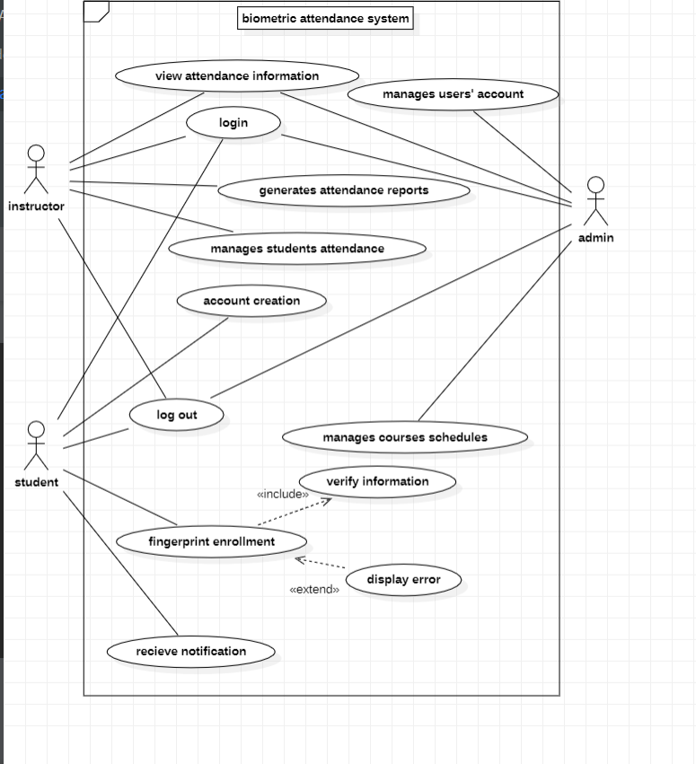Figure 2: Use case diagram of a biometric system attendance ,tool: startUML

**4. Sequence Diagram**

A sequence diagram is an interaction diagram that details how operations are carried out – what messages are sent and when.

It consists of group of objects that are represented by lifelines, and the messages that they exchange over time during the interaction.

With respect to this biometric attendance recording system, below are the sequence diagrams for the most essential parts of the system – biometric enrollment and attendance taking.

**4.1. Account Setup and Fingerprint enrollment Scenario**

The actor in this case is the Student and the objects are the client application or the student's application and the database.

Below are the steps on how the account setup and fingerprint enrollment work.

**1. Open Registration Page:**

The student opens the mobile app and navigates to the registration page.

**2. Display Registration Form:**

The app displays a form for the student to fill in their registration details (e.g., name, matricule, email, password).

**3. Enter and Submit Registration Details:**

The student enters the required information and submits the form.

The app sends the registration details to the database for storage.

**4. Registration Confirmation:**

The database creates a new user account, and sends a success message back to the app.

The app displays a success message to the student.

**5. Prompt for Fingerprint Enrollment:**

The app prompts the student to enroll their fingerprint.

The student places their finger on the in-display fingerprint sensor.

**6. Fingerprint Scanning:**

The app captures the student's biometric data (fingerprint).

**7. Send Biometric Data:**

The app sends the captured biometric data to the database for enrollment or storage.

**8. Enrollment Confirmation:**

The server processes the biometric data and stores it securely.

The server sends an enrollment success message back to the app.

The app displays a success message to the student confirming that the fingerprint enrollment is complete.

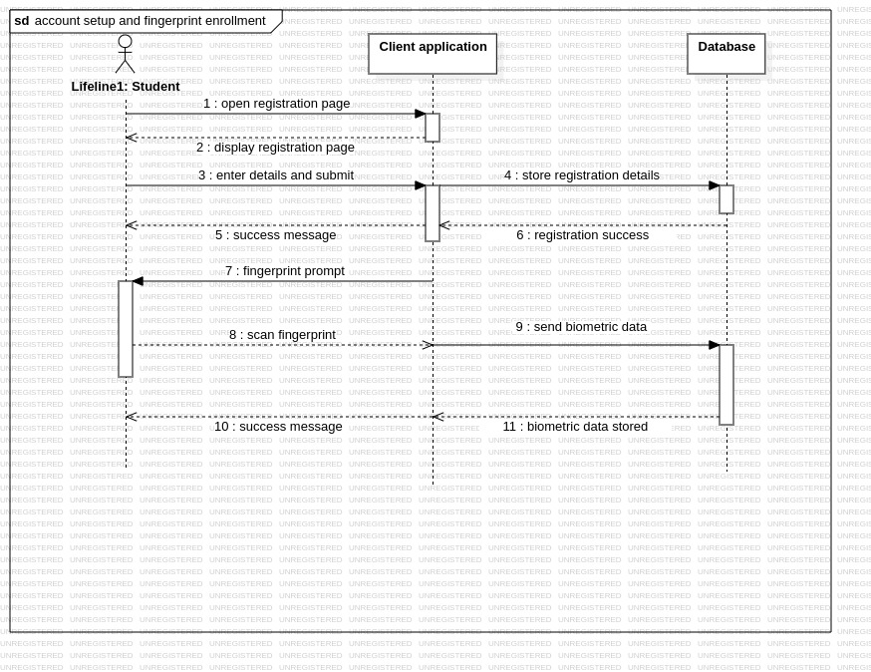Figure 3: sequence diagram for account setup and fingerprint enrollment scenario\

This sequence ensures that a student can successfully create an account and enroll their fingerprint for future authentication (during an attendance session) in the attendance application.

**4.2. Attendance Taking Scenario**

The actors are the Lecturers and the students while the objects are the server device (lecturer’s device), client application and the database.

**1. Teacher Initiates Attendance Session:**

The teacher opens the teacher's mobile app and starts an attendance session.

The lecturer activates the hotspot so that students can connect to.

**2. Students Connect to Hotspot:**

Each student uses their mobile app to connect to the teacher's hotspot.

**3. Fingerprint Authentication:**

Once connected, the student is prompted to scan their fingerprint using the in-display fingerprint sensor.

The student's mobile app captures the biometric data and sends it to the server for verification.

**4. Server Verifies Biometric Data:**

The server verifies the biometric data and returns the authentication result to the student's mobile app.

If the authentication is successful, the student's mobile app sends attendance data to the server.

**5. Attendance Confirmation:**

The server confirms the attendance data and updates the attendance record.

The confirmation is sent back to the student's mobile app, which updates the student on the successful attendance marking.

**6. Teacher Ends Attendance Session:**

The teacher ends the attendance session, and the teacher's mobile app closes the hotspot.

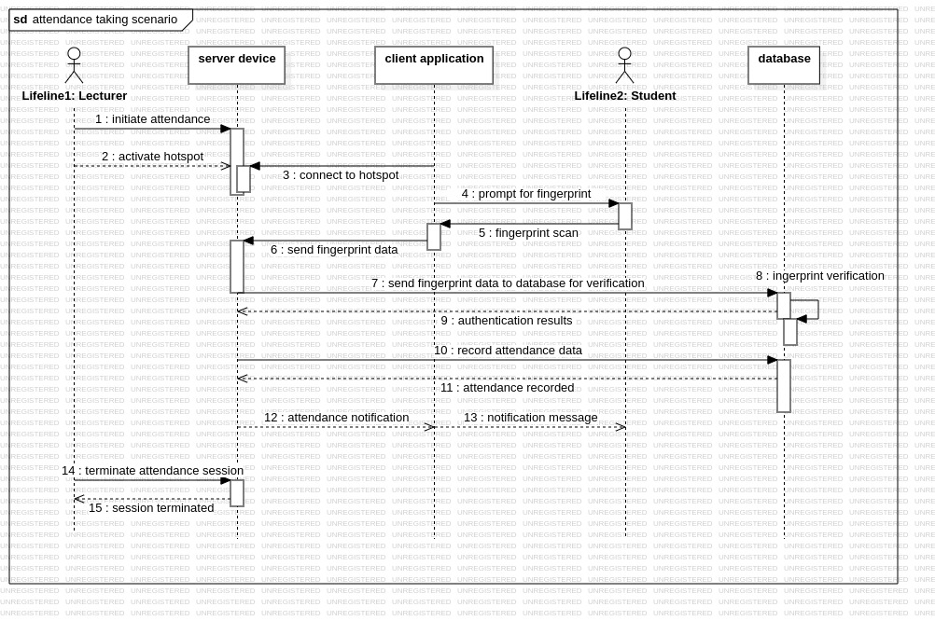Figure 4: sequence diagram for attendance taking scenario

This sequence ensures secure and efficient attendance marking using biometric authentication, providing a seamless experience for both teachers and students.

**5. Class Diagram**

A class diagram is a type of static structure diagram used in software engineering and design to describe the structure of a system by showing its classes, attributes, methods, and the relationships among objects. A class diagram consists of;

**5.1. Classes**: Represented by rectangles divided into three compartments:

* + - The top compartment contains the class name.
    - The middle compartment contains the attributes (properties) of the class.
    - The bottom compartment contains the methods (functions or operations) of the class.

**5.2. Attributes**: These are the properties or characteristics of the class.

**5.3. Methods:** These are the functions or operations that can be performed by instances of the class.

Key classes here involve;

* User
* Student
* Instructor
* Administrator
* AttendanceRecord
* FingerprintEnrollment
* Course
* Database
* Notification

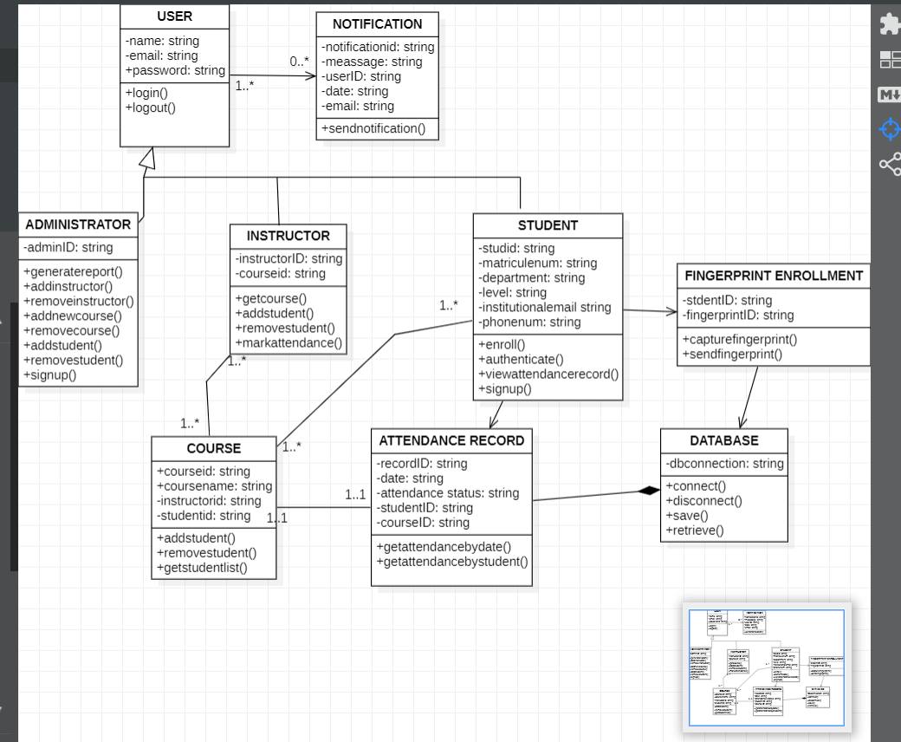Figure 5: class diagram for the biometric student attendance system with starUML

* **5.4. Relationships:** These illustrate how classes interact with each other. The relationships here include;
  + - Student, Instructor, and Administrator inherit from User.
    - Course has a one-to-many relationship with Student (each course can have multiple students).
    - Course has a one-to-one relationship with Instructor (each course has one instructor).
    - AttendanceRecord has a many-to-one relationship with Student (each attendance record is associated with one student).
    - AttendanceRecord has a many-to-one relationship with Course (each attendance record is associated with one course).
    - Notification has a many-to-one relationship with User (each notification is associated with one user).

**5.5. Benefits of class diagram**

* Class diagrams are simple, fast to read and give a sense of orientation.
* They are the foundation of creating systems.
* They provide detailed inside into the structure of your system
* They create complete charts that highlights specific code needed to be programmed and executed to the defined structure
* Provides an implementation- independent explanation of types used in a system that is later passed on to its component

**6. Deployment Diagram**

The deployment diagram represents the distribution of software components across different physical devices. It showcases the relationships and communication between the client devices, server applications, database servers, and other essential components of the system

**6.1. Main Physical Device**

a. Client Device (Student's Smartphone)

* Software Components:
* Client Application
* Fingerprint Scanner Module
* Network Module (to connect to the lecturer's hotspot)

b. Server Device (Lecturer's Tablet)

* Software Components:
* Server Application
* Fingerprint Matching Module
* Network Module (acts as a hotspot)

c. Database Server

* Software Components:
* Database Management System (DBMS)
* Attendance Records Database

d. Push Notification Server

* Software component:
* Sends attendance notifications

e. Computer device

* Software Component:
  + - Web browser
* Admin and Lecturer web interface Portal

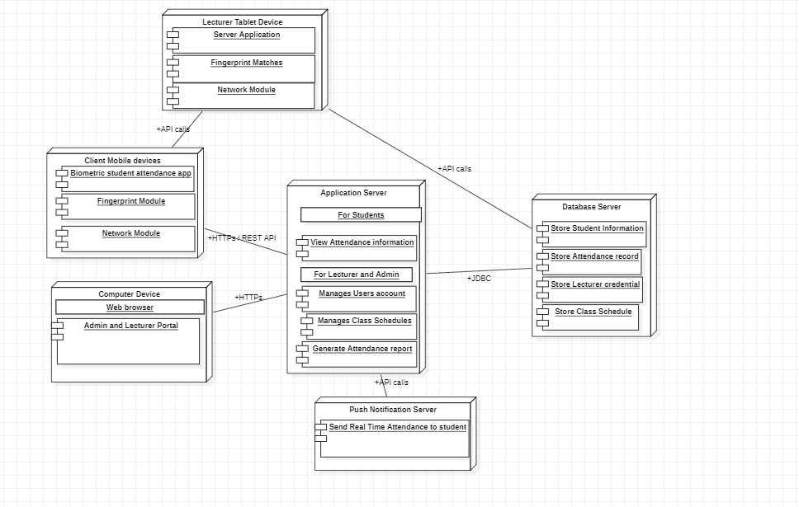Figure 6: Deployment Diagram: Biometric Student Attendance Mobile Application

**6.2. Deployment Diagram Description:**

**i. Client Device (Student's Smartphone)**

* Each student’s smartphone runs the client application.
* The application allows students to create an account, enrol their fingerprint, and connect to the lecturer's tablet via the lecturer's hotspot.

Components:

* + Biometric Student Attendance App: The mobile application used by students for fingerprint enrolment, attendance information and attendance marking.
  + Fingerprint Scanner Module: Captures and reads student fingerprints.
  + Network Module: Connects to the server device (lecturer’s tablet) via Wi-Fi hotspot.

**ii. Server Device (Lecturer’s Tablet)**

* The lecturer's tablet acts as a server device and hosts the server application.
* The application initiates the attendance process and communicates with students' smartphones.
* Server Application: Manages attendance sessions, processes incoming fingerprint data, and records attendance.
* Fingerprint Matching Module: Matches fingerprints received from student devices against stored data.
* Network Module (Hotspot): Provides a Wi-Fi hotspot for student devices to connect.

**iii. Database server:**

* + Stores students' attendance data,
  + Store attendance records,
  + Maintains record of student attendance
  + Store personal and enrollment details of students
  + Store lecturer credentials
  + Store Class Schedule: keeps details of class schedules, including timings, courses, and assigned instructors.

**iv. Application Server**

* For Students
* Provides functionalities for viewing attendance information and other student-related activities.
* For Lecturers and Admin
* Manages user accounts, class schedules, generates attendance reports and summary and manages student attendance list.

**v. Push Notification Server:**

* Sends attendance notifications to students, parents, or teachers (e.g., absence alerts).

**vi. Computer Device**

* **Web Browser (Admin and Lecturer Portal) :** Provides a web-based interface for administrators and lecturers to manage user accounts, course schedules, and generate attendance reports.

**6.3. Interaction Between Components**

1. Account Creation & Fingerprint Enrollment:

* The student installs the client application on their smartphone.
* The student creates an account using their student information.
* The student enrols their fingerprint using the client application.

1. Attendance Marking:

* The lecturer starts the attendance session on the server application (lecturer’s tablet).
* The server device (lecturer's tablet) sets up a Wi-Fi hotspot.
* Students connect their smartphones to the lecturer’s hotspot.
* The client application prompts students to mark their attendance using their fingerprint.
* The client application captures the fingerprint and sends the data to the server application.
* The server application processes the fingerprint data, matches it against the enrolled fingerprints, and updates the attendance records in the database.

1. Attendance information and Notification

* Students view their attendance information through the mobile application.
* The application server might trigger push notifications for various events (e.g., attendance confirmation, absence alert).

1. Administrative and Management
   * School administrators access the web interface throught the web browser to manage users, schedules, generate reports, and configure settings while lecturers access the web interface to manage student attendance list and generate attendance report and summary.
   * The admin portal retrieves and updates data from the database
2. Communication Protocols

* HTTPS and REST API

Used for secure communication between client mobile devices, the web browser, and the application server.

* API Calls

Facilitates interactions between the lecturer tablet device, the push notification server, and the application server.

* JDBC ( Java Database Connectivity)

Ensures efficient and secure data transactions between the application server and the database server.

**7. Conclusion**

The Biometric Student Attendance System (BSAS) represents a significant advancement in the management of student attendance within educational institutions. By harnessing the power of biometric technologies, this system offers a reliable, efficient, and secure method for tracking student attendance, addressing the limitations of traditional manual processes.

Throughout this report, we have meticulously examined the design and modeling of the BSAS using a variety of Unified Modeling Language (UML) diagrams. The context diagram provided a high-level overview of the system’s interaction with external entities, establishing a clear boundary for its scope. The use case diagram outlined the primary functionalities and interactions between users and the system, ensuring that all user requirements are met. Sequence diagrams depicted the flow of interactions for key use cases, highlighting the dynamic behavior of the system. Class diagrams illustrated the static structure, detailing the relationships and attributes of the system’s components. Finally, the deployment diagram described the physical architecture, ensuring that the system’s software components are appropriately distributed across hardware nodes for optimal performance.

In conclusion, the Biometric Student Attendance System offers a transformative approach to attendance management, leveraging cutting-edge biometric technology to deliver unparalleled accuracy, security, and efficiency. The detailed system design and modeling presented in this report provide a solid foundation for the implementation of the BSAS. By adopting such a system, educational institutions can not only streamline their attendance tracking processes but also enhance the overall educational experience for students and staff alike.