**Angel Louie R. Baisas**

**BSIT 3 – A**

**ITEL – 304**

**ACTIVITY 3.B**

**Input**

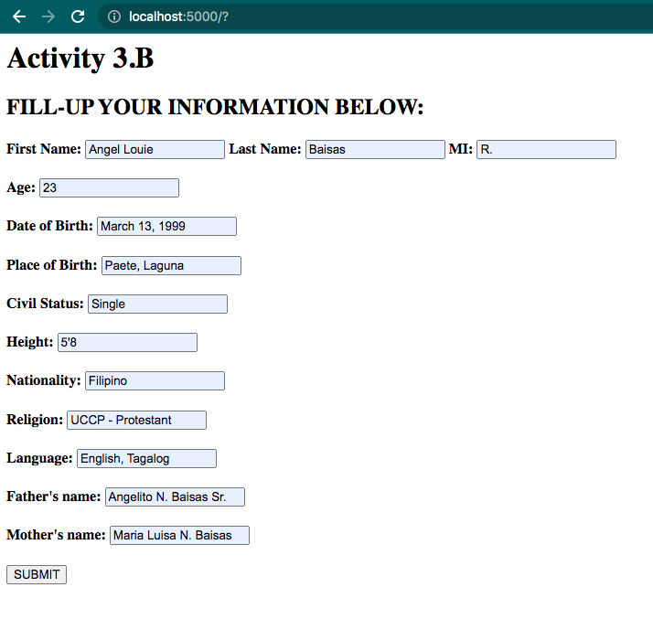

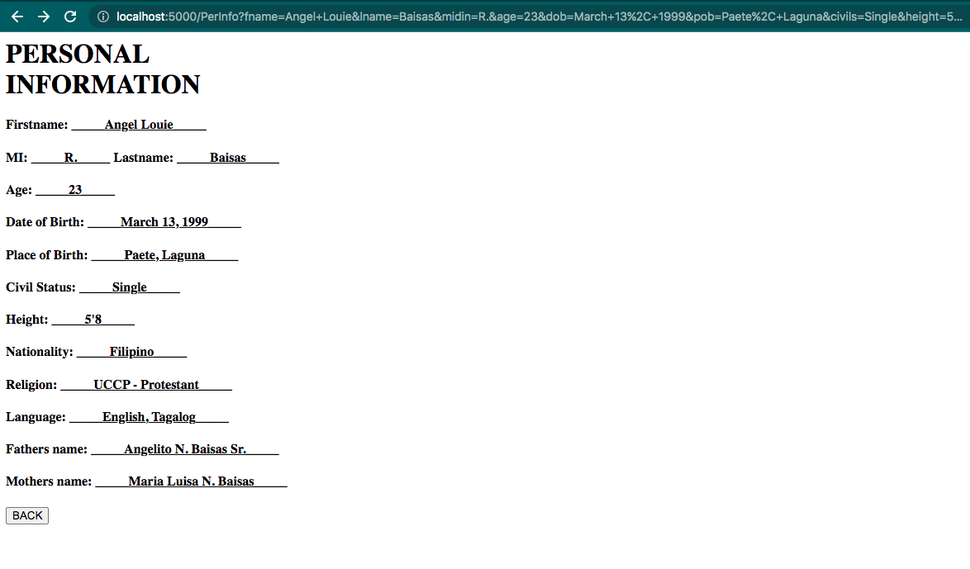**Output**

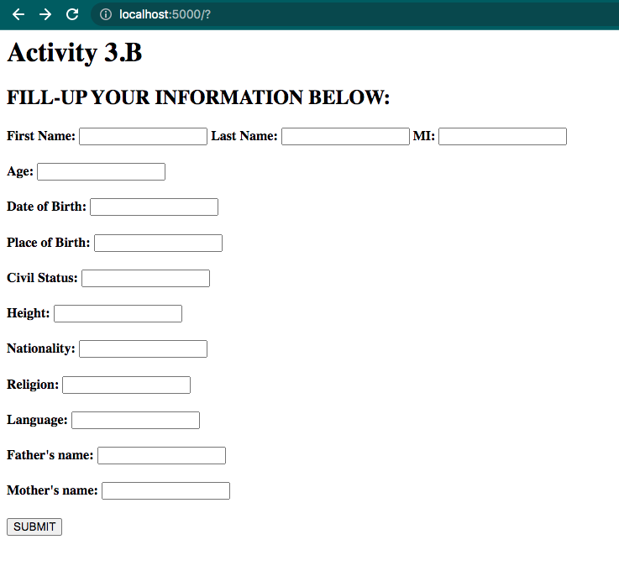**Without Input.B**

**Output of Without Input.B**

