**Angel Louie R. Baisas**

**BSIT 3 – A**

**ITEL – 304**

**ACTIVITY 3**

**Input**

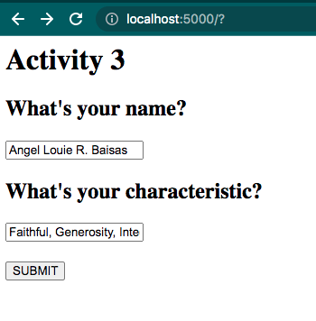

**Output**

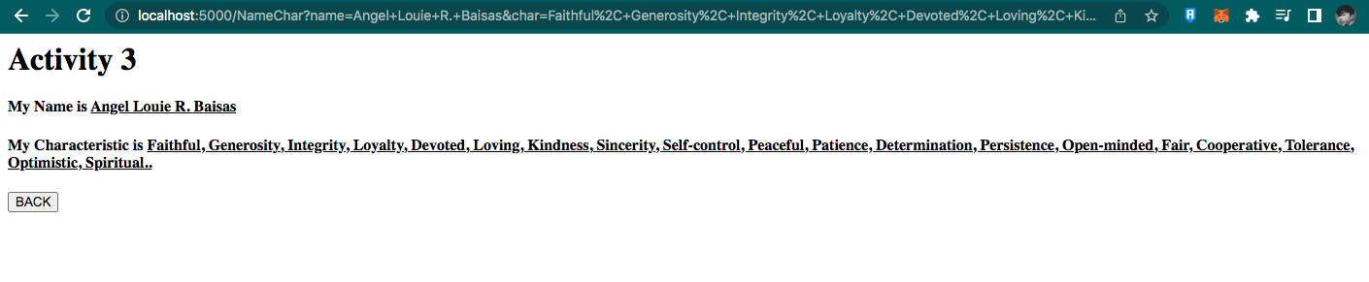

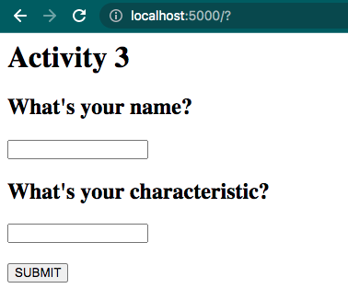**Without Input**

**Output that without Input**

