C:\Program Files (x86)\Microsoft Office\MEDIA\CAGCAT10\j0233070.wmf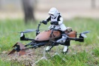C:\Program Files (x86)\Microsoft Office\MEDIA\CAGCAT10\j0233070.wmf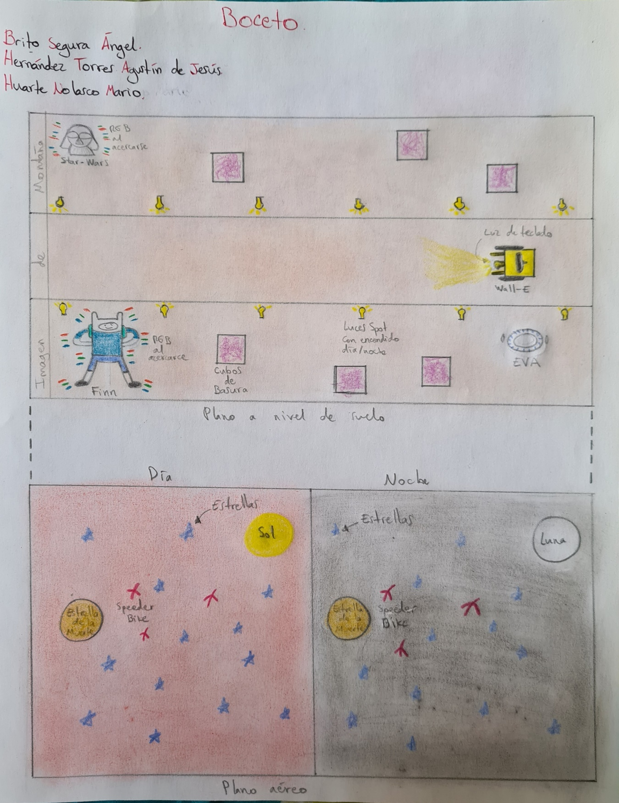

Yoda R2-D2

Speeder Bike

Interceptor

Jedi

Interceptor

Jedi

Deimos

Fobos