XENA Library as a Service (LaaS)
XENA SDK — Run Feature

Technical Design Proposal
Version 1.0 | Status: Proposal
Document | XENA SDK – Run Feature
Version | 1.0
Status | Proposal
Audience | Quants & Platform Engineering

Table of Contents

1. Overview
The first release of the XENA SDK introduced artifact discovery and debugging capabilities, allowing Quants to inspect XENA executions directly from their S3 artifacts.
The next evolution extends the SDK from a passive debugging tool into an execution tool capable of reproducing, validating, and launching XENA runs.
The SDK abstracts the internal XENA execution model, allowing users to execute pricing jobs without requiring knowledge of:
- S3 bucket names
- Folder structures
- Parquet generation
- Metadata encoding
- Input validation
- Storage conventions
The SDK exposes a debugger-like execution model centered on a single command:
xena-debug run

2. Objectives
The Run feature provides:
- Execution of new XENA runs
- Reproduction of previous executions
- Automatic Parquet generation
- Automatic metadata generation
- Contract validation
- Contract-compliant storage
- Schema validation
- Future extensibility
The SDK intentionally hides implementation details such as S3 uploads and storage layout.

3. Design Principles
The design follows the same principles adopted throughout XENA LaaS.

3.1 Business-Oriented Interface
The SDK exposes business concepts. Users execute Runs; users never upload files.
Instead of:
sdk.upload(...)
the SDK exposes:
sdk.run(...)
This matches the mental model used by debuggers and execution frameworks.

3.2 Configuration Driven
The SDK is configuration-driven. Execution rules are loaded from xena-config-{env} instead of being hardcoded. This allows new libraries, schemas, and contract versions to evolve independently from SDK releases.

3.3 Contract First
Every execution must satisfy the XENA S3 Contract. The SDK validates the contract before any upload occurs. Invalid executions fail locally.

4. High-Level Architecture
The diagram below illustrates the flow of configuration and execution data from the registry, through the SDK's internal engines, into XENA's input bucket and execution runtime.
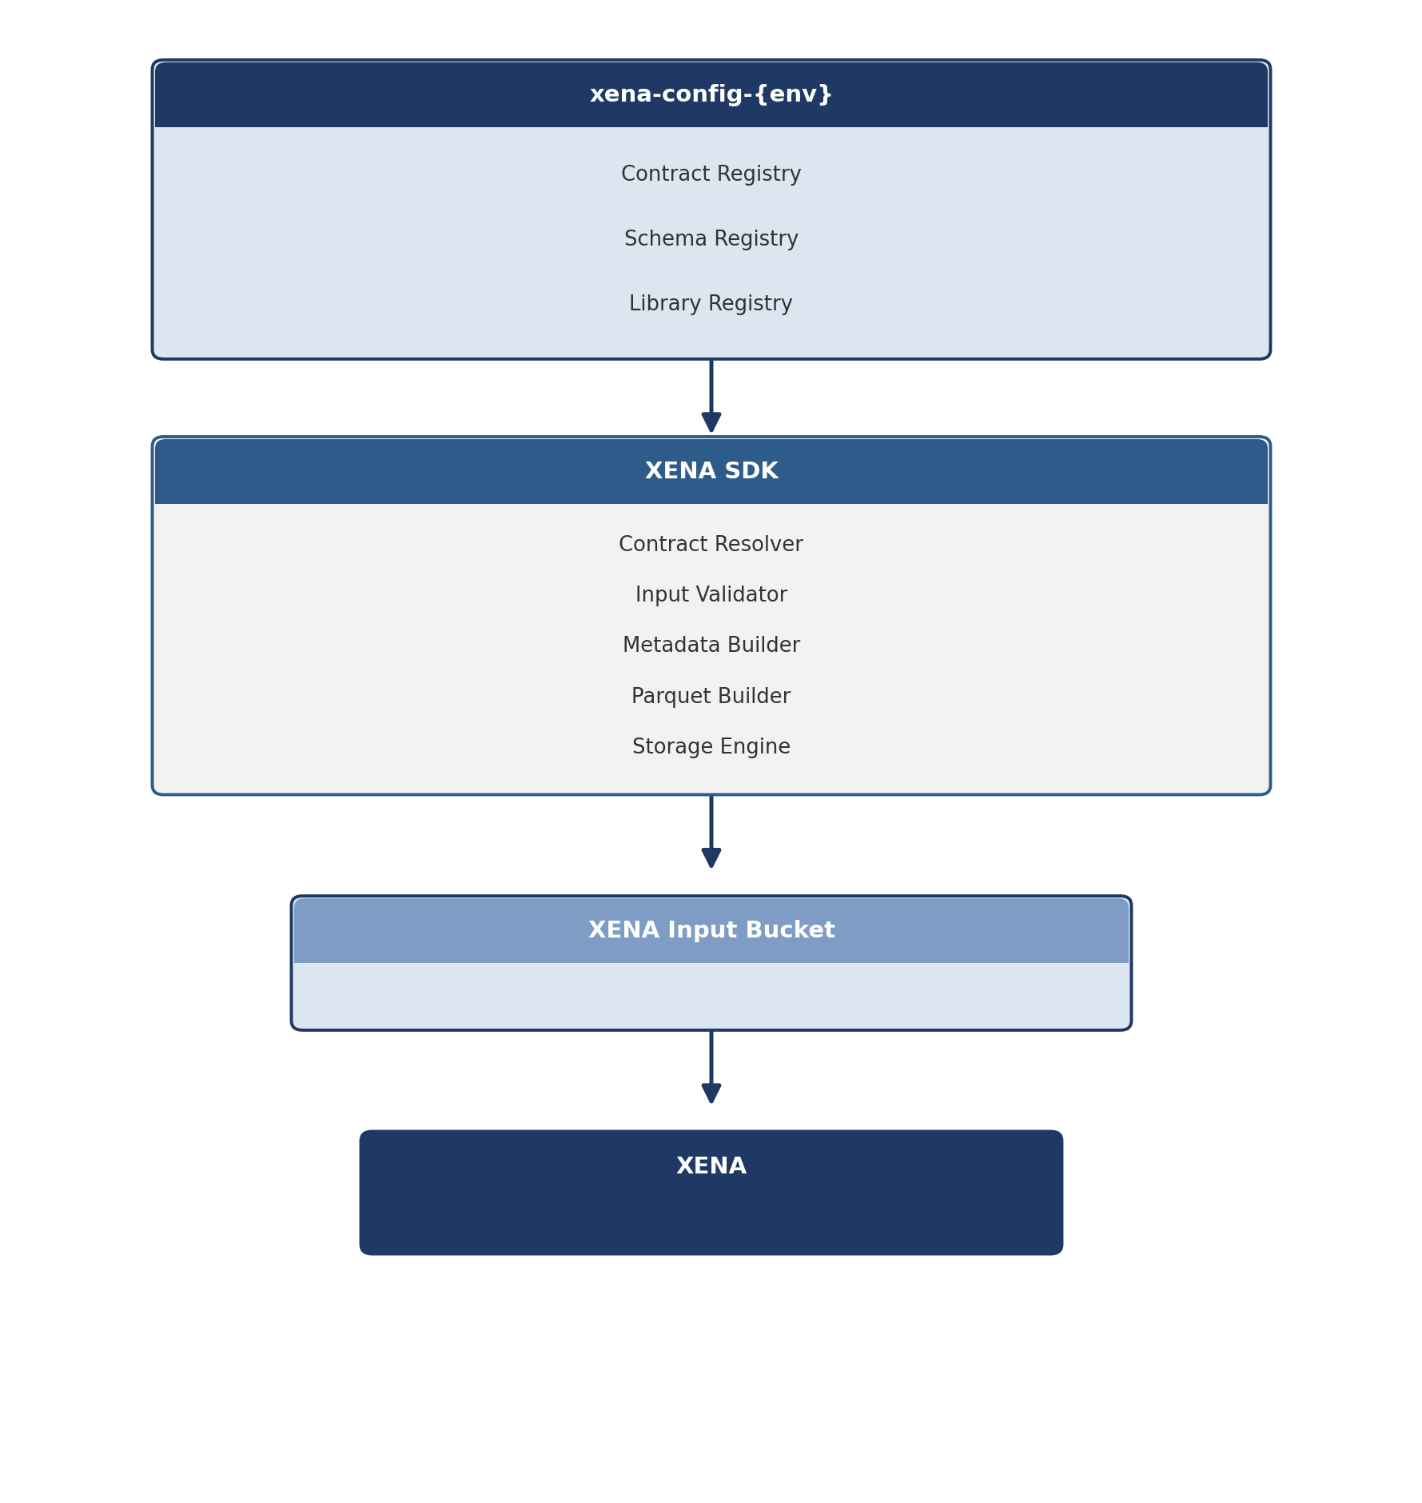
Figure 1 — XENA SDK high-level architecture

5. Supported Input Types
The SDK accepts multiple input formats.

5.1 Existing Parquet
book.parquet
The SDK validates:
- Schema
- Metadata
- Row groups
- Contract
before execution.

5.2 Single JSON
deal.json
The SDK generates book.parquet automatically.

5.3 Multiple JSON Files
deal001.json
deal002.json
deal003.json
...
The SDK builds a single Parquet file containing all inputs. This is the preferred workflow for Quants.

6. Batch Execution Model
Not every JobType represents a single logical execution. Some XENA flows naturally operate on collections of independent jobs.
Examples:
- FMTM
- EMIR
Those flows may receive multiple independent inputs during the same execution.
To preserve isolation and traceability, the S3 Contract introduces an optional seventh subfolder: JobId.
Example:
fmtm/
ES/
DAILY_BATCH/
20260604/
0/
1/
Book_001/
where Book_001 is the JobId.
The SDK automatically includes the following inside the Parquet metadata:
{
"jobId": "Book_001"
}
Therefore, the S3 Contract and the Parquet Metadata remain perfectly synchronized. Single-execution flows simply omit JobId.

7. Metadata Generation
The SDK automatically generates execution metadata. Example:
{
"targetLibrary": "iqlxva",
"targetVersion": "latest",
"filename": "book.parquet",
"geography": "ES",
"dataDatePart": "20260604",
"purpose": "DAILY_BATCH",
"subPurpose": "0",
"iteration": "1",
"jobId": "Book_001",
"objectType": "MARKET"
}
The JobId field is generated only when required by the JobType.
Field | Description
targetLibrary | Target pricing library (e.g. iqlxva)
targetVersion | Library version to execute against (e.g. latest)
filename | Name of the generated Parquet artifact
geography | Geography / market code (e.g. ES)
dataDatePart | Business date of the execution (YYYYMMDD)
purpose | Execution purpose (e.g. DAILY_BATCH)
subPurpose | Sub-classification of the purpose
iteration | Iteration number of the run
jobId | Optional batch identifier (FMTM, EMIR, ...)
objectType | Category of the input object (e.g. MARKET)

8. Contract Resolution
The SDK receives business parameters. Example:
sdk.run(
flow="fmtm",
geography="ES",
purpose="DAILY_BATCH",
date="20260604",
iteration=1,
job_id="Book_001",
input="./deals/"
)
The SDK resolves the corresponding storage location defined by the XENA Contract. Example:
fmtm/
ES/
DAILY_BATCH/
20260604/
0/
1/
Book_001/
The user never manipulates S3 paths directly.

9. Internal Processing Pipeline
Each run passes sequentially through the following stages before an artifact is uploaded to XENA.
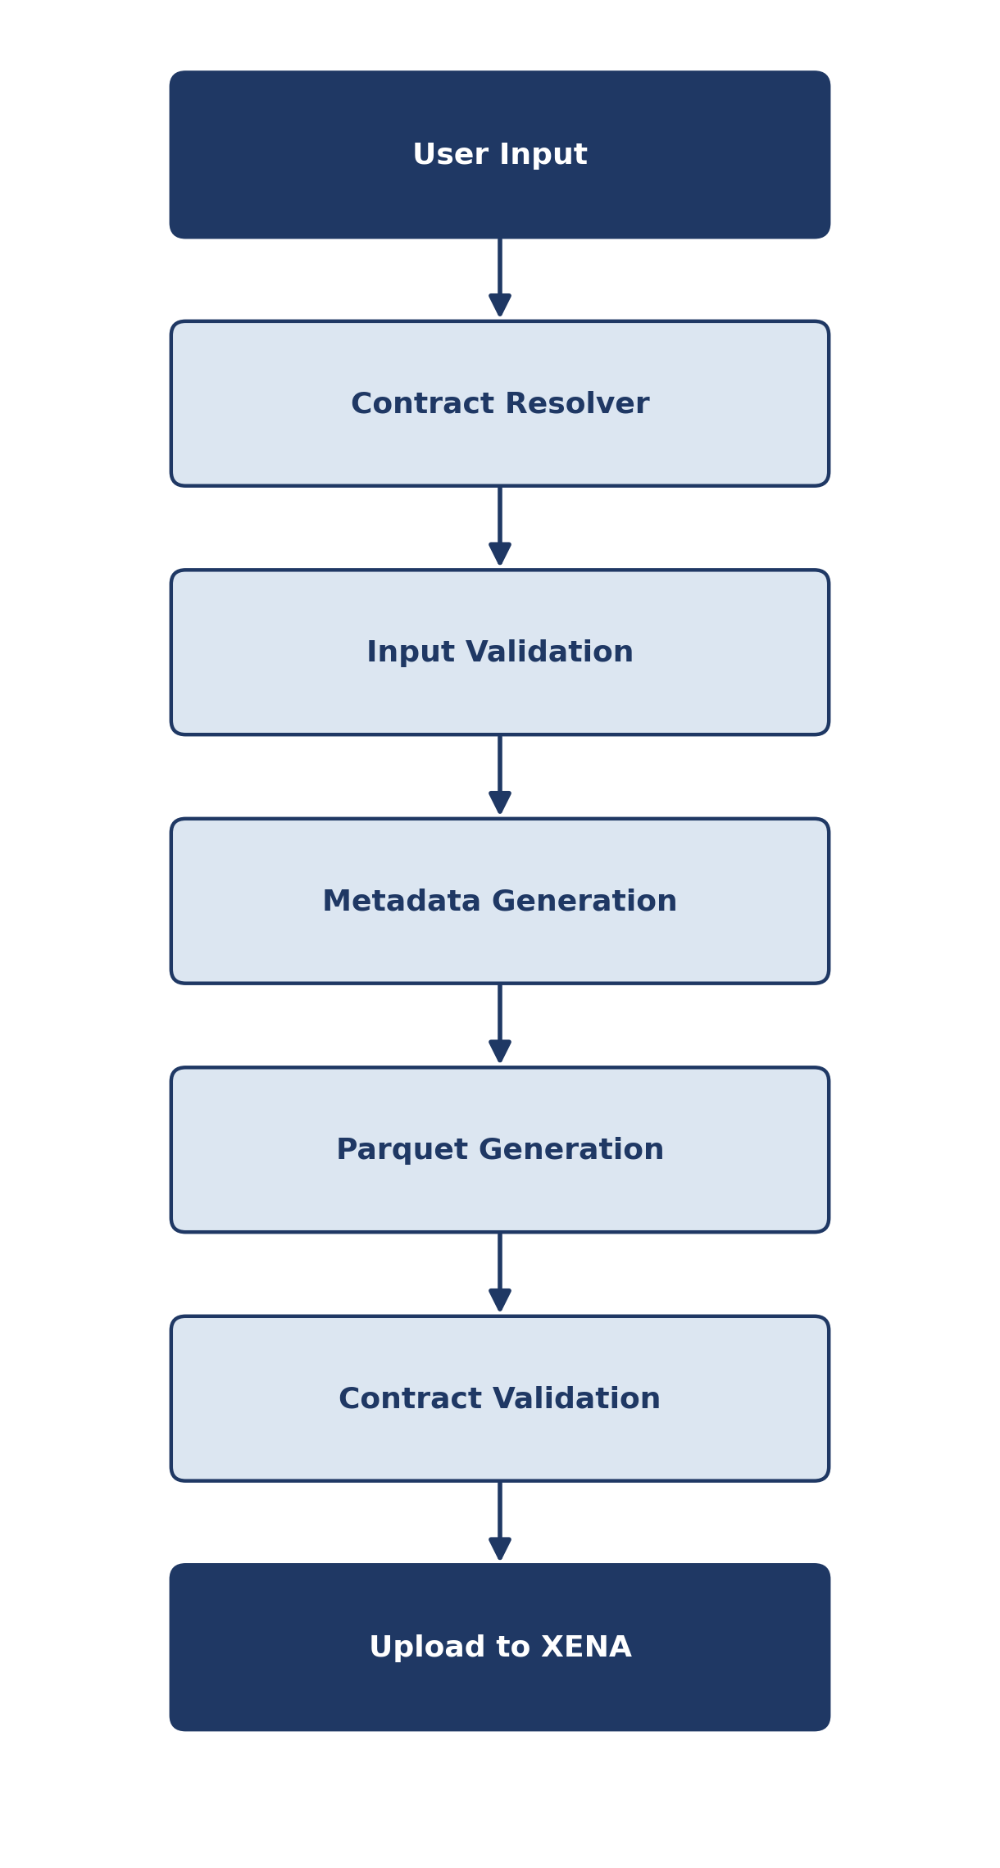
Figure 2 — Internal processing pipeline
The SDK does not generate execution manifests. Manifest generation remains the responsibility of the GRID libraries after successful processing.

10. Validation
Before uploading any artifact, the SDK validates:
- JobType
- Library
- Target version
- Geography
- Purpose
- Required metadata
- Supported schema
- Duplicate columns
- Mandatory fields
- Row group structure
- Parquet consistency
- Contract compliance
Errors are reported locally, before execution begins.

11. Registry Usage
The SDK consumes configuration stored under xena-config-{env}/registry/. Example:
registry/
libraries/
schemas/
contracts/
fmtm/
calibration/
emir/
Possible registry contents include:
- Supported libraries
- Latest versions
- Deprecated versions
- Schema definitions
- Default metadata
- Validation rules
No SDK redeployment is required when registry data changes.

12. CLI Examples

Run an existing Parquet
xena-debug run book.parquet

Run a single JSON
xena-debug run trade.json

Run multiple JSON files
xena-debug run ./deals/

Run specifying JobId
xena-debug run ./book \
--flow fmtm \
--job-id Book_001

Preview only
xena-debug run ./book --preview

Dry-run validation
xena-debug run ./book --dry-run

13. Architectural Benefits
Benefit | Description
Storage abstraction | Users never manipulate S3 buckets or prefixes.
Contract enforcement | All executions comply with the XENA Contract before upload.
Reproducibility | Previous executions can be recreated consistently.
Batch support | Native support for multi-input JobTypes such as FMTM and EMIR.
Configuration-driven | Registries evolve independently of SDK releases.
Decoupling | SDK logic is independent from storage implementation details.
Validation-first | Execution errors are detected locally instead of during processing.
Future extensibility | Additional JobTypes, metadata, or artifact formats can be introduced without changing the SDK architecture.

14. Future Evolution
The proposed architecture naturally enables additional capabilities without changing the public SDK interface:
- Run templates: recreate a previous execution while replacing only the input artifacts.
- Execution tracking: monitor run progress and retrieve execution status from XENA.
- Automatic output retrieval: download manifests, results, and error artifacts after completion.
- Alternative input formats: support future formats (e.g., Arrow, ORC) while preserving the same xena-debug run command.
- Schema evolution: leverage the Schema Registry in xena-config-{env} to support new Parquet schemas without SDK or XDE redeployments.

Architectural Summary
The Run feature transforms the XENA SDK from a debugging utility into a complete execution interface. By abstracting storage details, enforcing the XENA S3 Contract, generating compliant Parquet artifacts, and supporting both single and batch execution models, the SDK provides Quants with a debugger-like experience (xena-debug run) while preserving the architectural principles of XENA LaaS: configuration-driven behavior, contract-first validation, and loose coupling between users, storage, and execution engines.
The introduction of the optional JobId metadata for batch-oriented JobTypes (FMTM and EMIR) further ensures end-to-end consistency between the S3 Contract and the execution metadata, enabling reproducible, traceable, and scalable executions. This is a strong architectural direction that fits naturally with the rest of the XENA ecosystem.

