PROPOSAL
Adaptive Workload Partitioning Strategy for XENA
Balancing Row Groups, Parallelism, and Cluster Capacity
Version: 1.0
Author: Angel
Status: Proposal

1. Executive Summary
The current Parquet generation strategy uses a fixed Row Group size of 50 deals per Row Group. While simple, this approach assumes every workload should be partitioned identically, regardless of book size, processing complexity, environment capacity, business SLA, or historical execution time.
As a result, several structural problems emerge:
- Workloads become unbalanced across Jobs.
- XDE generates Jobs with very different execution times.
- Large Jobs exceed configured timeouts.
- Small Jobs finish quickly, leaving compute resources idle.
- GRID cannot efficiently utilize available workers.
This proposal introduces an Adaptive Workload Partitioning Strategy, where the number and distribution of Row Groups are determined dynamically using execution metrics, workload characteristics, and available compute capacity.

2. Current Architecture
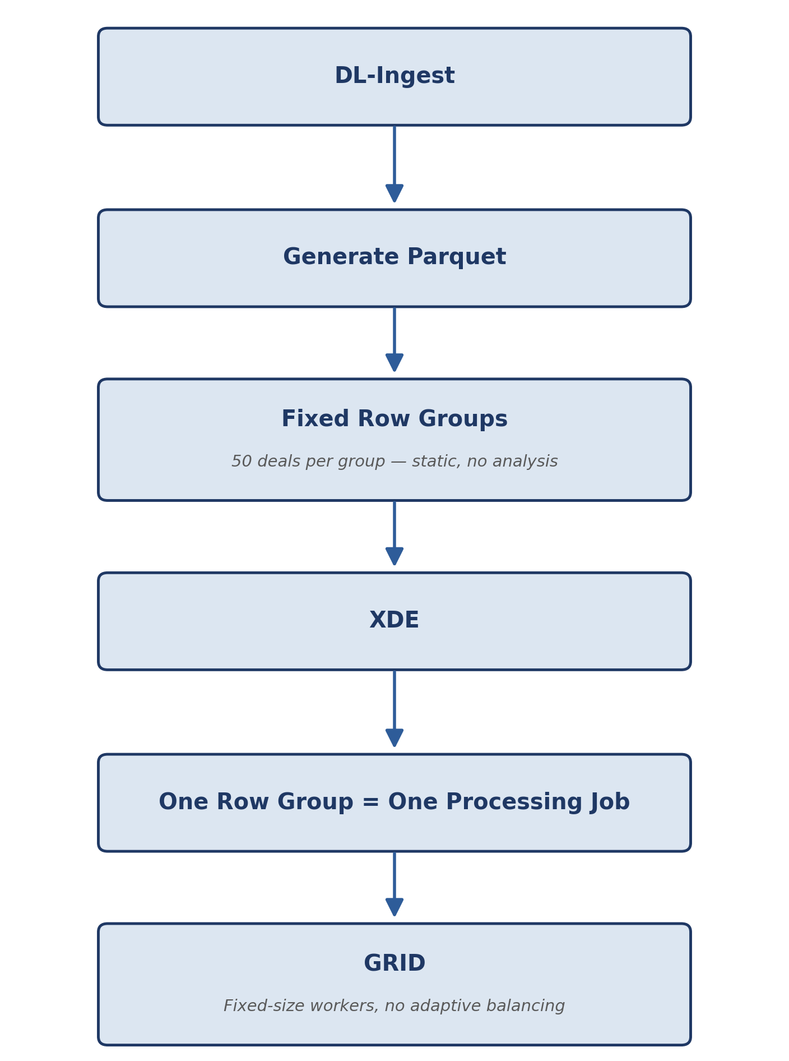
Figure 1 — Current fixed-size Row Group pipeline.
The current decision is a single static parameter:
Row Group Size = 50
This value is static and applied uniformly. No workload analysis is performed prior to partitioning, and the same rule governs every Book regardless of its size or processing profile.

3. Current Problems

3.1 Unbalanced Workloads
Consider a Book with 120 deals. The current fixed-size distribution produces three Jobs of uneven duration:
Job | Deals | Approx. Duration
Job 1 | 50 | 10 min
Job 2 | 50 | 10 min
Job 3 | 20 | 4 min
The shortest Job finishes in 4 minutes while the two largest Jobs run for 10 minutes each. The worker assigned to Job 3 becomes idle well before the other two Jobs complete, wasting available compute capacity for the remainder of the run.

3.2 Poor Parallelism
Consider a Book with 80 deals. The current fixed-size rule produces only two Jobs:
Job | Deals
Job 1 | 50
Job 2 | 30
Even when GRID has 64 Pods available, only two workers perform useful work for that Book — the remaining 62 Pods sit idle for the duration of the run.

3.3 Timeout Risk
Larger Row Groups require more execution time. Because the timeout is static rather than proportional to workload size, this creates a compounding reliability problem:
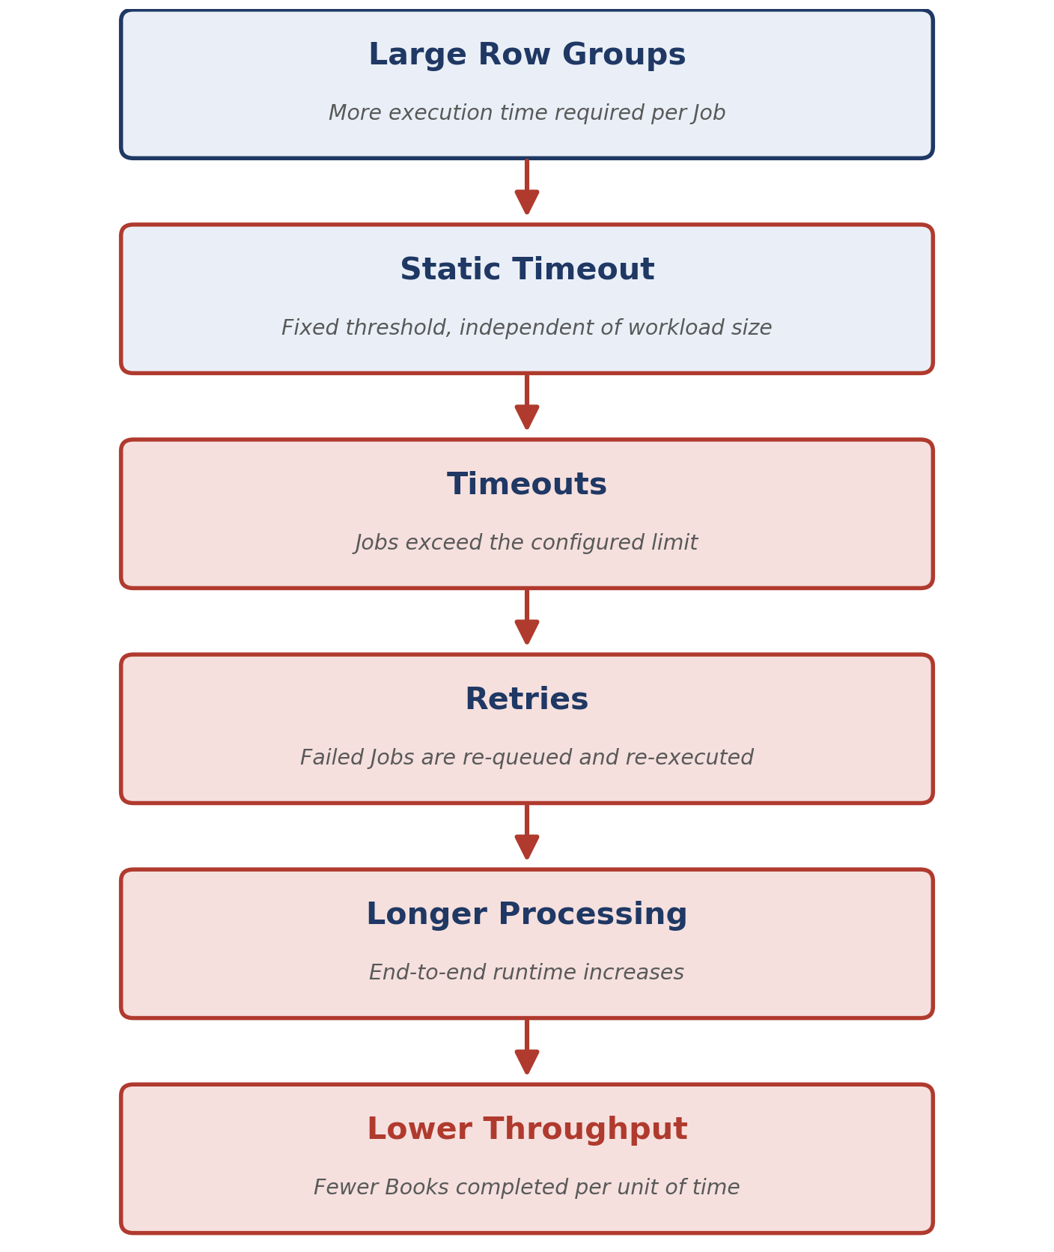
Figure 2 — How a fixed timeout compounds into lower throughput.

4. Design Principles
The proposal is grounded in four design principles.

Principle 1 — Storage and execution are different concerns
Parquet Row Groups optimize for compression, streaming, and I/O. Jobs optimize for parallelism, throughput, and load balancing. A storage decision should not dictate the execution strategy.

Principle 2 — Every Job should represent roughly equal work
The goal is a distribution such as 40 / 40 / 40 rather than 50 / 50 / 20, so that no single worker becomes a bottleneck and no worker sits idle while others are still processing.

Principle 3 — Partitioning must adapt to workload characteristics
Different workload types call for different partitioning goals:
Workload Type | Optimization Goal
Online Request | Minimize latency
Stress Testing | Maximize concurrency
Batch Processing | Maximize throughput
Backtesting | Maximize cluster utilization

Principle 4 — Historical metrics should inform future partitioning
The platform should continuously improve based on observed execution times, refining its partitioning decisions as more execution history becomes available.

5. Proposed Architecture
The proposed architecture introduces an Adaptive Partition Planner that consumes business metadata, historical execution metrics from XENA, and live capacity signals from GRID before any Parquet file is generated.
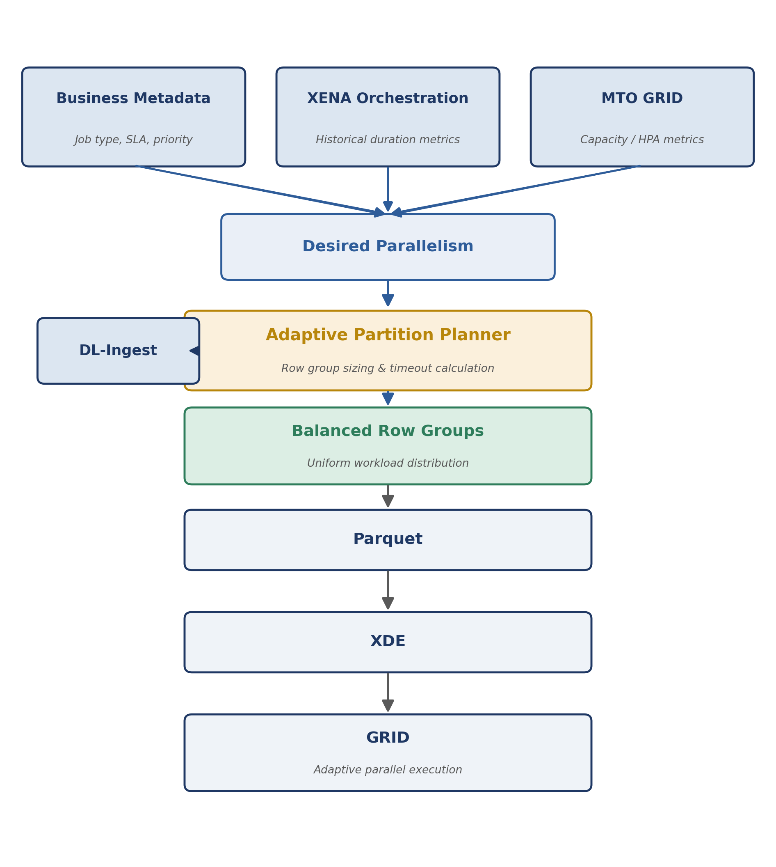
Figure 3 — Proposed adaptive partitioning architecture.

6. Desired Parallelism
Instead of a hardcoded constant such as Parallelism = 32, the platform derives desired parallelism as a function of several inputs:
DesiredParallelism = f(
JobType,
EstimatedDuration,
NumberOfDeals,
EnvironmentCapacity,
SLA
)
Input | Description | Example
JobType | The category of execution being requested | Online, Batch, Stress Test, Backtesting
EstimatedDuration | Obtained from XENA historical metrics | 18 sec/deal (Book_001 average)
EnvironmentCapacity | Provided by GRID | DEV: 4 Pods · QA: 16 Pods · UAT: 32 Pods · PROD: up to 300 Pods
SLA | Business latency objective | e.g., complete within 15 minutes

7. Proposed Formula
The planner first computes the desired parallelism, then derives the number of Row Groups, bounded by a configurable minimum Job size:
DesiredParallelism = f(
JobType,
EstimatedDuration,
AvailableCapacity,
SLA
)

RowGroups = max(
1,
min(
DesiredParallelism,
NumberOfDeals / MinimumDealsPerJob
)
)
Deals are then distributed uniformly across the resulting Row Groups. For a Book of 120 deals with a desired parallelism of 8, this produces:
Approach | Distribution | Balance
Current (fixed) | 50 / 50 / 20 | Unbalanced — 3 Jobs
Proposed (adaptive) | 15 / 15 / 15 / 15 / 15 / 15 / 15 / 15 | Balanced — 8 Jobs

8. Historical Metrics
XENA already owns execution metrics that can be reused directly for duration estimation. For example, Book_001 has an observed average of 18 seconds per deal:
Book: Book_001
Average duration: 18 sec/deal
Estimated duration: 120 deals x 18 sec = 36 minutes
With this estimate available before execution begins, the planner can determine the number of Jobs required, an appropriate timeout, and the expected completion time — all ahead of runtime rather than after the fact.

9. Dynamic Timeout
Timeout thresholds should scale with the estimated workload rather than remaining fixed:
Timeout = BaseTimeout + EstimatedDuration + SafetyMargin
Job Size | Effect on Timeout
Large Jobs | Longer timeout, proportional to estimated duration
Small Jobs | Smaller timeout, reducing false-positive failure detection delay

10. Responsibilities
Component | Responsibilities
Data Provisioning | Building Parquet files; applying the partition plan; generating balanced Row Groups
XENA | Historical execution metrics; duration prediction; SLA policies; recommended desired parallelism and timeout
GRID | Environment capacity; HPA configuration; provisioning limits; infrastructure scalability

11. Expected Benefits

Technical
- Better load balancing across Jobs
- Higher cluster utilization
- Fewer timeout failures
- Reduced retries
- Better scalability
- Improved throughput

Business
- Lower processing latency
- More predictable execution
- Better use of cloud resources
- Easier capacity planning

Operational
- Fewer production incidents
- Simpler troubleshooting
- Better observability

12. Future Evolution
This proposal also enables an adaptive scheduling model. Future versions could automatically learn:
- Average execution time per Deal type
- Average execution time per Library
- Average execution time per Purpose
- Average execution time per Product
- Historical timeout probability
With this data, the planner could predict the optimal partitioning strategy automatically, without manual tuning.

13. Conclusion
The current fixed Row Group strategy is simple but does not adapt to workload characteristics or available compute capacity. This proposal introduces an adaptive partitioning strategy that treats Row Groups as an execution planning decision rather than a fixed storage parameter.
By combining business context (Job type and SLA), operational intelligence (historical execution metrics from XENA), and infrastructure capacity (GRID provisioning and HPA), the platform can generate balanced Row Groups that improve parallelism, reduce timeout risk, and increase overall cluster utilization — while preserving the storage and streaming benefits of the Parquet format.

