COLLEGE OF COMPUTER STUDIES AND MULTIMEDIA ARTS
IT0049
(WEB SYSTEM TECHNOLOGIES)
TECHNICAL SUMMATIVE ASSESSMENT
2
TASKS FOR TODAY MANAGEMENT SYSTEM: FULL CRUD AND AUTHENTICATION
Student Name / Group Name: | Angel Clarise C. Tolentino
Members (if Group): | Individual activity
Section: | TW32
Professor: | Prof. Von Erick Magbitang

PROGRAM OUTCOME/S (PO) ADDRESSED BY THE LABORATORY EXERCISE
- Design, implement and evaluate computer-based systems or applications to meet desired needs and requirements. [PO: C]
COURSE LEARNING OUTCOME/S (CLO) ADDRESSED BY THE LABORATORY EXERCISE
- Apply advanced web development principles in creating, debugging, validating, and securing database-backed web applications. [CLO: 2]
- Design program flow and application structure for computing problems using CodeIgniter and Laravel frameworks. [CLO: 3]
INTENDED LEARNING OUTCOME/S (ILO) OF THE LABORATORY EXERCISE
At the end of this exercise, students must be able to:
- Extend an existing data-backed application with validated create, update, and delete workflows.
- Protect management actions behind authentication while keeping read-only pages public.
- Apply soft deletion instead of permanently removing records.
BACKGROUND INFORMATION
This assessment brings the Tasks for Today Management System from TSA1 up to the same standard as the POS application: validated forms, complete CRUD, and authentication. Permanently deleting records is generally discouraged in production systems, so this activity uses soft deletion — marking a record as archived instead of removing the row — which is the same practice discussed for the POS application in Module 3.
GRADING SYSTEM / RUBRIC
CRITERIA | Description
Functionality & Requirements Completeness (35 points max) | All required pages, records, and workflows are present and behave as specified in the activity instructions.
Code Structure & Organization (20 points max) | The application follows the framework's MVC conventions with a clear, consistent separation of concerns across controllers, models, and views.
Validation & Security (25 points max) | Forms validate required fields and reject bad input, passwords are hashed and verified correctly, and management actions are reliably restricted to logged-in users.
Documentation & Submission Quality (20 points max) | The GitHub repository is organized and complete, the README explains how to set up and run the project, and the hosted link is live and matches the submitted code.

LABORATORY ACTIVITY
Extend the Tasks for Today Management System from TSA1 with full CRUD for tasks and an authentication requirement for managing them.
1. Add a password column to the users table and set a hashed password for the demo user.
2. Build a login page and a logout action. The Welcome, Task List, Profile, and About pages remain viewable by anyone, but creating, editing, or deleting a task requires being logged in.
3. Add a New Task form (/tasks/new) that validates required fields (title required, task_date required).
4. Add an edit/update page for existing tasks.
5. Add an is_archived column to the tasks table (default false). Implement a "delete" action that sets this flag instead of removing the row, and exclude archived tasks from the Welcome and Task List pages.
6. Test your access control the same way as in TFA4: confirm protected actions redirect to login when logged out, and work normally when logged in.
Submission Requirements:
- A link to a GitHub repository containing your raw project files, including your database export or migration and seeder files.
- A link to your hosted, working version of the application.
REFERENCES
- CodeIgniter User Guide. Validation. https://codeigniter4.github.io/userguide/libraries/validation.html
- CodeIgniter User Guide. Controller Filters. https://codeigniter4.github.io/userguide/incoming/filters.html

SYSTEM IMPLEMENTATION AND DOCUMENTATION
This report documents the completed Tasks for Today Management System. The CodeIgniter 4 project implements public task viewing, authenticated full CRUD operations, validation, session-based login, CSRF protection, and soft deletion. The screenshots provide direct evidence of the database, protected workflows, and the existing GitHub repository used for submission.
A. DATABASE IMPLEMENTATION
The project uses the tasks_today_tsa2 MySQL database. The migrations and SQL export create the users and tasks tables, while the seeder adds the demonstration administrator account and sample task data.
Table | Key fields | Purpose
users | id, username, password, full_name, email | Stores the login identity and one-way password hash.
tasks | id, title, description, status, task_date, is_archived | Stores task records and the soft-delete state.

Database Rules
Requirement | Implementation | Status
Password security | password_hash() output is stored and password_verify() checks login. | Passed
Task validation | Title and a valid task date are required before create or update. | Passed
Soft deletion | Archive sets is_archived to 1; records remain in MySQL. | Passed
Public filtering | Archived tasks are excluded from Welcome and Task List queries. | Passed

A. DATABASE EVIDENCE
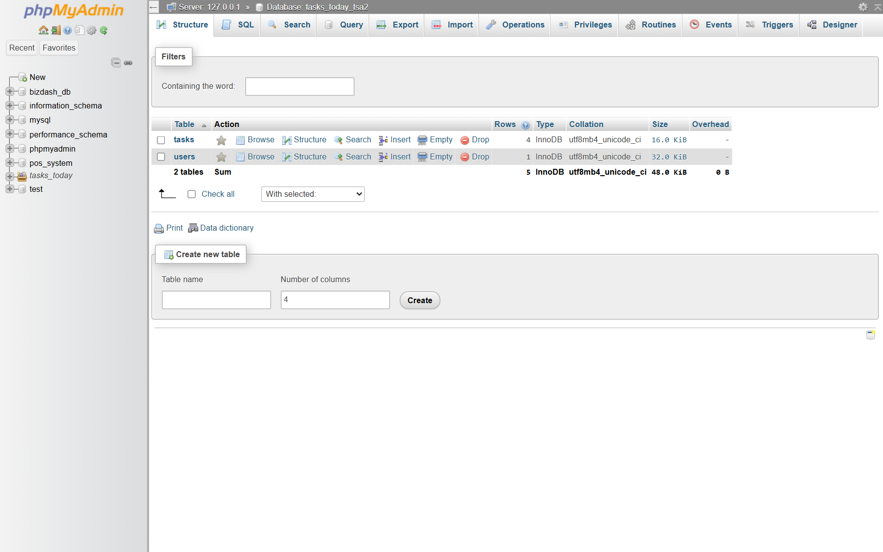
Figure 1. tasks_today_tsa2 database containing users and tasks tables.
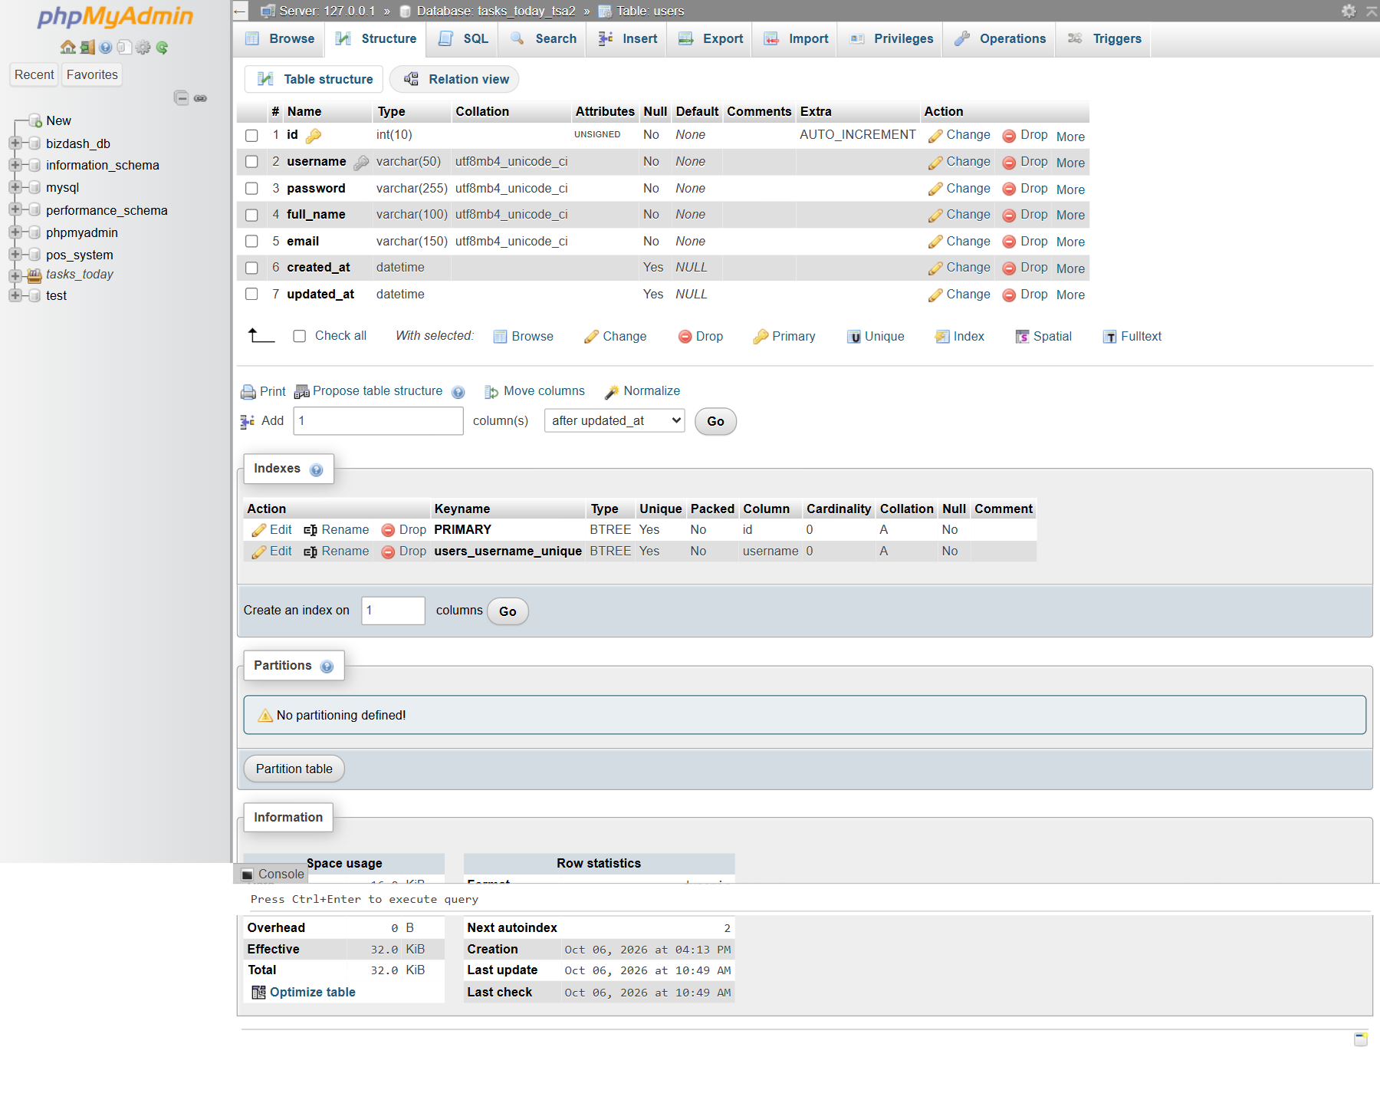
Figure 2. Users table structure including the password hash field.
A. DATABASE EVIDENCE
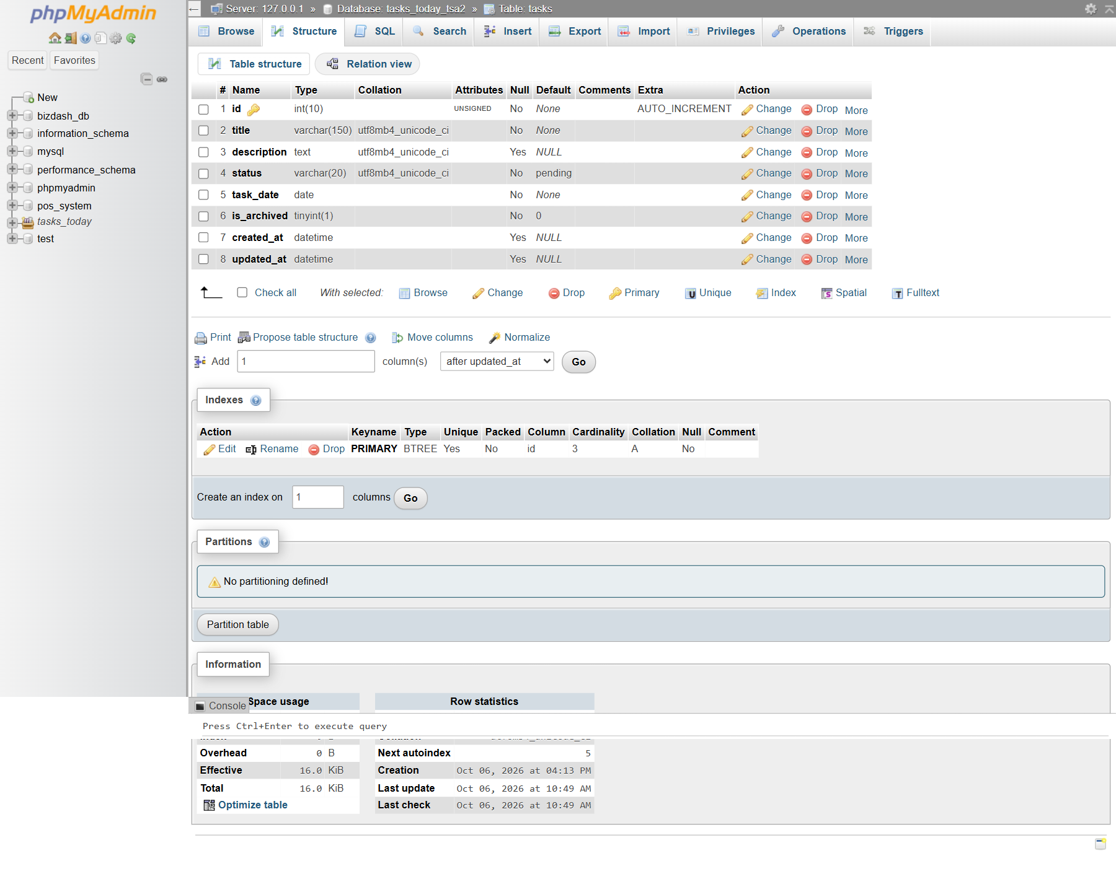
Figure 3. Tasks table structure including task_date and is_archived.
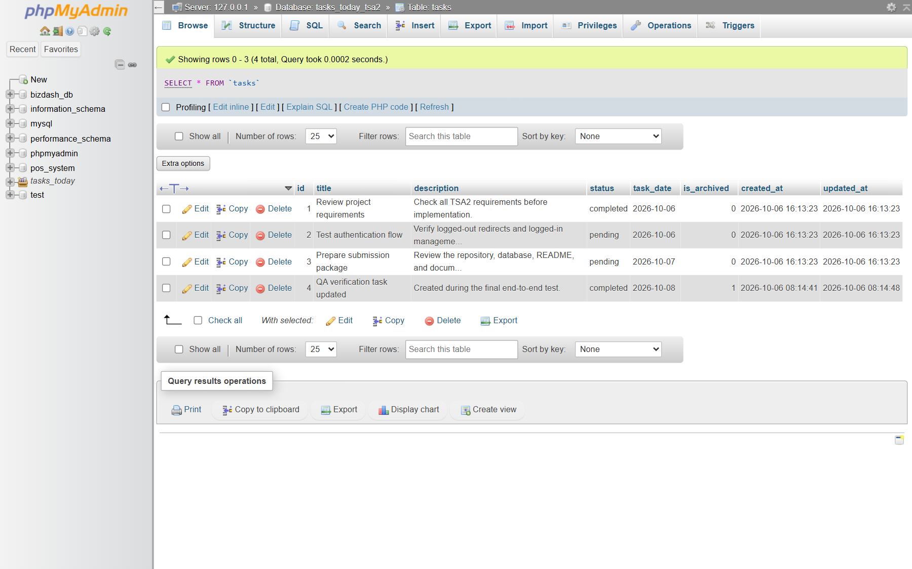
Figure 4. Task records retained in the database, including an archived QA record.

B. PROJECT STRUCTURE AND VERIFICATION
Component | Responsibility
app/Controllers/Login.php | Validates credentials, verifies the password hash, and manages the session.
app/Controllers/Tasks.php | Handles task list, create, edit, update, and archive workflows.
app/Filters/AuthFilter.php | Redirects logged-out users away from protected management routes.
app/Models/TaskModel.php | Defines allowed task fields and filters active records.
app/Config/Routes.php | Keeps reading routes public and applies auth to management routes.
app/Views | Provides the login, task list, form, profile, about, and dashboard pages.
database/tasks_today_tsa2.sql | Provides a ready-to-import database schema and demonstration data.

Functional Test Results
Test | Expected behavior | Result
Open /tasks/new while logged out | Redirect to /login | Passed
Submit invalid credentials | Show a login error without starting a session | Passed
Submit valid credentials | Regenerate session and open the authenticated task list | Passed
Create with missing required data | Show validation errors and retain submitted values | Passed
Create, edit, and update a valid task | Persist changes and show them in the active list | Passed
Archive a task | Retain row with is_archived = 1 and hide it publicly | Passed
Submit state-changing forms | Require valid CSRF tokens | Passed

C. SYSTEM PAGES AND TEST EVIDENCE
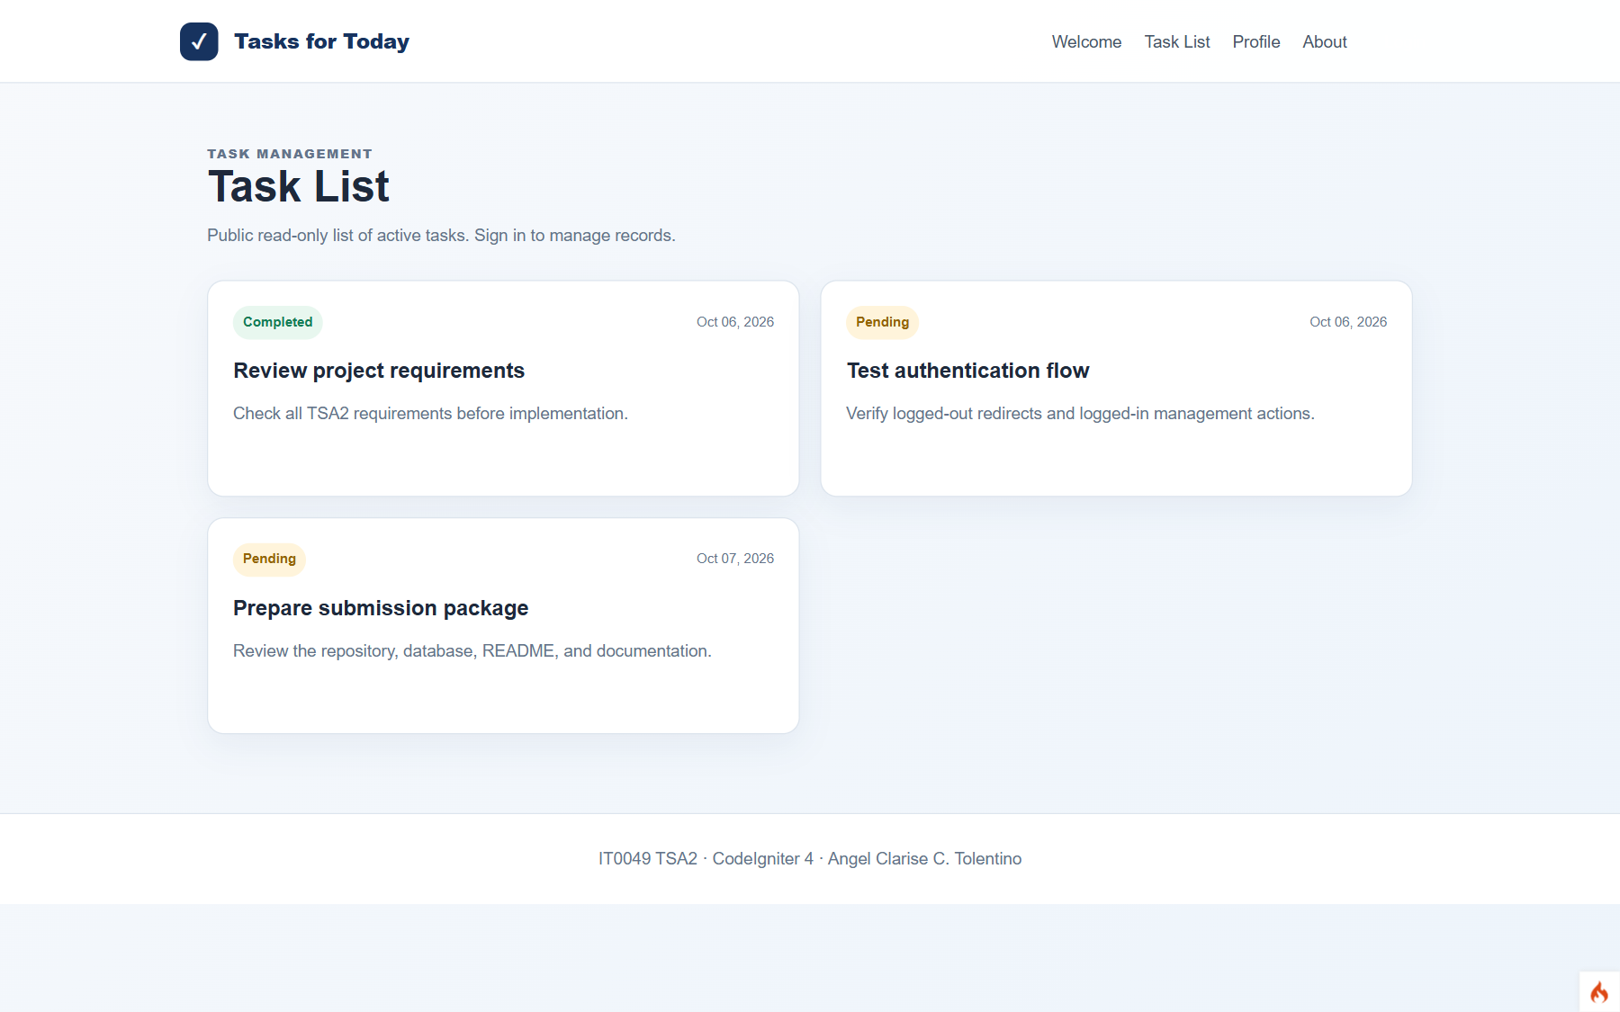
Figure 5. Public Task List shows active tasks without a login.
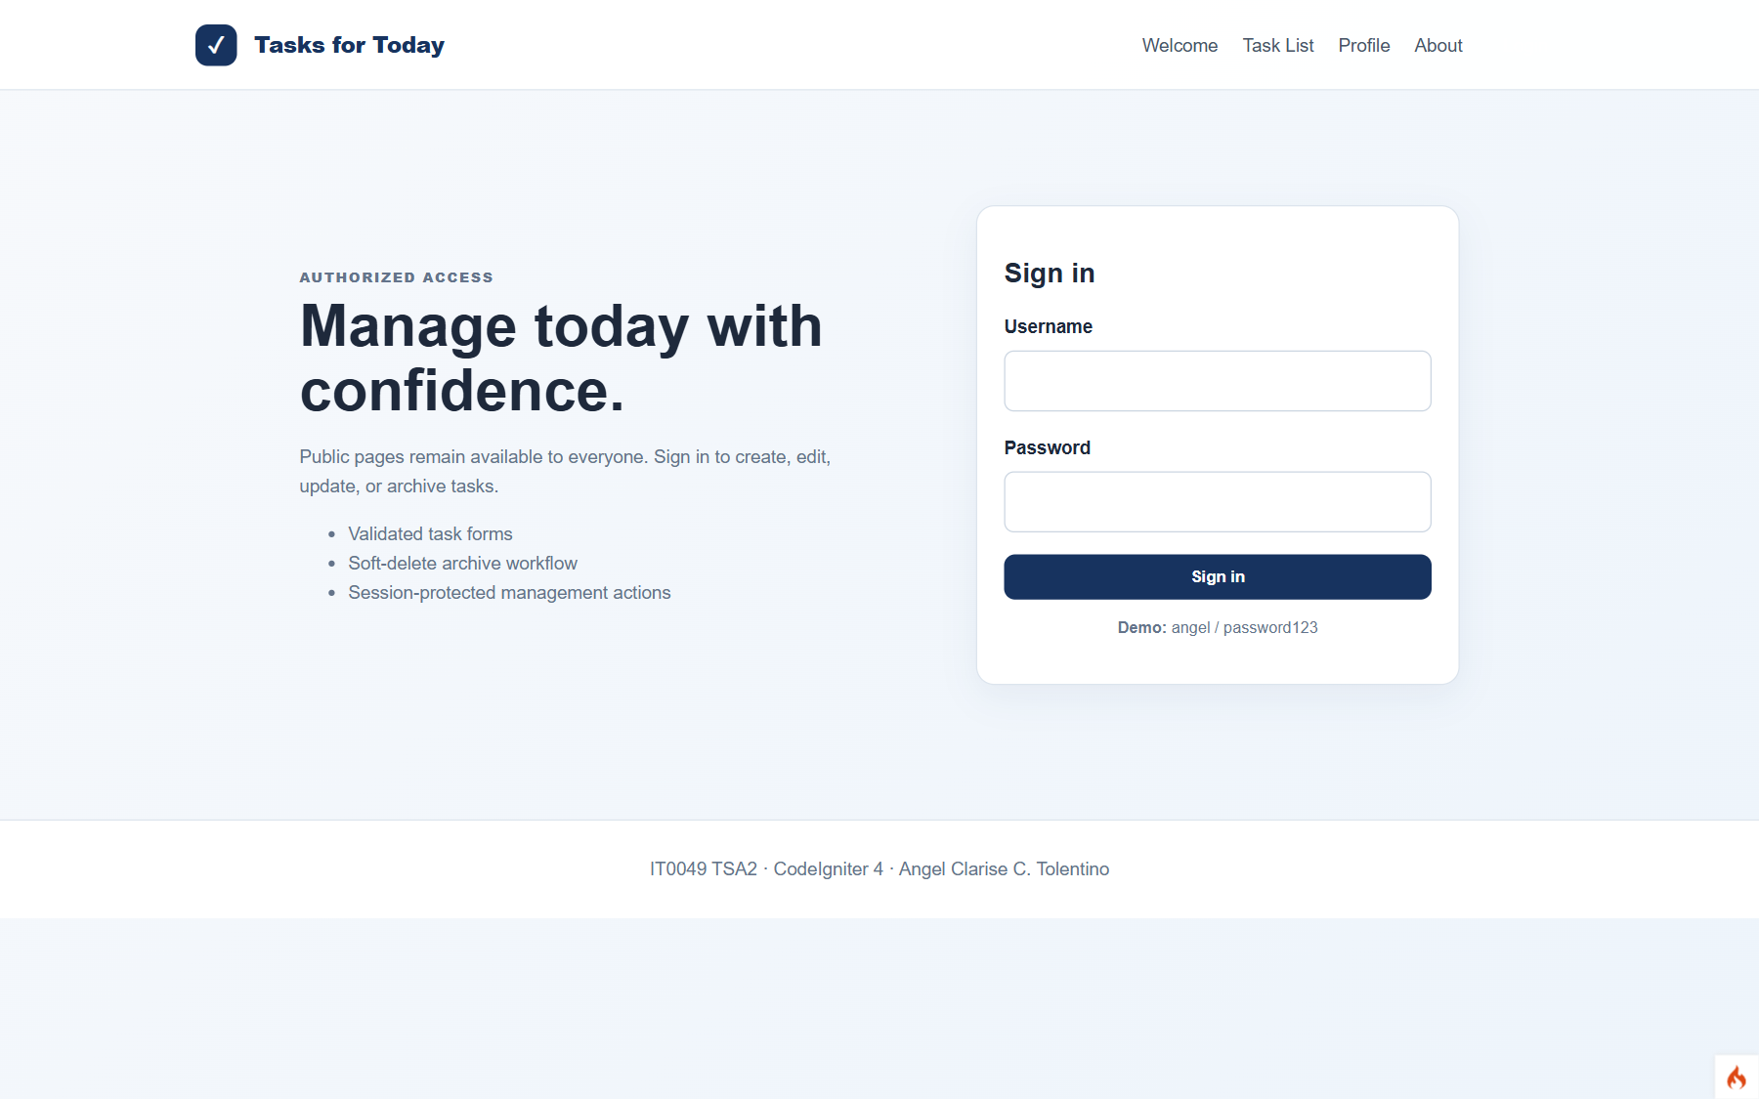
Figure 6. The protected new-task route redirects a logged-out user to Login.
C. SYSTEM PAGES AND TEST EVIDENCE
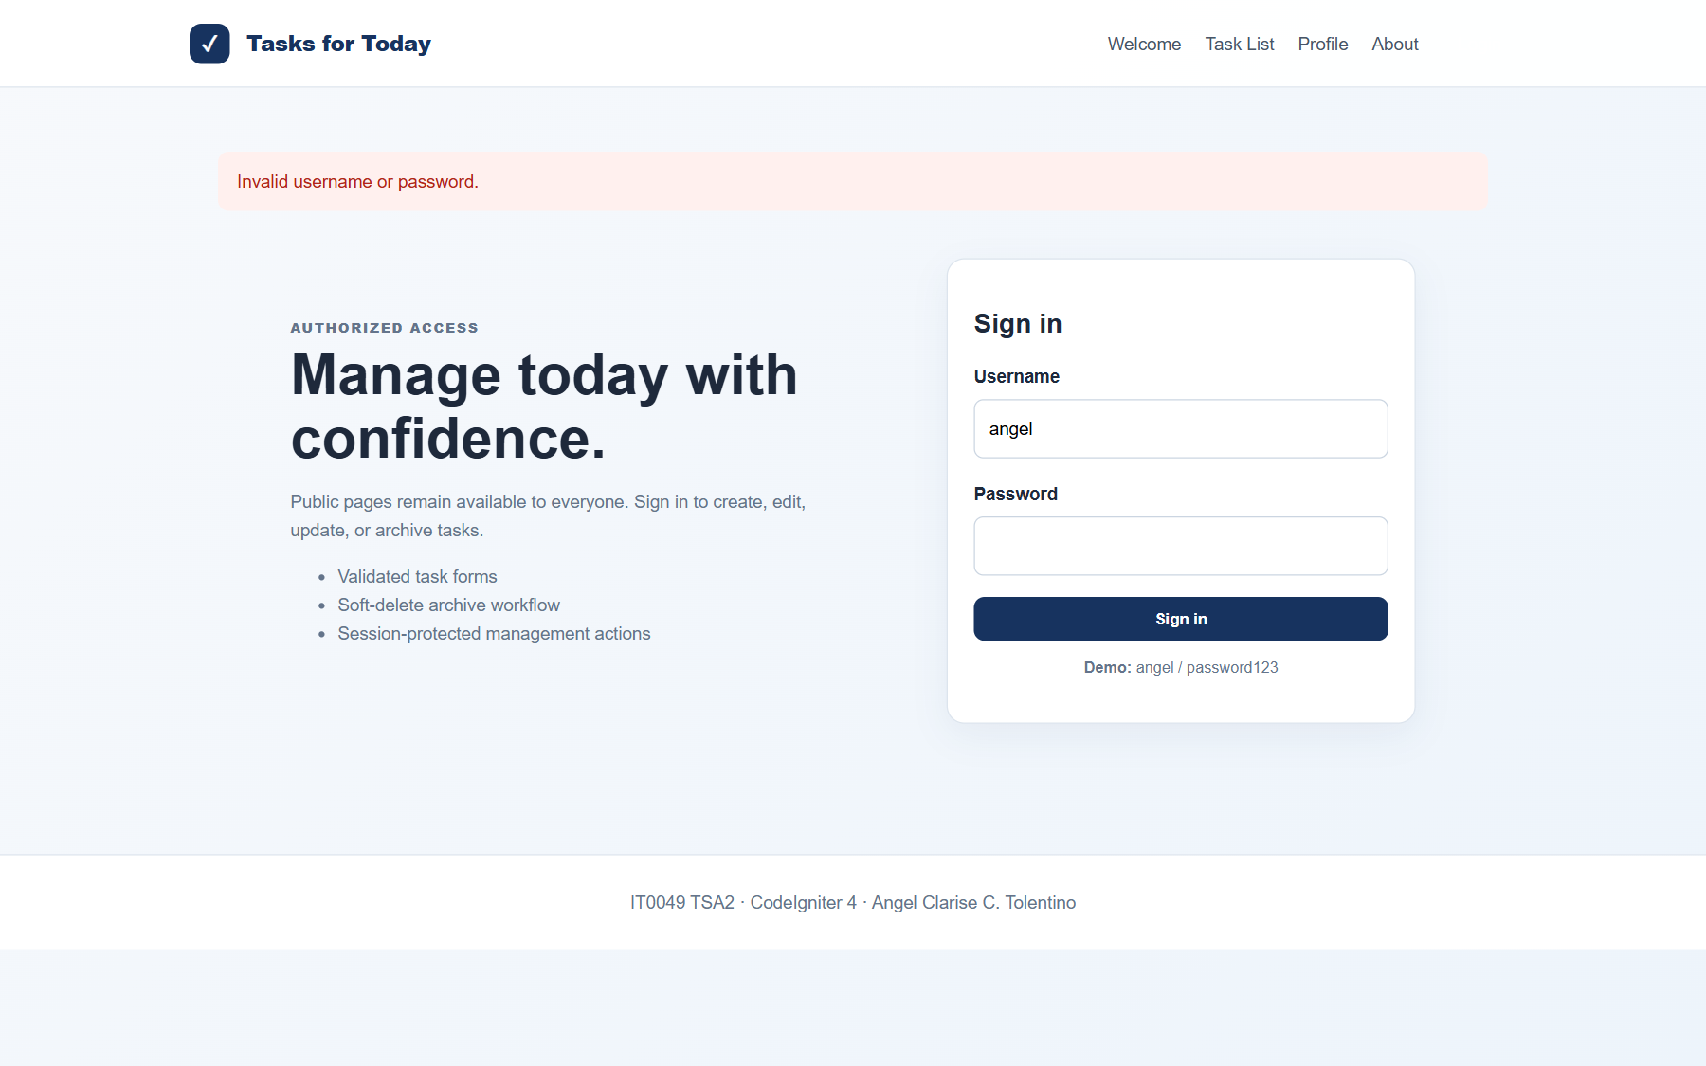
Figure 7. Invalid credentials display an authentication error.
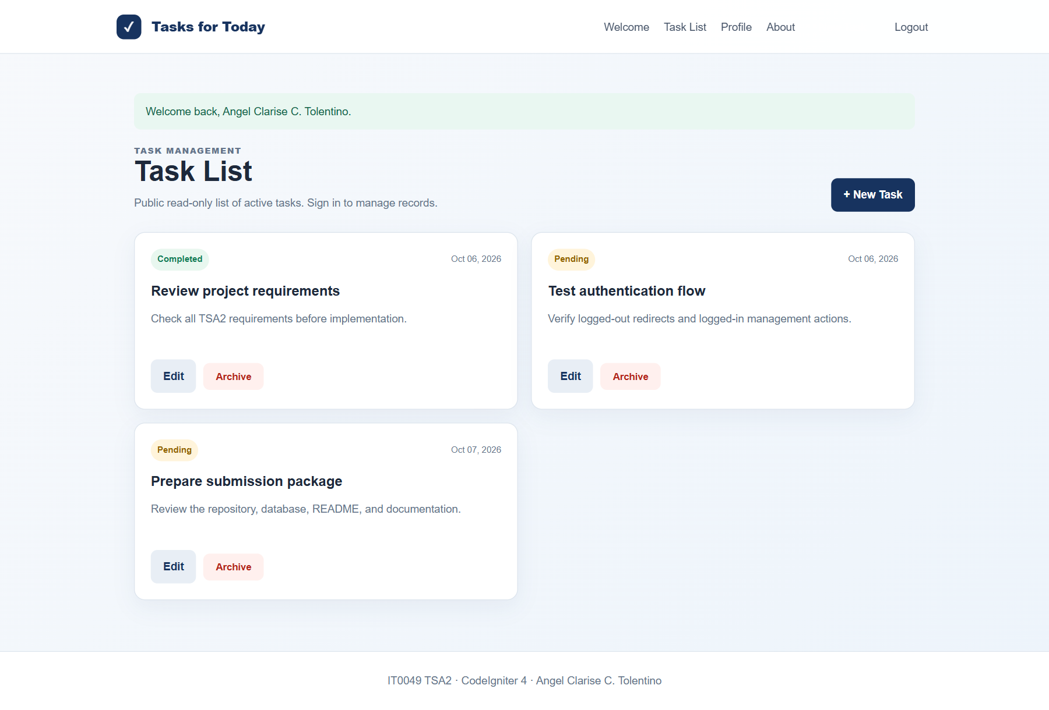
Figure 8. Authenticated task list with create, edit, and archive controls.
C. SYSTEM PAGES AND TEST EVIDENCE
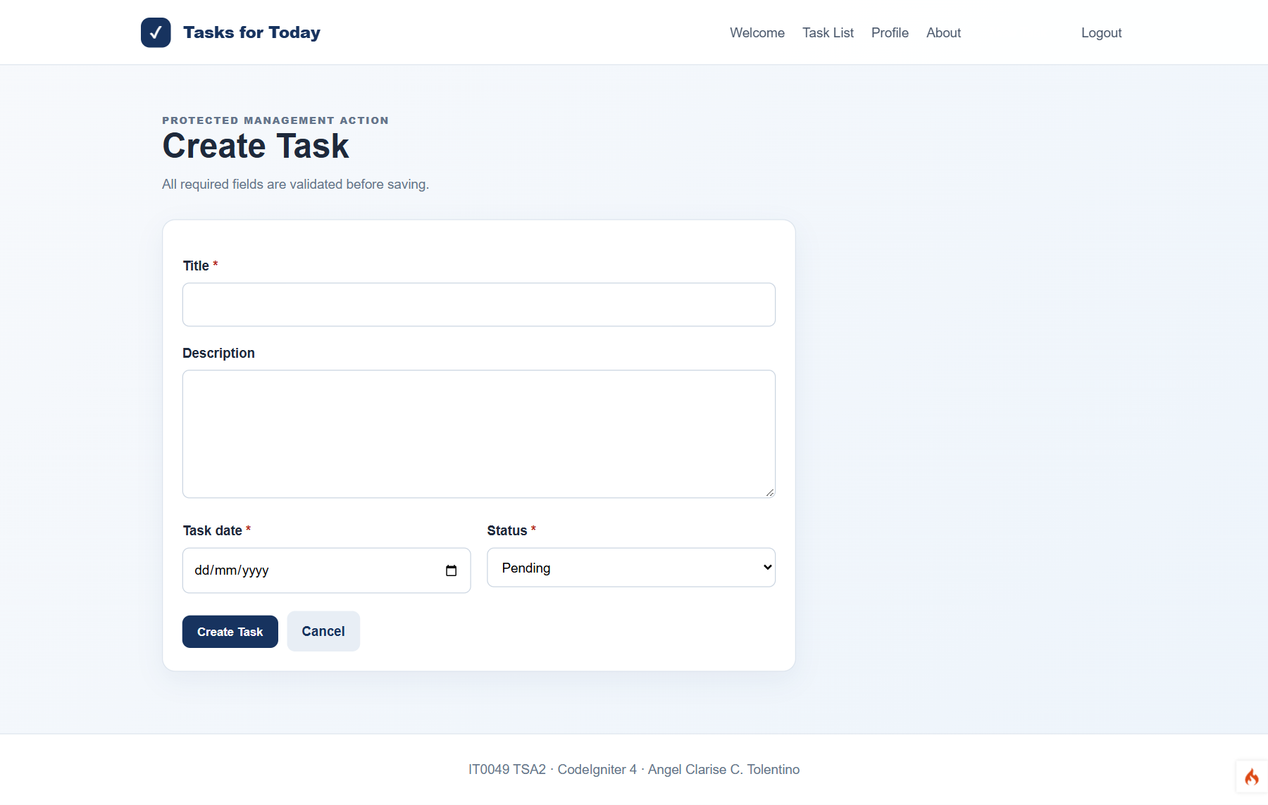
Figure 9. New Task form for authenticated users.
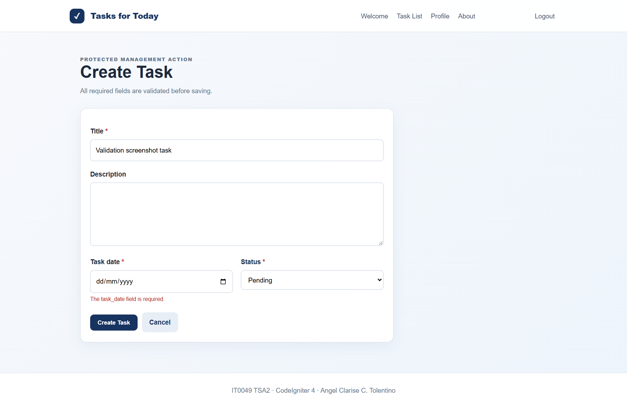
Figure 10. Server-side validation of the required task date.
C. SYSTEM PAGES AND TEST EVIDENCE
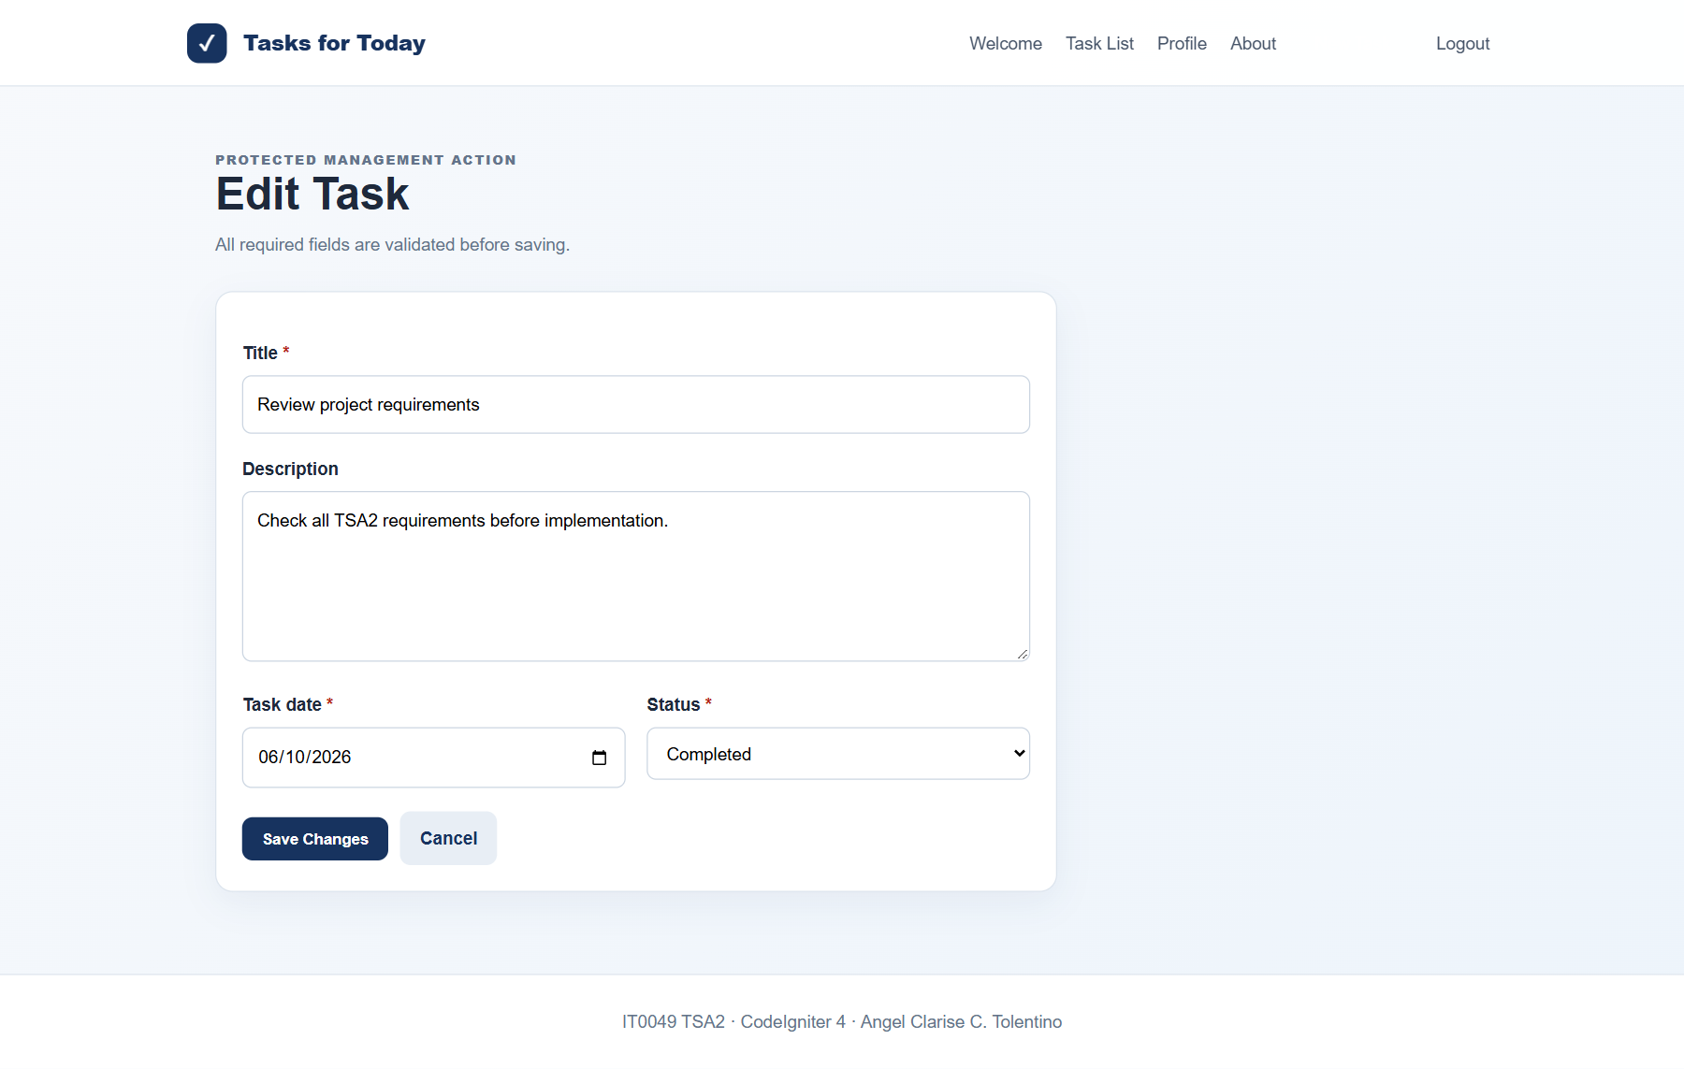
Figure 11. Edit Task form populated with the selected record.

D. GITHUB SUBMISSION
Repository link: https://github.com/angelc-byte/pos-system-tfa4
The same course repository shown in the previous activity was continued, as instructed. No new repository was created. Commit 3329ec5 adds the completed TSA2 full CRUD and authentication implementation to the main branch.
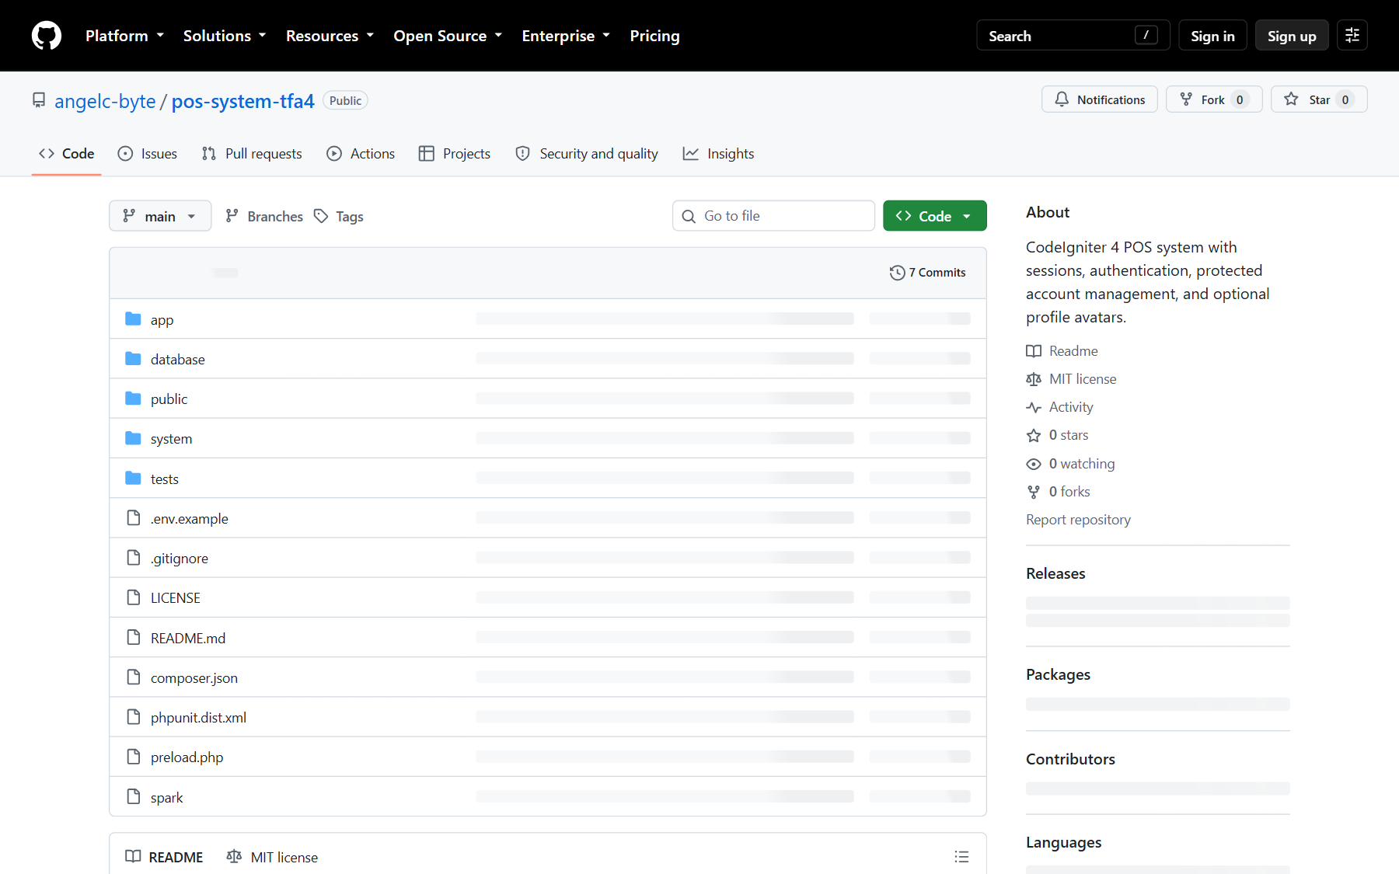
Figure 12. Existing course GitHub repository with the completed TSA2 commit.
Demonstration Credentials
Item | Value
Login URL | http://localhost/tasks-today-tsa2/public/login
Username | angel
Password | password123
Role | Administrator demonstration account

Local Setup
• Extract the project under C:\xampp\htdocs\tasks-today-tsa2.
• Copy .env.example to .env and confirm the MySQL settings.
• Import database/tasks_today_tsa2.sql in phpMyAdmin.
• Start Apache and MySQL, then open the local Login URL above.
Submission Package
The ZIP contains the CodeIgniter project, migrations, seeder, SQL export, README, and environment example. The documentation is supplied in editable DOCX and PDF formats. A hosted link is intentionally omitted because the instructor stated that deployment is not required.
CONCLUSION
The Tasks for Today Management System satisfies the required CodeIgniter authentication and CRUD outcomes. Public pages remain accessible, management actions require a verified session, task input is validated, archived rows are preserved and filtered, and the work is committed to the existing course repository. The included screenshots document the implemented behavior and database state needed for submission.

