
ST. JOHN PAUL II COLLEGE OF DAVAO
Data Structures and Algorithms
MINI-SYSTEM PROJECT

Implementation of ArrayList in a Student Score Management System
Researchers
[Full Names of Group Members]
Group Leader
[Full Name]
Instructor
[Instructor's Name]
Section
[Section Name/Code]
Date of Submission
[Month, Day, Year]

TABLE OF CONTENTS
Chapter I Introduction 2
1.1 Background of the Study 2
1.2 Objectives of the Study 2
1.3 Significance of the Study 2
Chapter II System Overview and Design 3
2.1 System Description 3
2.2 System Architecture and Flowchart 3
2.3 System Features 5

CHAPTER I INTRODUCTION

1.1 Background of the Study
Recording student scores requires a structure that can hold a changing number of records during a class session. A fixed-size arrangement would require a capacity decision before the number of entries is known. A Java ArrayList allows the system to append each accepted student record as it is submitted while preserving insertion order.
Each stored Student object contains a name, Assessment 1, Assessment 2, and Assessment 3. Duplicate names are allowed because different students may share the same name. The application calculates the arithmetic mean of the three scores and rounds the reported average to two decimal places in Java.
The prototype connects this data structure to a small web application. Java validates scores from 0 through 100, stores valid records in ArrayList<Student>, and traverses the list to determine the highest and lowest reported averages, including every tied name. Records remain in memory only and reset when the Java process restarts.

1.2 Objectives of the Study
The general objective of the project is to implement ArrayList in a working Student Score Management System and observe how the data structure supports record storage and report generation.
1. Store a flexible number of Student objects in a Java ArrayList while preserving their order of entry.
2. Accept a student name and three assessment scores, then reject blank, nonnumeric, or out-of-range values.
3. Calculate each student's arithmetic mean in Java and report it to two decimal places.
4. Traverse the stored records to identify all names tied for the highest or lowest reported average.
5. Present the returned records and summaries in a responsive browser interface and note improvements from the observed workflow.

1.3 Significance of the Study
Researchers. The project connects ArrayList operations with input validation, average calculation, and list traversal.
Data Structures and Algorithms students. Students can trace each record from form input to dynamic-list storage and report output.
Instructors. Instructors can demonstrate ArrayList storage, validation, and tie handling with a working web example.
Beginner programmers. Beginners can study a focused Java collection without persistent storage or extra record-management functions.

CHAPTER II SYSTEM OVERVIEW AND DESIGN

2.1 System Description
The Student Score Management System runs as one Spring Boot service. Spring Boot serves the HTML, CSS, and JavaScript interface and exposes REST endpoints for adding a student and retrieving the current report. A user enters a student name with Assessment 1, Assessment 2, and Assessment 3 through the browser form.
The browser performs required-field checks and sends the values to Java. Java applies the authoritative validation, creates a Student object, appends it to the in-memory ArrayList, calculates averages, and traverses the records for the highest and lowest results. The browser formats and displays the returned values but does not calculate averages or select the highest and lowest students.
The service returns student rows in insertion order together with the highest and lowest summaries. The collection is kept in memory, so the current records reset whenever the Java process restarts or the deployed service is redeployed.

2.2 System Architecture and Flowchart
The architecture keeps the browser responsible for data entry and presentation while Java owns validation, storage, average calculation, and high and low traversal. Figure 1 shows the implemented request and response flow, including the recoverable error path that retains the form values.
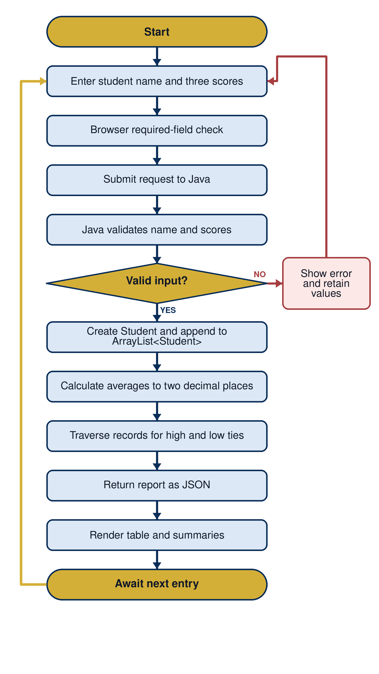
Figure 1 Student Score Management System Flowchart

Input. The input consists of the student's name and the three assessment scores entered in the browser. Each score must be numeric and fall from 0 through 100 inclusive.
Process. The browser checks required fields before submission. Java then validates the request, creates the Student object, appends it to ArrayList<Student>, calculates rounded averages, and traverses the list to collect all names tied for the highest and lowest values.
Output. The Java service returns JSON containing the student rows and the high and low summaries. JavaScript renders the formatted table and summaries, then leaves the interface ready for another entry.

2.3 System Features
1. Accepts a student name and exactly three assessment scores through a responsive browser form.
2. Validates required fields and scores from 0 through 100, while retaining entered values when submission fails.
3. Stores each accepted Student object in ArrayList<Student> in insertion order and allows duplicate student names.
4. Calculates the arithmetic mean of the three scores in Java and reports the average to two decimal places.
5. Traverses the stored records in Java to determine the highest and lowest reported averages.
6. Returns every student name tied for the highest or lowest average.
7. Displays the three scores, calculated average, and high and low summaries without reloading the page.
8. Handles an empty collection as a normal state and keeps accepted records in memory until the Java process restarts.

