**ASSIGNMENT 1,EOSC 410 (ANGELENE LEOW, 23162167)**

*Problem 1:*

1. Pearson correlation of x and y = 0.5800975391211216
2. Pearson correlation of x2 and y2 = 0.3397211855203799
3. Pearson correlation of x3 and y3 = -0.9010291351446986
4. Spearman correlation of x and y = 0.5724202626641651
5. Spearman correlation of x2 and y2 = 0.5724202626641651
6. Spearman correlation of x3 and y3 = 0.4318949343339587

Plot 1:

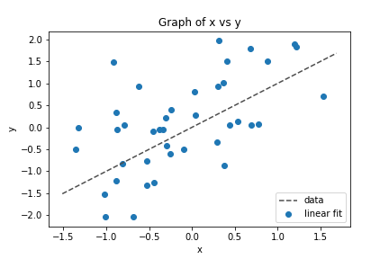

Plot 2:

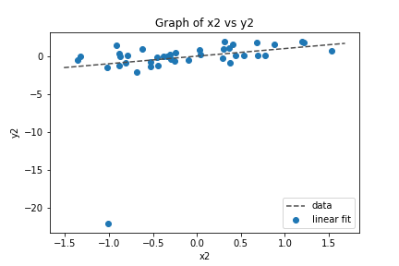

Plot 3:

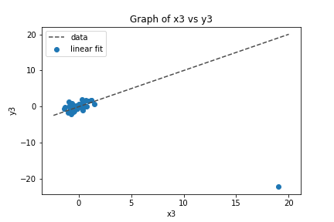

The outliers in plot 2 and plot 3 can be easily observed. Spearman correlation is more resistant to outliers than Pearson correlation. The Spearman coefficient of x and y is similar with x2 and y2 as the formula is biased against outliers. The 5th point (outlier) in plot 2 was at the lowest value in plot 1, hence there is no change in the ranking of the y data when the data point became an outlier in plot 2.

*Problem 2:*

***Using Multiple Linear Regresssion:***

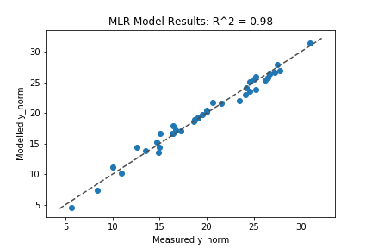

intercept = -820.3594995596047

coefficient of x1 = 84.0383574070665

coefficient of x2 = 0.39359447394793784

coefficient of x3 = -3.3446220660735007

coefficient of x4 = -6.690571786532005

coefficient of x5 = 0.18275533513346662

coefficient of x6 = 0.18275533513346662

***Using Stepwise:***

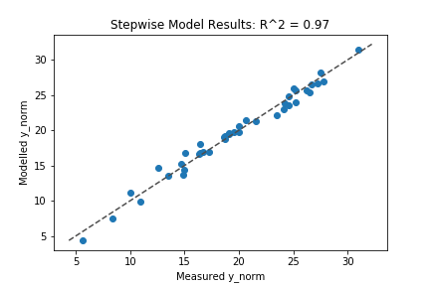

1. Add x6 with p-value 1.01879e-09
2. Add x4 with p-value 3.45675e-17
3. Add x3 with p-value 7.44399e-07
4. Add x1 with p-value 0.00532758

resulting features that are in:

['x6', 'x4', 'x3', 'x1']

features that are out:

[‘x2’,’x5’]

Stepwise coefficient results:

intercept = -796.5486994468267

coefficient of x1 = 0.040151625378134506

coefficient of x3 = -6.692578926452557

coefficient of x4 = -3.1517990772981745

coefficient of x6 = 81.66048798250597

***Results:***

*A stepwise regression only takes into account significant features whereas multiple linear regression (MLR) takes*

*all features/ predictors into account. Hence 4 predictors are chosen out of 6. For stepwise, the smaller p-value shows a higher significance. Therefore the 4 predictors in order of significance are x4, x6, x3 and x1.*

*The regression coefficients for both MLR and stepwise are different as stepwise only takes into account 4 predictors (x1,x3,x4,x6) whereas the coefficient of MLR is a result of all 6 predictors.*

By using a standardized predictor, where

$$x=\frac{mean\left(x\right)}{\sqrt{Var(x)}}$$

***Using Multiple Linear Regression:***

intercept = 19.722171524375096

coefficient of x1 = 0.4585615567584299

coefficient of x2 = 0.21761556761840684

coefficient of x3 = -2.1073752554131877

coefficient of x4 = -3.3863144555123483

coefficient of x5 = 0.11391349361394731

coefficient of x6 = 0.11391349361394731

***Using Stepwise:***

Add x6 with p-value 1.01879e-09

Add x4 with p-value 3.45675e-17

Add x3 with p-value 7.44399e-07

Add x1 with p-value 0.00532758

Resulting features:

['x6', 'x4', 'x3', 'x1']

features that are out:

[‘x2’,’x5’]

Stepwise coefficient results:

intercept = 19.722171524375096

coefficient of x1 = 2.8962539950672204

coefficient of x3 = -3.3873303338474217

coefficient of x4 = -1.985881589703753

coefficient of x6 = 0.44558653512856405

***Results:***

*After standardizing the x values , the sequence of order of significant predictors for the stepwise regression remains the same. However, the regression coefficients in MLR are higher which shows the increased importance of the predictors.*