README
- Production Environment
The following software is required.

- MATLAB/Simulink
- MATLAB/Simscape/Multibody

- Configuration
This folder has MATLAB/Simulink and Simscape/Multibody simulations about a double-inverted pendulum-type mobile robot. It is based on the experimental setup in Murakami Lab.

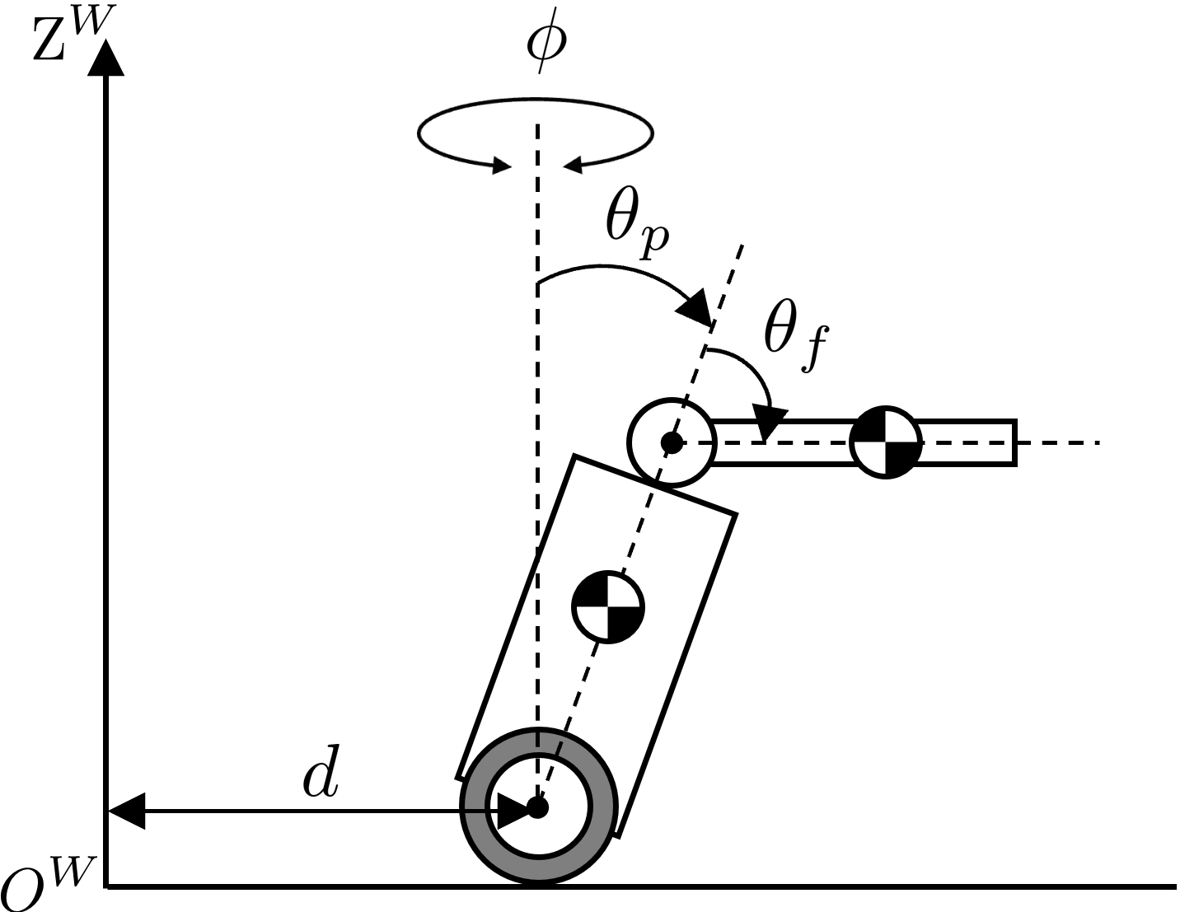
Fig. 1: Side view of the robot

The contents of the simulation folder are as follows.

Double_Inverted_Pendulum_Robot_ordinary_ver
-DIMR_main.m
-DIMR_ordinary.slx
-model
-model_params_without_errors.m
-model_params_with_errors.m
-model_params_env.m
-controller
-controller_init.m
-controller_PD_DOB.m

- How to use
When you simulate, you open “DIMR_main.m” and “DIMR_ordinary.slx” and run them. The controllers for the posture $θ_{p}$ stabilization, rotational angle $ϕ$ servo, and fork angle $θ_{f}$ servo have already been constructed. The position $d$ controller is NOT built.
The other files have variables for the robot’s model, the environment’s model, and the controller’s configurations (control period, gains, etc.). If you’d like to change the simulation’s parameters, you change them.

