Template for A Report of Independent Study
Student ID First A. Author, Supervisors First B. Author, First C. Author
Abstract— This is a report of Independent Study. Summarize your work in 1 page using this template. The submission deadline is January 15 (Thur) 23:59 pm, Japan Standard Time.

INTRODUCTIONry
Describe the background and objective of your work. Cite the related prior work [1].

Theory

A. Heading
Text
       
Note that the equation is centered using a center tab stop. Be sure that the symbols in your equation have been defined before or immediately following the equation. Use “(1)”, not “Eq. (1)” or “equation (1)”, except at the beginning of a sentence: “Equation (1) is . . .”

B. Heading
Text.

Table and Figure
- Table Type Styles
Table Head | Table Column Head
Table Head | Table column subhead | Subhead | Subhead
Copy | More table copyª
a. Sample of a Table footnote. (Table footnote)

We suggest that you use a text box to insert a graphic (which is ideally a 300 dpi TIFF or EPS file, with all fonts embedded) because, in an MSW document, this method is somewhat more stable than directly inserting a picture.
To have non-visible rules on your frame, use the MSWord “Format” pull-down menu, select Text Box > Colors and Lines to choose No Fill and No Line.
- Example of a figure caption. (figure caption)
Figure Labels: Use 8 point Times New Roman for Figure labels. Use words rather than symbols or abbreviations when writing Figure axis labels to avoid confusing the reader. As an example, write the quantity “Magnetization”, or “Magnetization, M”, not just “M”. If including units in the label, present them within parentheses. Do not label axes only with units. In the example, write “Magnetization (A/m)” or “Magnetization {A[m(1)]}”, not just “A/m”. Do not label axes with a ratio of quantities and units. For example, write “Temperature (K)”, not “Temperature/K.”

Conclusion
A conclusion might elaborate on the importance of the work or suggest applications and extensions.

References
- G. O. Young, “Synthetic structure of industrial plastics (Book style with paper title and editor),” in Plastics, 2nd ed. vol. 3, J. Peters, Ed. New York: McGraw-Hill, 1964, pp. 15–64.
- W.-K. Chen, Linear Networks and Systems (Book style). Belmont, CA: Wadsworth, 1993, pp. 123–135.
- Y. Yorozu, M. Hirano, K. Oka, and Y. Tagawa, “Electron spectroscopy studies on magneto-optical media and plastic substrate interfaces(Translation Journals style),” IEEE Transl. J. Magn.Jpn., vol. 2, Aug. 1987, pp. 740–741 [Dig. 9th Annu. Conf. Magnetics Japan, 1982, p. 301].
- S. Chen, B. Mulgrew, and P. M. Grant, “A clustering technique for digital communications channel equalization using radial basis function networks,” IEEE Trans. Neural Networks, vol. 4, pp. 570–578, July 1993.

- 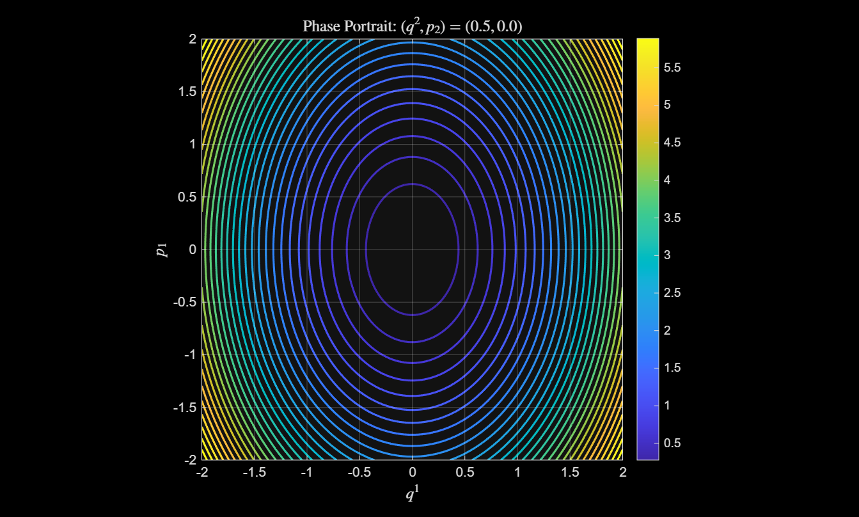

Fill up this page.

