University of Notre Dame
Department of Computer Science and Engineering

CSE 60745
Graph Learning: Techn & Apps

Assignment Date: | 09 / 18 / 2026
Sumission Date: | 09 / 18 / 2026
Student Name: | Angeles Marin- Batana

* This assignment contains 100 points. You are encouraged to finish independently. Any submitted work that it copied from any source or too similar to be an independent write-up will not be given credit. Please submit this homework (as a PDF or Word file including the cover page) to ND Canvas by 11:59pm on Monday, 09/14/2026.

Part A – Graph Creation and Modification (30 pts)

In this part, you will learn “Graph Creation and Modification”.
Note: You may use NetworkX, a python library for studying graphs and answering below questions. The NetworkX Tutorial can help you start working with NetworkX.

Q1: Graph Creation (15 pts)
Create the following undirected graph and show visualization of this graph. (Note: You may read NetworkX tutorial to facilitate your solutions.)

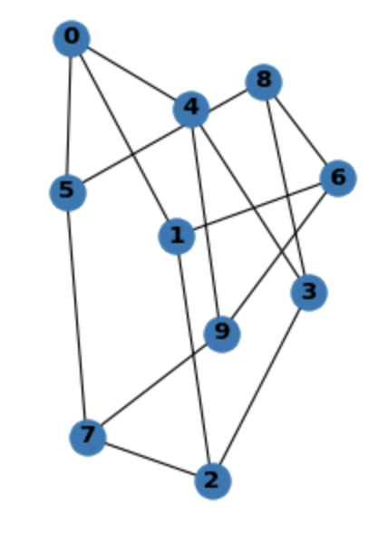
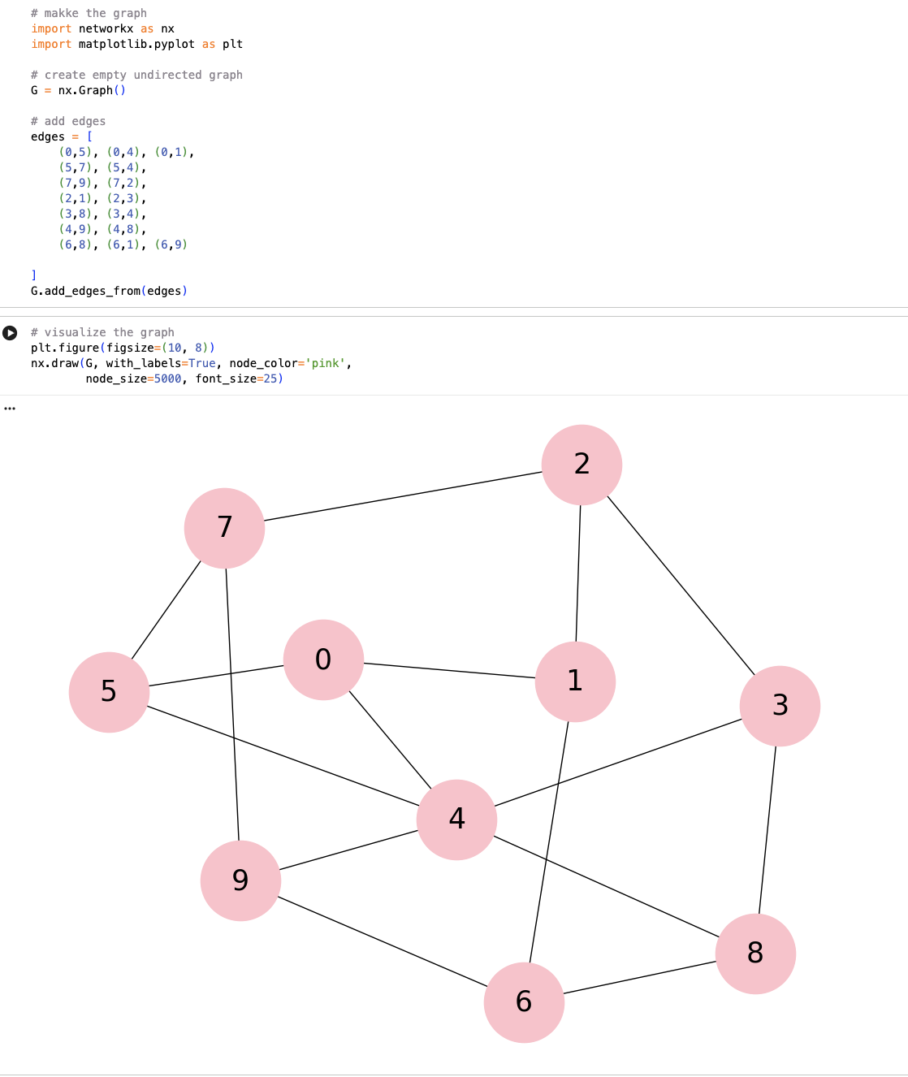

Q2: Graph Modification (15 pts)
Based on graph created in Q1, remove node 1, edge (0, 4) and edge (0, 5). List remaining components and visualize remaining graph. (Note: You may use NetworkX to facilitate your solutions.)

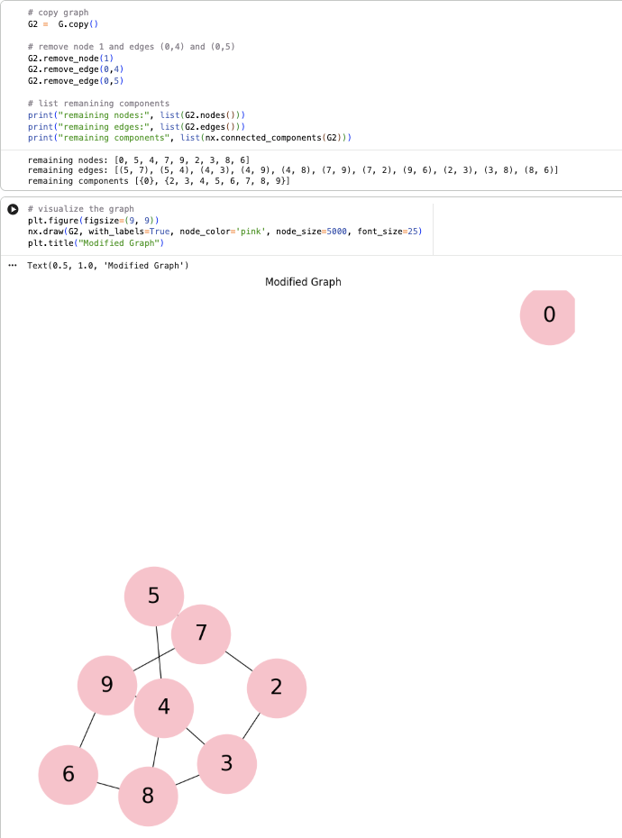

Part B – Graph Essentials and Measures (70 pts)

In this part, you will create a graph and compute related graph essentials and measures.
Note: You may use NetworkX, a python library for studying graphs and answering below questions.

Q3: Graph Creation (10 pts)
(Note: You may use NetworkX to facilitate your solutions.)
Create undirected graph using edge list file from graph.txt (attached in this assignment). Report node and edge numbers, number of connected components.
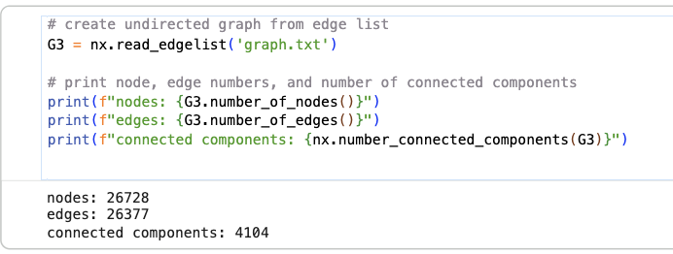

Q4: Graph Essentials (30 pts)
(Note: You may use NetworkX to facilitate your solutions.)
Based on the created graph in Q3, get the largest connected component, report node and edge number of this component (10 pts).
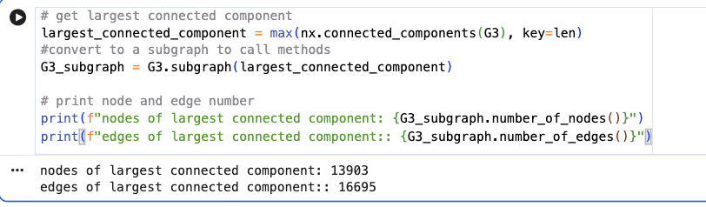
Show visualization of the second largest connected component (10 pts).
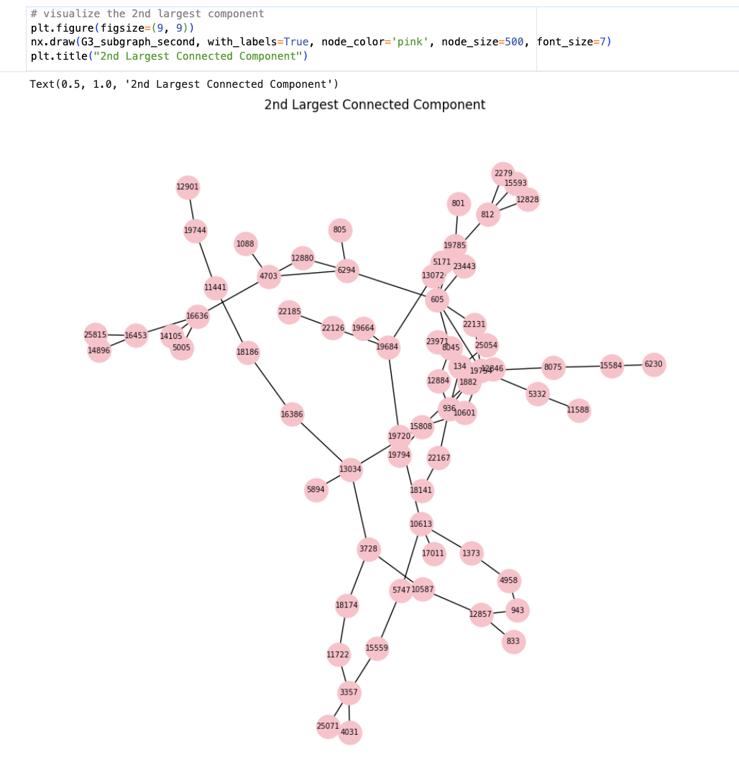
Plot degree distribution of the whole graph (10 pts).
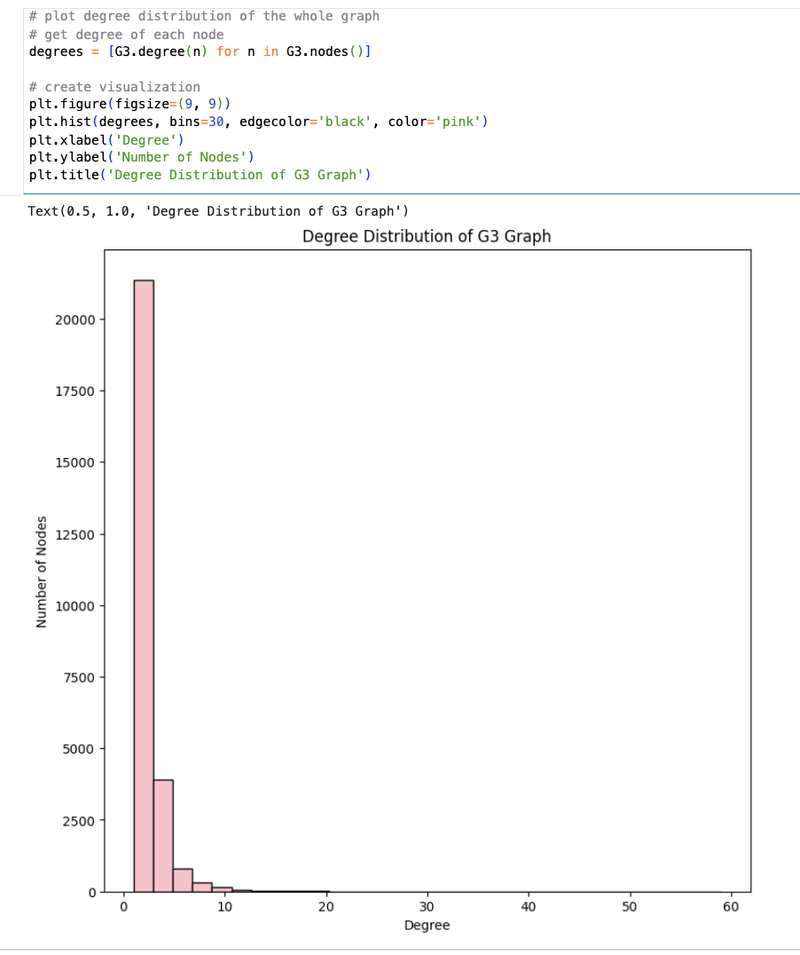

Q5: Graph Measures (30 pts)
(Note: You may use NetworkX to facilitate your solutions.)
Based on the created graph in Q3, generate eigenvector centrality, report top-10 nodes with largest eigenvector centrality (10 pts). (You can use default parameters in NetworkX)
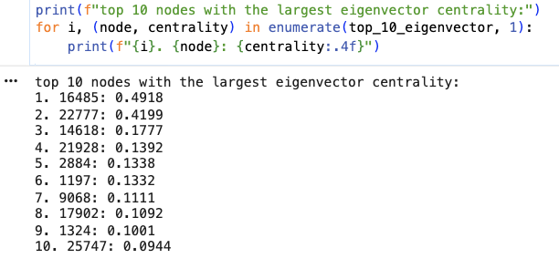
Generate katz centrality, report top-10 nodes with largest katz centrality (10 pts). (You can use default parameters in NetworkX)
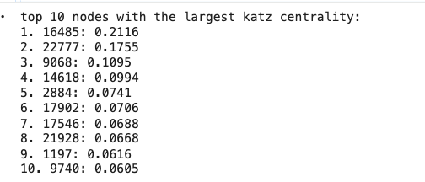
Report average clustering coefficient of all nodes in the graph, report average Jaccard similarity of all connected node pairs in the graph (10 pts).
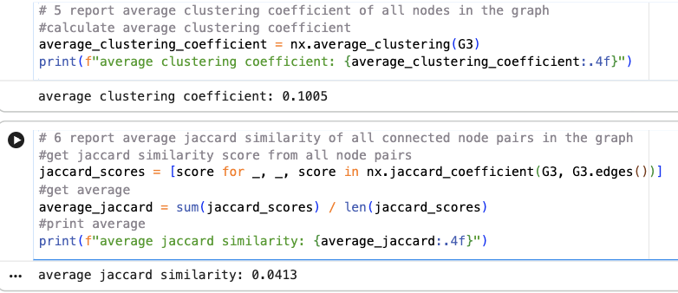

Github repo: link

