**“Mobile Applications Development”**

**course**

**a.y. 2014/2015**

**“Share A Ride”**

**Design**[1]**,**[2]

|  |  |  |
| --- | --- | --- |
| **Team Members**[3] |  | |
| **Name** | | **Student Number** |
| **Konstantinos Kallas** | | **241589** |
| **Danail Yankov** | | **241254** |
|  | |  |
|  | |  |
|  | |  |

Strategy

# Product Overview

The application ShareARide makes the organisation of shared travel very easy and accesible to everyone. The term “shared travel” means traveling by car with a stranger sharing the cost.

## Competitors

The main competitor of our application is CarPooling. It an app that offers most of the features that ShareARide offers, such as (rating system for safety, easy navigation and use). The main advantage of ShareARide is that it also allows organising of sharing daily rides (for example a ride everyday from home to university ). This feature will be very useful especially in big cities because it will help reduce the total amount of cars driving or rush hour leading to reduced CO2 emissions nad less traffic.

There are also two other competitor apps Lyft and Uber that offer a slightly different experience than ShareARide. The most important difference is that Lyft and Uber offer rides with dedicated drivers, whereas ShareARide offers rides with practically anybody who drives a car.

# User Research

The app is made to provide a way to organise cheap and fast transport for everyone. It will also give every driver the ability to meet new people and experiences while saving money. All of the above happen in a very safe environment because every driver and passenger has a unique registration in our database which allows for ratings and comments on its person.

## Persona

The target group is essentially every adult person, either studying or working. Although it will be mostly used by students who travel a lot and are already familiar with the ideas of hitch-hiking and carpooling. Nowadays more and more people start using alternative methods of traveliing(for example hitch-hiking) because that way they achieve deeper experiences during their travels and the also save money.

An example of a “persona” using the app would be an average university student who travels a lot on his free time alone , and likes meeting new people in his travels creating relationships and also learning the culturar characteristics of the places he goes.

Scope

**Features**

A list with the features the app provides:

* Choosing from different people to share a ride.
* A lot of easy ways to join a ride.
* Seeing the map, visualizing the route.
* To see the person and his rating with whom you are traveling.
* Chat with the people.
* Adding preferences to the ride/ travel.
* Easy to use, one click to achieve your goal.

**Scenarios**

Propose a scenario that describe how the “persona” can interact with your app (here it is mandatory to use the same persona you defined in the previous chapter).

A possible scenario of the persona mentioned before using the application is:

The persona(University student) is going to his university every day by bus , and because he leaves far from there needs to change two buses and the total time taken to reach the university is about one and a'half hour.So he decides to download the application ShareARide.

After searching a ride for everyday at 9 o'clock to his university, he finds one that suits him and chats with the owner of the ride. They decide the place of pickup and the next day he goes to university that way.The driver though didnt have a nice behaviour and was aggressive while having the radio at a very high level, so the “persona” decides to leave a comment and rating on the drivers profile so that others know about his behaviour. He also organises with another driver for the ride to university.

The student also wants to travel to city “A” far from his own to a friend for vacation. Using the app he is able to find a ride that goes to the city “A” but begins from another city “B” closer to his, so he finds another ride that goes from his city “C” to city “B”. After chatting with the drivers he can discuss details and he is ready to go.

Structure

# Navigation model

**Launch Screen:**

The first view of the app which welcomes you and allows you to login with credentials or facebook, or redirects you to Register.

**Register:**

In this view the user can create a new user and profile for the application.

Which then redirects you to the main view of the application.

**Facebook:**

The facebook login view to login with your facebook account.

**Main View:**

This is the main view of the application in which the user can search for a trip via origin and/or destination and/or date and the available seats. He can also search for a regular trip , choosing the days of the week he would likt to travel. This view also redirects to the create trip view of the application.

**Search Results:**

After the search is done this view is returned with all the trips in a list , and allows the user to choose a trip and inspect its details.

**Create View:**

The create view offers the user the ability to create a new trip via a form, it then redirects to the trip detailed view.

**Trip Detailed View:**

Show the user who created the trip , its details , the positions on the map, and the people who have joined it.

It allows the user to join or unjoin the trip, and it also allows the creator of the trip to delete it if he wants.

Whenever the user taps on the profile picture or the profile button the app redirects to the detailed profile view.

**Profile View:**

The detailed profile view shows the profile of the user , his details , and also some reviews done to him and some trips he has participated in.

**Settings view:**

The settings view can be always accessed via the top toolbar.

It allows the user to redirect to his profile, his trips and the trips he participates in, old trips, or log out. 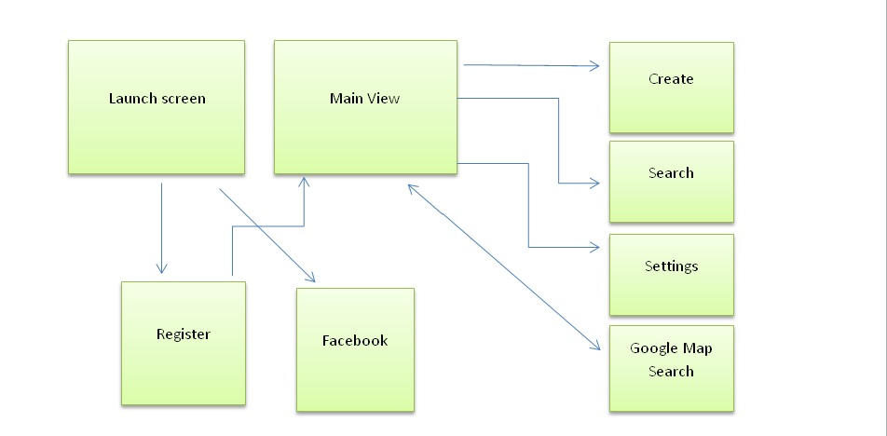

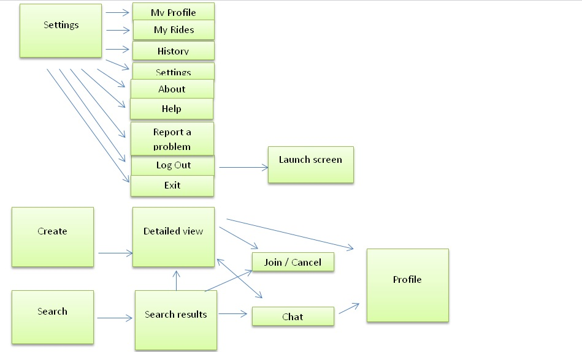

# Data

The data diagram is just a possibility because difficulties might arise when implementing so it might change:

-class Profile:

string Name

string Email

three ints Date of birth

encrypted string Password

char Gender

Review Reviews

int Number of shared rides

bool SignedInWithFacebook

bitarray ProfilePicture

DateTime and DateSignedUp

-class Ride:

Place Starting point

Place Destination

DateTime and Date

bool IsFrequentRide

int AvailableSeats

int NumberOfLuggage

string Description

Profile Owner

Profile(s) Riders

-class Review:

int Rating

Profile Writer

Profile ForWhomIsTheReview

string Comment

ints Time and DateWritten

-class Place:

string Name

string Province

string Country

Ride[] ListofRides

double latitude

-class Conversation:

Message[] Messages

Profile[] Participants

-class Message:

string Message

Date timeAndDateWritten

Profile Writer

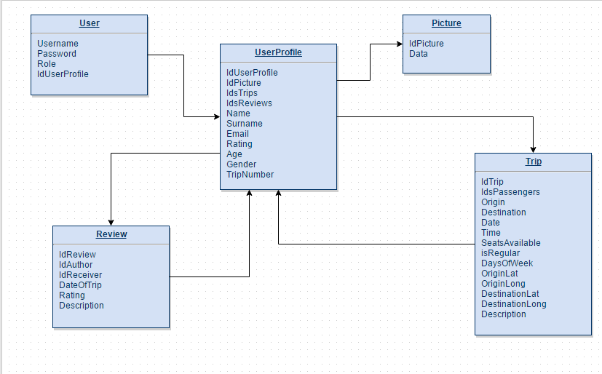

Skeleton

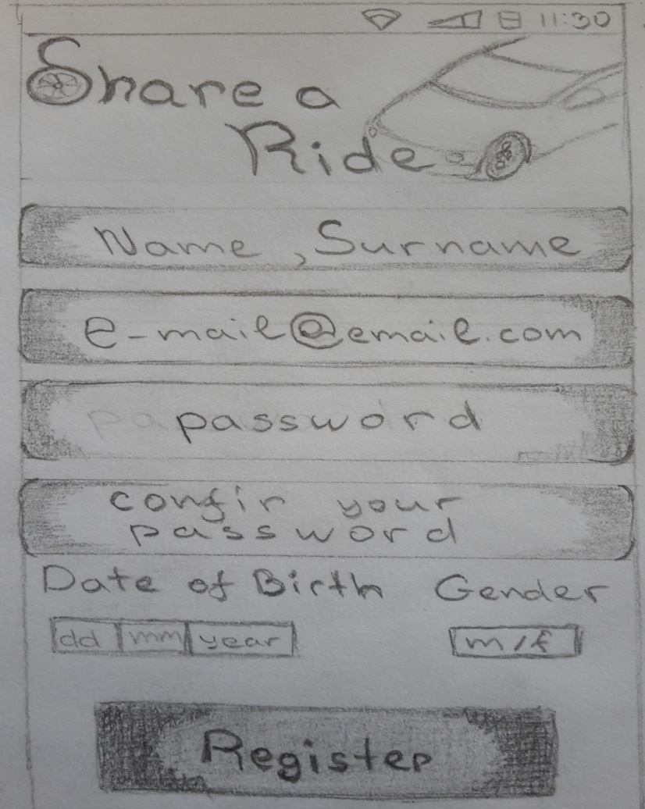

**Register:** contains 4 input forms that are name, e-mail, password and we have additional date of birth and gender with a button.

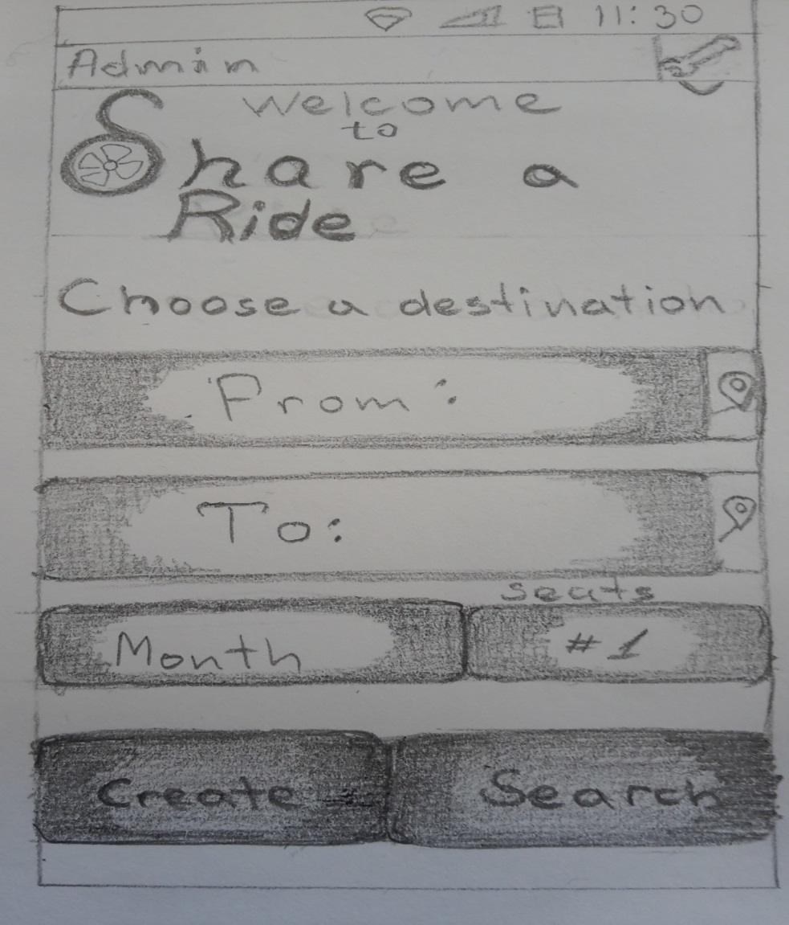

**Search trip:** this where you search a trip, here we have two input fields form which you chose your destination, clickable map icons. We have also Date, Seats and a two buttons that are Create and Search.

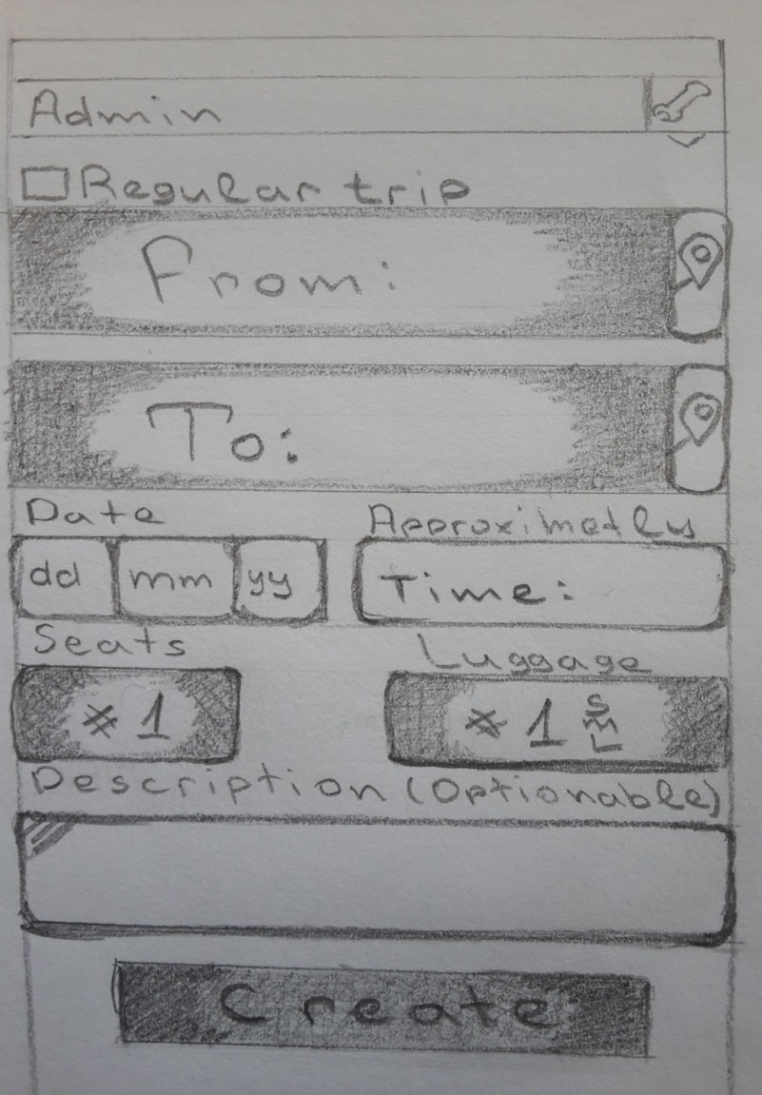

**Create trip:** this is where you can create trip here we have two fields from which you create a destination, with clickable map icons, date, time, seats, luggage and we also add textarea, that contains Description with a button Create.

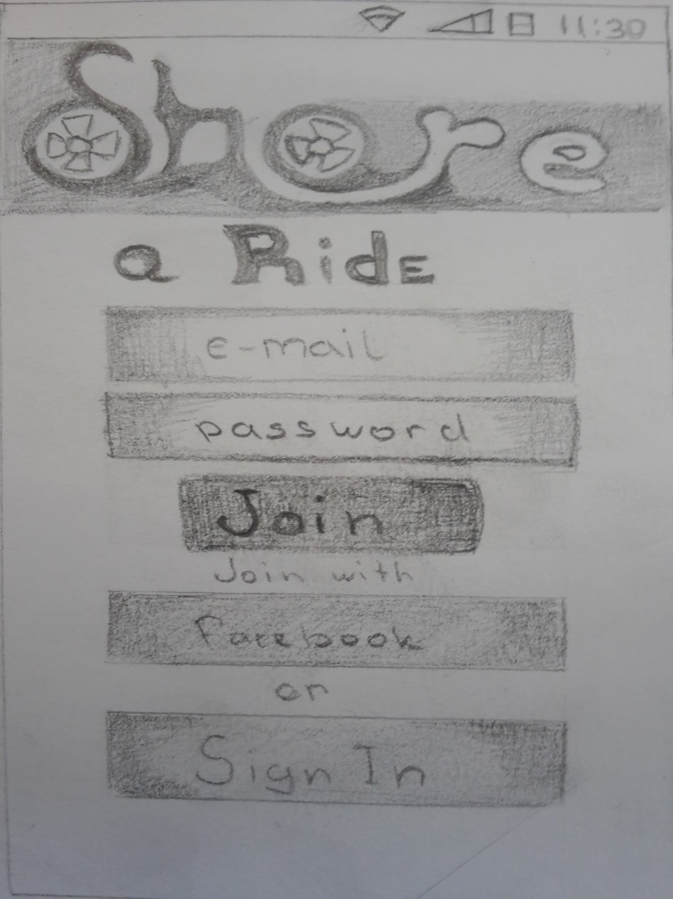

**Main:** this is the window that you see when you open the application, it contains 2 fields with E-mail Passowrd.If you have account you join, if not you press Sign In to go to a sign in page.

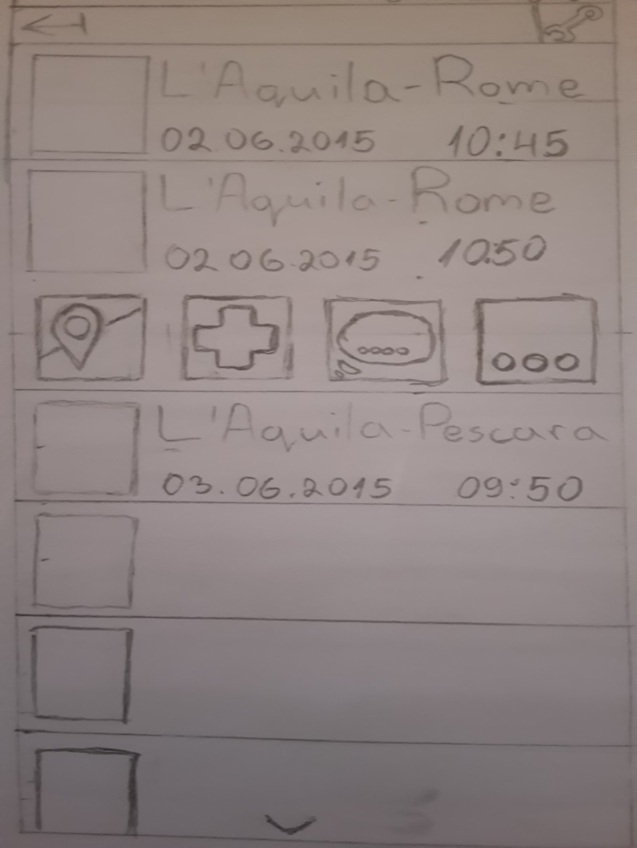

**TripList:** this are the results from searching here is the trip view list.Here we have fields with a picture and some information about the trip, with visual buttons when you click on a trip.

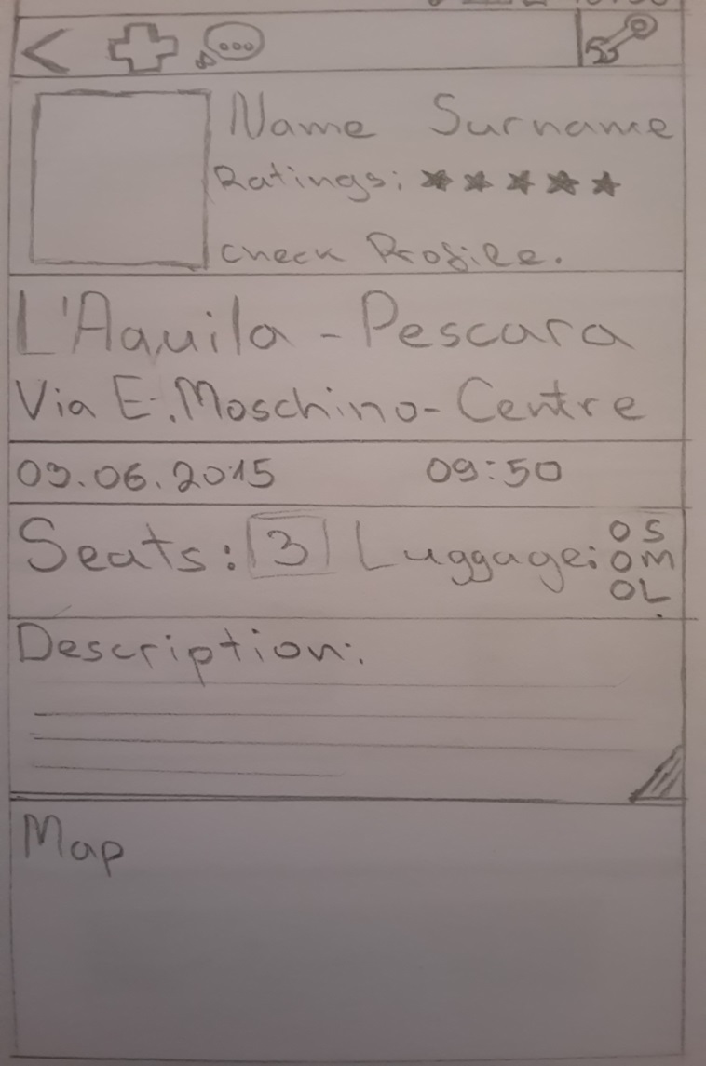

**Tripview:** this is how it looks when you open a trip. It contains the creator of the trip his ratings you can check his profile. The destination of the trip, date, seats, time and description. With a place for a Map that you can check.

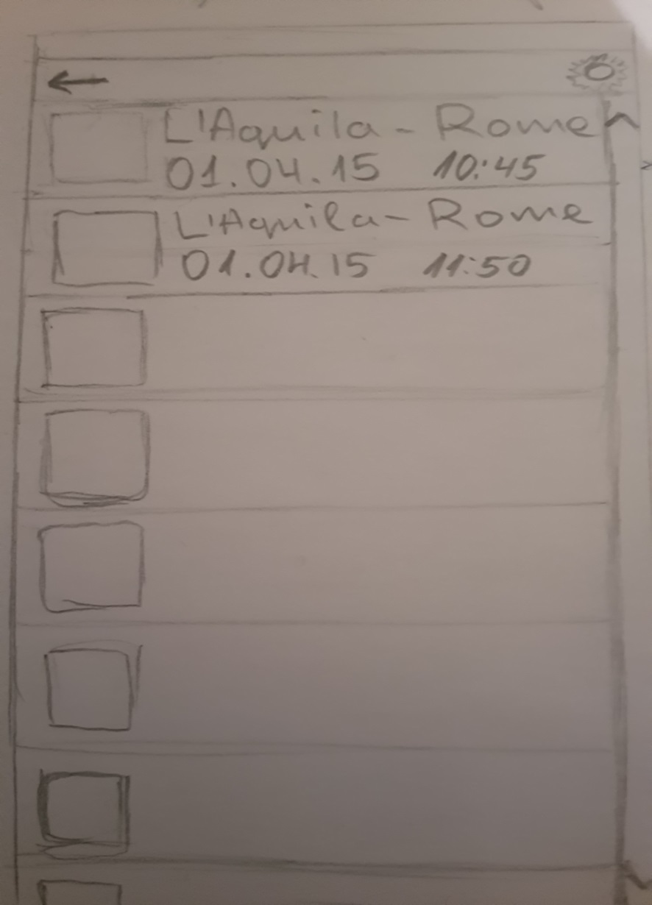

**Small trip list:** here basicly got the same functionalities like the **Trip List** but its not clicked on a trip.

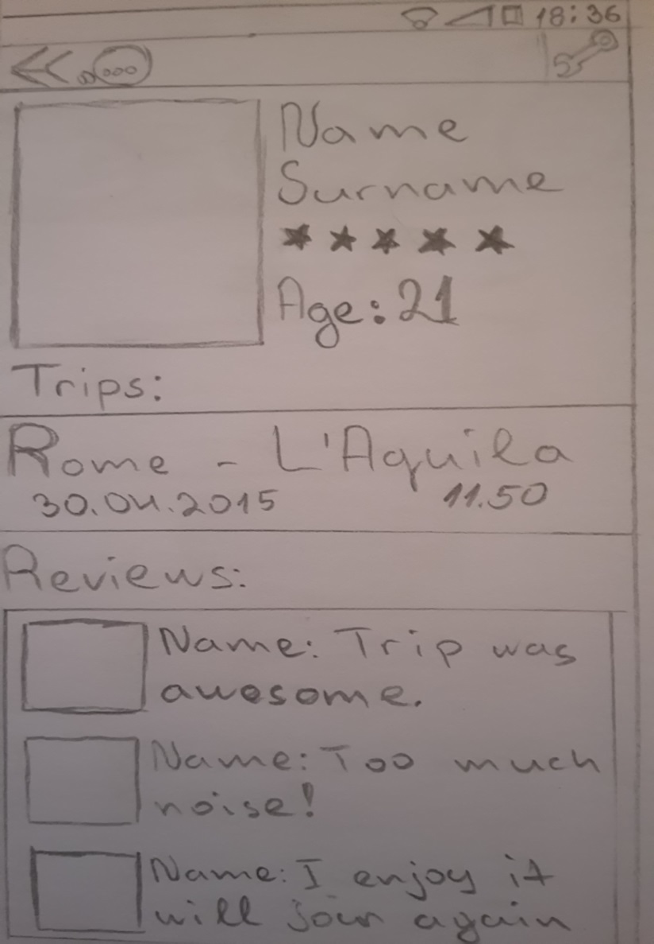

**Profile view:** contains all the information about a User. Name, age, ratings etc. and trips and reviews.

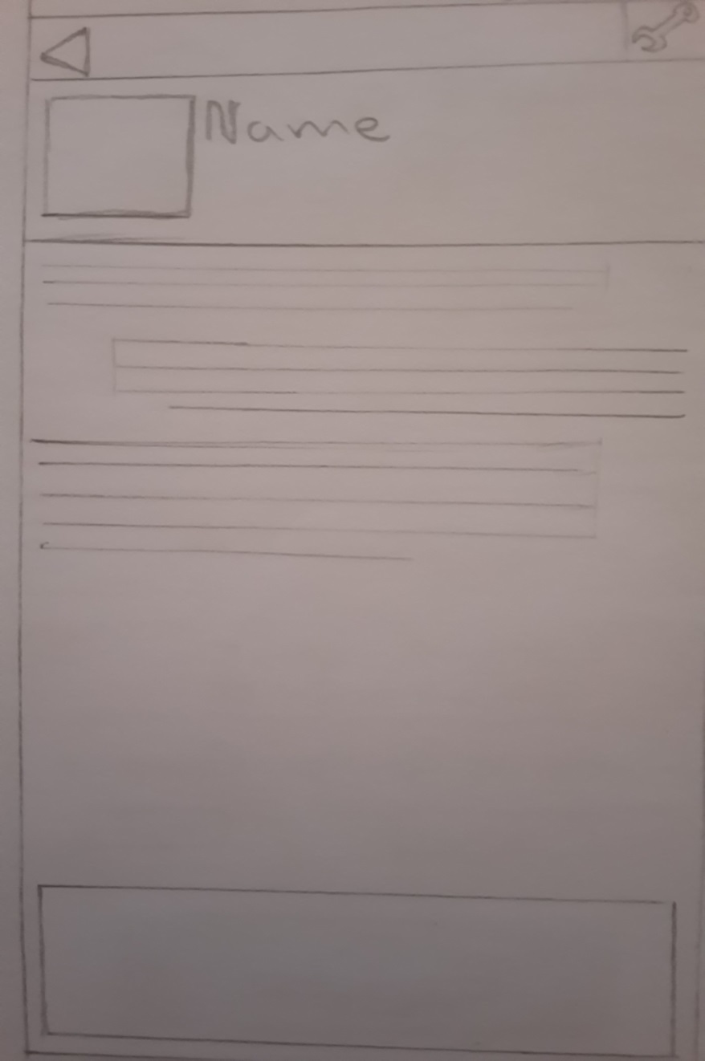

**Chat view:** chat basically to communicate with the person you want to travel with. Contains profile picture, Name, chat log and a chatting input area.

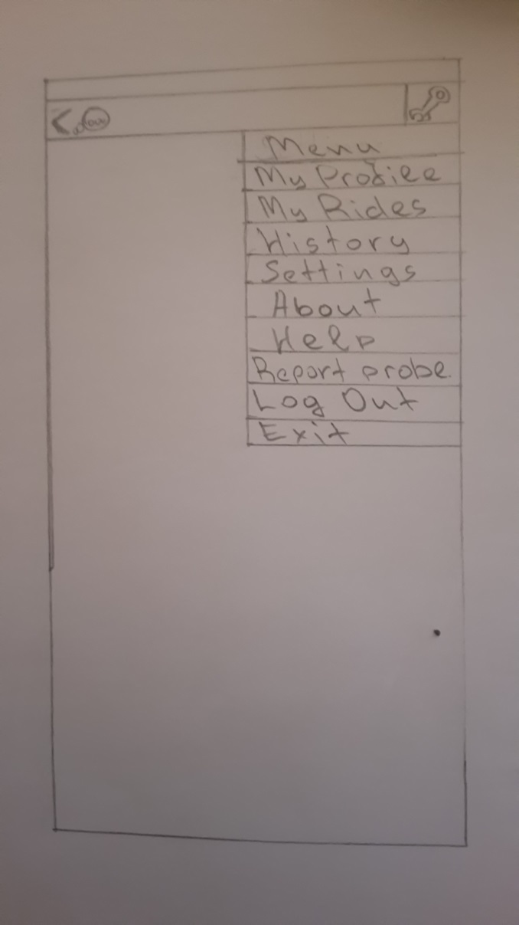

**Settings:** settings view, it is a Drop down and you can see all the things that you can adjust from the settings. It is a controller that contains different pages and redirects you through the application.

Surface

Description: This is profile view.

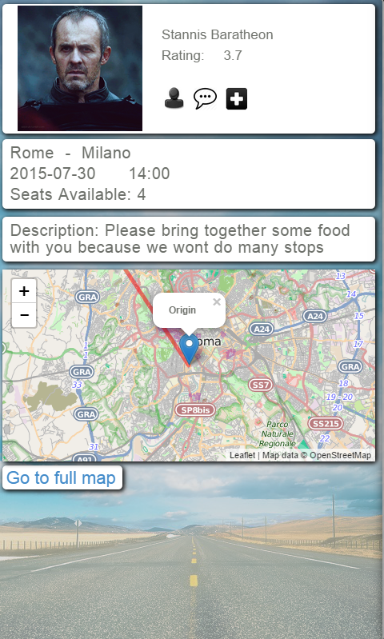

1. The max length of this document is 25 pages
2. The structure of this document is fixed, it cannot be changed in any way
3. The team leader is listed as first member in this list