“Mobile Applications Development”
course
a.y. 2014/2015

Share A Ride

Technical Documentation,

Team Members
Name | Student Number | E-mail address
Danail Yankov | 241254 | dannyyankov@gmail.com
Konstantinos Kallas | 241589 | konkallas@hotmail.com
Architecture

MVC architecture
The project Architecture is based on MVC. The main controller unit is the router, which maps links to views and their respective pages.

LoginView: It is the first view of the application , it allows the user to either login using his credentials or redirects him to the signup.

Signup: It allows the user to create a new profile with his details and credentials and validates them to make sure they are valid before creating the profile.

Settings: It is always accesibble on the top navigation bar of the application and redirects the user to some views like his Profile, or his trips.

SearchTripView: It is the main view of the application where the user can search for trips the way he wants them.

ListView: It is the results view of the application with a list of the trips that are loaded via a search query. It redirects to each trip if the user taps it.

TripView: It is the view that shows a trip, its details , and a map of the coordinates of the trip. It allows the user to join the trip , or unjoin, see the creators profile, or if they are the creator to delete it.

ProfileView: It is the view that shows the profile, showing its details , and the trips the user participates in , and the reviews that have been written for him.

CreateTripView: It is the view that allows the user to create a trip with all of its details and then redirects to it.
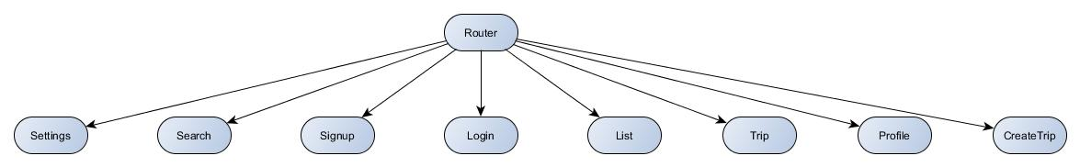

Data sources
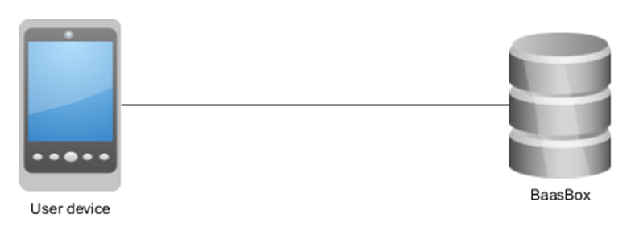

Used libraries and frameworks
- Backbone.js – as the main MVC framework provider;
- Handlebars.js – helpful for templating the content of the views;
- Icecream – helpful for arranging the views in a manageable grid view;
- JQuery.js – for simplifying object access and JS in general;
- Ratchet – for frontend issues;
- Require.js – for modularizing the application;
- Spin.js – used in order to simplify creating the spinner, which shows during loading periods;
Leaflet - an open-source JavaScript library for mobile-friendly interactive maps;

Development activities

Smart solutions
One of the smart solution that we use is one for the trip list view, that is not loading all trips at one time and there is a button for a loading more. This makes the list not heavy and hard to understand.
We used dynamic shadows so it’s a little bit more dynamic not so static application and you don’t like stare at it and lose focus.

Difficulties
LOW – for the html 5 coding and the stuff that are connected to it.
MEDIUM – For us it was medium difficult to make the css and js things connected, Baasbox.
HIGH – To make the Queries and the validations, BaasBox register users don’t have access to other users content, and we found the way to grant permission too late so we didn’t implement it on the version that we submitted.

Used tools
- Notepad++ – as the main development environment for JS;
- Ripple Emulator – as the main debugging environment;
- GitHub – as a team synchronization tool;
- Apache Cordova, Android SDK – for building the project and as the connection point for deploying the application on a real mobile device;
- Microsoft Office Word – for writing documentation;
- yEd Graph Editor – for creating the graphs for documentation;

The max length of this document is 10 pages
The structure of this document is fixed, it cannot be changed in any way
The team leader is listed as first member in this list

