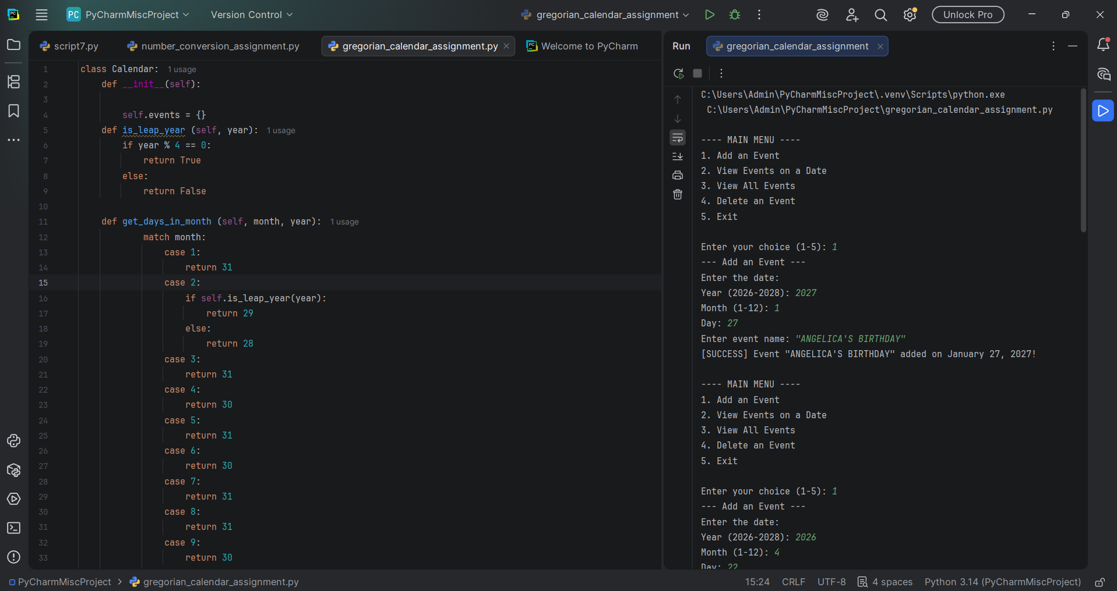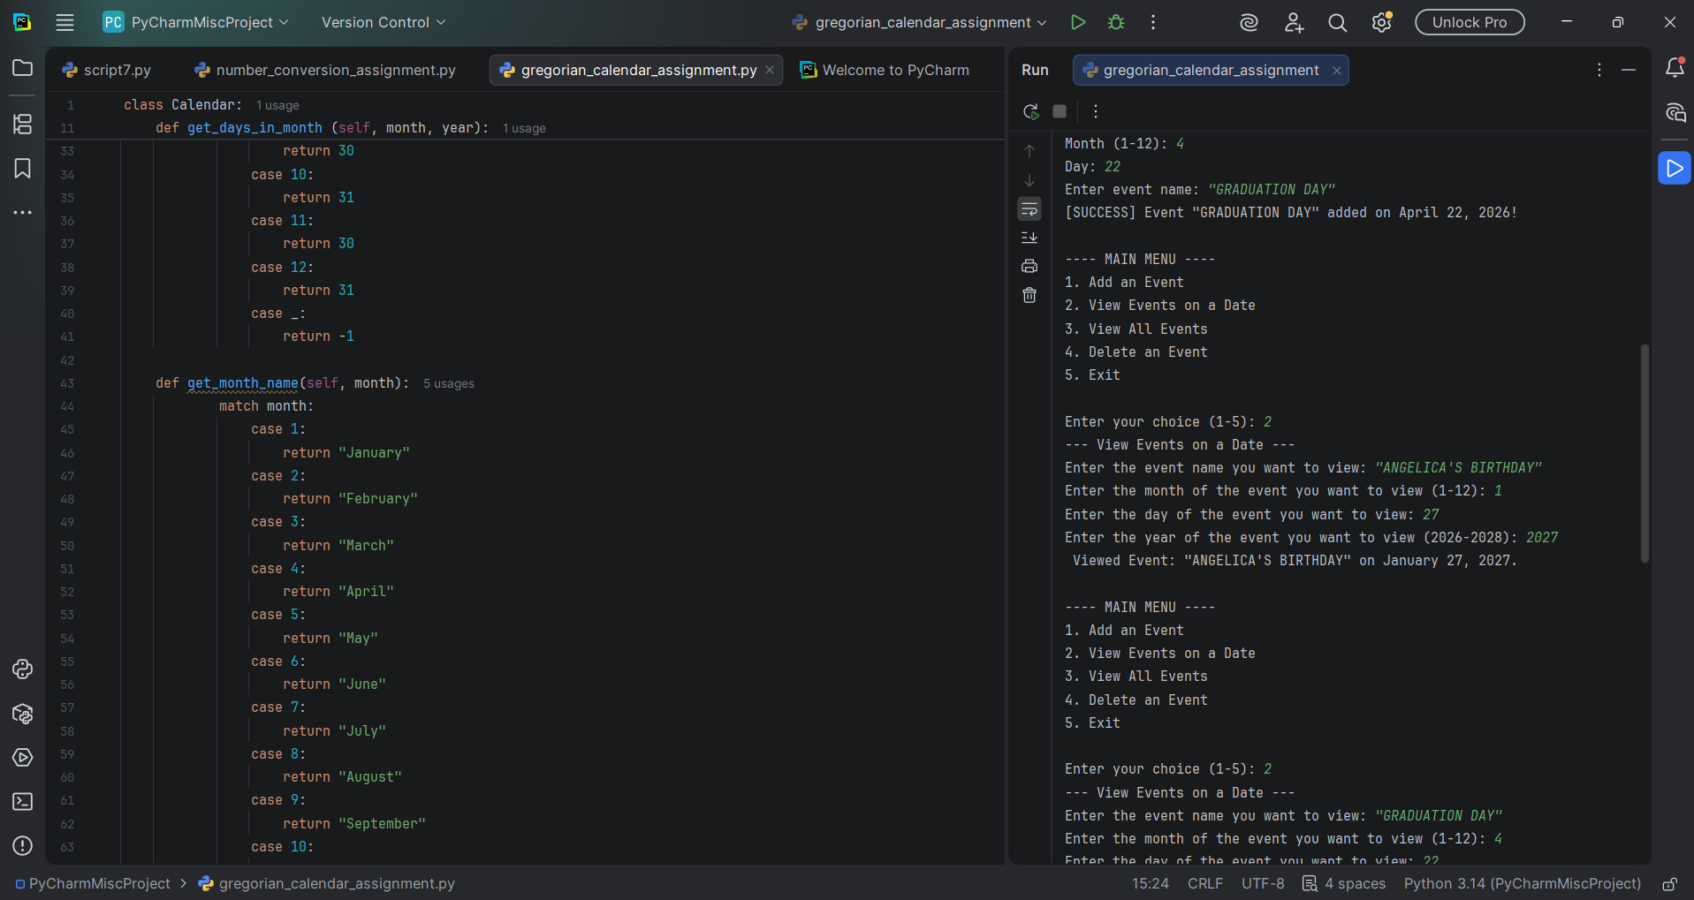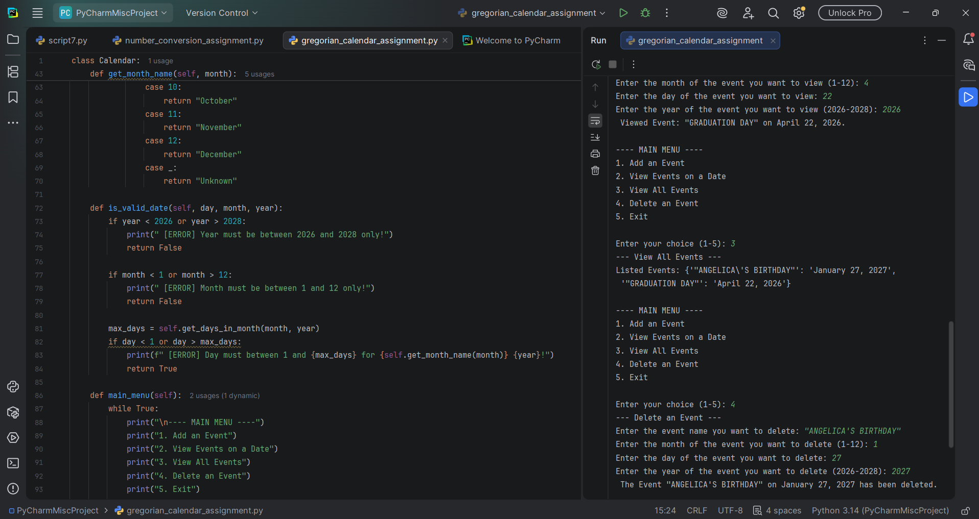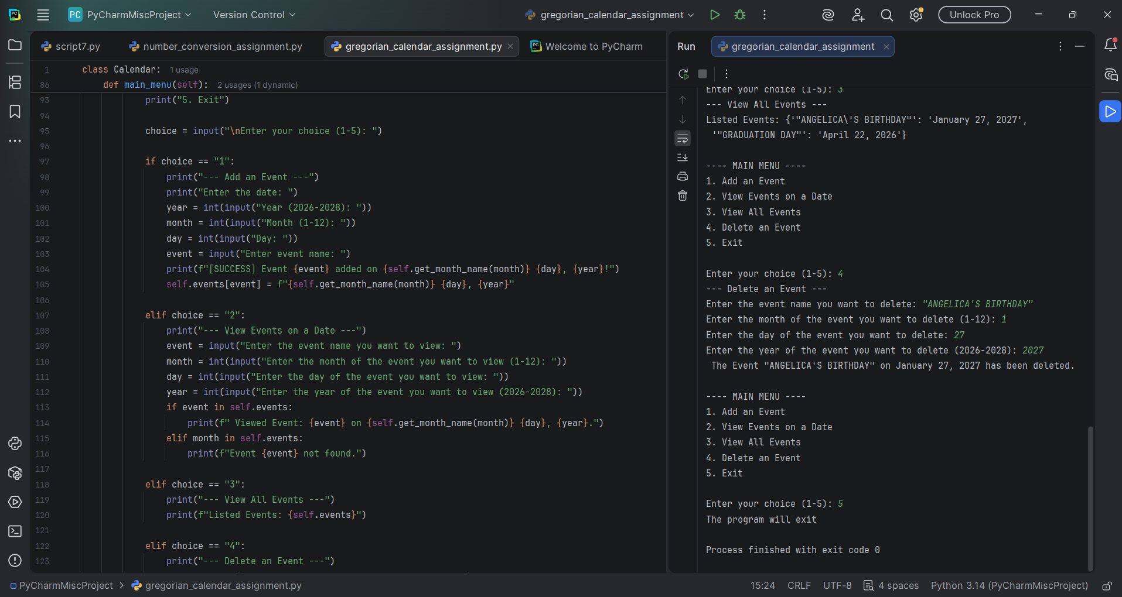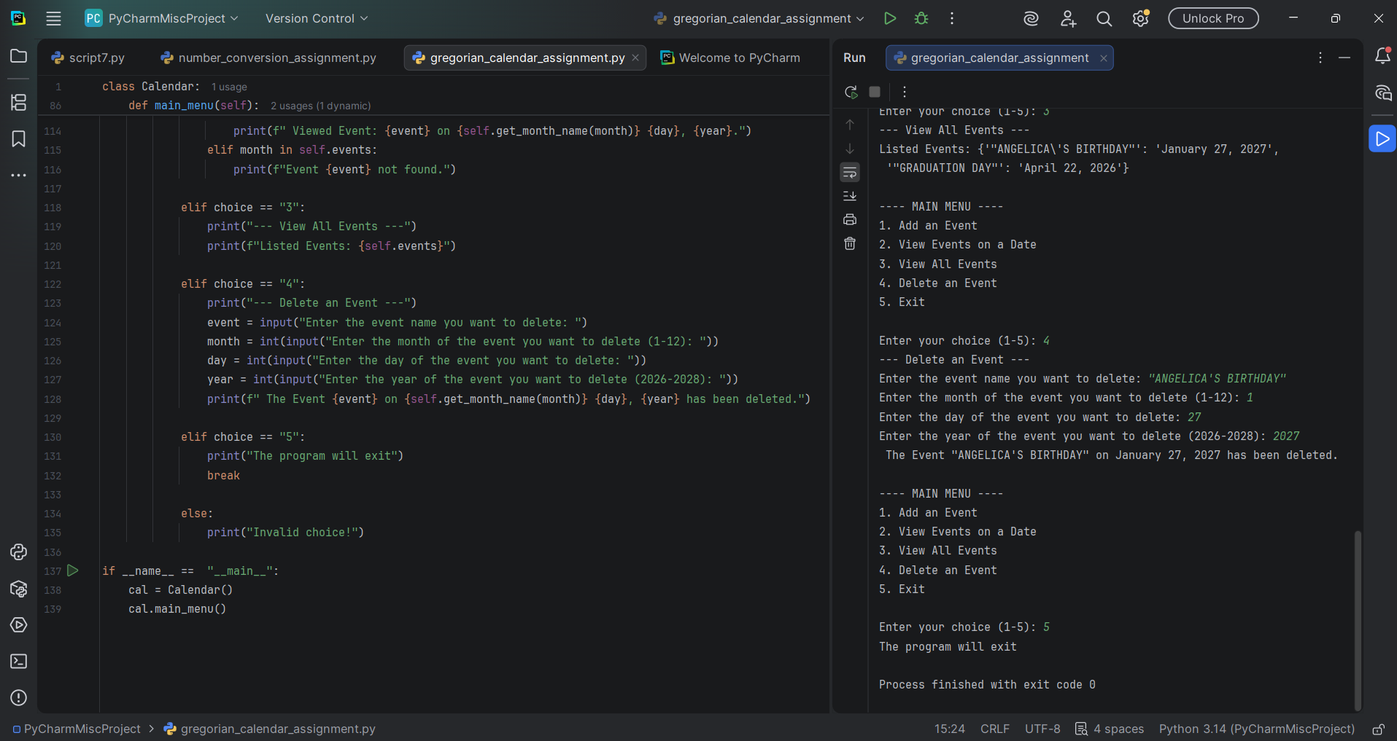

The program shows the Gregorian Calendar and have five main menu.
Number 1. Add an event
Number 2. View events on a date
Number 3. View all events
Number 4. Delete an event
Number 5. Exit
And user chose 1-5 and the program ask the year, month, day, and event name.

