Calibrating the Manta’s Turner Fluorometers

October 2013



This document explains how to calibrate a Manta fluorometer. Another document, Standardizing Eureka’s Turner Fluorometers, details a procedure recommended if direct calibration methods are not feasible.

Why do we use Turner fluorometers in our Manta multiprobes?

We use Turner fluorometric sensors first because of Turner’s excellent reputation as a provider of optical sensors and years of experience in measurement of chlorophyll, blue-green algae, CDOM, and other parameters of interest to water-quality investigators. The Turner fluorometric sensors are also well-built, a convenient size, and extremely reliable.

What fluorometric sensors are available in the Manta?

chlorophyll
fluorescein
crude oil
refined oil
optical brighteners
phycocyanin (fresh-water blue-green algae)
phycoerythrin (marine blue-green algae)
rhodamine
tryptophan
CDOM/FDOM (Colored Dissolved Organic Matter, also known as fDOM - fluorescent Dissolved Organic Matter, chromophoric dissolved organic matter, yellow substance, and gelbstoff)

How do fluorometric sensors work?

The major difference between fluorometric sensors and most other multiprobe sensors is that fluorometric sensors do not make direct measurements of ions, gases, or particles. Instead, they measure light wavelengths that strongly correlate with the fluorescent behavior of the intended analytes. For instance, the chlorophyll sensor emits light at a specific frequency that is known to excite chlorophyll pigments. Then it measures light of another specific frequency known to be the fluorescent response by chlorophyll to the emitted light frequency. The relative intensities of the emitted and measured light are not identical to chlorophyll because some of the myriad chemicals and particles in natural waters may have a fluorescence response very similar to chlorophyll pigments. This is true, for instance, for some types of dissolved organic matter. However, the fluorescence is usually quite strongly correlated to chlorophyll.

What else should I know about fluorometric sensors?

We have integrated the Turner fluorometric sensors so that they operate much like all our other sensors. Their calibration software, data display, maintenance, etc. are just like, for instance, the conductivity or turbidity sensors. However, there are several other things you should consider when using fluorometric sensors.

- At very high concentrations, fluorometric sensor readings do not increase at a constant rate in comparison to the change in analyte concentration. At even higher concentrations, the reading will decrease even though the sample concentrations are continuing to increase. This effect is known as “signal quenching”. Quenching usually occurs at concentrations outside the sensors’ specified ranges but can be checked by diluting a sample 1:1 or some other convenient ratio. If the sample is still in the linear range, the reading will decrease in direct proportion to the dilution. If the reading does not decrease in direct proportion to the dilution, or if the reading increases, the sample is beyond the linear range.

- As the temperature of a sample increases, the fluorescence decreases. For greatest accuracy, record the sample temperature and correct the sensor output for changes in temperature. Further information on how temperature, light, water quality and the physiological state of the algal cells affect the measurement of chlorophyll a can be found at: http://www.turnerdesigns.com/esupport/understanding.html

- Several of the analytes are difficult to define because they may have many different constituents. For instance, “blue-green algae” is a general term for many different biological species, and each of those species, or combinations of species, have different fluorescence responses. Similarly, “crude oil”: is a general term for combinations of many different oil-related compounds that vary widely from site to site.

What is the best way to calibrate fluorometric sensors?

The customer may choose either one-point or two-point calibrations; one of the two-point calibrations must be zero. The best way to set a zero is using the specific source water with the analyte removed; this zeroes-out any background fluorescence not due to the analyte. This is feasible with all the sensors except CDOM. For CDOM, and when it is not possible to use source water, de-ionized water will suffice for zero settings. Below are the recommended methods for setting non-zero points (i.e. slope).

There are five ways to calibrate fluorometric sensors; you must choose the method that best suits your situation:

- Factory default - At the factory, we establish a default calibration based on Turner’s published specification for each fluorometric sensor and based on the fact that all Turner sensors have a maximum signal output of 5 volts. For instance, Turner’s specification for the upper limit of the crude-oil sensor is 2700 ppb – so we scale the sensor to read 2700 ppb when the sensor output is 5 volts. Accordingly, the sensor will read 1350 ppb when the sensor output is 2.5 volts.

Yet because different types of crude oil have different fluorescence responses, and because many natural waters may have other compounds that mimic the fluorescence behavior of crude oil components, it is likely that the concentration of crude oil in your particular water is higher or lower than 2700 ppb when the sensor output is 5 volts. But this default calibration is consistent, so that you can choose to not calibrate your fluorometric sensors and rely on relative readings. But should you later develop information specific to your waters, you can easily correct all previous data gathered under the default calibration. For instance, if a laboratory analysis shows that a sample that reads 1000 ppb on the default-calibrated sensor has an actual crude oil concentration of 500 ppb, then you can correct your previous data by dividing them by 2 (provided that data refers to waters similar to those for which the laboratory analysis was made).

Specifications for the other sensors are shown in Appendix 1.

- Secondary Optical Standard - Turner provides a device called a Solid Secondary Standard (SSS). The SSS provides a very stable fluorescent signal, so it can be used in place of a primary liquid standard once a correlation between a primary standard and the solid standard has been established. Also, it can be used to check the stability of the instrument, and/or check for loss in sensitivity resulting from the growth of bio-fouling organisms on the sensor optics. For these reasons, the fluorometers for chlorophyll, fresh-water blue-green algae, marine blue-green algae, crude oil, and refined fuels are often calibrated not with a time- and location-specific standard, but with relative optical standards. Use Turner’s Solid Secondary Standard (SSS; see below). Slope points for chlorophyll sensors can be simulated with Turner’s Solid Secondary Standard (SSS), an optical device that provides a very stable fluorescent signal. The SSS is tested at Turner against known standards, and its reference value for chlorophyll is marked on the SSS. These values are relative, as they do not reflect the variables of speciation and other unique properties of your specific waters. But you can use these values in place of a primary liquid standard, and to check the sensor for stability and loss of sensitivity resulting from the growth of bio-fouling organisms or damage to the sensor optics.

- Sample analysis - Use a sample for which you know the true chlorophyll concentration (determined with an actual chlorophyll extraction, a trusted lab fluorometer, HPLC, etc.). are difficult to separate from water so as to prepare a calibration standard. And even if you did prepare a calibration standard from a crude-oil sample, there is no guarantee that the calibration would be valid for a sample from any other location or time – there are simply too many different types of crude oil.

- Overlapping solutions - Use a rhodamine solution for which you know the value that solution should show on a chlorophyll sensor.

- Commercial standards - Use a commercially available surrogate standard.

- Surrogate solutions - Several analytes are difficult to calibrate directly. For instance, it is difficult to separate CDOM from water so that it can be weighed and used for calibration. However, another material, quinine sulfate, fluoresces at nearly the same wavelength as CDOM and is easily measured. So quinine sulfate is often used to calibrate CDOM sensors. Several of the other sensors have similar situations.

Maintenance

The sensor should be rinsed or soaked in freshwater following each deployment, ideally until it is completely clean again. The sensor should not come in contact with any organic solvents, such as acetone and methanol, or strong acids and bases.

The sensor’s optical window should be visually inspected after each deployment following a soaking in fresh water. If cleaning is needed, use optical tissue to clean the window with soapy water.

Problems? No problem. E-mail us at sales@WaterProbes.com or call 512-302-4333, Ext 1111.

Eureka Water Probes
2113 Wells Branch Parkway
Austin TX 78728 512-302-4333
www.WaterProbes.com

Appendix 1 - Turner Specifications
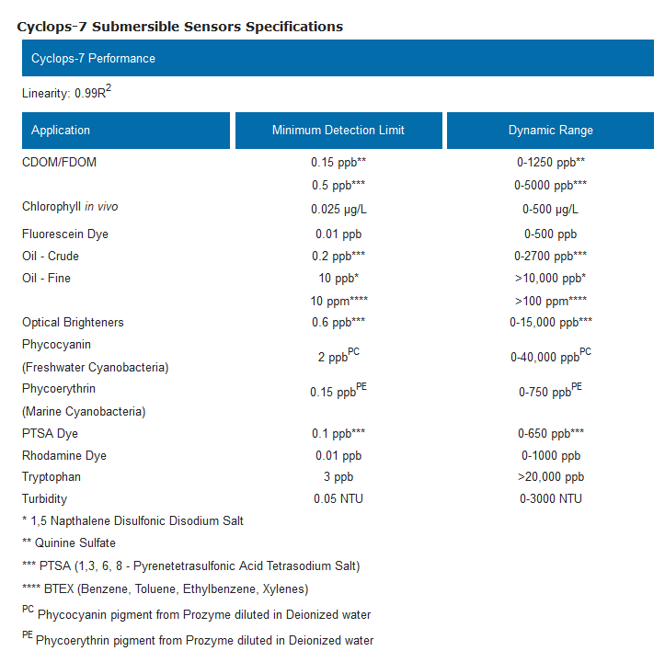

Appendix 2 - The SSS

Using the Solid Secondary Standard (SSS) for In Vivo Chlorophyll Applications - You can match your SSS to a known value of chlorophyll a:

- Perform a chlorophyll extraction using a laboratory fluorometer, spectrophotometer, or HPLC to determine the actual chlorophyll a concentration in a sample.
- Immerse the chlorophyll sensor in a sample containing algae, and note the reading.
- Dry off the chlorophyll sensor, attach the SSS, and adjust the SSS to produce the same reading as the algae (turning the SSS adjustment screw clockwise produces a lower signal).

Now the SSS can be used to check/establish a new correlation between a known chlorophyll a concentration and the reading. Information on doing a chlorophyll extraction can be found at: http://www.turnerdesigns.com/t2/doc/appnotes/998_9000.html .

You can also establish a correlation between a primary standard and the solid standard by analyzing a sample representative of your waters, and then re-marking the SSS with the value you found during the analysis. For instance, you could calibrate a chlorophyll sensor directly with a newly analyzed chlorophyll sample at, say, 20 µg/l. Then you can attach the SSS and re-mark the SSS with the reading made of the SSS with your sensor that has been calibrated with a sample of your specific chlorophyll speciation.

Using the Solid Secondary Standard (SSS) for Blue-Green Algae Applications – Use exactly the procedure as for in vivo chlorophyll applications, except use a blue-green algae sample instead of a chlorophyll standard.

Using the Solid Secondary Standard (SSS) for Dye Tracing Applications - Use exactly the procedure as for in vivo chlorophyll applications, except use a dye sample instead of a chlorophyll standard.

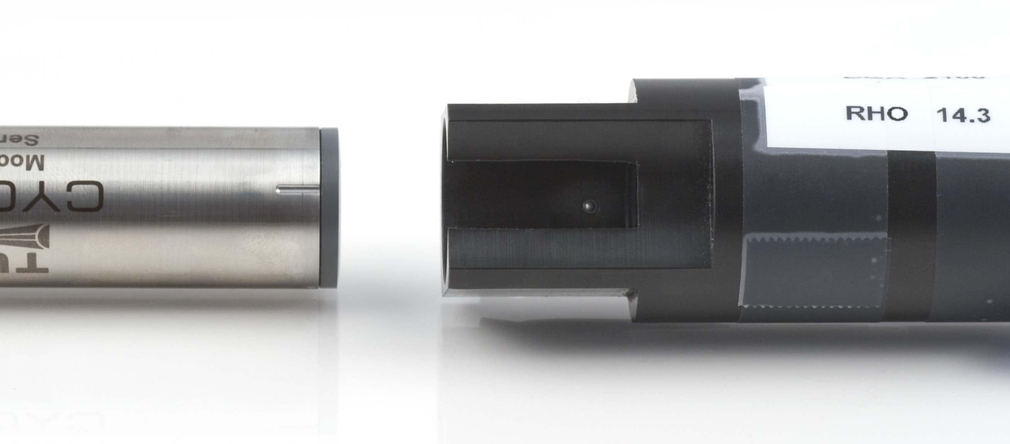

The SSS has an adjustment screw so that you can tune the SSS to provide a signal to match a specific sample:

- Make sure that the optical surface of the sensor is completely clean and dry.
- Place the SSS on to the optical end of the sensor.
- With the SSS fully pressed on, rotate in either direction until you feel the SSS indexing ball click into the indexing mark on the sensor.

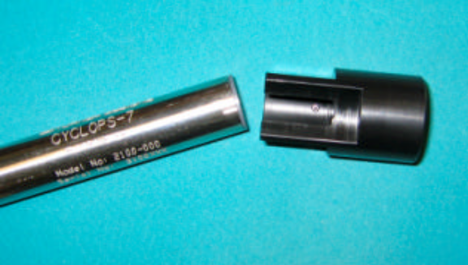
Align the index mark and indexing ball when installing the chlorophyll sensor in the Solid Secondary Standard.

- Use a small, flat-blade screwdriver to unscrew the locking nut as far as it will go.
- Insert the screwdriver blade through the hole in the locking nut, and rotate the blade until it engages with the adjustment screw that is beneath the locking nut.

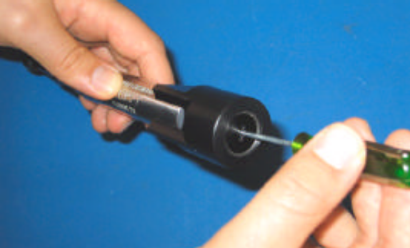
Insert the screwdriver blade through the hole in the locking nut to reach the adjustment screw.

- Turn the adjustment screw to change the reading.
- Once the desired reading has been obtained, the locking nut should be screwed down so that the adjustment screw is held firmly in place.

