lab-4-Rscript.R

angelicarock

2024-10-11

# My first Rscript  
x <- 1:50  
plot(x)

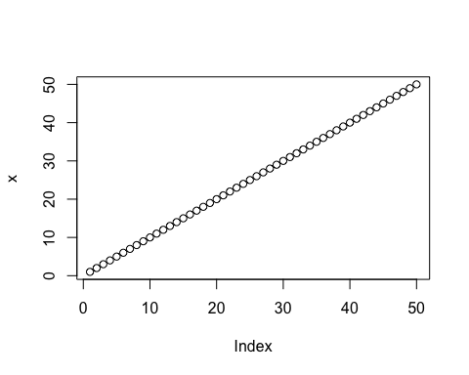

plot(x, sin(x), type = "l", col = "purple")

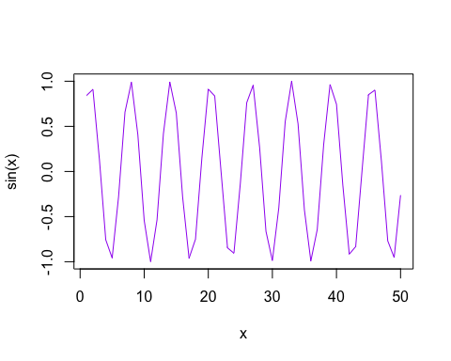

plot(x=x, y=sin(x), col="purple", typ="l", lwd=3)

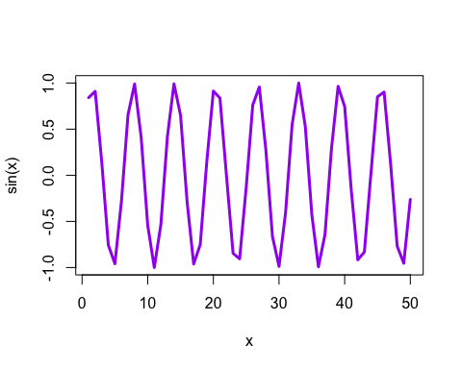

log(10,base = 2)

## [1] 3.321928