**WeatherPy**

**Starter Code to Generate Random Geographic Coordinates and a List of Cities**

#you need to install --!pip install citipy

#!conda activate geoviews

Collecting citipy

Using cached citipy-0.0.6.tar.gz (675 kB)

Preparing metadata (setup.py): started

Preparing metadata (setup.py): finished with status 'done'

Collecting kdtree>=0.12 (from citipy)

Using cached kdtree-0.16-py2.py3-none-any.whl (7.7 kB)

Building wheels for collected packages: citipy

Building wheel for citipy (setup.py): started

Building wheel for citipy (setup.py): finished with status 'done'

Created wheel for citipy: filename=citipy-0.0.6-py3-none-any.whl size=675977 sha256=5d01e804ba21b02833ee66d41f24df2f6d65fc97c2b0013395387005d00fafc8

Stored in directory: c:\users\osvar\appdata\local\pip\cache\wheels\4b\b5\88\49107ff846ec6967b34c17d369176c591fc90ed93b706755ad

Successfully built citipy

Installing collected packages: kdtree, citipy

Successfully installed citipy-0.0.6 kdtree-0.16

# Dependencies and Setup

import matplotlib.pyplot as plt

import pandas as pd

import numpy as np

import scipy.stats as st

import requests

import time

import hvplot

# Impor the OpenWeatherMap API key

from api_keys import weather_api_key

# Import citipy to determine the cities based on latitude and longitude

from citipy import citipy

#x, y = [1, 2, 3, 4, 5, 6, 7], [10, 9, 2.5, 6, 4, 3, 2]

#res = st.pearsonr(x, y)

#res

PearsonRResult(statistic=-0.828503883588428, pvalue=0.021280260007523286)

**Generate the Cities List by Using the citipy Library**

# Empty list for holding the latitude and longitude combinations

lat_lngs = []

# Empty list for holding the cities names

cities = []

# Range of latitudes and longitudes

lat_range = (-90, 90)

lng_range = (-180, 180)

# Create a set of random lat and lng combinations

lats = np.random.uniform(lat_range[0], lat_range[1], size=1500)

lngs = np.random.uniform(lng_range[0], lng_range[1], size=1500)

lat_lngs = zip(lats, lngs)

# Identify nearest city for each lat, lng combination

for lat_lng in lat_lngs:

city = citipy.nearest_city(lat_lng[0], lat_lng[1]).city_name

# If the city is unique, then add it to a our cities list

if city not in cities:

cities.append(city)

# Print the city count to confirm sufficient count

print(f"Number of cities in the list: {len(cities)}")

Number of cities in the list: 600

**Requirement 1: Create Plots to Showcase the Relationship Between Weather Variables and Latitude**

**Use the OpenWeatherMap API to retrieve weather data from the cities list generated in the started code**

# Set the API base URL

url = "http://api.openweathermap.org/data/2.5/weather?"

# Define an empty list to fetch the weather data for each city

city_data = []

# Print to logger

print("Beginning Data Retrieval ")

print("-----------------------------")

# Create counters

record_count = 1

set_count = 1

# Loop through all the cities in our list to fetch weather data

for i, city in enumerate(cities):

# Group cities in sets of 50 for logging purposes

if (i % 50 == 0 and i >= 50):

set_count += 1

record_count = 0

# Create endpoint URL with each city

city_url = f"{url}q={city}&units=metric&appid={weather_api_key}"

# Log the url, record, and set numbers

print("Processing Record %s of Set %s | %s" % (record_count, set_count, city))

# Add 1 to the record count

record_count += 1

# Run an API request for each of the cities

try:

# Parse the JSON and retrieve data

city_weather = (requests.get(city_url)).json()

# Parse out latitude, longitude, max temp, humidity, cloudiness, wind speed, country, and date

city_lat = city_weather["coord"]["lat"]

city_lng = city_weather['coord']['lon']

city_max_temp = city_weather['main']['temp_max']

city_humidity = city_weather['main']['humidity']

city_clouds = city_weather['clouds']['all']

city_wind = city_weather['wind']['speed']

city_country = city_weather['sys']['country']

city_date = city_weather["dt"]

# Append the City information into city_data list

city_data.append({"City": city,

"Lat": city_lat,

"Lng": city_lng,

"Max Temp": city_max_temp,

"Humidity": city_humidity,

"Cloudiness": city_clouds,

"Wind Speed": city_wind,

"Country": city_country,

"Date": city_date})

# If an error is experienced, skip the city

except:

print("City not found. Skipping...")

pass

# Indicate that Data Loading is complete

print("-----------------------------")

print("Data Retrieval Complete ")

print("-----------------------------")

Beginning Data Retrieval

-----------------------------

Processing Record 1 of Set 1 | lerwick

Processing Record 2 of Set 1 | maceio

Processing Record 3 of Set 1 | kapa'a

Processing Record 4 of Set 1 | port-aux-francais

Processing Record 5 of Set 1 | petropavlovsk-kamchatsky

Processing Record 6 of Set 1 | albany

Processing Record 7 of Set 1 | iqaluit

Processing Record 8 of Set 1 | nuuk

Processing Record 9 of Set 1 | duncan town

City not found. Skipping...

Processing Record 10 of Set 1 | yellowknife

Processing Record 11 of Set 1 | waitangi

Processing Record 12 of Set 1 | blackmans bay

Processing Record 13 of Set 1 | hawaiian paradise park

Processing Record 14 of Set 1 | port elizabeth

Processing Record 15 of Set 1 | trinity beach

Processing Record 16 of Set 1 | colonia

Processing Record 17 of Set 1 | ciudad bolivar

Processing Record 18 of Set 1 | crane

Processing Record 19 of Set 1 | ribeira grande

Processing Record 20 of Set 1 | dudinka

Processing Record 21 of Set 1 | wailua homesteads

Processing Record 22 of Set 1 | smithers

Processing Record 23 of Set 1 | taiohae

City not found. Skipping...

Processing Record 24 of Set 1 | haiku-pauwela

Processing Record 25 of Set 1 | isafjordur

Processing Record 26 of Set 1 | tura

Processing Record 27 of Set 1 | shingu

Processing Record 28 of Set 1 | aasiaat

Processing Record 29 of Set 1 | hadibu

Processing Record 30 of Set 1 | abashiri

Processing Record 31 of Set 1 | edinburgh of the seven seas

Processing Record 32 of Set 1 | kadaura

Processing Record 33 of Set 1 | mitchell

Processing Record 34 of Set 1 | ancud

Processing Record 35 of Set 1 | sur

Processing Record 36 of Set 1 | hammerfest

Processing Record 37 of Set 1 | puerto san carlos

City not found. Skipping...

Processing Record 38 of Set 1 | adamstown

Processing Record 39 of Set 1 | longyearbyen

Processing Record 40 of Set 1 | thompson

Processing Record 41 of Set 1 | kone

Processing Record 42 of Set 1 | saipan

Processing Record 43 of Set 1 | kwang binh

Processing Record 44 of Set 1 | nadym

Processing Record 45 of Set 1 | geraldton

Processing Record 46 of Set 1 | bethel

Processing Record 47 of Set 1 | grytviken

Processing Record 48 of Set 1 | bredasdorp

Processing Record 49 of Set 1 | klyuchi

Processing Record 50 of Set 1 | egilsstadir

Processing Record 0 of Set 2 | tazacorte

Processing Record 1 of Set 2 | bukene

Processing Record 2 of Set 2 | puerto natales

Processing Record 3 of Set 2 | puerto deseado

Processing Record 4 of Set 2 | margaret river

Processing Record 5 of Set 2 | selogiri

Processing Record 6 of Set 2 | kantunilkin

Processing Record 7 of Set 2 | hermanus

Processing Record 8 of Set 2 | byron bay

Processing Record 9 of Set 2 | dinguiraye

Processing Record 10 of Set 2 | vila velha

Processing Record 11 of Set 2 | puerto ayora

Processing Record 12 of Set 2 | ushuaia

Processing Record 13 of Set 2 | olonkinbyen

Processing Record 14 of Set 2 | uturoa

Processing Record 15 of Set 2 | lospalos

Processing Record 16 of Set 2 | ust'-talovka

Processing Record 17 of Set 2 | tiksi

Processing Record 18 of Set 2 | yermakovskoye

Processing Record 19 of Set 2 | recreo

Processing Record 20 of Set 2 | arraial do cabo

Processing Record 21 of Set 2 | kulia village

City not found. Skipping...

Processing Record 22 of Set 2 | buchanan

Processing Record 23 of Set 2 | stanley

Processing Record 24 of Set 2 | mlowo

Processing Record 25 of Set 2 | kapit

Processing Record 26 of Set 2 | yemetsk

Processing Record 27 of Set 2 | avarua

Processing Record 28 of Set 2 | suwayr

Processing Record 29 of Set 2 | dakoro

Processing Record 30 of Set 2 | hanceville

Processing Record 31 of Set 2 | qaqortoq

Processing Record 32 of Set 2 | sitia

Processing Record 33 of Set 2 | fort bragg

Processing Record 34 of Set 2 | la sarre

Processing Record 35 of Set 2 | punta arenas

Processing Record 36 of Set 2 | talnakh

Processing Record 37 of Set 2 | weno

Processing Record 38 of Set 2 | east london

Processing Record 39 of Set 2 | ilulissat

Processing Record 40 of Set 2 | coquimbo

Processing Record 41 of Set 2 | papatowai

Processing Record 42 of Set 2 | usinsk

Processing Record 43 of Set 2 | enewetak

Processing Record 44 of Set 2 | amga

Processing Record 45 of Set 2 | xining

Processing Record 46 of Set 2 | sitangkai

Processing Record 47 of Set 2 | larkird

Processing Record 48 of Set 2 | 'ohonua

City not found. Skipping...

Processing Record 49 of Set 2 | maine soroa

Processing Record 0 of Set 3 | obo

Processing Record 1 of Set 3 | forio

Processing Record 2 of Set 3 | namibe

Processing Record 3 of Set 3 | sinop

Processing Record 4 of Set 3 | mount gambier

Processing Record 5 of Set 3 | davyd-haradok

Processing Record 6 of Set 3 | kirovskiy

Processing Record 7 of Set 3 | fale old settlement

Processing Record 8 of Set 3 | santa ana

Processing Record 9 of Set 3 | revda

Processing Record 10 of Set 3 | colac

Processing Record 11 of Set 3 | fuding

Processing Record 12 of Set 3 | waingapu

Processing Record 13 of Set 3 | afaahiti

Processing Record 14 of Set 3 | tabou

Processing Record 15 of Set 3 | paradip garh

Processing Record 16 of Set 3 | lesogorsk

Processing Record 17 of Set 3 | elmendorf air force base

City not found. Skipping...

Processing Record 18 of Set 3 | susuman

Processing Record 19 of Set 3 | ballina

Processing Record 20 of Set 3 | port alfred

Processing Record 21 of Set 3 | andahuaylas

Processing Record 22 of Set 3 | al qusayr

Processing Record 23 of Set 3 | box elder

Processing Record 24 of Set 3 | grand falls-windsor

Processing Record 25 of Set 3 | bac lieu

Processing Record 26 of Set 3 | chernyshevskiy

Processing Record 27 of Set 3 | aqsay

Processing Record 28 of Set 3 | happy valley-goose bay

Processing Record 29 of Set 3 | kerikeri

Processing Record 30 of Set 3 | kujuvar

City not found. Skipping...

Processing Record 31 of Set 3 | constantia

Processing Record 32 of Set 3 | lamu

Processing Record 33 of Set 3 | bonthe

Processing Record 34 of Set 3 | kodiak

Processing Record 35 of Set 3 | wankyi

Processing Record 36 of Set 3 | anadyr

Processing Record 37 of Set 3 | leava

Processing Record 38 of Set 3 | invercargill

Processing Record 39 of Set 3 | luganville

Processing Record 40 of Set 3 | chandler

Processing Record 41 of Set 3 | jamestown

Processing Record 42 of Set 3 | kerema

Processing Record 43 of Set 3 | lata

Processing Record 44 of Set 3 | conception bay south

Processing Record 45 of Set 3 | alice springs

Processing Record 46 of Set 3 | puerto lopez

Processing Record 47 of Set 3 | melfi

Processing Record 48 of Set 3 | magadan

Processing Record 49 of Set 3 | veinticinco de mayo

Processing Record 0 of Set 4 | ongjin

Processing Record 1 of Set 4 | talcher

Processing Record 2 of Set 4 | tinde

Processing Record 3 of Set 4 | timbuktu

Processing Record 4 of Set 4 | zaozersk

Processing Record 5 of Set 4 | newquay

Processing Record 6 of Set 4 | keflavik

Processing Record 7 of Set 4 | big stone gap

Processing Record 8 of Set 4 | acarau

Processing Record 9 of Set 4 | carnarvon

Processing Record 10 of Set 4 | tenno

Processing Record 11 of Set 4 | kingston

Processing Record 12 of Set 4 | kununurra

Processing Record 13 of Set 4 | sokcho

Processing Record 14 of Set 4 | tazovsky

Processing Record 15 of Set 4 | namanga

Processing Record 16 of Set 4 | bilibino

Processing Record 17 of Set 4 | tarija

Processing Record 18 of Set 4 | usogorsk

Processing Record 19 of Set 4 | agadez

Processing Record 20 of Set 4 | kapuskasing

Processing Record 21 of Set 4 | nikolayevsk-on-amure

Processing Record 22 of Set 4 | la ronge

Processing Record 23 of Set 4 | zhongxiang

Processing Record 24 of Set 4 | vadso

Processing Record 25 of Set 4 | college

Processing Record 26 of Set 4 | aripuana

Processing Record 27 of Set 4 | vernon

Processing Record 28 of Set 4 | broken hill

Processing Record 29 of Set 4 | murzuq

Processing Record 30 of Set 4 | tocopilla

Processing Record 31 of Set 4 | whitehorse

Processing Record 32 of Set 4 | haimen

Processing Record 33 of Set 4 | novo horizonte

Processing Record 34 of Set 4 | linqiong

Processing Record 35 of Set 4 | cabedelo

Processing Record 36 of Set 4 | obihiro

Processing Record 37 of Set 4 | portland

Processing Record 38 of Set 4 | nar'yan-mar

Processing Record 39 of Set 4 | ola

Processing Record 40 of Set 4 | lompoc

Processing Record 41 of Set 4 | mantenopolis

Processing Record 42 of Set 4 | kitimat

Processing Record 43 of Set 4 | praia da vitoria

Processing Record 44 of Set 4 | ierapetra

Processing Record 45 of Set 4 | iskateley

Processing Record 46 of Set 4 | luza

Processing Record 47 of Set 4 | san antonio de pale

Processing Record 48 of Set 4 | lebu

Processing Record 49 of Set 4 | roma

Processing Record 0 of Set 5 | shimoda

Processing Record 1 of Set 5 | veymandoo

City not found. Skipping...

Processing Record 2 of Set 5 | wynyard

Processing Record 3 of Set 5 | ostroleka

Processing Record 4 of Set 5 | malango

Processing Record 5 of Set 5 | atafu village

Processing Record 6 of Set 5 | chonchi

Processing Record 7 of Set 5 | indramayu

Processing Record 8 of Set 5 | valparaiso

Processing Record 9 of Set 5 | georgetown

Processing Record 10 of Set 5 | bridgewater

Processing Record 11 of Set 5 | bozoum

Processing Record 12 of Set 5 | salinopolis

Processing Record 13 of Set 5 | west island

Processing Record 14 of Set 5 | ascension

Processing Record 15 of Set 5 | castillos

Processing Record 16 of Set 5 | vorgashor

Processing Record 17 of Set 5 | copala

Processing Record 18 of Set 5 | karratha

Processing Record 19 of Set 5 | tshabong

Processing Record 20 of Set 5 | naze

Processing Record 21 of Set 5 | galle

Processing Record 22 of Set 5 | port mathurin

Processing Record 23 of Set 5 | harper

Processing Record 24 of Set 5 | sitka

Processing Record 25 of Set 5 | ilgaz

Processing Record 26 of Set 5 | kyshtovka

Processing Record 27 of Set 5 | el granada

Processing Record 28 of Set 5 | dul'durga

Processing Record 29 of Set 5 | corner brook

Processing Record 30 of Set 5 | konarka

Processing Record 31 of Set 5 | port douglas

Processing Record 32 of Set 5 | calama

Processing Record 33 of Set 5 | beyneu

Processing Record 34 of Set 5 | salavan

Processing Record 35 of Set 5 | al kiremit al 'arakiyyin

City not found. Skipping...

Processing Record 36 of Set 5 | kenora

Processing Record 37 of Set 5 | new norfolk

Processing Record 38 of Set 5 | kolonia town

Processing Record 39 of Set 5 | bryne

Processing Record 40 of Set 5 | caleta de carquin

Processing Record 41 of Set 5 | pangody

Processing Record 42 of Set 5 | luderitz

Processing Record 43 of Set 5 | errachidia

Processing Record 44 of Set 5 | lensk

Processing Record 45 of Set 5 | puerto armuelles

Processing Record 46 of Set 5 | watsa

Processing Record 47 of Set 5 | kayangel

Processing Record 48 of Set 5 | lagunas

Processing Record 49 of Set 5 | saint-joseph

Processing Record 0 of Set 6 | midvagur

Processing Record 1 of Set 6 | tofol

Processing Record 2 of Set 6 | jayapura

Processing Record 3 of Set 6 | brisas barra de suchiate

Processing Record 4 of Set 6 | sao vicente

Processing Record 5 of Set 6 | balqash

Processing Record 6 of Set 6 | katsuren-haebaru

Processing Record 7 of Set 6 | codrington

Processing Record 8 of Set 6 | haukipudas

Processing Record 9 of Set 6 | ankazobe

Processing Record 10 of Set 6 | sierra grande

Processing Record 11 of Set 6 | mudanjiang

Processing Record 12 of Set 6 | san pedro pochutla

Processing Record 13 of Set 6 | gusinoozyorsk

Processing Record 14 of Set 6 | namtsy

Processing Record 15 of Set 6 | pemba

Processing Record 16 of Set 6 | tranovaho

City not found. Skipping...

Processing Record 17 of Set 6 | launceston

Processing Record 18 of Set 6 | jiazi

Processing Record 19 of Set 6 | kupang

Processing Record 20 of Set 6 | alness

Processing Record 21 of Set 6 | eyl

Processing Record 22 of Set 6 | namdrik

Processing Record 23 of Set 6 | kokpekty

Processing Record 24 of Set 6 | kadoma

Processing Record 25 of Set 6 | matagalpa

Processing Record 26 of Set 6 | agat village

Processing Record 27 of Set 6 | donghai

Processing Record 28 of Set 6 | khandyga

Processing Record 29 of Set 6 | vila franca do campo

Processing Record 30 of Set 6 | sisimiut

Processing Record 31 of Set 6 | amparafaravola

Processing Record 32 of Set 6 | wajir

Processing Record 33 of Set 6 | sabang

Processing Record 34 of Set 6 | tromso

Processing Record 35 of Set 6 | meulaboh

Processing Record 36 of Set 6 | buckner

Processing Record 37 of Set 6 | tsiombe

Processing Record 38 of Set 6 | fereydun kenar

Processing Record 39 of Set 6 | utete

Processing Record 40 of Set 6 | igarka

Processing Record 41 of Set 6 | nelson bay

Processing Record 42 of Set 6 | yuzhno-kurilsk

Processing Record 43 of Set 6 | karwar

Processing Record 44 of Set 6 | kayyerkan

Processing Record 45 of Set 6 | oum hadjer

Processing Record 46 of Set 6 | arkhangel'sk

Processing Record 47 of Set 6 | port macquarie

Processing Record 48 of Set 6 | nantucket

Processing Record 49 of Set 6 | mazagao

Processing Record 0 of Set 7 | stanytsya luhans'ka

City not found. Skipping...

Processing Record 1 of Set 7 | mount pearl

Processing Record 2 of Set 7 | howrah

Processing Record 3 of Set 7 | pacasmayo

Processing Record 4 of Set 7 | udachny

Processing Record 5 of Set 7 | crucecita

Processing Record 6 of Set 7 | nova sintra

Processing Record 7 of Set 7 | holualoa

Processing Record 8 of Set 7 | porto novo

Processing Record 9 of Set 7 | kavieng

Processing Record 10 of Set 7 | ouellah

City not found. Skipping...

Processing Record 11 of Set 7 | kachkanar

Processing Record 12 of Set 7 | road town

Processing Record 13 of Set 7 | nemuro

Processing Record 14 of Set 7 | spearfish

Processing Record 15 of Set 7 | bayan nur

City not found. Skipping...

Processing Record 16 of Set 7 | boda

Processing Record 17 of Set 7 | antsiranana

Processing Record 18 of Set 7 | ta`u

Processing Record 19 of Set 7 | posse

Processing Record 20 of Set 7 | sindirgi

Processing Record 21 of Set 7 | bantogon

Processing Record 22 of Set 7 | zhangjiakou

Processing Record 23 of Set 7 | qarqaraly

Processing Record 24 of Set 7 | salym

Processing Record 25 of Set 7 | ocean pointe

City not found. Skipping...

Processing Record 26 of Set 7 | kyzyl-suu

Processing Record 27 of Set 7 | san felice circeo

Processing Record 28 of Set 7 | oyem

Processing Record 29 of Set 7 | navirai

Processing Record 30 of Set 7 | tanjung selor

City not found. Skipping...

Processing Record 31 of Set 7 | hasaki

Processing Record 32 of Set 7 | st. john's

Processing Record 33 of Set 7 | aberdeen

Processing Record 34 of Set 7 | carutapera

Processing Record 35 of Set 7 | cargados carajos

City not found. Skipping...

Processing Record 36 of Set 7 | mejit

Processing Record 37 of Set 7 | kangding

Processing Record 38 of Set 7 | kothi

Processing Record 39 of Set 7 | mulayjah

Processing Record 40 of Set 7 | kralendijk

Processing Record 41 of Set 7 | mao

Processing Record 42 of Set 7 | uige

Processing Record 43 of Set 7 | manokwari

Processing Record 44 of Set 7 | isangel

Processing Record 45 of Set 7 | vohipaho

City not found. Skipping...

Processing Record 46 of Set 7 | ust-nera

Processing Record 47 of Set 7 | pathein

Processing Record 48 of Set 7 | chulakkurgan

Processing Record 49 of Set 7 | khash

Processing Record 0 of Set 8 | taroa

Processing Record 1 of Set 8 | korla

Processing Record 2 of Set 8 | majie

Processing Record 3 of Set 8 | mae sai

Processing Record 4 of Set 8 | itoman

Processing Record 5 of Set 8 | al fallujah

Processing Record 6 of Set 8 | vilyuchinsk

Processing Record 7 of Set 8 | micheweni

Processing Record 8 of Set 8 | kamyzyak

Processing Record 9 of Set 8 | qamdo

Processing Record 10 of Set 8 | gadzhiyevo

Processing Record 11 of Set 8 | nova kakhovka

Processing Record 12 of Set 8 | ciudad lazaro cardenas

Processing Record 13 of Set 8 | oshakati

Processing Record 14 of Set 8 | ad dabbah

Processing Record 15 of Set 8 | fortuna

Processing Record 16 of Set 8 | cumaribo

City not found. Skipping...

Processing Record 17 of Set 8 | tralee

Processing Record 18 of Set 8 | baotou

Processing Record 19 of Set 8 | tera

Processing Record 20 of Set 8 | chahuites

Processing Record 21 of Set 8 | tamandare

Processing Record 22 of Set 8 | zakynthos

Processing Record 23 of Set 8 | ghat

Processing Record 24 of Set 8 | tezu

Processing Record 25 of Set 8 | walvis bay

Processing Record 26 of Set 8 | pathardi

Processing Record 27 of Set 8 | dom pedrito

Processing Record 28 of Set 8 | saldanha

Processing Record 29 of Set 8 | saint-philippe

Processing Record 30 of Set 8 | mweka

Processing Record 31 of Set 8 | lihue

Processing Record 32 of Set 8 | sonsorol village

City not found. Skipping...

Processing Record 33 of Set 8 | pimentel

Processing Record 34 of Set 8 | el jadid

Processing Record 35 of Set 8 | horta

Processing Record 36 of Set 8 | amacuzac

Processing Record 37 of Set 8 | ardestan

Processing Record 38 of Set 8 | toliara

Processing Record 39 of Set 8 | bacsalmas

Processing Record 40 of Set 8 | rovaniemi

Processing Record 41 of Set 8 | hithadhoo

Processing Record 42 of Set 8 | tonota

Processing Record 43 of Set 8 | viligili

City not found. Skipping...

Processing Record 44 of Set 8 | ahau

City not found. Skipping...

Processing Record 45 of Set 8 | coria

Processing Record 46 of Set 8 | san antonio del estrecho

City not found. Skipping...

Processing Record 47 of Set 8 | talara

Processing Record 48 of Set 8 | kargasok

Processing Record 49 of Set 8 | kroya

Processing Record 0 of Set 9 | chinde

Processing Record 1 of Set 9 | shahrak-e pabedana

City not found. Skipping...

Processing Record 2 of Set 9 | la paz

Processing Record 3 of Set 9 | berezovyy

Processing Record 4 of Set 9 | chirilagua

Processing Record 5 of Set 9 | san patricio

Processing Record 6 of Set 9 | orita eruwa

Processing Record 7 of Set 9 | valentin gomez farias

Processing Record 8 of Set 9 | tidjikja

Processing Record 9 of Set 9 | jerome

Processing Record 10 of Set 9 | badger

Processing Record 11 of Set 9 | sonoita

Processing Record 12 of Set 9 | punta alta

Processing Record 13 of Set 9 | fuvahmulah

City not found. Skipping...

Processing Record 14 of Set 9 | tyukhtet

Processing Record 15 of Set 9 | cave spring

Processing Record 16 of Set 9 | hamilton

Processing Record 17 of Set 9 | brisas de zicatela

Processing Record 18 of Set 9 | sishui

Processing Record 19 of Set 9 | presidente prudente

Processing Record 20 of Set 9 | alofi

Processing Record 21 of Set 9 | anna regina

Processing Record 22 of Set 9 | kharkhorin

Processing Record 23 of Set 9 | kataragama

City not found. Skipping...

Processing Record 24 of Set 9 | palmer

Processing Record 25 of Set 9 | puerto santa

Processing Record 26 of Set 9 | qingnian

Processing Record 27 of Set 9 | fort st. john

Processing Record 28 of Set 9 | deqen

Processing Record 29 of Set 9 | ulladulla

Processing Record 30 of Set 9 | fiche

Processing Record 31 of Set 9 | utrik

Processing Record 32 of Set 9 | bandar-e lengeh

Processing Record 33 of Set 9 | molde

Processing Record 34 of Set 9 | sovetskaya gavan'

Processing Record 35 of Set 9 | rikaze

Processing Record 36 of Set 9 | ikang

Processing Record 37 of Set 9 | asha

Processing Record 38 of Set 9 | esquipulas

Processing Record 39 of Set 9 | houghton

Processing Record 40 of Set 9 | bafra

Processing Record 41 of Set 9 | remire-montjoly

Processing Record 42 of Set 9 | tuban

Processing Record 43 of Set 9 | saint-hilaire-de-talmont

Processing Record 44 of Set 9 | port lincoln

Processing Record 45 of Set 9 | baker city

Processing Record 46 of Set 9 | keren

Processing Record 47 of Set 9 | san fernando de apure

Processing Record 48 of Set 9 | san luis de la loma

Processing Record 49 of Set 9 | middelburg

Processing Record 0 of Set 10 | anori

Processing Record 1 of Set 10 | ramos arizpe

Processing Record 2 of Set 10 | novyy urgal

Processing Record 3 of Set 10 | jining

Processing Record 4 of Set 10 | ixtapa

Processing Record 5 of Set 10 | sao tome

Processing Record 6 of Set 10 | chibougamau

Processing Record 7 of Set 10 | mossendjo

Processing Record 8 of Set 10 | faya-largeau

Processing Record 9 of Set 10 | luena

Processing Record 10 of Set 10 | tinana

City not found. Skipping...

Processing Record 11 of Set 10 | cayambe

Processing Record 12 of Set 10 | okakarara

Processing Record 13 of Set 10 | carbondale

Processing Record 14 of Set 10 | kailua-kona

Processing Record 15 of Set 10 | seven pagodas

Processing Record 16 of Set 10 | kamloops

Processing Record 17 of Set 10 | huron

Processing Record 18 of Set 10 | lahat

Processing Record 19 of Set 10 | cabo san lucas

Processing Record 20 of Set 10 | rasht

Processing Record 21 of Set 10 | igrim

Processing Record 22 of Set 10 | ribeira brava

Processing Record 23 of Set 10 | camabatela

Processing Record 24 of Set 10 | port blair

Processing Record 25 of Set 10 | ibshaway

Processing Record 26 of Set 10 | gamba

Processing Record 27 of Set 10 | callao

Processing Record 28 of Set 10 | yagry

City not found. Skipping...

Processing Record 29 of Set 10 | flin flon

Processing Record 30 of Set 10 | karaisali

Processing Record 31 of Set 10 | thinadhoo

Processing Record 32 of Set 10 | kinablangan

Processing Record 33 of Set 10 | la passe

Processing Record 34 of Set 10 | chicxulub puerto

City not found. Skipping...

Processing Record 35 of Set 10 | quellon

Processing Record 36 of Set 10 | maulavi bazar

Processing Record 37 of Set 10 | el haouaria

Processing Record 38 of Set 10 | northwest harborcreek

Processing Record 39 of Set 10 | nagqu

Processing Record 40 of Set 10 | isle of lewis

City not found. Skipping...

Processing Record 41 of Set 10 | atbasar

Processing Record 42 of Set 10 | tabuk

Processing Record 43 of Set 10 | shush

Processing Record 44 of Set 10 | necochea

Processing Record 45 of Set 10 | wainwright

Processing Record 46 of Set 10 | kikwit

Processing Record 47 of Set 10 | columbia

Processing Record 48 of Set 10 | rongelap

Processing Record 49 of Set 10 | al hawatah

Processing Record 0 of Set 11 | ponmana

City not found. Skipping...

Processing Record 1 of Set 11 | mohr

Processing Record 2 of Set 11 | nicoya

Processing Record 3 of Set 11 | palikir - national government center

Processing Record 4 of Set 11 | ulsteinvik

Processing Record 5 of Set 11 | grantsville

Processing Record 6 of Set 11 | kavaratti

Processing Record 7 of Set 11 | nebbi

Processing Record 8 of Set 11 | port-cartier

Processing Record 9 of Set 11 | salalah

Processing Record 10 of Set 11 | sodankyla

Processing Record 11 of Set 11 | ilave

Processing Record 12 of Set 11 | higuera de zaragoza

Processing Record 13 of Set 11 | balabac

Processing Record 14 of Set 11 | ayod

City not found. Skipping...

Processing Record 15 of Set 11 | chom thong

Processing Record 16 of Set 11 | san rafael

Processing Record 17 of Set 11 | lubang

Processing Record 18 of Set 11 | romanovka

Processing Record 19 of Set 11 | okha

Processing Record 20 of Set 11 | salamanca

Processing Record 21 of Set 11 | khutar

Processing Record 22 of Set 11 | wanning

Processing Record 23 of Set 11 | bishkul

Processing Record 24 of Set 11 | soio

Processing Record 25 of Set 11 | papao

Processing Record 26 of Set 11 | homer

Processing Record 27 of Set 11 | kencong

Processing Record 28 of Set 11 | rouissat

Processing Record 29 of Set 11 | riohacha

Processing Record 30 of Set 11 | tuchkovo

Processing Record 31 of Set 11 | sakata

Processing Record 32 of Set 11 | zaraza

Processing Record 33 of Set 11 | verkhotur'ye

Processing Record 34 of Set 11 | labuan

Processing Record 35 of Set 11 | al fuwayliq

Processing Record 36 of Set 11 | alenquer

Processing Record 37 of Set 11 | santa marta

Processing Record 38 of Set 11 | sorong

Processing Record 39 of Set 11 | chimore

Processing Record 40 of Set 11 | santa cruz

Processing Record 41 of Set 11 | laredo

Processing Record 42 of Set 11 | vitorino freire

Processing Record 43 of Set 11 | susa

Processing Record 44 of Set 11 | minas de marcona

Processing Record 45 of Set 11 | abepura

Processing Record 46 of Set 11 | villa hernandarias

Processing Record 47 of Set 11 | gisborne

Processing Record 48 of Set 11 | lazaro cardenas

Processing Record 49 of Set 11 | mariestad

Processing Record 0 of Set 12 | guaiba

Processing Record 1 of Set 12 | karachi

Processing Record 2 of Set 12 | cambria

Processing Record 3 of Set 12 | manismata

Processing Record 4 of Set 12 | qa'en

Processing Record 5 of Set 12 | acapulco de juarez

Processing Record 6 of Set 12 | mayo-belwa

Processing Record 7 of Set 12 | dhidhdhoo

Processing Record 8 of Set 12 | loen

Processing Record 9 of Set 12 | north bend

Processing Record 10 of Set 12 | gola gokarannath

Processing Record 11 of Set 12 | vanino

Processing Record 12 of Set 12 | viedma

Processing Record 13 of Set 12 | posto fiscal rolim de moura

Processing Record 14 of Set 12 | juli

Processing Record 15 of Set 12 | tuba city

Processing Record 16 of Set 12 | muromtsevo

Processing Record 17 of Set 12 | kawthoung

City not found. Skipping...

Processing Record 18 of Set 12 | strelka

Processing Record 19 of Set 12 | felidhoo

City not found. Skipping...

Processing Record 20 of Set 12 | bayganin

Processing Record 21 of Set 12 | el fasher

Processing Record 22 of Set 12 | dubbo

Processing Record 23 of Set 12 | taghazout

Processing Record 24 of Set 12 | sokoni

Processing Record 25 of Set 12 | mednogorsk

Processing Record 26 of Set 12 | trairi

Processing Record 27 of Set 12 | upington

Processing Record 28 of Set 12 | eseka

Processing Record 29 of Set 12 | kuqa

Processing Record 30 of Set 12 | cova figueira

Processing Record 31 of Set 12 | hami

Processing Record 32 of Set 12 | mili

Processing Record 33 of Set 12 | plastun

Processing Record 34 of Set 12 | ca mau

Processing Record 35 of Set 12 | kenai

Processing Record 36 of Set 12 | preobrazheniye

Processing Record 37 of Set 12 | hotan

Processing Record 38 of Set 12 | bengkulu

Processing Record 39 of Set 12 | saint-francois

Processing Record 40 of Set 12 | collinsville

Processing Record 41 of Set 12 | levuka

Processing Record 42 of Set 12 | mount pleasant

Processing Record 43 of Set 12 | cockburn town

Processing Record 44 of Set 12 | guerrero negro

Processing Record 45 of Set 12 | al kut

Processing Record 46 of Set 12 | miquelon

Processing Record 47 of Set 12 | bikenibeu village

Processing Record 48 of Set 12 | whakatane

Processing Record 49 of Set 12 | el gouna

-----------------------------

Data Retrieval Complete

-----------------------------

# Convert the cities weather data into a Pandas DataFrame

city_data_df = pd.DataFrame(city_data)

# Show Record Count

city_data_df.count()

City 567

Lat 567

Lng 567

Max Temp 567

Humidity 567

Cloudiness 567

Wind Speed 567

Country 567

Date 567

dtype: int64

# Display sample data

city_data_df.head()

|  | **City** | **Lat** | **Lng** | **Max Temp** | **Humidity** | **Cloudiness** | **Wind Speed** | **Country** | **Date** |
| --- | --- | --- | --- | --- | --- | --- | --- | --- | --- |
| **0** | lerwick | 60.1545 | -1.1494 | 13.00 | 73 | 100 | 13.04 | GB | 1691592767 |
| **1** | maceio | -9.6658 | -35.7353 | 27.69 | 69 | 75 | 5.14 | BR | 1691592861 |
| **2** | kapa'a | 22.0752 | -159.3190 | 27.18 | 81 | 100 | 8.75 | US | 1691592874 |
| **3** | port-aux-francais | -49.3500 | 70.2167 | 2.47 | 75 | 14 | 8.67 | TF | 1691592875 |
| **4** | petropavlovsk-kamchatsky | 53.0452 | 158.6483 | 13.33 | 77 | 0 | 4.00 | RU | 1691592685 |

# Export the City_Data into a csv

city_data_df.to_csv("../output_data/cities.csv", index_label="City_ID")

# Read saved data

city_data_df = pd.read_csv("../output_data/cities.csv", index_col="City_ID")

# Display sample data

city_data_df.head()

|  | **City** | **Lat** | **Lng** | **Max Temp** | **Humidity** | **Cloudiness** | **Wind Speed** | **Country** | **Date** |
| --- | --- | --- | --- | --- | --- | --- | --- | --- | --- |
| **City_ID** |  |  |  |  |  |  |  |  |  |
| **0** | lerwick | 60.1545 | -1.1494 | 13.00 | 73 | 100 | 13.04 | GB | 1691592767 |
| **1** | maceio | -9.6658 | -35.7353 | 27.69 | 69 | 75 | 5.14 | BR | 1691592861 |
| **2** | kapa'a | 22.0752 | -159.3190 | 27.18 | 81 | 100 | 8.75 | US | 1691592874 |
| **3** | port-aux-francais | -49.3500 | 70.2167 | 2.47 | 75 | 14 | 8.67 | TF | 1691592875 |
| **4** | petropavlovsk-kamchatsky | 53.0452 | 158.6483 | 13.33 | 77 | 0 | 4.00 | RU | 1691592685 |

**Create the Scatter Plots Requested**

**Latitude Vs. Temperature**

# Build scatter plot for latitude vs. temperature

plt.scatter(city_data_df["Lat"],city_data_df["Max Temp"])

# Incorporate the other graph properties

plt.title("City Latitude vs. Max Temperature (%s)" % time.strftime("%x"))

plt.xlabel("Latitude")

plt.ylabel("Max Temperature")

plt.grid(True)

# Save the figure

plt.savefig("../output_data/Fig1.png")

# Show plot

plt.show()

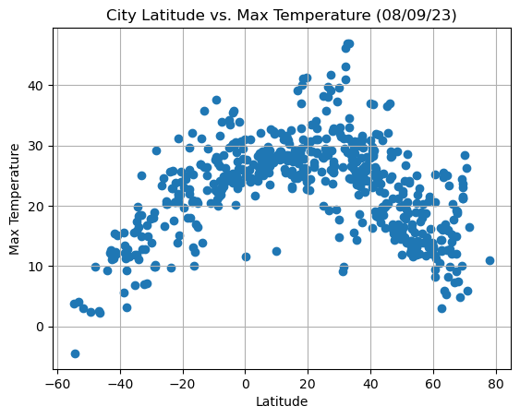

**Latitude Vs. Humidity**

# Build the scatter plots for latitude vs. humidity

plt.scatter(city_data_df["Lat"],city_data_df["Humidity"])

# Incorporate the other graph properties

plt.title("City Latitude vs. Humidity (%s)"% time.strftime("%x"))

plt.xlabel("Latitude")

plt.ylabel("Humidity")

plt.grid(True)

# Save the figure

plt.savefig("../output_data/Fig2.png")

# Show plot

plt.show()

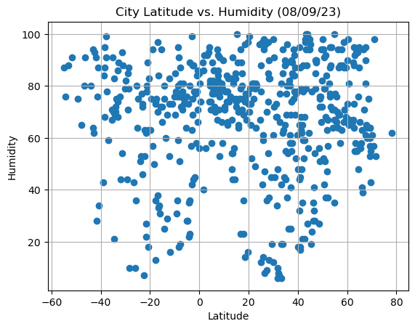

**Latitude Vs. Cloudiness**

# Build the scatter plots for latitude vs. cloudiness

plt.scatter(city_data_df["Lat"],city_data_df["Cloudiness"])

# Incorporate the other graph properties

plt.title(f"City Latitude vs. Cloudiness (%s)"% time.strftime("%x"))

plt.xlabel("Latitude")

plt.ylabel("Cloudiness")

plt.grid(True)

# Save the figure

plt.savefig("../output_data/Fig3.png")

# Show plot

plt.show()

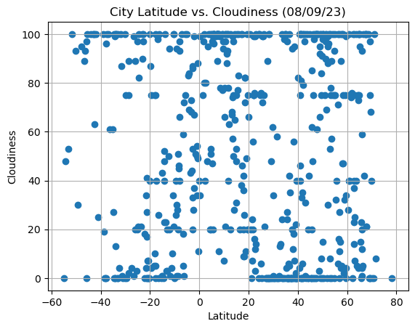

**Latitude vs. Wind Speed Plot**

# Build the scatter plots for latitude vs. wind speed

plt.scatter(city_data_df["Lat"], city_data_df["Wind Speed"])

# Incorporate the other graph properties

plt.title(f"City Latitude vs. Wind Speed (%s)"% time.strftime("%x"))

plt.xlabel("Latitude")

plt.ylabel("Wind Speed")

plt.grid(True)

# Save the figure

plt.savefig("../output_data/Fig4.png")

# Show plot

plt.show()

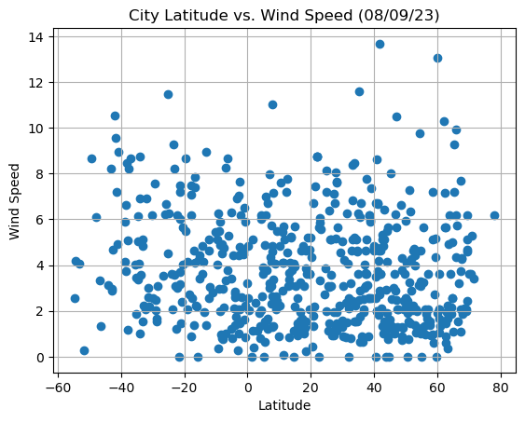

**Requirement 2: Compute Linear Regression for Each Relationship**

# Define a function to create Linear Regression plots

def plot_linear_regression(x_values, y_values, title, y_label, text_coordinates):

r = st.pearsonr(x_values, y_values)

print(f"The r-value is: {r[0]}")

print(f"The p_value is: {r[1]}")

# Run regression on hemisphere weather data.

(slope, intercept, r_value, p_value, std_err) = linregress(x_values, y_values)

# Calculate the regression line "y values" from the slope and intercept.

regress_values = x_values * slope + intercept

# Get the equation of the line.

line_eq = "y = " + str(round(slope,2)) + "x + " + str(round(intercept,2))

# Create a scatter plot and plot the regression line.

plt.scatter(x_values,y_values)

plt.plot(x_values,regress_values,"r")

# Annotate the text for the line equation.

plt.annotate(line_eq, text_coordinates, fontsize=15, color="red")

plt.xlabel('Latitude')

plt.ylabel(y_label)

plt.show()

# Create a DataFrame with the Northern Hemisphere data (Latitude >= 0)

northern_hemi_df = city_data_df.loc[city_data_df["Lat"] >= 0]

# Display sample data

northern_hemi_df.head()

|  | **City** | **Lat** | **Lng** | **Max Temp** | **Humidity** | **Cloudiness** | **Wind Speed** | **Country** | **Date** |
| --- | --- | --- | --- | --- | --- | --- | --- | --- | --- |
| **City_ID** |  |  |  |  |  |  |  |  |  |
| **0** | lerwick | 60.1545 | -1.1494 | 13.00 | 73 | 100 | 13.04 | GB | 1691592767 |
| **2** | kapa'a | 22.0752 | -159.3190 | 27.18 | 81 | 100 | 8.75 | US | 1691592874 |
| **4** | petropavlovsk-kamchatsky | 53.0452 | 158.6483 | 13.33 | 77 | 0 | 4.00 | RU | 1691592685 |
| **5** | albany | 42.6001 | -73.9662 | 24.89 | 68 | 98 | 1.34 | US | 1691592634 |
| **6** | iqaluit | 63.7506 | -68.5145 | 5.85 | 93 | 100 | 4.92 | CA | 1691592687 |

# Create a DataFrame with the Southern Hemisphere data (Latitude < 0)

southern_hemi_df = city_data_df.loc[city_data_df["Lat"] < 0]

# Display sample data

southern_hemi_df.head()

|  | **City** | **Lat** | **Lng** | **Max Temp** | **Humidity** | **Cloudiness** | **Wind Speed** | **Country** | **Date** |
| --- | --- | --- | --- | --- | --- | --- | --- | --- | --- |
| **City_ID** |  |  |  |  |  |  |  |  |  |
| **1** | maceio | -9.6658 | -35.7353 | 27.69 | 69 | 75 | 5.14 | BR | 1691592861 |
| **3** | port-aux-francais | -49.3500 | 70.2167 | 2.47 | 75 | 14 | 8.67 | TF | 1691592875 |
| **9** | waitangi | -43.9535 | -176.5597 | 9.34 | 80 | 59 | 3.13 | NZ | 1691592875 |
| **10** | blackmans bay | -43.0167 | 147.3167 | 12.07 | 64 | 100 | 2.97 | AU | 1691592875 |
| **12** | port elizabeth | -33.9180 | 25.5701 | 18.39 | 72 | 75 | 8.75 | ZA | 1691592775 |

**Temperature vs. Latitude Linear Regression Plot**

# Linear regression on Northern Hemisphere

x_values = northern_hemi_df["Lat"]

y_values = northern_hemi_df["Max Temp"]

plt.title(f"Linear Regression on the Northern Hemisphere \n for Maximum Temperature")

# Call the function.

plot_linear_regression(x_values, y_values,

"Linear Regression on the Northern Hemisphere for Maximum Temperature",

"Max Temp",(5,5))

The r-value is: -0.5936638256215205

The p_value is: 1.8679736053847768e-39

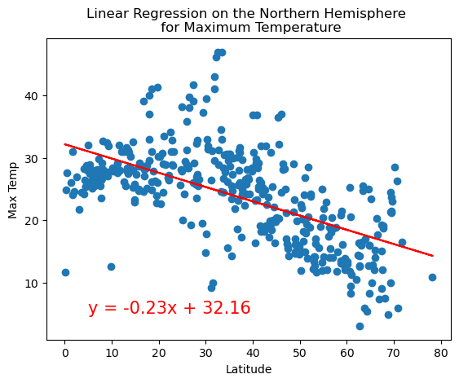

# Linear regression on Southern Hemisphere

x_values = southern_hemi_df["Lat"]

y_values = southern_hemi_df["Max Temp"]

plt.title(f"Linear Regression on the Southern Hemisphere \n for Maximum Temperature")

# Call the function.

plot_linear_regression(x_values, y_values,

'Linear Regression on the Southern Hemisphere for Maximum Temperature',

'Max Temp',(-50,30))

The r-value is: 0.8095010877666934

The p_value is: 5.280820045459488e-40

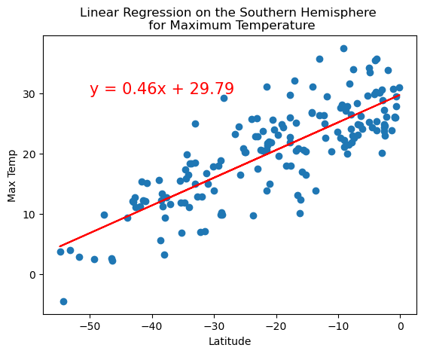

**Discussion about the linear relationship:** The linear regression is modeling what happens to temperature as latitudes increase in the northern and southern hemispheres. In addition, this means that for the northern hemisphere as latitude increases you move further away from the equator. On the other hand, in the southern hemisphere latitudes decrease as we move away from the equator. For the northern hemisphere there is a significant negative correlation between latitude and maximum temperature. Whereas, in the southern hemisphere there is a positive correlation between latitude and maximum temperature.

**Humidity vs. Latitude Linear Regression Plot**

# Northern Hemisphere

x_values = northern_hemi_df["Lat"]

y_values = northern_hemi_df["Humidity"]

plt.title(f"Linear Regression on the Northern Hemisphere \n for % Humidity")

# Call the function.

plot_linear_regression(x_values, y_values,

'Linear Regression on the Northern Hemisphere for % Humidity',

'% Humidity',(45,10))

The r-value is: -0.05826840582523992

The p_value is: 0.24494751239504658

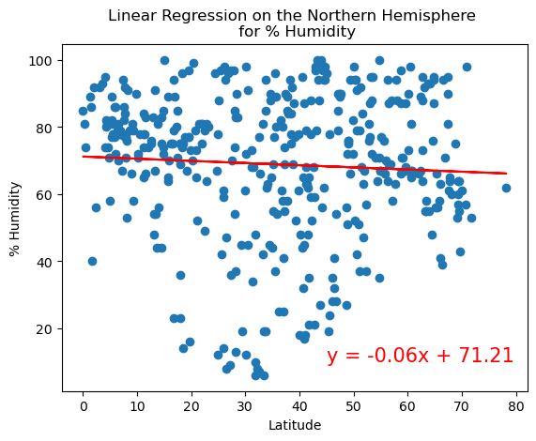

# Southern Hemisphere

x_values = southern_hemi_df["Lat"]

y_values = southern_hemi_df["Humidity"]

plt.title(f"Linear Regression on the Southern Hemisphere \n for % Humidity")

# Call the function.

plot_linear_regression(x_values, y_values,

'Linear Regression on the Southern Hemisphere for % Humidity',

'% Humidity',(-50,15))

The r-value is: -0.16952023226696822

The p_value is: 0.028516524483361033

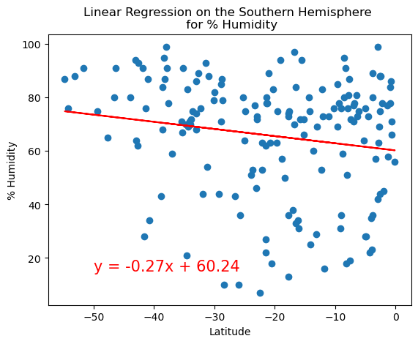

**Discussion about the linear relationship:** The linear regression is modeling what happens to humidity as latitude decrease in the northern and southern hemispheres. As latitude decrease for the northern hemisphere we move further away from the equator, and as latitude decrease for the southern hemisphere we move to the equator. As latitude decrease in the northern hemisphere so does humidity, which means there is a negative correlation. There is no significant correlation between latitudes and humidity in the southern hemisphere.

**Cloudiness vs. Latitude Linear Regression Plot**

# Northern Hemisphere

x_values = northern_hemi_df["Lat"]

y_values = northern_hemi_df["Cloudiness"]

plt.title(f"Linear Regression on the Northern Hemisphere \n for % Cloudiness")

# Call the function.

plot_linear_regression(x_values, y_values,

'Linear Regression on the Northern Hemisphere for % Cloudiness',

'% Cloudiness',(40,10))

The r-value is: -0.07116574775002928

The p_value is: 0.15541490330698127

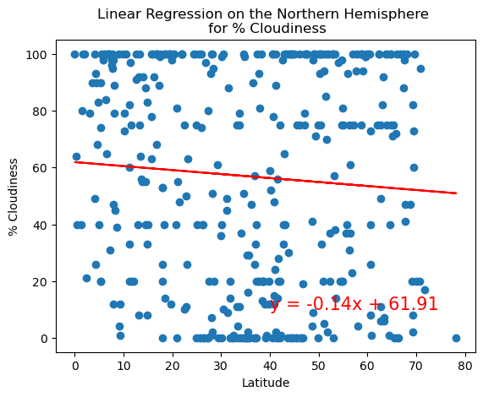

# Southern Hemisphere

x_values = southern_hemi_df["Lat"]

y_values = southern_hemi_df["Cloudiness"]

plt.title(f"Linear Regression on the Southern Hemisphere \n for % Cloudiness")

# Call the function.

plot_linear_regression(x_values, y_values,

'Linear Regression on the Southern Hemisphere for % Cloudiness',

'% Cloudiness',(-50,70))

The r-value is: -0.14503689049579024

The p_value is: 0.061468156736790326

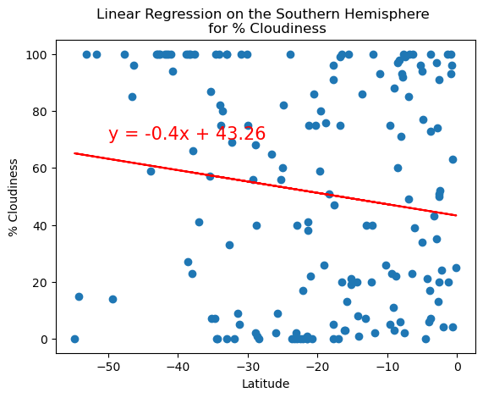

**Discussion about the linear relationship:** The linear regression is modeling what happens to cloudiness as latitudes decrease in the northern and southern hemispheres. As latitude decrease for the northern hemisphere we move further away from the equator, and as latitude decrease for the southern hemisphere we move closer to the equator. For the northern hemisphere, decrease in latitude appear to be weakly related to decrease in cloudiness, but there is significant negative relationship/correlation. On the other hand, there is no relationship between latitude and cloudiness in the southern hemisphere.

**Wind Speed vs. Latitude Linear Regression Plot**

# Northern Hemisphere

x_values = northern_hemi_df["Lat"]

y_values = northern_hemi_df["Wind Speed"]

plt.title("Linear Regression on the Northern Hemisphere \n for Wind Speed")

# Call the function.

plot_linear_regression(x_values, y_values,

"Linear Regression on the Northern Hemisphere \n for Wind Speed",

"Wind Speed",(5,10))

The r-value is: 0.0071257404334752845

The p_value is: 0.8870242309988863

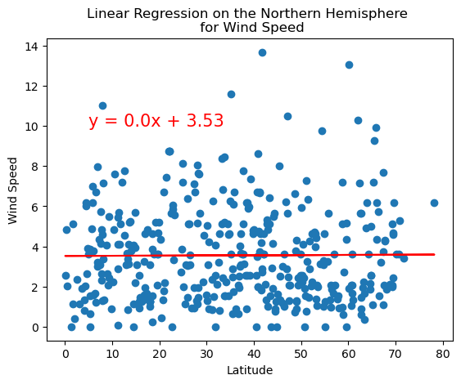

# Southern Hemisphere

x_values = southern_hemi_df["Lat"]

y_values = southern_hemi_df["Wind Speed"]

plt.title("Linear Regression on the Southern Hemisphere \n for Wind Speed")

# Call the function.

plot_linear_regression(x_values, y_values,

"Linear Regression on the Southern Hemisphere \n for Wind Speed",

"Wind Speed",(-50,10))

The r-value is: -0.18797466361844822

The p_value is: 0.014988846188932288

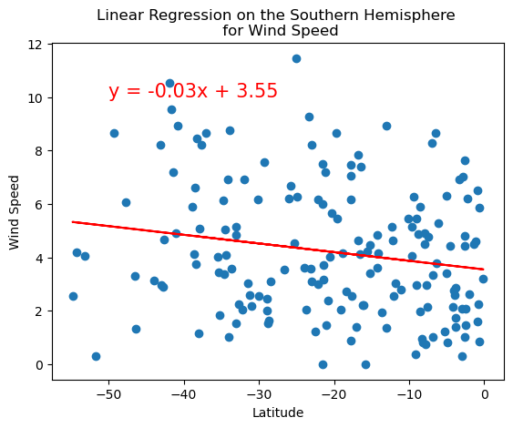

**Discussion about the linear relationship:** The linear regression is modeling what happens to wind speed as latitudes increase in the northern and southern hemispheres. As latitude increases for the northern hemisphere we move further away from the equator, and as latitude increases for the southern hemisphere we move closer to the equator. In the northern hemisphere, although the relationship between increasing latitude and wind speed is significant (based on the p-value), there only appears to be a weak correlation. On the other hand, in the southern hemisphere there is no correlation between the increasing latitude and wind speed.